Subject: Software Requirements
Title: Progress Test 2
Content: Chapter 4,5,7,8
Time: 30’
Number of question: 32/32
QN=1 | Which of the following is A context diagram that can be further detailed by indicating explicitly which component controls a shared phenomena, which component constitutes the machine needs to be built, and which components are affected by which requirements?
a. | Frame diagram
b. | Problem diagram
c. | State machine diagram
d. | Entity-relationship diagram
ANS: | B
PTS: | 1
UNIT: | 4
MIX CHOICES: | YES

QN=2 | A_________ is captured by a sequence of state transitions for the system items that the component control
a. | Behavior
b. | State
c. | SM state transition
d. | SM trace
e. | SM State
ANS: | A
PTS: | 1
UNIT: | 4
MIX CHOICES: | YES

QN=3 | 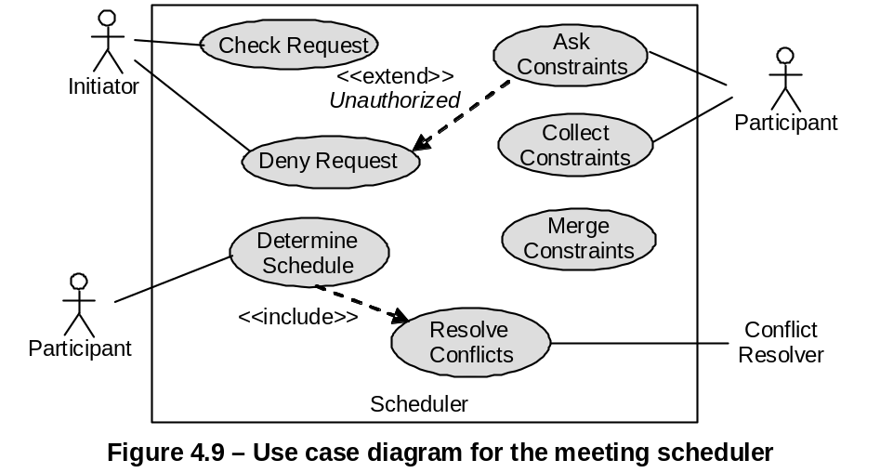  In Figure 4.9 [file: Figure-4.9.jpg], “DenyRequest - <<extend>> - AskConstraints” means:
a. | DenyRequest is a sub-operation of AskConstraints.
b. | DenyRequest is an alternative operation of AskConstraints.
c. | DenyRequest is a variant operation of AskConstraints, when the condition named Unauthorized holds.
d. | None of the others
ANS: | C
PTS: | 1
UNIT: | 4
MIX CHOICES: | YES

QN=4 | Actigrams (Datagrams) declare activities (data) by their input/output data (producing/consuming activities) and interconnect them through data (___________) dependency links.
a. | Action
b. | Value
c. | Data
d. | Control
ANS: | D
PTS: | 1
UNIT: | 4
MIX CHOICES: | YES

QN=5 | ER diagram is made from three core constructs: entities, __________ and relationships.
a. | Classes
b. | Methods
c. | Objects
d. | Attributes
ANS: | D
PTS: | 1
UNIT: | 4
MIX CHOICES: | YES

QN=6 | 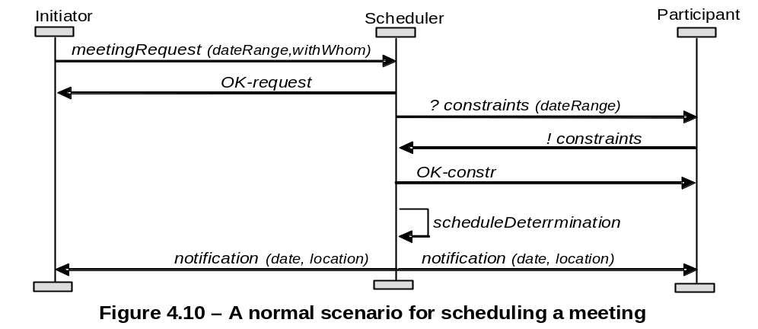  Figure 4.10 [file: Figure-4.10.jpg] shows an Event Trace Diagram specifying a meeting scheduling scenario. The first event is meetingRequest, ________ by an Initiator instance and _________ by a Scheduler instance.
a. | controlled/monitored
b. | monitored/controlled
c. | requested/responded
d. | responded/requested
ANS: | A
PTS: | 1
UNIT: | 4
MIX CHOICES: | YES

QN=7 | Which of the following specifies all the operations that a system component is required to perform, possibly under a particular condition, in response to a particular input stimulus?
a. | A use-case diagram
b. | An event trace diagram
c. | An R-net diagram
d. | A SADT diagram
ANS: | c
PTS: | 1
UNIT: | 4
MIX CHOICES: | YES

QN=8 | Which of the followings captures the activities and data in the system (system-to-be or system-as-is), these diagrams allow these activities and data to be documented in a graphical way?
a. | SADT diagrams
b. | Dataflow diagrams
c. | Entity-relationship diagrams
d. | Context diagrams
ANS: | A
PTS: | 1
UNIT: | 4
MIX CHOICES: | YES

QN=9 | Which of the following activities should NOT be done in the phase “Defect evaluation at review meetings” of “Requirements inspection & review process”?
a. | The defects found by each inspector are collected and discussed by the meeting participants
b. | The meeting participants keep only defects on which all agree
c. | Each inspector reads the RD or part of it individually to look for defects.
d. | The team documents the conclusions in an inspection report
ANS: | C
PTS: | 1
UNIT: | 5
MIX CHOICES: | YES

QN=10 | Requirements Inspection process uses __________ guidelines to make it more effective in finding defects.
a. | WHY-WHAT-WHO
b. | WHY-WHAT-WHO-HOW
c. | WHAT-WHO-WHEN-WHERE
d. | WHY-WHAT-WHO-WHERE
ANS: | C
PTS: | 1
UNIT: | 5
MIX CHOICES: | YES

QN=11 | The phase “Individual reviewing”, inspectors reads the Requirement Document for defects. They can operate this phase in which of the following modes?
a. | Free mode, process-based mode, checklist-based mode
b. | Free mode, guideline-based mode, checklist-based mode
c. | Free mode, guideline-based mode, process-based mode
d. | Free mode and checklist-based mode
ANS: | A
PTS: | 1
UNIT: | 5
MIX CHOICES: | YES

QN=12 | Which of the following modes of individual reviewing rely on lists of specific issues to address while searching for defects?
a. | Checklist-based mode
b. | Checklist-based and process-based modes
c. | Free mode
d. | None of the others
ANS: | B
PTS: | 1
UNIT: | 5
MIX CHOICES: | YES

QN=13 | ____________________ form an effective technique for quality assurance, it is the widest in scope and applicability.
a. | “Requirements inspection and reviews”
b. | “Queries on a requirements database”
c. | “Requirements validation by specification animation”
d. | None of the others
ANS: | A
PTS: | 1
UNIT: | 5
MIX CHOICES: | YES

QN=14 | All of the following questions should be in the checklist used for verifying "Poor structuring" defect type, EXCEPT?
a. | Is the structuring rule for organizing these RD sections apparent?
b. | Does this RD item cover unrelated requirements?
c. | Does this RD item mix requirements and assumptions together?
d. | Would there be alternative sensible choices?
ANS: | d
PTS: | 1
UNIT: | 5
MIX CHOICES: | YES

QN=15 | Because the requirements errors are the most expensive, numerous and persistent software errors, so “requirements inspection & review process” should be applied as soon as possible.
a. | TRUE
b. | FALSE
ANS: | B
PTS: | 1
UNIT: | 5
MIX CHOICES: | YES

QN=16 | __________specialize the defect-based ones to the specific constructs of the structured, semi-format or formal specification language used in the requirement document.
a. | Domain-specific checklists
b. | Quality-specific checklists
c. | Defect-based checklist
d. | Language-based checklist
ANS: | d
PTS: | 1
UNIT: | 5
MIX CHOICES: | YES

QN=17 | Unlike domain properties and ________, goals may be refined, negotiated, assigned as responsibilities to agents and transformed in case of conflict or overexposure to risks.
a. | assumptions
b. | expectations
c. | requirements
d. | hypotheses
ANS: | D
PTS: | 1
UNIT: | 7
MIX CHOICES: | YES

QN=18 | An expectation is a goal assigned to a single agent of the _________.
a. | problem world
b. | environment
c. | software-to-be
d. | system-as-is
ANS: | B
PTS: | 1
UNIT: | 7
MIX CHOICES: | YES

QN=19 | Which of the following statements is a “soft goal”?
a. | If a book is requested then within a week a copy of the book is borrowed by the requesting patron.
b. | If a train is at a platform then within 5 minutes the train is at the next platform.
c. | The meeting scheduler software should be easy to use by administrative staff.
d. | If a meeting is requested then sooner-or-later the meeting takes place and is attended by all important invited participants.
ANS: | C
PTS: | 1
UNIT: | 7
MIX CHOICES: | YES

QN=20 | In the goal model, the finer-grained a goal is, the _______ are required to satisfy it.
a. | fewer requirements
b. | better agents
c. | more agents
d. | fewer agents
ANS: | D
PTS: | 1
UNIT: | 7
MIX CHOICES: | YES

QN=21 | A goal refinement graph show the refinement and contribution links among goals. ________ appear as leaf nodes in this graph.
a. | Soft goals
b. | Domain properties
c. | Requirements
d. | Behavior goals
ANS: | C
PTS: | 1
UNIT: | 7
MIX CHOICES: | YES

QN=22 | ___________ prescribe different types of protection of agent assets against unintended behaviors.
a. | Accuracy goals
b. | Information goals
c. | Security goals
d. | Stimulus-response goals
ANS: | c
PTS: | 1
UNIT: | 7
MIX CHOICES: | YES

QN=23 | Behavioral goals are used for building _________ specifications of the system.
a. | Operational
b. | Non-functional
c. | Critical requirements
d. | None of the others
ANS: | A
PTS: | 1
UNIT: | 7
MIX CHOICES: | YES

QN=24 | _______ are used as criteria for selecting system options among multiple alternatives.
a. | Maintain goals
b. | Avoid goals
c. | Achieve goals
d. | Soft goals
ANS: | D
PTS: | 1
UNIT: | 7
MIX CHOICES: | YES

QN=25 | An AND-refinement of a goal G into sub-goals G1, G2, …, Gn should be
a. | Complete, inconsistent, minimal
b. | Complete, accuracy, coverage
c. | Complete, consistent, minimal
d. | Complete, consistent, minimal, entailments
ANS: | C
PTS: | 1
UNIT: | 8
MIX CHOICES: | YES

QN=26 | Which of the following is an INCORRECT statements about the leaf nodes in goals refinement trees?
a. | They are nodes that need not be refined further.
b. | They are nodes whose responsibility can be assigned to single software agents.
c. | They are nodes whose responsibility can be assigned to single environment agents.
d. | They cannot be domain properties or hypotheses.
ANS: | D
PTS: | 1
UNIT: | 8
MIX CHOICES: | YES

QN=27 | The goal model captures ______ and responsibility links from goals to system agents
a. | concern links between goals and conceptual objects
b. | obstruction links between goals and obstacles
c. | operationalization links between goals and system operations
d. | coverage links between goals and scenarios
ANS: | a
PTS: | 1
UNIT: | 8
MIX CHOICES: | YES

QN=28 | A goal model makes it possible to capture alternative options by_____
a. | alternative goal refinements
b. | alternative goal refinements or alternative responsibility assignments
c. | alternative goal refinements, AND-refinement, or alternative responsibility assignments
d. | None of the others
ANS: | B
PTS: | 1
UNIT: | 8
MIX CHOICES: | YES

QN=29 | We can build refinement and abstraction paths in a goal diagram by recursively asking ___ and ___ questions about available goals, respectively
a. | WHY / HOW
b. | WHY / WHAT
c. | HOW / WHY
d. | WHAT / WHY
ANS: | C
PTS: | 1
UNIT: | 8
MIX CHOICES: | YES

QN=30 | 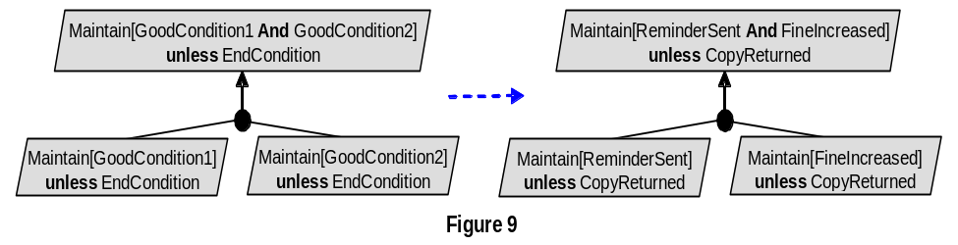  Figure 9 [file: Figure-8.9.jpg] shows the __________________
a. | Unrealizability-driven refinement pattern.
b. | Unmonitorability-driven refinement pattern.
c. | Divide-and-conquer refinement pattern.
d. | Milestone-driven refinement pattern
ANS: | C
PTS: | 1
UNIT: | 8
MIX CHOICES: | YES

QN=31 | 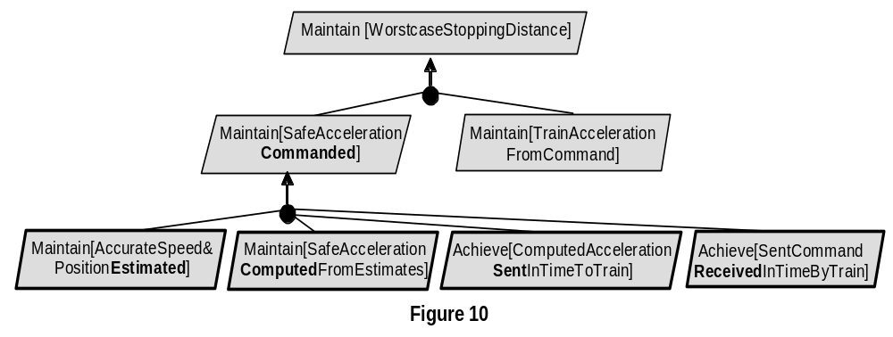  Figure 10 [file: Figure-8.10.jpg] shows the __________________
a. | Case-driven refinement pattern
b. | Guard-introduction pattern
c. | Divide-and-conquer pattern
d. | Milestone-driven refinement pattern
ANS: | D
PTS: | 1
UNIT: | 8
MIX CHOICES: | YES

QN=32 | The goals G1, G2, …, Gn are divergent in a domain Dom if we can find a feasible boundary condition B under which the goals cannot satisfied the arguments. Which of the following reflects the above definition?
a. | {G1, G2, …, Gn, B, Dom} |= true
b. | {G1, G2, …, Gn, B, Dom} |= false
c. | {G1, G2, …, Gn, B, Dom} |= G
d. | {G1, G2, …, Gn, B, Dom} satisfied G
ANS: | B
PTS: | 1
UNIT: | 8
MIX CHOICES: | YES

