Subject: Software Requirements
Title: Progress Test 3
Content: Chapter 10,11,12
Time: 30’
Number of question: 33

QN=1 | An object model provides a _________ of the system-as-is and system-to-be.
a. | Intentional view
b. | Functional view
c. | structural view
d. | behavioral view
e.
f.
ANS: | C
PTS: | 1
CHAPTER: | 10
MIX CHOICES: | YES

QN=2 | A/an _________ is a discrete set of instances of a domain-specific concept that are manipulated by the modelled system
a. | System state
b. | State variable
c. | Object class
d. | Conceptual object
e.
f.
ANS: | D
PTS: | 1
CHAPTER: | 10
MIX CHOICES: | YES

QN=3 | The features shared by object instances include:
a. | common vocabularies, glossary of terms, object’s attributes and definition
b. | goals, agents, operations and behavior models
c. | object’s definition, type, individual attributes, associations, domain invariants
d. | None of the others
e.
f.
ANS: | C
PTS: | 1
CHAPTER: | 10
MIX CHOICES: | YES

QN=4 | An entity is ___________.
a. | An autonomous and active object
b. | A conceptual object dependent on other objects that it links.
c. | An instantaneous object
d. | None of the others
e.
f.
ANS: | D
PTS: | 1
CHAPTER: | 10
MIX CHOICES: | YES

QN=5 | The association is also called under synonymous term __________
a. | ‘relation’
b. | ‘relationship’
c. | ‘linked object’
d. | none of the others
e.
f.
ANS: | B
PTS: | 1
CHAPTER: | 10
MIX CHOICES: | YES

QN=6 | Each linked object in an association plays specific _____ in the association
a. | Relation
b. | Role
c. | Link
d. | none of the others
e.
f.
ANS: | B
PTS: | 1
CHAPTER: | 10
MIX CHOICES: | YES

QN=7 | The multiplicity on one side of an association specifies the minimum and maximum number of object instances on _______ that may be associated with one target object instance.
a. | the other side
b. | this side
c. | both sides
d. | None of the others
e.
f.
ANS: | B
PTS: | 1
CHAPTER: | 10
MIX CHOICES: | YES

QN=8 | An attribute is _______________.
a. | An intrinsic feature of an object regardless of other objects in the model
b. | A relevant feature of an object, including the association with other objects in the model
c. | A quantitative feature of an object
d. | none of the others
e.
f.
ANS: | A
PTS: | 1
CHAPTER: | 10
MIX CHOICES: | YES

QN=9 | A specialization link may be introduced in a model between an object SubOb and an object SuperOb if every current instance of _____ is a current instance of _____ as well.
a. | SuperOb / SubOb
b. | SubOb / SuperOb
c.
d.
e.
f.
ANS: | B
PTS: | 1
CHAPTER: | 10
MIX CHOICES: | YES

QN=10 | In specialization, the object SubOb plays the role ______ whereas the object SuperOb plays the inverse role ______.
a. | Generalizes / Specializes
b. | Specializes / Generalizes
c. | IsA / SubClassOf
d. | SubClassOf / IsA
e.
f.
ANS: | B
PTS: | 1
CHAPTER: | 10
MIX CHOICES: | YES

QN=11 | An______ link may be introduced between an object Ob and objects PartOb1,… PartObn if every current instance of Ob is a tuple of current instances of PartOb1, …., PartObn.
a. | aggregation
b. | composition
c. | association
d. | combination
e.
f.
ANS: | a
PTS: | 1
CHAPTER: | 10
MIX CHOICES: | YES

QN=12 | An agent model captures the ____-dimension of requirements engineering
a. | WHY
b. | WHO
c. | WHAT
d. | HOW
e.
f.
ANS: | B
PTS: | 1
CHAPTER: | 11
MIX CHOICES: | YES

QN=13 | An agent is an ______ system component play a role in goal satisfaction.
a. | Active
b. | Passive
c. | Instantaneous
d. | none of the others
e.
f.
ANS: | A
PTS: | 1
CHAPTER: | 11
MIX CHOICES: | YES

QN=14 | Which of the following statements about agent capabilities is wrong?
a. | An agent monitors an attribute of an object if its instances can get the value of this attribute from object instances
b. | An agent monitors an association if its instances can control this association holds between object instances
c. | An agent controls an attribute of an object if its instances can set values for this attribute on object instances
d. | An agent controls an association if its instances can create and delete association instances
e.
f.
ANS: | B
PTS: | 1
CHAPTER: | 11
MIX CHOICES: | YES

QN=15 | A goal under the responsibility of an agent must be realizable by the agent in view of its ________.
a. | Responsibilities
b. | Capabilities
c. | Realizabilities
d. | None of the others
e.
f.
ANS: | B
PTS: | 1
CHAPTER: | 11
MIX CHOICES: | YES

QN=16 | Agent capabilities are defined in terms of the system variables that the agent can _____ and _____.
a. | Assign / evaluate
b. | Specify / realize
c. | Monitor / control
d. | none of the others
e.
f.
ANS: | C
PTS: | 1
CHAPTER: | 11
MIX CHOICES: | YES

QN=17 | 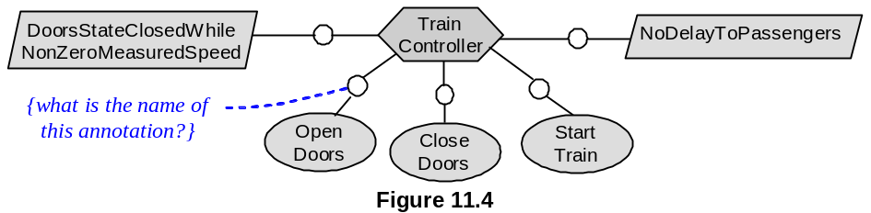  In figure 11.4 [file: Figure-11.4.jpg], what is the name of the annotation attached to the link between the agent and the operation in the agent model?
a. | Responsibility instance declaration
b. | Capability instance declaration
c. | Performance instance declaration
d. | none of the others
e.
f.
ANS: | C
PTS: | 1
CHAPTER: | 11
MIX CHOICES: | YES

QN=18 | Which of the following statements is the definition of “capability instance declaration” (CID)?
a. | It annotating a performance link in an agent diagram makes precise which agent instance is performing the operation on which input/output object instance
b. | It annotating a monitoring or control link makes precise which agent instance is monitoring or controlling the attribute/association of which object instance
c. | It annotating a responsibility link in an agent diagram makes it precise which agent instance is responsible for which goal instantiation to specific object instances
d. | None of the others
e.
f.
ANS: | B
PTS: | 1
CHAPTER: | 11
MIX CHOICES: | YES

QN=19 | In the agent model, an agent ag1 is said to depend on another agent ag2 for a goal G under the responsibility of ag2, if ___’s failure to get G satisfied can result in ___’s failure to get one of its assigned goals satisfied
a. | ag1 / ag2
b. | ag2 / ag1
c.
d.
e.
f.
ANS: | B
PTS: | 1
CHAPTER: | 11
MIX CHOICES: | YES

QN=20 | What is an agent-goal co-refinement process?
a. | A process in which an agent and its assigned goals are refined in parallel into finer-grained agents, sub-goals and responsibility assignments
b. | A process in which agents and assigned goals are generalized in parallel into coarse-grained agents and abstract goals
c. | Both of above statements are wrong
d.
e.
f.
ANS: | A
PTS: | 1
CHAPTER: | 11
MIX CHOICES: | YES

QN=21 | 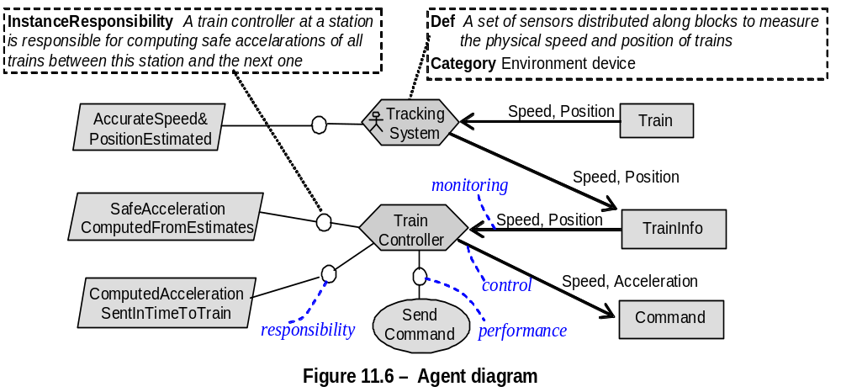  In figure 11.6 [file:Figure-11.6.jpg], “Train” and “TrainInfo” are classified as
a. | Agents
b. | Events
c. | Entities
d. | Associations
e.
f.
ANS: | C
PTS: | 1
CHAPTER: | 11
MIX CHOICES: | YES

QN=22 | Which of the following is NOT a rule for agent responsibility when building agent model?
a. | Assignment to wisher
b. | Assignment refinement
c. | Assignment based on goal-capability matching
d. | Assignment selection based on achieve goal
e.
f.
ANS: | D
PTS: | 1
CHAPTER: | 11
MIX CHOICES: | YES

QN=23 | A/An ________ designates an object instance to which the operation applies. The state of this instance affects the application of the operation.
a. | State variable
b. | Input variable
c. | Out variable
d. | None of the others
e.
f.
ANS: | B
PTS: | 1
CHAPTER: | 12
MIX CHOICES: | YES

QN=24 | A particular application of the operation yields a state _______ from a state in InputState to a state in OutputState.
a. | transformation
b. | exchange
c. | transition
d. | none of the others
e.
f.
ANS: | C
PTS: | 1
CHAPTER: | 12
MIX CHOICES: | YES

QN=25 | Domain pre- and post-conditions are prescriptive.
a. | True
b. | False
c.
d.
e.
f.
ANS: | B
PTS: | 1
CHAPTER: | 12
MIX CHOICES: | YES

QN=26 | The specification of an operation therefore includes a set of prescriptive conditions on operation applications. These conditions are aimed at ensuring that ______.
a. | the operation is dependent on the goals
b. | the goals underlying the operation are satisfied
c. | the operation associates with the goals
d. | None of the others
e.
f.
ANS: | B
PTS: | 1
CHAPTER: | 12
MIX CHOICES: | YES

QN=27 | Which of the following statements about required condition is true?
a. | Required pre-condition captures an obligation.
b. | Required trigger condition captures an additional effect.
c. | Required post-condition captures a permission.
d. | none of the others
e.
f.
ANS: | D
PTS: | 1
CHAPTER: | 12
MIX CHOICES: | YES

QN=28 | The operation is not applied if a trigger condition becomes true in a state where the operation’s domain pre-condition is not true.
a. | True
b. | False
c.
d.
e.
f.
ANS: | A
PTS: | 1
CHAPTER: | 12
MIX CHOICES: | YES

QN=29 | Which of the following statements is false?
a. | An operation may operationalizes multiple goals.
b. | A goal may be operationalized by multiple operations.
c. | Multiple agents perform an operation.
d. | An agent may perform multiple operations.
e.
f.
ANS: | C
PTS: | 1
CHAPTER: | 12
MIX CHOICES: | YES

QN=30 | An operationalization diagram is an annotated graph showing the system operations, their ______ to goals in the goal model and input/output links to objects in the object model.
a. | performance links
b. | operationalization links
c. | capability links
d. | None of the others
e.
f.
ANS: | B
PTS: | 1
CHAPTER: | 12
MIX CHOICES: | YES

QN=31 | A use case diagram provides an outline view of an operation model by showing the operations that an agent performs together with ________ with other agents.
a. | interaction links.
b. | responsibility links
c. | operationalization links
d. | None of the others
e.
f.
ANS: | A
PTS: | 1
CHAPTER: | 12
MIX CHOICES: | YES

QN=32 | In _______ scheme, the agent instance applies the operation when it is really obliged to do so; that is, when one of the operation’s required trigger conditions becomes true.
a. | an eager behaviour
b. | a lazy behaviour
c.
d.
e.
f.
ANS: | B
PTS: | 1
CHAPTER: | 12
MIX CHOICES: | YES

QN=33 | Which of the following designates an object instance on which the operation acts (The state of this instance is changed by the application of the operation.)?
a. | An input variable
b. | An output variable
c. | State variables
d. | Instance variables
e.
f.
ANS: | B
PTS: | 1
CHAPTER: | 12
MIX CHOICES: | YES

