Subject: Software Requirements
Title: Progress Test 2
Content: Chapter 4,5,7,8
Time: 30’
Number of question: 40/40
QN=1 | Which of the following is A context diagram that can be further detailed by indicating explicitly which component controls a shared phenomena, which component constitutes the machine needs to be built, and which components are affected by which requirements?
a. | Frame diagram
b. | Problem diagram
c. | State machine diagram
d. | Entity-relationship diagram
ANS: | B
PTS: | 1
UNIT: | 4
MIX CHOICES: | YES

QN=2 | A_________ is captured by a sequence of state transitions for the system items that the component control
a. | Behavior
b. | State
c. | SM state transition
d. | SM trace
e. | SM State
ANS: | A
PTS: | 1
UNIT: | 4
MIX CHOICES: | YES

QN=3 | 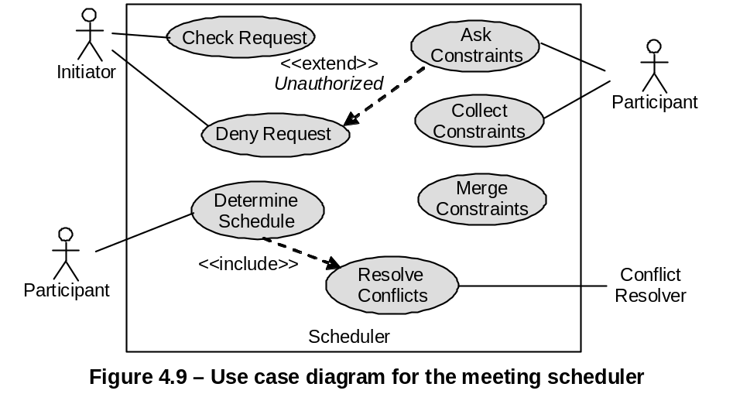  In Figure 4.9 [file: Figure-4.9.jpg], “DenyRequest - <<extend>> - AskConstraints” means:
a. | DenyRequest is a sub-operation of AskConstraints.
b. | DenyRequest is an alternative operation of AskConstraints.
c. | DenyRequest is a variant operation of AskConstraints, when the condition named Unauthorized holds.
d. | None of the others
ANS: | C
PTS: | 1
UNIT: | 4
MIX CHOICES: | YES

QN=4 | Actigrams (Datagrams) declare activities (data) by their input/output data (producing/consuming activities) and interconnect them through data (___________) dependency links.
a. | Action
b. | Value
c. | Data
d. | Control
ANS: | D
PTS: | 1
UNIT: | 4
MIX CHOICES: | YES

QN=5 | ER diagram is made from three core constructs: entities, __________ and relationships.
a. | Classes
b. | Methods
c. | Objects
d. | Attributes
ANS: | D
PTS: | 1
UNIT: | 4
MIX CHOICES: | YES

QN=6 | 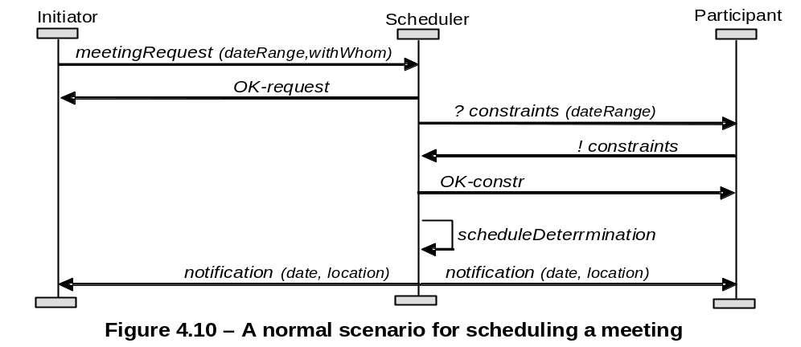  Figure 4.10 [file: Figure-4.10.jpg] shows an Event Trace Diagram specifying a meeting scheduling scenario. The first event is meetingRequest, ________ by an Initiator instance and _________ by a Scheduler instance.
a. | controlled/monitored
b. | monitored/controlled
c. | requested/responded
d. | responded/requested
ANS: | A
PTS: | 1
UNIT: | 4
MIX CHOICES: | YES

QN=7 | Which of the following specifies all the operations that a system component is required to perform, possibly under a particular condition, in response to a particular input stimulus?
a. | A use-case diagram
b. | An event trace diagram
c. | An R-net diagram
d. | A SADT diagram
ANS: | c
PTS: | 1
UNIT: | 4
MIX CHOICES: | YES

QN=8 | Which of the followings captures the activities and data in the system (system-to-be or system-as-is), these diagrams allow these activities and data to be documented in a graphical way?
a. | SADT diagrams
b. | Dataflow diagrams
c. | Entity-relationship diagrams
d. | Context diagrams
ANS: | A
PTS: | 1
UNIT: | 4
MIX CHOICES: | YES

QN=9 | Which of the following activities should NOT be done in the phase “Defect evaluation at review meetings” of “Requirements inspection & review process”?
a. | The defects found by each inspector are collected and discussed by the meeting participants
b. | The meeting participants keep only defects on which all agree
c. | Each inspector reads the RD or part of it individually to look for defects.
d. | The team documents the conclusions in an inspection report
ANS: | C
PTS: | 1
UNIT: | 5
MIX CHOICES: | YES

QN=10 | Requirements Inspection process uses __________ guidelines to make it more effective in finding defects.
a. | WHY-WHAT-WHO
b. | WHY-WHAT-WHO-HOW
c. | WHAT-WHO-WHEN-WHERE
d. | WHY-WHAT-WHO-WHERE
ANS: | C
PTS: | 1
UNIT: | 5
MIX CHOICES: | YES

QN=11 | The phase “Individual reviewing”, inspectors reads the Requirement Document for defects. They can operate this phase in which of the following modes?
a. | Free mode, process-based mode, checklist-based mode
b. | Free mode, guideline-based mode, checklist-based mode
c. | Free mode, guideline-based mode, process-based mode
d. | Free mode and checklist-based mode
ANS: | A
PTS: | 1
UNIT: | 5
MIX CHOICES: | YES

QN=12 | Which of the following modes of individual reviewing rely on lists of specific issues to address while searching for defects?
a. | Checklist-based mode
b. | Checklist-based and process-based modes
c. | Free mode
d. | None of the others
ANS: | B
PTS: | 1
UNIT: | 5
MIX CHOICES: | YES

QN=13 | ____________________ form an effective technique for quality assurance, it is the widest in scope and applicability.
a. | “Requirements inspection and reviews”
b. | “Queries on a requirements database”
c. | “Requirements validation by specification animation”
d. | None of the others
ANS: | A
PTS: | 1
UNIT: | 5
MIX CHOICES: | YES

QN=14 | All of the following questions should be in the checklist used for verifying "Poor structuring" defect type, EXCEPT?
a. | Is the structuring rule for organizing these RD sections apparent?
b. | Does this RD item cover unrelated requirements?
c. | Does this RD item mix requirements and assumptions together?
d. | Would there be alternative sensible choices?
ANS: | d
PTS: | 1
UNIT: | 5
MIX CHOICES: | YES

QN=15 | Because the requirements errors are the most expensive, numerous and persistent software errors, so “requirements inspection & review process” should be applied as soon as possible.
a. | TRUE
b. | FALSE
ANS: | B
PTS: | 1
UNIT: | 5
MIX CHOICES: | YES

QN=16 | __________specialize the defect-based ones to the specific constructs of the structured, semi-format or formal specification language used in the requirement document.
a. | Domain-specific checklists
b. | Quality-specific checklists
c. | Defect-based checklist
d. | Language-based checklist
ANS: | d
PTS: | 1
UNIT: | 5
MIX CHOICES: | YES

QN=17 | Unlike domain properties and ________, goals may be refined, negotiated, assigned as responsibilities to agents and transformed in case of conflict or overexposure to risks.
a. | assumptions
b. | expectations
c. | requirements
d. | hypotheses
ANS: | D
PTS: | 1
UNIT: | 7
MIX CHOICES: | YES

QN=18 | An expectation is a goal assigned to a single agent of the _________.
a. | problem world
b. | environment
c. | software-to-be
d. | system-as-is
ANS: | B
PTS: | 1
UNIT: | 7
MIX CHOICES: | YES

QN=19 | Which of the following statements is a “soft goal”?
a. | If a book is requested then within a week a copy of the book is borrowed by the requesting patron.
b. | If a train is at a platform then within 5 minutes the train is at the next platform.
c. | The meeting scheduler software should be easy to use by administrative staff.
d. | If a meeting is requested then sooner-or-later the meeting takes place and is attended by all important invited participants.
ANS: | C
PTS: | 1
UNIT: | 7
MIX CHOICES: | YES

QN=20 | In the goal model, the finer-grained a goal is, the _______ are required to satisfy it.
a. | fewer requirements
b. | better agents
c. | more agents
d. | fewer agents
ANS: | D
PTS: | 1
UNIT: | 7
MIX CHOICES: | YES

QN=21 | A goal refinement graph show the refinement and contribution links among goals. ________ appear as leaf nodes in this graph.
a. | Soft goals
b. | Domain properties
c. | Requirements
d. | Behavior goals
ANS: | C
PTS: | 1
UNIT: | 7
MIX CHOICES: | YES

QN=22 | ___________ prescribe different types of protection of agent assets against unintended behaviors.
a. | Accuracy goals
b. | Information goals
c. | Security goals
d. | Stimulus-response goals
ANS: | c
PTS: | 1
UNIT: | 7
MIX CHOICES: | YES

QN=23 | Behavioral goals are used for building _________ specifications of the system.
a. | Operational
b. | Non-functional
c. | Critical requirements
d. | None of the others
ANS: | A
PTS: | 1
UNIT: | 7
MIX CHOICES: | YES

QN=24 | _______ are used as criteria for selecting system options among multiple alternatives.
a. | Maintain goals
b. | Avoid goals
c. | Achieve goals
d. | Soft goals
ANS: | D
PTS: | 1
UNIT: | 7
MIX CHOICES: | YES

QN=25 | An AND-refinement of a goal G into sub-goals G1, G2, …, Gn should be
a. | Complete, inconsistent, minimal
b. | Complete, accuracy, coverage
c. | Complete, consistent, minimal
d. | Complete, consistent, minimal, entailments
ANS: | C
PTS: | 1
UNIT: | 8
MIX CHOICES: | YES

QN=26 | Which of the following is an INCORRECT statements about the leaf nodes in goals refinement trees?
a. | They are nodes that need not be refined further.
b. | They are nodes whose responsibility can be assigned to single software agents.
c. | They are nodes whose responsibility can be assigned to single environment agents.
d. | They cannot be domain properties or hypotheses.
ANS: | D
PTS: | 1
UNIT: | 8
MIX CHOICES: | YES

QN=27 | The goal model captures ______ and responsibility links from goals to system agents
a. | concern links between goals and conceptual objects
b. | obstruction links between goals and obstacles
c. | operationalization links between goals and system operations
d. | coverage links between goals and scenarios
ANS: | a
PTS: | 1
UNIT: | 8
MIX CHOICES: | YES

QN=28 | A goal model makes it possible to capture alternative options by_____
a. | alternative goal refinements
b. | alternative goal refinements or alternative responsibility assignments
c. | alternative goal refinements, AND-refinement, or alternative responsibility assignments
d. | None of the others
ANS: | B
PTS: | 1
UNIT: | 8
MIX CHOICES: | YES

QN=29 | We can build refinement and abstraction paths in a goal diagram by recursively asking ___ and ___ questions about available goals, respectively
a. | WHY / HOW
b. | WHY / WHAT
c. | HOW / WHY
d. | WHAT / WHY
ANS: | C
PTS: | 1
UNIT: | 8
MIX CHOICES: | YES

QN=30 | 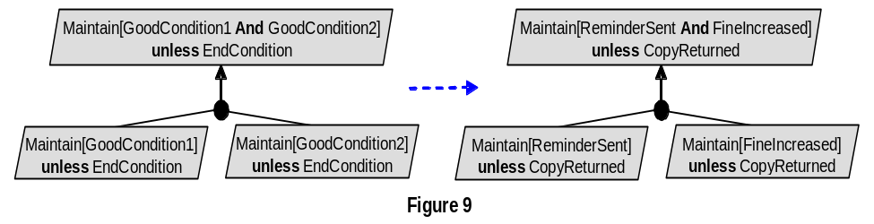  Figure 9 [file: Figure-8.9.jpg] shows the __________________
a. | Unrealizability-driven refinement pattern.
b. | Unmonitorability-driven refinement pattern.
c. | Divide-and-conquer refinement pattern.
d. | Milestone-driven refinement pattern
ANS: | C
PTS: | 1
UNIT: | 8
MIX CHOICES: | YES

QN=31 | 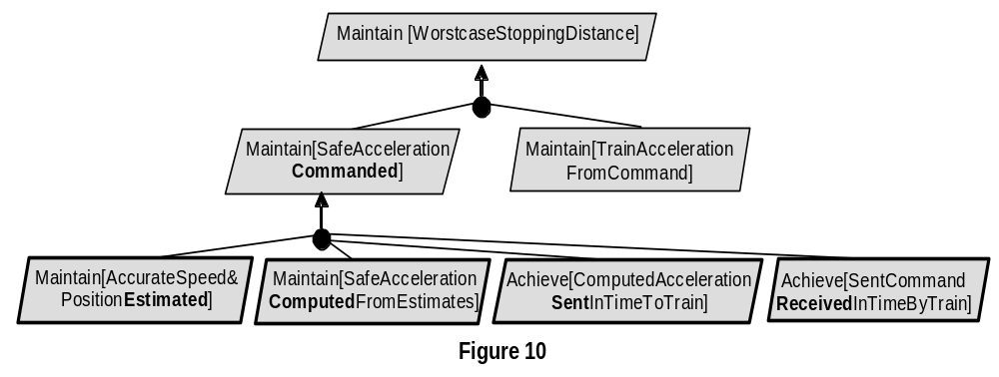  Figure 10 [file: Figure-8.10.jpg] shows the __________________
a. | Case-driven refinement pattern
b. | Guard-introduction pattern
c. | Divide-and-conquer pattern
d. | Milestone-driven refinement pattern
ANS: | D
PTS: | 1
UNIT: | 8
MIX CHOICES: | YES

QN=32 | The goals G1, G2, …, Gn are divergent in a domain Dom if we can find a feasible boundary condition B under which the goals cannot satisfied the arguments. Which of the following reflects the above definition?
a. | {G1, G2, …, Gn, B, Dom} |= true
b. | {G1, G2, …, Gn, B, Dom} |= false
c. | {G1, G2, …, Gn, B, Dom} |= G
d. | {G1, G2, …, Gn, B, Dom} satisfied G
ANS: | B
PTS: | 1
UNIT: | 8
MIX CHOICES: | YES

QN=33 | The process of asking WHY question along refinement path in the goal model terminates when we reach a high-level goal_________.
a. | whose parent goals cannot be satisfied through the cooperation of the system's agents only.
b. | whose parent goals can be satisfied through the cooperation of the system's agents only.
c. | whose parent goals cannot be satisfied through the cooperation of the system's agents and other system's agents.
d.
ANS: | A
PTS: | 1
UNIT: | 8
MIX CHOICES: | YES

QN=34 | Which of the following is NOT a goal identification rule?
a. | Ask HOW question in scenario episodes
b. | Identifying goals along refinement branches by asking WHY/HOW question.
c. | Instantiate goal categories
d. | Split responsibility among agents
ANS: | A
PTS: | 1
UNIT: | 8
MIX CHOICES: | YES

QN=35 | We can identify______ by analyzing the pros and cons of alternative refinement in goal model.
a. | Soft goals
b. | Behavioral goals
c. | Functional goals
d. | Achieve goals
ANS: | A
PTS: | 1
UNIT: | 8
MIX CHOICES: | YES

QN=36 | Given statement:  "FU Student shall have to complete software requirement course in order to finish SE program"  The above statement is an example of______.
a. | behavioral goals
b. | software goals
c. | non-functional goals
d. | requirements
ANS: | A
PTS: | 1
UNIT: | 8
MIX CHOICES: | YES

QN=37 | We can identify _______ by checking the converse of achieve goal.
a. | maintain goals
b. | software goal
c. | non-functional goals
d. | functional goals
ANS: | A
PTS: | 1
UNIT: | 8
MIX CHOICES: | YES

QN=38 | ______ captures the set of all situations where some variable characterizing the controlled item always has the same value regardless of other characterizing variables, whose values may differ from one situation in this set to the other.
a. | A SM state
b. | A state transition
c. | A Guard
d. | An event
ANS: | A
PTS: | 1
UNIT: | 4
MIX CHOICES: | YES

QN=39 | In state diagram, a condition or an expression enclosed in brackets (e.g. [all available]) on the connection link between states called_____.
a. | A guard
b. | A state transition
c. | A SM state
d. | An event
ANS: | A
PTS: | 1
UNIT: | 4
MIX CHOICES: | YES

QN=40 | In state diagram, __________is sufficient condition for transition firing, whereas ___ is a necessary condition for firing.
a. | a guard/ event occurrence
b. | event occurrence/a guard
ANS: | B
PTS: | 0.5
UNIT: | 4
MIX CHOICES: | YES

