
Trading and service information company

TaxiNet
Development Guides

Project Code: TaxiNet
Document Code: TaxiNet_Development Guides_v0.1

Hanoi, Dec 2014
Record of change
*A - Added M - Modified D - Deleted
Effective Date | Changed Items | A*  M, D | Change Description | New Version | Name
13-Dec-2014 | Whole document | A | Create new | 1.0 | BinhPH

SIGNATURE PAGE

ORIGINATOR: Pham Hai Binh Dec 14th, 2014

REVIEWERS: Project Team Dec 17th, 2014

APPROVAL: Nguyen Van Sang Dec 17th, 2014

TABLE OF CONTENTS
1 Introduction 5
2 Development Environment 5
2.1 Software Requirements 5
2.1.1 Android Application 5
2.1.2 Web Application 6
2.1.3 iOs Application 8
2.2 Hardware Requirements 8
3 Setup Application Development ENV 8
3.1 Web Application Development 8
3.2 Android Application Development 14
3.3 iOS Application Development 14

Introduction
This document contains guide-lines step by step to build up development environment for TaxiNet application, and set up the TaxiNet database.
This document assumes that a My SQL database server and a Tomcat, JBoss Application Server, JDK, and JRE have been setup properly.

Development Environment

Software Requirements

Android Application

The following section will describe all software tools and libraries that will be used to develop android application
Table 2-1: Software Tools for Android Application Development and runtime
# |  | Software | Version | Purposes
1 |  | ADT-Android Development Tools |  | Android Tools for development  Source: http://developer.android.com
2 | Subclipse |  | 1.10.4 | Plug-in of eclipse is used to integrate with SVN server. Subclipse is an Eclipse Team Provider for the Subversion version control system.  Source: http://subclipse.tigris.org/
3 | Subversion Client Adapter |  | 1.10.1 | Plug-in of eclipse is used to integrate with SVN server. Subversion Client Adapter provides a common API for Subversion client functionality.  Source: http://eclipse.org/subversive/
4 | Subversion Revision Graph |  | 1.1.1 | Plug-in of eclipse is used to integrate with SVN server. Subversion Revision Graph for Subclipse  Source: http://subclipse.tigris.org/
5 | Subversion JavaHL Native Library Adapter |  | 1.8.8 | Plug-in of eclipse is used to integrate with SVN server  Source: http://subclipse.tigris.org/
6 | Subversion Client Adapter |  | 1.8.3 | Plug-in of eclipse is used to integrate with SVN server  Source: http://eclipse.org/subversive/
7 | Subclipse Integration for Mylyn 3.x |  | 3.0.0 | Provides integration features between Subclipse and Mylyn, such as automatic change set management and linking projects to issue tracking systemsbased on svn properties.  Source: http://subclipse.tigris.org/
 | CollabNet Merge client |  | 4.0.2 | The CollabNet Merge client provides powerful Subversion merge capabilities within the Eclipse environment.  Source: https://desktop-eclipse.open.collab.net/source/browse/desktop-eclipse/
 | SVNKit Library |  | 1.8.5.r2xx | SVNKit is a pure java Subversion client library that may be used through its own API or serve as a transparent replacement of native javahl bindings.  Source: http://org.tmatesoft
8 | SQLite Developer Lite

Web Application

Below is summary of software that are used for development environment
Table 2-2: Software Tools for Web Application Development
# | Software | Version | Purposes
1 | Eclipse Juno | Juno Service Release 2 | Eclipse Java EE IDE for Web Developers.  Source: http://www.eclipse.org/downloads/packages/eclipse-ide-java-ee-developers/lunasr1
2 | Subclipse | 1.10.4 | Plug-in of eclipse is used to integrate with SVN server. Subclipse is an Eclipse Team Provider for the Subversion version control system.  Source: http://subclipse.tigris.org/
3 | Subversion Client Adapter | 1.10.1 | Plug-in of eclipse is used to integrate with SVN server. Subversion Client Adapter provides a common API for Subversion client functionality.  Source: http://eclipse.org/subversive/
4 | Subversion Revision Graph | 1.1.1 | Plug-in of eclipse is used to integrate with SVN server. Subversion Revision Graph for Subclipse  Source: http://subclipse.tigris.org/
5 | Subversion JavaHL Native Library Adapter | 1.8.8 | Plug-in of eclipse is used to integrate with SVN server  Source: http://subclipse.tigris.org/
6 | Subversion Client Adapter | 1.8.3 | Plug-in of eclipse is used to integrate with SVN server  Source: http://subclipse.tigris.org/
7 | Subclipse Integration for Mylyn 3.x | 3.0.0 | Provides integration features between Subclipse and Mylyn, such as automatic change set management and linking projects to issue tracking systemsbased on svn properties.  Source: http://subclipse.tigris.org/
8 | Hibernate Tools | 3.6.0 Final | Hibernate Tools Eclipse Plugin provides development wizards, a query console and a mapping editor for Hibernate 3. Also includes hibernate-tools.jar for use with standalone Ant tools.  Source: http://tools.jboss.org/downloads/jbosstools/juno/
9 | CollabNet Merge Client | 4.0.2 | The CollabNet Merge client provides powerful Subversion merge capabilities within the Eclipse environment.  Source: https://desktop-eclipse.open.collab.net/source/browse/desktop-eclipse/
10 | JBoss Central Community | 1.1.0 | JBoss Central provides a central hub for new and experienced users to get access to quickstarts, projects, documentation resources, news blogs and access to easy installation of recommended additonal plugins. Includes all dependencies to get started with JBoss Central.  Source: http://tools.jboss.org/downloads/jbosstools/juno/
11 | JBoss tools and library |  | JBoss tools from http://tools.jboss.org/downloads/jbosstools/juno/
12 | Spring Dashboard | 3.5.0xxx | This feature provides the STS dashboard for displaying RSS feeds and the extensions page  Source: http://projects.spring.io/spring-framework/
13 | Spring IDE | 3.5.0.xxx | This feature provides integration for Spring IDE with Eclipse AJDT.  Source: http://projects.spring.io/spring-framework/
14 | Eclipse Quick search | 3.5.0.xxx | This feature provides a QuickSearch dialog that can be accessed quickly by a keyboard shortcut.  Source: http://projects.spring.io/spring-framework/
14 | Tomcat Plugin | 3.3.1 | Plugin for Tomcat in Eclipse  Source: http://marketplace.eclipse.org/content/eclipse-tomcat-plugin
15 | My SQL Database server | 5.7 | Database server  Source: http://www.mysql.com/downloads/

Table 2-3: Software & Libraries for Web Application runtime
# | Software | Version | Purposes
1 | Spring core | 4.1.2 | Framework for business and data access layer  Source: http://www.springframework.org
2 | Hibernate | 4.3.7 | Libraries for Data Object mapping and access data in DB  Source: http://hibernate.org/
3 | Log4j | 2.1 | Use for logging of the application  Source: http://logging.apache.org/
4 | JSF (Mojarra) | 2.1 | Use for User Interface Development and runtime  Source: https://javaserverfaces.java.net/download.html
5 | Mysql-connector-java | 5.1.17 | Use for connecting My SQL  Source: http://dev.mysql.com/downloads/connector/j/5.0.html
6 | Jquery | 2.1.1 | Use for user interface development and runtime  Source: http://jquery.com/
7 | My SQL Database | 5.7 | Use for Database Server  Source: http://www.mysql.com/downloads/

iOs Application

Table 2-4: Software & Libraries for iOS Application runtime
# | Software | Version | Purposes
1 | XCode | 6.x | Tools for iOS application develop  Source: https://developer.apple.com/xcode/
2 | iOS SDK |  | Libraries for iOS application development  Source: https://developer.apple.com/library/ios/navigation/
3 | iOS | 7.x | Runtime environment for iOS application  Source: https://developer.apple.com/library/ios/navigation/

Hardware Requirements

# | Hardware | Configuration | Purposes
1 | Laptop/Desktop | Core Dual 1.8Mhz or above, 2GB RAM, 100GB Hard disk | Used for development environment
2 | PC Server | Core Dual 1.8Mhz or above, 2GB RAM, 50GB Hard disk | Install database server and JBoss Test server
3 | Android Smartphone | ?, 12GB RAM | Install Android application for testing
4 | iPhone 4 12GB | 12GB RAM | Install iOS application for testing

Setup Application Development ENV

Web Application Development
Step 1: Set-up JDK, JRE version 7
Step 2: Download and install Eclipse Juno from http://www.eclipse.org/downloads/packages/eclipse-ide-java-ee-developers/lunasr1

After installing, click Eclipse icon desktop or menu of Windows, the following screen is displayed
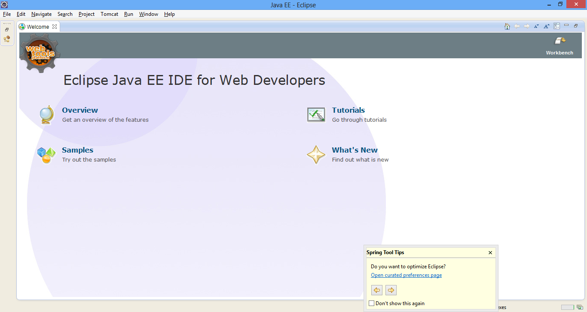

Step 3: Install Plugin
CAP/

Figure 1: Start Windows of Eclipse

Step 3: Install Tomcat Plugin, spring tools, JBoss, Hibernate ….
Step 3.1: Go to menu Help→ Eclipse Marketplace, The following screen is displayed
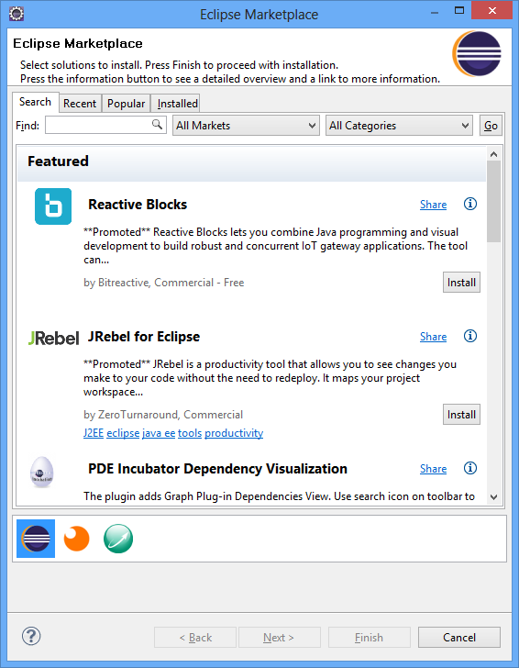

Type name of Plugin here

Figure 2: Eclipse Marketplace for installing plugin software

Step 3.2: Type name of plugin software into “Find” field e.g. Tomcat and click on “Go” button. The result may displayed as below
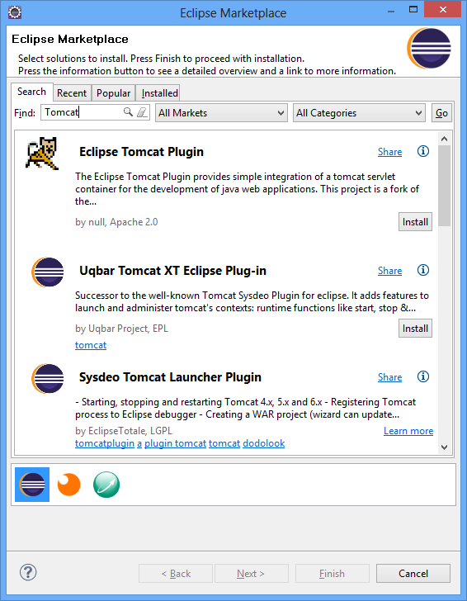

Click

k here to install Plugin

Figure 3: Eclipse Marketplace Search Result for installing plugin software

Step 3.3: Click on “Install” button to install plugin.
Step 3.4: Repeat step 3 to install all necessary plugins as described in Software requirements section

Step 4: Connect SVN server in code.google.com (or other SVN server)
After install SVN plugin (Subclipse, SVN Client…), go to “Window→Preferences→Team→SVN” to check SVN have installed or not. If SVN plugin have installed, the windows will be as below.
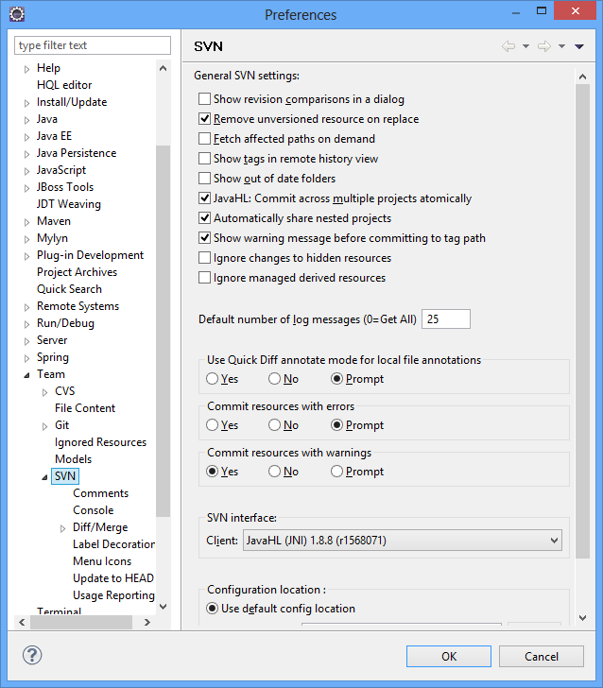

Figure 4: SVN configuration in Eclipse

Step 5: Checkout project (source codes) from SVN server:
Step 5.1: Go to File→New→ New Project. The screen is displayed as below
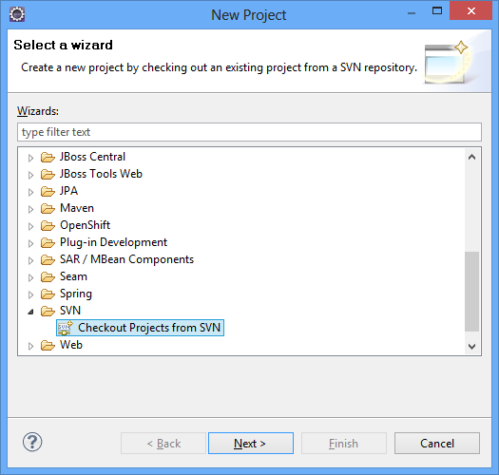

Step 5.2: Select “SVN” and then choose “Checkout Projects from SVN”. The following screen is displayed
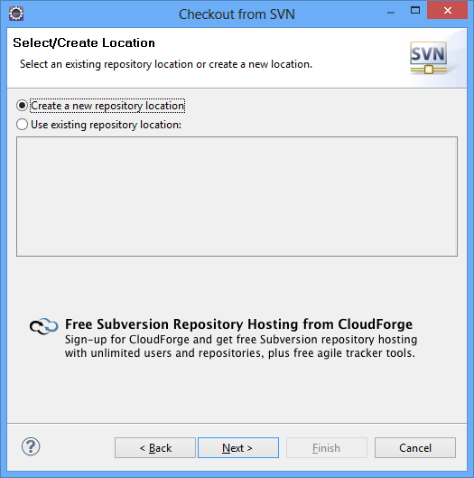

Step 5.3: Select “Create a new repository location” and
Put URL: https://tns-project.googlecode.com/svn/trunk/WIP/Sources/Backend/
of SVN server into Url field and then click on “Finish” button
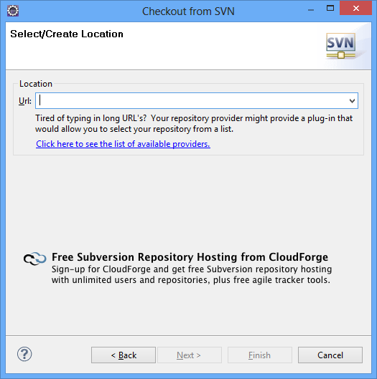

After checkout source, the Eclipse will have the following screen
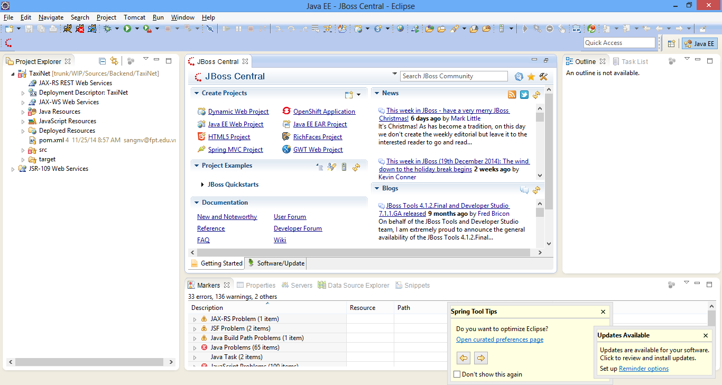

Android Application Development
Step 1: Download Android Development Tools from http://developer.android.com
Step 2: Install Plugin for SVN.
Step 2.1: Go to Help→Install New Software, the following screen will be displayed.
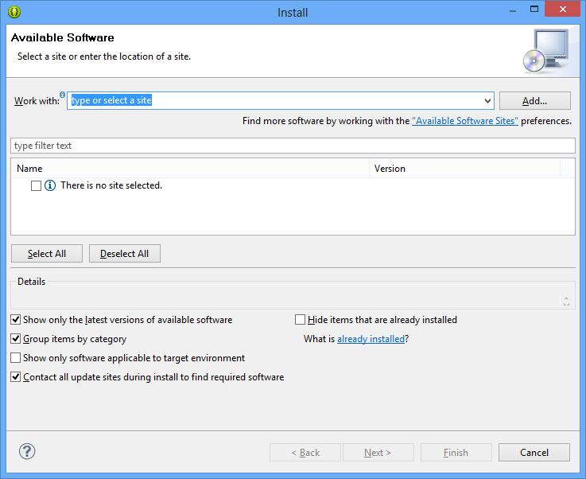

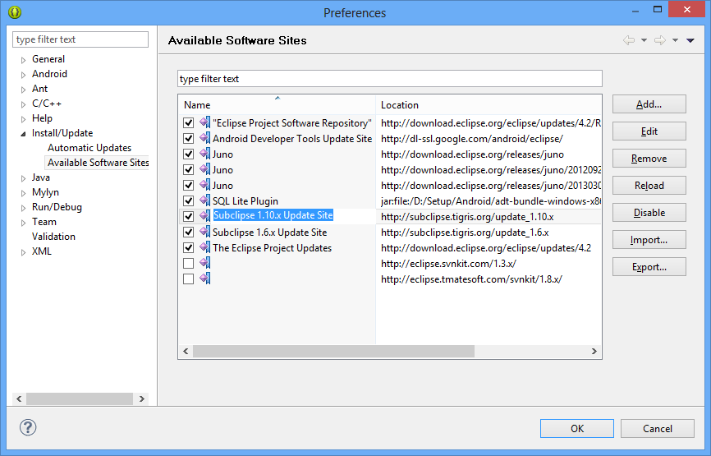
Step 2.2: Type url E.g. http://subclipse.tigris.org/update_1.10.x of software plugin in “Work with” field and enter. You can see screen below for url references

After installed plugin for ADT, we will have the following libraries in ADT as below
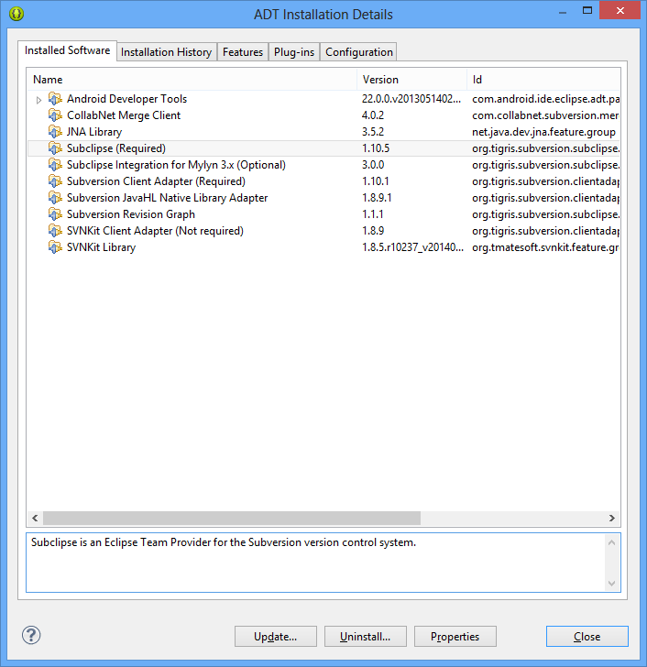

Step 3: Checkout project from SVN server
- TaxiNetM: Common project which is referenced by TaxiNetMR project and TaxiNetMD project
- TaxiNetMR: Android project for development of Android application for Rider
- TaxiNetMD: Android project for development of Android application for Driver

To checkout project from SVN server, go to File→ New Project→ SVN→ Checkout from SVN

iOS Application Development
Further discussion (for Ngo Minh Nhat: will document this section)

