|  |  |
| --- | --- |
| Logo_FPT_University_doc | **MINISTRY OF EDUCATION AND TRAINING** |

**FPT UNIVERSITY**

**Capstone Project Document**

**Taxinet**

**Report #1 – Introduction**

|  |  |
| --- | --- |
| **Taxinet** | |
| **Group Members** | |  |  | | --- | --- | | Đỗ Ngọc Tuấn | SE02939 | | Trương Hoàng Hà | SE02580 | | Đào Trung Hiếu | SE02895 | | Đinh Quang Dương | SE02461 | | Trần Cảnh Quân | 01657 | |  |  | |
| **Supervisor** | Mr. Nguyễn Văn Sang |
| **Project code** | Taxinet |

- Hanoi, 01/2015 -

Table of Contents

[1 INTRODUCTION 3](#_Toc410443010)

[1.1 Purpose 3](#_Toc410443011)

[1.2 Acronyms and Definitions 3](#_Toc410443012)

[2 ABSTRACT 3](#_Toc410443013)

[3 LITERATURE REVIEW 4](#_Toc410443014)

[4 PROPOSAL 7](#_Toc410443015)

[4.1 The idea 7](#_Toc410443016)

[4.2 Objectives 7](#_Toc410443017)

[4.3 Brief description about system 7](#_Toc410443018)

[4.4 System features 7](#_Toc410443019)

[5 BENEFIT FROM PROJECT 9](#_Toc410443020)

[5.1 For Organization 9](#_Toc410443021)

[5.2 For our group 9](#_Toc410443022)

[5.3 For Community 9](#_Toc410443023)

[6 CRITICAL ASSUMPTION AND CONSTRAINTS 10](#_Toc410443024)

[7 POTENTIAL RISKS 10](#_Toc410443025)

[8 REFERENCES 10](#_Toc410443026)

# INTRODUCTION

## Purpose

This document is prepared as the introduction for project Taxinet, in scope of Capstone Project at FPT University. It does not only explain the basic concept and idea for our project but also discuss what project’s benefits and threats are, what opportunities it offers and what existing problem it solves.

## Acronyms and Definitions

|  |  |  |
| --- | --- | --- |
| Acronym & Abbreviation | Definition | Note |
| GPS | Global Positioning System |  |
| App | Application |  |

Table 1-1: Definitions and Acronyms

# ABSTRACT

A taxicab, also known as a taxi or a cab, is a type of vehicle for hire with a driver, used by a single passenger or small group of passengers, often for a non-shared ride. A taxicab conveys passengers between locations of their choice. This differs from other modes of public transport where the pick-up and drop-off locations are determined by the service provider, not by the passenger, although demand responsive transport and share taxis provide a hybrid bus/taxi mode.Nowadays, Taxi has become very popular means of transport and available in most countries. As time, the number of taxi increase rapidly.

As a customer, when you want to go by taxi, you can go directly to a free taxi and ask the driver. Or, if you don’t see any free taxi near there, you can call to Taxi company and take one; or you can stay in the sidewalk, wait for a taxi then take one. But all that way, you can’t take a taxi proactively. What happen if there aren’t taxi there, or sometimes you don’t know taxi company number, or you wait for so long but the taxi that you wait doesn’t come. Our application will help you to solve that problem by sending request directly to a taxi driver or taxi company near where you stand.

As a taxi driver, with our application, you can take a customer easily. You can see the request from customer in your phone screen, and you can accept/cancel it. And you can do more than it.

Our application will be built as Android, iOS and Web application. The main purpose of this application is to help customer and driver can find each other easier, by the fastest way they can. In addition, it will help the taxi company can manage their driver.

# LITERATURE REVIEW

Currently, there are lots of Taxi applications that help user to take a taxi, like Grab Taxi, Easy Taxi, Uber,…

**GrabTaxi:**

GrabTaxi is a smartphone-based taxi booking and dispatching service.

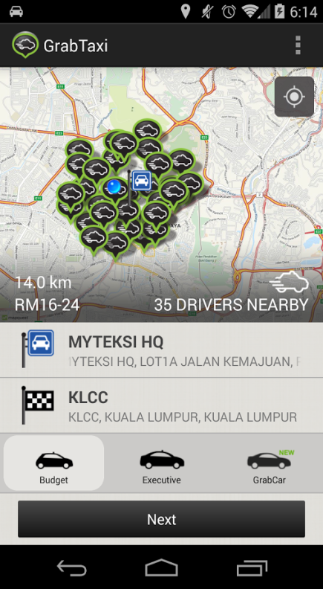 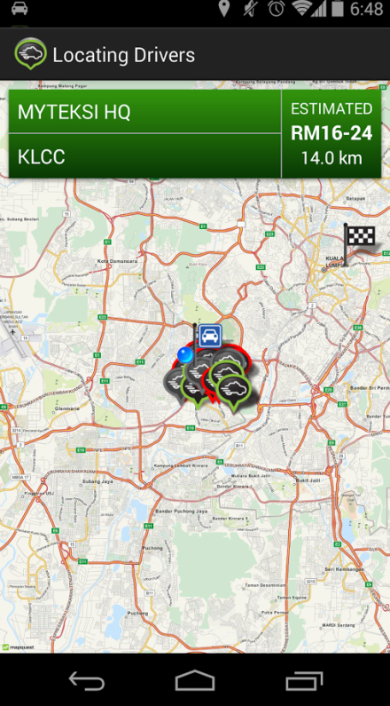 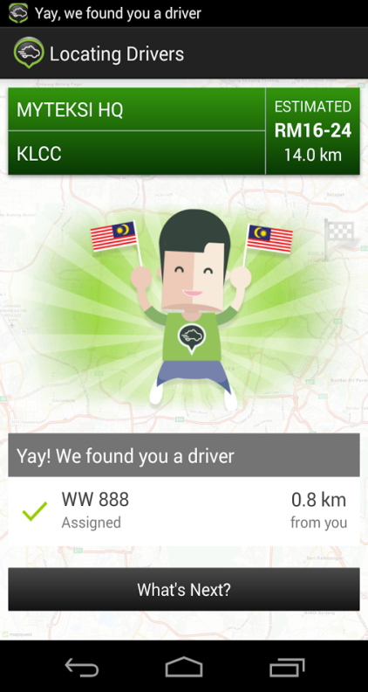

* Advantages:
* **Speed**
* **Safety**
* **Cheaply**
* **Free to use app**
* Disadvantages
* There are lots of Taxi markers on Google map that causes distraction
* No direction
* User can’t send direct request to taxi driver

**Easy Taxi:**

Easy Taxi is an application that connects drivers and passengers in a smooth, easy and safe way

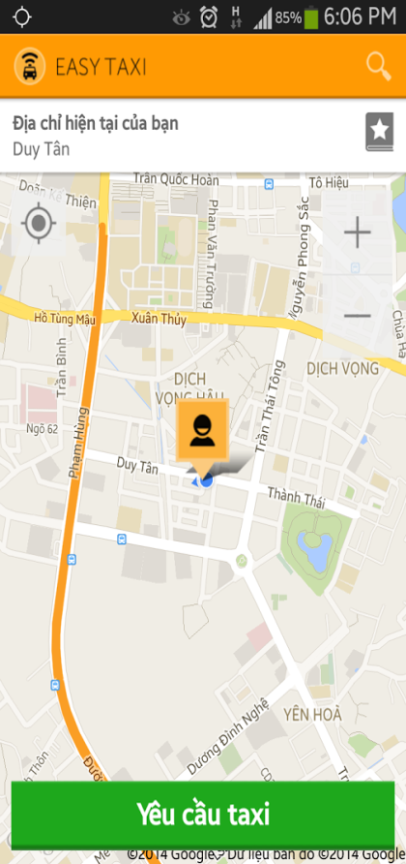 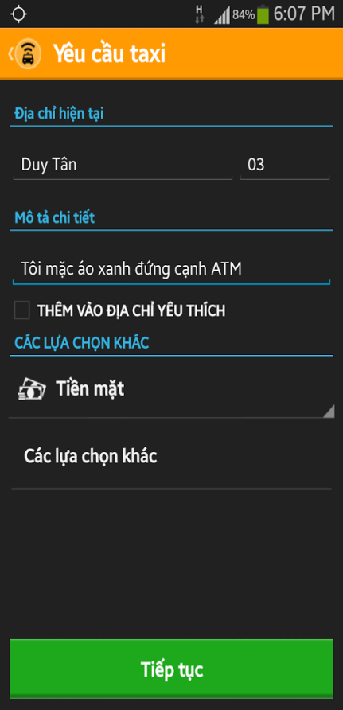 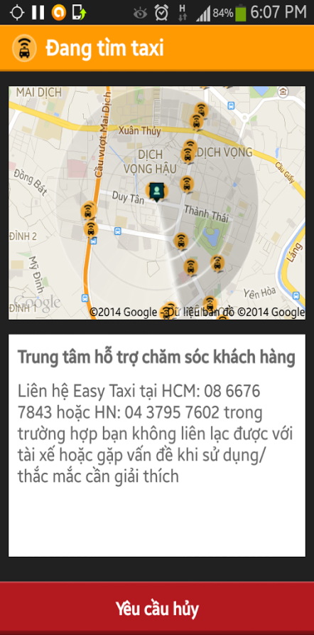

* Advantages:
* **Speed**
* **Safety**
* Easy to use
* Free to use
* Disadvantages
* User can’t send direct request to taxi driver

**Uber:**

Grab Taxi is a smartphone-based taxi booking and dispatching service.

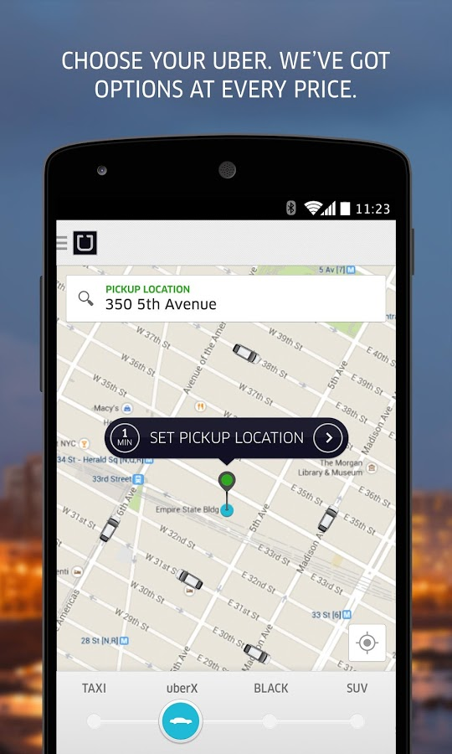 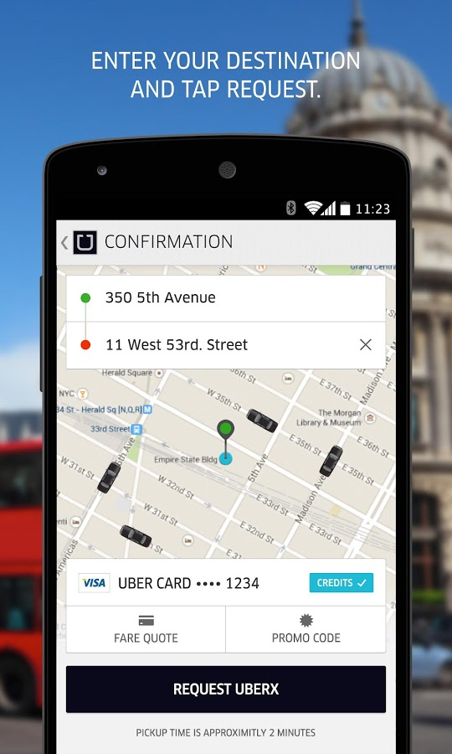 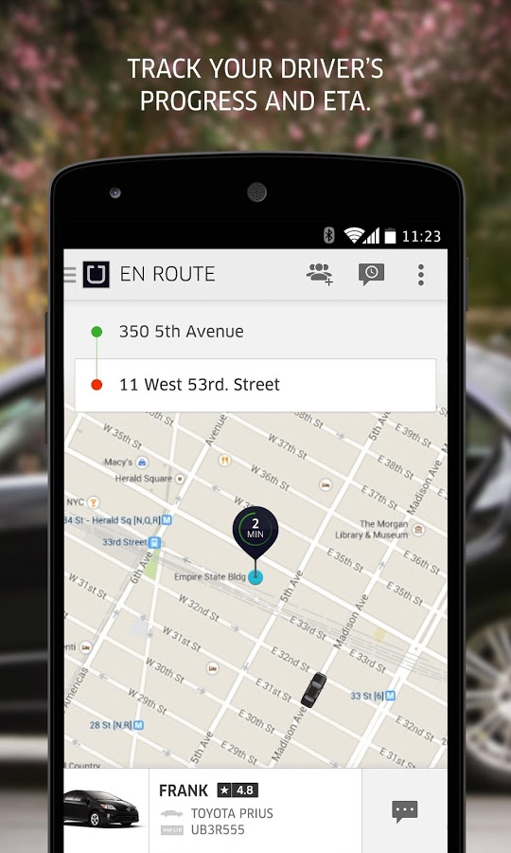

* Advantages:
* **Speed**
* Lots of car models to choose
* Cheaply
* Disadvantages
* No safety
* Can’t pay by cash

# PROPOSAL

## The idea

The idea of creating a Taxi application is not new. However, our Taxinet App will provide the best service not only for user and driver but also for Taxi Company. And we’ll add some new functions for user and driver, like: Share a cheap trip (User/Driver can find a partner to go with them), Favorite Customer/Driver,...

## Objectives

Firstly, we do this project to fulfill the requirements from FPT University studying program. During the time do this, we can learn how to develop a project, how to communicate with other team members, how to control time, how to do teamwork effectively. Therefore, after finishing this project, we can practice what we have learnt in university and learn so many new things. It is very necessary for our future work after graduating from FPT University.

Secondly, we want to create an application that help user can share their trip, so they can have partners to go with them. And they can call a taxi easier, even that there is no taxi near them. In that case, we’ll contact to a Taxi company that near your place and send a request to them. And about Taxi Company, we give them not only an application to manage their driver but also lots of new customers. So, we hope that people can travel easier, go everywhere they want with the cheapest Taxi fee.

## Brief description about system

The application has three versions for: iOS, Android and Web.

About iOS and Android app, with friendly interface, customer will use app to send direct request to a taxi. We use Google map to display the position of customer and taxi nearby. Customer click on Taxi marker then select “Send request”. After filling some information (optional choice), a request from customer will be sent to Web service and Google Cloud Messaging, then taxi driver’s device. Driver can accept/cancel it. Almost functions will send input to or retrieve information from through Web service, Web service implementation function and send return output to Smartphone device.

In Web application, user (driver and rider) can see information about Taxi Driver, Taxi company and promotion. And Taxi Company’s Admin can edit their company information, make promotion, and manage taxi driver.

## System features

**General features** (run on both mobile and web module)**:**

* Create cheap trip: Create a trip that you want to share with another people to reduce cost.
* Find cheap trip: Find a trip that you can go with someone else.
* Update information: Update information of customer and driver.

**Mobile application features:**

***+ Customer:***

* + Display Google map and position of customer and taxi driver nearby.
  + Register-Log in-Log out
  + Send direct request to taxi driver
  + Manage favorite driver list
  + Display and update information.
  + Map direction
  + Rate Taxi driver

***+Driver:***

* + Register-Log in-Log out
  + Display Google map and position of customer (who sent request only).
  + Display and update information, current position, current status.
  + Response request.
  + Request History
  + Manage VIP customer list
  + Map direction
  + Rate customer

**Web application features:**

**+*Customer:***

* + Register-Log in-Log out
  + Display and update information.
  + Map direction
  + Rate Taxi driver
  + Display promotion information

+***Driver:***

* + Register-Log in-Log out
  + Display and update information.
  + Map direction
  + Rate customer

***+Taxi Company’s Admin:***

* + Register-Log in-Log out
  + Manage Taxi drivers of company
  + Update information of company
  + Make promotion

+***Agent:***

* + Register-Log in-Log out
  + Recharge account
  + Statistic, history

# BENEFIT FROM PROJECT

## For Organization

Taxi Company who uses Taxinet:

* Manage Driver
* Assign Driver to Customer
* Promote image of the company

## For our group

After developing and implementing that project we will:

* Understand new technology like Android, iOS, Spring, Hibernate, My SQL, Source code managing…
* Have the opportunity to experience and improve working in group skill
* Know how to manage project, limit risk, control working time more effective
* Know more about the business of taxi company
* Take money profit from customer

## For Community

With a smartphone device that connect to Internet using our application,

Customer can:

* Send request directly to Taxi driver or Taxi company
* Search Cheap Trip
* Search your trip and have some partners
* Manage Favorite Taxi Driver List

Taxi Driver can:

* Take request from customer rapidly
* Manage VIP Customer List
* See the way to go to pick up customer

# CRITICAL ASSUMPTION AND CONSTRAINTS

After analyzing this project, we realize that there are some critical assumptions. First, we assume that all team members will have no problem of health, because we need more than 100% performance to finish the project. Second, we assume that we can learn new technique in a short time and apply to the project. It’s key to the success of the project.

About constraint, we have to finish the project on time (4 months since we had taken the project). And 4 months includes 2 weeks of Tet holiday, so we have exactly 3 months and 2 weeks to do. We don’t have more experiment in making document of the application so it will need a lot of time and effort. In addition, we don’t know more about Google map, Hibernate and other technique, so we have to learn it as soon as possible.

Anyway, we will try our best to make the best application as we can.

# POTENTIAL RISKS

After studying about this project, we find out some problem that we may be encountered:

* Requirement can be changed many times, so we have to focus on project.
* We have not much knowledge in the framework and technique of both Smartphone and web (Spring, Google map API,…). Therefore, we have to study all of these things from the beginning.
* We don’t have any knowledge about business of Taxi Company, what they want, what they need.
* We don’t have more experience in managing a project.
* Short duration, so we maybe miss some functions.
* Other Taxi apps were launched before so they have many customers and famous. So, it’s hard for us to provide our service to customer.

# REFERENCES

[1] Uber

<https://play.google.com/store/apps/details?id=com.ubercab>

[2] Easy Taxi

<https://play.google.com/store/apps/details?id=br.com.easytaxi>

[3] GrabTaxi

<https://play.google.com/store/apps/details?id=com.grabtaxi.passenger>