Analysis of XOR frequency multipliers for genetic oscillators
Term project for Principles of Synthetic Biology (MITx 20.305x) , @daromart

Introduction
Oscillators can have numerous applications such as the expression of regulatory genes at specific time intervals. When the expression of genes at different time intervals is required, having to design a separate oscillator for each interval becomes a rather complicated task. A better alternative could be to have a single but reliable oscillator, the “master clock”, and then use network motifs to derivate oscillators at multiple frequencies.

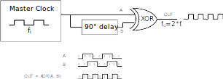
Figure 1: XOR frequency multiplier logic circuit.
This project analyzes and explores the feasibility of using XOR frequency multipliers as the network motifs for the later approach. Figure 1 illustrates the logic of system: a master clock input gets XOR'ed against a delayed copy of itself in order to produce an output clock with double the original frequency.

The main contribution of this document is a genetic model for the circuit in Figure 1, provided in Section 2, and its analysis through a simulation framework. Simulations show that the system is in fact feasible and produces a rather stable mean period. However, the dynamic period of the derived oscillators has been observed to present noticeable deviations. For that reason, the study concludes that the system may be usable for producing coarse-grained oscillators but has limitations on the precision of the dynamic period.

The remainder of this document is structured as follows: Section 2 describes the genetic model of the circuit and the methods used to analyze it; Section 3 discusses the results of the analysis; and Section 4 provides a few references.

Methods

Genetic regulatory network
The biological implementation for the logic circuit presented in Figure 1 is illustrated in Figure 2 (delay subsystem) and Figure 3 (XOR gate).

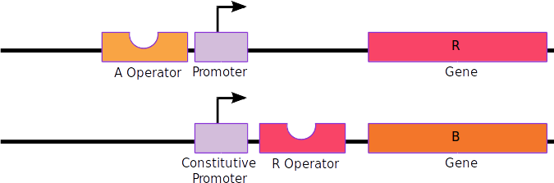Figure 2: Biological implementation of the delay logic circuit
The delay subsystem works as follows: a master clock supplies the input protein A. When present, A activates a repressor protein R that disables the production of protein B which is otherwise produced constitutively (A → R ¬ B). In other words, B is a negated version of A delayed by a time offset that can be adjusted by choosing the appropriate components.

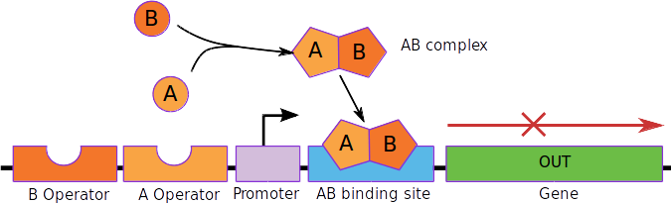Figure 3: Biological implementation of the XOR frequency multiplier logic circuit.
The XOR gate is implemented as follows: proteins A and B behave as activators for the output protein OUT, except when they form an AB complex which acts as a repressor. One activator is enough to trigger the production of the output protein OUT, and the AB repressor complex is stronger than any of the activators.

Simplifications
- By using timescale separation all mRNA concentrations are considered to have reached steady state.
- The dilution of plasmids will not be taken into account.
- mRNA is not produced unless an activator is present or the promoter is constitutive.
- The frequency of the master clock is assumed not to be affected by its load.

Constants
- O_a, O_b, O_r, O_ab: operators for activators A, B and repressors R and AB.
- K_a, K_b, K_r, K_ab: dissociation constants for A, B, R and AB (Hill behavior).
- n_a, n_b, n_r, n_ab: cooperativity constants for A, B, R and AB (Hill behavior).
- k_on: AB complex formation rate.
- k_off: AB complex dissociation rate.
- k_trxb, k_trxr, k_trxo: transcription rates for B, R and OUT.
- k_tln: translation rate for all mRNAs.
- k_mdeg: mRNA degradation rate
- k_pdeg: protein degradation rate.

Reactions
- A ↔ AO_a (Hill function K_a, n_a)
- B ↔ BO_b (Hill function K_b, n_b)
- R ↔ RO_r (Hill function K_r, n_r)
- AB ↔ ABO_ab (Hill function K_ab, n_ab)
- A + B ↔ AB (k_on, k_off)
- A → Ø, B → Ø, AB → Ø (k_pdeg)
- OUT → Ø (k_pdeg)

Model
Figure 4: Equations that model the XOR frequency multiplier.

Analysis method
The model will be simulated in Matlab by using the “Parts&Composition” framework. The simulation process will follow these steps.

- First, the system will be simulated with typical values for each of the constants and the delay system will be manually tuned to achieve the required functionality.
- Then, the effect of each constant on the output signal will be measured by repeating the same simulation over a range of different values for the constant.
- Finally, the values that produce the best output signal will be selected manually.

Results

Step 1: Tuning the delay system
The delay system depends on the parameters associated to the R repressor and the production of B. Figure 5 shows how the value of k_trxr can be used for adjusting the delay of B.

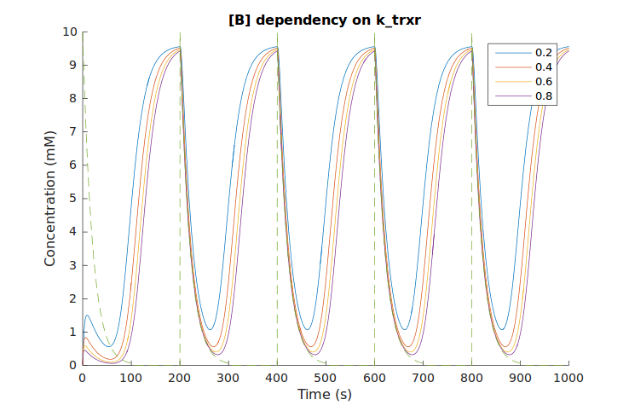Figure 5: B's delay depends on the k_trxr constant.

Step 2: Dependencies on constant values
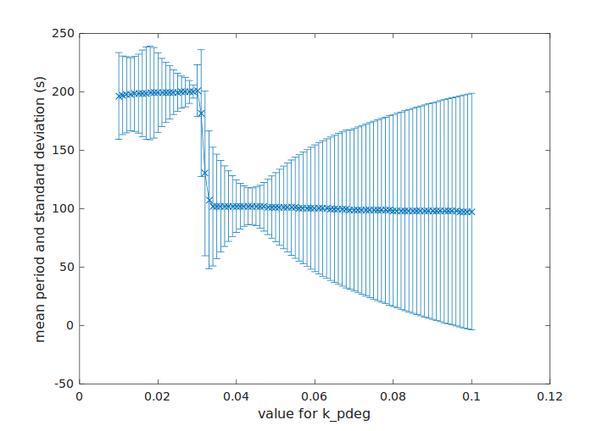
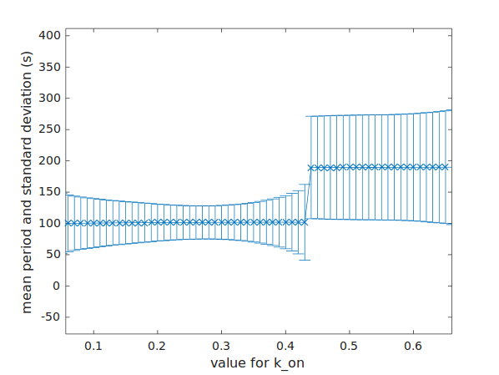Figure 6: Mean and standard deviation of the OUT's period dependency.
Figure 6 shows the mean period and its standard deviation for a range of values assigned to k_on (k_off=1-k_on) and k_pdeg. The values with the smallest deviation are around k_on=0.25 and k_pdeg=0.042. The same procedure was carried out for the rest of constants which are not shown here due to space limitations.

Step 3: Manual tuning
From step 2, the best parameters were selected and the OUT signal simulated. After a bit of manual fine-tuning, Figure 7 shows the resulting OUT signal. Despite some deviation in the dynamic period (mean:101.29s, std_deviation:7.36s) and amplitude, the OUT signal does oscillate at half the period of the input signal A (200s) as required.
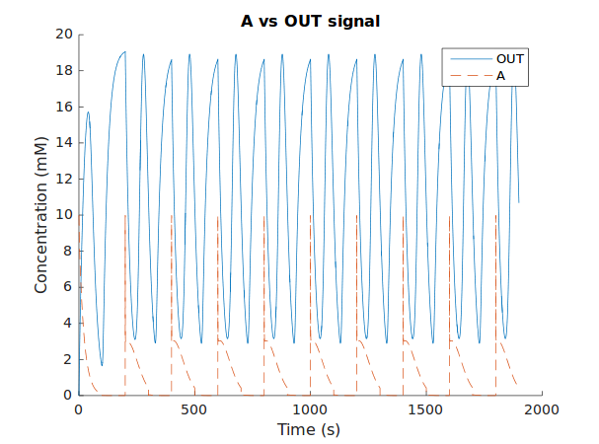Figure 7: Simulated OUT signal at double the frequency of the input A
The values finally selected to achieve the OUT signal in Figure 7 are written below. Some of them are not exactly the same as those that gave the smallest period deviation because they also affected deviations in the amplitude of the OUT signal:
- A: pulses of amplitude 10 every 200 seconds.
- K_a=K_b=K_ab=K_r=1
- n_a=n_b=n_r=n_ab=4
- k_on=0.2, k_off=0.8
- k_trxo=k_trxr=0.6
- k_trxb=0.5
- k_tln=0.8
- k_mdeg=0.5
- k_pdeg=0.05

Discussion
Simulations show that the implementation of XOR frequency multipliers as a genetic regulatory network may be feasible. Noticeable deviations in the dynamic period of the output signal have been observed, which may limit its usability to systems where only the mean period needs to be accurate.

As future work, the system should be simulated with more precision by removing the simplifications taken in this study, and using stochastic simulation algorithms. The feasibility of implementing the genetic circuit in reality also needs assessment.

References
[1] Conventional Verification for Unconventional Computing: a Genetic XOR Gate Example. Savas et al. https://pdfs.semanticscholar.org/13e5/20b0bfee8bc463a91f5da0aaf334b58fdbcc.pdf
[2] Genetic Logic Circuits. Sauro et al. http://sbw.kgi.edu/sbwwiki/_media/sysbio/labmembers/hsauro/geneticlogiccircuits.pdf
http://blog.analogmachine.org/2012/05/29/genetic-xor-circuit/
[3] A Multi-Functional Synthetic Gene Network: A Frequency Multiplier, Oscillator and Switch. Purcell et al. http://journals.plos.org/plosone/article/asset?id=10.1371%2Fjournal.pone.0016140.PDF

