Trends within Variability

Climatological averages and trends need to be seen relative to the inter-annual variability

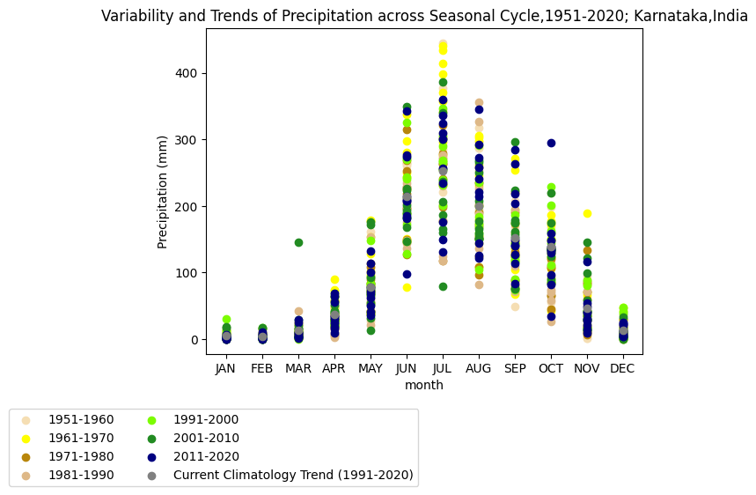

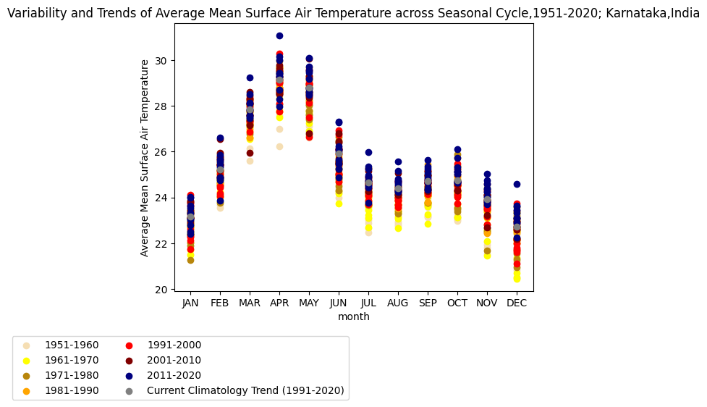

### II – Variability and Change in Variability

Trends don’t necessarily imply a simple shift in climate and its variability envelope. Changes in variability can be very important for both climatic means as well as at the weather scale (extremes).

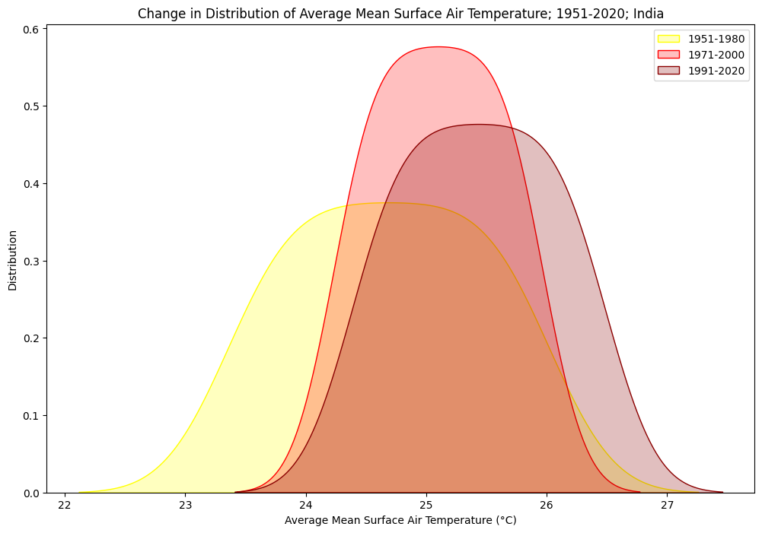

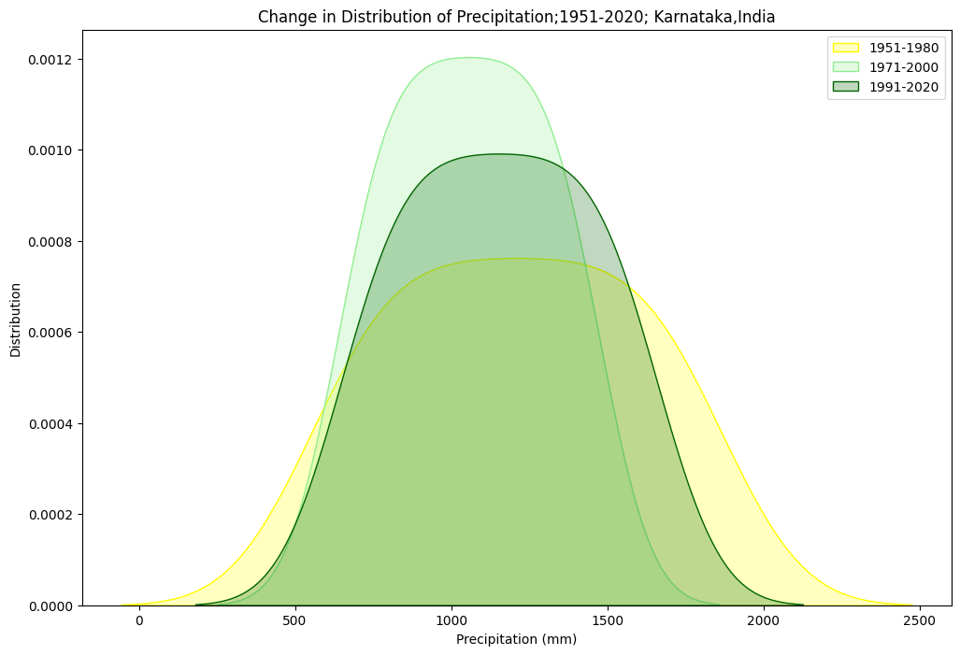

III – Change and Significance

Trends determined on different length of timeseries can be a good indicator of change. A period dominated by natural variability (low trend) can be seen in contrast to the emergence of an (anthropogenically) forced trend.

