UNIVERSITY OF SCIENCE
HO CHI MINH NATIONAL UNIVERSITY
FACULTY OF INFORMATION TECHNOLOGY

FINAL ASSIGNMENT REPORT

SUBJECT
Introduction to Computer Science
(CS161)

LECTURER: Professor Dinh Ba Tien
GROUP 16 MEMBER
Pham Van Tan Sang – 21125063
Dang Hoang Nhat Hung – 21125041

TABLE OF
CONTENT

I. Features 1
II. Links 2
III. Tasklist 2
IV. Screenshots 3
1. Welcome scene 3
2. Instruction scene 3
3. Leaderboard scene 4
4. Game mode scene 5
5. In-game display 6
6. Some warning messages shown when playing 7

CS161 FINAL ASSIGNMENT REPORT

Features
- Adjust the game’s resolution based on the current level to improve user experience (in Beginner level, the size of the cells are bigger)
- Using the keyboard to play and navigate the menu.
- Display a real-time timer when playing
- Display the rank of the user if they win a position on the leaderboard
- Save the current playing game in midgame: saving both the board and the timer
- Continue saved game (timer starts from saved timestamp too)
- Replay the current game while playing (by pressing “R”)
- Displaying the number of flags left
- You can flag a cell twice to mark a cell as a “questioning” cell
- Reveal all adjacent cells when finish flagging the mines (by pressing “K”)
- Save player’s rank in leaderboard
- ASCII art for UI
- Escape to menu while playing
- Message box
- Guarantee that the first cell opened is not a bomb

- There are 3 game levels:
- Beginner: 9x9 cells, 10 mines.
- Intermediate: 16x16 cells, 40 mines.
- Expert: 30x16 cells, 99 mines.
- How to Play
- W , A , S , D : Move cursor.
- J , Enter : Select options | Reveal current cell.
- K : Reveal all adjacent cells of the current cell.
- L : Flag current cell.
- O : Save current board.
- R : Restart current game.
- Esc : Exit current game | Go back to menu.

Links
- Github repository
- Task planner on Notion
- Game flowchart using draw.io

Tasklist
Week | Tấn Sang (21125063) | Nhật Hưng (21125041)
15/11  ⇓  21/11 | - Plan out the project  - Set up the developing environment (Task planner on Notion)  - Set up Github repository  - Research about “windows.h” for manipulating the console  Create our own “cmanip.h” library used to manipulate the console  Set up game scenes structure + files architect for the game  Finish the welcome scene | - Research about the game rules  - Learn how to use Git  - Use draw.io to plan out the functions of the project (Game flowchart using draw.io)  - Start implementing game logic
22/11  ⇓  28/11 | - Refactor the whole game after merging with Hung’s code  Add keyboard maneuvering mechanics into Hung’s “game-logic”  - Design the UI for the game board  - Review + merge my code with Hung’s code  - Discuss the overall shape of the game | - Finish implementing game logic  - Set up saving and loading game data  - Design + code leaderboard scene  - Design + code level-choosing scene  - Discuss the overall shape of the game
29/11  ⇓  5/12 | - Add Timer  - Add Replay midgame functionality  - Add Endgame message box  - Optimize the render functions  - Fixing bugs from the “windows.h” library | - Add reset leaderboard option  - Return rank of a player when they win  - Update several UI elements  - Design + code Instruction scene
6/12  ⇓  12/12 | - Test the game  - Edit the README file on Github repo  - Look through the whole project and make a report about the project | - Test the game  - Edit the README file on Github repo  - Look through the whole project and make a report about the project

Screenshots

Welcome scene
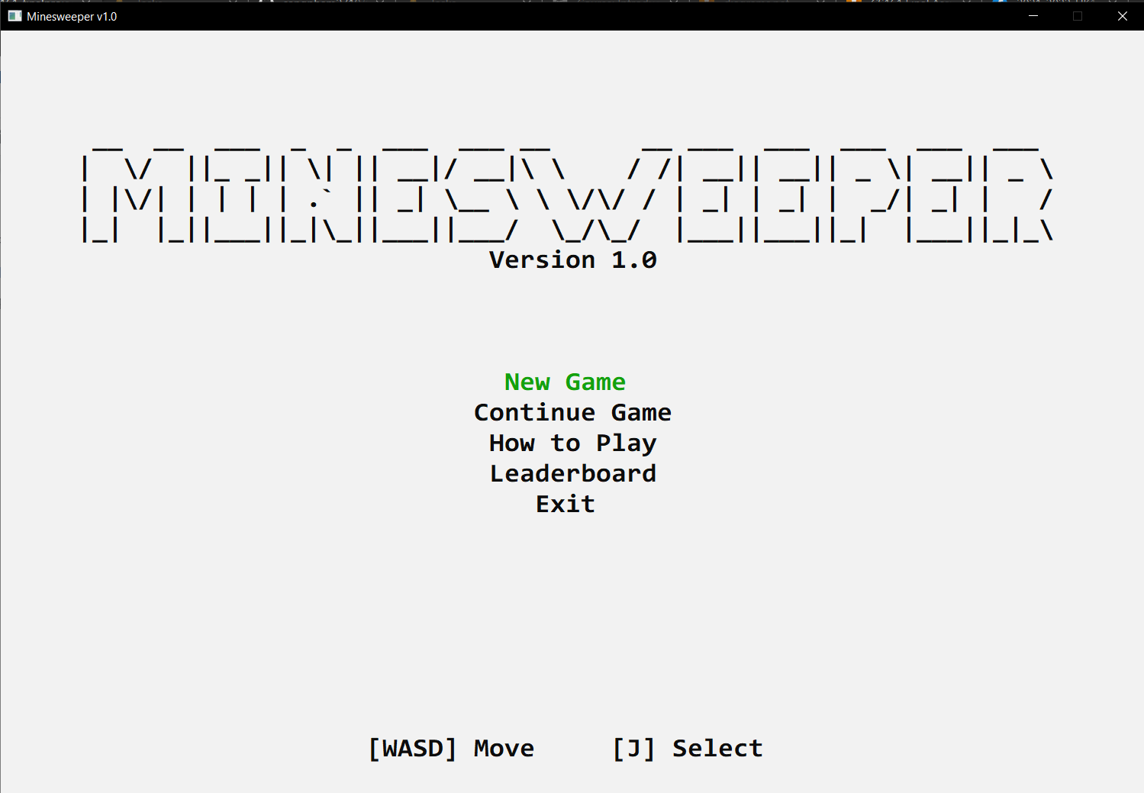

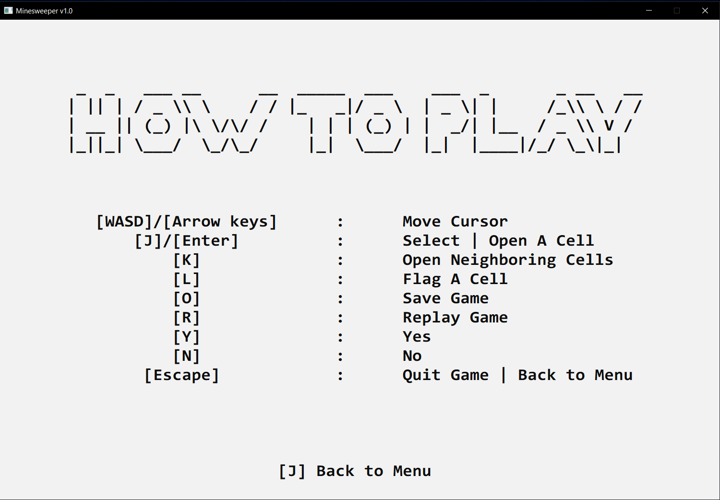
Instruction scene

Leaderboard scene
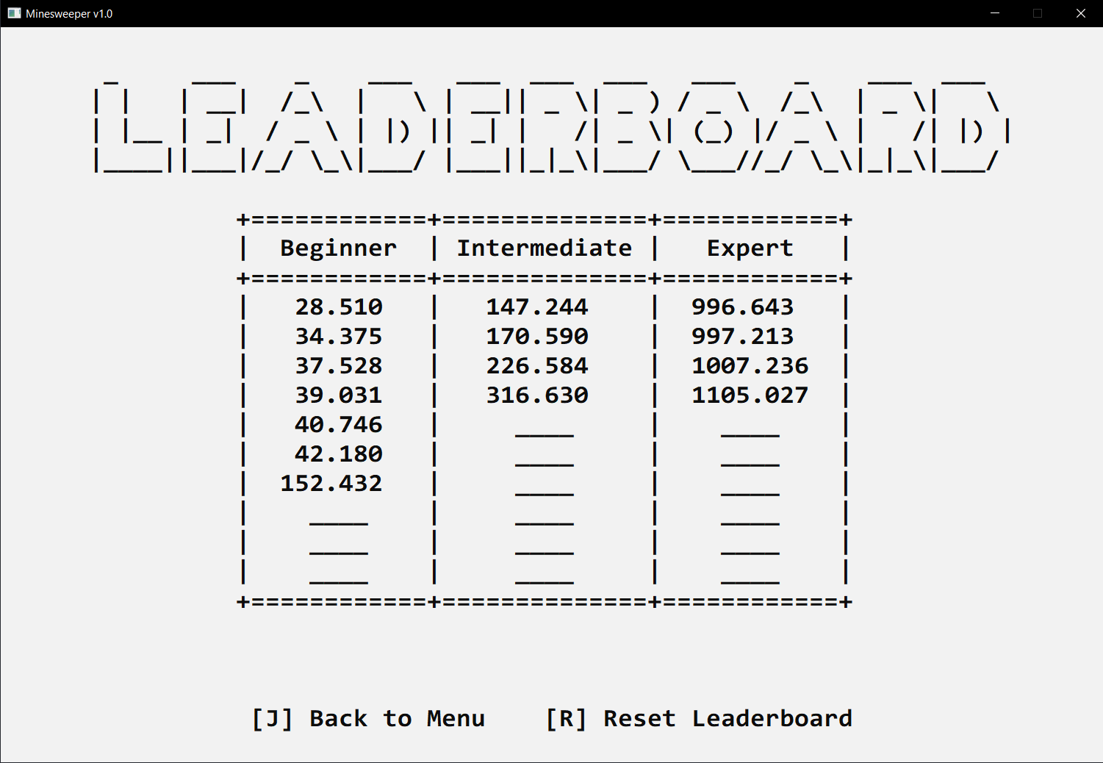
Leaderboard scene
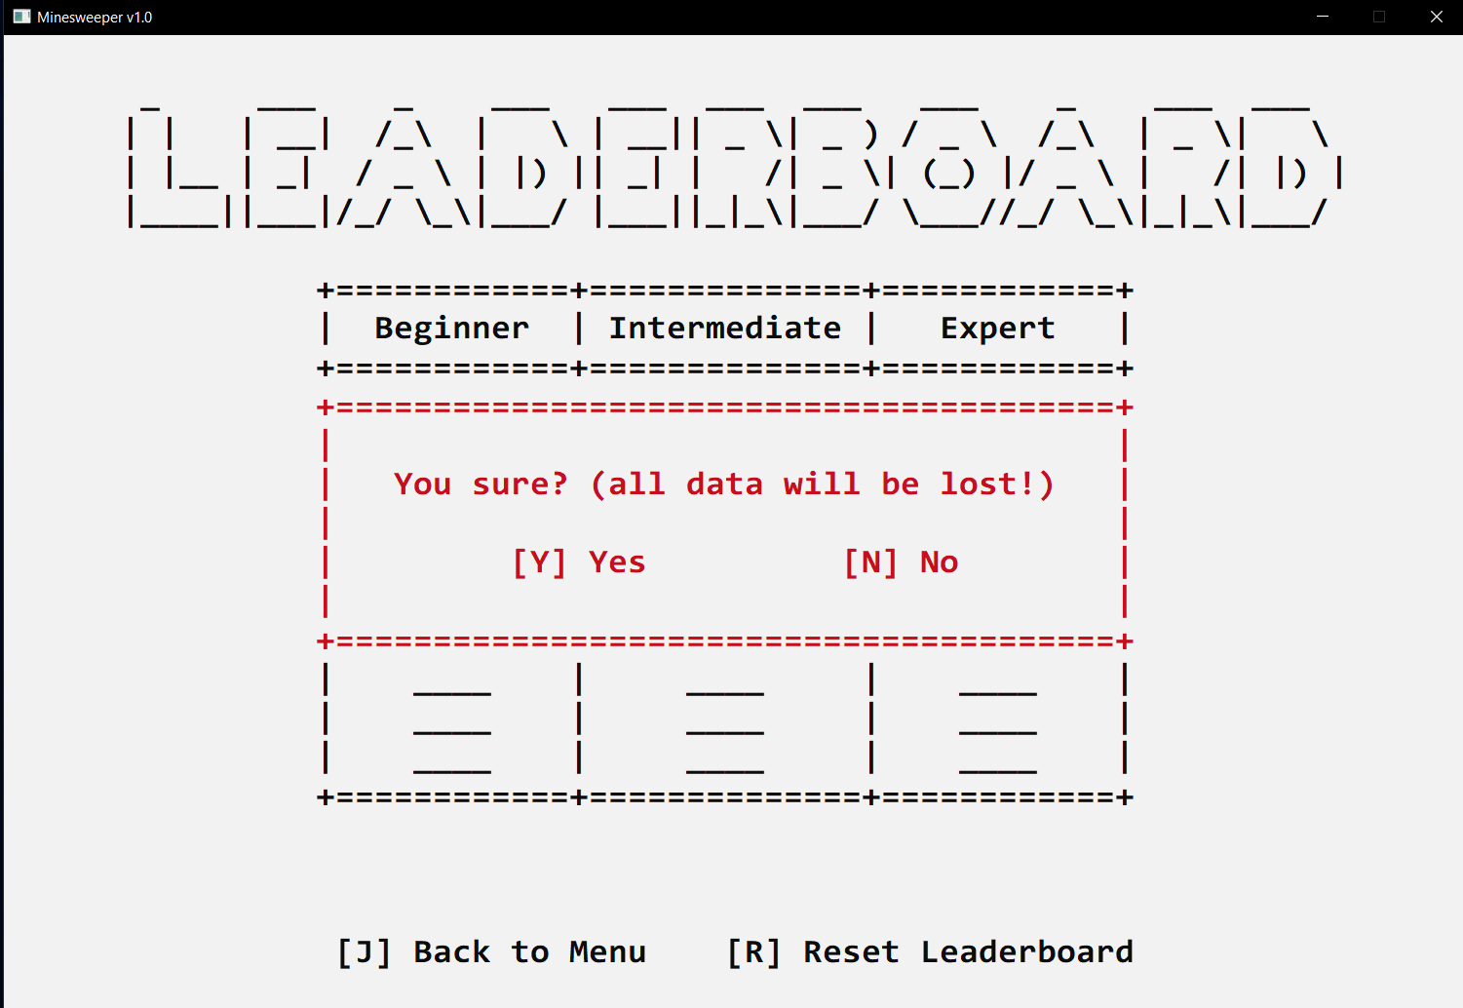
Warning before resetting leaderboard

Game mode scene
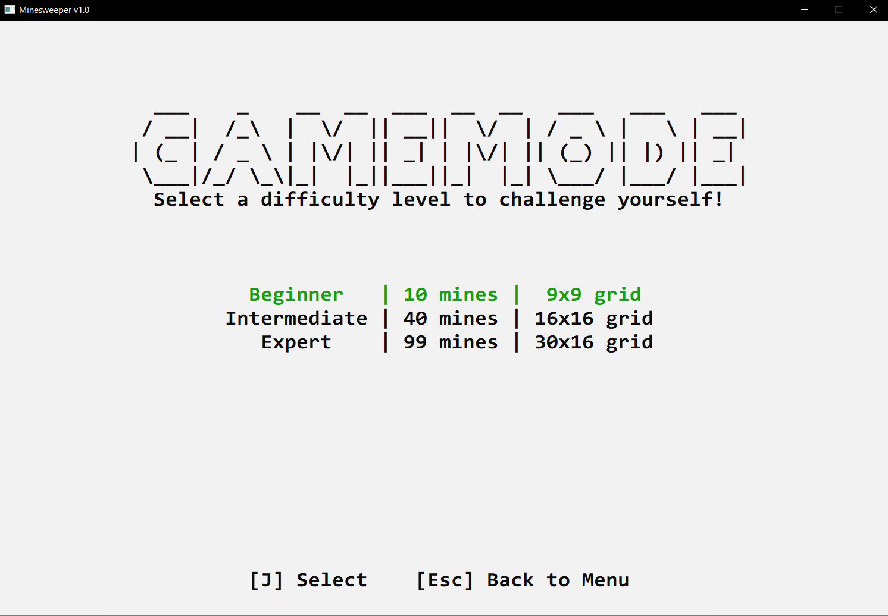
Choosing game mode scene
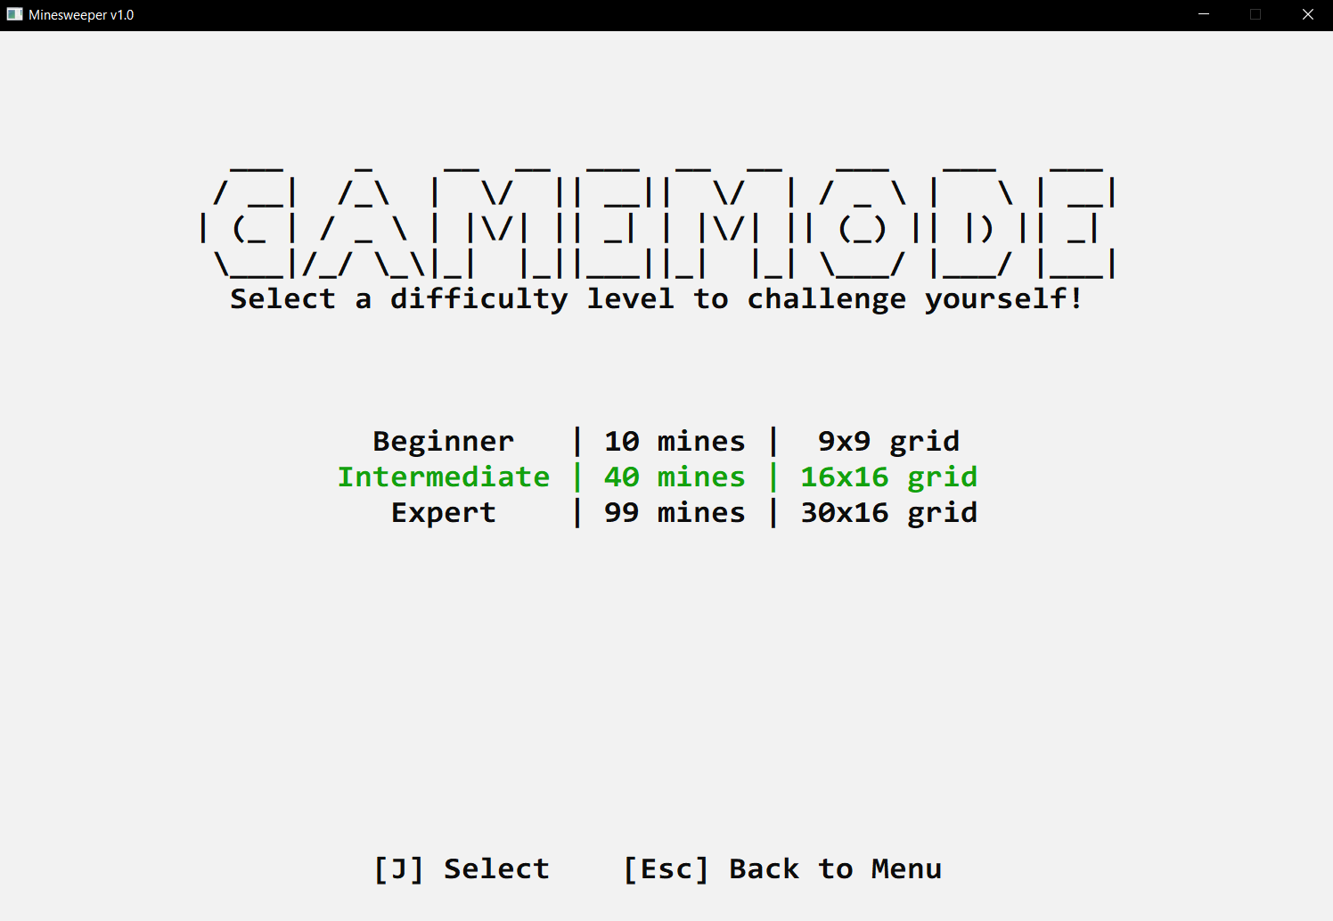
The intermediate game mode is selected

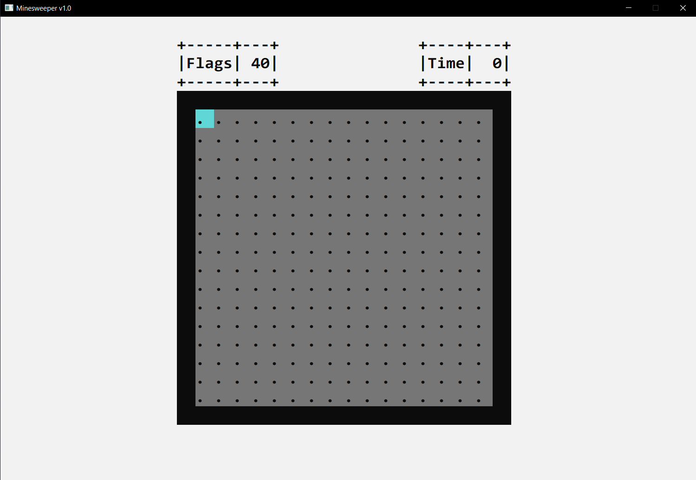
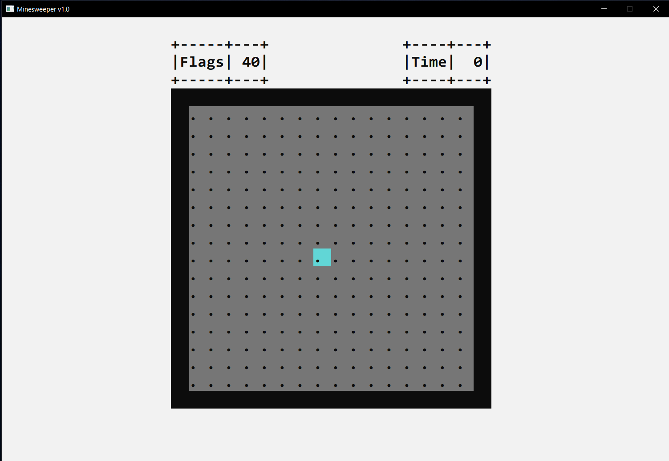
In-game display
Main game display (intermediate game mode)
You can move the cursor around

.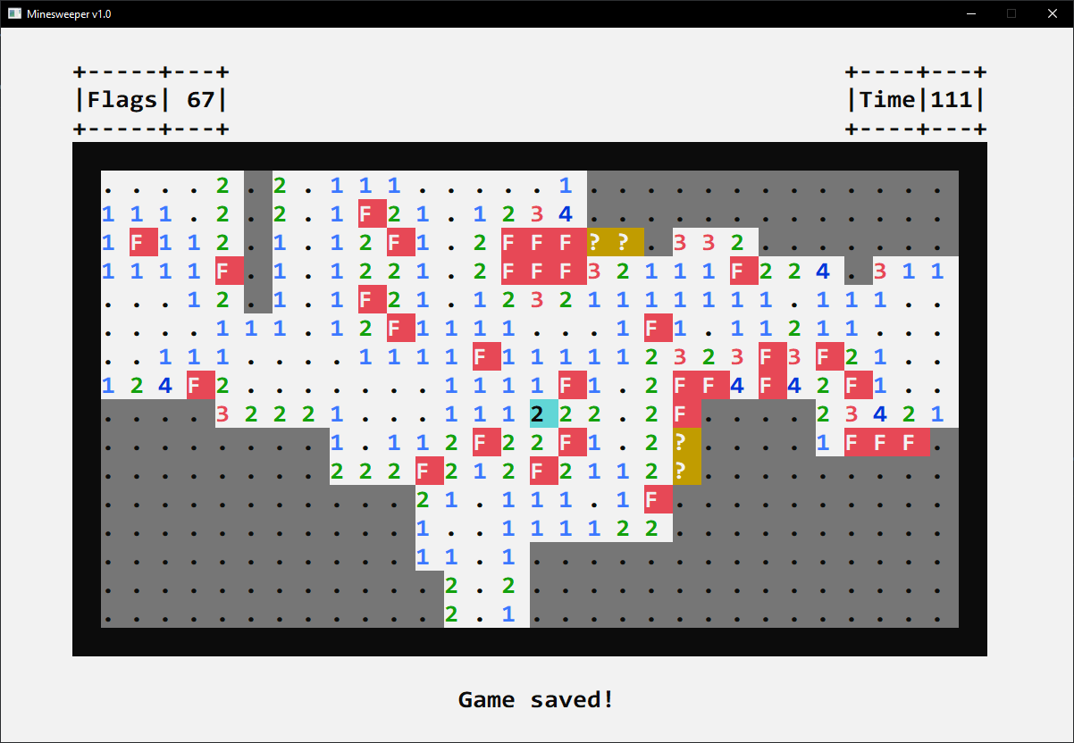
Cells with 4 states: Opened, Flagging, Questioning and Unknown

- Some warning messages shown when playing
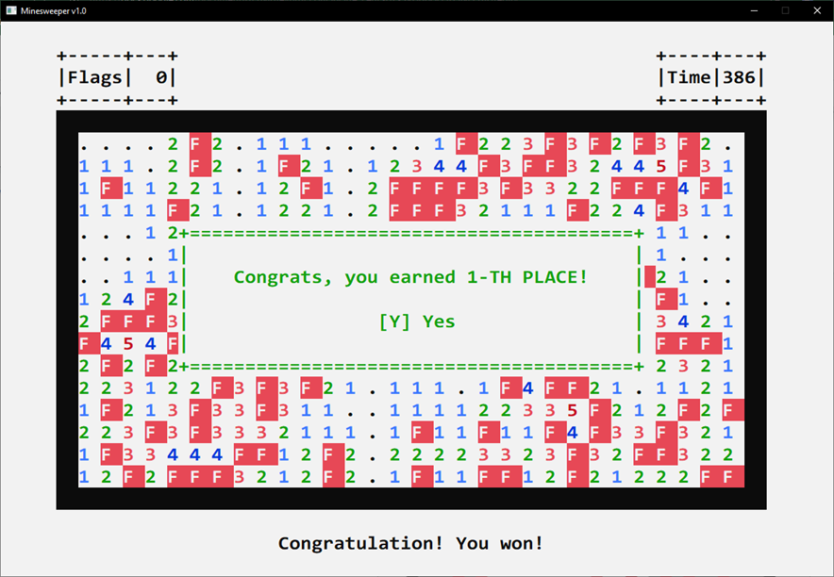
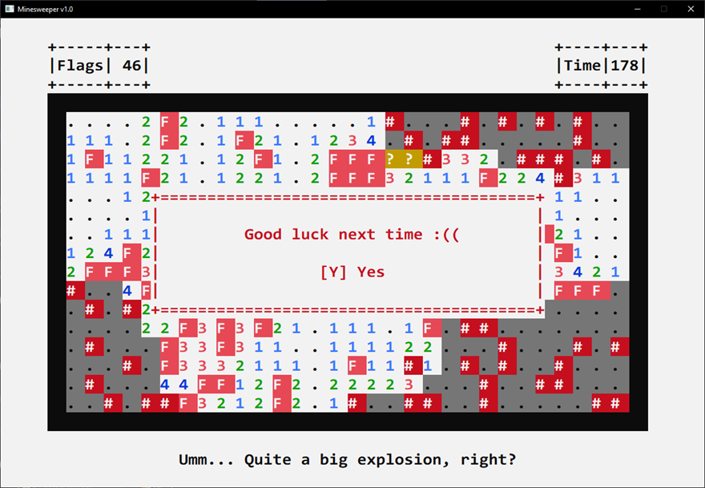
Win message
Lose message

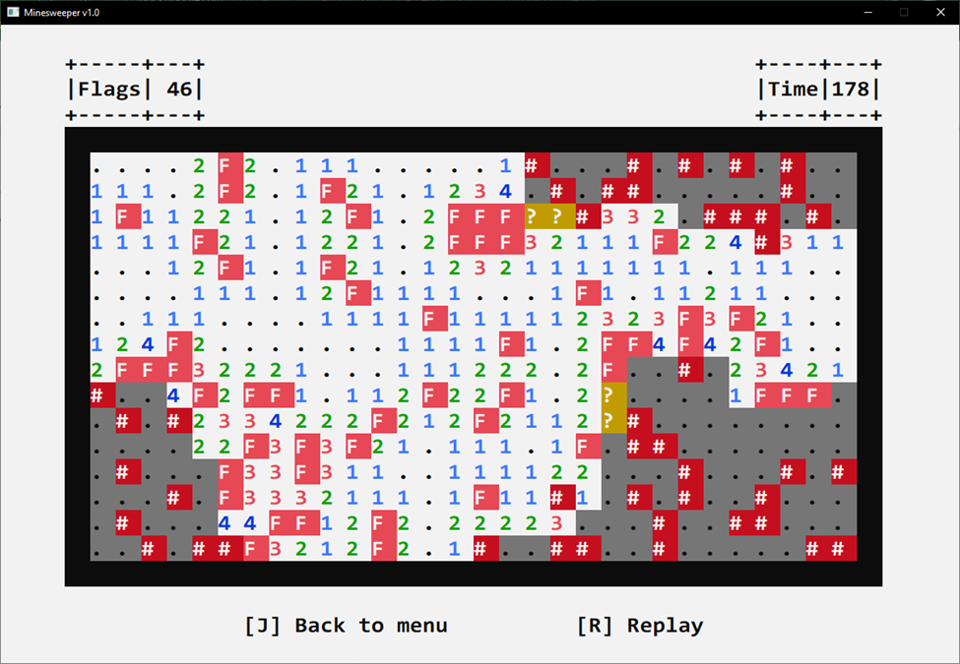
Pause screen when losing/winning

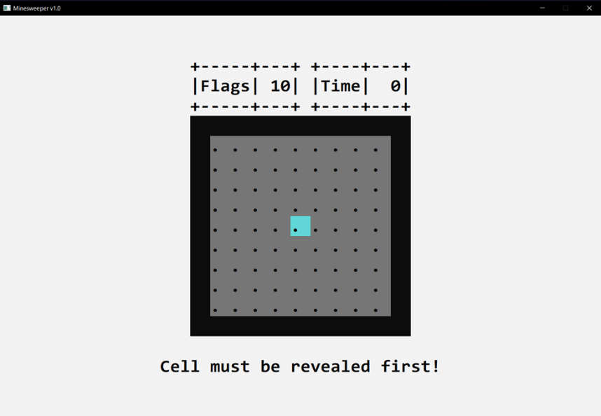
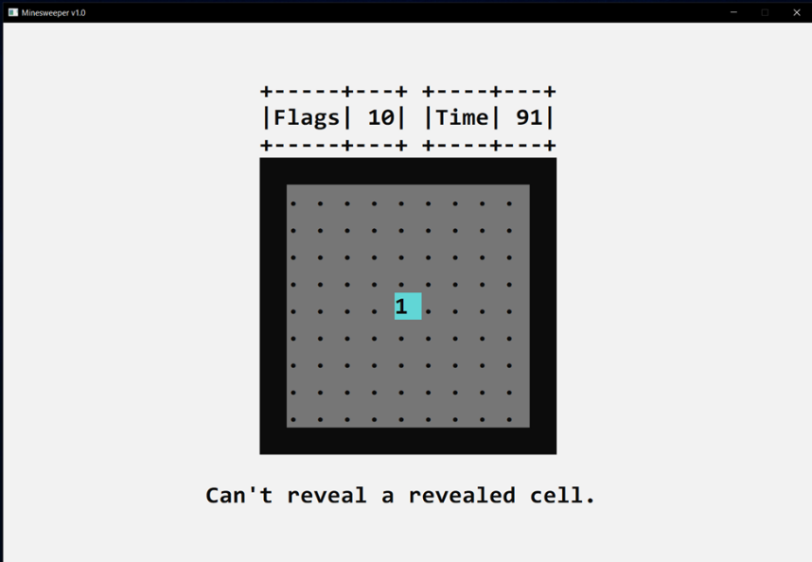
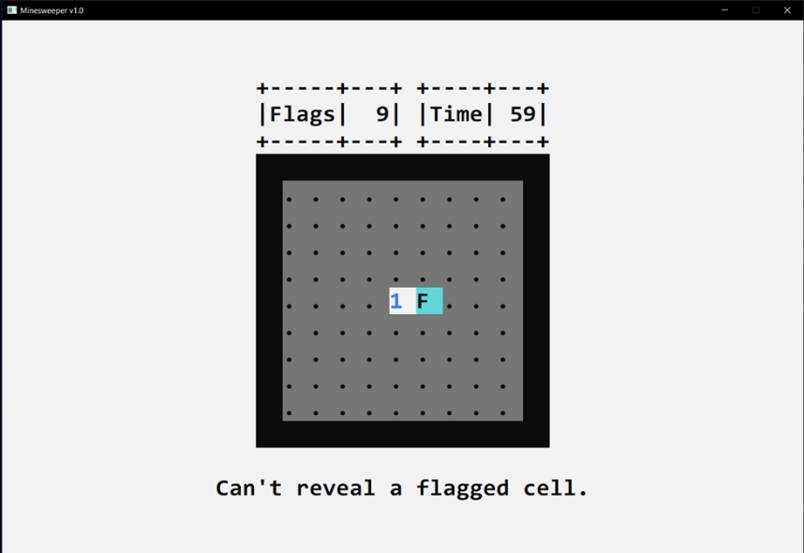
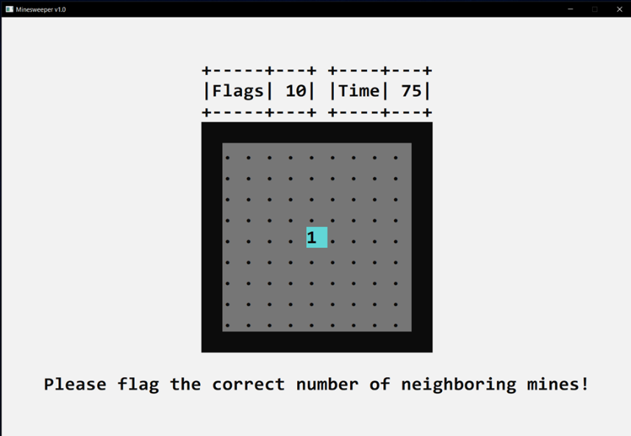
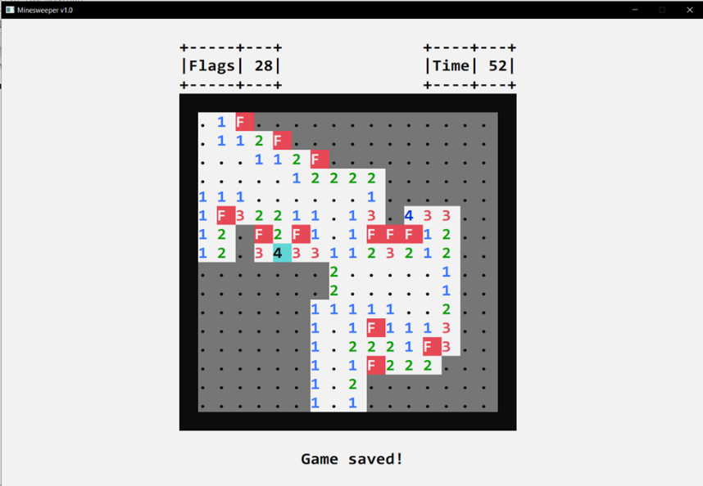
Flag a unopened cell
Reveal a revealed cell
Open a flagged cell
Open the neighboring cells without flagging the correct number of neighboring mines

Succesfully save game message

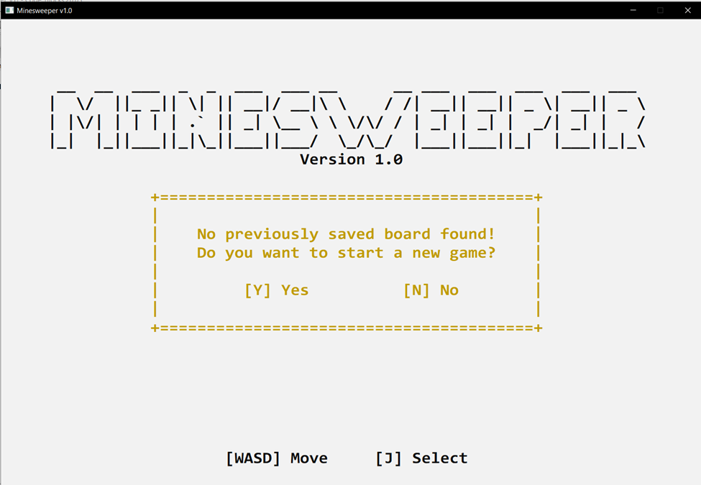
Warning when unsuccessfully find previous game save
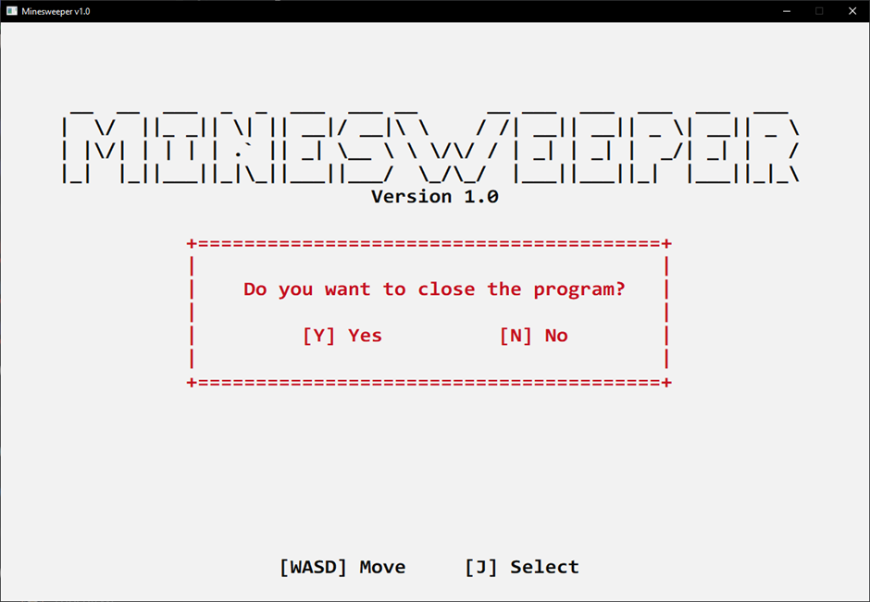
Warning when closing the game

