**UNIVERSITY OF SCIENCE**

**HO CHI MINH NATIONAL UNIVERSITY**

**FACULTY OF INFORMATION TECHNOLOGY**



**FINAL ASSIGNMENT REPORT**

**SUBJECT**

Introduction to Computer Science

(CS161)

**LECTURER:** Professor Dinh Ba Tien

**GROUP 16 MEMBER**

Pham Van Tan Sang – 21125063

Đang Hoang Nhat Hung – 21125041

**TABLE OF**

**CONTENT**

I. Features 1

II. Links 2

III. Tasklist 2

IV. Screenshots 3

1. Welcome scene 3

2. Instruction scene 3

3. Leaderboard scene 4

4. Game mode scene 5

5. In-game display 6

6. Some warning messages shown when playing 7

**CS161 FINAL ASSIGNMENT REPORT**

# **Features**

* Adjust the game’s resolution based on the current level to improve user experience (in Beginner level, the size of the cells are bigger)
* Using the keyboard to play and navigate the menu.
* Display a real-time timer when playing
* Display the rank of the user if they win a position on the leaderboard
* Save the current playing game in midgame: saving both the board and the timer
* Continue saved game (timer starts from saved timestamp too)
* Replay the current game while playing (by pressing “R”)
* Displaying the number of flags left
* You can flag a cell twice to mark a cell as a “questioning” cell
* Reveal all adjacent cells when finish flagging the mines (by pressing “K”)
* Save player’s rank in leaderboard
* ASCII art for UI
* Escape to menu while playing
* Message box
* Guarantee that the first cell opened is not a bomb

* **There are 3 game levels:**
* Beginner: 9x9 cells, 10 mines.
* Intermediate: 16x16 cells, 40 mines.
* Expert: 30x16 cells, 99 mines.
* **How to Play**
* **W** ,  **A** ,  **S** ,  **D** : Move cursor.
* **J** ,  **Enter** : Select options | Reveal current cell.
* **K** : Reveal all adjacent cells of the current cell.
* **L** : Flag current cell.
* **O** : Save current board.
* **R** : Restart current game.
* **Esc** : Exit current game | Go back to menu.

# **Links**

* [Github repository](https://github.com/sangpham2710/CS161-Project.git)
* [Task planner on Notion](https://rek7on.notion.site/CS161-Project-b3d39b222c7e4c7f81fc2d7a9d140882)
* [Game flowchart using draw.io](https://drive.google.com/file/d/1fZ_NB8qzpoKiIMiNAhKyPqUrIfS4zaid/view?usp=sharing)

# **Tasklist**

|  |  |  |
| --- | --- | --- |
| **Week** | **Tấn Sang (21125063)** | **Nhật Hưng (21125041)** |
| 15/11  ⇓  21/11 | * Plan out the project * Set up the developing environment ([Task planner on Notion](https://rek7on.notion.site/CS161-Project-b3d39b222c7e4c7f81fc2d7a9d140882)) * Set up [Github repository](https://github.com/sangpham2710/CS161-Project.git) * Research about “windows.h” for manipulating the console Create our own “cmanip.h” library used to manipulate the console Set up game scenes structure + files architect for the game Finish the welcome scene | * Research about the game rules * Learn how to use Git * Use draw.io to plan out the functions of the project ([Game flowchart using draw.io](https://drive.google.com/file/d/1fZ_NB8qzpoKiIMiNAhKyPqUrIfS4zaid/view?usp=sharing)) * Start implementing game logic |
| 22/11  ⇓  28/11 | * Refactor the whole game after merging with Hung’s code Add keyboard maneuvering mechanics into Hung’s “game-logic” * Design the UI for the game board * Review + merge my code with Hung’s code * Discuss the overall shape of the game | * Finish implementing game logic * Set up saving and loading game data * Design + code leaderboard scene * Design + code level-choosing scene * Discuss the overall shape of the game |
| 29/11  ⇓  5/12 | * Add Timer * Add Replay midgame functionality * Add Endgame message box * Optimize the render functions * Fixing bugs from the “windows.h” library | * Add reset leaderboard option * Return rank of a player when they win * Update several UI elements * Design + code Instruction scene |
| 6/12  ⇓  12/12 | * Test the game * Edit the README file on Github repo * Look through the whole project and make a report about the project | * Test the game * Edit the README file on Github repo * Look through the whole project and make a report about the project |

# **Screenshots**

## Welcome scene

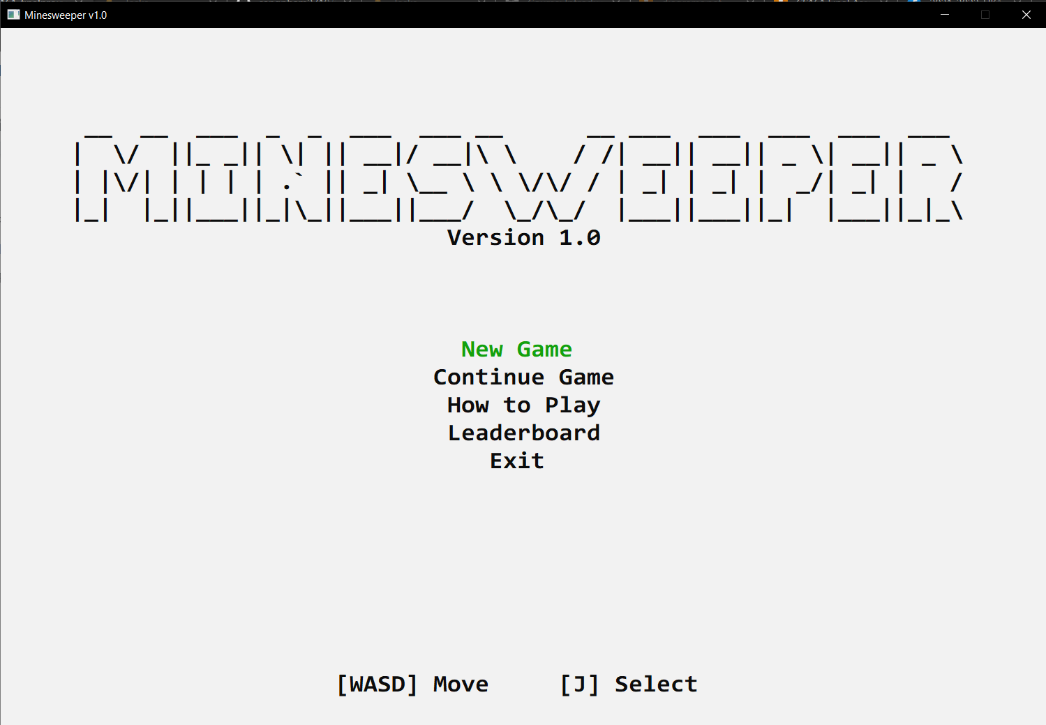

## Instruction scene

## Leaderboard scene

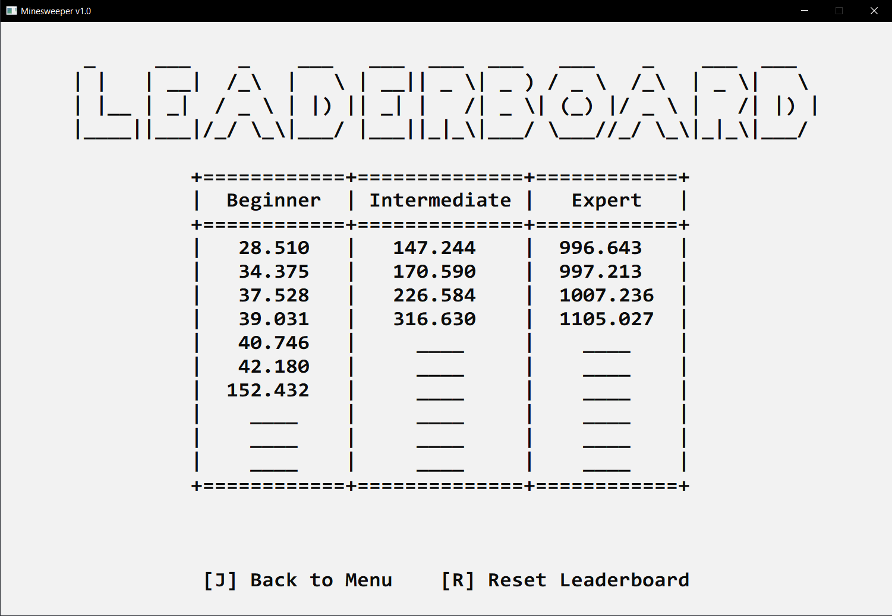

*Leaderboard scene*

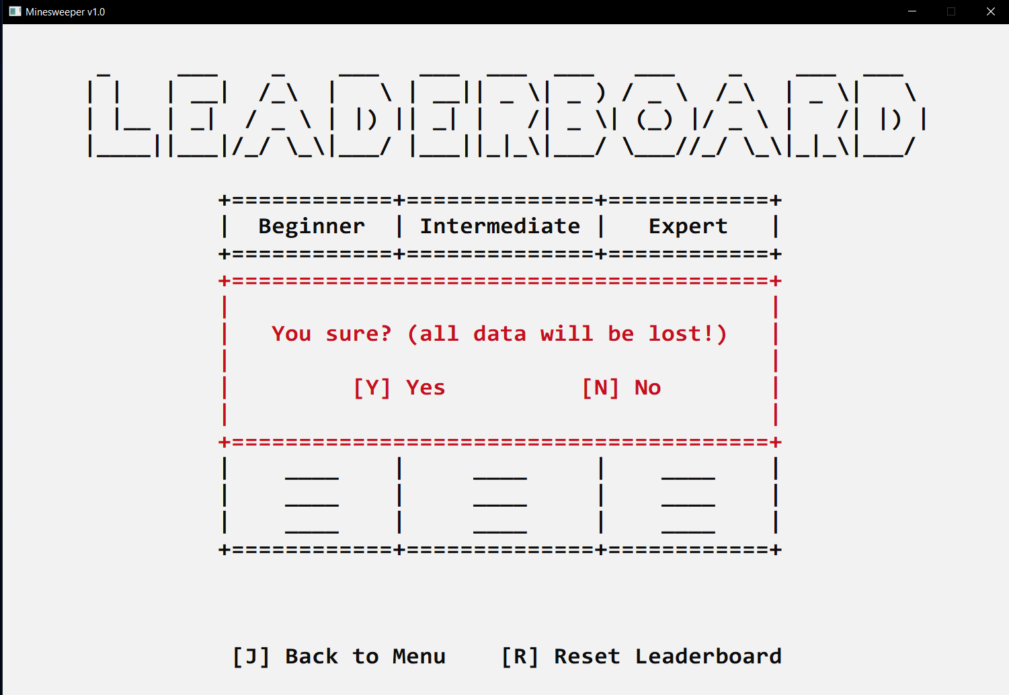

*Warning before resetting leaderboard*

## Game mode scene

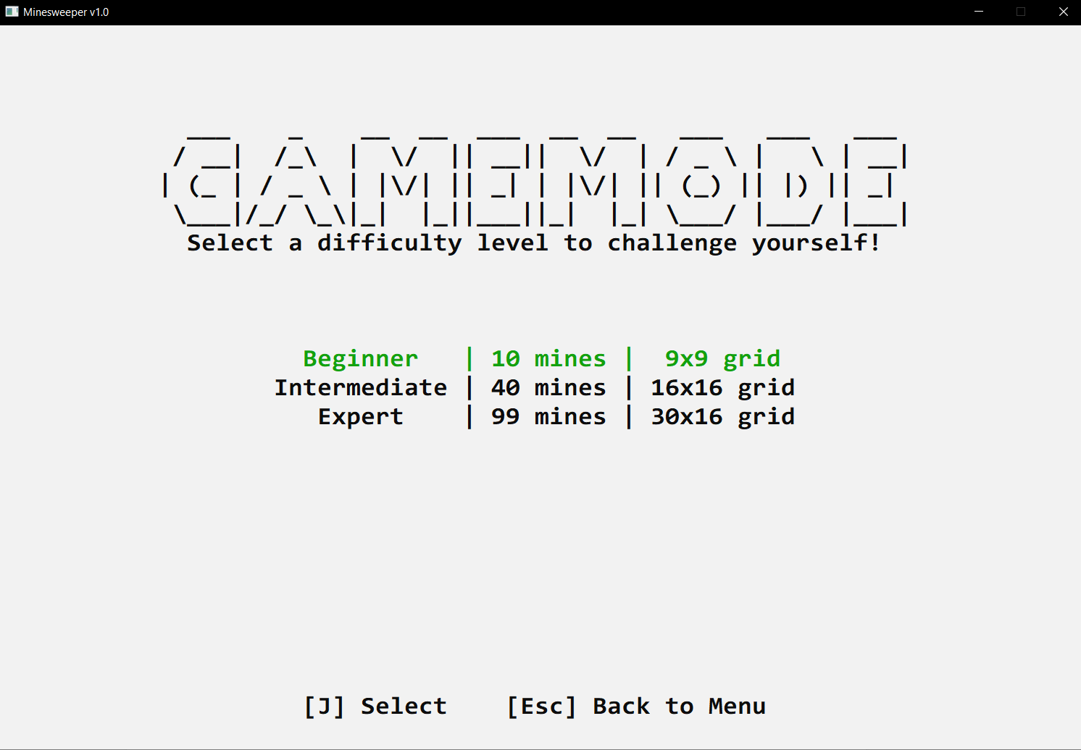

*Choosing game mode scene*

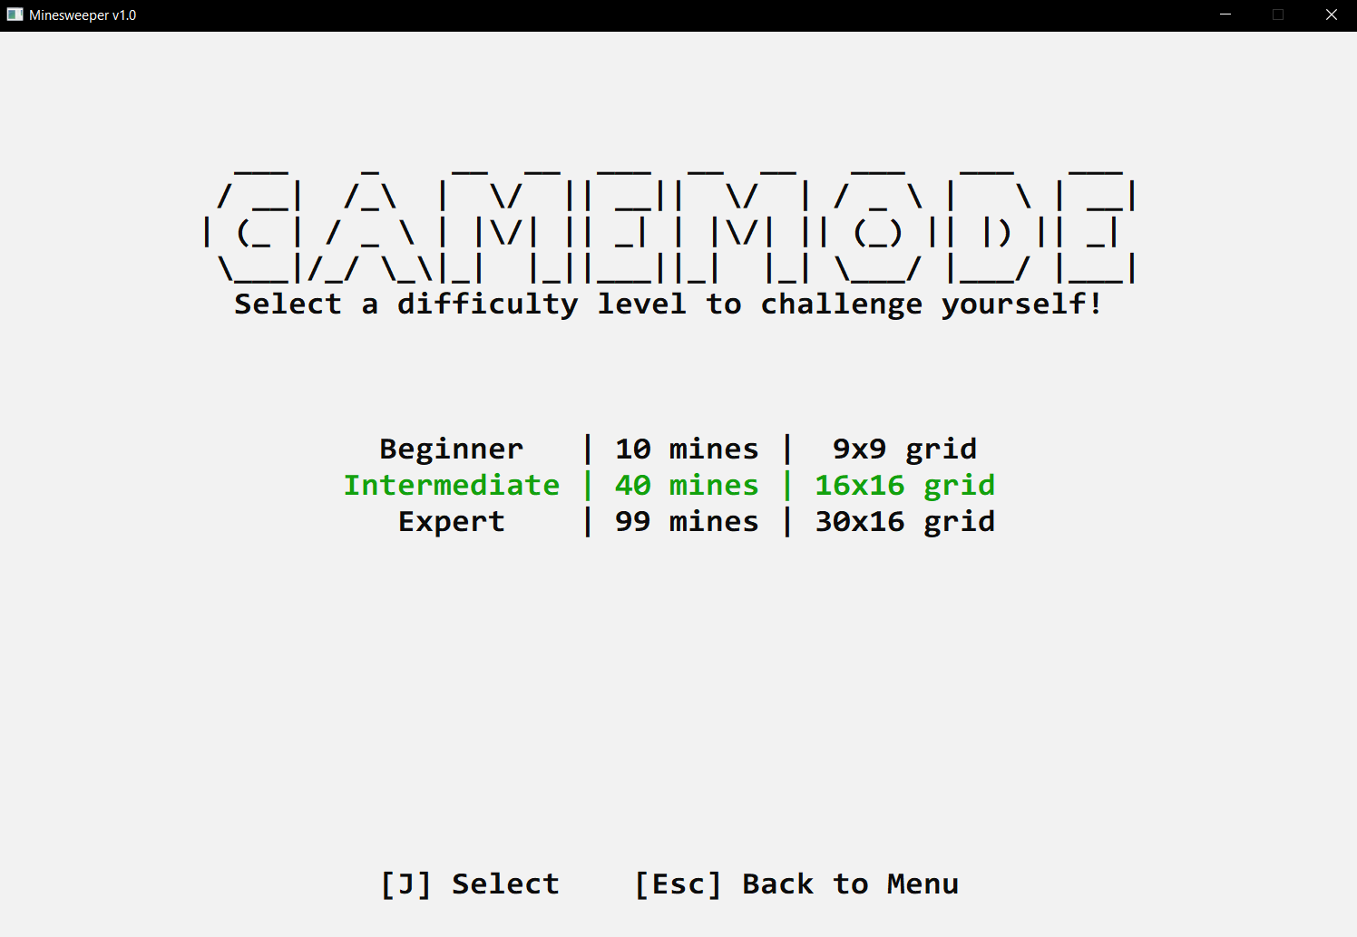

*The intermediate game mode is selected*

## In-game display

*You can move the cursor around*

*Main game display (intermediate game mode)*

.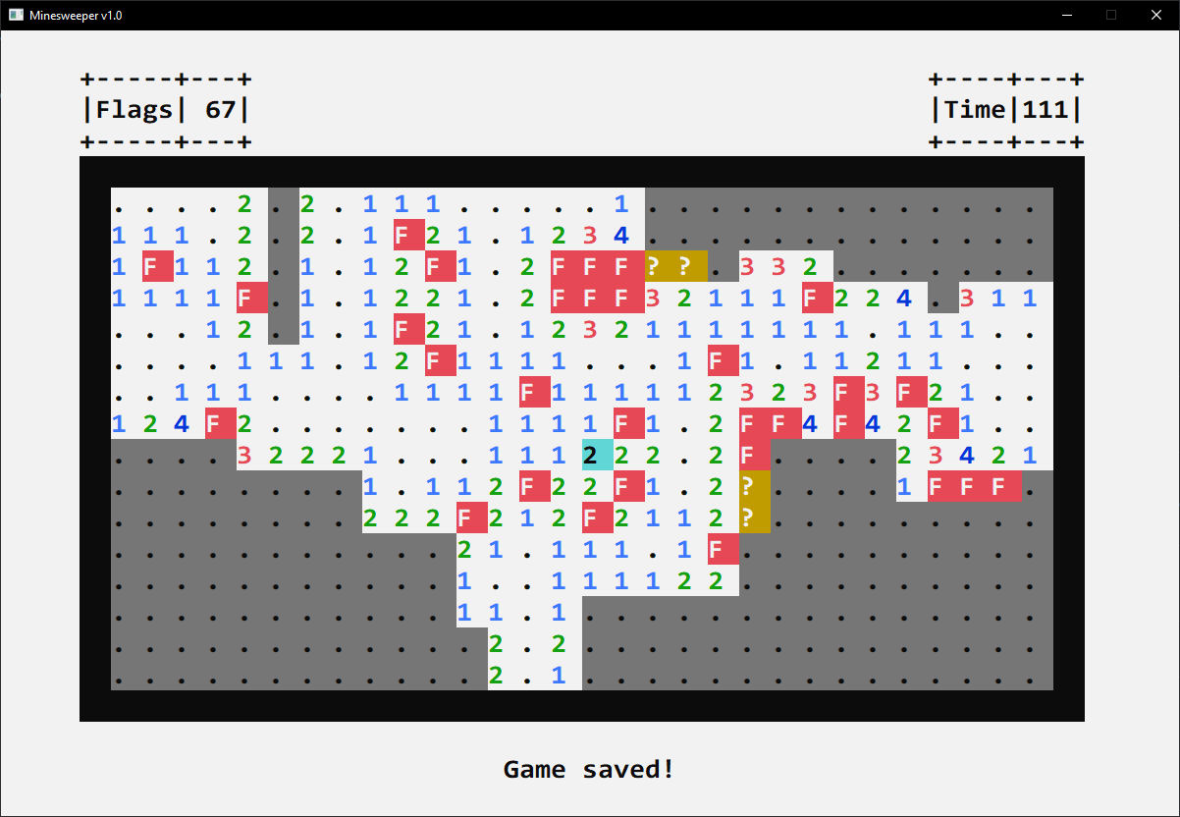

*Cells with 4 states: Opened, Flagging, Questioning and Unknown*

1. **Some warning messages shown when playing**

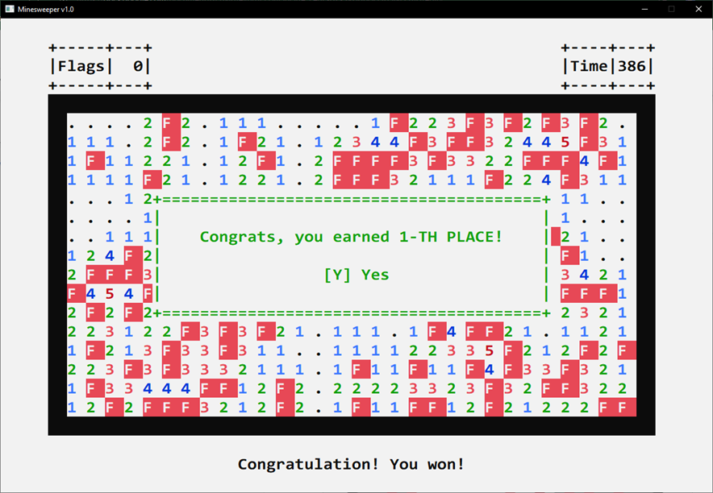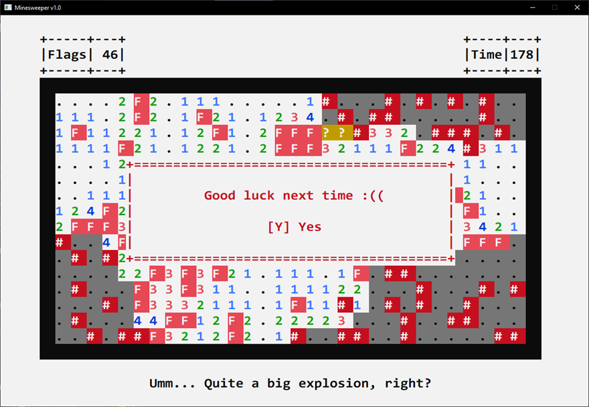

*Win message*

*Lose message*

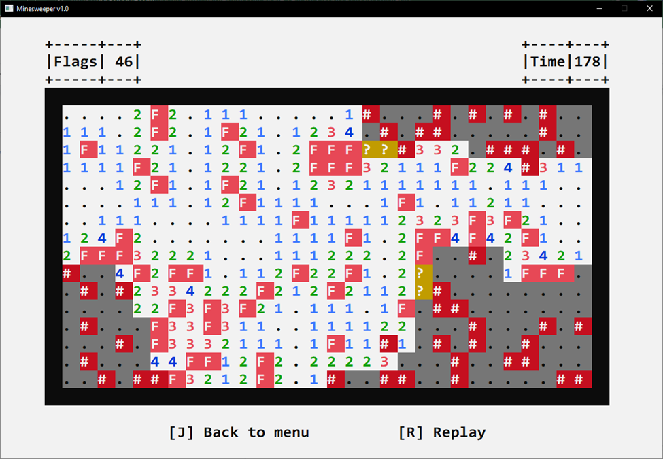

*Pause screen when losing/winning*

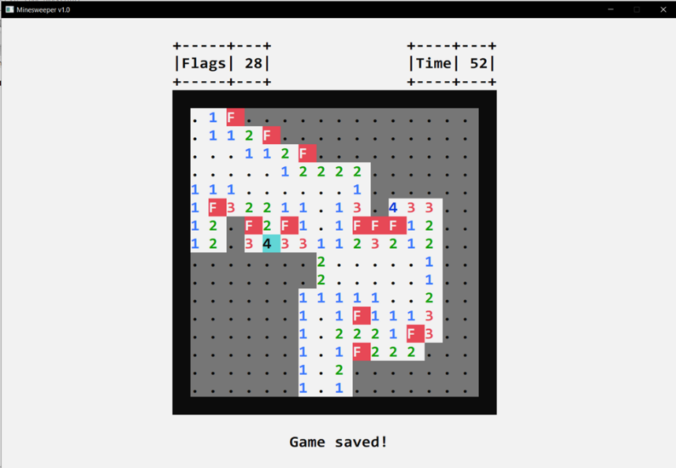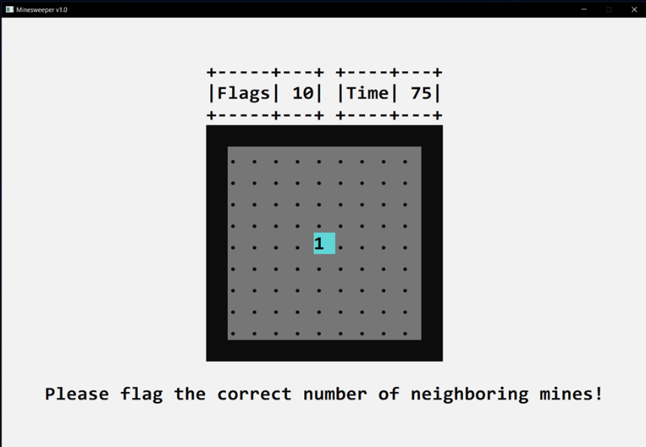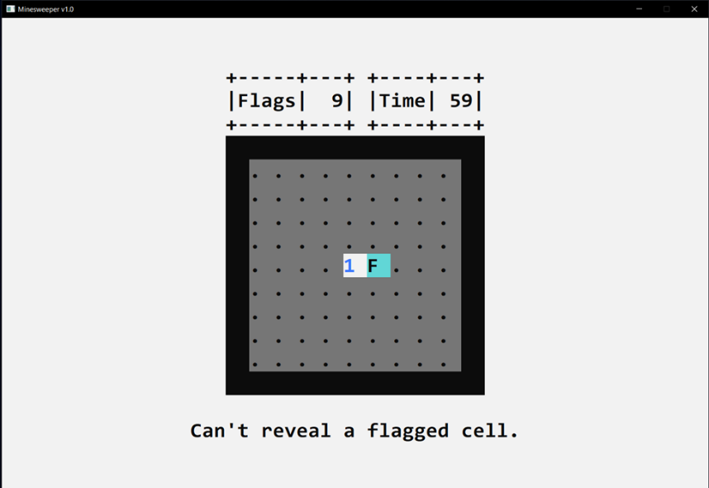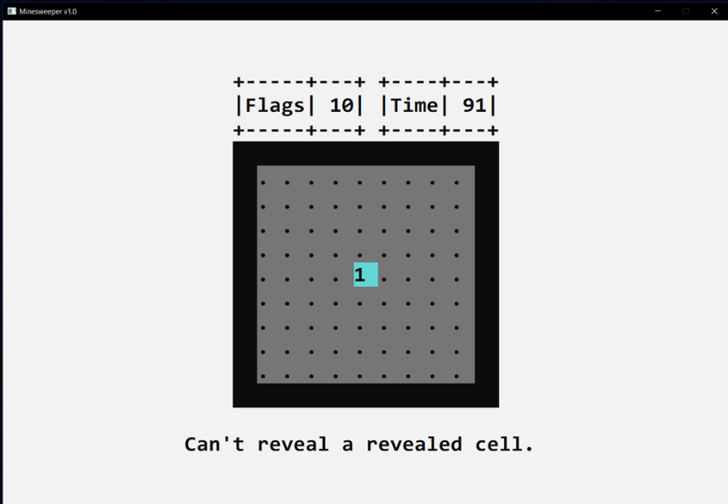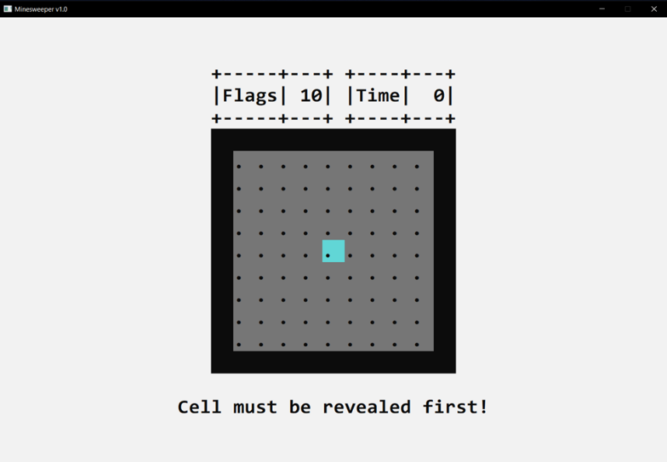

*Open a flagged cell*

*Open the neighboring cells without flagging the correct number of neighboring mines*

*Flag a unopened cell*

*Reveal a revealed cell*

*Succesfully save game message*

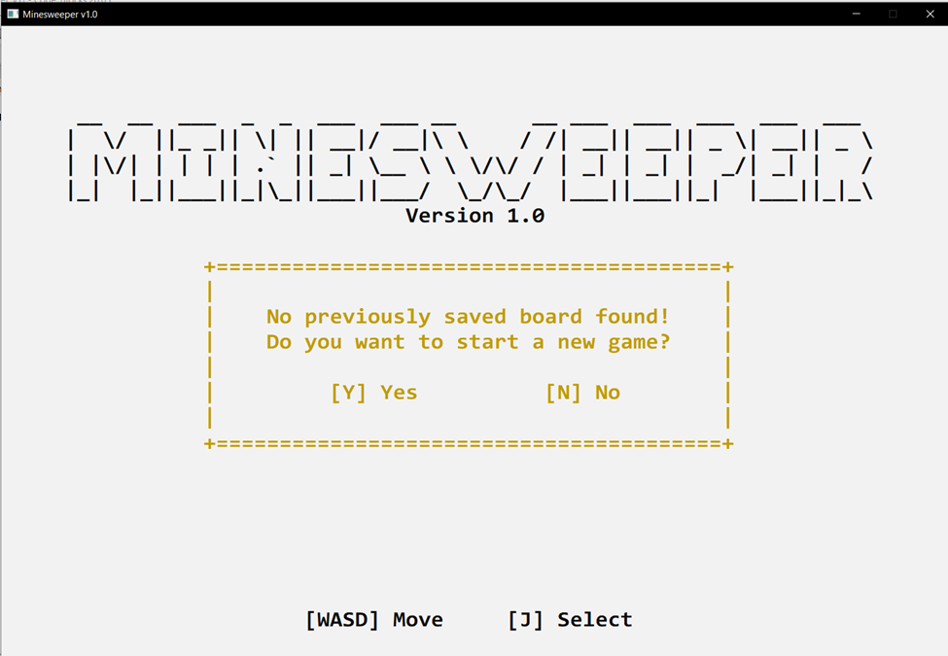

*Warning when unsuccessfully find previous game save*

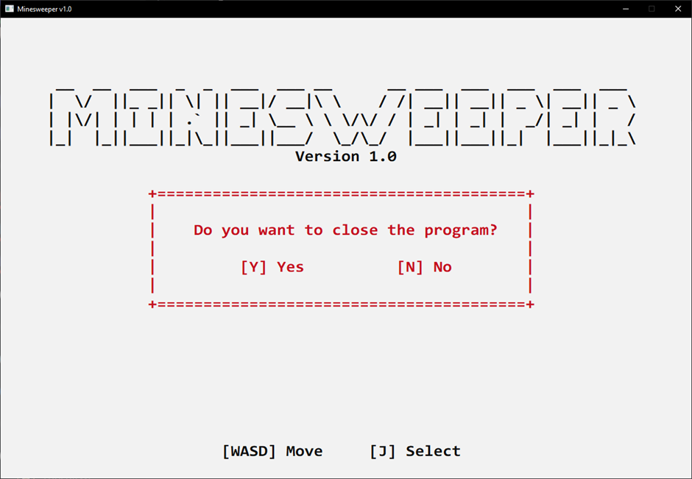

*Warning when closing the game*