1. **Report No. 1 Introduction**
   1. **Project Information**
      1. Project name: **Design and implement the model of smart garden**
      2. Abbreviation: **DIMOSG**
      3. Product Type: **Device**
      4. Start Date: **May 9th 2016**
      5. End Date: **September 2016**
   2. **Introduction**

Nowadays, farming is absolutely vital for every society. However, land costs too much and farming make too little, its depend on spread of land. Besides that, people don’t have enough time to take care the plant and easy to forget the schedule about gardening. The actual situation is people don’t know when the most convenient time to watering or fertilize the plants, it is easy make the plants to die or waste the resource. This project can help farmer increase productivity even in a small land, reduce the water or fertilizer, helps plants to have a better life.

* 1. **Current Situation**

As you know, we should give a hoot the specification of weather such as temperature, humidity, light, and PH degree to find the suitable way to take care each plant. That helps controlling water and fertilize for plants.

* Other trade product systems on the world:

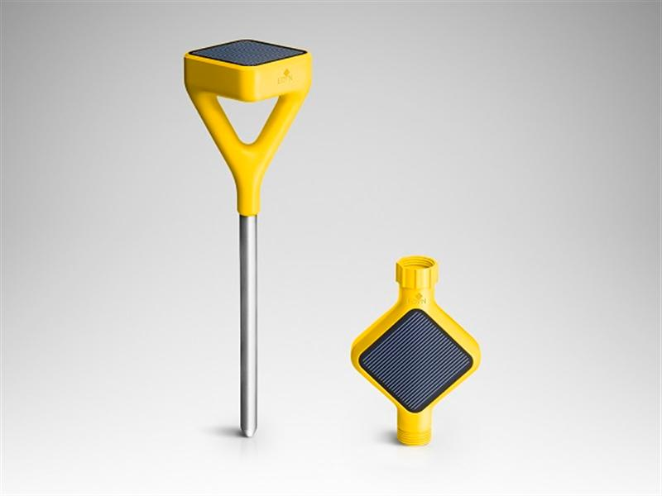 + Edyn – Smart Garden System: They have 2 part which is Edyn Garden Sensor and Edyn Water Valve. Edyn Garden Sensor will track light, humidity, temperature, soil nutrition and moisture and cross-references collected data with plant, soil science, and weather databases to recommend which plants will thrive; monitors continuously and alerts users to changes that require immediate action. Edyn Water Valve automatically controls existing water system based on data collected by the Garden Sensor and adapts to changes in the weather forecast. Edyn app provides information on what plants that will grow best, the optimal time for planting, and even plant groupings with the same conditional needs. It can also be used to manually control the Edyn Water Valve. Advantage: Solar Powered, in addition to rechargeable lithium iron phosphate battery when not in full sun; Measures ambient temperature, humidity, light intensity and soil electrical conductivity. Many sensors are just in one device; Water and fertilizer resistant; Connects to the cloud.

+ Parrot Flower Power: collects a variety of plant-relevant data accurately and uses it in conjunction with its excellent database to make plant-specific recommendations. Advantage: Has a huge database about plant (7000 plants)

.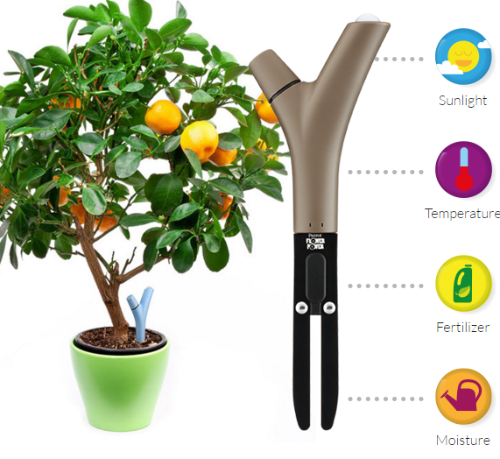

* In Vietnam:

In usually, gardeners in Vietnam have to measure indexes above manually and separately. After that, they also have to calculate and make plans base on those indexes and plants’ information.

There are some companies such as vuonnhaxanh.com or vuonthongminh.com which has some smart systems for garden. Main purpose of their system is measure light and temperature sensors or timer for controlling volume of water valve, turn light for plants.

There are some similar projects about smart garden in other university such as Wireless sensor networks in agriculture from University of Economic and Industries in Long An (2013). They build a Wi-Fi station for monitoring and controlling environmental parameters, such as the environmental parameters (air temperature, air humidity, light, insects, weeds, etc.) and other parameters related to soil conditions (soil moisture, pH, etc.). The data are collected, stored, and transmitted wirelessly to the farmers to handle in server, through which they can control and take appropriate actions for their farm to increase production and quality.

* 1. **Problem Definition**

With Edyn Garden System, they connect to Wi-Fi network to send valuable insights through the corresponding Edyn app. That’s a big problem if the garden has a large area (outside Wi-Fi distance). Price of Edyn is about 100$ without tax which is high with Vietnamese’ average income for a small garden. There has not a support and warranty system, so Vietnamese gardener has not high reliability with this system.

With Parrot Flower Power, the device can only transmit data to a Bluetooth device, meaning have to be close to the device to get any data, limiting ability to monitor your plant or get alerts on the go.

With the current system in the market, we must have paid so much for using the smart garden and it is not suitable for Viet Nam environment. And some kind of control application is hard for Vietnamese people.

With similar projects, such as Wireless sensor networks in agriculture, they have a huge device which is not comfortable with a small garden.

With gardener in Vietnam: Measuring equipment, for temperature, humidity, light and PH degree in the market, have many different types and individual. Gardener will spend lots of time to get indexes from these devices manually. It is also difficult to combine these indexes together to find a solution for taking care of plants. Besides that, plants are usually influenced by extreme weather events and by gradual climate changes. With this routine in garden of Vietnamese, they have many things to do if it is rain too much or dry in a long time.

* 1. **Proposed Solution**

The proposed solution is “Design and implement the model of smart garden”.

This model will combine from above model such as:

* + - Integrate sensors in a device like Edyn or Parrot.
    - Reaction with the change indexes.
    - Making plan, reminder, or suggestion based on sensors’ indexes.

This model will resolve problems such as:

* + - Limit transmit and control distance.
    - System is difficult to use.
    - Applicable with a small or large area.
    - Not depend on what kind of trees.

We want this model will be an improvement over other systems in Vietnam:

* + - More reactive based on indexes and weather condition than just control volume of water valve or turn light on/off.
    - Detail Planning for gardener, it is not just a timer.

This model will build to resolve problems which are easy to use, save time, transmit distance, planning and weather condition in gardening.

This model building a garden monitoring system. This system can not only use measuring devices automatically but also combines their indexes to make a better plan for controlling water, fertilize, reminding improving soil, tracking life cycle of plants. This system has some backup solution when the weather change. The gardener has less thing to do, they can manage garden from anywhere outside the home.

* 1. 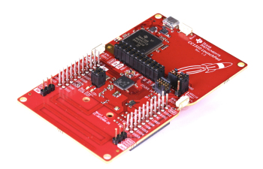**Feature functions**
     + This system has a microcontroller (such as Arduino, ARM Cortex, CC1310 Launchpad) hooked up to sensors (temperature, humidity, soil moisture, PH degree and light) and actuators (like water pump, nebulizer…).
     + Gardener will control this system through a mobile application where they can be monitoring, tracking and get some advisers, reminder for their plants. This solution can be flexible with small or large garden via Wi-Fi or RF waves.
     + A web server will be built not only communicate with mobile application, but also receive parameters from the sensors and controlling actuators through microcontroller via Wi-Fi or RF waves.
  2. **Advantages and disadvantages**

Advantages:

* + - Spend less time for gardening but increase productivity of plants.
    - Waste reduction of resources such as water, fertilize.
    - Simply collect data and monitor the conditions of land and plants.
    - Plant disease, forecasting, make a better criteria conditions for each plant.

Disadvantages:

* + - The lack of technology knowledge from Vietnam gardener
    - Accuracy and durability of sensors or electric devices in a long time with hard weather.
  1. **Functional Requirements**
  2. 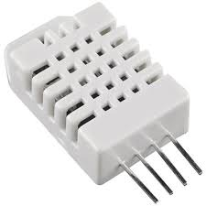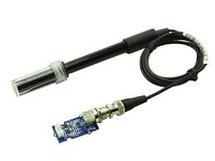**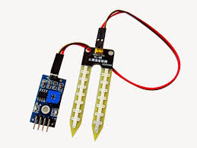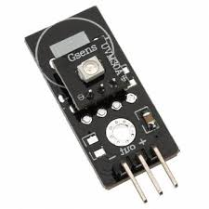Sensors Management**
     + Setting range of allowed indexes
     + Tracking report of indexes
     + Setting period time for each sensors
  3. **Actuators Management**
     + Add new a device
     + Setting levels, volumes of resources
  4. **Plant Management**
     + Add new plant.
     + Add criteria conditions for each plant.
     + Getting report of plants’ indexes.
     + Suggestion plan for gardener
     + Setting time, life cycle for each plant.
  5. **Web server** 
     + Provide API for managing on mobile via internet.
     + Receive indexes from sensors and transmit signal to control actuators through microcontroller via Wi-Fi or RF.
     + Chart or report conditions of land and plant.
  6. **Mobile App**
     + Tracking report, chart for gardener.
     + Reminder plan.
  7. **Role and Responsibility**

|  |  |  |  |  |
| --- | --- | --- | --- | --- |
| **No** | **Full Name** | **Role** | **Position** | **Contact** |
| 1 | Nguyễn Đức Lợi | Product owner | Supervisor | loind@fpt.edu.vn |
| 2 | Phan Thành Sang | Developer | Leader | [sangptse61252@fpt.edu.vn](mailto:sangptse61252@fpt.edu.vn) |
| 3 | Lê Văn Pháp | Developer | Member | [@fpt.edu.vn](mailto:cuonghhse61155@fpt.edu.vn) |
| 4 | Phạm Hoàng Chinh | Developer | Member | [chinhph60147@fpt.edu.vn](mailto:chinhph60147@fpt.edu.vn) |
| 5 | Huỳnh Hữu Nghị | Developer | Member | Nghihhse61055@fpt.edu.vn |

***Table 1 : Roles and Responsibilities***