C. Report No.3 Software Requirement Specification

1. User Requirement Specification

Nowadays, there are many reports about the unhealthy side-effects found in the foods we buy and eat. Large food which is introduced by chemical to grow food quicker and use pesticides to prevent loss from being destroyed by worms. In this country, it’s cheaper for a family to eat fast food or meats than it is to eat organically grown fruits and vegetables. In addition to the foods, we are developing industry and modern too fast with a lot of harmful effects for environment, air quality as poor as less space to relax after work at home. A small garden in house which is not only makes your house look good but they also keeps you healthy with fresh air and safe fruit or vegetables; this is also the best place to reduce stress and lighten mind which cannot be done being inside four walls. But we have to face too much pressure and differences works in day, this make us have less time to take care a garden day by day. Come from real needs, users want a system which help them to take care a small garden in house less time, smarter and flexibility. The system should meet the below needs:

1.1. Monitoring the status of garden

Users can tracking indexes of garden through sensors.

Users can monitor the status of garden from anywhere in anytime.

**1.2. Response with expected problems**

User can be notified when unexpected problems occurred of weather with their garden (rain, high temperature ...).

System can automatically react with problems which is harmful for garden.

**1.3. Manage the system**

Users can control one or multi devices to solve some specific tasks such as limit volume water for some kind of plant in blooming lately.

Users can manage all devices, tracking reliability and durability of devices; add, remove or configure a specific devices.

Users can start or stop any automatically actions in their garden

**1.4. Schedule**

Users can create a plan which using time of each device in the system such duration time of sensor measurements by manually or automatically.

Users will be received auto schedule after processing indexes on server.

Users need to be notified some reminder with situations which meet plant’s requirement or auto actions deadline nearly

**1.5. Consumption and durability**

All sensors which used in the system, have to a long battery life.

All sensors have a great durability when usually contact with water day by day.

**1.6. High security**

Users have to be authenticated before using the system

A user can only manipulate their own device (có phân chia user trong 1 khu vườn không?)

Data and commands which transmit in system via RF and Wi-Fi should be protected.

**1.7. Interoperability**

New end devices can be added to the system and interact with other ones regardless of manufacturing origin.

2. System Requirement Specification

2.1 External Interface Requirement

2.1.1. User interface

- User interface use Graphical User Interface must be simple, clear and easy to use. Each screen will have the instruction to guide user how to use it.

2.1.1.1. Main Menu

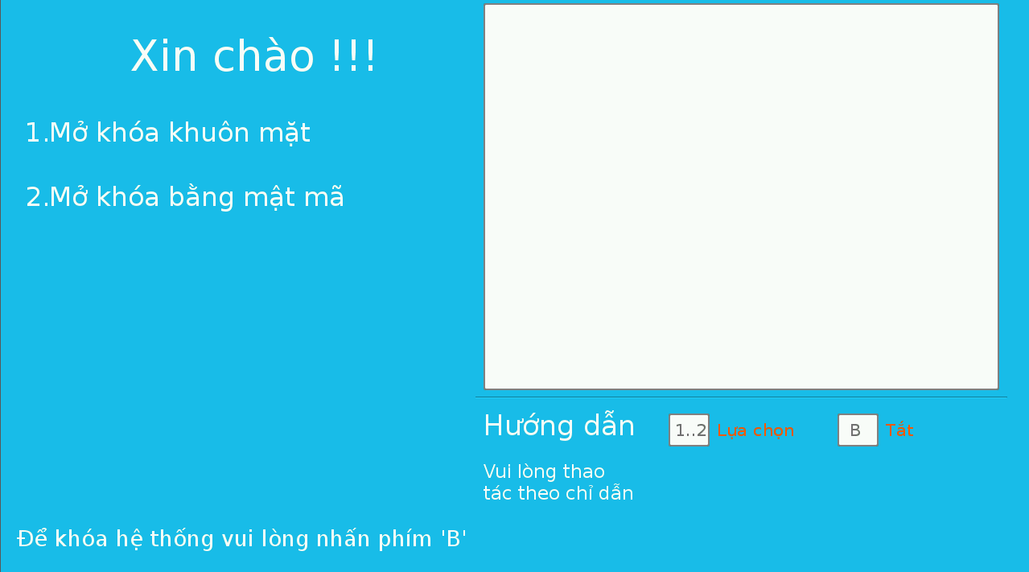

Figure 3. “Main menu” screen

2.1.1.2. System management

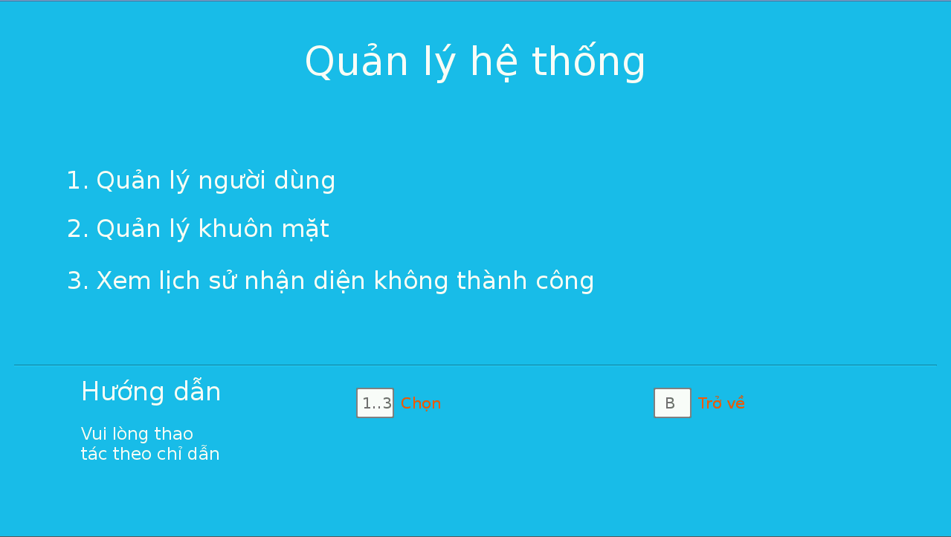

Figure 4. “System management” screen

2.1.1.3. User management

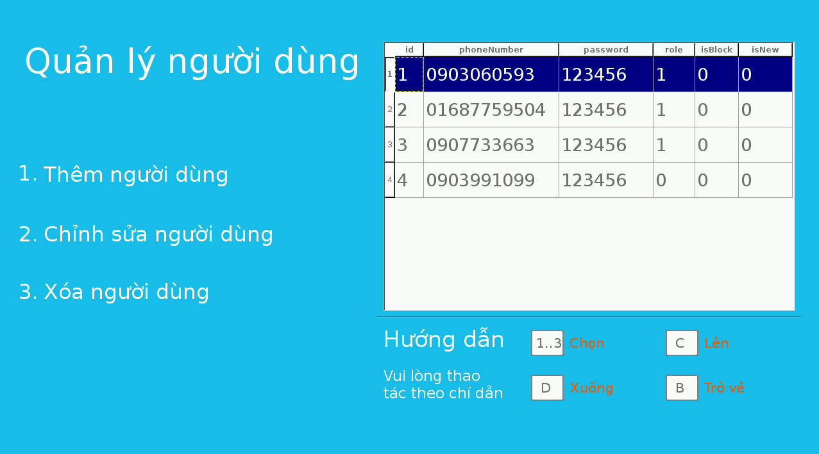

Figure 5. “User management” screen

2.1.1.4 Add user

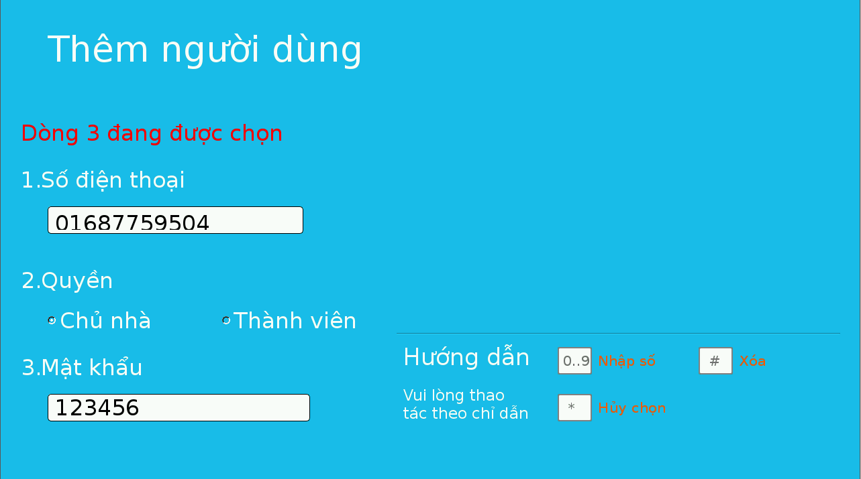

Figure 6. “Add user” screen

2.1.1.5. Modify User

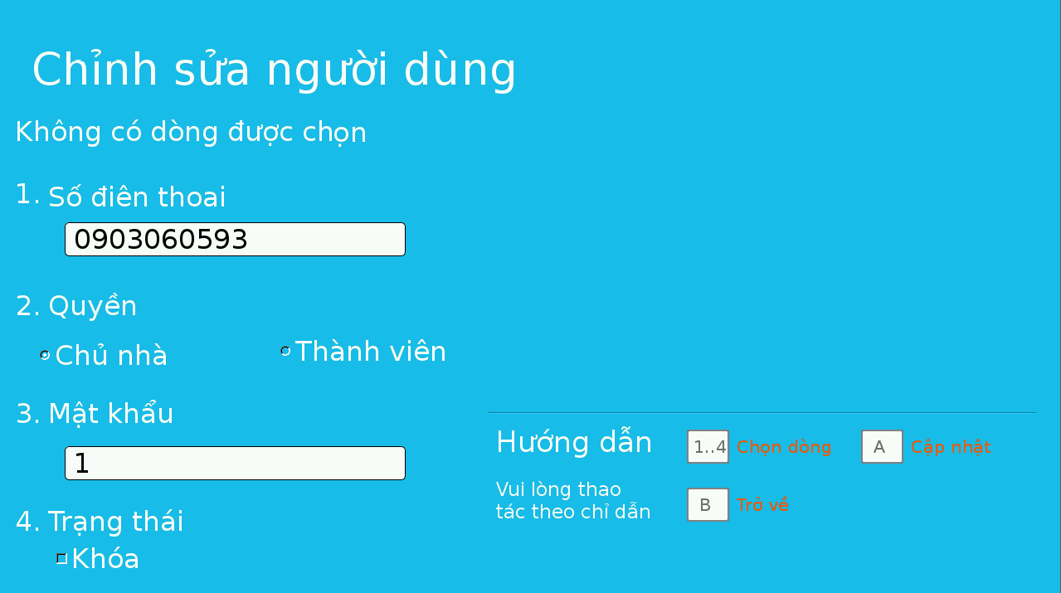

Figure 7. “Modify user” screen

2.1.1.6. Manage face

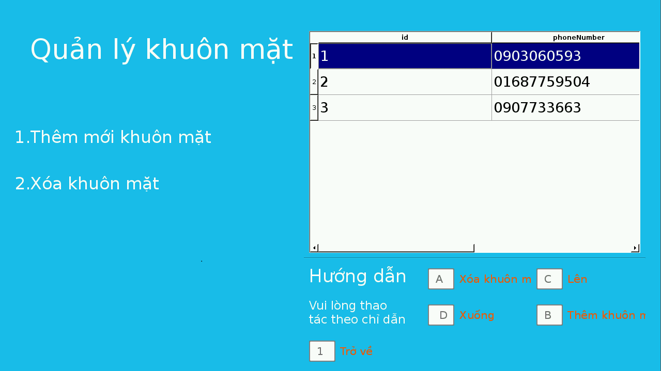

Figure 8. “Face management” screen

2.1.1.7. Add face

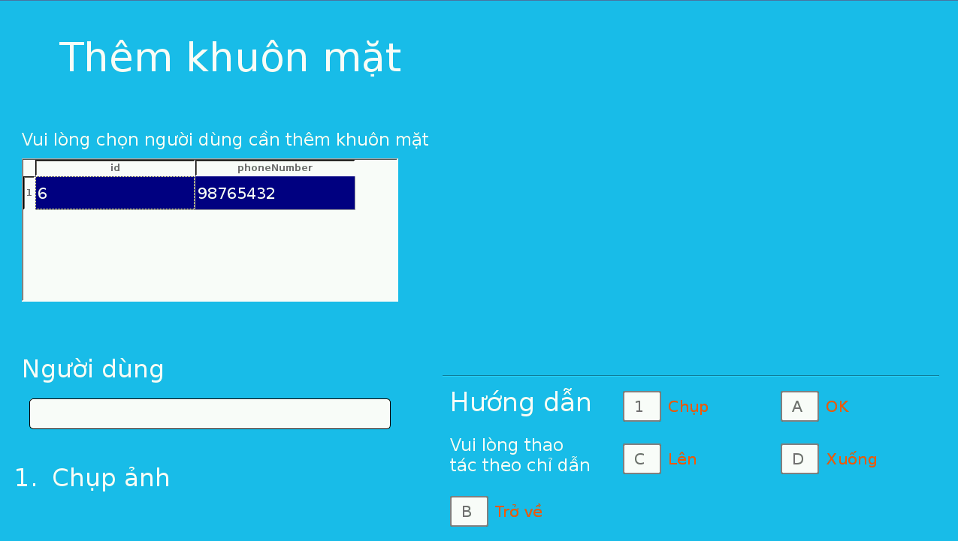

Figure 9. “Add face” screen

2.1.1.8. Show log face

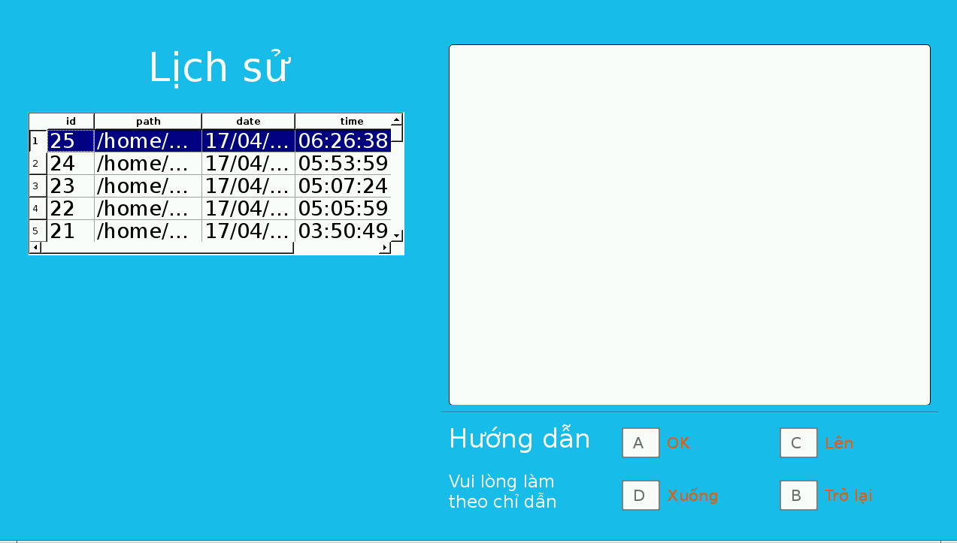

Figure 10. “Show log face” screen

2.1.1.9. Keypad mode

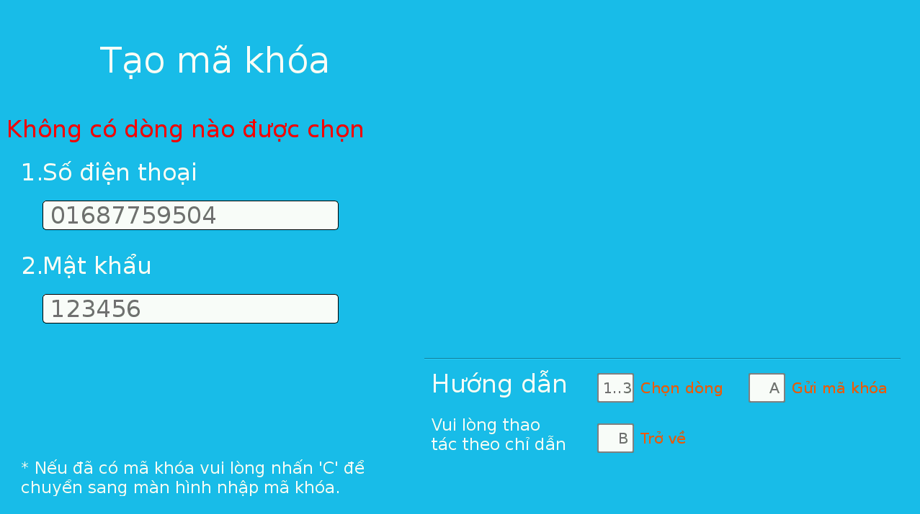

Figure 11. “Keypad mode” screen

2.1.1.10 Enter passcode

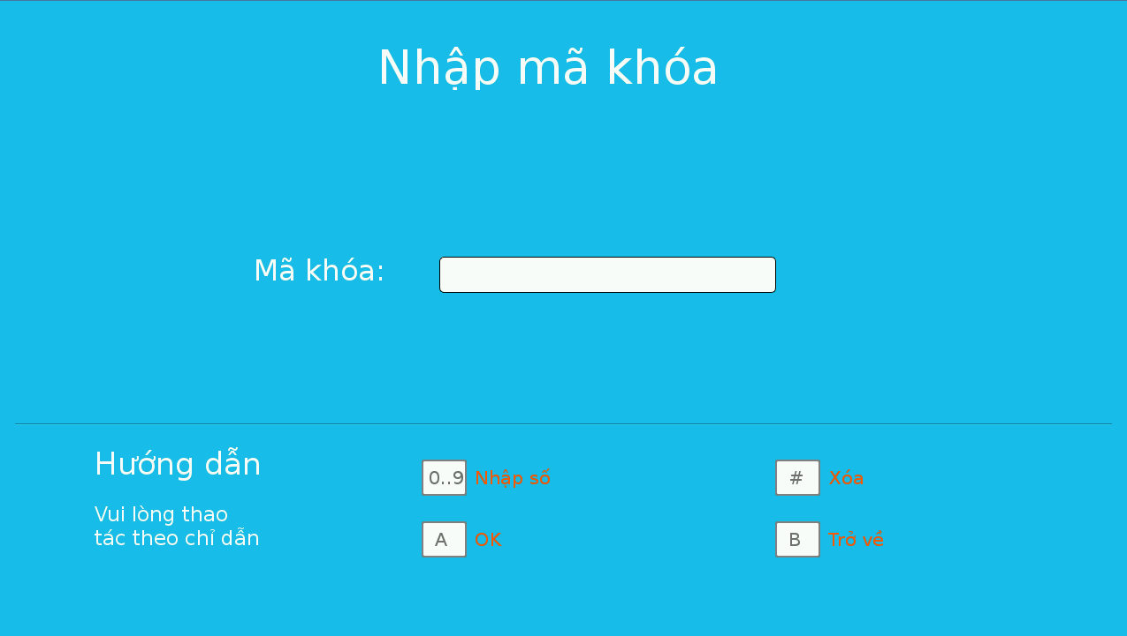

Figure 12. “Enter passcode” screen

2.1.1.11. Setting screen

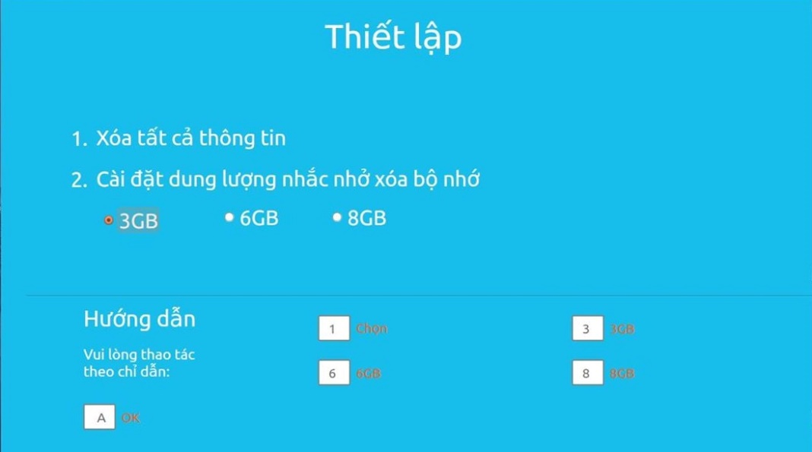

Figure 13. “Setting” screen

2.1.1.12. Alert screen

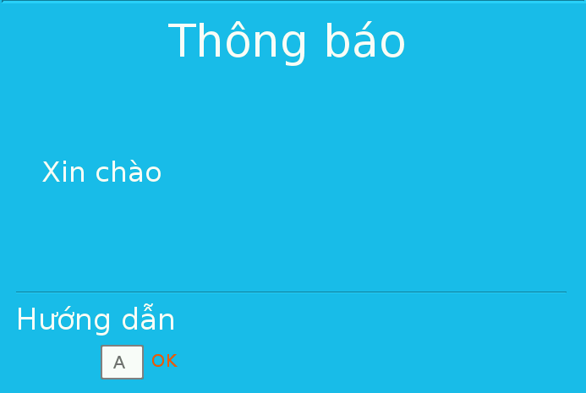

Figure 14. “Alert” screen

2.1.1.13. Confirm screen

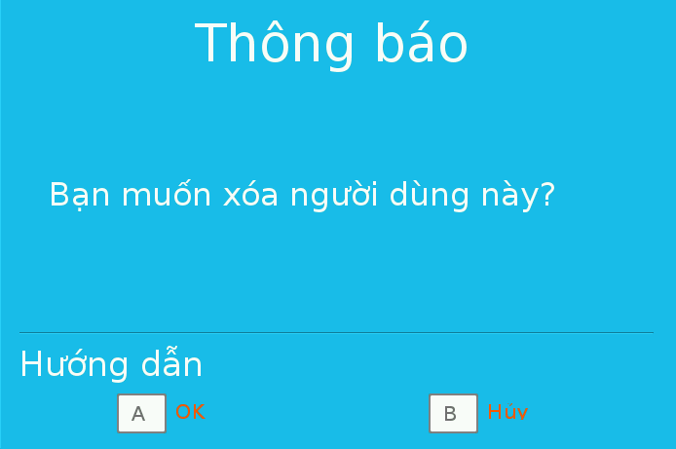

Figure 15. “Confirm” screen

2.1.2. Hardware interface

- Raspberry Pi B2 with SDRAM 1GB, Quad-core, 900MHz ARM Cortex-A7 chip

- Number keypad have 0-9 number, ‘* #’ special characters and ‘A B C D’ characters.

- Camera module of Raspberry Kit.

- Cabinet Door Electric Lock Assembly Solenoid DC12V 0.6A Square bevel latch

2.1.3. Software Interface

- QT 4 Development Tools Version v4.8.2 and Q make version 2.01a

2.2 System Overview Use Case

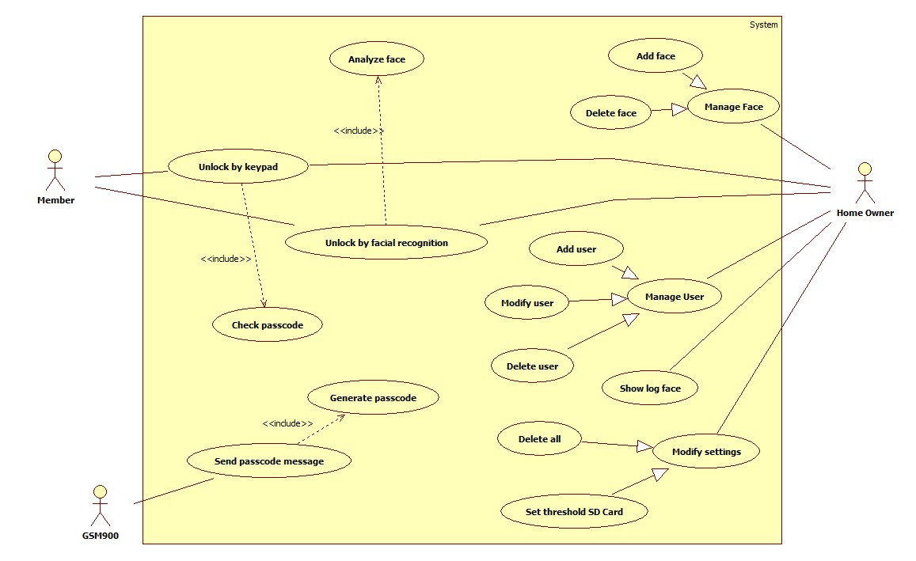

Figure 16. System overview use case

2.3. List of Use Case

2.3.1. <Member>,<Home owner> Overview Use Case

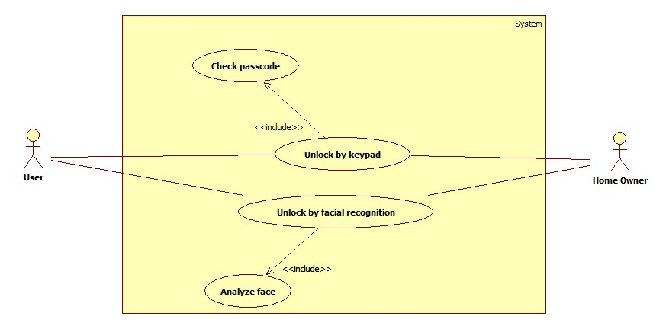

Figure 17 . <Member>,<Home owner> Overview use case

2.3.1.1. Unlock by keypad

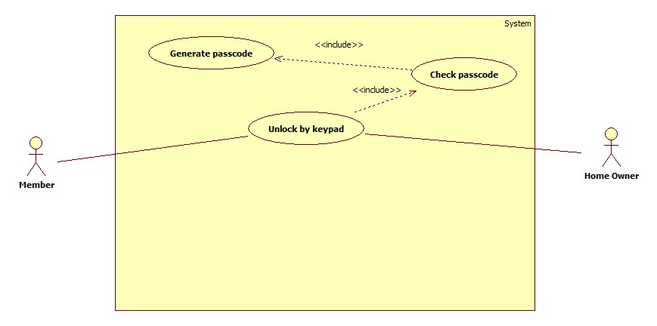

Figure 18. “Unlock by keypad” use case

|  |  |  |  |
| --- | --- | --- | --- |
| **USE CASE – UUC01** | | | |
| **Use Case No.** | **UUC01** | **Use Case Version** | 2.0 |
| **Use Case Name** | Unlock by keypad | | |
| **Author** | Nguyen Kieu Hanh Ha | | |
| **Date** | 30/1/2015 | **Priority** | High |
| **Actor:**  - Member  - Home owner  **Summary:**  - In case user can not unlock by facial recognition, user will use unlock by keypad mod to unlock. After switch mode, user will enter the passcode which is received by registered phone number.  **Goal:**  - User will unlock successfully.  **Triggers:**  - Press “2” button on keypad to open unlock keypad screen.  **Preconditions:**  - User entered “Unlock by keypad” screen.  **Post Conditions:**  - Success: User opens lock successfully. Lock will be opened.  - Fail: User can not unlock. Dialog will show message base on exception.  **Main Success Scenario:**   |  |  |  | | --- | --- | --- | | Step | Actor Action | System Response | | 1 | Press “2” button on keypad  [Alternative Scenario] | LCD will show screen with contains the following information  - Phone number: label  - Password: label | | 2 | Press “1” button on keypad | Phone number will be selected for user entered his phone number | | 3 | Press “*” button on keypad | System will be exchange no line is selected to wait next action. | | 4 | Press “2” button on keypad | Password will be selected for user entered password | | 5 | Press “*” button on keypad | System will be exchange no line is selected to wait next action. | | 6 | Press “A” button on keypad  [ Exception 1] | System will generate passcode and open “Enter passcode” screen. | | 7 | Press “0..9” button on keypad | Entered number of passcode | | 8 | Press “A” button on keypad  [ Exception 2]  [ Exception 3] | System check passcode and lock will be opened. |   **Alternative Scenario:**   |  |  |  | | --- | --- | --- | | Step | Actor Action | System Response | | 1 | Press “C” button on keypad | Open “Enter passcode” screen. | | 2 | Press “0..9” button on keypad | Entered number of passcode | | 3 | Press “A” button on keypad | System check passcode and lock will be opened. |   **Exceptions:**   |  |  |  | | --- | --- | --- | | No | Actor Action | System Response | | 1 | User entered phone number which is not registered by home owner or invalid password | Dialog will show “Số điện thoại chưa được đăng kí hoặc mật khẩu không đúng” message. | | 2 | Press invalid passcode | Dialog will show “Mã khóa không đúng.” message. | | 3 | Press expired passcode | Dialog will show “Mã khóa đã hết hạn.” message. |   **Relationships:**  - Have <<include>> relationship with “Check passcode” use case.  **Business Rules:**  - Users will use unlock by keypad in case they are guests or they do not have permission to unlock by facial recognition.  - Users must have a phone number which is registered by home owner to receive the passcode.  - User will enter the passcode which is received to unlock.  - The expired time of the passcode is one hour after this is generated by system. And the passcode is one time passcode. | | | |

Table 9. ”Unlock by keypad” specification.

2.3.1.2. Unlock by facial recognition

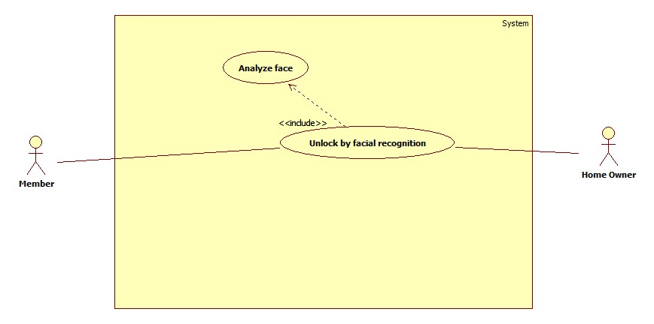

Figure 19. “Unlock by facial recognition” use case

|  |  |  |  |
| --- | --- | --- | --- |
| **USE CASE – UUC02** | | | |
| **Use Case No.** | **UUC02** | **Use Case Version** | 2.0 |
| **Use Case Name** | Unlock by facial recognition | | |
| **Author** | Nguyen Kieu Hanh Ha | | |
| **Date** | 30/1/2015 | **Priority** | High |
| **Actor:**  - Member  - Home owner  **Summary:**  - User will be opened lock by using face. User will stand in front of camera for system recognize, if system recognize successfully, lock will be opened.  **Goal:**  - User will unlock successfully.  **Triggers:**  - Press “1” button on keypad in “Menu” screen  **Preconditions:**  - User use mode unlock by facial recognition.  **Post Conditions:**  - Success: Lock will be opened.  - Fail: User can not unlock. Dialog will show message base on exception.  **Main Success Scenario:**   |  |  |  | | --- | --- | --- | | Step | Actor Action | System Response | | 1 | Press “1” button on keypad | Face of user will be shown in screen | | 2 | Stand in front of camera about 3-5 seconds and look at the camera.  [ Exception 1]  [ Exception 2] | Lock will be opened if system recognize successfully. |   **Alternative Scenario:**  **-** N/A  **Exceptions:**   |  |  |  | | --- | --- | --- | | No. | Actor Action | System Response | | 1 | System can not recognize face | Dialog will show “Mở khóa không thành công” message. | | 2 | User is blocked | Dialog will show “Người dùng đã bị khóa” message. |   **Relationships:**  - Have <<include>> relationship with “Analyze face” use case.  **Business Rules:**  - Users will press “1” to active system and camera then stand front of the camera and check in LCD the position of their face and adjust for system easy recognition. | | | |

Table 10.”Unlock by facial recognition” specification.

2.3.2. <Home Owner> Overview Use Case

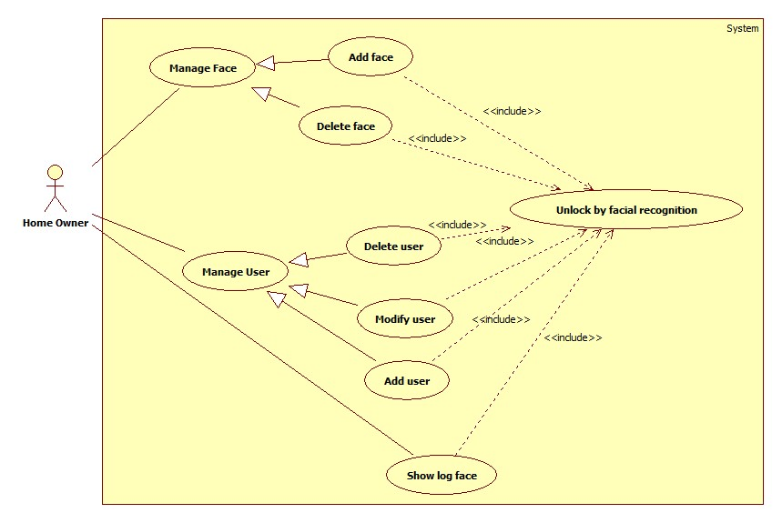

Figure 20. <Home owner> Overview use case

2.3.2.1. Add face

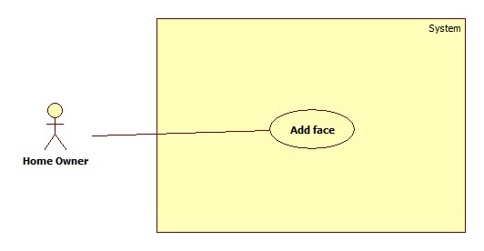

Figure 21. “Add face” use case

|  |  |  |  |
| --- | --- | --- | --- |
| **USE CASE – HUC01** | | | |
| **Use Case No.** | **HUC01** | **Use Case Version** | 2.0 |
| **Use Case Name** | Add face | | |
| **Author** | Nguyen Kieu Hanh Ha | | |
| **Date** | 30/1/2015 | **Priority** | High |
| **Actor:**  - Home owner  **Summary:**  - Home owner will add list of face using when system recognize face. System will base on list of face to recognize and unlock if the user has face in database.  **Goal:**  - New face will be added into database.  **Triggers:**  - Press “1” button on keypad in “Face management” screen  **Preconditions:**  - Using facing recognition to unlock with “Home owner” role.  - Go to “Face management” screen  **Post Conditions:**  - Success: Add new face in database successfully. Message will be shown in LCD screen  “Thêm khuôn mặt thành công”  - Fail: User can not add new face in database. Warning message will be shown in LCD screen “Bị lỗi trong quá trình thực thi. Vui lòng thực hiện lại sau”.  **Main Success Scenario:**   |  |  |  | | --- | --- | --- | | Step | Actor Action | System Response | | 1 | Press “C” button to up and “D” button to down on keypad.  [ Exception 1] | Name of member will be changed base on user scroll the list | | 2 | Press “A” button on keypad | Select user will be added face | | 3 | Stand in front of camera then press “1” button on keypad. | System will capture new face and save it to database. After capture 10 pictures, dialog will show “Thêm khuôn mặt mới thành công.” message. | | 4 | Press “A” button to back “Face management” screen. | “Face management” screen will be shown. |   **Alternative Scenario:**  **-** N/A  **Exceptions:**   |  |  |  | | --- | --- | --- | | No. | Actor Action | System Response | | 1 | User press “1” button on keypad | Dialog will show “Vui lòng chọn người dùng cần thêm khuôn mặt” message. |   **Relationships:**  - N/A  **Business Rules:**  **-**This face will belong user which is added so before add new face you need to add new user, this user will has attribute to let system know that user has not have face. Then system will show the name of users who have not face in table.  - 10 pictures will be captured then executed after save into database. | | | |

Table 11.”Add face” specification.

2.3.2.2. Delete face

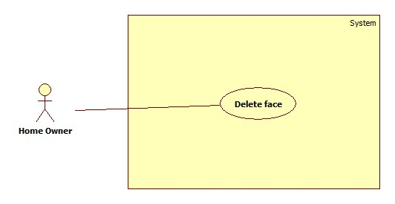

Figure 22. “Delete face” use case

|  |  |  |  |
| --- | --- | --- | --- |
| **USE CASE – HUC02** | | | |
| **Use Case No.** | **HUC02** | **Use Case Version** | 2.0 |
| **Use Case Name** | Delete face | | |
| **Author** | Nguyen Kieu Hanh Ha | | |
| **Date** | 30/1/2015 | **Priority** | High |
| **Actor:**  - Home owner  **Summary:**  - Home owner will delete face in database when user wants to add new face into database. System will base on list of face to recognize and unlock if the user has face in database.  **Goal:**  - New face will be added into database.  **Triggers:**  - Press “2” button on keypad in “System management” screen  **Preconditions:**  - Using facing recognition to unlock with “Home owner” role.  **Post Conditions:**  - Success: Delete face in database successfully. Message will be shown in LCD screen “Xóa khuôn mặt thành công”.  - Fail: User can not delete face in database. Warning message will be shown in LCD screen “Bị lỗi trong quá trình thực thi. Vui lòng thực hiện lại sau”.  **Main Success Scenario:**   |  |  |  | | --- | --- | --- | | Step | Actor Action | System Response | | 1 | Press “C” button to up and “D” button to down on keypad. | Name of member will be changed base on user scroll the list | | 2 | Press “2” button on keypad  [Exception 1] | Confirm dialog will show”Bạn muốn xóa khuôn mặt này?” message. | | 3 | Press “A” button on keypad | Face will be deleted in database |   **Alternative Scenario:**  **-** N/A  **Exceptions:**   |  |  |  | | --- | --- | --- | | No. | Actor Action | System Response | | 1 | Press “B” button on keypad | Face will not be deleted in database |   **Relationships:**  **-** N/A  **Business Rules:**  **-** Table will list all users who have existed face in database. After user delete face, user can use add face to add new face. If user does not have any face in database this user will not appear in table. | | | |

Table 12.”Delete face” specification.

2.3.2.3. Add user

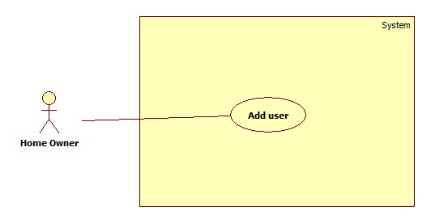

Figure 23. “Add user” use case

|  |  |  |  |
| --- | --- | --- | --- |
| **USE CASE – HUC03** | | | |
| **Use Case No.** | **HUC03** | **Use Case Version** | 2.0 |
| **Use Case Name** | Add user | | |
| **Author** | Nguyen Kieu Hanh Ha | | |
| **Date** | 30/1/2015 | **Priority** | High |
| **Actor:**  - Home owner  **Summary:**  - Home owner will add new user into database that means new user can unlock by using facial recognition or unlock by keypad.  **Goal:**  - New user will be added into database.  **Triggers:**  - Press “1” button on keypad in “User management” screen  **Preconditions:**  - Using facing recognition to unlock with “Home owner” role.  - Go to “User management” screen.  **Post Conditions:**  - Success: Add new user in database successfully. Message will be shown in LCD screen “Thêm người dùng thành công”  - Fail: New user can not be added in database. Warning message will be shown in LCD screen “Bị lỗi trong quá trình thực thi. Vui lòng thực hiện lại sau”.  **Main Success Scenario:**   |  |  |  | | --- | --- | --- | | Step | Actor Action | System Response | | 1 | Press “1” button on keypad  [ Exception 1]  [ Exception 2] | Phone number will be selected for user entered his phone number | | 2 | Press “*” button on keypad | System will be exchange no line is selected to wait next action. | | 3 | Press “2” button on keypad  [ Exception 2] | Role will be selected for user choose role | | 4 | Press “*” button on keypad | System will be exchange no line is selected to wait next action. | | 5 | Press “3” button on keypad  [ Exception 1]  [ Exception 2] | Password will be selected for user entered password | | 6 | Press “*” button on keypad | System will be exchange no lie is selected to wait next action. | | 7 | Press “A” button on keypad | New user will be added into database |   **Alternative Scenario:**  **-** N/A  **Exceptions:**   |  |  |  | | --- | --- | --- | | No. | Actor Action | System Response | | 1 | Press character | Dialog will show “Vui lòng nhập số” message. | | 2 | Press “A” button | Dialog will show “Vui long điền đầy đủ thông tin” message. |   **Relationships:**  **-** N/A  **Business Rules:**  **-** User has home-owner or member role when add user.  - After add new user, user can add new face. | | | |

Table 13.”Add user” specification.

2.3.2.4. Modify user

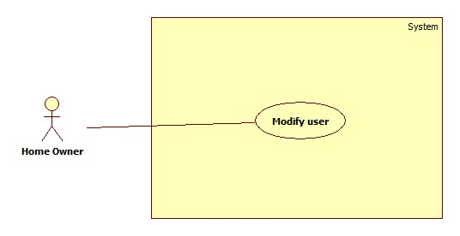

Figure 24. “Modify user” use case

|  |  |  |  |
| --- | --- | --- | --- |
| **USE CASE – HUC04** | | | |
| **Use Case No.** | **HUC04** | **Use Case Version** | 2.0 |
| **Use Case Name** | Modify user | | |
| **Author** | Nguyen Kieu Hanh Ha | | |
| **Date** | 30/1/2015 | **Priority** | High |
| **Actor:**  - Home owner  **Summary:**  - Home owner will update user’s information includes phone number, password, status of user into database.  **Goal:**  - New information of user will be updated into database.  **Triggers:**  - Press “2” button on keypad in “User management” screen  **Preconditions:**  - Using facing recognition to unlock with “Home owner” role.  - Go to “User management” screen, select user to update by press “C” button to up and “D” button to down.  **Post Conditions:**  - Success: Update user in database successfully. Message will be shown in LCD screen “Cập nhật người dùng thành công”.  - Fail: New user can not be added in database. Warning message will be shown in LCD screen “Bị lỗi trong quá trình thực thi. Vui lòng thực hiện lại sau”.  **Main Success Scenario:**   |  |  |  | | --- | --- | --- | | Step | Actor Action | System Response | | 1 | Press “1” button on keypad  [ Exception 1]  [ Exception 2] | Phone number will be selected for user entered his phone number | | 2 | Press “*” button on keypad | System will be exchange no line is selected to wait next action. | | 3 | Press “2” button on keypad  [ Exception 2] | Role will be selected for user choose role | | 4 | Press “*” button on keypad | System will be exchange no line is selected to wait next action. | | 5 | Press “3” button on keypad  [ Exception 1]  [ Exception 2] | Password will be selected for user entered password | | 6 | Press “*” button on keypad | System will be exchange no lie is selected to wait next action. | | 7 | Press “A” button on keypad | Update new information of user into database. |   **Alternative Scenario:**  **-** N/A  **Exceptions:**   |  |  |  | | --- | --- | --- | | No. | Actor Action | System Response | | 1 | Press character | Dialog will show “Vui lòng nhập số” message. | | 2 | Press “A” button | Dialog will show “Vui long điền đầy đủ thông tin” message. |   **Relationships:**  **-** N/A  **Business Rules:**  **-** User who is blocked can not unlock by using facial recognition or unlock by keypad | | | |

Table 14.”Update user” specification.

2.3.2.5. Delete user

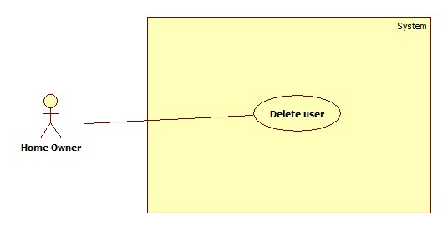

Figure 25. “Delete user” use case

|  |  |  |  |
| --- | --- | --- | --- |
| **USE CASE – HUC05** | | | |
| **Use Case No.** | **HUC05** | **Use Case Version** | 2.0 |
| **Use Case Name** | Delete user | | |
| **Author** | Nguyen Kieu Hanh Ha | | |
| **Date** | 30/1/2015 | **Priority** | High |
| **Actor:**  - Home owner  **Summary:**  - Home owner will delete face in database when user wants to add new face into database. System will base on list of face to recognize and unlock if the user has face in database.  **Goal:**  - New face will be added into database.  **Triggers:**  - Press “3” button on keypad in “User management” screen  **Preconditions:**  - Using facing recognition to unlock with “Home owner” role.  - Go to “User management” screen, select user to delete by press “C” button to up and “D” button to down.  **Post Conditions:**  - Success: Delete user in database successfully. Message will be shown in LCD screen. “Xóa người dùng thành công”.  - Fail: User can not delete user in database. Warning message will be shown in LCD screen “Bị lỗi trong quá trình thực thi. Vui lòng thực hiện lại sau”.  **Main Success Scenario:**   |  |  |  | | --- | --- | --- | | Step | Actor Action | System Response | | 3 | Press “A” button on keypad | User will be deleted in database |   **Alternative Scenario:**  **-** N/A  **Exceptions:**   |  |  |  | | --- | --- | --- | | Step | Actor Action | System Response | | 1 | Press “C” button to up and “D” button to down on keypad. | Name of member will be changed base on user scroll the list | | 2 | Press “3” button on keypad | Confirm dialog will show”Bạn muốn xóa người dùng?” message. | | 3 | Press “B” button on keypad | Face will be deleted in database |   **Relationships:**  **-** N/A  **Business Rules:**  **-** Table will list all users who have existed face in database. After user delete face, user can use add face to add new face. If user do not have any face in database this user will not appear in table. | | | |

Table 15.”Delete user” specification.

2.3.2.6. Show log face

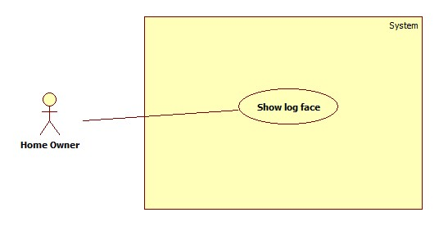

Figure 26. “Show log face” use case

|  |  |  |  |
| --- | --- | --- | --- |
| **USE CASE – HUC06** | | | |
| **Use Case No.** | **HUC06** | **Use Case Version** | 2.0 |
| **Use Case Name** | Show log face | | |
| **Author** | Nguyen Kieu Hanh Ha | | |
| **Date** | 30/1/2015 | **Priority** | High |
| **Actor:**  - Home owner  **Summary:**  - Home owner can view history of face, user who used to use facial recognition mode.  **Goal:**  - Show image of who used to use facial recognition mode.  **Triggers:**  - Press “A” button on keypad  **Preconditions:**  - Using facing recognition to unlock with “Home owner” role.  - Go to “Show Log Face” screen, then select face want to see by press “C” button to up and “D” button to down.  **Post Conditions:**  - Success: Show face in view  **Main Success Scenario:**  **-** N/A  **Alternative Scenario:**  **-** N/A  **Exceptions:**  - N/A  **Relationships:**  **-** N/A  **Business Rules:**  **-** Face in system will be shown with nearly date. This log face can be removed if the storage of SD card is full. | | | |

Table 16.”Show log face” specification.

2.3.2.7. Delete all information

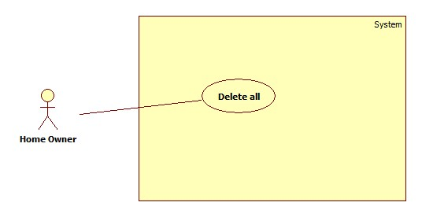

Figure 27. “Delete all information” use case

|  |  |  |  |
| --- | --- | --- | --- |
| **USE CASE – HUC07** | | | |
| **Use Case No.** | **HUC07** | **Use Case Version** | 2.0 |
| **Use Case Name** | Delete all information | | |
| **Author** | Nguyen Kieu Hanh Ha | | |
| **Date** | 21/05/2015 | **Priority** | High |
| **Actor:**  - Home owner  **Summary:**  - Home owner will delete all data in database in case he/she wants to renew system.  **Goal:**  - All data will be deleted.  **Triggers:**  - Press “1” button on keypad in “Modifying setting” screen  **Preconditions:**  - Using facing recognition to unlock with “Home owner” role.  **Post Conditions:**  - Success: Delete all data in database succesfully. Message will be shown in LCD screen “Xóa thông tin thành công”.  - Fail: User can not delete data in database. Warning message will be shown in LCD screen “Bị lỗi trong quá trình thực thi. Vui lòng thực hiện lại sau”.  **Main Success Scenario:**   |  |  |  | | --- | --- | --- | | Step | Actor Action | System Response | | 1 | Press “A” button on keypad | Confirm dialog will show”Bạn muốn xóa tất cả dữ liệu?” message. | | 3 | Press “A” button on keypad | Data will be deleted in database |   **Alternative Scenario:**  **-** N/A  **Exceptions:**   |  |  |  | | --- | --- | --- | | No. | Actor Action | System Response | | 1 | Press “B” button on keypad | Data will not be deleted in database |   **Relationships:**  **-** N/A  **Business Rules:**  **-** All information of system include information of user, information of face, information of log face will be deleted. The system is renew after this user case | | | |

Table 17.”Delete all information” specification.

2.3.2.8. Set threshold for SD card

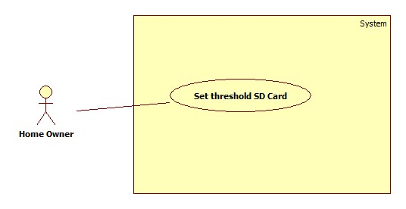

Figure 28. “Set threshold SD Card” use case

|  |  |  |  |
| --- | --- | --- | --- |
| **USE CASE – HUC08** | | | |
| **Use Case No.** | **HUC08** | **Use Case Version** | 2.0 |
| **Use Case Name** | Set threshold SD Card | | |
| **Author** | Nguyen Kieu Hanh Ha | | |
| **Date** | 21/05/2015 | **Priority** | High |
| **Actor:**  - Home owner  **Summary:**  - Home owner can set threshold for system when log face data will be deleted. If size which is used to store log face is increase and equal with threshold user will be notified to delete all log faces in database.  **Goal:**  - Log faces will be deleted when the used size of SD card is caught the threshold.  **Triggers:**  - Press “2” button on keypad in “Modifying setting” screen  **Preconditions:**  - Using facing recognition to unlock with “Home owner” role.  **Post Conditions:**  - Success: Set threshold successfully. Message will be shown in LCD screen “Cài đặt thành công”.  - Fail: User can not set threshold. Warning message will be shown in LCD screen “Bị lỗi trong quá trình thực thi. Vui lòng thực hiện lại sau”.  **Main Success Scenario:**   |  |  |  | | --- | --- | --- | | Step | Actor Action | System Response | | 1 | Press “1” button on keypad  Press “2” button on keypad  Press “3” button on keypad | “3GB” will be selected.  “6GB” will be selected.  “8GB” will be selected | | 3 | Press “A” button on keypad | Setting will be saved in configuration file. |   **Alternative Scenario:**  **-** N/A  **Exceptions:**   |  |  |  | | --- | --- | --- | | No. | Actor Action | System Response | | 1 | Press “B” button on keypad | Setting will not be saved in configuration file. |   **Relationships:**  **-** N/A  **Business Rules:**  **-** The ability to store data of SD card is limited. In case too much log faces are saved can me the storage full. This use case can help use set threshold which they want all log faces will be deleted if the used size is caught the threshold. | | | |

Table 18.”Set threshold of SD Card” specification.

2.3.3. <System> Overview Use Case

2.3.3.1. Analyze face

|  |  |  |  |
| --- | --- | --- | --- |
| **USE CASE – SUC01** | | | |
| **Use Case No.** | **SUC01** | **Use Case Version** | 2.0 |
| **Use Case Name** | Analyze face | | |
| **Author** | Nguyen Kieu Hanh Ha | | |
| **Date** | 30/1/2015 | **Priority** | High |
| **Actor:**  - System  **Summary:**  - System will analyze the face of user at real time and compare it with other faces in database to determine that which user can unlock and can not.  **Goal:**  - Provide result about the face of user at real time that does he/she has permission to unlock.  **Triggers:**  **-** Press “1” button on keypad in “Menu” screen.  **Preconditions:**  -N/A  **Post Conditions:**  - Success: return result that means lock can open or not.  **Main Success Scenario:**   |  |  |  | | --- | --- | --- | | Step | Actor Action | System Response | | 1 | Press “1” button on keypad | Camera is active to capture face. | | 2 | Stand in front of camera from 3 to 5 seconds for system analyze the face  [ Exception 1] | System will return result for lock system |   **Alternative Scenario:**  **-** N/A  **Exceptions:**  **-** N/A  **Relationships:**  **-** Have <<include>> relationship with “Unlock facial recognition” use case  **Business Rules:**  - Analyze face can be executed a lots of process base on face recognition algorithm. Face of user will be detected by the system then his face can be prepare with data in database to check this face is existed in database. | | | |

Table 19.”Analyze face” specification.

2.3.3.2. Generate passcode

|  |  |  |  |
| --- | --- | --- | --- |
| **USE CASE – SUC02** | | | |
| **Use Case No.** | **SUC02** | **Use Case Version** | 2.0 |
| **Use Case Name** | Generate passcode | | |
| **Author** | Nguyen Kieu Hanh Ha | | |
| **Date** | 30/1/2015 | **Priority** | Normal |
| **Actor:**  - System  **Summary:**  - If user use unlock by keypad, system will generate passcode which is available in one hour and send it to the phone number.  **Goal:**  - System will generate passcode to send to phone number which is entered by user.  **Triggers:**  - Press “A” button after fill in all required information in “Keypad mode” screen.  **Preconditions:**  - N/A  **Post Conditions:**  - Success: Passcode will be generated successfully and send to phone number through SMS.  - Fail: Passcode can not generate.  **Main Success Scenario:**   |  |  |  | | --- | --- | --- | | Step | Actor Action | System Response | | 1 | Generate random passcode | Passcode will be saved | | 2 | Send passcode to phone number |  |   **Alternative Scenario:**  - N/A  **Exceptions:**  **-** N/A  **Relationships:**  **-** Have <<include>> relationship with “Check passcode” use case  **Business Rules:**  - Passcode will be generated random by the system. This passcode will be saved and valid in one hour after generated time. | | | |

Table 20.“Generate passcode” specification.

2.3.3.3. Check passcode

|  |  |  |  |
| --- | --- | --- | --- |
| **USE CASE – SUC03** | | | |
| **Use Case No.** | **SUC03** | **Use Case Version** | 2.0 |
| **Use Case Name** | Check passcode | | |
| **Author** | Nguyen Kieu Hanh Ha | | |
| **Date** | 30/1/2015 | **Priority** | Normal |
| **Actor:**  - System  **Summary:**  - If user use unlock by keypad, system will check passcode which user entered with passcode that system generate and send to the phone number. If the passcode is valid the lock will be opened.  **Goal:**  - User unlock successfully after entered valid passcode.  **Triggers:**  - Press “A” button to check passcode in “Enter passcode” screen.  **Preconditions:**  - User uses mode unlock by keypad.  **Post Conditions:**  - Success: User can unlock.  - Fail: User can not unlock. LCD will show warning message.  **Main Success Scenario:**   |  |  |  | | --- | --- | --- | | Step | Actor Action | System Response | | 1 | Check passcode with system | - Valid passcode: unlock  - Invalid passcode: dialog will show “Mã khóa không đúng.” message.  - Expired passcode: dialog will show “Mã khóa đã hết hạn.” message. |   **Alternative Scenario:**  **-** N/A  **Exceptions:**  **-** N/A  **Relationships:**  **-** Have <<include>> relationship with “Unlock by keypad” use case  **Business Rules:**  - Passcode is valid for one hour after it was generated by the system. After one hour passcode will expired and user must generate again to use “Unlock by keypad” feature. | | | |

Table 21. “Check passcode” specification.

2.3.4. <GSM 900> Overview Use Case

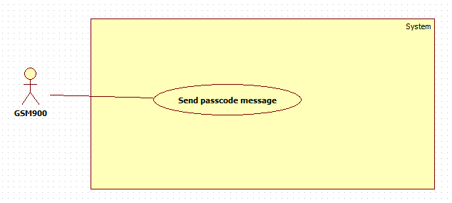

Figure 29.<GSM 900> Overview use case

2.3.4.1. Send passcode

|  |  |  |  |
| --- | --- | --- | --- |
| **USE CASE – GUC01** | | | |
| **Use Case No.** | **GUC01** | **Use Case Version** | 2.0 |
| **Use Case Name** | Send passcode | | |
| **Author** | Nguyen Kieu Hanh Ha | | |
| **Date** | 30/1/2015 | **Priority** | Normal |
| **Actor:**  - GSM SIM 900  **Summary:**  - GSM SIM 900 will send passcode to phone number which is entered after passcode has generated.  **Goal:**  - Passcode will be sent to phone number which is entered.  **Triggers:**  - Press “A” button on keypad in “Keypad Mode” screen after fill in required information.  **Preconditions:**  -N/A  **Post Conditions:**  - Success: return result that means lock can open or not.  **Main Success Scenario:**   |  |  |  | | --- | --- | --- | | Step | Actor Action | System Response | | 1 | Generate passcode | Save passcode | | 2 | Send passcode |  |   **Alternative Scenario:**  **-** N/A  **Exceptions:**  - N/A  **Relationships:**  **-** Have <<include>> relationship with “Generate passcode” use case  **Business Rules:**  - N/A | | | |

Table 22.”Send passcode” specification.

3. Software System Attribute

3.1. Reliability

- The system use biometric method to recognition so the ability to be entered invalid is very minor.

- The system can work precision according to user’s behavior.

3.2. Availability

- System is related security of home so the system can be active 24/7. In case, the power is blackout system will be use backup battery which can supply power up to 8 hours. When the power comes back, backup batter will be charged.

3.3. Security

- System can cover the most of cases to protect your hour out of attack of thieves.

3.4. Maintainability

- When one of component parts is broken, it is easy to fix the problem by changing a new one.

3.5. Performance

- System can recognize face in the range from 3 to 5 seconds.

3.6. Usability

- System provides user friendly GUI with guideline.

-System provides alternative case to unlock in case facial recognition is not working.

4. Conceptual Diagram

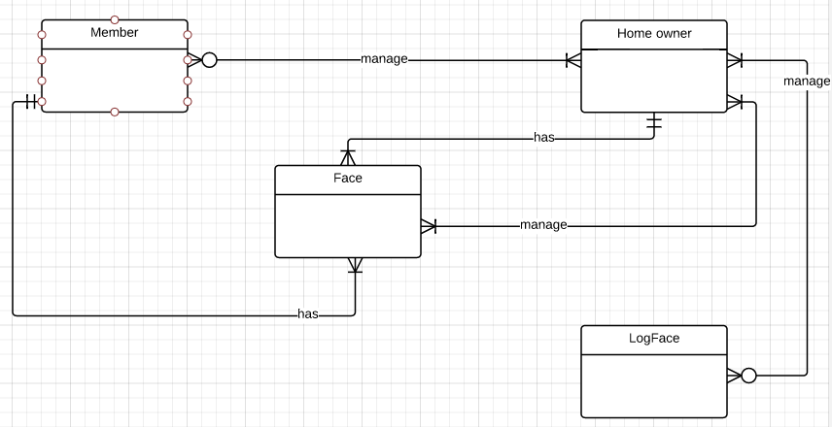

Figure 30.Conceptual diagram

|  |  |
| --- | --- |
| **Entity Data dictionary** | |
| **Entity Name** | **Description** |
| Member | - Member can is managed by one or more home owners  - Member just has one and only one face |
| Home owner | - Home owner manages zero or more members  - Home owner has one or more phone numbers  - Home owner just has one and only one face  - Home owner manages one or more faces  - Home owner manages zero or more log face. |
| Face | - Face is managed by one or more home owners  - Face just belongs one and only member.  - Face just belongs one and only home owner. |
| Log Face | - Log face is managed by one or more home owners. |

Table 23. Entity data dictionary