2. System Requirement Specification

2.1 External Interface Requirement

2.1.1.1. Login

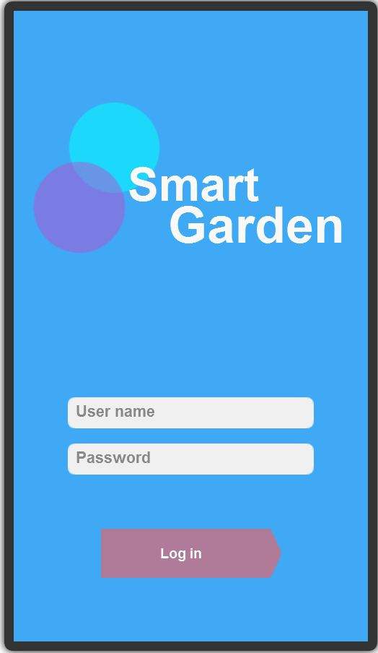

Figure 3. “Login” screen

Fields

|  |  |  |  |  |  |  |
| --- | --- | --- | --- | --- | --- | --- |
| **No** | **Field Name** | **Description** | **Read only** | **Mandatory** | **Control Type** | **Data Type** |
| 1 | Username | Fill username | No | Yes | TextBox | String |
| 2 | Password | Fill password | No | Yes | Password | String |

**Buttons/Hyperlinks**

|  |  |  |  |  |
| --- | --- | --- | --- | --- |
| **No** | **Function** | **Description** | **Validation** | **Outcome** |
| 3 | Login | Log-in into the system | - Not null  - No special characters  - Password at least 8 character | Transfer to home screen |

2.1.1.2. Zone management

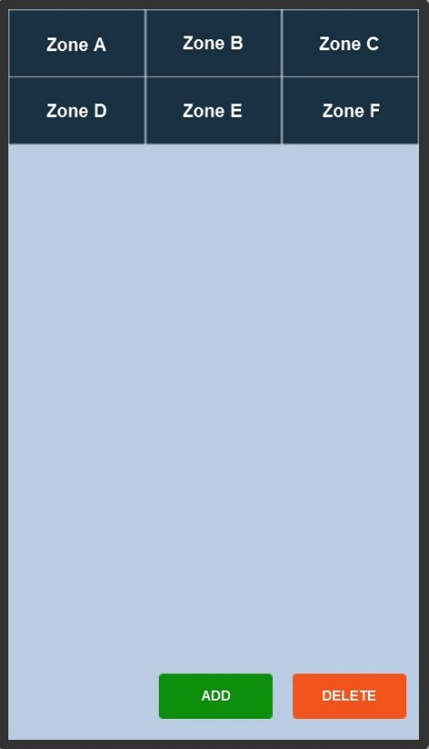

Figure 4. “Zone management” screen

**Buttons/Hyperlinks**

|  |  |  |  |  |
| --- | --- | --- | --- | --- |
| **No** | **Function** | **Description** | **Validation** | **Outcome** |
| 1 | Zone A (B, C …) | Zone A (B, C, …) Screen | N/A | Show Zone A (B, C, …) Screen |
| 2 | Add | Add Screen | N/A | Show Add Screen |
| 3 | Delete | Delete Screen | N/A | Delete Zone |

**2.1.1.3. Add Zone**

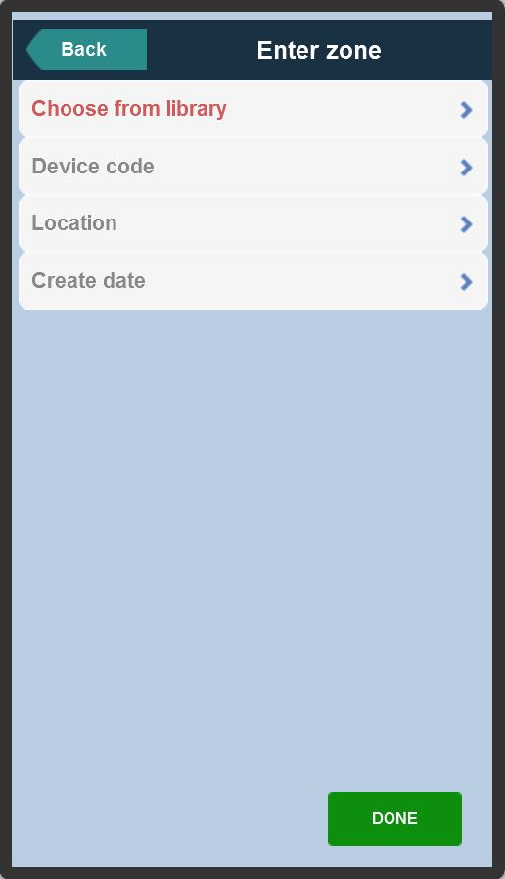

**Figure 5. “Add zone” screen**

Fields

|  |  |  |  |  |  |  |
| --- | --- | --- | --- | --- | --- | --- |
| **No** | **Field Name** | **Description** | **Read only** | **Mandatory** | **Control Type** | **Data Type** |
| 1 | Enter zone | Fill zone name | No | Yes | TextBox | String |
| 2 | Device code | Fill device code | No | Yes | TextBox | String |
| 3 | Location | Fill location | No | Yes | TextBox | String |
| 4 | Create day | Fill day | No | Yes | TextBox | Daytime |

**Buttons/Hyperlinks**

|  |  |  |  |  |
| --- | --- | --- | --- | --- |
| **No** | **Function** | **Description** | **Validation** | **Outcome** |
| 5 | Choose from library | Library Screen | No | Show library screen |
| 6 | Done | Finish adding new zone | Fill all the field | Add zone to home screen |
| 7 | Back | Back to previous screen | No | Show previous screen |

**2.1.1.4. Add from library**

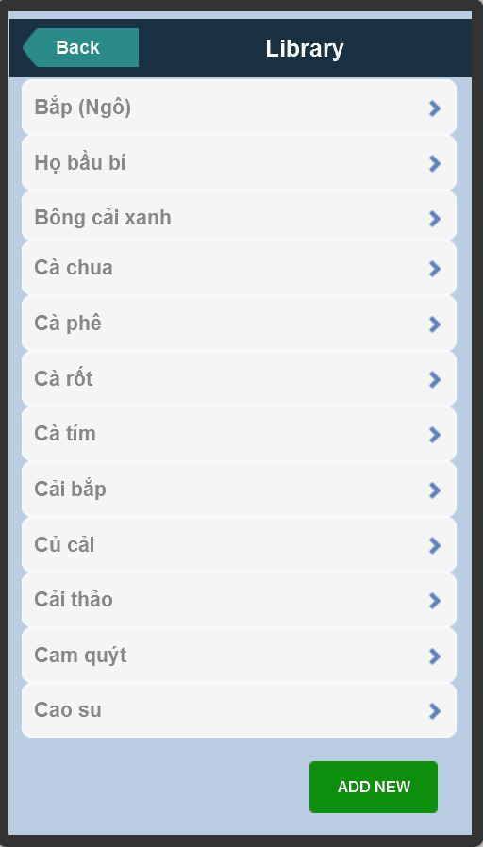

**Figure 6. “Add from library” screen**

**Buttons/Hyperlinks**

|  |  |  |  |  |
| --- | --- | --- | --- | --- |
| **No** | **Function** | **Description** | **Validation** | **Outcome** |
| 1 | Choose from library (Bắp, Họ bầu bí, Bông cải xanh, …) | Choosing tree from library | No | Add tree to new zone |
| 2 | Add new | Add new tree with new information | No | Add new tree with new information |
| 3 | Back | Back to previous screen | No | Show previous screen |

**2.1.1.5. Add new**

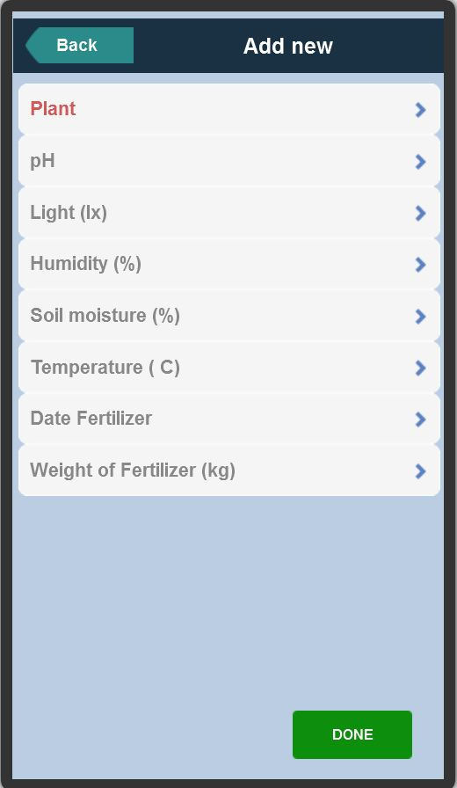

**Figure 7. “Add new” screen**

Fields

|  |  |  |  |  |  |  |
| --- | --- | --- | --- | --- | --- | --- |
| **No** | **Field Name** | **Description** | **Read only** | **Mandatory** | **Control Type** | **Data Type** |
| 1 | Plant | Fill plant name | No | Yes | TextBox | String |
| 2 | pH | Fill pH index | No | Yes | TextBox | Float |
| 3 | Light | Fill light index | No | Yes | TextBox | Float |
| 4 | Humidity | Fill humidity index | No | Yes | TextBox | Float |
| 5 | Soil moisture | Fill soil moisture index | No | Yes | TextBox | Float |
| 6 | Temperature | Fill temperature index | No | Yes | TextBox | Float |
| 7 | Date Fertilizer | Fill Date fertilizer | No | Yes | TextBox | Float |
| 8 | Weigh of fertilizer | Fill weigh of fertilizer | No | Yes | TextBox | Float |

**Buttons/Hyperlinks**

|  |  |  |  |  |
| --- | --- | --- | --- | --- |
| **No** | **Function** | **Description** | **Validation** | **Outcome** |
| 9 | Done | Finish adding new tree to library | Fill all the field | Add new tree to zone |
| 10 | Back | Back to previous screen | No | Show previous screen |

**2.1.1.6 Zone management: Indexes**

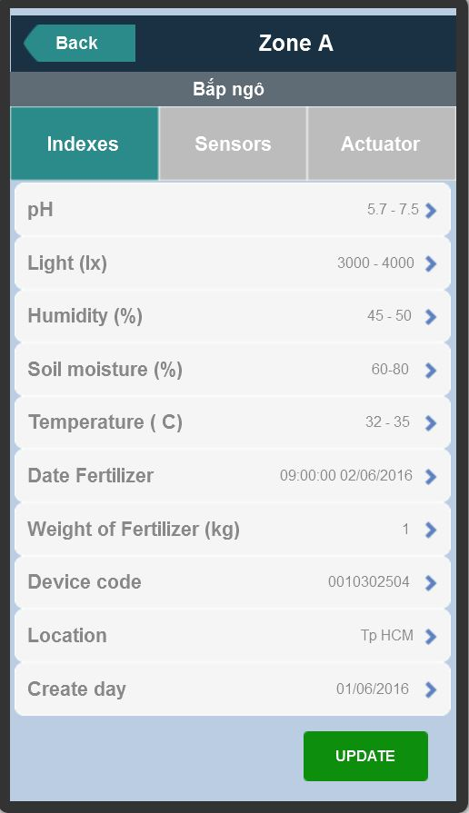

**Figure 8. “Tree information” screen**

**Buttons/Hyperlinks**

|  |  |  |  |  |
| --- | --- | --- | --- | --- |
| **No** | **Function** | **Description** | **Validation** | **Outcome** |
| 1 | Sensors | Show tab sensors | No | Show tab sensors |
| 2 | Actuator | Show tab actuator | No | Show tab actuator |
| 3 | Update | Update tree information | No | Enable to change indexes field |
| 4 | Back | Back to previous screen | No | Show previous screen |

**2.1.1.7 Zone management: Tracking sensors**

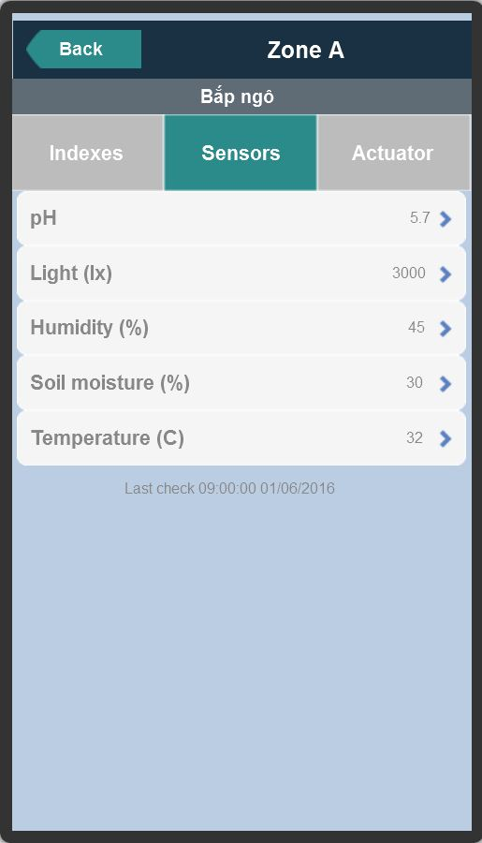

**Figure 9. “Tracking sensors” screen**

**Buttons/Hyperlinks**

|  |  |  |  |  |
| --- | --- | --- | --- | --- |
| **No** | **Function** | **Description** | **Validation** | **Outcome** |
| 1 | Indexes | Show tab indexes | No | Show tab indexes |
| 2 | Actuator | Show tab actuator | No | Show tab actuator |
| 3 | Back | Back to previous screen | No | Show previous screen |

**2.1.1.8 Zone management: Actuator management**

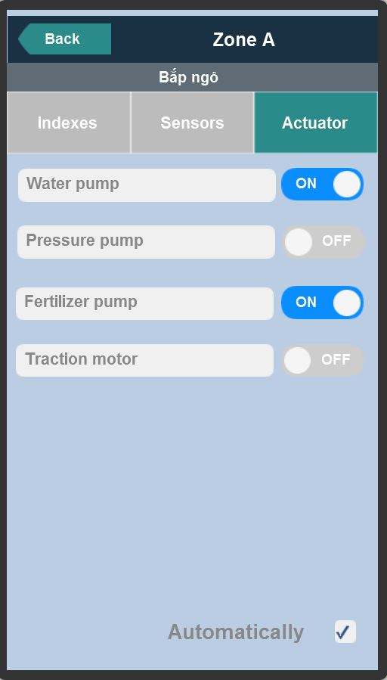

**Figure 10. “Actuator management” screen**

**Buttons/Hyperlinks**

|  |  |  |  |  |
| --- | --- | --- | --- | --- |
| **No** | **Function** | **Description** | **Validation** | **Outcome** |
| 1 | Indexes | Show tab indexes | No | Show tab indexes |
| 2 | Sensors | Show tab sensors | No | Show tab sensors |
| 3 | Water pump on/off | Turn on/off water pump | No | Turn on/off water pump |
| 4 | Pressure pump on/off | Turn on/off pressure pump | No | Turn on/off pressure pump |
| 5 | Fertilizer pump on/off | Turn on/off fertilizer pump | No | Turn on/off fertilizer pump |
| 6 | Traction motor on/off | Turn on/off traction motor | No | Turn on/off traction motor |
| 7 | Back | Back to previous screen | No | Show previous screen |