**

**CAPSTONE PROJECT REGISTER**

Class: Duration time: from ..…….../20…. To ..….…./20…..

(*) Profession: <Software Engineer> Specialty: <ES> <IS>

x

(*) Kinds of person make registers: Lecturer Students

x

1. Register information for supervisor (if have)

|  |  |  |  |  |
| --- | --- | --- | --- | --- |
|  | **Full name** | **Phone** | **E-Mail** | **Title** |
| Supervisor 1 | Loi nguyen duc | 093 857 2994 | loind@fpt.edu.vn |  |
| Supervisor 2 (if have) |  |  |  |  |

2. Register information for students (if have)

|  |  |  |  |  |  |
| --- | --- | --- | --- | --- | --- |
|  | **Full name** | **Student code** | **Phone** | **E-mail** | **Role in Group** |
| Student 1 |  |  |  |  |  |
| Student 2 |  |  |  |  |  |
| Student 3 |  |  |  |  |  |
| Student 4 |  |  |  |  |  |
| Student 5 |  |  |  |  |  |
| Student 6 |  |  |  |  |  |

3. Register content of Capstone Project

(*) 3.1. Capstone Project name:

English: Design and implement the model of smart garden

Vietnamese: Thiết kế và thi công mô hình vườn thông minh

Abbreviation:

(*) 3.2. Main proposal content (including result and product)

Farming is absolutely vital for every society. However,land costs too much and farming make too little, its depend on spread of land. This project can help farmer increase productivity even in a small land.

Microprocessor will get value of Humidity/light/temperature/PH degree from sensors, then send to web api, web api will processing and send the command for microprocessor execute the command such as: spray water, fertilize. The mobile app connect with web api to monitor and control microprocessor. This project will not depend on what kind of trees. Its can use for all kind of farming.

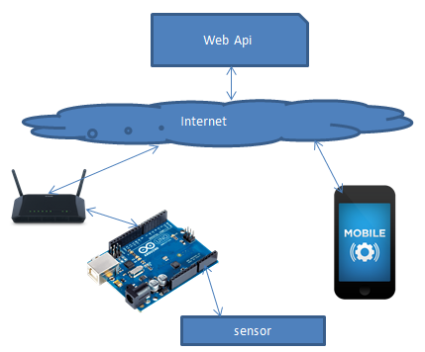

1. Theory and practice (document):

* Research PH sensor
* How about bluetooth / wifi interface
* Research light sensor
* Research microprocessor (Arduino or ARM Cortex-M4)
* Research humidity sensor
* Research temperature sensor
* Research solenoid
* Soil research
* Study plants
* Seed research
* Fertilizer Research

Program:

Java programming skill (for Android) or Objective-C (for iOs); C# Asp.Net and Tools: Keil uVision, Eclipse, …

Other products:

4. Other comment (propose all relative thing if have)

References

[1] Chin-Shyurng Fahn, and Herman Sun: Development of a Fingertip Glove Equipped with Magnetic Tracking Sensors, Sensors 2010, 10, 1119-1140

[2] Information on <http://arduino.cc/en/Main/arduinoBoardUno>

[3] Jinjun Rao, Tongyue Gao, Zhenbang Gong and Zhen Jiang; Low Cost Hand Gesture Learning and Recognition System Based on Hidden Markov Model. Second International Symposium on Information Science and Engineering, IEEE (2011), 433-438

[4] Information on <http://www.smart-farms.net/>

|  |  |
| --- | --- |
| **Supervisor (If have)**  *(Sign and full name)* | Tp.HCM, date /04 /2016  **On behalf of Registers**  *(Sign and full name)*  Loi Nguyen Duc |