I2C Soil moisture sensor

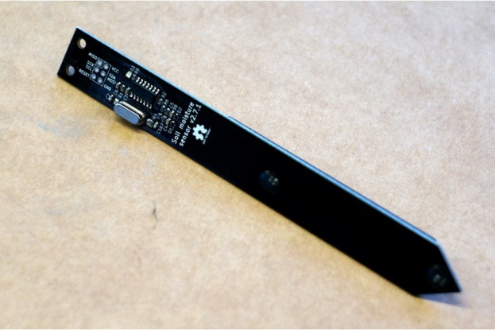

* Version 2.7.1
* Supply voltage 3.3V - 5V
* Current consumption: 1.1mA @ 5V, 0.7mA @ 3.3V when idle, 14mA @ 5V, 7.8mA @ 3.3V when taking a measurement. When constantly polling sensor at full speed, current consumption averages to 4.5mA @ 5V, 2.8mA @ 3.3V
* Operating temperature 0°C - 85°C
* Moisture reading drift with temperature - <10% over full temp range
* Don't forget to provide pullups for SCL and SDA lines
* Default I2C address is 0x20 (hex)
* To read soil moisture, read 2 bytes from register 0
* To read light level, start measurement by writing 3 to the device I2C address, wait for 3 seconds, read 2 bytes from register 4
* To read temperature, read 2 bytes from register 5
* To change the I2C address of the sensor, write a new address (one byte [1..127]) to register 1; the new address will take effect after reset
* To reset the sensor, write 6 to the device I2C address.

$13.00 (290.212 ₫ VND)

Shipping to Vietnam starts at $5.00 (111.620 ₫ VND)

<https://www.tindie.com/products/miceuz/i2c-soil-moisture-sensor/>

Cảm biến nhiệt độ và độ ẩm I2C AM2320

Cảm biến nhiệt độ và độ ẩm I2C AM2320

Thông số sản phẩm:

- Nguồn cung cấp: 3.1V - 5.5VDC

- Giao tiếp: I2C

- Dải đo độ ẩm: 0 - 99.9%RH

- Dải đo nhiệt độ: -40 ~ 80 ℃

- Độ chính xác: ± 0.5 ℃ ± 2% RH

- Độ phân dải: 0.1 ℃ 0.1% RH

- Khoảng cách chân: 2.54MM

- Giá: 85.000đ

http://www.dientu4u.com/product/11259/Cam-bien-nhiet-do-va-do-am-I2C-AM2320.html

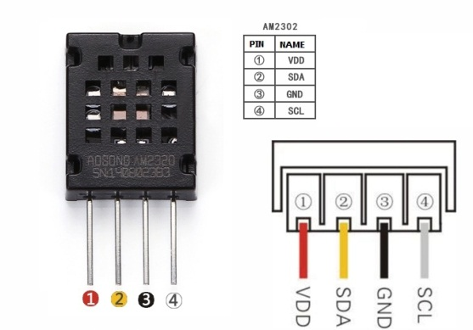

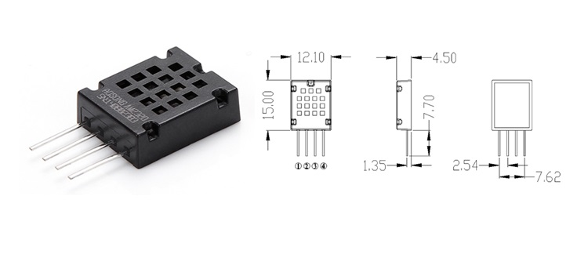

Cảm biến độ ẩm nhiệt độ AM2315

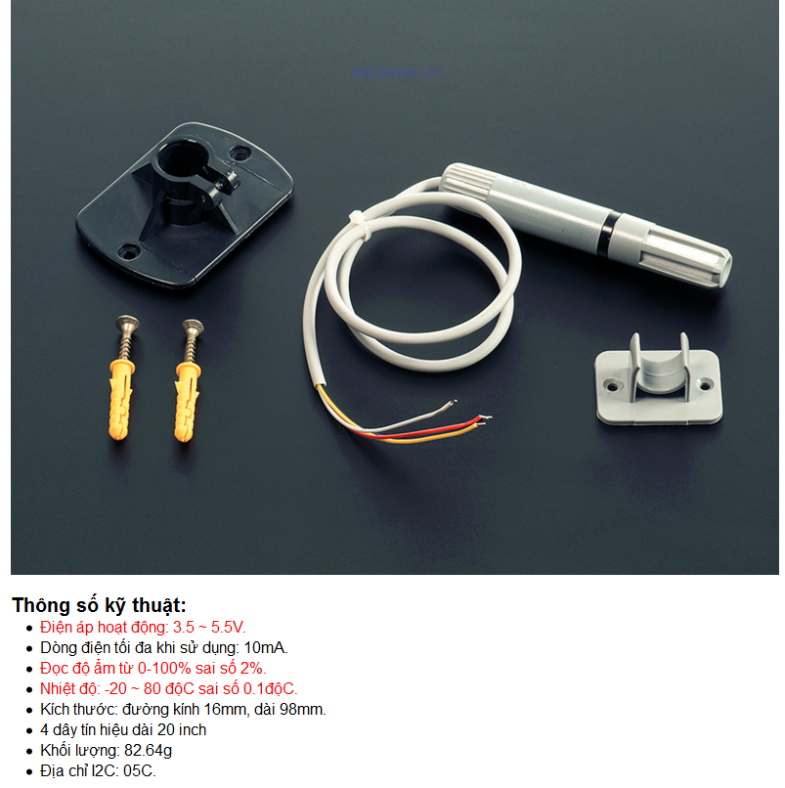

* Giá: 450,000đ

<http://hshop.vn/products/cam-bien-do-am-nhiet-do-am2315>