**EZO™ pH Circuit**

**Reads**

• Full range pH reading from .001 to 14.000

• Accurate pH readings down to the

thousandths place (+/- 0.02)

• Temperature dependent or temperature

independent readings

• Flexible calibration protocol supports single point,

2 point, or 3 point calibration

• Calibration required only once per year with

Atlas Scientific pH probe

• Single reading or continuous reading modes

• Data format is ASCII

**Two data protocols**

• UART asynchronous serial connectivity

• (RX/TX voltage swing 0-VCC)

• I2C (default I2C address 0x63)

• Compatible with any microprocessor that supports

UART, or I2C protocol

• Operating voltage: 3.3V to 5V

• Works with any off-the-shelf pH probe

**Sleep mode power consumption**

• 0.995mA at 3.3V

**Pin Out**

**GND :** Return for the DC power supply

 **Vcc:** Operates on 3.3V – 5.5V

**TX/SDA:** All EZO™ class circuits can operate in either UART mode,

or I2C mode.

The default state is UART mode.

In UART mode, this pin acts as the transmit (TX) line.

The default baud rate is 9600, 8 bits, no parity, no flow

control, one stop bit. If standard RS232 voltage levels are

desired, connect an RS232 converter such as a MAX232.

If the devices is in I2C mode, this pin acts as the Serial

Data Line (SDA). The I2C protocol requires an external

pull up resistor on the SDA line (resistor not included).

**RX / SCL:** All EZO™ class circuits can operate in either UART mode,

or I2C mode.

The default state is UART mode.

In UART mode, this pin acts as the receive (RX) line.

If the devices is in I2C mode, this pin acts as the Serial

Clock Line (SCL). The I2C protocol requires an external

pull up resistor on the SCL line (resistor not included).

**PRB:** This pin connects to the output lead of a pH probe/

sensor/electrode

**PGND:** This pin connects to the ground lead of a pH probe/

sensor/electrode.

**Default LED blink pattern**



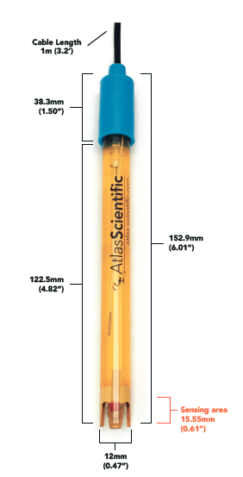**pH Probe v2.2**

**Typical Applications**

• Standard Lab use

• Field use

• Soil

• Low ionic and ultra-pure water

• High pH Solutions (up to 14pH)

• Samples containing Heavy metals

• Photography Development

• Beer, wine and other liquor

• Food Safe

**Specifications**

• pH Range: 0-14 (Na+ error at >12.3 pH)

• Operating temperature: 1°C - 99°C

• Max Pressure: 690 kPa (100PSI)

• Max Depth 60 M (197 ft)

• Cable length: 1 Meter

• Weight: 49 grams

• Speed of response: 95% in 1 second

• Isopotential point: pH 7.00 (0 mV)

• Dimensions 12mm X 150mm (1/2" X 6")

• BNC connector

• Sterilization