Sensor BH 1750

BH1750FVI Is a Digital Light sensor, which is a digital Ambient Light Sensor IC for I2C bus interface. This IC is the most suitable to obtain the ambient light data for adjusting LCD and Keypad backlight power of Mobile phone. It is possible to detect wide range at High resolution

Technical Specification:

* Power supply: 3.3 ­> 6v DC.
* I2 C bus Interface
* Wide range and High resolution. ( 1 - 65535 lx )

Operating principle:

How sensors can recognize light:

General operation principles of light sensor: When light shines on sensor the sensor resistance of the circuit make changes.

* Sensor BH 1750:

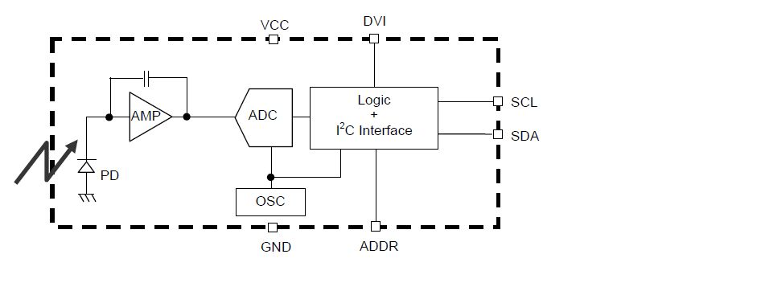

* When lighting: PD on the picture is photodiode (diot opposite pole mounting) task is for the current running through when the light shines.
* AMP: off amp circuit amplifies the signal up several times.
* ADC: Analog digital converter
* OSC: parts for oscillators. Provides backwards ADC. Create vibrations for general microprocessor of sensor.
* Processor on sensor calculate. Signals are vulnerable to interference formula for calculating resistor will the average person: r = sqrt(Rmax \*Rmin)
* Conversion Table resistor to lux(unit of light intensity)

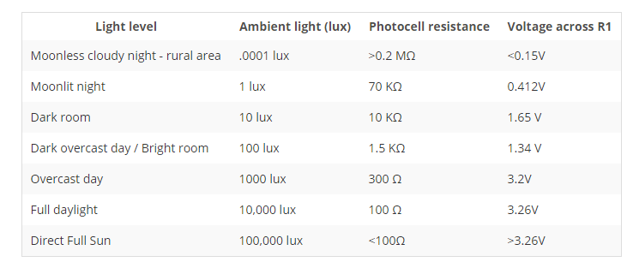

Selling links: <http://hshop.vn/products/cam-bien-cuong-do-onh-song-lux-bh1750>

DATASHEET: https://e-radionica.com/productdata/BH1750FVI.pdf