

**Picture : Front Screen**

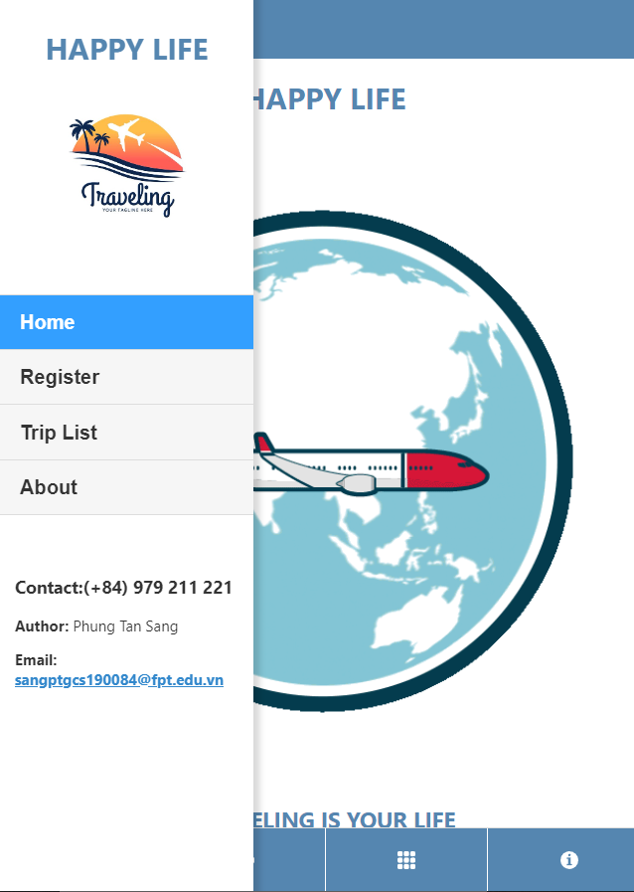

**Pic : List view**

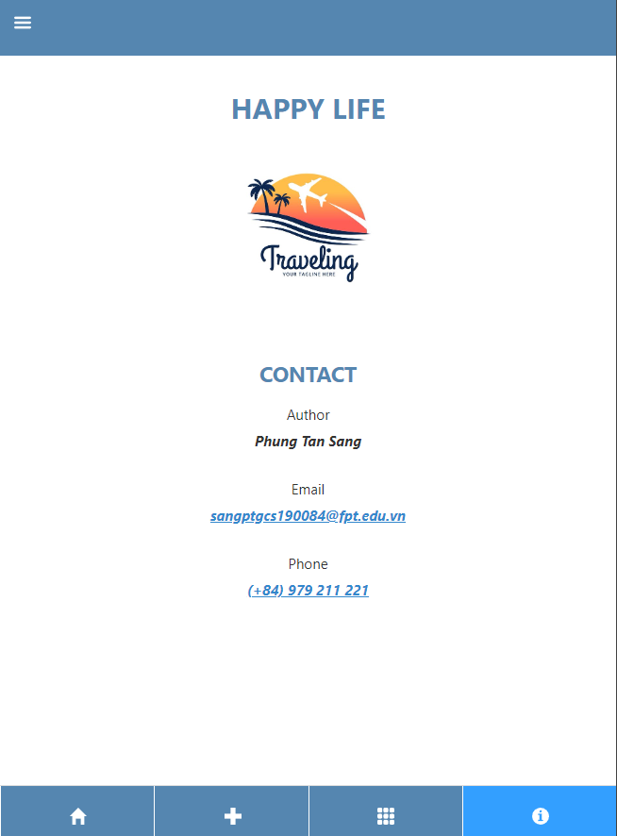

**Pic contact**

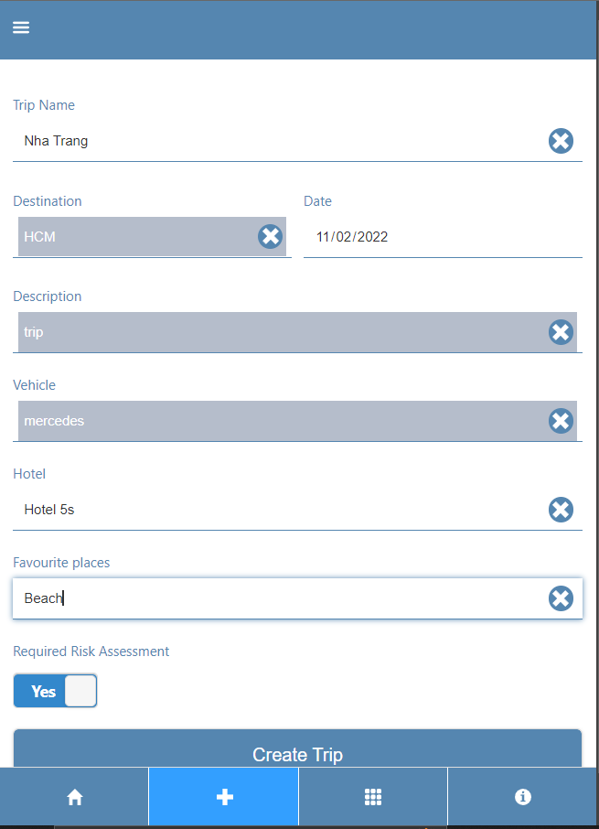

**Pic : Enter Trip**

**The first tab of the application will let the user enter all the available field**

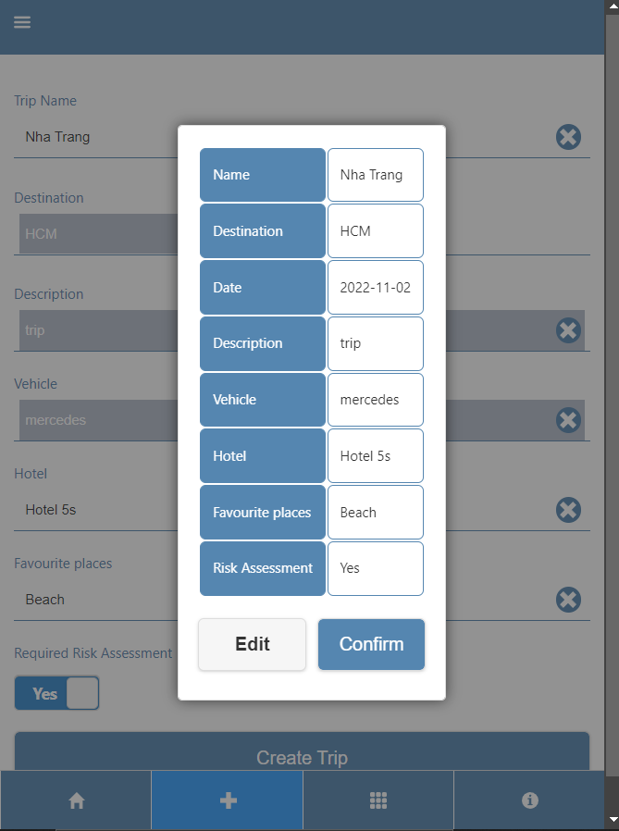

**Pic Confirm Trip**

**After enter all the field a pop up box will appear to ensure all the information the user enter is correct and they don’t need to edit anything**

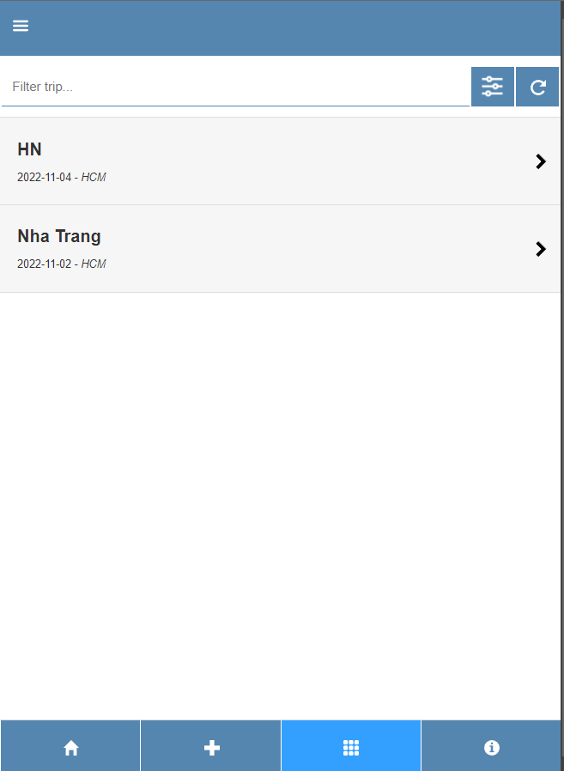

**Pic Trip List**

**The added trip will move to the trip list and display like above**

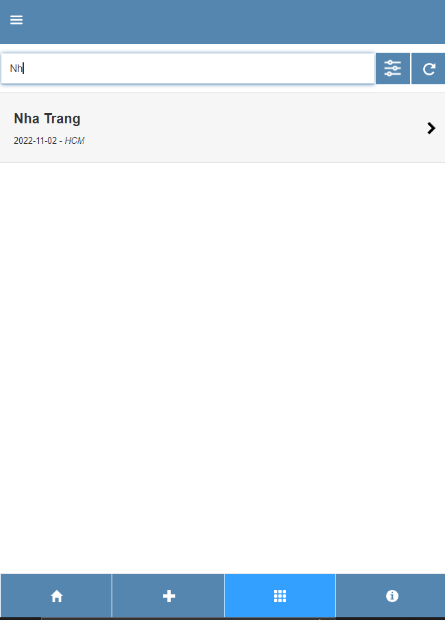

**Pic Search**

**Employee can search their trip by entering to the search engine**

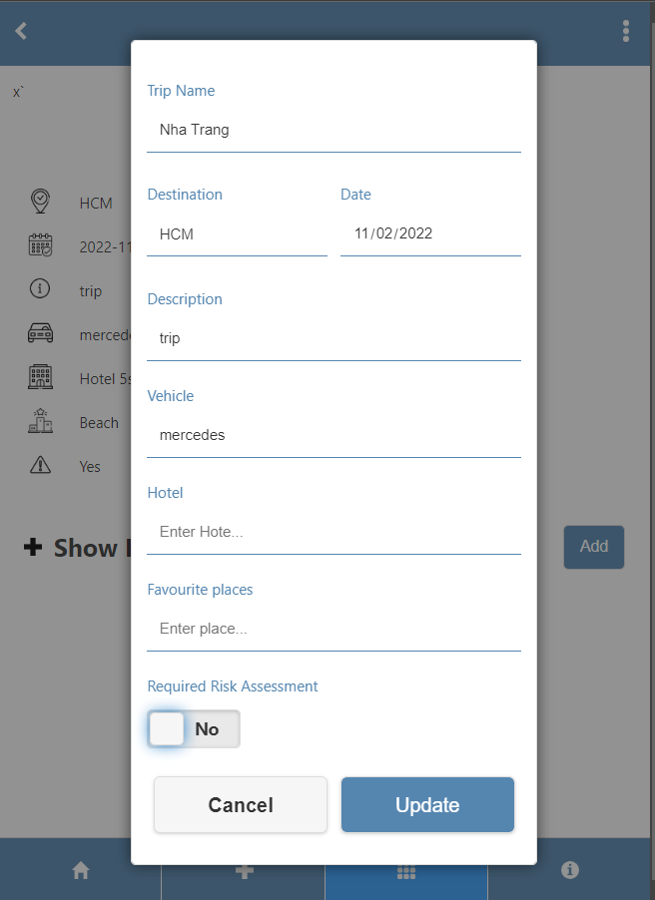

**Pic Update Trip**

**Employee can also update their trip by enter the follow queries**

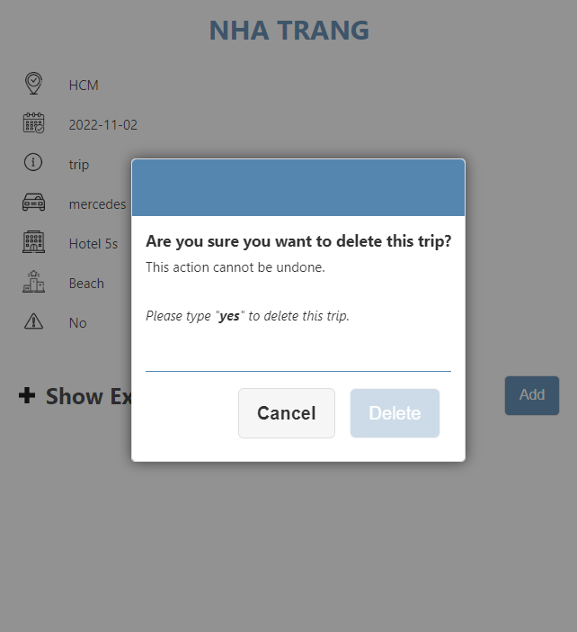

**Pic Confirm Delete**

**The trip can be deleted by enter “Yes”**

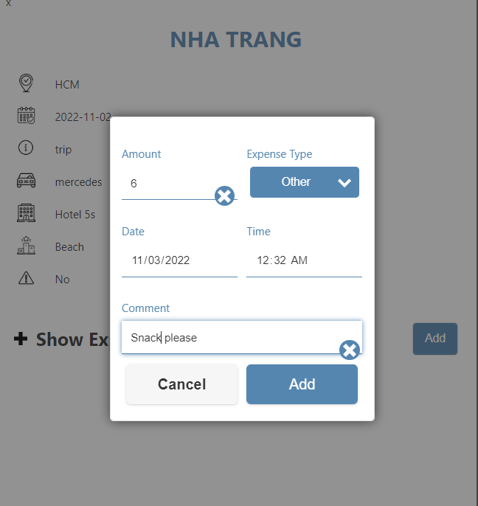

**Pic expense**

**Employee can enter the expense**

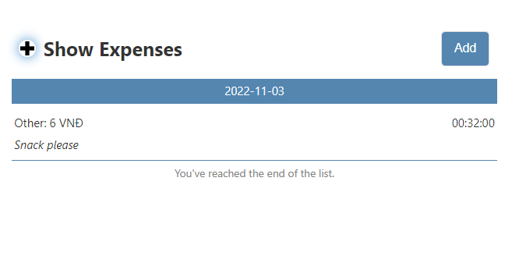

**Pic show expense**

**Employee can click the “+” to view expense**

1. **Generated code**

function registerTrip(e) {

    e.preventDefault();

    let name = $('#page-create #frm-register #name').val();

    let destination = $('#page-create #frm-register #destination').val();

    let date = $('#page-create #frm-register #date').val();

    let description = $('#page-create #frm-register #description').val();

    let risk = $('#page-create #frm-register #risk').val();

    let vehicle = $('#page-create #frm-register #vehicle').val();

    let hotel = $('#page-create #frm-register #hotel').val();

    let place = $('#page-create #frm-register #place').val();

    db.transaction(function (tx) {

        let query = `INSERT INTO Trip (Name, Destination, Description, Risk, Vehicle, Hotel, Place, Date) VALUES (?, ?, ?, ?, ?, ?, ?, julianday('${date}'))`;

        tx.executeSql(query, [name, destination, description, risk, vehicle, hotel, place], transactionSuccess, transactionError);

        function transactionSuccess(tx, result) {

            let message = `Added trip '${name}'.`;

            log(message);

            toast(message);

            $('#page-create #frm-register').trigger('reset');

            $('#page-create #frm-register #name').focus();

            $('#page-create #frm-confirm').popup('close');

        }

    });

}

**In order to registered trip, this function was implemented, by give let a statement ( name, destination, date, etc) and set the query later it will able to store the register information later**

function confirmTrip(e) {

    e.preventDefault();

    log('Open the confirmation popup.');

    $('#page-create #frm-confirm #name').text($('#page-create #frm-register #name').val());

    $('#page-create #frm-confirm #destination').text($('#page-create #frm-register #destination').val());

    $('#page-create #frm-confirm #date').text($('#page-create #frm-register #date').val());

    $('#page-create #frm-confirm #description').text($('#page-create #frm-register #description').val());

    $('#page-create #frm-confirm #vehicle').text($('#page-create #frm-register #vehicle').val());

    $('#page-create #frm-confirm #hotel').text($('#page-create #frm-register #hotel').val());

    $('#page-create #frm-confirm #place').text($('#page-create #frm-register #place').val());

    $('#page-create #frm-confirm #risk').text($('#page-create #frm-register #risk').val());

    $('#page-create #frm-confirm').popup('open');

}

**The function that will pop up the confirmation box after enter all the information, this to confirm that employyes enter all the correct information**

function showDetail() {

    let id = localStorage.getItem(currentTripId);

    db.transaction(function (tx) {

        let query = `SELECT *, date(Date) AS DateConverted FROM Trip WHERE Id = ?`;

        tx.executeSql(query, [id], transactionSuccess, transactionError);

        function transactionSuccess(tx, result) {

            if (result.rows[0] != null) {

                log(`Get details of trip '${result.rows[0].name}' successfully.`);

                $('#page-detail #detail #name').text(result.rows[0].Name);

                $('#page-detail #detail #destination').text(result.rows[0].Destination);

                $('#page-detail #detail #description').text(result.rows[0].Description);

                $('#page-detail #detail #vehicle').text(result.rows[0].Vehicle);

                $('#page-detail #detail #hotel').text(result.rows[0].Hotel);

                $('#page-detail #detail #place').text(result.rows[0].Place);

                $('#page-detail #detail #risk').text(result.rows[0].Risk);

                $('#page-detail #detail #date').text(result.rows[0].DateConverted);

                showExpense();

            }

            else {

                let errorMessage = 'Trip not found.';

                log(errorMessage, ERROR);

                $('#page-detail #detail #name').text(errorMessage);

                $('#page-detail #btn-update').addClass('ui-disabled');

                $('#page-detail #btn-delete-confirm').addClass('ui-disabled');

            }

        }

    });

}

**Function that shows the details of the registered page, it will get data from the database and transaction to the table**

function confirmDeleteTrip() {

    let text = $('#page-detail #frm-delete #txt-confirm').val();

    if (text == 'yes') {

        $('#page-detail #frm-delete #btn-delete').removeClass('ui-disabled');

    }

    else {

        $('#page-detail #frm-delete #btn-delete').addClass('ui-disabled');

    }

}

**This function is used to confirm delete trip, you have to enter “Yes “ to confirm delete**

function deleteTrip(e) {

    e.preventDefault();

    let tripId = localStorage.getItem(currentTripId);

    db.transaction(function (tx) {

        let name = '';

        let query = 'SELECT * FROM Trip WHERE Id = ?';

        tx.executeSql(query, [tripId], function (tx, result) {

            name = result.rows[0].Name;

        }, transactionError);

        query = 'DELETE FROM Expense WHERE TripId = ?';

        tx.executeSql(query, [tripId], function (tx, result) {

            log(`Delete expenses of trip '${tripId}' successfully.`);

        }, transactionError);

        query = 'DELETE FROM Trip WHERE Id = ?';

        tx.executeSql(query, [tripId], function (tx, result) {

            let message = `Deleted trip '${name}'.`;

            log(message);

            toast(message);

            $('#page-detail #frm-delete').trigger('reset');

            $.mobile.navigate('#page-list', { transition: 'none' });

        }, transactionError);

    });

}

**This function shows how the application delete the trip, by ontain the trip ID it will delete the trip and show the message ‘Delete trip’${name}'.’**

function addExpense(e) {

    e.preventDefault();

    let tripId = localStorage.getItem(currentTripId);

    let type = $('#page-detail #frm-add-expense #type').val();

    let amount = parseInt($('#page-detail #frm-add-expense #amount').val());

    let date = $('#page-detail #frm-add-expense #date').val();

    let time = $('#page-detail #frm-add-expense #time').val();

    let comment = $('#page-detail #frm-add-expense #comment').val();

    db.transaction(function (tx) {

        let query = `INSERT INTO Expense (Type, Amount, Comment, TripId, Date, Time) VALUES (?, ?, ?, ?, julianday('${date}'), julianday('${time}'))`;

        tx.executeSql(query, [type, amount, comment, tripId], transactionSuccess, transactionError);

        function transactionSuccess(tx, result) {

            let message = `Added expense '${amount.toLocaleString("en-US")} VNĐ (${type})'.`;

            log(message);

            toast(message);

            $('#page-detail #frm-add-expense').trigger('reset');

            $('#page-detail #frm-add-expense').popup('close');

            showExpense();

        }

    });

}

**This is how the addexpense function works, the functions that let the employee add the expense, same with the register page, this also requires let statement and the query for store and load**

function showExpense() {

    let id = localStorage.getItem(currentTripId);

    db.transaction(function (tx) {

        let query = `SELECT *, date(Date) AS DateConverted, time(Time) AS TimeConverted FROM Expense WHERE TripId = ? ORDER BY Date DESC, Time DESC`;

        tx.executeSql(query, [id], transactionSuccess, transactionError);

        function transactionSuccess(tx, result) {

            log(`Get list of expenses successfully.`);

            let expenseList = '';

            let currentDate = '';

            for (let expense of result.rows) {

                if (currentDate != expense.DateConverted) {

                    expenseList += `<div class='list-date'>${expense.DateConverted}</div>`;

                    currentDate = expense.DateConverted;

                }

                expenseList += `

                    <div class='list'>

                        <table style='white-space: nowrap; width: 100%;'>

                            <tr style='height: 25px;'>

                                <td>${expense.Type}: ${expense.Amount.toLocaleString('en-US')} VNĐ</td>

                                <td style='text-align: right;'>${expense.TimeConverted}</td>

                            </tr>

                            <tr>

                                <td colspan='2'><em>${expense.Comment}</em></td>

                            </tr>

                        </table>

                    </div>`;

            }

            expenseList += `<div class='list end-list'>You've reached the end of the list.</div>`;

            $('#page-detail #expense #list').empty().append(expenseList);

            log(`Show list of expenses successfully.`);

        }

    });

}

**This function works when you click to the “+” button and the list of expense will pop down, it work by take data from the database and log it out**

function showUpdate() {

    let id = localStorage.getItem(currentTripId);

    db.transaction(function (tx) {

        let query = `SELECT *, date(Date) as DateConverted FROM Trip WHERE Id = ?`;

        tx.executeSql(query, [id], transactionSuccess, transactionError);

        function transactionSuccess(tx, result) {

            if (result.rows[0] != null) {

                log(`Get details of trip '${result.rows[0].Name}' successfully.`);

                $(`#page-detail #frm-update #name`).val(result.rows[0].Name);

                $(`#page-detail #frm-update #destination`).val(result.rows[0].Destination);

                $(`#page-detail #frm-update #risk`).val(result.rows[0].Risk).slider("refresh");

                $(`#page-detail #frm-update #date`).val(result.rows[0].DateConverted);

                $(`#page-detail #frm-update #description`).val(result.rows[0].Description);

                $(`#page-detail #frm-update #vehicle`).val(result.rows[0].Vehicle);

                changePopup($('#page-detail #option'), $('#page-detail #frm-update'));

            }

        }

    });

}

function updateTrip(e) {

    e.preventDefault();

    let id = localStorage.getItem(currentTripId);

    let name = $('#page-detail #frm-update #name').val();

    let destination = $('#page-detail #frm-update #destination').val();

    let date = $('#page-detail #frm-update #date').val();

    let description = $('#page-detail #frm-update #description').val();

    let vehicle= $('#page-detail #frm-update #vehicle').val();

    let risk = $('#page-detail #frm-update #risk').val();

    db.transaction(function (tx) {

        let query = `UPDATE Trip SET Name = ?, Destination = ?, Description = ?, Vehicle= ?, Risk = ?, Date = julianday('${date}') WHERE Id = ?`;

        tx.executeSql(query, [name, destination, description, vehicle, risk, id], transactionSuccess, transactionError);

        function transactionSuccess(tx, result) {

            let message = `Updated trip '${name}'.`;

            log(message);

            toast(message);

            showDetail();

            $('#page-detail #frm-update').popup('close');

        }

    });

}

**2 of these function , one wil able to pop out the update box which let the user update their information, the other is same with register page aand addexpense where they need let statements and query in order to load the new data for updating**

function filterTrip() {

    let filter = $('#page-list #txt-filter').val().toLowerCase();

    let li = $('#page-list #list-trip ul li');

    for (let i = 0; i < li.length; i++) {

        let a = li[i].getElementsByTagName('a')[0];

        let text = a.textContent || a.innerText;

        li[i].style.display = text.toLowerCase().indexOf(filter) > -1 ? '' : 'none';

    }

}

function openFormSearch(e) {

    e.preventDefault();

    $('#page-list #frm-search').popup('open');

}

function search(e) {

    e.preventDefault();

    let name = $('#page-list #frm-search #name').val();

    let destination = $('#page-list #frm-search #destination').val();

    let date = $('#page-list #frm-search #date').val();

    db.transaction(function (tx) {

        let query = `SELECT *, date(Date) as DateConverted FROM Trip WHERE`;

        query += name ? ` Name LIKE "%${name}%"   AND` : '';

        query += destination ? ` Destination LIKE "%${destination}%"   AND` : '';

        query += date ? ` Date = julianday('${date}')   AND` : '';

        query = query.substring(0, query.length - 6);

        tx.executeSql(query, [], transactionSuccess, transactionError);

        function transactionSuccess(tx, result) {

            log(`Search trips successfully.`);

            displayList(result.rows);

            $('#page-list #frm-search').trigger('reset');

            $('#page-list #frm-search').popup('close');

        }

    });

}

**This is the search function , base on the query user can search base on name, destintion and even date**