II/ Interaction design and Interaction theories

< Nhớ lấy ảnh khác nha bis bis >

1. . Interaction design

The process for interactions design are five revolves stages that had been used by designers in order to solve solution while designing

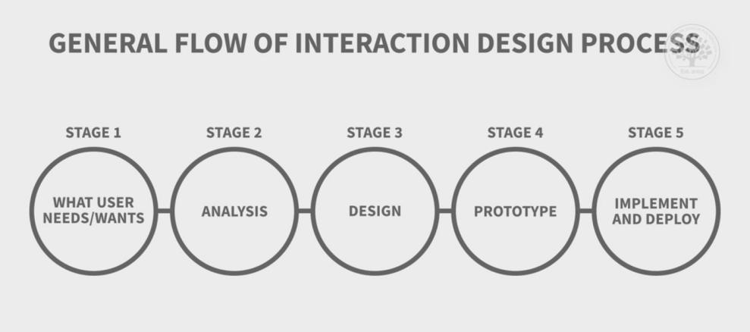

1. Find what users/wants

In general, user may not understand what they desire for, we have to find and understand what they needs/wants and by using these some techniques like through observation, interview, by using survey or questionnaire even using test sample/prototype, the designers can have a basic understanding on what the users want

2 Analysis

After the designers find out what customer needs, this step focuses on reflecting the data that had collected from the users with the beginning design desire, together the design will do cross-elimination on what the requirements that are not suitable or necessary. This can be descibed in

+Narrative/story This will show how the system be used by the customer, what they need and don’t need

+Analyze it and break them to sub-levels

3 Design

After analyzing , this step will take the designers to design all the requirements that are needed. This can be understood like how the user use the product, how do they interact with it, what icon is the best suitable for the interface, how to scroll, to zoom the product and even navigation, etc.

1. Prototype

The step when the designer give the users how the product looks like and let them test it or this can also be taken by expert developers

1. Implement and deploy

The designers will once again reflect the answer that had been collected from the previous step with what they already had, make some changes and after that the implement will be begun

The designers always remember rhat interaction desgin is iterative, this means no one is correct at the beginning, everything can change. It is crucial to understand the prototype we are using, so the product can be ideal but still keep its iterative. The key of the produc is the user, they need to be in every steps during the process. Goal and usability need to be identified and necessary documents are required for data collection and studies

1. Interaction theory

Products need its usability and these can be measured by these criteria

+ Users can use the product easily

+ work efficiency

+ secured

+ Good utilities

+ Easy to Approach

+ tasks, functions are easy to remember

* 1. BASIC UX

BASIC UX has five criteria and has been used a lot in many products

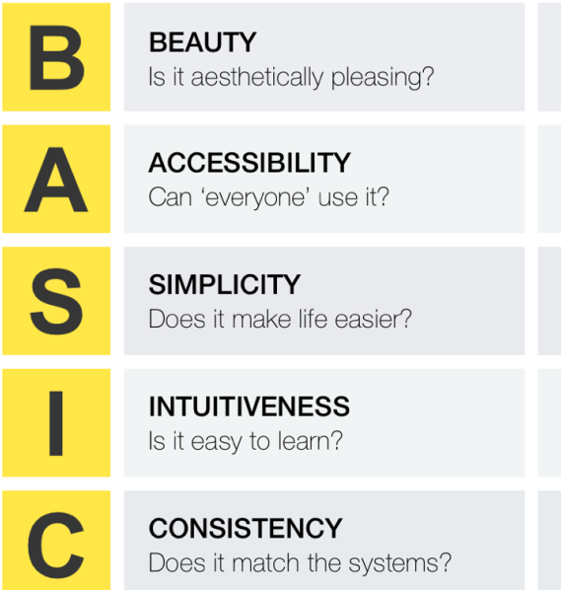

1. Beauty

What can make the first impression to the user, it should be the look of it. A good design is not only revolve in it is meet all the requirements but it is also need to be aesthetically pleading . It is a wise decision for designer to understand the visualization

1. Accessibly

The criteria took place in the user can use the product in any conditions, despite harsh environment, geographical. If somehow the product got shut down in certain criteria , it will decrease the experience also the product should be easy not to complex, so everyone can use it.

1. Simplicity

User may use the product when they are having some problems related with it. The product need to be simple and easy and can solve user problems efficiency. The designers can achieve this by highlight all the main functions, core functions of the product and well-organize UX so the user can see what can solve their problem immediately. Logical also important

1. Intutiveness

The product should be easy to approach. Users don’t need a guidebook in order to understand what can the product do. If there is a learning process, the designers need to make sure that it is can be done as quick as possible

5 Consistency

The criteria is small but it connects all the above criteria. It is crucial to organize the icons,size, fonts consistency and match with the product. Labels and warning also need to be highlighted.

* 1. User centered design

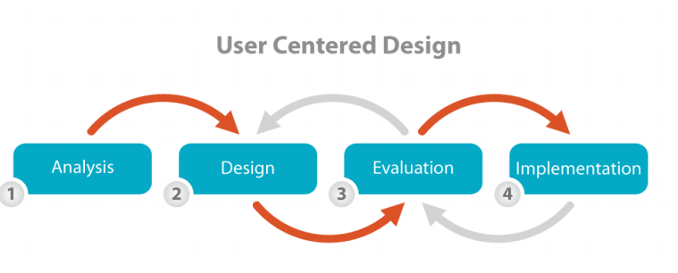

The design that put users as center and design around it

1. Analysis : Designer need to understand who will use the product, what they want
2. Design : Design all the requirements that are suitable for the product
3. Evaluation: This step mainly build a conceptual design to a complete design
4. Implementation:Design and testing
   1. Goal centered design

The design focus on what basic of designing should aim for - the goal. The design will based on behavior and make what is the best for its user

In order to success, the designers should be comprehensive the customer behaviors and their habits

Create requirements based on daily basics, how user interact, what user like and dislike

Goal keeps user satisfy and improvement for interaction design

* 1. Cognitive psychology

Psychology affects users’emotion, their feeling for the product

Cognitive psychology is a study around user’s bahavior through some psychology process : Memory, Attention, Thinking,, Perception, creativity,language,problem solving

* 1. GOMS

Goal Operation Moderator Selection is a method that helps the human-interaction process, this process will cross-out what is unecessary

Cái này lq đến product chú sang nên chú sang viết

1. Goal : Mục đích app chú sang
2. Operation:: Những thứ cần để cái app này thành công
3. Method: Cách thực hiện
4. Selection:

Vd

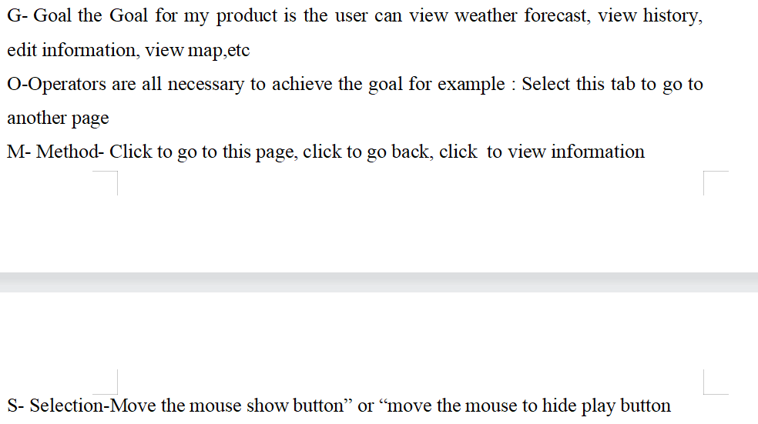

Xong òi đó , giúp chú tân app 1 +2 đê thưng nhiều