https://www.nndc.bnl.gov/ensdf/
https://radware.phy.ornl.gov/cgi-bin/agsdir2?228
id - spnuclear
password- Spnuclear@123

To access the other desktop
[Nuclear@localhost ~]$ ssh -X sangram@192.168.1.57
sangram@192.168.1.57's password: Sem82023
Last login: Mon Jan 16 07:47:56 2023 from 192.168.1.210
[sangram@localhost ~]$ ls
level_schemes papers woods-saxon
[sangram@localhost ~]$ cd woods-saxon/
[sangram@localhost woods-saxon]$ ls
bin hfb-b3 Ra220 swbeta
crank_qpb3.com hfbc Ra220_new swbplot
crank_qpb3_Ra218.com jxbeta Ra220_qpb3.com swbplot_ce130.com
crank_qpb_ce130.com jxbeta3 Ra220_qpb3_new.com swbplot.com
crank_qpb.com jxbeta3.o Rn218 swbplot.com-new
crank_qpg_ce128.com jxbeta.o Rn218_qpb3.com swbplot_n.dat
crank_qpg.com jxgamma Rn218_qpb3_new.com swbplot_p.dat
crank_spb_ce132.com N245.com spag2psk swgamma
crank_spg_hf168.com papers spag2psk.o whfbc
[sangram@localhost woods-saxon]$ cd ..
[sangram@localhost ~]$ ls
level_schemes papers woods-saxon
[sangram@localhost ~]$ cd level_schemes/
[sangram@localhost level_schemes]$ ls
222Th_ensdf_HI_xng.ags th222.gls
[sangram@localhost level_schemes]$ dixie_gls

fonts: 2

fonts: 2

DIXIE_GLS Version 2.0 D. C. Radford Oct 1999
Welcome....

This is a program to calculate and display I_x, alignments,
Routhians and moments of inertia for rotational bands
in nuclei. Data is taken from .gls level scheme files.

Name of GLS level scheme file = ?
(rtn to abort)
(default .ext = .gls)th222
Starting values for Harris parameters I0, I2 = ?
Next command?
Next command?st
Are you sure you want to exit? (Y/N)y
Name for new GLS level scheme file = ? Nuclear@192.168.1.210:
(Type q to abort)
(default .ext = .gls)
(rtn for th222.gls)q
[sangram@localhost ~]$ ls
level_schemes papers Untitled 1.odt
libreoffice terminal notes.odt woods-saxon
To tranfer a file from that system to this one.
- scp terminal\ notes.odt Nuclear@192.168.1.210: (in that system there is space in the file name so \ is used or write ter then enter tab. Then password is nuclear123(current system))
To tranfer a file from this system to that one.
scp -r level_schemes sangram@192.168.1.57:/home/sangram/levelscheme_new
make a new folder named levelscheme_new there then copy the path by writing pwd and paste it after ip address.
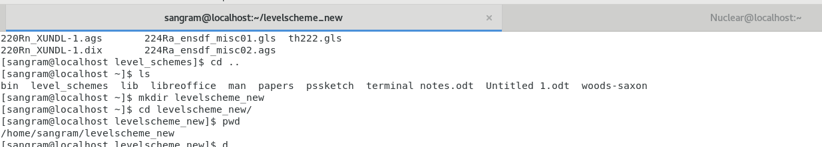
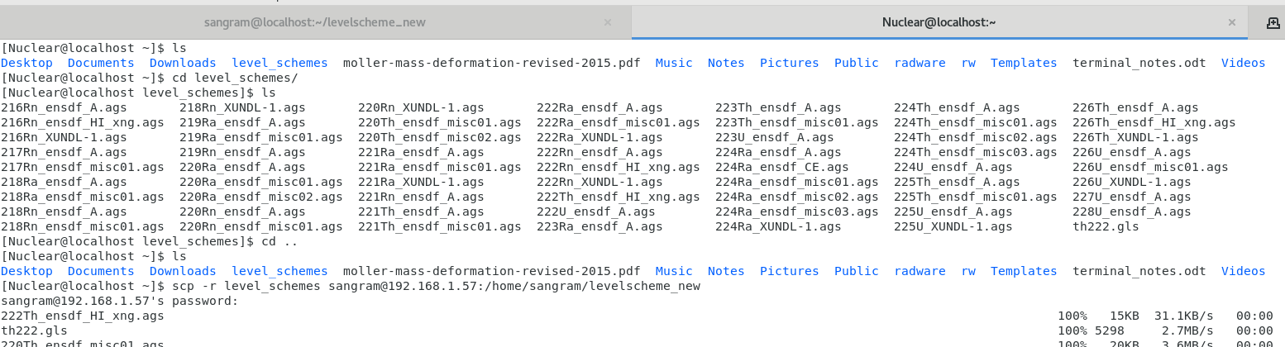
---------------------------------------------------------------------------------------------------------------------------
- gls_conv
- 4
- file name
- gls_conv
- ascii(.ags) to binary(.gls)
- name of the file to convert
- dixie_gls (to analyse the gls file asks name of the file) --- ls *.gls means all files having extension .gls
- then give random harris parameters
- xm ( x for x window and m for MOI)
- 2
- type help to get

XA examine alignment data
XE examine (E_x - RigidRotor) data
XI examine I_x data
XM examine moment-of-inertia data
XR examine Routhian data
X0,NX set up data display X-axis
Y0,NY set up data display Y-axis
EX expand display using cursor
CH change Harris parameters
CR call cursor
DD redisplay data
DD1 redisplay data with autoscale
WD write displayed data to dixie-type file
WP write displayed plot to plotdata-type file
ST stop and exit program

Next command?wd
Output file = ? (default .ext = .dix)th222.dix
Next command?st
Are you sure you want to exit? (Y/N)y
Name for new GLS level scheme file = ?
(Type q to abort)
(default .ext = .gls) or just type q and enter here itself
(rtn for th222.gls) press enter
File th222.gls already exists - overwrite? (Y/N)n
New file name = ?
(default .ext = .gls)q
[sangram@localhost level_schemes]$ ls -ltr
total 608
-rw-------. 1 sangram sangram 15474 Jan 16 12:32 222Th_ensdf_HI_xng.ags
-rw-------. 1 sangram sangram 5298 Jan 16 12:32 t218Rn_ensdf_A.agsh222.gls
-rw-rw-r--. 1 sangram sangram 20392 Jan 16 12:32 220Th_ensdf_misc01.ags
-rw-rw-r--. 1 sangram sangram 5298 Jan 23 06:45 q.gls
[sangram@localhost level_schemes]$ rm q.gls (To remove a file) mv (to remove and shift one file to another directory)
[sangram@localhost level_schemes]$ gedit th222.dix

xmgls 216Rn_XUNDL-1.gls (opens gls file) (To compare different files)

Theoretical Work
using the file Ra224_qpb3_new.com create other 16 files for Th Ra Rn Th by copying and creating file by changing the N,Z and beta deformation parameters from the book Nuclear ground-state masses and deformations: FRDM(2012) named moller-mass-deformation-revised-2015 Like this:
[sangram@localhost woods-saxon]$ ls
bin hfb-b3 Ra220 swbeta
crank_qpb3.com hfbc Ra220_new swbplot
crank_qpb3_Ra218.com jxbeta Ra220_qpb3.com swbplot_ce130.com
crank_qpb_ce130.com jxbeta3 Ra220_qpb3_new.com swbplot.com
crank_qpb.com jxbeta3.o Rn218 swbplot.com-new
crank_qpg_ce128.com jxbeta.o Rn218_qpb3.com swbplot_n.dat
crank_qpg.com jxgamma Rn218_qpb3_new.com swbplot_p.dat
crank_spb_ce132.com N245.com spag2psk swgamma
crank_spg_hf168.com papers spag2psk.o whfbc
[sangram@localhost woods-saxon]$ gedit Ra220_qpb3_new.com
[sangram@localhost woods-saxon]$ cp Ra220_qpb3_new.com Ra222_qpb3_new.com
[sangram@localhost woods-saxon]$ gedit Ra222_qpb3_new.com
[sangram@localhost woods-saxon]$ cp Ra220_qpb3_new.com Ra224_qpb3_new.com
[sangram@localhost woods-saxon]$ gedit Ra224_qpb3_new.com
[sangram@localhost woods-saxon]$ cp Ra220_qpb3_new.com Ra218_qpb3_new.com
[sangram@localhost woods-saxon]$ gedit Ra218_qpb3_new.com
[sangram@localhost woods-saxon]$ cp Ra220_qpb3_new.com Rn216_qpb3_new.com
[sangram@localhost woods-saxon]$ gedit Rn216_qpb3_new.com
[sangram@localhost woods-saxon]$ cp Ra220_qpb3_new.com Rn218_qpb3_new.com
[sangram@localhost woods-saxon]$ gedit Rn218_qpb3_new.com
[sangram@localhost woods-saxon]$ cp Ra220_qpb3_new.com Rn220_qpb3_new.com
[sangram@localhost woods-saxon]$ gedit Rn220_qpb3_new.com
[sangram@localhost woods-saxon]$ cp Ra220_qpb3_new.com Rn222_qpb3_new.com

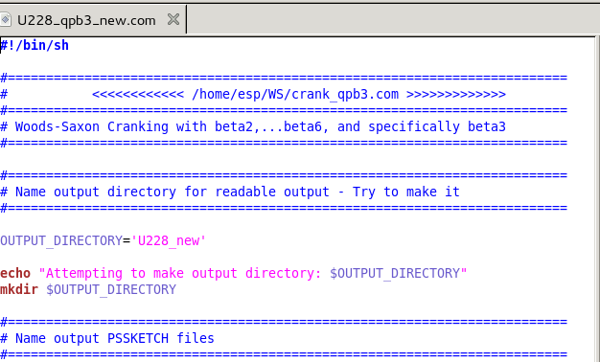
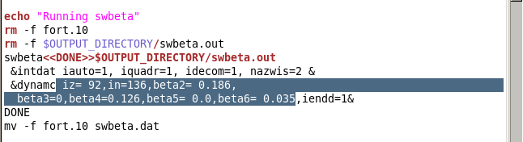
Then open the file and check whether the info is correct or not and then make the shell script into executable (u means user and x means executable) and then execute by ./ file name. Do this for all 16 files.
[sangram@localhost woods-saxon]$ gedit Th226_qpb3_new.com
[sangram@localhost woods-saxon]$ chmod u+x Th226_qpb3_new.com
[sangram@localhost woods-saxon]$ ./Th226_qpb3_new.com
chmod thing might not be necessary if already executable permission is already there.
Convert .psk files into .ps by using pssketch
[sangram@localhost Th224_new]$ ls
qpb3_n.psk qpb3_p.psk
[sangram@localhost Th224_new]$ pssketch qpb3_p.psk qpb3_p.ps
PSSKETCH Sun Version 5.19 Mon Feb 20 09:01:55 2023
PSSKETCH Sun Version 5.19 Mon Feb 20 09:01:55 2023
[sangram@localhost Th224_new]$ pssketch qpb3_n.psk qpb3_n.ps
PSSKETCH Sun Version 5.19 Mon Feb 20 09:02:04 2023
PSSKETCH Sun Version 5.19 Mon Feb 20 09:02:04 2023
open the ps file with evince
---------------------------------------------------------------------------------------------gtkgls – to create a gls file

