Project Report On

### Aegle Health Application

Submitted By

| Sr No | Name | Gr No | Roll No |
| --- | --- | --- | --- |
| 1 | Anuj Dube | 21810299 | 433042 |
| 2 | Sangram Shinde | 21810248 | 433003 |
| 3 | Aniruddha Ghadge | 21810708 | 433055 |
| 4 | Roshan Wazare | 21810420 | 433054 |

Under the Guidance

of

Prof. Mr. Pawan Wawage

*In Partial fulfillment of*

#### Bachelor of Technology

[B. Tech. Information Technology] [2021-2022]

At



Department of Information Technology Vishwakarma Institute of Information Technology, Pune 411048

*Affiliated To*



Savitribai Phule Pune University, Pune Bansilal Ramnath Agarwal Charitable Trust’s

AEGLE HEALTH APPLICATION

#### Vishwakarma Institute of Information Technology, Pune 411048



Certificate

This is to certify that the work entitled **“AEGLE HEALTH APPLICATION"** is a bonafide work carried out by respective team in partial fulfillment of the award of Bachelor of Technology in Information Technology, Savitribai Phule Pune University, Pune, during the year 2021. The project report has been approved as it satisfies the academic requirements in respect of the project work prescribed for the Bachelor of Technology Degree.

Prof. Mr. Pawan Wawage

#### Project Guide

Prof. P.Futane

#### Head, IT Department Director, VIIT, Pune

Date:

Examiners: 1. . . . . . . . . . . . . . . 2. . . . . . . . . . . . . . .

### Acknowledgement

We take this opportunity to thank Head of the Department Prof. P. Futane and our project guide Prof. Pawan Wawage for their valuable guidance and providing all the necessary facilities, which were indispensable in the completion of this project report. We are also thankful to all the staff members of the Department of Information Technology, VIIT, Pune for their valuable time, support, comments, suggestions and persuasion.

AEGLE HEALTH APPLICATION

## ABSTRACT

The prime objective of creating “Aegle Health App” is to create a fully-fledged application to facilitate both the doctor and the patient. This project will connect doctor and patient very quickly and easily from any location without any involvement of any third party. This would be an app which can be used for Tele Consulting in the domain of healthcare by Aegle Clinic. It connects Doctor and Patient using an app and patients can search for a doctor and book his/her appointment or prescription using their Smartphone. There will be a dashboard for doctors from which they can see the previous history of a particular patient and can prescribe on the basis of the history of the patient. Any doctor of Aegle Clinic and patient can easily use this application by registering themselves, and doctors can diagnose the patient and prescribe the required medicines. This system also notifies the Doctor and patient through the app about the doctor’s appointment and prescription within the shortest possible time. The patients and the doctors will get access to various features such as consultation, monitoring health parameters, emergency report backup, appointment booking, reminders of important dates, etc.

# Contents

| **Sr.** | **Chapter** | **Page No.** |
| --- | --- | --- |
| **1.** | **Introduction** | 9 |
| 1.1 | Motivation | 9 |
| 1.2 | Need of Aegle Health Application | 9 |
| 1.3 | Brief Introduction of Aegle Health Application | 10 |
| **2.** | **Literature Survey** | 11 |
| 2.1 | Literature Review | 11 |
| 2.2 | Review of existing system | 12 |
| **3.** | **Project Statement** | 13 |
| 3.1 | Purpose behind the project | 13 |
| 3.2 | Decision of scope | 13 |
| 3.3 | Methodology for solving this proposed theme | 13 |
|  | 3.3.1 Proposed System Architecture | 13 |
|  | 3.3.2 Flowchart of the system | 15 |
| **4.** | **System Requirements and Specifications** | 16 |
| 4.1 | Software Requirements and Specifications | 16 |
|  | 4.1.1 Introduction | 16 |

|  |  |
| --- | --- |

1

VIIT-INFORMATION TECHNOLOGY 2020-21

|  | 4.1.3 Operating Environment | 16 |
| --- | --- | --- |
|  | 4.1.4 External Interface Requirements | 16 |
|  | 4.1.5 Functional Requirement | 17 |
|  | 4.1.6 Other Non-Functional Requirements | 17 |
| **5** | **Project Analysis and Design** | 18 |
| 5.1 | Use Case Diagram | 18 |
| 5.2 | Activity Diagram | 19 |
| 5.3 | Sequence Diagram | 20 |
| 5.4 | Workflow | 21 |
| 5.4 | Time Schedule | 22 |
| 5.5 | Team Organization | 23 |
|  | 5.5.1 Team Structure | 23 |
| 5.6 | Interface and Details | 24 |
| **6** | **Implementation and Software Testing** | 26 |
| 6.1 | Implementation | 26 |
| 6.2 | Database | 31 |
| 6.3 | Test Cases and Results | 32 |

| **7** | **Conclusion and Future Work** | 33 |
| --- | --- | --- |
| 7.1 | Conclusion | 33 |
| 7.2 | Future Scope | 33 |
| **8** | **Reference** | 34 |

# List of Figures & Table

# 

| **Sr. No.** | **Figure Name** | **Page No.** |
| --- | --- | --- |
| Fig.3.3.1 | Proposed System Architecture | 14 |
| Fig.3.3.2 | Flowchart of System | 14 |
| Fig.5.1 | Use case diagram | 17 |
| Fig.5.2 | Activity Diagram | 18 |
| Fig.5.3 | Sequence Diagram | 19 |
| Fig.5.4 | Class Diagram | 20 |
|  |  |  |

## Chapter 1

**Introduction**

### Motivation

Health clinic Management application often becomes a great asset to the modern healthcare domain. Still, lots of ready-made solutions offer complex interfaces, low functionality, and a bunch of unnecessary features. That's why more and more companies tend to develop mobile applications specifically for the convenience of the users. In our project, we are going to cover the main functions of the Health clinic system. There is no existing mobile application for Aegle Clinic. They mainly operate through their existing website which helps patients to interact with the doctors upto an extent. The system is also unable to remind and notify patients about their appointments as it is operated on a web console. They currently do not have a platform or a dashboard to store their health files while operating through their existing website. Which is why an application for Doctor and Patient management related to healthcare is required.

### Need of Aegle Health Application

This work has the objective of developing a mobile application and web app that improves healthcare communication among patients, doctors, and other stakeholders. Through new technology with internet access, it will assist them in scheduling appointments, managing prescriptions, and managing patient data. The objectives of the research are:

1) Creating an application that will be simple to use without learning any additional skills.

2) The development of an application that focuses on improving users' awareness and knowledge of medication and its use.

3) Creating a framework that will assist both doctors and patients to manage this process better.

### Brief Introduction to Aegle Health Application

The prime objective of creating “Aegle Health App” is to create an Android application to facilitate for the patient and webapp for doctors. This combined system can be used for Tele Consulting in the domain of healthcare by Aegle Clinic. It connects Doctor and Patient using an android app and web app. Patients can book his/her appointment or prescription using their Smartphone. The webapp shows the Doctors the previous history of a particular patient and can prescribe on the basis of the history of the patient. The main objective of this project is connecting doctor and patient very quickly and easily from any location without any involvement of any third party. Any doctor of Aegle Clinic and patient can easily use this system by registering themselves, and doctors can diagnose the patient and prescribe the required medicines. This system also notifies the Doctor and patient through the app about the doctor’s appointment and prescription within the shortest possible time. The patients and the doctors will get access to various features such as video consultation, monitoring health parameters, emergency backup, appointment booking, reminders of important dates, etc.

## Chapter 2

**Literature Survey**

### Literature Review

### Many Medication Systems have been developed based on different platforms and concepts. The use of healthcare-related apps is growing but there are many issues related to their functionality. In this section, we reviewed some of the literature and applications that are related to our work.

### 1) Practo -

### This application enables for consumers to find best doctors, book instant appointments, consultations and make better more informed health decisions.

### 2) Doctor at Work -

### This application manages patient records, appointments, patient visit notes, bill patients, track customer payments and balance due. This app can be useful for medical professionals and students that visit patients every now and then. It also helps the patients to get the appointments with doctors and sends the reminder through SMS or by email, creates itemized bills for patients to track the due amount, maintains the visit history of the patients, etc.

### 3) Diagnotes -

### This mobile application is web-based and provides healthcare practitioners the tools to enhance doctor interaction with their patients and other support staff. The user is expected to first create his account to enable him to have access to all the functionalities of the application. It routes phone calls and text, supports documentation of every encounter for continuity of patient care.

### All the existing applications discussed above are kind of more commercial and money making, but this our proposed system cares more for a patient- centered approach, and provides an optimal communication between doctors and patients. This app is helpful to patients to ask questions and state their concerns to doctors regarding their health condition.This app will facilitate the patients to interact with doctors without making any physical appointments.

* 1. **Review of existing System**

There is no existing mobile application for Aegle Clinic. They mainly operate through their existing website which helps patients to interact with the doctors upto an extent. The system is also unable to remind and notify patients about their appointments as it is operated on a web console. They currently do not have a platform or a dashboard to store their health files while operating through their existing website.

## Chapter 3

**Project Statement**

### Purpose behind the Project

This work has the objective of developing a mobile application and web app that improves healthcare communication among patients, doctors, and other stakeholders. Through mobile and web technology with internet access, it will assist them in scheduling appointments, managing prescriptions, and managing patient data. The objectives of the research are:

1) Creating an application that will be simple to use without learning any additional skills.

2) The development of an application that focuses on improving users' awareness and knowledge of medication and its use.

3) Creating a framework that will assist both doctors and patients to manage this process better.

### Decision of Scope

This project aims to create an android application and web application for Aegle Clinic. Where patients can schedule and manage their appointments and also view their health files itself in that application. It's for seamless communication between patients and doctors of the clinic.

### Methodology for solving this proposed theme

#### Proposed system Architecture

The proposed system is a mobile application and web application that can accommodate the communication needs between doctors and patients. The application must be able to handle processes ranging from the doctor’s search process, check registration, queue number settings and notifications, easy-to-access medical records, and chats between doctors and patients. This, therefore, helps in making critical information more readily available for review on an individual basis.

These changes will be more than automated and more efficient versions of what we already do. There will be new ways to support and even provide healthcare: replacements and refinements for existing processes, procedures, and work habits that will improve outcomes. Other benefits of the proposed new system are:

• **Improved Communication between Patients and Providers**

This mobile application improves healthcare by making readily available instructions for patients. The greater part of what doctors tell patients is forgotten by the time they leave the hospital and half of what they remember is incorrect. Better communication can also take place through use of mobile application and web app before patients enter their physician’s office. Mobile and web technology can be used to send patient reminders and decrease the number of missed appointments, which leads to a reduction in costs.

• **Mobile Healthcare Technology Decreases Readmissions**

The patient’s healthcare experience does not stop once they leave the hospital. Providers need to find ways to effectively communicate with patients throughout their healthcare journey or face further health problems in the long-term. Today’s healthcare providers face a growing number of readmissions, with so many patients coming back to them within a short while of care. When mobile technology is used to empower patients with information on how to better manage their health, the level of readmission decreases resulting in less cost for the patient.

• **Attracting New Patients**

The availability of healthcare apps on the internet helps patients quickly access reliable information when they feel sick. This speaks to the growing desire for mobile healthcare content. By offering this content, a healthcare system could gain the attention of a user early in his life, thus increasing the likelihood that he would choose that system for future healthcare needs.

#### Fig 3.3.1: Proposed system Architecture

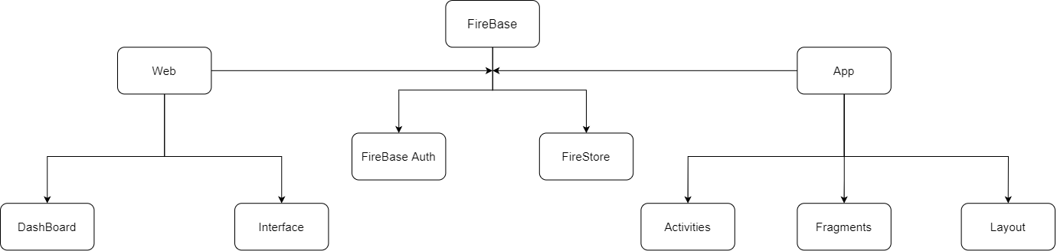

#### Flowchart of System

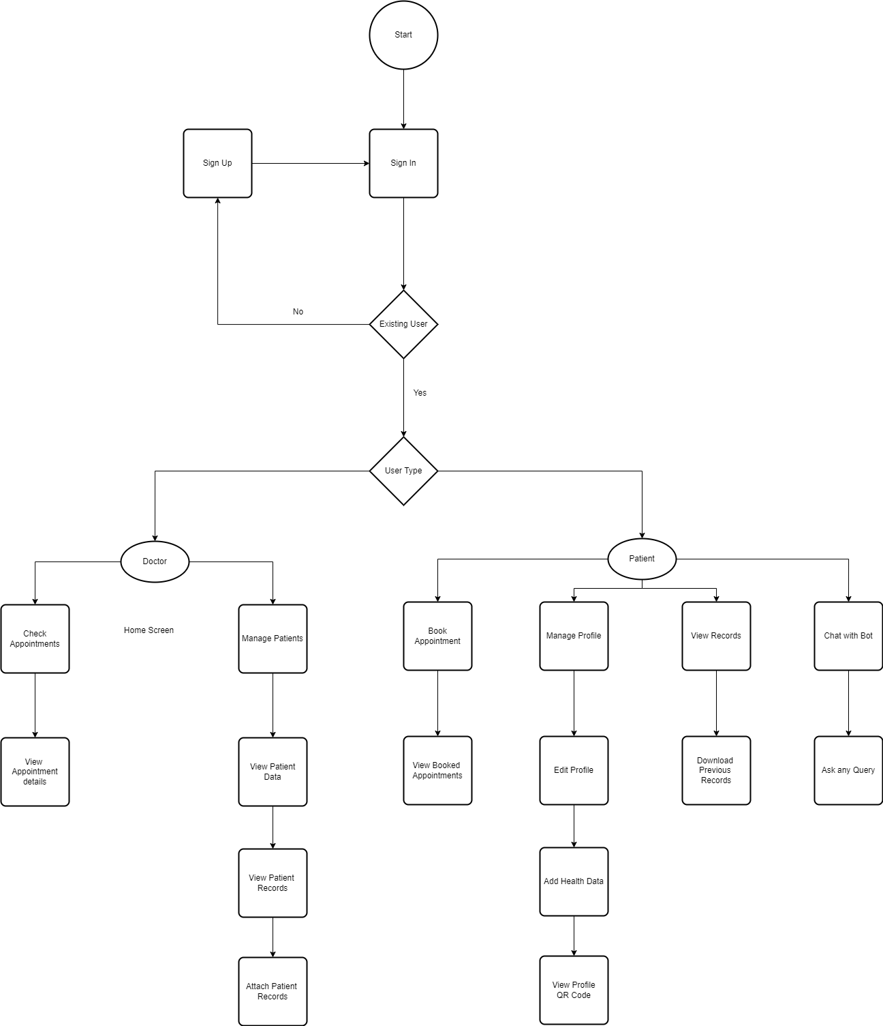

#### Fig 3.3.2: Flowchart of the System

**Chapter 4**

**System requirement and specification**

* 1. **Software requirements specifications:**
     1. **Introduction**

Intended Audience and Reading Suggestions: Users of the system are Patients and Doctors of Aegle Clinic. The members are assumed to have basic knowledge of computer and internal browsing while the administrator should have more knowledge so that he/she can resolve small problems and perform information.

The intended audience includes all stakeholders as mentioned below

* + - 1. Developers
      2. Users/Designers
      3. Testers
      4. Documentation Writers

#### Operating Environment

The system has 2 components. First is a mobile based application that can only work on the Android Operating System. It just requires an internet connection to book appointments and avail all other facilities. The second is a web application which needs a web browser and internet connection to work.

#### External Interface Requirements

User Interfaces: User interface will be a mobile application page which consists of a sign-in and sign- up option where users need to sign-up on the system before booking an appointment. For Doctors we have created a web application which has only a sign in option. and credentials for doctors can be provided by developers

Hardware Requirements:

* + - 1. Android Mobile with Internet Connection and browser
      2. Laptop or computer with web browser

**Software Requirements:**

**For Android application**

* Operating System: Android OS; Windows 10.
* Design – Figma
* Front-End – xml
* Language – Kotlin
* Framework - Android Studio.
* Back-end – Firebase
* Authentication - Firebase auth
* Cloud database - Firebase firestore

**For Web application**

* Operating System: Windows 10.
* Front-end – HTML,CSS,Material UI
* Language – Javascript
* Framework - React.
* Back-end – Firebase
* Authentication - Firebase auth
* Cloud database - Firebase firestore

#### Functional Requirement

**For Android Application**

* View health files - When clicked on the specific file it should show the details of the same file and no other.
* Login - New user id and otp or incorrect otp when entered shouldn’t login into the system

Once logged in it should open a different UI depending on the user.

* Register - All the requirements for login & password with the inculcated rules should be satisfied. If not, the user entry for the same shouldn’t be considered. New entries should be saved in the specific domain only.
* Book Appointment - Once clicked should open and book the appointment on the selected date and time slot.

For Web Application

* View Each user Data:- When clicked on used it should redirect to user page where it will show all its information
* View past appointment of user=> In each users page it should show his past appointments
* Upload files to user=> In each users page there should be area to view and upload health files
* View/Delete future appointments=> One page should show all future appointments and doctor should be able to view and delete those appointments.

#### Other Non-functional Requirements

* Data Input Requirements:

1. Phone Number is required to generate OTP

* Security Requirements:

1. System should not grant authentication to any unauthorized person. 2. The system should not be vulnerable to security attacks.

3. Information related to patient access should be confidential.

* Software Quality Attributes:

The system ensures the following application quality attributes:

1. Reliability
2. Efficiency
3. Security
4. User-friendliness
5. Flexibility

**Chapter 5**

**Project Analysis and Design**

* 1. **Use Case Diagram**

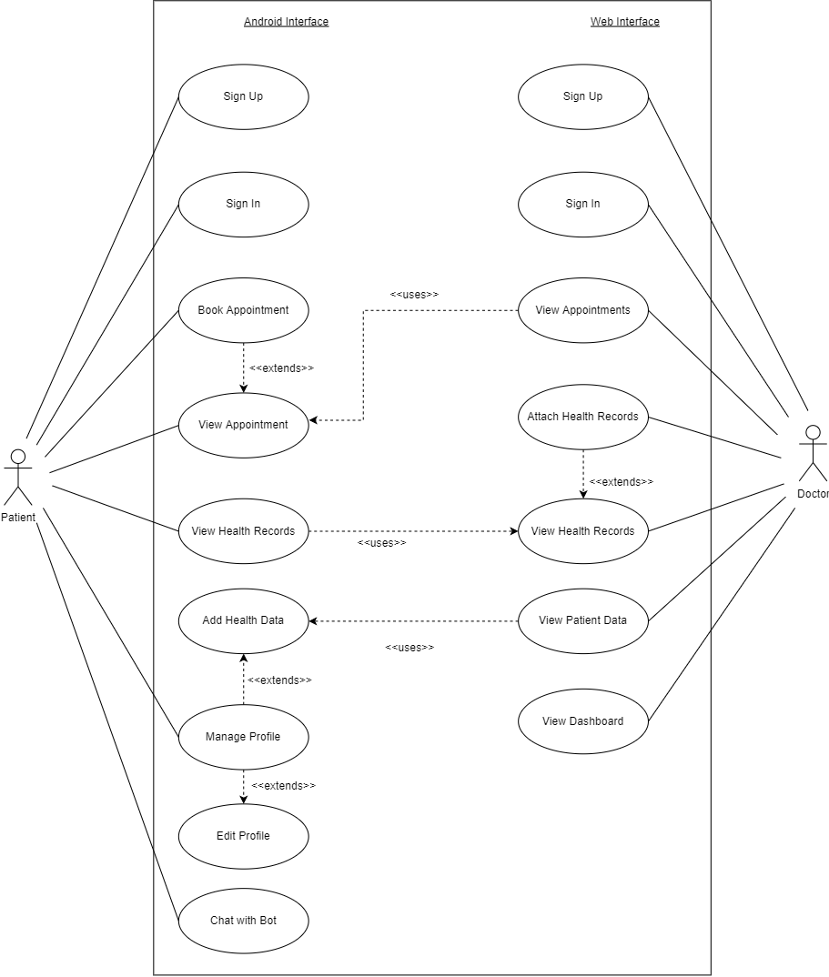

**Fig 5.1: Use case Diagram**

#### Activity Diagram

Activity diagram description: The Activity diagram is presented for the actor in the project. It explains the detailed processing for each function and what happens from each end.

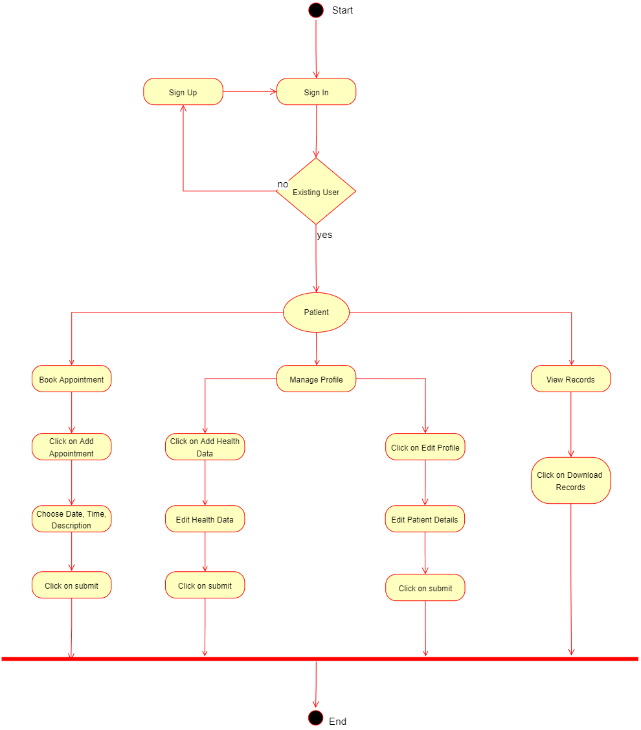

**Fig 5.2: Activity Diagram**

* 1. **Sequence Diagram**

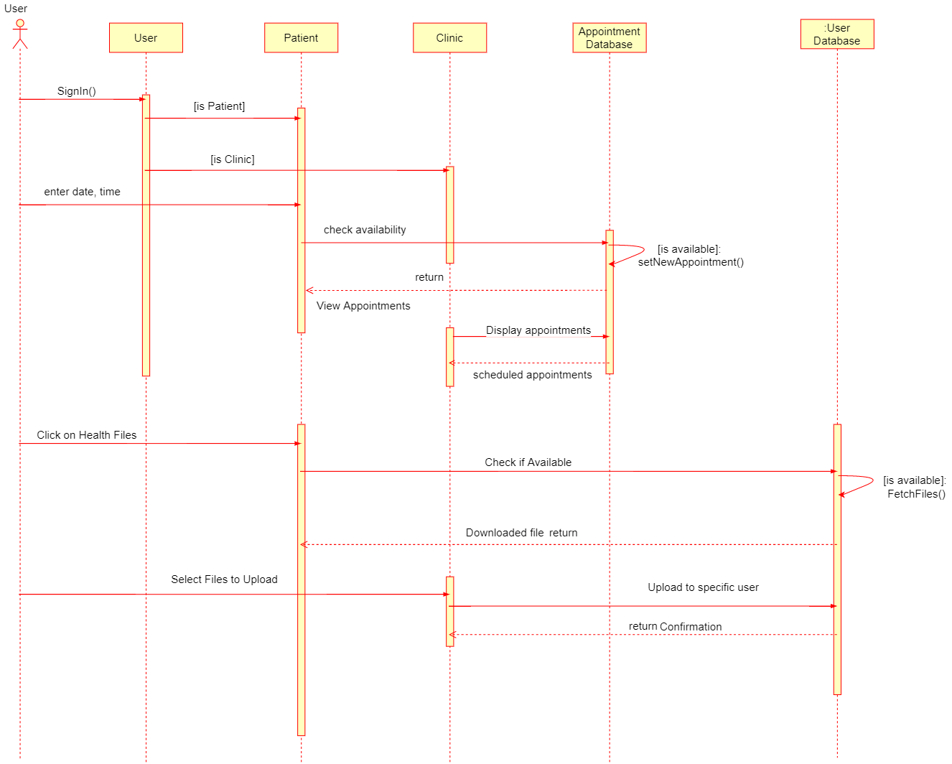

**Fig 5.3: Sequence Diagram**

#### Class Diagram

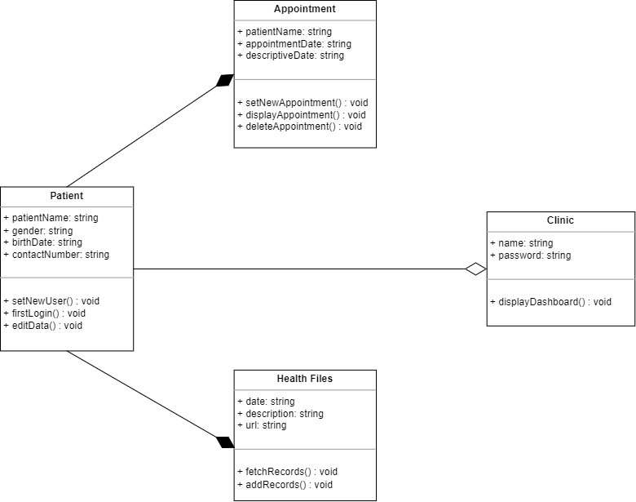

**Fig 5.4: Class Diagram**

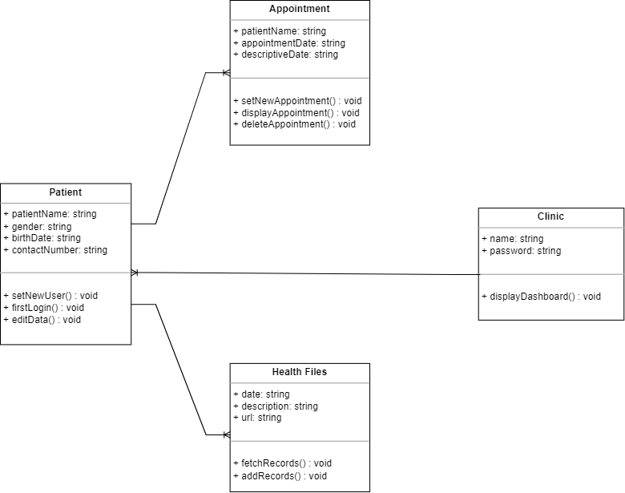

* 1. **Time Schedule**

| **Task** | **Start** | **Status** |
| --- | --- | --- |
| Front End Layout Design for android application | January | Completed |
| Full Front End For android and web application | February | Completed |
| Backend Architecture | march | Completed |
| Backend (Firebase Database) | April | Completed |
| Bug Fixing, Testing | April | Completed |

**Table No.5.5: Time Schedule**

* 1. **Team Organization**
     1. **Team Structure**

The team:- The team consists of developers, internal guides.

Developers :

* + - * Anuj Dube
      * Sangram Shinde
      * Aniruddha Ghadge
      * Roshan Wazare

Internal Guide :

* + - * Mr. Pawan Wawage

#### Interface Details and Screenshots

**Android Application**

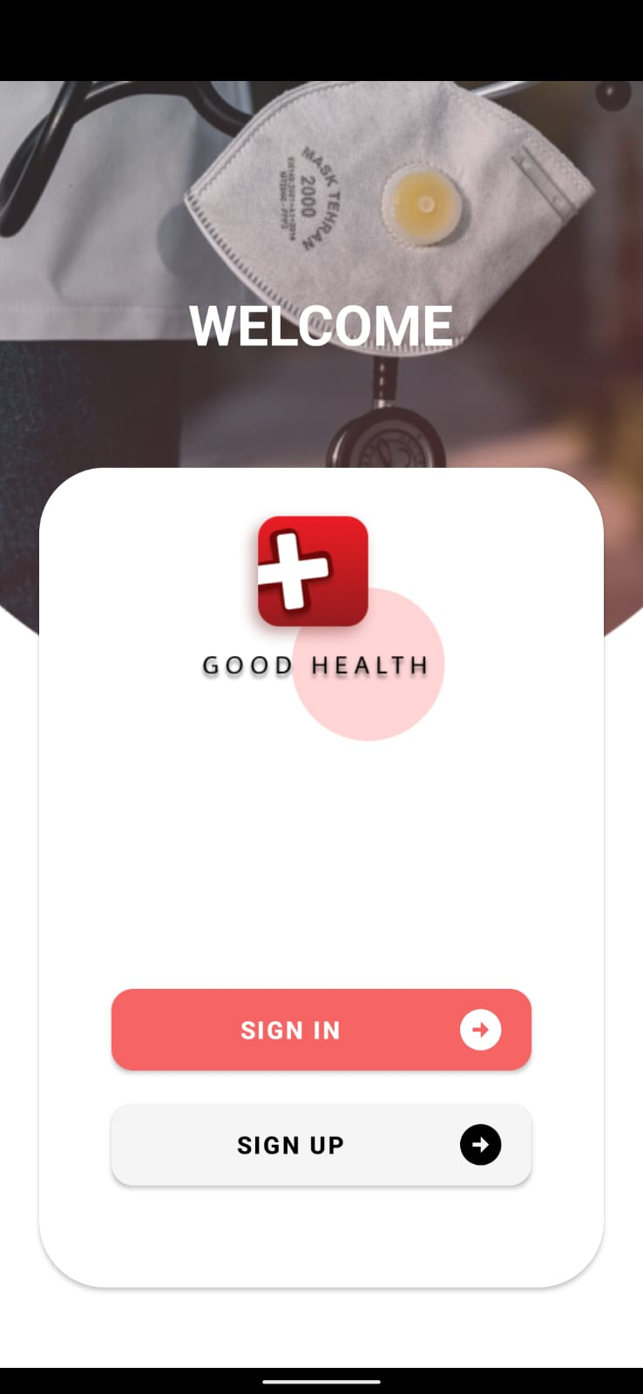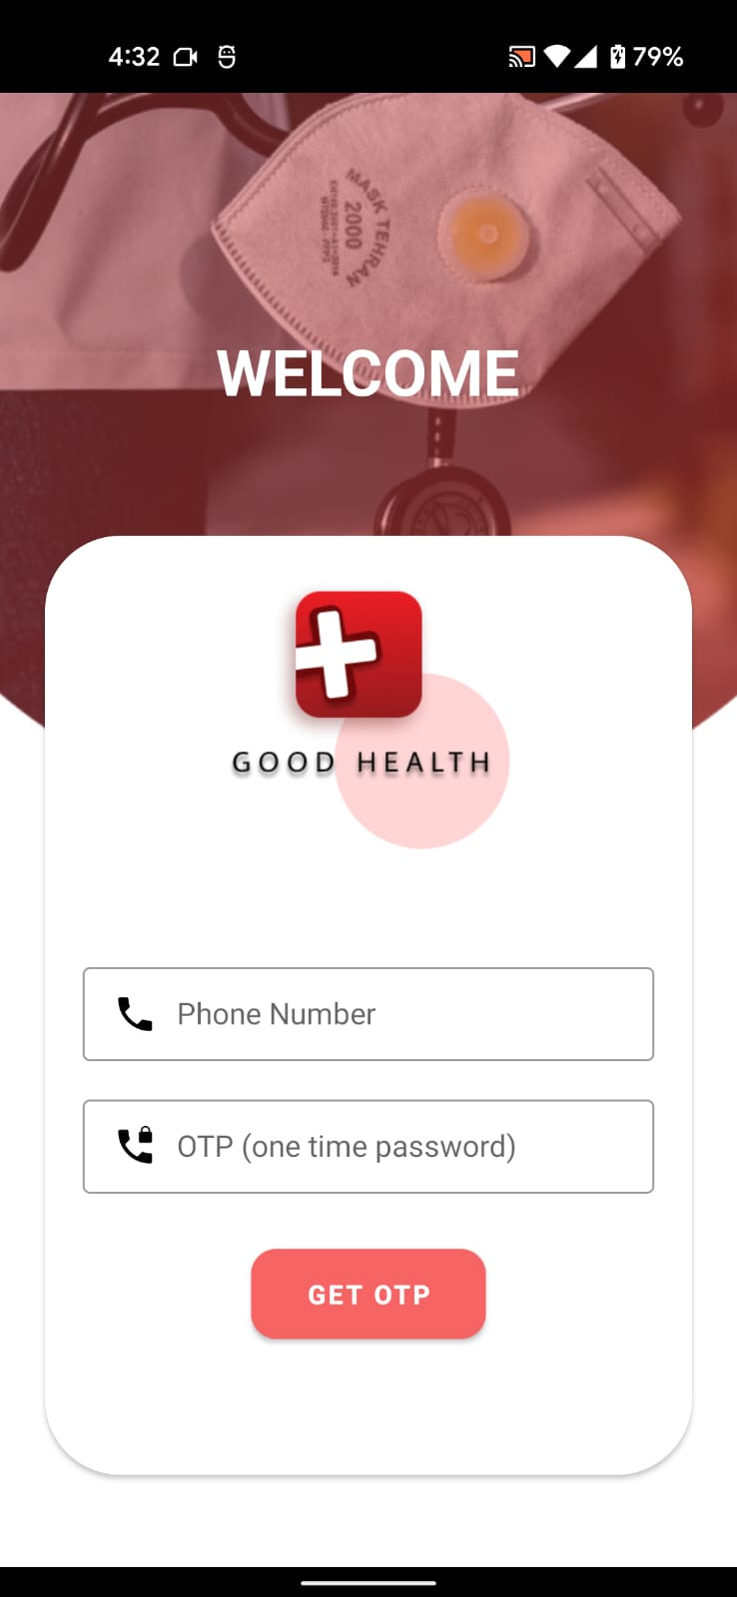

**Fig 5.6.1 Main Screen Fig 5.6.2 Sign In OTP**

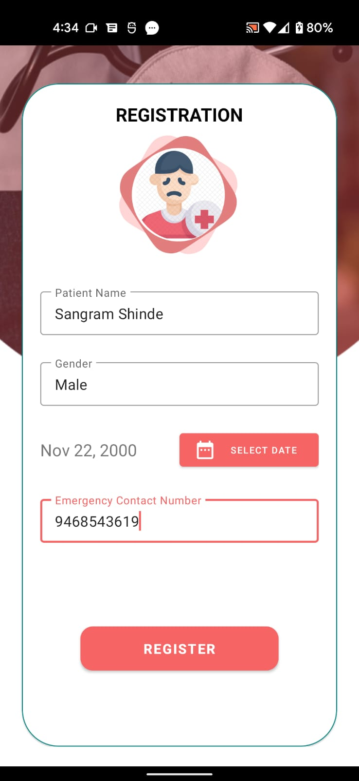

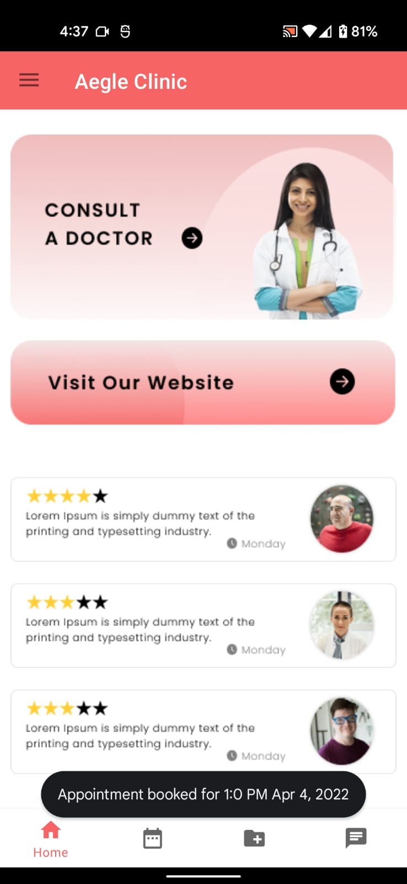

**Fig 5.6.3 Registration Fig 5.6.4 Home**

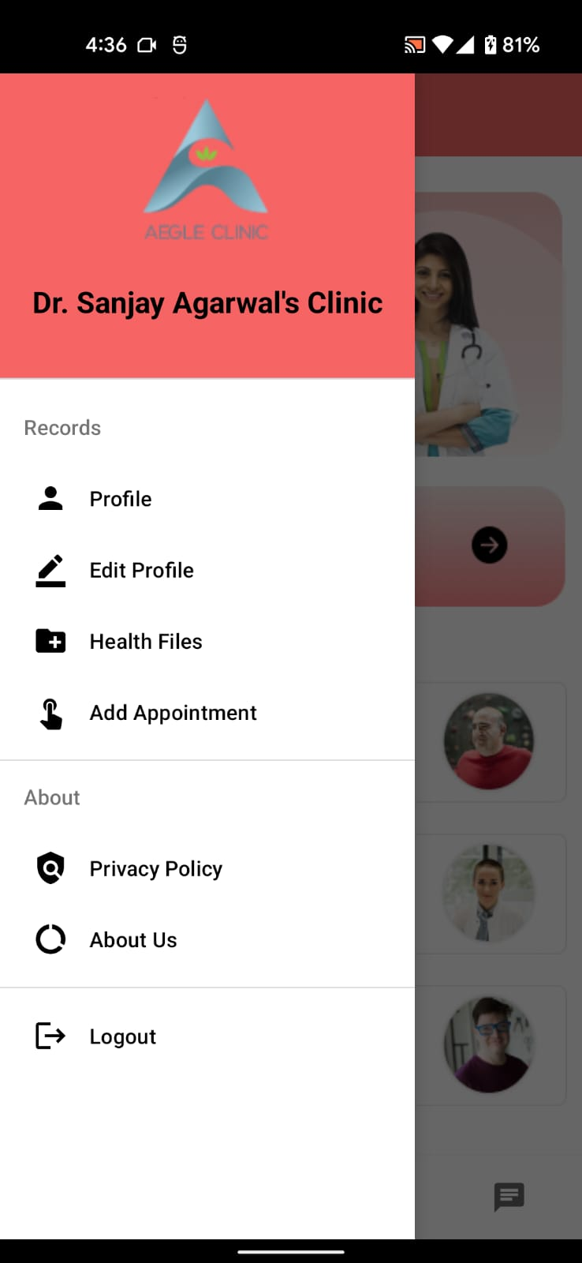 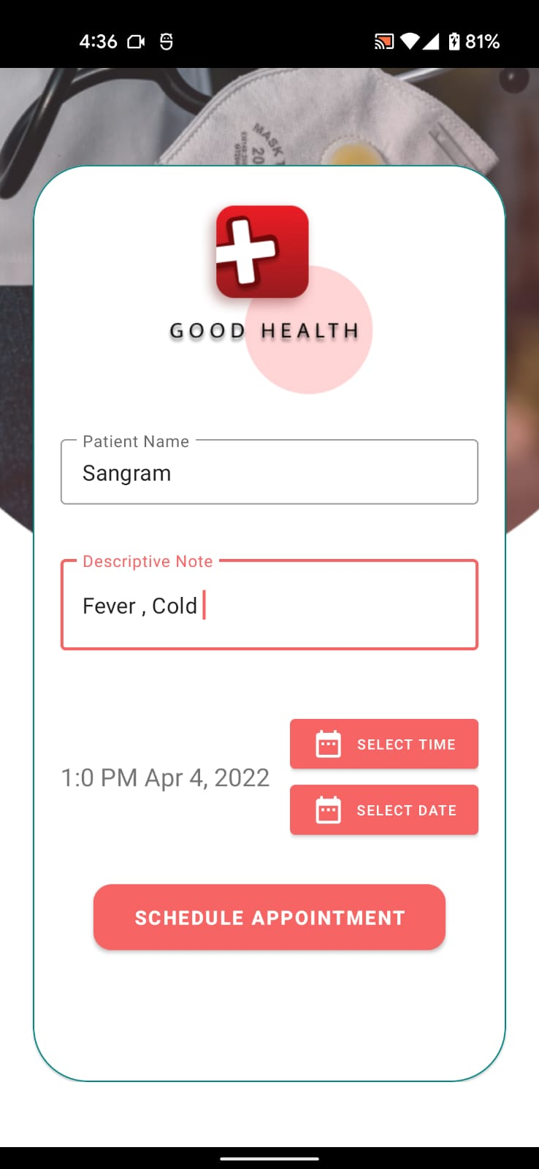

**Fig 5.6.5 Side Navigation Fig 5.6.6 Schedule Appointment**

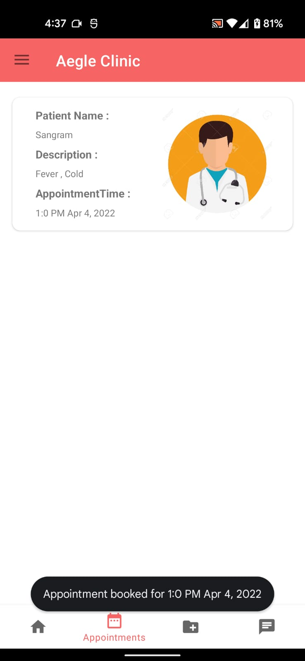 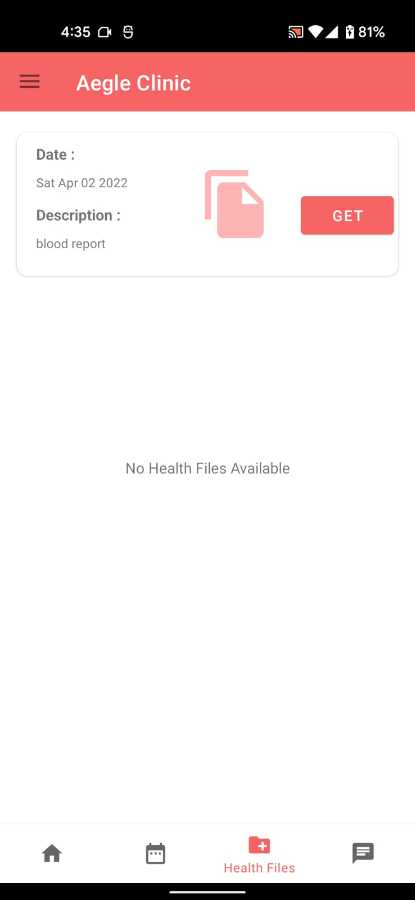

**Fig 5.6.7 Appointments Tab Fig 5.6.8 Health Files Tab**

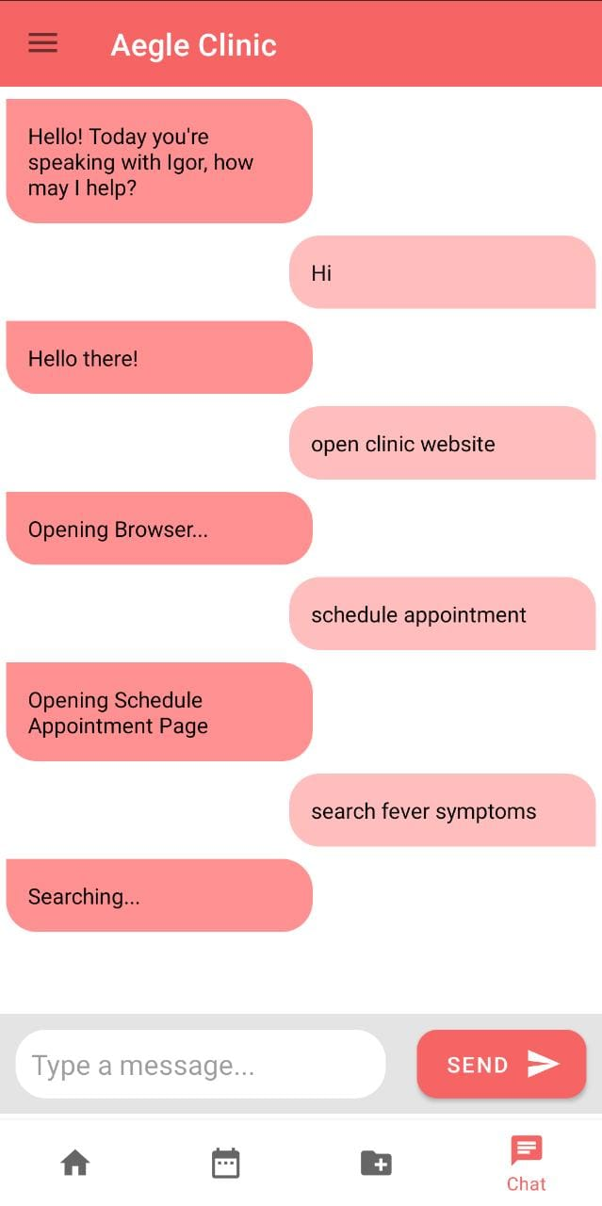

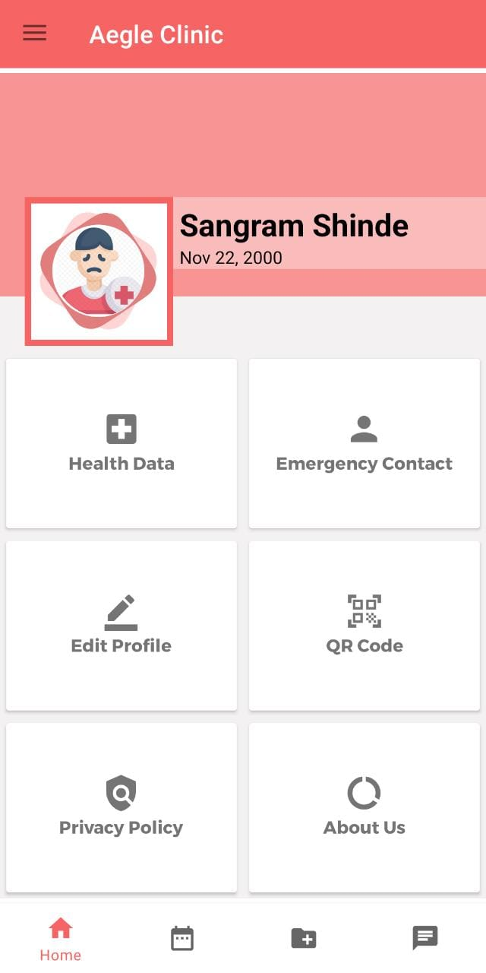

**Fig 5.6.10 Profile**

**Fig 5.6.9 Static Chat Bot**

**Web Application**

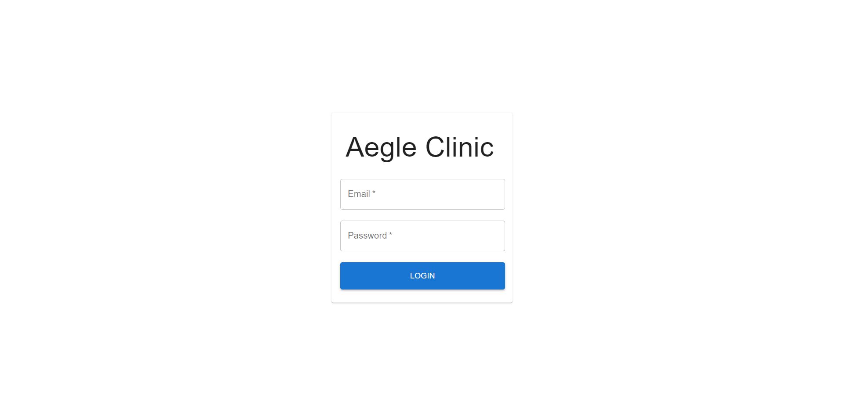

**Fig 5.6.11 Web app login**

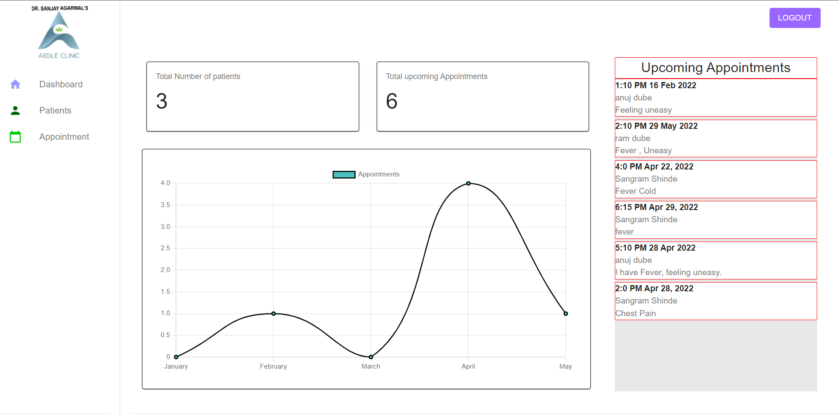

**Fig 5.6.12 Web app dashboard page**

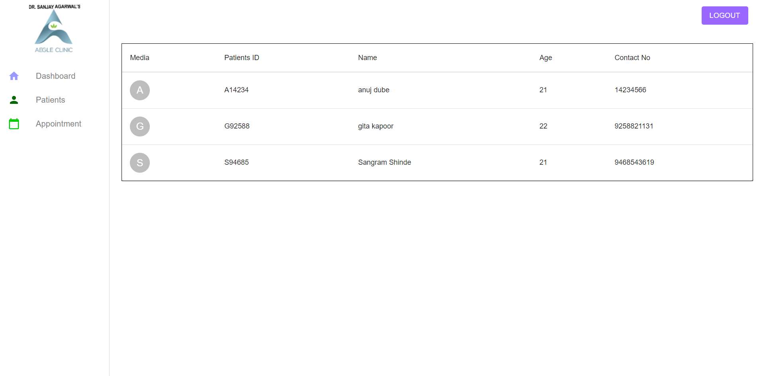

**Fig 5.6.13 Web app all Patients page**

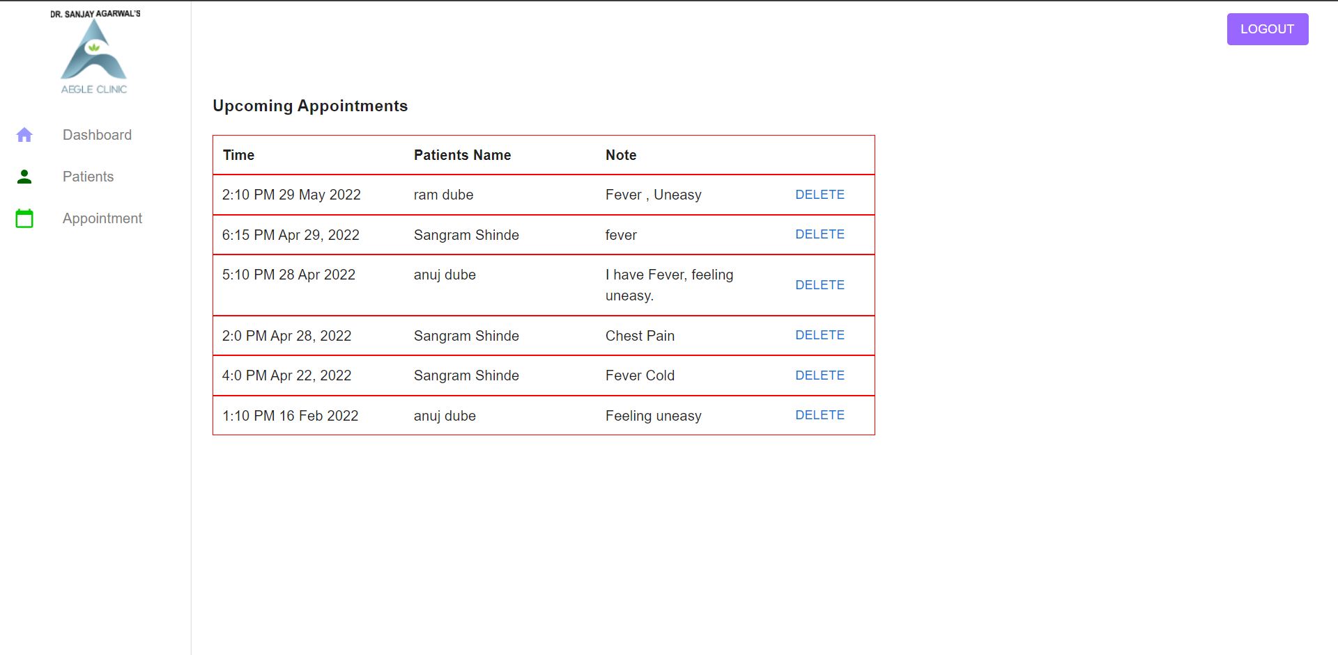

**Fig 5.6.14 Web app upcoming appointments page**

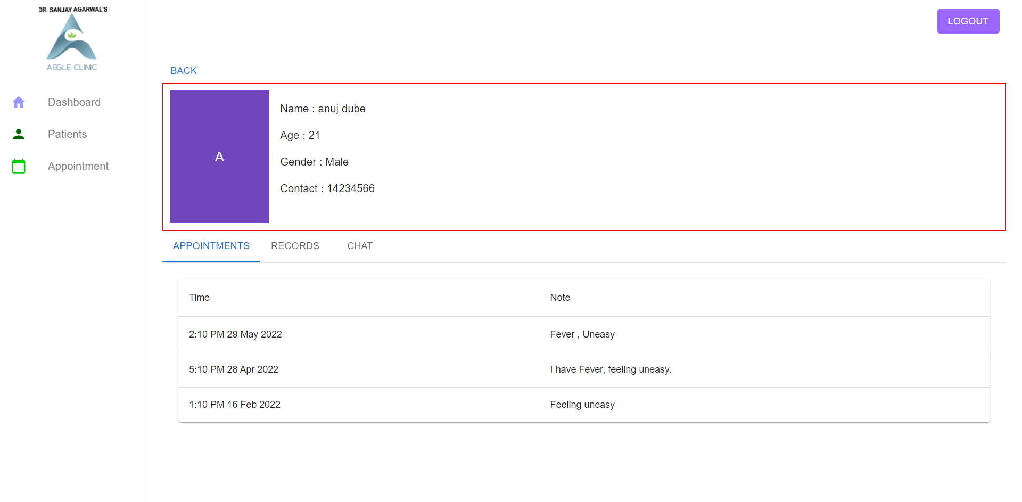

**Fig 5.6.15 Web app individual patient page showing past appointments**

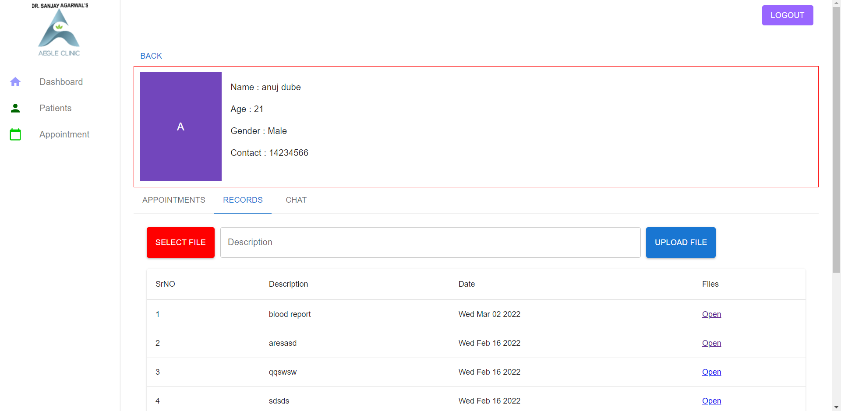

**Fig 5.6.16 Web app individual patient page showing are to view and upload reports**

**Chapter 6**

**Implementation Software Testing**

* 1. **GitHub Links**[**https://github.com/sangram2200/AegleClinicApp**](https://github.com/sangram2200/AegleClinicApp)
  2. **Firebase Database**

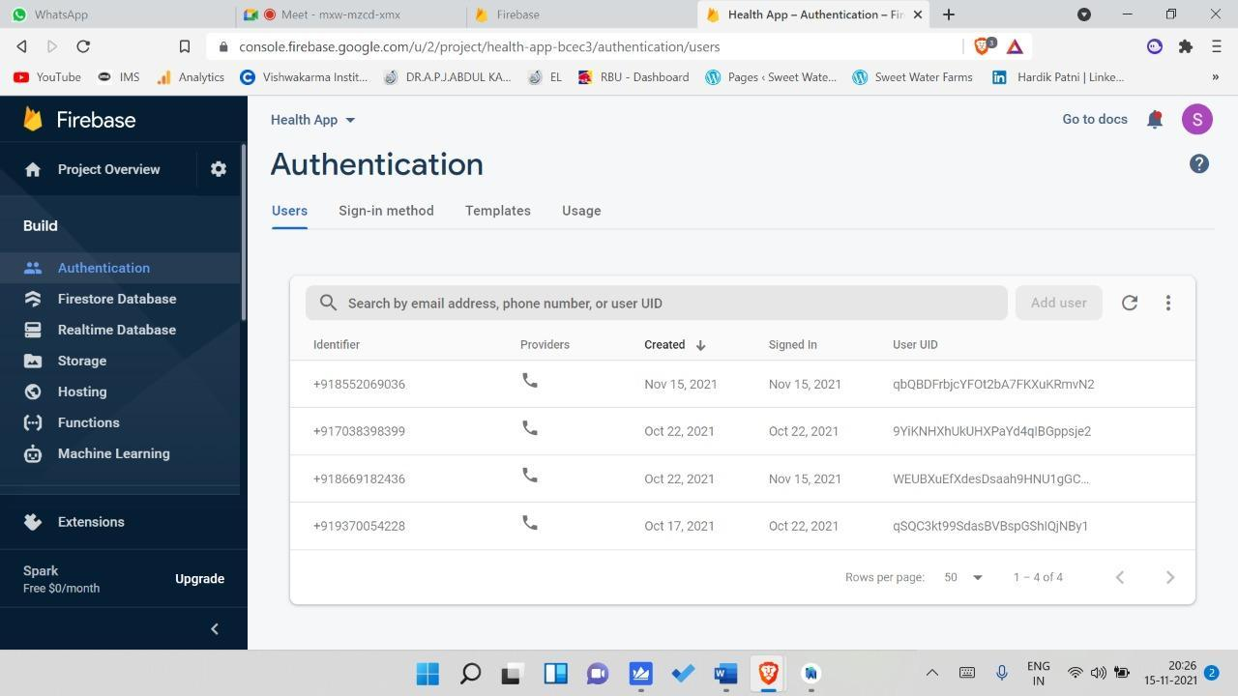

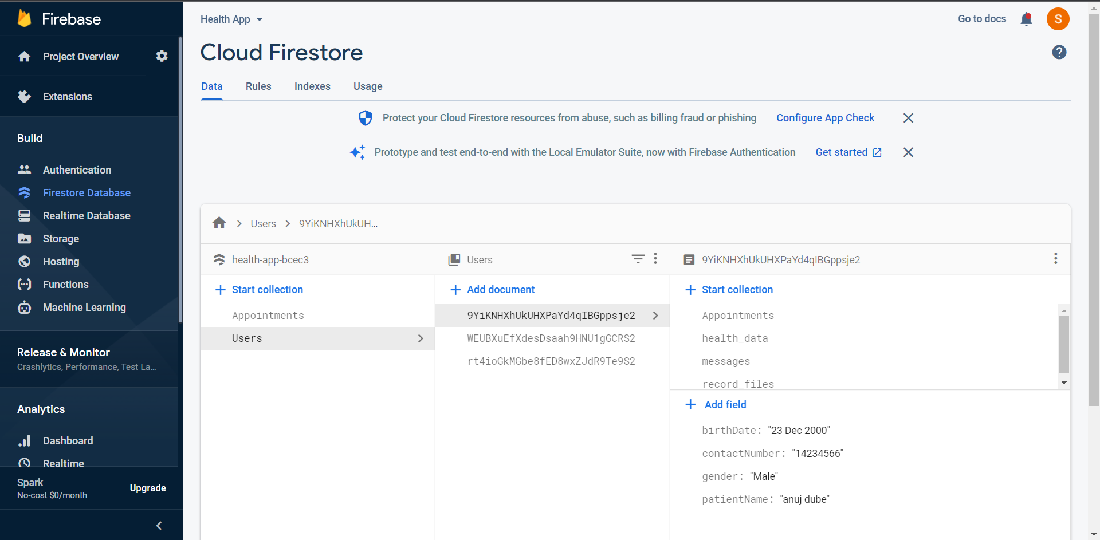

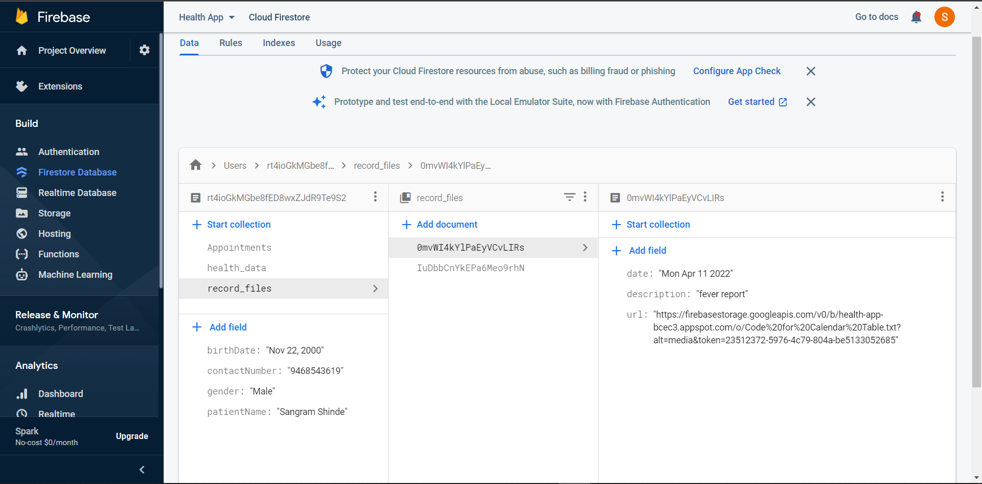

**6.3 Test Cases And Results**

| Test Case No. | Test Case Name | Prerequisites | Action | Excepted Result | Actual Result | Status |
| --- | --- | --- | --- | --- | --- | --- |
| 1 | Android Login | Username and OTP should be entered  . | Click on login button | Successful login for correct username and OTP and Unsuccessful login  for wrong username and OTP | Login is working correctly | Pass |
| 2 | Android Signup | All details must be entered  . | Click on signup button | Successful sign- up for correct details | Sign- up is working correctly | Pass |
| 3 | Web Login | email and password should be entered | Click on login button | Successful login for correct email and password and Unsuccessful login for wrong email or password | Login For web app is working correctly | Pass |
| 4 | Upload documents | Select Document to upload and enter comments for document | Click on upload button | document is uploaded successfully on firebase firestore and you can see it in android app | Uploading document is working correctly and it’s visible in android app | Pass |
| 5 | Delete appointment | Select appointment to delete | click on delete button | appointment will be deleted from database and web and android side will be both updated | appointment is deleted from database and you can see it’s deleted from android and web app also | Pass |

**Table No 6.3 Test Cases**

**Chapter 7**

**Conclusion and Future work**

* 1. **Conclusion**

The application works for the benefit of the clinic and provides an interactive interface between the patient and the doctor. This paper proposed a healthcare system that provides both healthcare providers and patients access to accurate and up-to-date information with less time and effort as well as improved efficiency of the information flow. The main advantage of this system is that doctors will be provided with a full history of their patients’ health status and patients will hold their data wherever they go. The proposed system will also help Medical Doctors to speed up diagnosis and treatment of patients through the advice and interaction with the patient.

The system is portable and can easily be installed and used on any mobile phones supporting Android OS. and for web app we just need a browser to access the system. The use of this system can result in a reduction in the number of hours spent searching for doctors and contacting them at the time of need. It also provides an interface that is easy to understand by the users and greatly helps in adapting to the use of this system.

### Future Scope

This application can be improved in the future by adding the following functionalities:

* Supporting video calls to discuss the problems with doctors.
* Implement hardware for monitoring status of the patient.
* Patients' reports can be stored in encrypted form.
* The system can also be enhanced by using the voice recognition feature of the Android.

# References

[1]   Using Mobile Application to Improve Doctor-Patient Interaction in Healthcare Delivery System - [Ekwonwune Emmanuel Nwabueze](https://m.scirp.org/s/searchPaper.action?kw=Ekwonwune%20Emmanuel+Nwabueze&sf=au)1, [Onuoha Oju](https://m.scirp.org/s/searchPaper.action?kw=Onuoha+Oju&sf=au)

[2]   Android Application for Healthcare Appointment Booking System - Asst. Prof. N. V. Chaudhari, Akshay Phadnis, Prajakta Dhomane, Jayshree Nimje, Akansha Sharma

# [3]   A Systematic Review of Healthcare Applications for Smartphones - [Abu Saleh Mohammad Mosa](https://bmcmedinformdecismak.biomedcentral.com/articles/10.1186/1472-6947-12-67#auth-Abu_Saleh_Mohammad-Mosa), [Illhoi Yoo](https://bmcmedinformdecismak.biomedcentral.com/articles/10.1186/1472-6947-12-67#auth-Illhoi-Yoo), [Lincoln Sheets](https://bmcmedinformdecismak.biomedcentral.com/articles/10.1186/1472-6947-12-67#auth-Lincoln-Sheets)

[4] Olga Schors, Top UI Design Principles To Keep In Mind

[5] User Interface Design Tips, Techniques and Principles (ambysoft.com)

[6] Inkbot Design, Medium.com 13 UI Design Principles, A Good Interface? 13 UI Design Principles