# **Name- Sangram Mandal (SupersetID:** **6363848)**

# **WEEK – 7 (Handson- Exercises)**

**React:**

**LAB-9:** **ReactJS-HOL:-**

### **Code:**

**In Components/ListOfPlayers.js:**

iimport React from 'react';

const ListofPlayers = () => {

  const players = [

    { name: "Virat Kohli", score: 85 },

    { name: "Rohit Sharma", score: 45 },

    { name: "KL Rahul", score: 60 },

    { name: "Shreyas Iyer", score: 77 },

    { name: "Hardik Pandya", score: 30 },

    { name: "Ravindra Jadeja", score: 95 },

    { name: "Jasprit Bumrah", score: 65 },

    { name: "Mohammed Shami", score: 82 },

    { name: "Kuldeep Yadav", score: 70 },

    { name: "Ishan Kishan", score: 48 },

    { name: "Suryakumar Yadav", score: 91 }

  ];

  const below70 = players.filter(player => player.score < 70);

  return (

    <div>

      <h2>All Players</h2>

      <ul>

        {players.map((player, index) => (

          <li key={index}>{player.name} - {player.score}</li>

        ))}

      </ul>

      <h2>Players with score below 70</h2>

      <ul>

        {below70.map((player, index) => (

          <li key={index}>{player.name} - {player.score}</li>

        ))}

      </ul>

    </div>

  );

};

export default ListofPlayers;

**In Components/IndianPlayers.js:**

import React from 'react';

const IndianPlayers = () => {

  const allPlayers = ["Virat", "Rohit", "Rahul", "Iyer", "Hardik", "Jadeja", "Bumrah", "Shami", "Kuldeep", "Ishan", "Surya"];

  const oddPlayers = allPlayers.filter((_, i) => i % 2 !== 0);

  const evenPlayers = allPlayers.filter((_, i) => i % 2 === 0);

  const T20players = ["Virat", "Rohit", "Surya"];

  const RanjiTrophyPlayers = ["Pujara", "Rahane", "Jadeja"];

  const mergedPlayers = [...T20players, ...RanjiTrophyPlayers];

  return (

    <div>

      <h2>Odd Team Players</h2>

      <ul>

        {oddPlayers.map((player, index) => <li key={index}>{player}</li>)}

      </ul>

      <h2>Even Team Players</h2>

      <ul>

        {evenPlayers.map((player, index) => <li key={index}>{player}</li>)}

      </ul>

      <h2>Merged Players (T20 + Ranji)</h2>

      <ul>

        {mergedPlayers.map((player, index) => <li key={index}>{player}</li>)}

      </ul>

    </div>

  );

};

export default IndianPlayers;

**In App.js:**

import React from 'react';

import ListofPlayers from './ListofPlayers';

import IndianPlayers from './IndianPlayers';

function App() {

  const flag = true;

  return (

    <div>

      <h1>🏏 Cricket App</h1>

      {flag ? <ListofPlayers /> : <IndianPlayers />}

    </div>

  );

}

export default App;

**Output:**

**When Flag = true;**

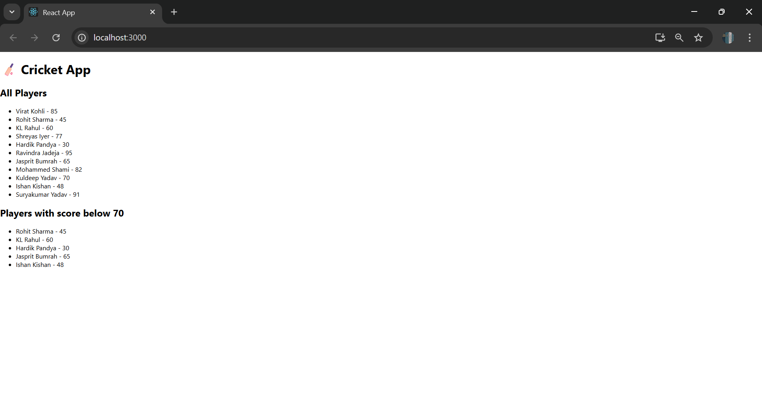

**LAB-10:** **ReactJS-HOL:-**

**Code:**

**In SRC/App.js:**

import React from 'react';

import './App.css';

function App() {

  const element = "Office Space";

  const sr = "https://officebanao.com/wp-content/uploads/2024/05/bright-office-interior-with-city-view-1200x675.jpg";

  const ItemName = {

    Name: "DBS",

    Rent: 50000,

    Address: "Chennai"

  };

  let rentClass = "";

  if (ItemName.Rent <= 60000) {

    rentClass = "textRed";

  } else {

    rentClass = "textGreen";

  }

  return (

    <div className="App">

      <h1>{element} , at Affordable Range</h1>

      <img src={sr} width="25%" height="25%" alt="Office Space" />

      <h1>Name: {ItemName.Name}</h1>

      <h3 className={rentClass}>Rent: Rs. {ItemName.Rent}</h3>

      <h3>Address: {ItemName.Address}</h3>

    </div>

  );

}

export default App;

**Output:**

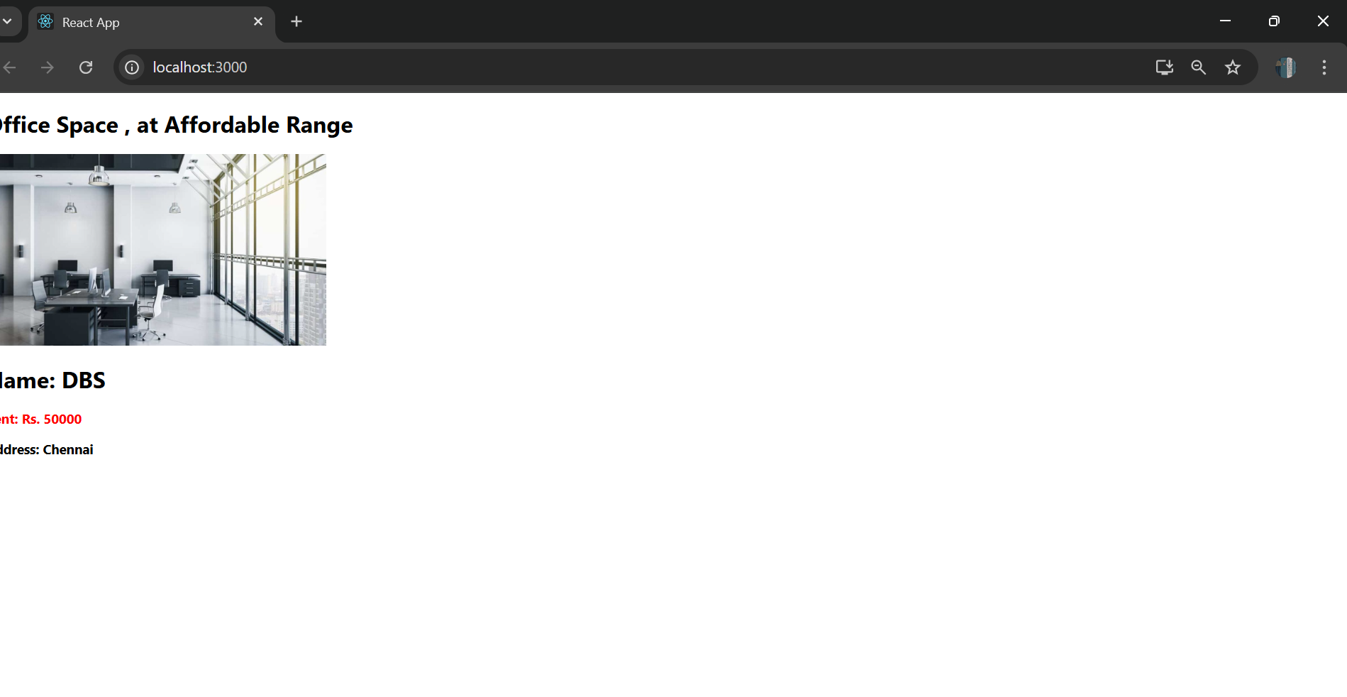

**LAB-11:** **ReactJS-HOL:-**

**Code:**

**In SRC/App.js:**

import React, { useState } from 'react';

import './App.css';

function CurrencyConvertor() {

  const [amount, setAmount] = useState('');

  const [currency, setCurrency] = useState('');

  const handleSubmit = (e) => {

    e.preventDefault();

    const euroRate = 80;

    const converted = amount * euroRate;

    alert(`Converting to ${currency} Amount is ${converted}`);

  };

  return (

    <div>

      <h2 style={{ color: 'green' }}>Currency Convertor!!!</h2>

      <form onSubmit={handleSubmit}>

        <div>

          <label>Amount: </label>

          <input

            type="text"

            value={amount}

            onChange={(e) => setAmount(e.target.value)}

          />

        </div>

        <div>

          <label>Currency: </label>

          <input

            type="text"

            value={currency}

            onChange={(e) => setCurrency(e.target.value)}

          />

        </div>

        <button type="submit">Submit</button>

      </form>

    </div>

  );

}

function App() {

  const [count, setCount] = useState(0);

  const increment = () => {

    setCount(prev => prev + 1);

    sayHello();

  };

  const decrement = () => {

    setCount(prev => prev - 1);

  };

  const sayHello = () => {

    alert("Hello Member1");

  };

  const sayWelcome = (msg) => {

    alert(msg);

  };

  const onClickHandler = () => {

    alert("I was clicked");

  };

  return (

    <div className="App">

      <h3>{count}</h3>

      <button onClick={increment}>Increment</button>

      <button onClick={decrement}>Decrement</button>

      <br /><br />

      <button onClick={() => sayWelcome("welcome")}>Say welcome</button>

      <br /><br />

      <button onClick={onClickHandler}>Click on me</button>

      <br /><br />

      <CurrencyConvertor />

    </div>

  );

}

export default App;

**Output:**

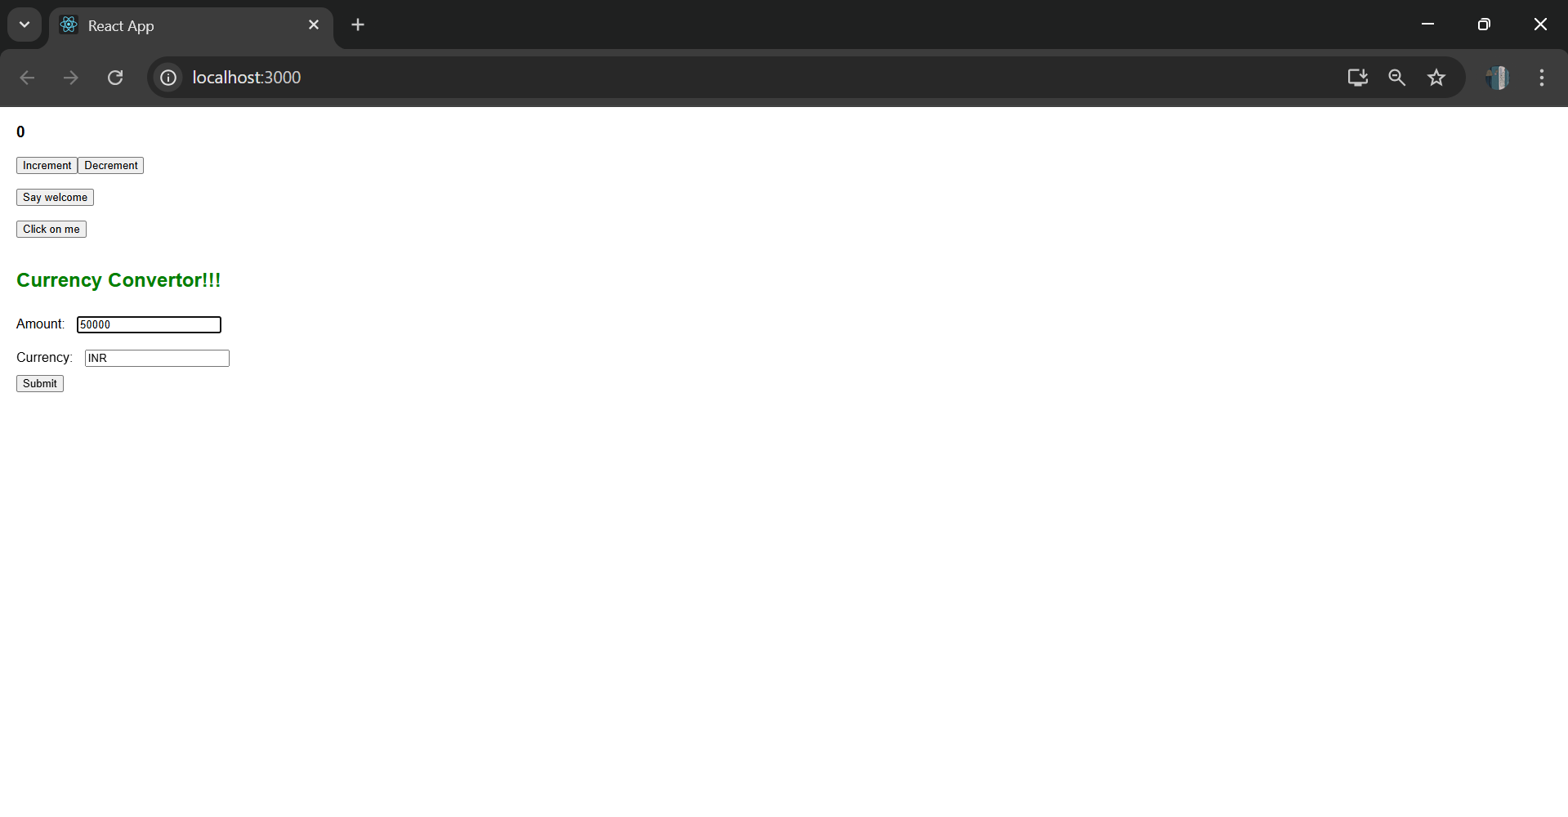

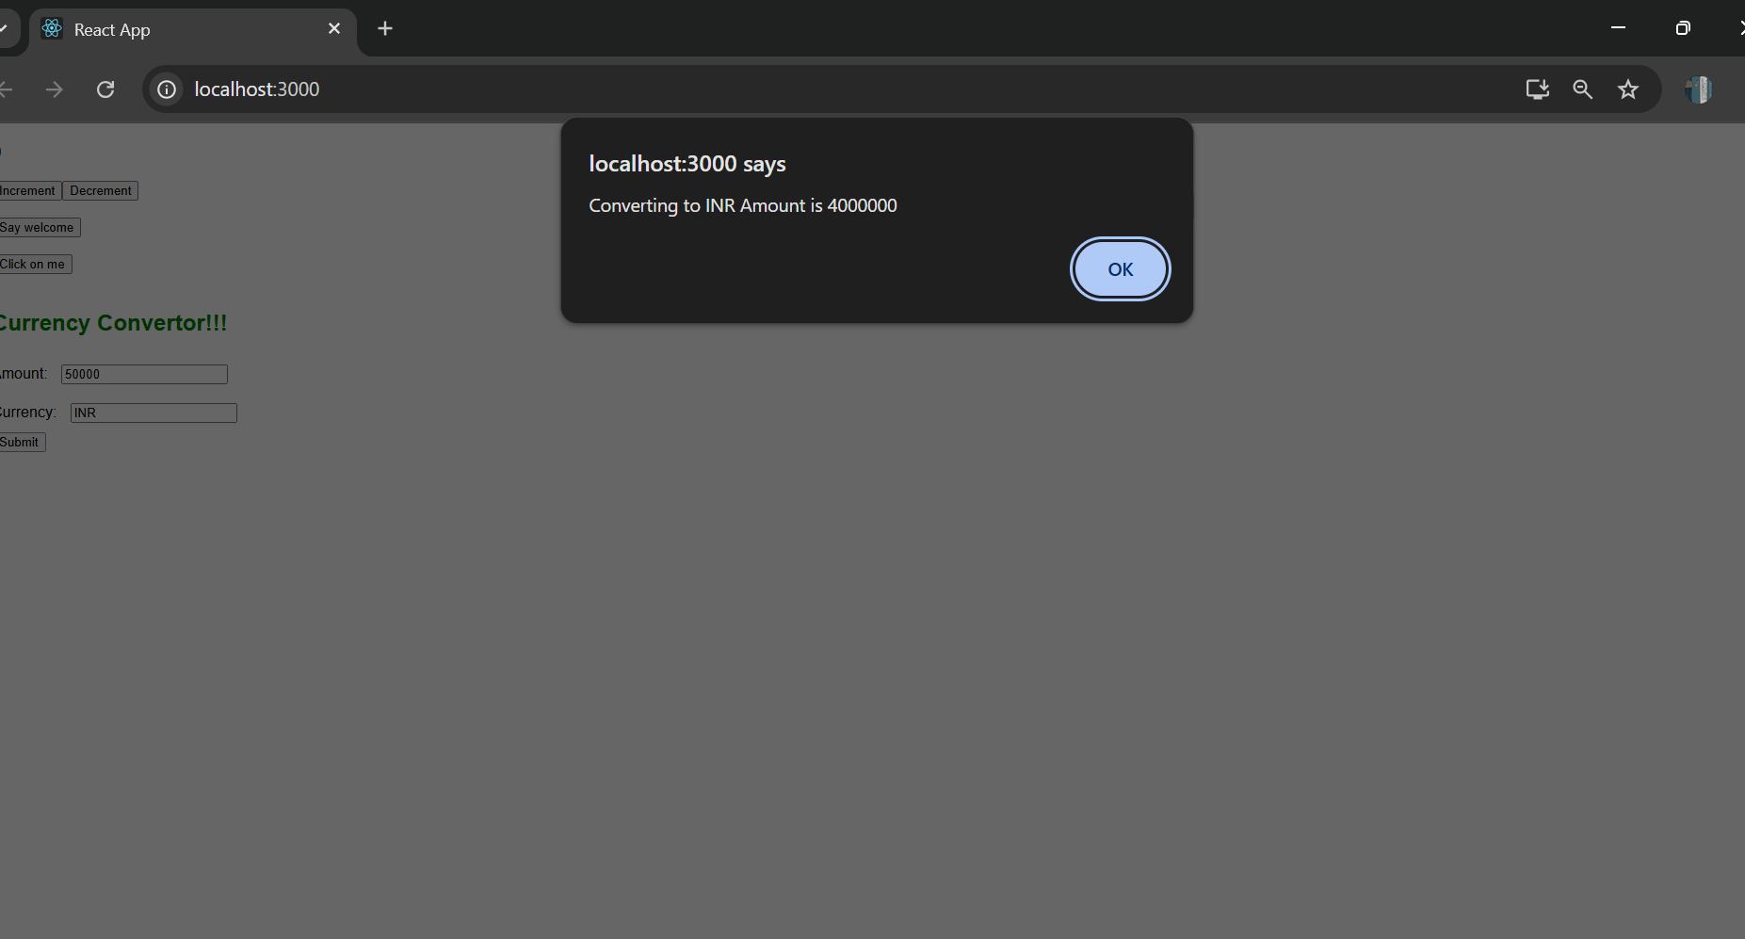

**LAB-12 :ReactJS-HOL:-**

**Code:**

**In Components/GuestPage.js:**

import React from "react";

const GuestPage = () => {

  return (

    <div style={{ padding: "20px", border: "1px solid black" }}>

      <h2>Welcome, Guest!</h2>

      <p>You can browse available flights but must log in to book tickets.</p>

      <h3>Available Flights:</h3>

      <ul>

        <li>Flight A - Delhi to Mumbai</li>

        <li>Flight B - Bangalore to Kolkata</li>

        <li>Flight C - Chennai to Hyderabad</li>

      </ul>

    </div>

  );

};

export default GuestPage;

**In Components/UserPage.js:**

import React from "react";

const UserPage = () => {

  return (

    <div style={{ padding: "20px", border: "1px solid green" }}>

      <h2>Welcome, User!</h2>

      <p>You are logged in. You can book your flight tickets below.</p>

      <h3>Book Your Flight:</h3>

      <ul>

        <li>Flight A - <button>Book Now</button></li>

        <li>Flight B - <button>Book Now</button></li>

        <li>Flight C - <button>Book Now</button></li>

      </ul>

    </div>

  );

};

export default UserPage;

**In App.js:**

import React, { Component } from "react";

import GuestPage from "./Components/GuestPage";

import UserPage from "./Components/UserPage";

class App extends Component {

  constructor(props) {

    super(props);

    this.state = {

      isLoggedIn: false,

    };

  }

  handleLogin = () => {

    this.setState({ isLoggedIn: true });

  };

  handleLogout = () => {

    this.setState({ isLoggedIn: false });

  };

  render() {

    const { isLoggedIn } = this.state;

    let pageContent;

    if (isLoggedIn) {

      pageContent = <UserPage />;

    } else {

      pageContent = <GuestPage />;

    }

    return (

      <div style={{ padding: "20px", fontFamily: "Arial" }}>

        <h1>Ticket Booking App</h1>

        {isLoggedIn ? (

          <button onClick={this.handleLogout}>Logout</button>

        ) : (

          <button onClick={this.handleLogin}>Login</button>

        )}

        <hr />

        {pageContent}

      </div>

    );

  }

}

export default App;

**Output:**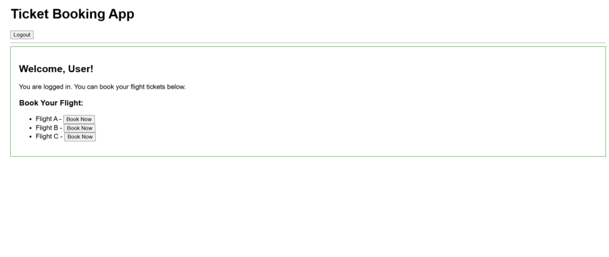

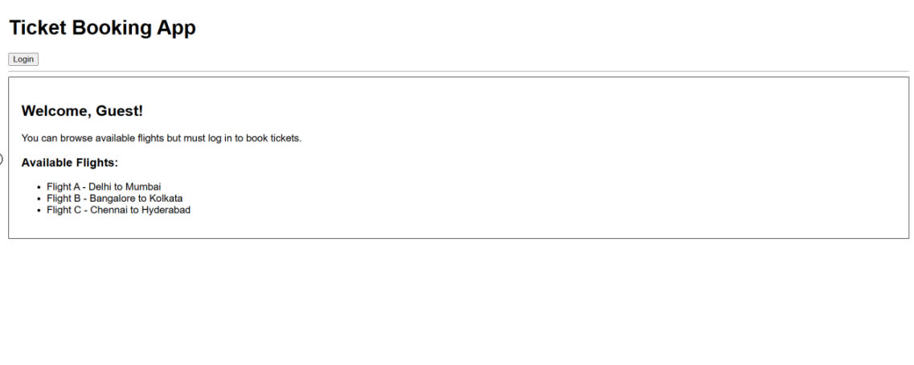

**LAB-13 :ReactJS-HOL:-**

**Code:**

**In Components/BookDetails.js:**

import React from "react";

function BookDetails() {

  const books = [

    { title: "Master React", price: 670 },

    { title: "Deep Dive into Angular 11", price: 800 },

    { title: "Mongo Essentials", price: 450 }

  ];

  return (

    <div style={{ flex: 1, borderRight: "3px solid green", padding: "0 20px" }}>

      <h2>Book Details</h2>

      {books.map((book, index) => (

        <div key={index} style={{ marginBottom: "15px" }}>

          <h3>{book.title}</h3>

          <p style={{ margin: "5px 0" }}>Price: ₹{book.price}</p>

        </div>

      ))}

    </div>

  );

}

export default BookDetails;

**In Components/BlogDetails.js:**

import React from "react";

function BlogDetails() {

  const blogs = [

    {

      title: "React Learning",

      author: "Stephen Biz",

      content: "Welcome to learning React!"

    },

    {

      title: "Installation",

      author: "Schwezdenier",

      content: "You can install React from npm."

    }

  ];

  return (

    <div style={{ flex: 1, padding: "0 20px" }}>

      <h2>Blog Details</h2>

      {blogs.map((blog, index) => (

        <div key={index} style={{ marginBottom: "20px" }}>

          <h3>{blog.title}</h3>

          <p style={{ margin: "5px 0", fontWeight: "bold" }}>Author: {blog.author}</p>

          <p>{blog.content}</p>

        </div>

      ))}

    </div>

  );

}

export default BlogDetails;

**In Components/CourseDetails.js:**

import React from "react";

function CourseDetails() {

  const courses = [

    { name: "Angular", date: "4/5/2021" },

    { name: "React", date: "6/3/2021" }

  ];

  return (

    <div style={{ flex: 1, borderRight: "3px solid green", padding: "0 20px" }}>

      <h2>Course Details</h2>

      {courses.map((course, index) => (

        <div key={index} style={{ marginBottom: "15px" }}>

          <strong>{course.name}</strong>

          <p>{course.date}</p>

        </div>

      ))}

    </div>

  );

}

export default CourseDetails;

**In App.js:**

import React, { useState } from "react";

import CourseDetails from "./Components/CourseDetails";

import BookDetails from "./Components/BookDetails";

import BlogDetails from "./Components/BlogDetails";

function App() {

  const [section, setSection] = useState("");

  const renderSection = () => {

    switch (section) {

      case "course":

        return <CourseDetails />;

      case "book":

        return <BookDetails />;

      case "blog":

        return <BlogDetails />;

      default:

        return <p>Please select a section to view.</p>;

    }

  };

  return (

    <div style={{ padding: "30px", fontFamily: "Arial" }}>

      <h1>Blogger App</h1>

      {/* Navigation Buttons */}

      <div style={{ marginBottom: "20px" }}>

        <button onClick={() => setSection("course")}>Show Course</button>

        <button onClick={() => setSection("book")} style={{ marginLeft: "10px" }}>

          Show Book

        </button>

        <button onClick={() => setSection("blog")} style={{ marginLeft: "10px" }}>

          Show Blog

        </button>

      </div>

      {/* Conditionally Render Section */}

      <div style={{ display: "flex", justifyContent: "center" }}>

        {renderSection()}

      </div>

    </div>

  );

}

export default App;

**Output:**



