Name-Sangram Mandal

Superset Id-6363848

Week-2(Handson-Exercise)

1. MOQ Handson
2. Write Testable Code with Moq

Code :

In Mailsender.cs :

using System.Net;

using System.Net.Mail;

namespace CustomerCommLib

{

    public interface IMailSender

    {

        bool SendMail(string toAddress, string message);

    }

    public class MailSender : IMailSender

    {

        public bool SendMail(string toAddress, string message)

        {

            MailMessage mail = new MailMessage();

            SmtpClient SmtpServer = new SmtpClient("smtp.gmail.com");

            mail.From = new MailAddress("your_email_address@gmail.com");

            mail.To.Add(toAddress);

            mail.Subject = "Test Mail";

            mail.Body = message;

            SmtpServer.Port = 587;

            SmtpServer.Credentials = new NetworkCredential("username", "password");

            SmtpServer.EnableSsl = true;

            SmtpServer.Send(mail);

            return true;

        }

    }

}

In CustomerComm :

namespace CustomerCommLib

{

    public class CustomerComm

    {

        private IMailSender _mailSender;

        public CustomerComm(IMailSender mailSender)

        {

            _mailSender = mailSender;

        }

        public bool SendMailToCustomer()

        {

            _mailSender.SendMail("cust123@abc.com", "Some Message");

            return true;

        }

    }

}

Output :

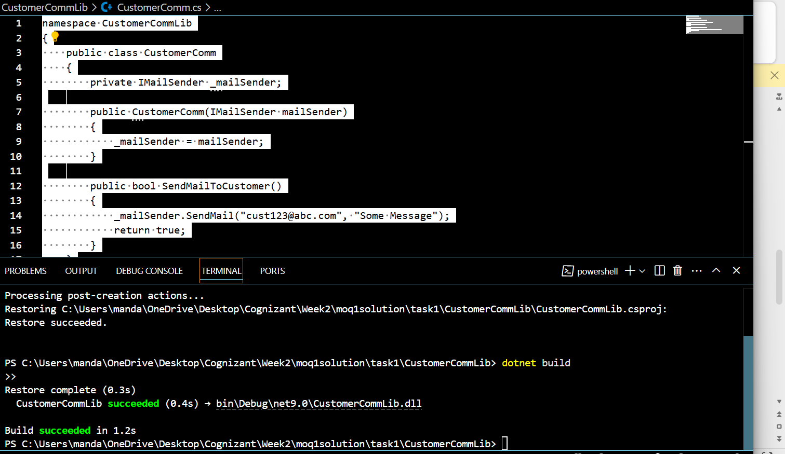

**Task 2 :**

**Output :**

