Name-Sangram Mandal

Superset Id-6363848

Week-6(Handson-Exercise)

**LAB-1:** **ReactJS-HOL:-**

1. change the whole **app.js** code with:

import React from 'react';

function App() {

  return (

    <div>

      <h1>Welcome to the first session of React</h1>

    </div>

  );

}

export default App;

**Output:**

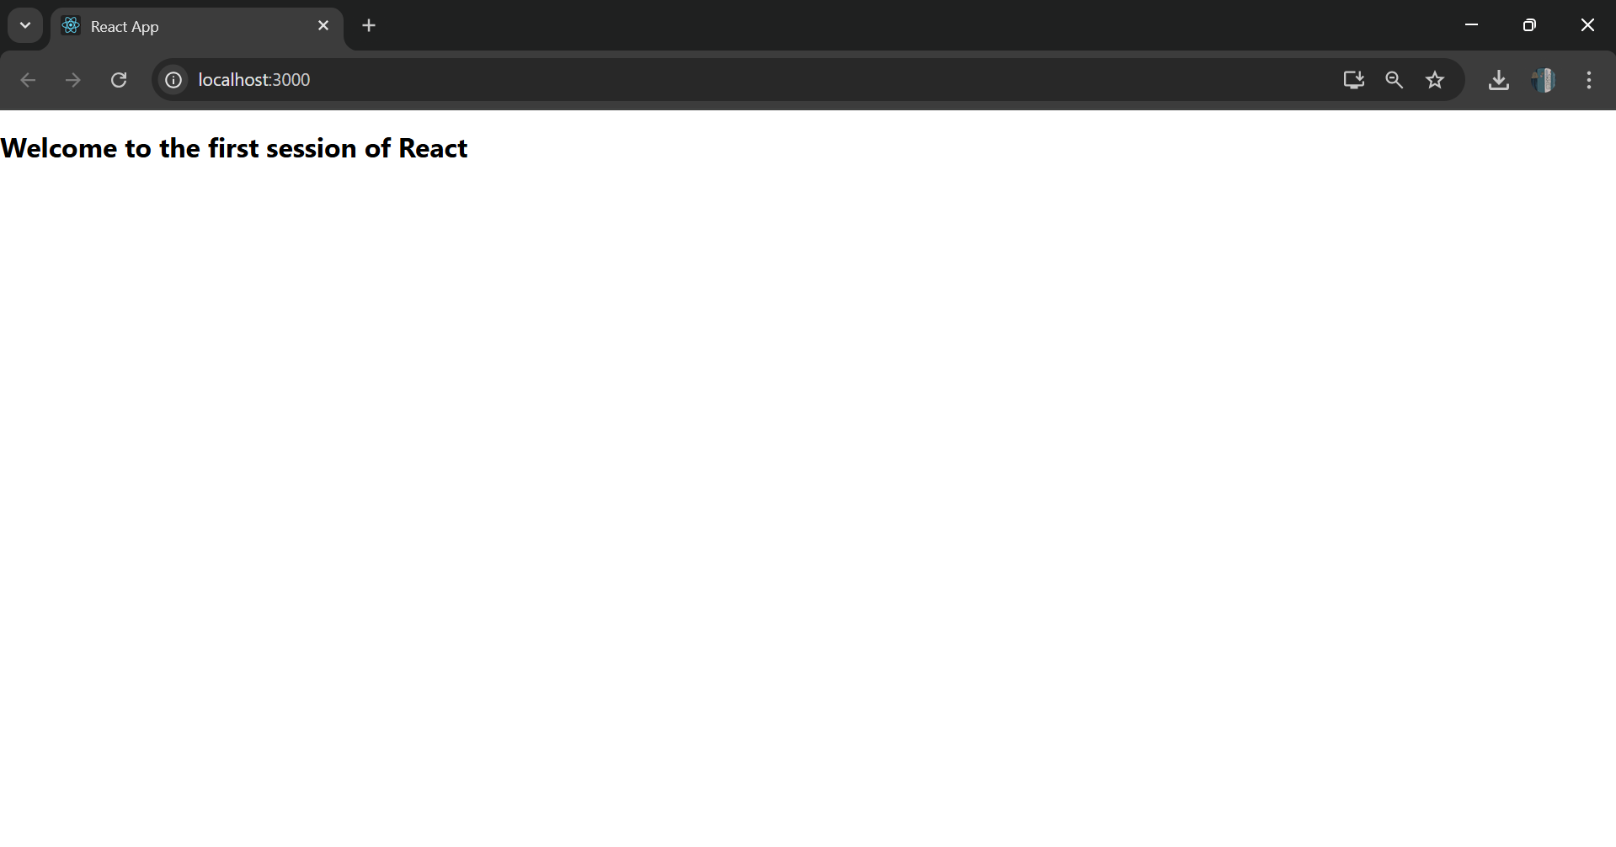

**LAB-2:** **ReactJS-HOL:-**

**Code:**

**Created a studentapp:**

npx create-react-app studentapp

**In Home.js:**

**In Home.js:**

import React, { Component } from 'react';

class Home extends Component {

  constructor() {

    super();

  }

  render() {

    return (

      <div>

        <h2>Welcome to the Home page of Student Management Portal</h2>

      </div>

    );

  }

}

export default Home;

**In About.js:**

import React, { Component } from 'react';

class About extends Component {

  constructor() {

    super();

  }

  render() {

    return (

      <div>

        <h2>Welcome to the About page of the Student Management Portal</h2>

      </div>

    );

  }

}

export default About;

**In Contact.js:**

import React, { Component } from 'react';

class Contact extends Component {

  constructor() {

    super();

  }

  render() {

    return (

      <div>

        <h2>Welcome to the Contact page of the Student Management Portal</h2>

      </div>

    );

  }

}

export default Contact;

**In App.js:**

import React from 'react';

import Home from './Components/Home';

import About from './Components/About';

import Contact from './Components/Contact';

function App() {

  return (

    <div className="App">

      <Home />

      <About />

      <Contact />

    </div>

  );

}

export default App;

**Output:**

**npm start:**

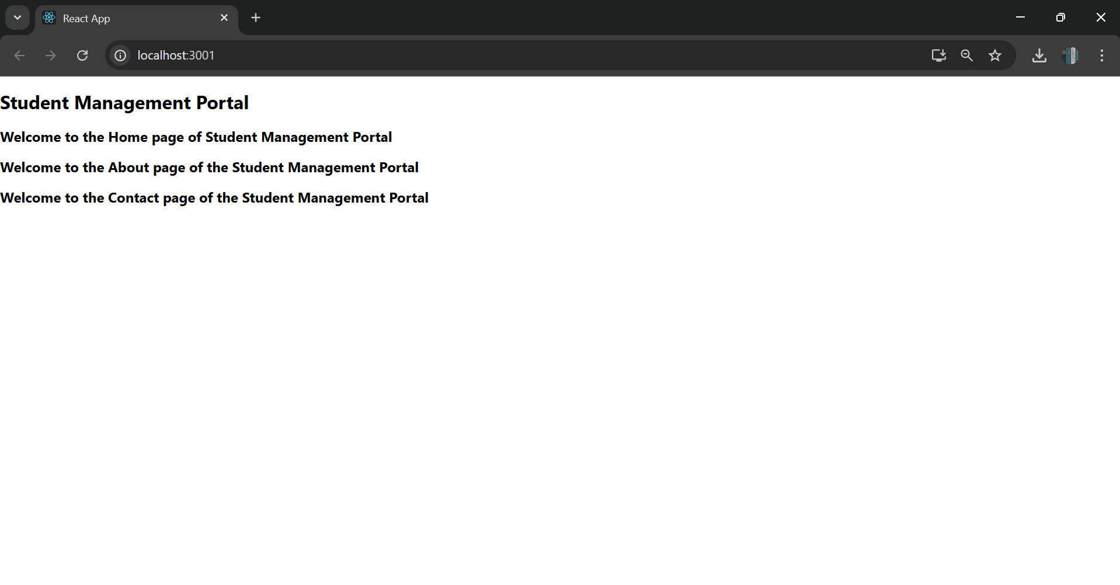

**LAB-3:** **ReactJS-HOL:-**

**Code:**

**CalculateScore.js:**

import React from 'react';

import '../Stylesheets/mystyle.css';

function CalculateScore() {

  const name = "Sangram Mandal";

  const school = "Nayabasat P.M Siskha Niketan";

  const totalMarks = 425;

  const numberOfSubjects = 5;

  const goal = 90;

  const average = totalMarks / numberOfSubjects;

  return (

    <div className="score-container">

      <h2>Score Calculator</h2>

      <p><strong>Name:</strong> {name}</p>

      <p><strong>School:</strong> {school}</p>

      <p><strong>Total Marks:</strong> {totalMarks}</p>

      <p><strong>Goal:</strong> {goal}%</p>

      <p className="average"><strong>Average Score:</strong> {average}</p>

    </div>

  );

}

export default CalculateScore;

**In Stylesheets:**

**MyStyle.css:**

.score-container {

  background-color: #f0f8ff;

  border: 2px solid #0077cc;

  padding: 20px;

  border-radius: 10px;

  width: 400px;

  margin: 30px auto;

  font-family: Arial, sans-serif;

  box-shadow: 0px 0px 10px rgba(0, 0, 0, 0.1);

}

.score-container h2 {

  text-align: center;

  color: #0077cc;

}

.average {

  color: green;

  font-size: 18px;

}

**In App.js:**

import React from 'react';

import './App.css';

import CalculateScore from './Components/CalculateScore';

function App() {

  return (

    <div className="App">

      <CalculateScore />

    </div>

  );

}

export default App;

**Output:**

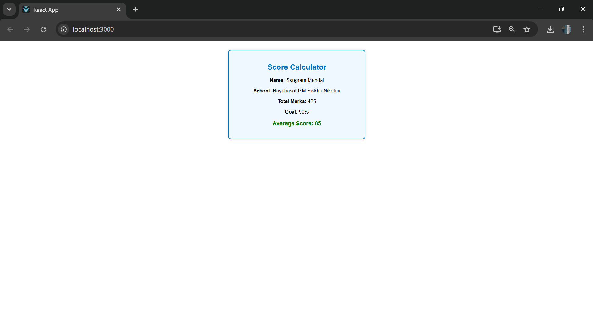

**LAB-4:ReactJS-HOL:-**

**Code:**

**npx create-react-app blogapp**

**cd blogapp**

**In SRC/ Post.js:**

class Post {

  constructor(userId, id, title, body) {

    this.userId = userId;

    this.id = id;

    this.title = title;

    this.body = body;

  }

}

export default Post;

**In SRC/Posts.js:**

import React, { Component } from 'react';

import Post from './Post';

class Posts extends Component {

  constructor(props) {

    super(props);

    this.state = {

      posts: [],

      hasError: false

    };

  }

  loadPosts() {

    fetch('https://jsonplaceholder.typicode.com/posts')

      .then(response => response.json())

      .then(data => {

        const postObjects = data.map(

          item => new Post(item.userId, item.id, item.title, item.body)

        );

        this.setState({ posts: postObjects });

      })

      .catch(error => {

        console.error('Error fetching posts:', error);

        this.setState({ hasError: true });

      });

  }

  componentDidMount() {

    this.loadPosts();

  }

  componentDidCatch(error, info) {

    alert("Something went wrong while loading the posts.");

    console.error(error, info);

  }

  render() {

    if (this.state.hasError) {

      return <h2>Error loading posts.</h2>;

    }

    return (

      <div>

        <h1>Blog Posts</h1>

        {this.state.posts.map(post => (

          <div key={post.id}>

            <h2>{post.title}</h2>

            <p>{post.body}</p>

            <hr />

          </div>

        ))}

      </div>

    );

  }

}

export default Posts;

**In App.js:**

import React from 'react';

import './App.css';

import Posts from './Posts';

function App() {

  return (

    <div className="App">

      <Posts />

    </div>

  );

}

export default App;

**Output:**

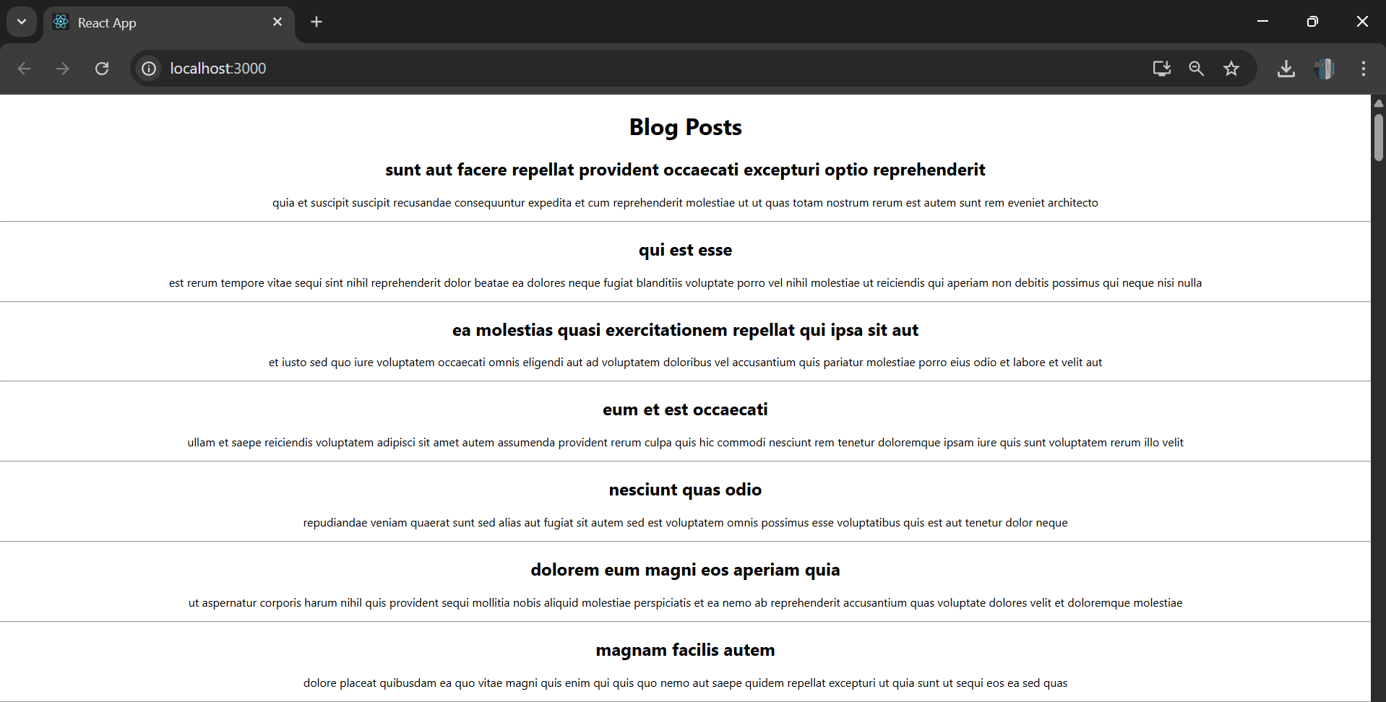

**LAB-5:ReactJS-HOL:-**

**Code:**

**In SRC/** **CohortDetails.module.css:**

.box {

  width: 300px;

  display: inline-block;

  margin: 10px;

  padding: 10px 20px;

  border: 1px solid black;

  border-radius: 10px;

}

dt {

  font-weight: 500;

}

**In CohortDetails.js:**

import React from 'react';

import styles from '../Styles/CohortDetails.module.css';

const CohortDetails = ({ name, startDate, status }) => {

  return (

    <div className={styles.box}>

      <h3 style={{ color: status === 'ongoing' ? 'green' : 'blue' }}>{status}</h3>

      <dl>

        <dt>Name:</dt>

        <dd>{name}</dd>

        <dt>Start Date:</dt>

        <dd>{startDate}</dd>

      </dl>

    </div>

  );

};

export default CohortDetails;

**In App.js:**

import React from 'react';

import './App.css';

import CohortDetails from './Components/CohortDetails';

function App() {

  const cohorts = [

    { name: 'React Bootcamp', startDate: '2025-07-01', status: 'ongoing' },

    { name: 'NodeJS Fundamentals', startDate: '2025-06-01', status: 'completed' },

    { name: 'Fullstack Live', startDate: '2025-05-15', status: 'completed' },

  ];

  return (

    <div className="App">

      <h1>Cohort Dashboard</h1>

      {cohorts.map((cohort, index) => (

        <CohortDetails

          key={index}

          name={cohort.name}

          startDate={cohort.startDate}

          status={cohort.status}

        />

      ))}

    </div>

  );

}

export default App;

**Output:**

