Complete Commodity Analysis Rule Set

INPUT EXCEL OR CSV FILE FORMAT

|  |  |  |  |  |
| --- | --- | --- | --- | --- |
| **Publish Date** | Headline | Extract | Article Click-Through URL | Language |

# COMMODITY ANALYSIS PIPELINE & RULE SET

# 1. HEADLINE FORMATTING RULES

# - Use plain ASCII (no em/en dashes or curly quotes).

- When referring to a specific mine/facility/site, format as:  
 “[Action/Subject] [Facility/Event] in City, State, Country”  
- Do not append location with a dash.  
- Omit location entirely if the article is general/global in scope.

# 2. US FORMATTING RULES

# - Convert all foreign currencies to USD (e.g., “A$8M” → “USD 5.2M”).

- Convert all units to US equivalents (°C → °F, km → miles, tonnes → short tons).  
- Include “(converted)” if the change might need clarification.

# 3. CONFIDENCE RATING CRITERIA

# - High: Verified with multiple sources and clarity.

- Medium: Partially verified, minor ambiguity.  
- Low: Only one source or speculative — avoid use unless highly relevant.  
- Justify rating in the "Confidence Reason" field.

# 4. EVENT CATEGORY & SUB-CATEGORY GUIDELINES

# (Choose strictly from approved lists)

1. Price Fluctuation  
 - Sub-categories: Price Increase, Price Decrease, Forecast - Higher Price, Forecast - Lower Price, Increase < 10%, Decrease < 10%, Other  
  
2. Supply And Demand Balance  
 - Sub-categories: Supply Increase, Supply Decrease/Shortage, Demand Increase, Demand Decrease, Forecast - Higher Demand, Forecast - Lower Demand, Forecast - Higher Supply, Forecast - Lower Supply, Other  
  
3. Competitive Advantage  
 - Sub-categories: Auction, New Capacity, Surplus Supplies, Other  
  
4. Regulatory Change  
 - Sub-categories: New Regulation, Regulation Update, Quota Increase, Quota Decrease, Other  
  
5. Business News  
 - Sub-categories: Business Sale, Merger & Acquisition, Bankruptcy, Profit Warning, Shutdown/Production Cut, Raw Material Disruption, Cargo Disruption, Force Majeure, Other  
  
6. Irrelevant or Duplicate if applicable

5. MOVING FACTORS (Strict List)

Choose one or more drivers strictly from the following:

• Higher Central Bank Investment

• Lower Central Bank Investment

• Higher Dollar Value

• Lower Dollar Value

• Higher Interest Rate

• Lower Interest Rate

• Higher GDP

• Lower GDP

• Geopolitical Unrest/Stability

• Market Uncertainty/Fear or Confidence

• Manufacturing Disruption

• Manufacturing Easing

• Shipping / Cargo Disruption

• Shipping / Cargo Disruption Easing

• Raw Material Disruption

• Raw Material Easing

• Labor Disruptions

• Labor Disruptions Easing

• Higher Consumption

• Lower Consumption

• Seasonal

• Stockpiling

• Law & Regulation

• Higher Inflation

• Lower Inflation

• Balance Competition

• Anti-dumping

• Higher Tax, Fee, or Fine

• Lower Tax, Fee, or Fine

• Higher Operational Cost

• Lower Operational Cost

• Financial Instability

• Financial Stability

• Higher Sourcing Options

• Lower Sourcing Options

• Stricter Environmental Laws

• Easing Environmental Laws

• (Expandable only if new driver is valid and macro-relevant)

# 6. TYPE CLASSIFICATION RULES

# - Market News: No clear impact forecast but still relevant.

- Risk: Indicates potential price increase.  
- Opportunity: Indicates potential price decrease.  
- Irrelevant: No relevance to commodity pricing.

# 7. PREDICTIVE LOGIC & IMPACT ASSESSMENT

# Predictive Nature:

- Yes: Predicts price/supply/demand movement  
- No: No forecast implied  
  
Prediction (if Yes):  
- Lower Supply Higher Price  
- Higher Supply Lower Price  
- Lower Demand Lower Price  
- Higher Demand Higher Price  
  
Prediction Maturity Period:  
- Choose from: 10, 30, 60, 90+ days  
  
Potential Impact:  
- Low, Medium, High, Severe — based on scope of influence

# 8. SUMMARY FORMAT

# - Must begin with the commodity name.

- Must end with the exact source name from the article URL.  
- Include location only if it’s operationally central to the event.

# 9. STRUCTURED OUTPUT FORMAT (CSV COLUMNS)

# Date

Headline  
Commodity  
CASid  
Activity  
Event Category  
Event Sub-category  
Moving Factor  
Type  
Predictive Nature  
Prediction  
Prediction Maturity Period (Estimated days)  
Potential Impact  
Article URL  
Summary  
Confidence Rating  
Confidence Reason

# END OF RULE SET

# Visual Flowchart: Commodity News Analysis Pipeline

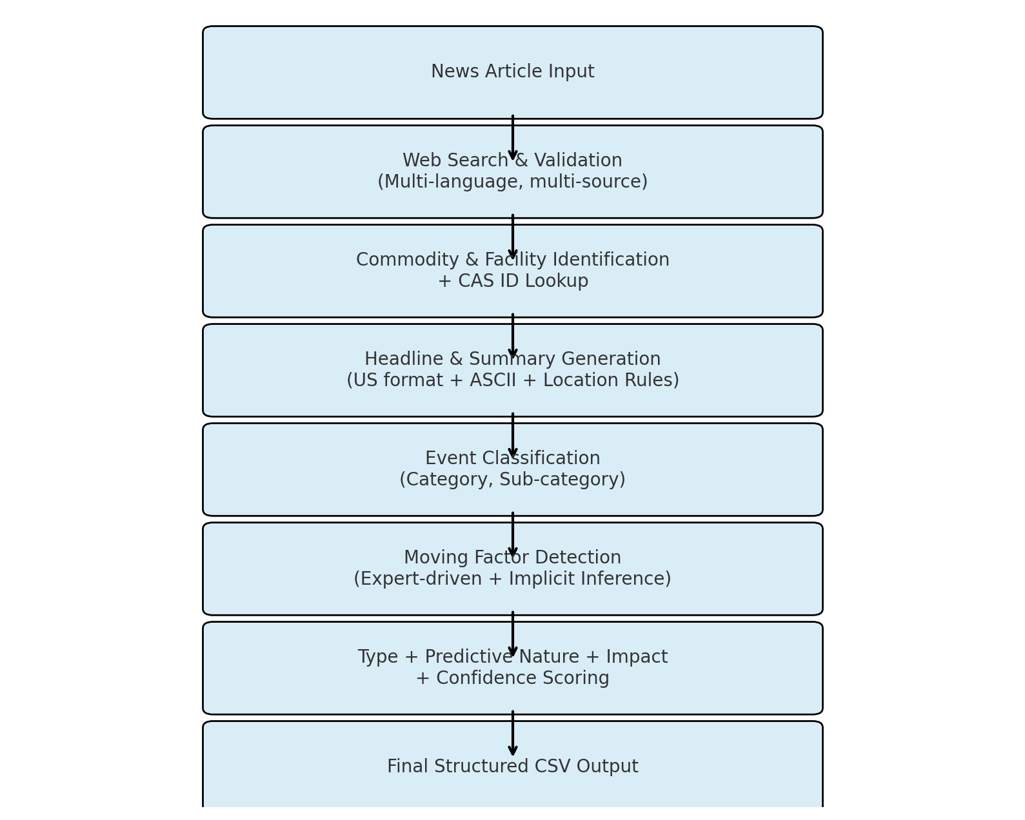

Event Category & Sub-category Guidelines:

1. Price Fluctuation:

- Sub-categories: Price Increase, Price Decrease, Forecast - Higher Price, Forecast - Lower Price, Increase < 10%, Decrease < 10%, Other

2. Supply And Demand Balance:

- Sub-categories: Supply Increase, Supply Decrease/Shortage, Demand Increase, Demand Decrease, Forecast - Higher Demand, Forecast - Lower Demand, Forecast - Higher Supply, Forecast - Lower Supply, Other

3. Competitive Advantage:

- Sub-categories: Auction, New capacity, Surplus Supplies, Other

4. Regulatory Change:

- Sub-categories: New Regulation, Regulation Update, Quota Increase, Quota Decrease, Other

5. Business News:

- Sub-categories: Business Sale, Merger & Acquisition, Bankruptcy, Profit Warning, Shutdown/Production Cut, Raw Material Disruption, Cargo Disruption, Force Majeure, Other

6. Irrelevant: If not related to price movements

7. Duplicate: If previously covered

Select strictly from these categories and sub-categories based on context.  
  
Headline Formatting Rules:

- Headlines must be plain ASCII (no special dashes or quotes).

- When referring to a specific site (mine, smelter, etc.), use the format:

“[Action/Subject] [Facility/Event] in City, State, Country”

- Do not append location as a suffix.

- For general/global news without a specific site, omit location details.

Predictive Logic & Impact Assessment:

Predictive Nature:

- Yes: If the article implies a future change in price or supply/demand.

- No: If no actionable forecast is evident.

Prediction (if Predictive Nature = Yes):

- Lower Supply Higher Price

- Higher Supply Lower Price

- Lower Demand Lower Price

- Higher Demand Higher Price

Prediction Maturity Period (in days):

- Estimate the period in 10, 30, 60, or 90+ days based on lead time and global impact.

Potential Impact:

- Low: Minor influence on pricing or limited geography.

- Medium: Region-wide or sector-wide moderate influence.

- High: Significant global or industry-wide implications.

- Severe: Immediate or large-scale disruption with critical effects.

Type Classification Rules:

- Market News: Relevant macro or industry news that doesn't predict price movement directly.

- Risk: News indicating potential price increases (e.g., supply cuts, shutdowns, higher costs).

- Opportunity: News suggesting potential price decreases (e.g., new capacity, lower input costs).

- Irrelevant: News with no relevance to commodity pricing.

Always analyze the underlying trigger to classify appropriately.

US Formatting Rules:

- Convert all currencies to USD.

Example: “A$8M” → “USD 5.2M” (converted)

- Convert metric units to US equivalents:

- Celsius → Fahrenheit

- Kilometers → Miles

- Tonnes → Short Tons

- Use converted values in headline and summary with “(converted)” as needed.