**----------------------------------------Practice-------------------------------------**

Name:-Suryawanshi Sangramsingh Sambhaji

Batch: - Delta - DCA (Java) 2024 Date:-30/7/2024

1. WAP to print the cube of each digit from the inputted number

Input: 1234

Output: 182764

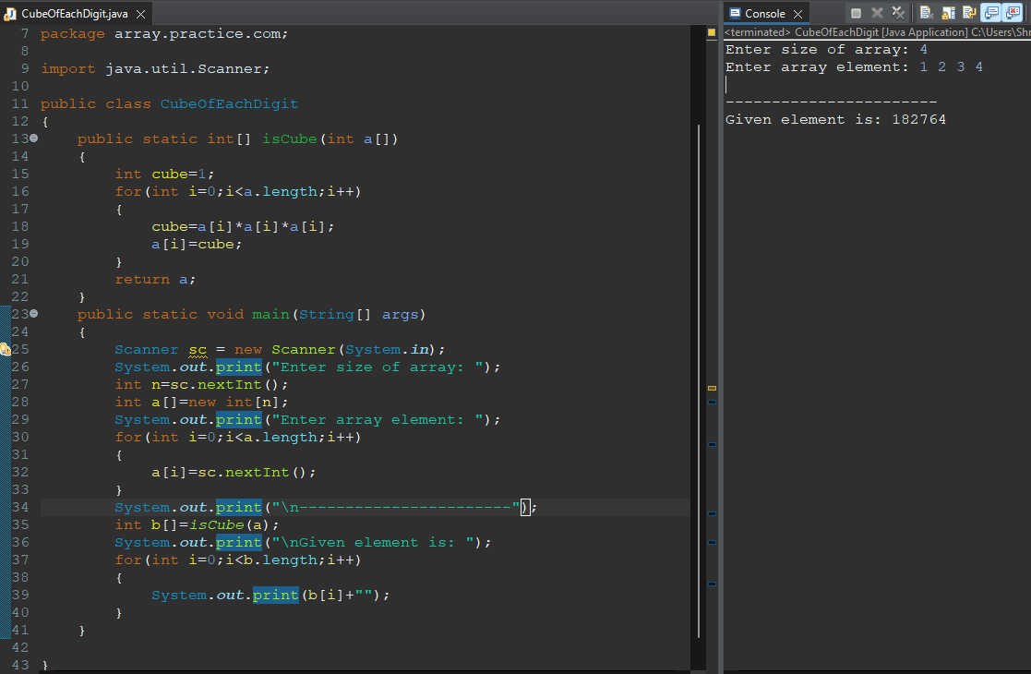

2. WAP to print the factorial of each prime digit from the inputted number

Input: 1234

Output: 1264 (since 1 and 4 are not primes, 2 -> 2, 3 -> 6)

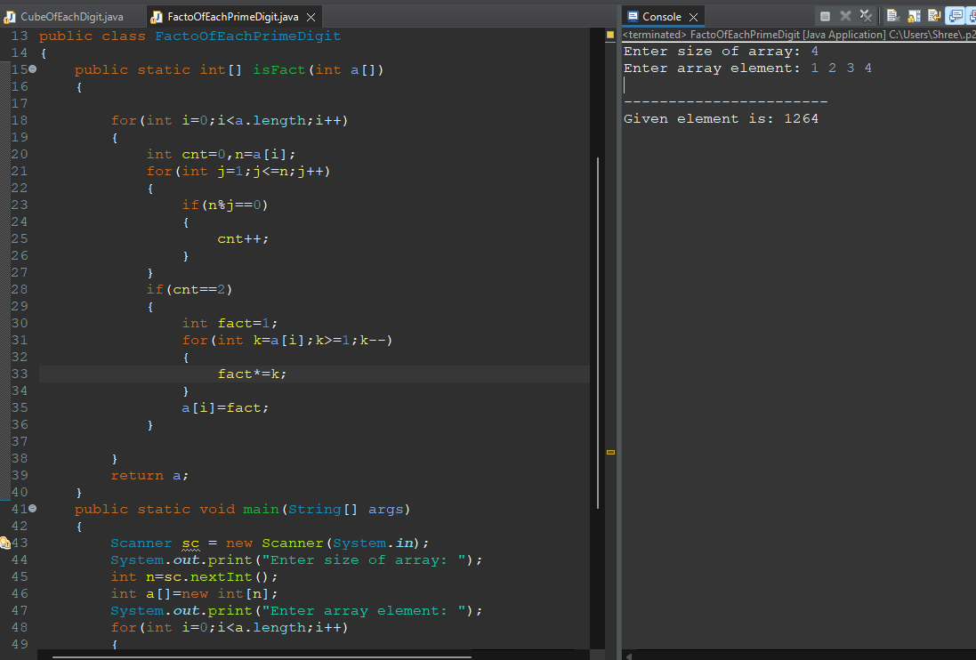

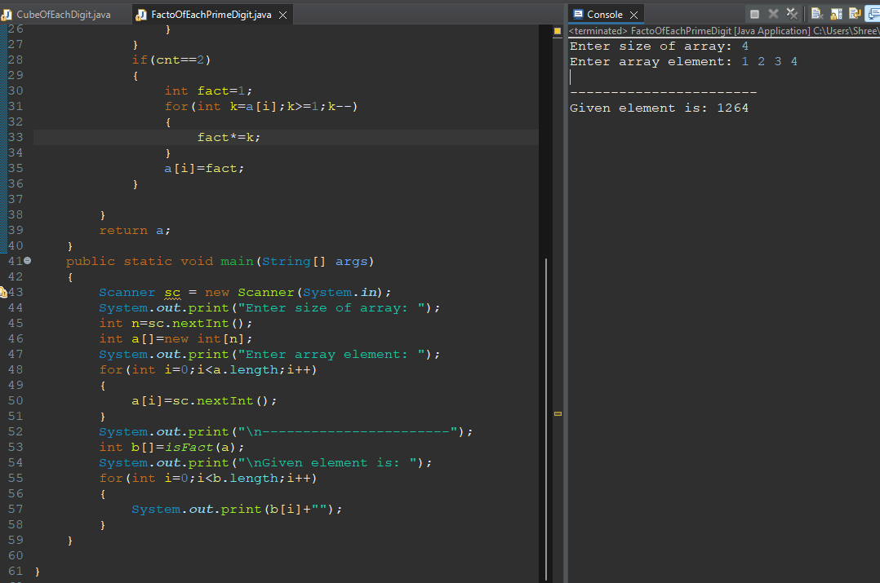

3. WAP to reverse each even digit and leave odd digits unchanged in the inputted number

Input: 1234 Output: 1432 (2 and 4 are reversed in their positions)

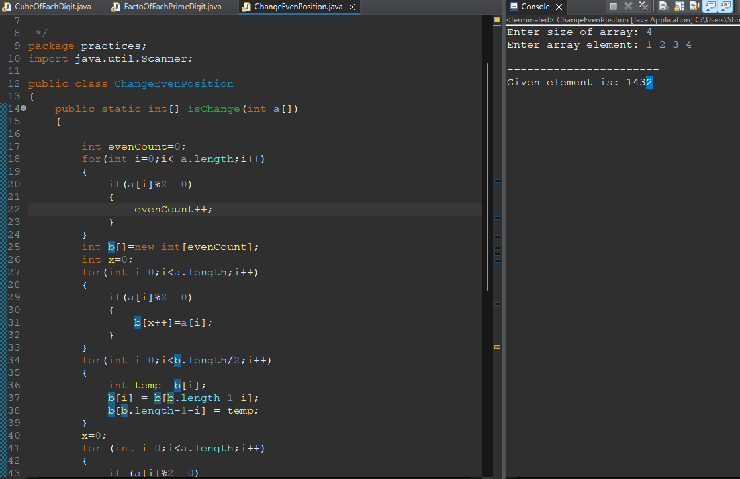

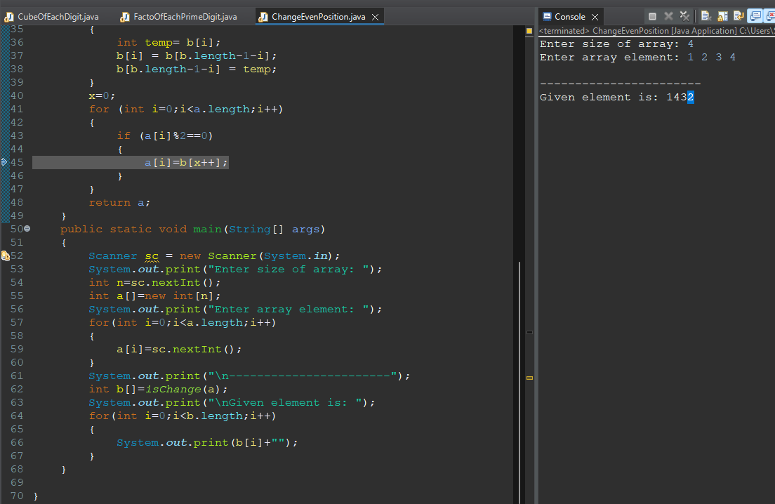

4. WAP to double each digit at an even index in the inputted number (starting from 0)

Input: 1234

Output: 2264 (1 and 3 are at even indices, so they are doubled)

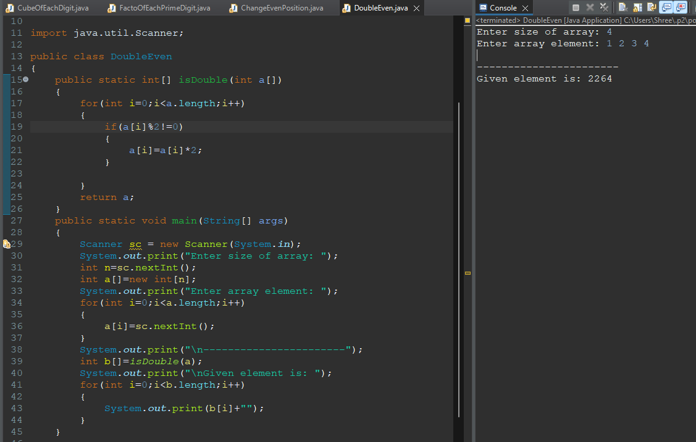

5. WAP to replace each digit by the sum of its neighbors in the inputted number

Input: 1234

Output: 1464 (for digit 1, no left neighbor so only 2, for digit 2, neighbors are 1 and 3, and so on: 1+0, 1+3, 2+4, 3+0)

