1. Write a Java program to reverse a string.

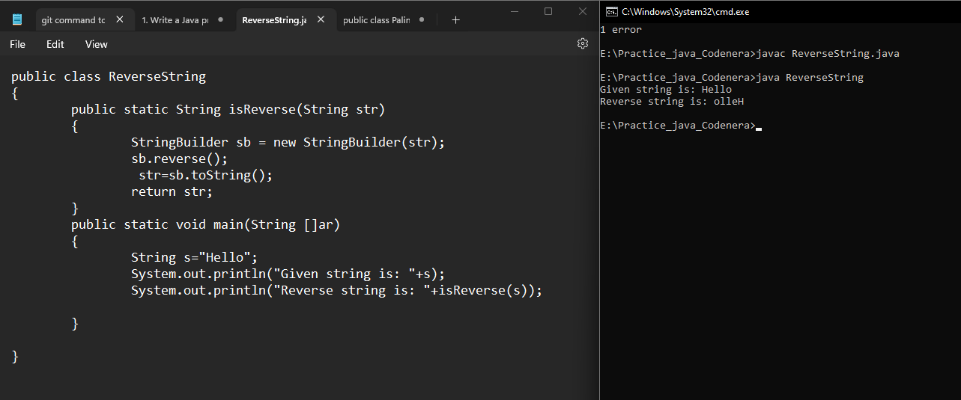

2. Implement a Java program to check if a number is a palindrome.

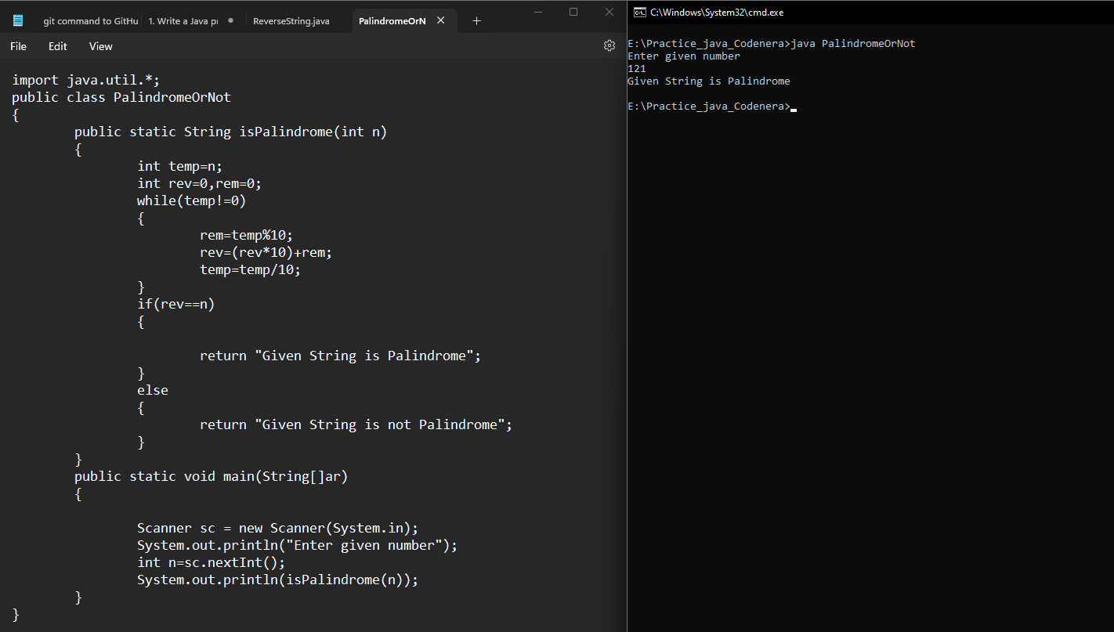

3. Write a Java program to find the factorial of a number.

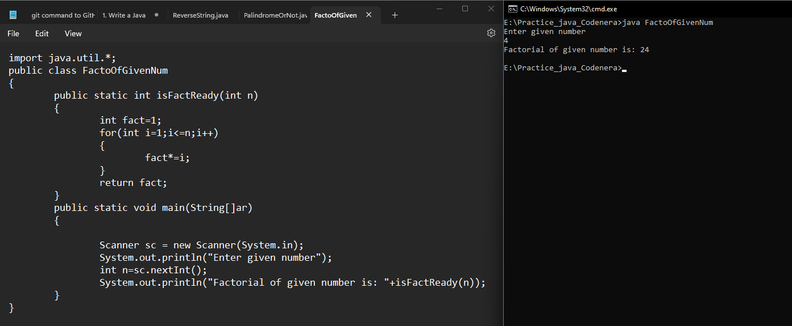

4. Implement a program to check if a string is an anagram of another string.

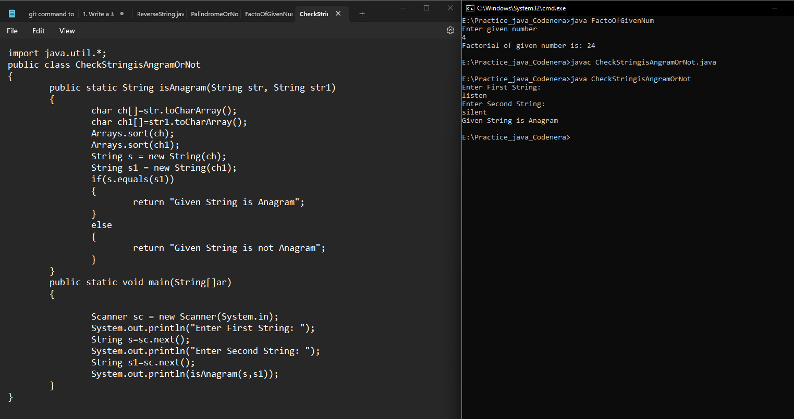

5. Write a Java program to find the Fibonacci series up to a given number.

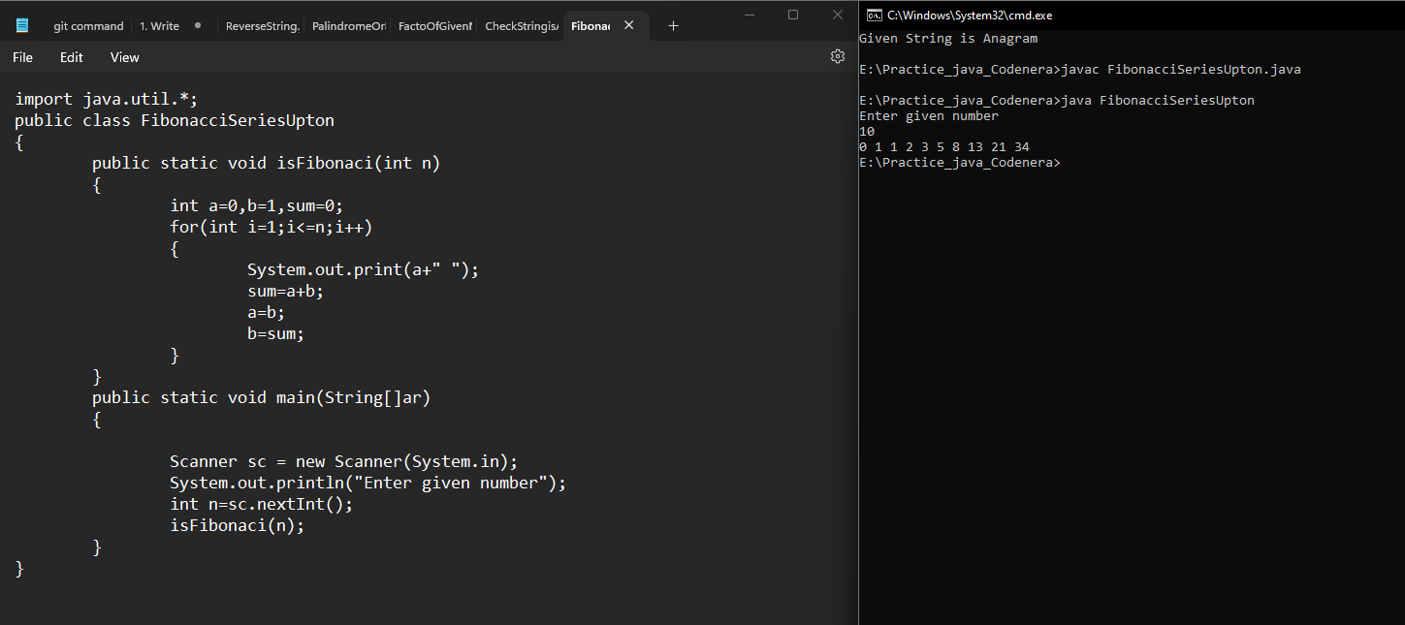

6. Implement a program to check if a number is prime.

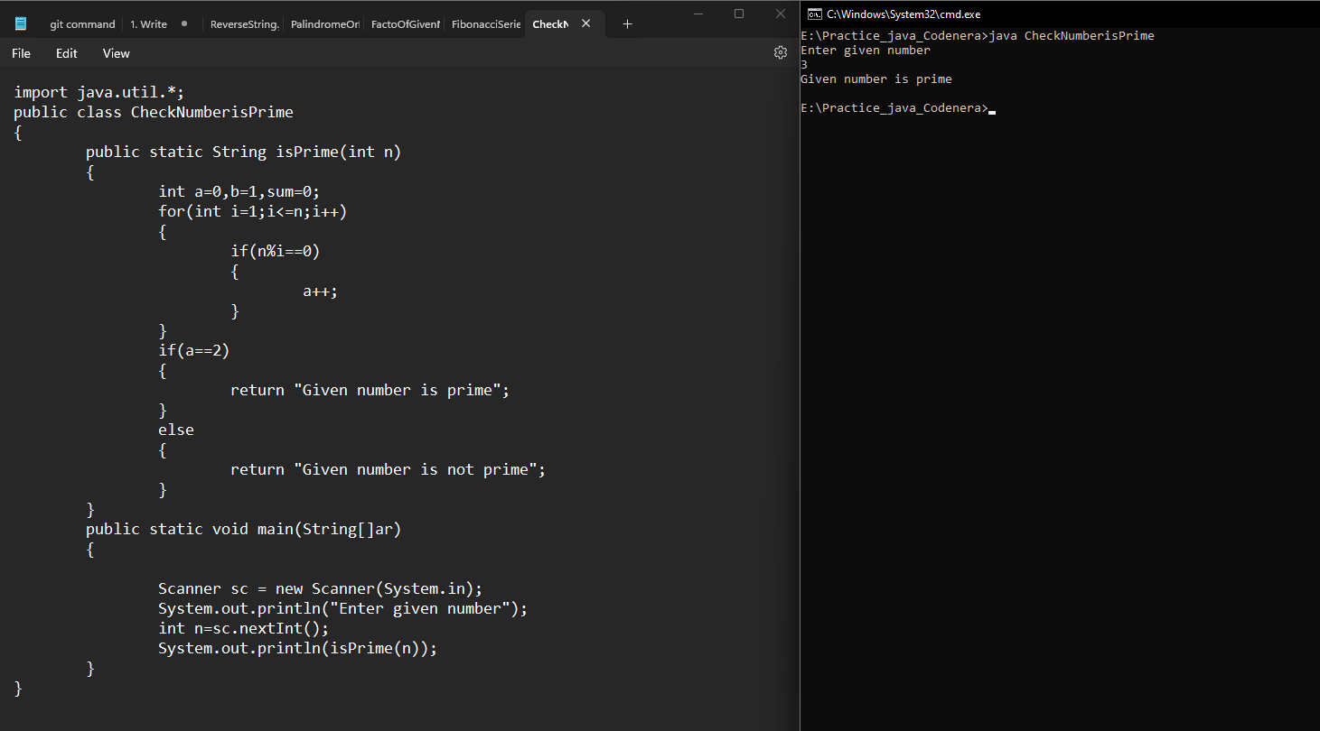

7. Write a Java program to sort an array using the Bubble Sort algorithm.

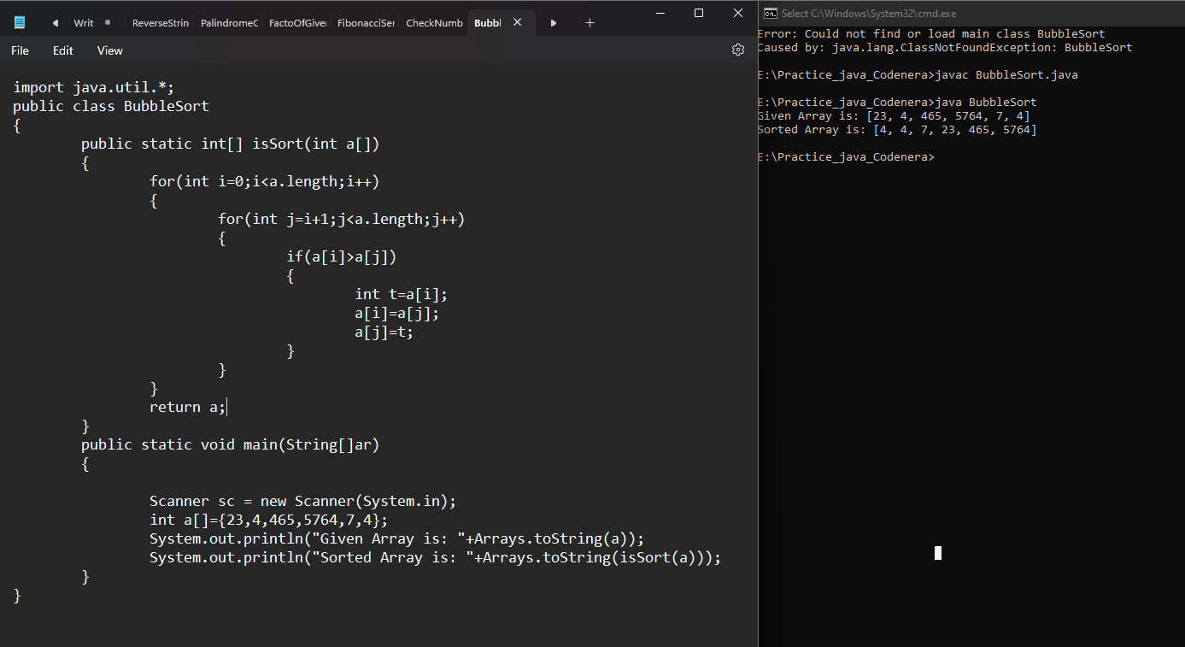

8. Implement a Java program to find the largest and smallest element in an array.

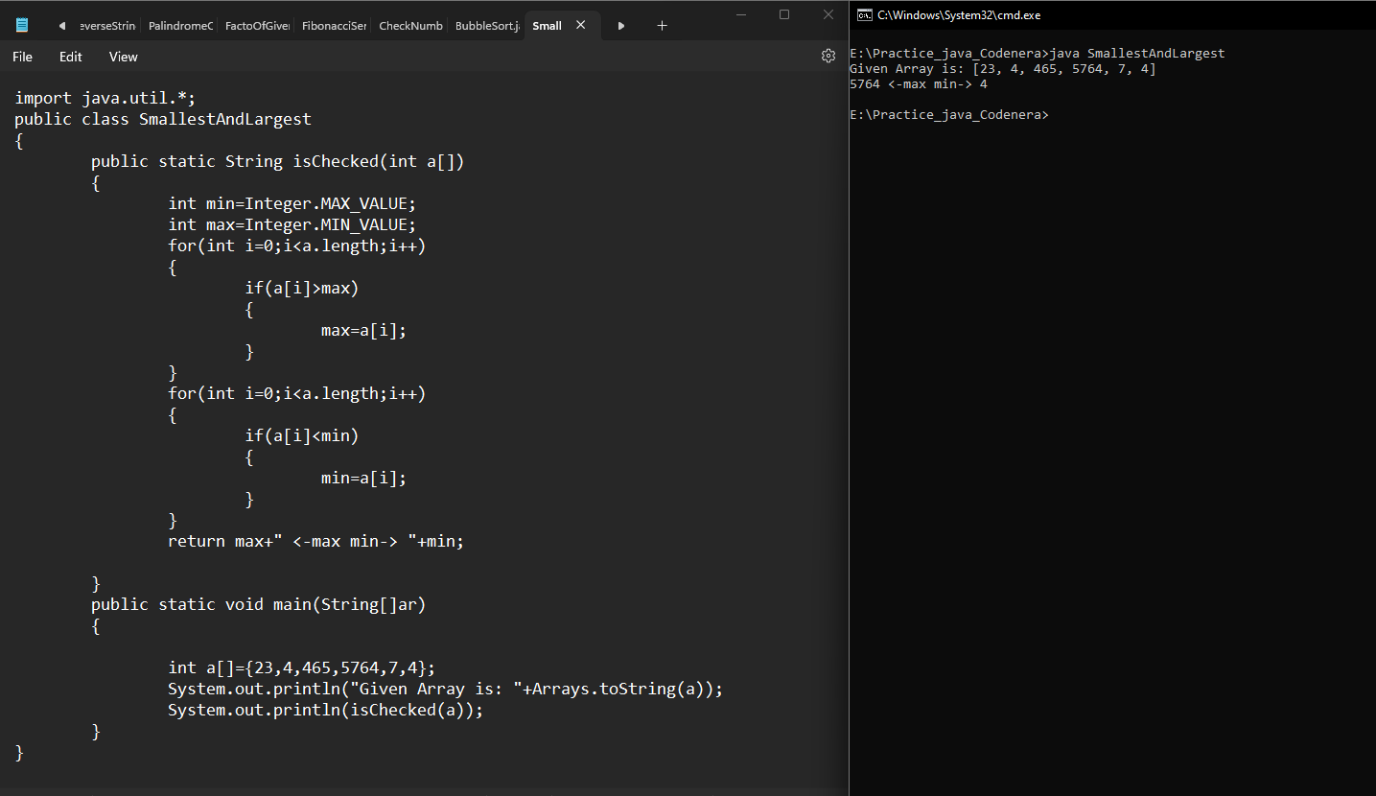

9. Write a program to check if a given number is an Armstrong number.

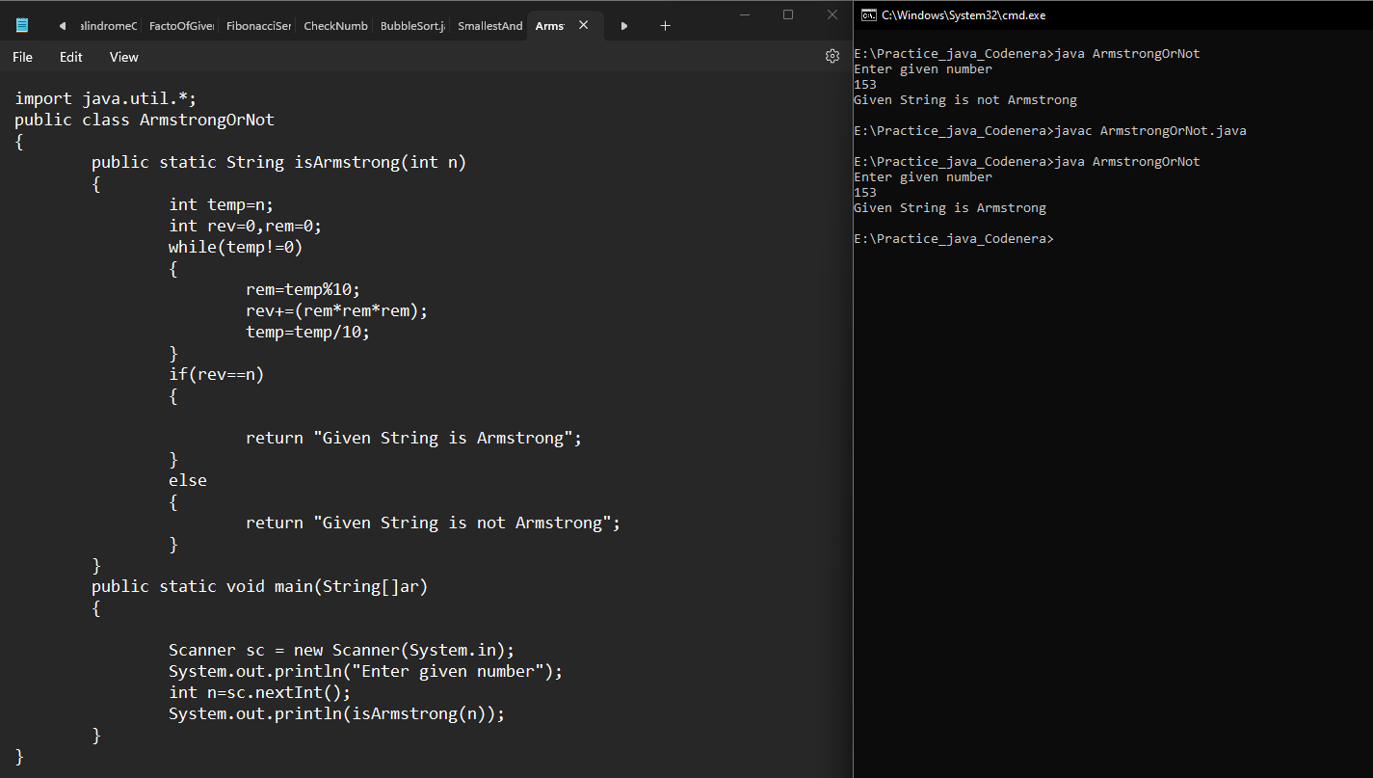

10. Implement a Java program to remove duplicates from an array.

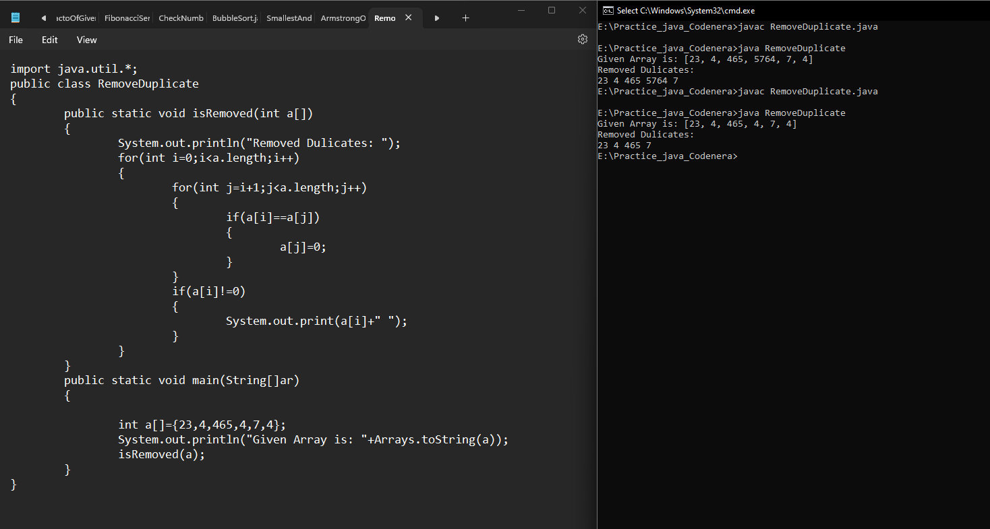

11. Write a Java program to find the sum of digits of a given number.

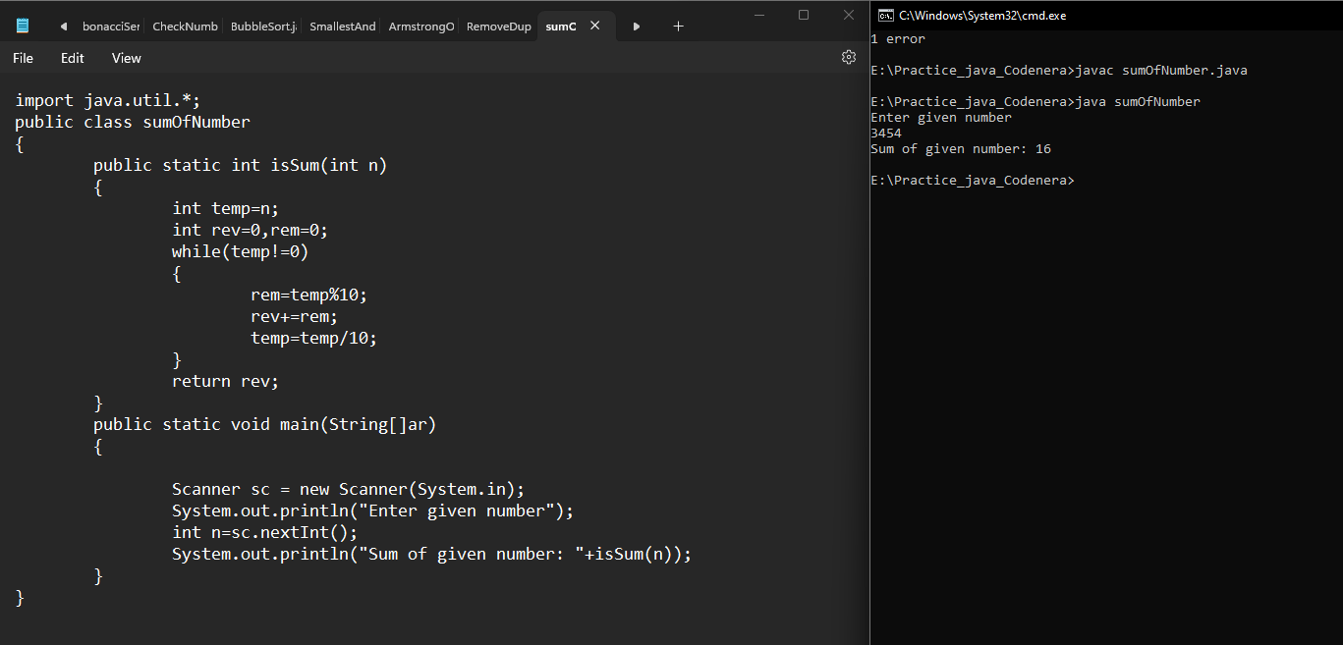

12. Implement a Java program to check if a given year is a leap year.

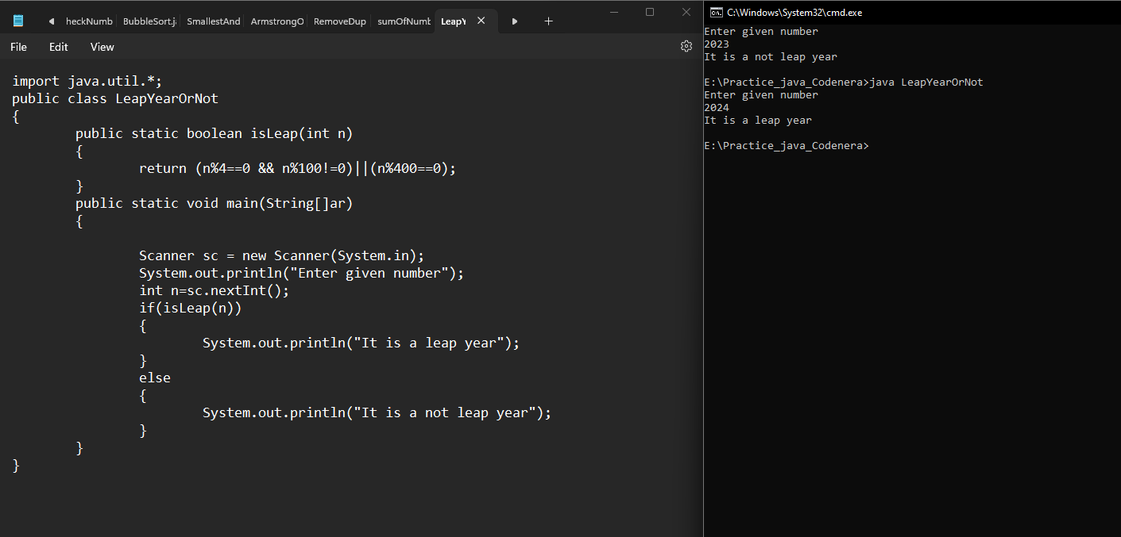

13. Write a Java program to find the second largest number in an array.

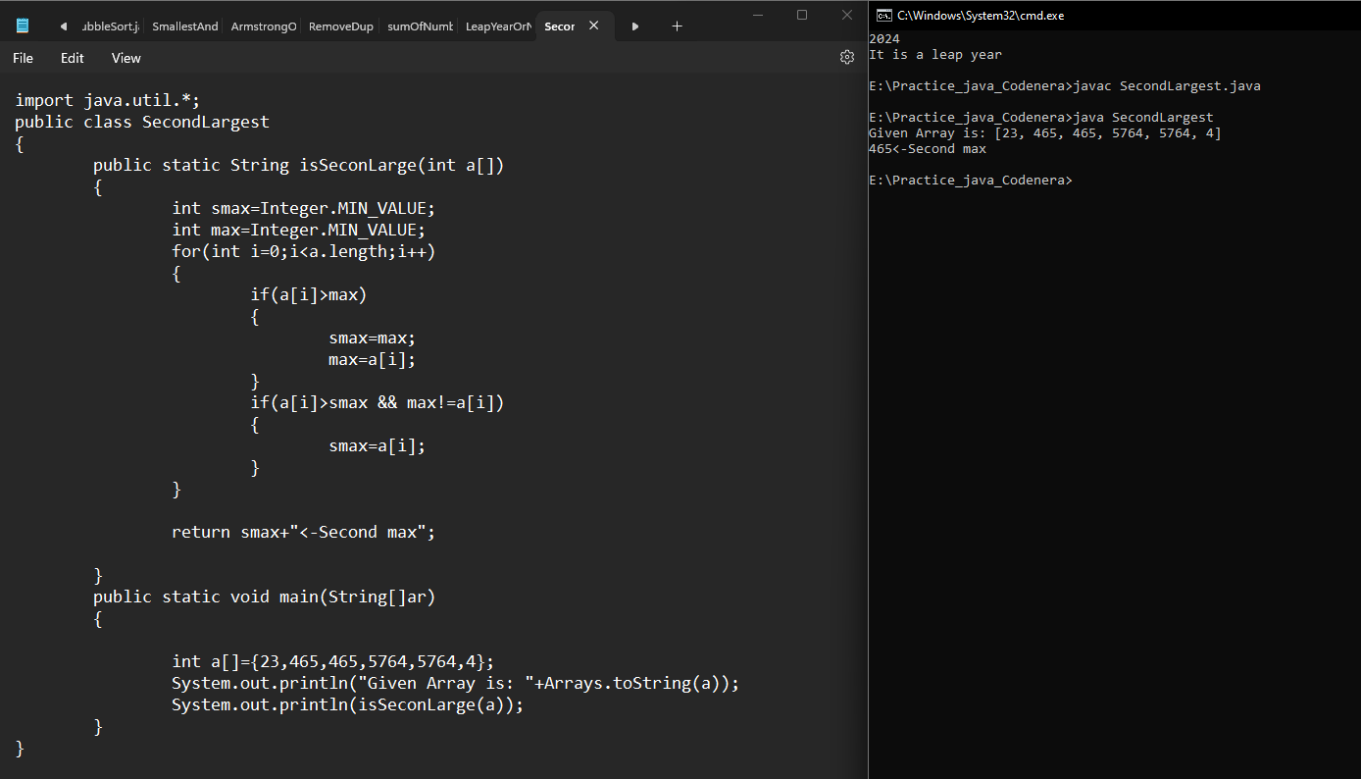

14. Implement a Java program to check if a string contains only digits.

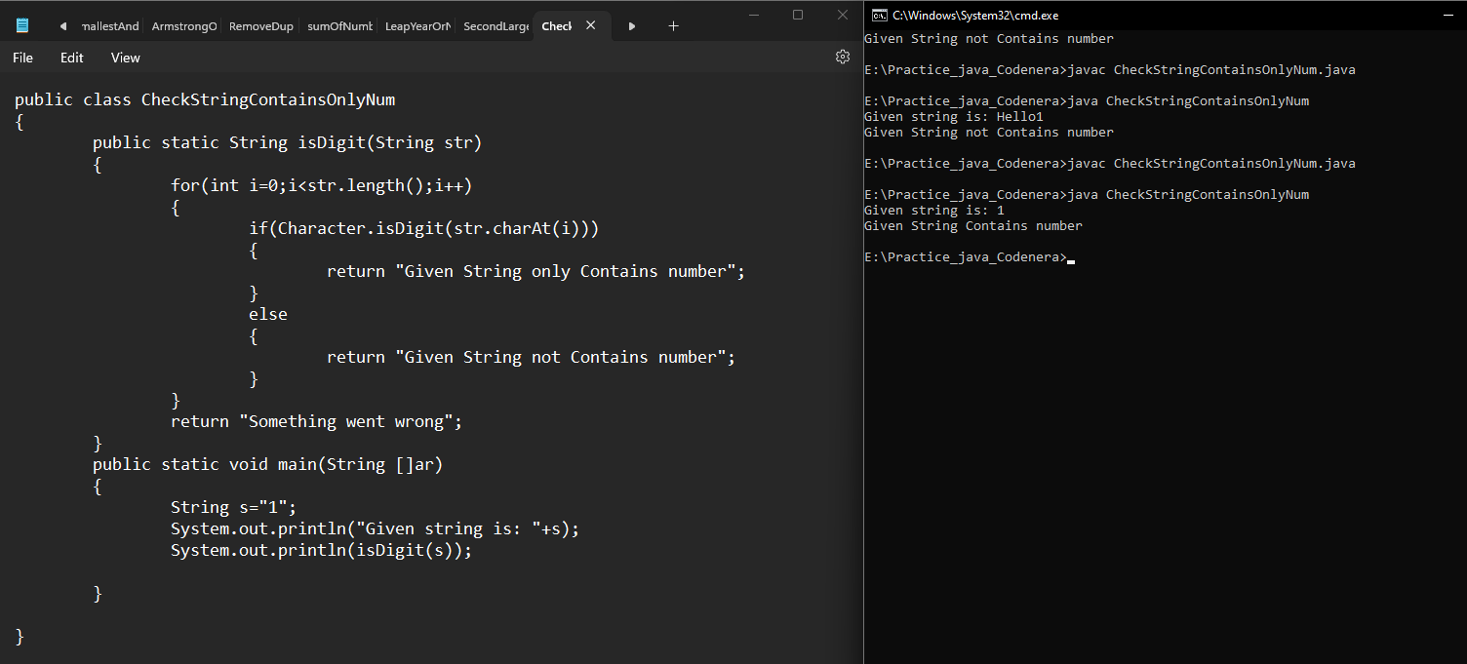

15. Write a Java program to merge two sorted arrays.

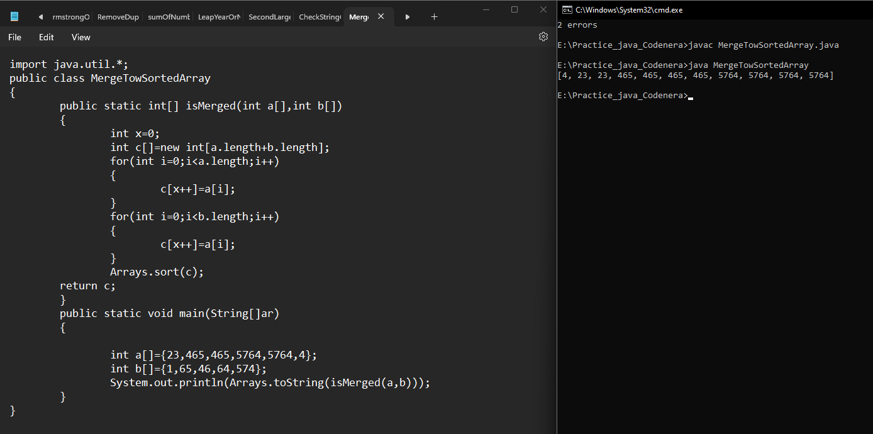

16. Implement a program to count the number of vowels and consonants in a string.

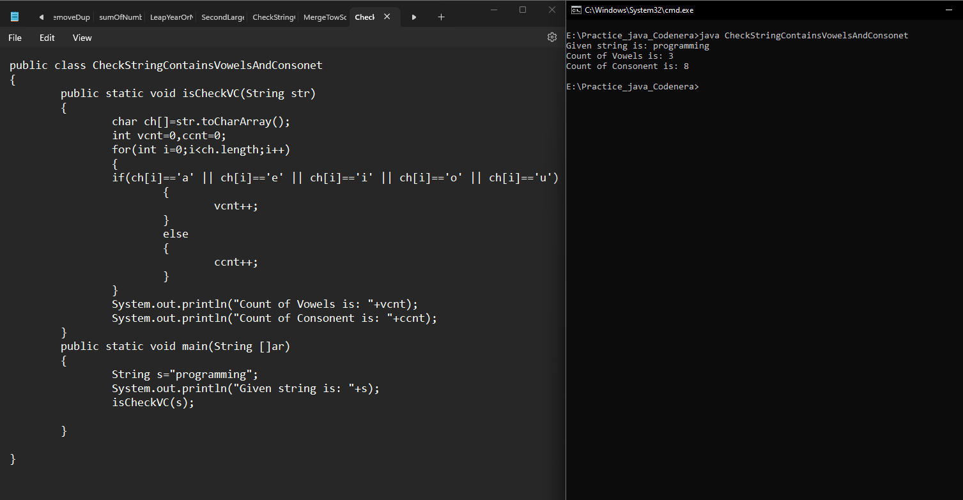

17. Write a Java program to find the GCD (Greatest Common Divisor) of two numbers.

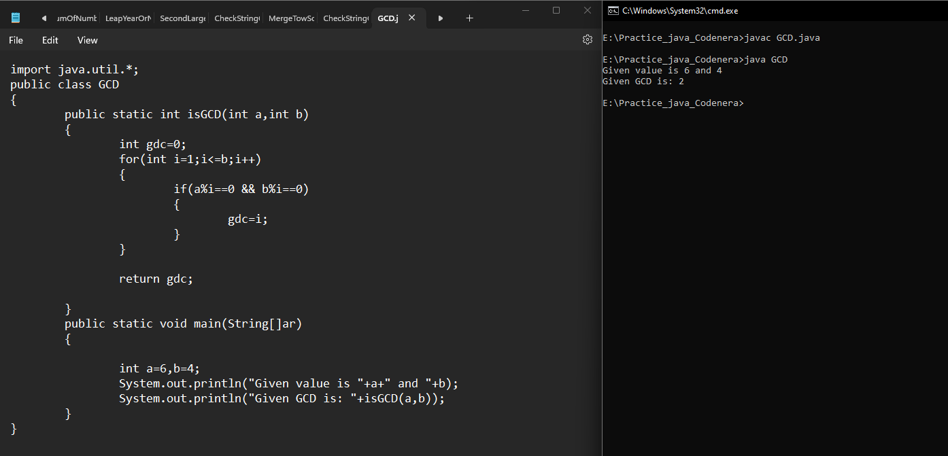

18. Implement a program to find the length of the longest substring without repeating characters.

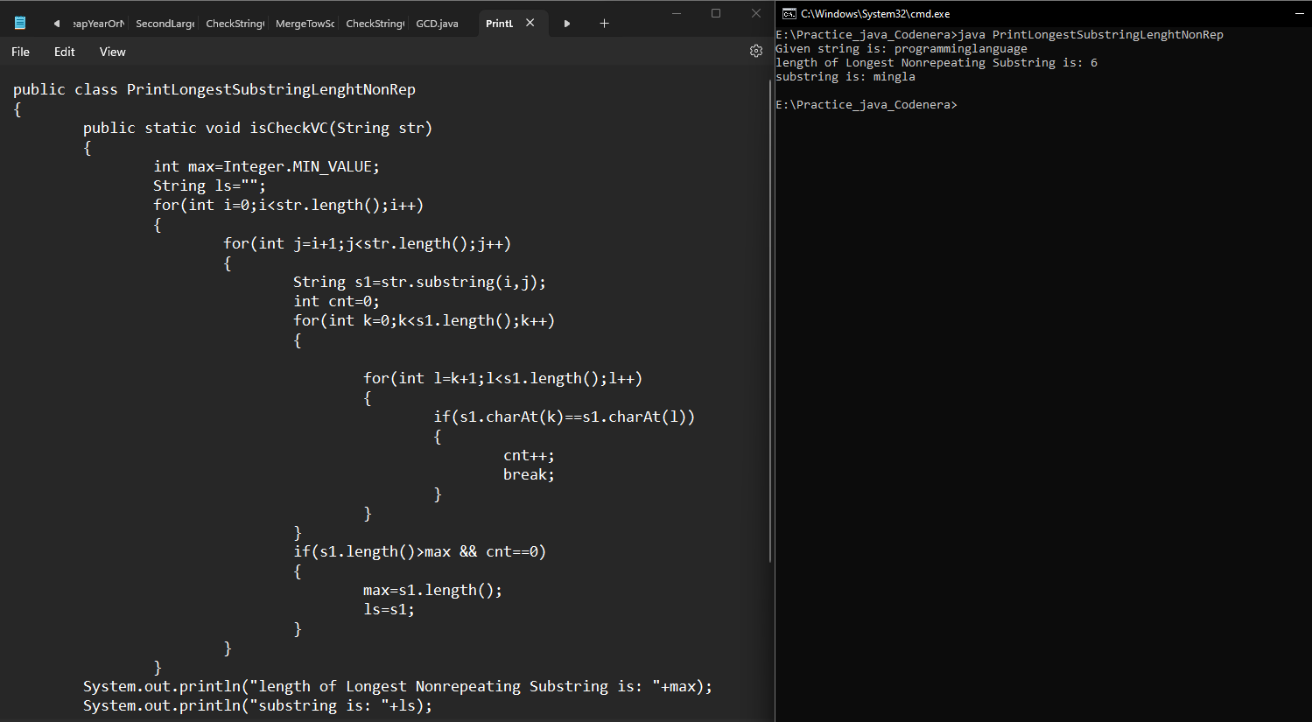

19. Write a Java program to rotate an array by a given number of positions.

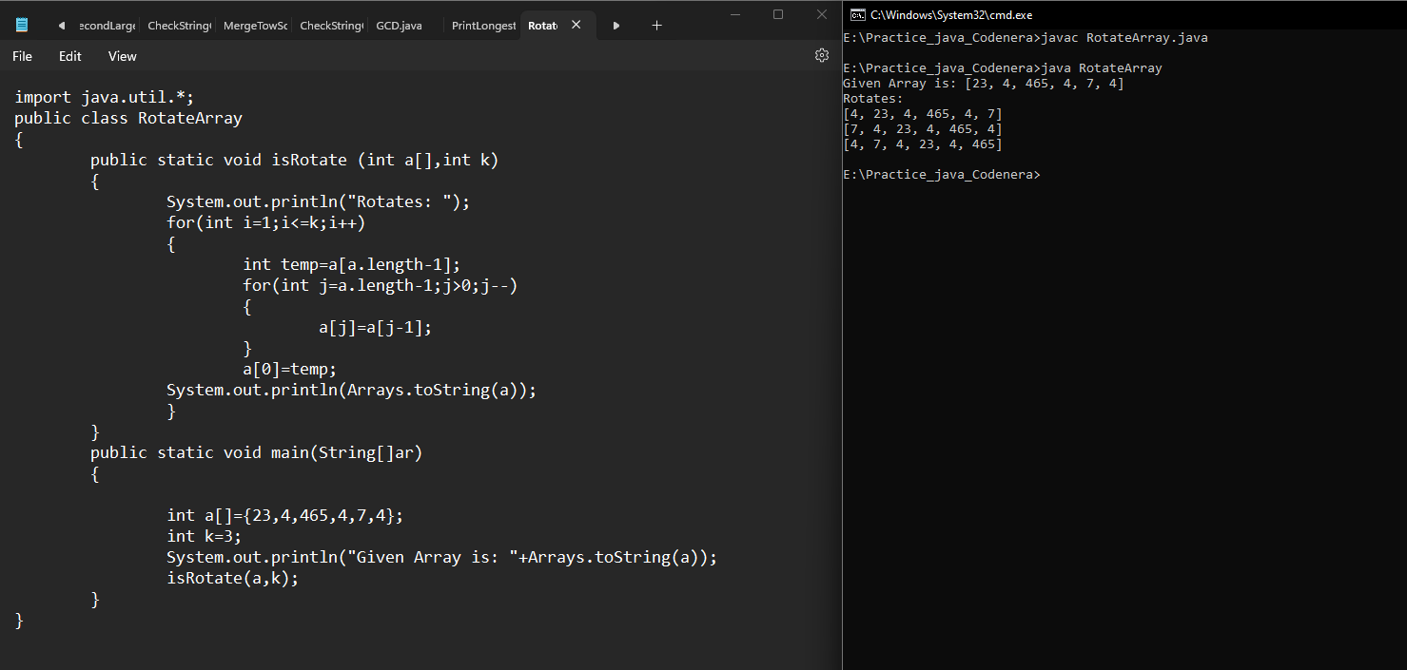

20. Implement a Java program to check if a string is a valid palindrome, ignoring non-alphanumeric characters.

21. Write a Java program to implement the binary search algorithm.

22. Implement a program to convert a given binary number to a decimal number.

23. Write a Java program to find the intersection of two arrays.

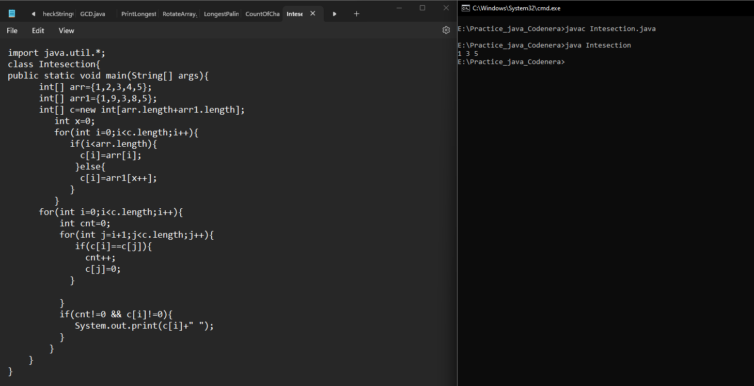

24. Implement a Java program to check if two strings are rotations of each other.

25. Write a program to find the missing number in an array of integers from 1 to n.

26. Implement a Java program to find the duplicate elements in an array.

27. Write a Java program to implement the insertion sort algorithm.

28. Implement a program to check if a given matrix is a magic square.

29. Write a Java program to count the occurrences of each character in a string.

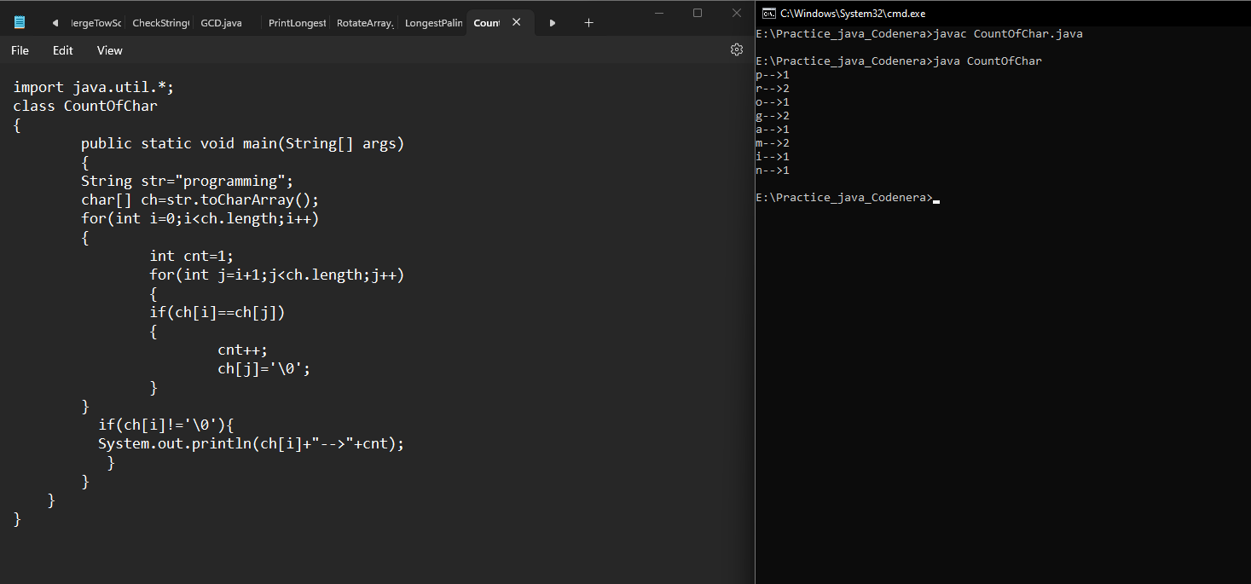

30. Implement a Java program to find the majority element in an array (the element that appears more than n/2 times).

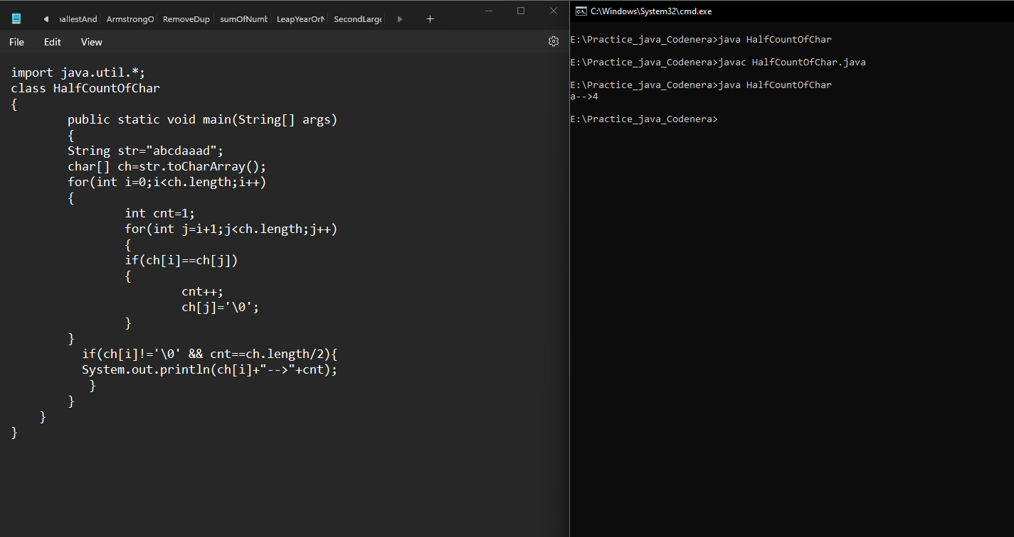

31. Longest palindrom in java

