

Warped world

Game Report



Green Academy

Trần Nguyễn Tấn Sang

Table of Contents

**INTRODUCTION** 2

**Part I: UI (User Interface)** 2

**1.** **Main menu:** 2

**2.** **Level menu:** 2

**3.** **Pause Menu:** 3

**4.** **Win UI:** 4

**5.** **Game Over Menu:** 4

**6.** **GamePlay UI:** 5

**Part II: Game Play (Control Description and Guides)** 5

**1.** **Movement:** 5

**2.** **Shooting:** 6

**3.** **Finish Level condition:** 6

**Part III: List of Enemies** 7

**1.** **Octopus:** 7

**2.** **Crab:** 7

**3.** **Spider:** 7

**4.** **Giant Octopus (Boss):** 7

**Part IV: Evaluation** 7

**1.** **Requirements of teacher:** 7

**2.** **Archived:** 8

**3.** **Not Archived:** 8

**4.** **Future addition in version 1.1:** 8

**CONCLUSION** 9

# **INTRODUCTION**

This is my 2D platform game used for my demo project in 2D course at Green Academy. Game Engine used in this project is Unity with version 2021.1.14f. Game loop is very simple with a main character came from Space, his task is that he has to collect all the power pieces lost from the space and drop into a mysterious planet. However, on his track, there are many monsters are attractive by the power of power pieces. Therefore, he has to kill all the monster and find out lost power pieces. In this Document, I will show you how to play this action game.

# **Part I: UI (User Interface)**

1. **Main menu:**

When Game began, MainMenu UI will be display on the scene.

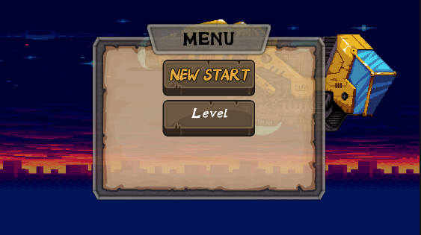

Figure MainMenu UI

Functions in MainMenu:

* + : Redirect to Level 1.
  + : Redirect to Level Menu.

1. **Level menu:**

After pressing “Level” button, this scene will be rendered. Press on level you want to play, then you will be redirected to Level chosen.

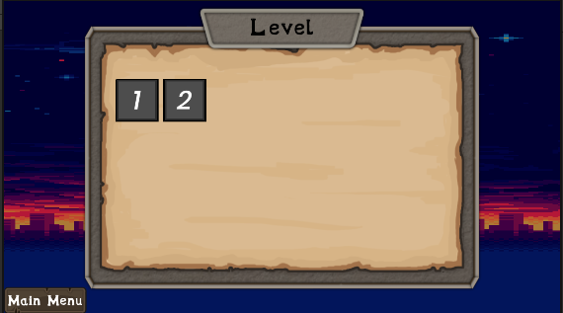

Figure Level Menu UI

Functions in Level Menu:

* + : Redirect to scene level
  + : Back to Main Menu

1. **Pause Menu:**

When Game is paused, this is the scene you will see.

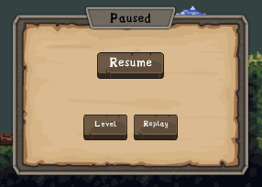

Figure Pause UI

Functions in Pause UI:

*  : Continue Game Play
* : Redirect to Level Menu
* : Restart the scene level

1. **Win UI:**

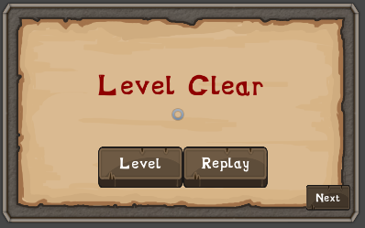

Functions in Win UI:

* : Back to Level Menu
* : Restart the Level
* : Redirect to next Level

1. **Game Over Menu:**

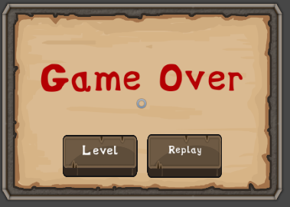

Figure Game Over UI

Functions in Game Over UI:

* : Back to Level Menu
* : Restart the Level

1. **GamePlay UI:**

This is the game scene in Level 1.

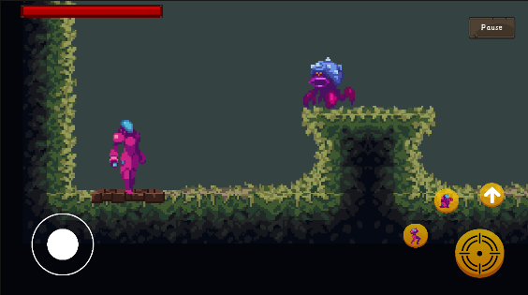

Your Health bar displays character’s current health in the level. . You will die when your health is 0.

Pressing  to pause the game play.

# **Part II: Game Play (Control Description and Guides)**

1. **Movement:**

To control the Player, there is a Joystick (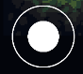) used for moving the character left and right.

After Jumping on Wall, hold the direction to the Wall to slide down the Wall. Combine with Shoot button, you can slide and shoot at the same time.

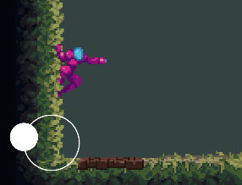

Figure Sliding

Pressing  to Jump.

Pressing  to Crouch.

Pressing  to Head up.

1. **Shooting:**

Pressing button  to Shoot.

 + : You can couch and shoot.

 + : You can shoot up.

 + move Left/Right: You can shoot while running.

1. **Finish Level condition:**

To finish the level, you have to collect all  power in that level.

# **Part III: List of Enemies**

Enemies are objects that the player is hurt when collide with them or is attacked.

1. **Octopus:**

These objects are designed by AI (Behavior Designer tools). When they see you in a specific distance, they will chase after you and make damage.

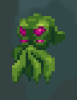

1. **Crab:**



There are two states of Crab (Moving or Idle).

1. **Spider:**

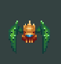

The Spiders jump on a specific area.

1. **Giant Octopus (Boss):**

This monster is very dangerous because when it can see you in specific distance, it will Chase after and Shoot until you die. Its amount of health is very high.

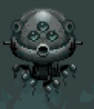

# **Part IV: Evaluation**

## **Requirements of teacher:**

Using animator (meet the requirement)

Animation Sprite or Skeletal (meet the requirement)

Tilemap, collision, rigidbody (meet the requirement)

Save Profile, MainMenu, Level Select Menu, Win/Lose, Pause (meet the requirement)

Player movement (Run, Jump, Shoot) (meet the requirement)

Boss (meet the requirement)

Particle, AI, Touch control (meet the requirement)

## **Archived:**

* Save Player Data in local.
* Pathfinding by A*
* Enemy using AI by supported behavior tree tools
* Using Pool Manager to generate object.
* Applying successfully Singleton Pattern.
* Particle system
* Building on Android platform
* Control by Joystick and Touch Control
* Health bar for Player
* Cinemachine
* DoTween
* Animator
* Animation Sprite
* Tilemap
* UI for menu and Gameplay
* Player movement

## **Not Archived:**

* Beautiful UI
* Health bar for Boss
* Not using exactly Factory Pattern for Enemy objects in project.
* Level is too few

## **Future addition in version 1.1:**

* Add more Enemies.
* Add more levels
* Using Skeletal Animation.
* Health bar for Boss
* Add more skill for player
* Create dialog for gameplay.
* Loading bar scene.

# **CONCLUSION**

Because the project duration is short, I can not create the project perfectly. However, I almost meet the requirements proposed by the teacher. In the future, I will complete this project more and obey the rules of “clean code” and design patterns to structure my project professionally to make it easy for maintenance. Through this project, I have learned how to using Unity to create 2D game, and in the future, base on this basic knowledge, I can learn more advanced knowledge and make some more complex game.