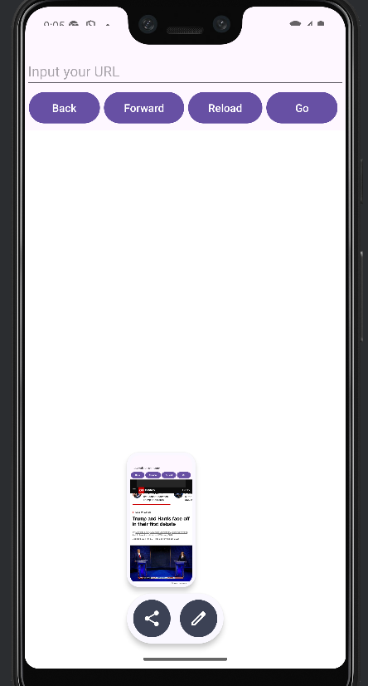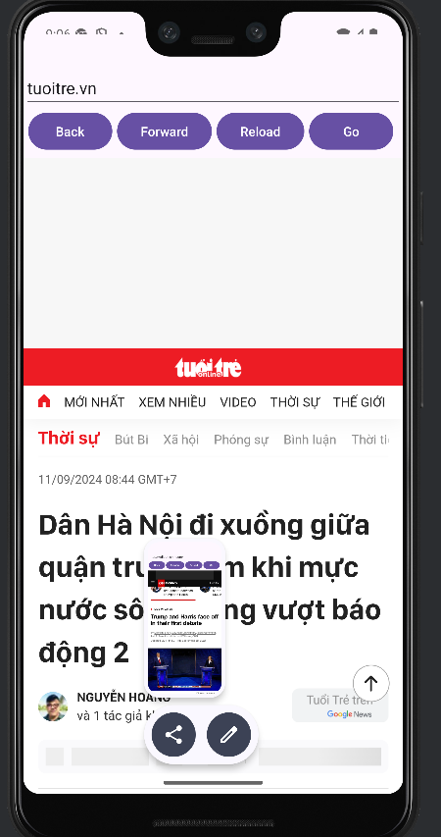

<?xml version="1.0" encoding="utf-8"?>
<manifest xmlns:android="http://schemas.android.com/apk/res/android"
xmlns:tools="http://schemas.android.com/tools">
<uses-permission android:name="android.permission.INTERNET" />
<application
android:allowBackup="true"
android:dataExtractionRules="@xml/data_extraction_rules"
android:fullBackupContent="@xml/backup_rules"
android:icon="@mipmap/ic_launcher"
android:label="@string/app_name"
android:usesCleartextTraffic="true"
android:roundIcon="@mipmap/ic_launcher_round"
android:supportsRtl="true"
android:theme="@style/Theme.WebApp"
tools:targetApi="31">
<activity
android:name=".MainActivity"
android:exported="true">
<intent-filter>
<action android:name="android.intent.action.MAIN" />
<category android:name="android.intent.category.LAUNCHER" />
</intent-filter>
</activity>
</application>
</manifest>

activity_main.xml
<?xml version="1.0" encoding="utf-8"?>
<LinearLayout xmlns:android="http://schemas.android.com/apk/res/android"
xmlns:app="http://schemas.android.com/apk/res-auto"
xmlns:tools="http://schemas.android.com/tools"
android:id="@+id/main"
android:layout_width="match_parent"
android:layout_height="match_parent"
android:orientation="vertical"
android:layout_marginTop="50dp"
tools:context=".MainActivity">
<EditText
android:id="@+id/editText"
android:layout_width="match_parent"
android:layout_height="wrap_content"
android:layout_marginTop="10dp"
android:ems="10"
android:inputType="text"
android:hint="Input your URL"
/>
<LinearLayout
android:layout_width="match_parent"
android:layout_height="wrap_content"
android:layout_marginHorizontal="5dp"
android:orientation="horizontal">
<Button
android:id="@+id/button"
android:layout_width="wrap_content"
android:layout_height="wrap_content"
android:layout_weight="1"
android:onClick="backButton"
android:layout_marginEnd="5dp"
android:text="Back" />
<Button
android:id="@+id/button2"
android:layout_width="wrap_content"
android:layout_height="wrap_content"
android:layout_marginEnd="5dp"
android:layout_weight="1"
android:onClick="fwdButton"
android:text="Forward" />
<Button
android:id="@+id/button3"
android:layout_width="wrap_content"
android:layout_height="wrap_content"
android:layout_weight="1"
android:onClick="reloadButton"
android:layout_marginEnd="5dp"
android:text="Reload" />
<Button
android:id="@+id/button4"
android:layout_width="wrap_content"
android:layout_height="wrap_content"
android:layout_weight="1"
android:layout_marginEnd="5dp"
android:onClick="goBack"
android:text="Go" />
</LinearLayout>
<WebView
android:layout_width="match_parent"
android:layout_height="match_parent"
android:layout_marginTop="5dp"
android:id="@+id/webView"
>
</WebView>
</LinearLayout>

ActivityMain.java
