***ACKNOWLEDGEMENT***

Most successful feats involve the efforts of many people. Our project is no exception. I am blissful for completions of our project but I can’t take full credit. Here are some of the people who are also involved for accomplishment of this project.

Firstly, we have done lots of analysis prior to dive into the development process, for this we met lots of people who furnished us lots of ideas and information about “Student information forum”.

Secondly we are much excited to give credit to our project guide Assistant Prof. Anirban Maitra who helped to make it happen. We are lucky to finish this project under his excellence guidance, because we think without his proper guidance we might not have completed our project on time.



**Salesian College**

**Sonada**

***CERTIFICATE***

*This is to certify that the project entitled* ***“ALPINE LODGE”*** *is a tremendous work done by the students of* ***Bachelor of Computer Application*** *3rd year, in partial fulfillment of 6th semester assignment for major Project. It was carried out under the direct supervision and guidance of Mr****. Bryan Kerr,*** *Department Of Computer Application.*

*The project was carried out over a duration of almost three months at the premises of Salesian College Sonada. The students have taken up the challenging task and have completed the assignment during the stipulated time. This report or a similar report on the topic has not been submitted for any other assignment and does not form part of any other course undergone by the candidates.*

*Student’s Name & Roll No:*

*Dipankar Roy (roll- 13/BCA/150015)*

*Sangye Tenphel (roll- 13/BCA/150016)*

*Signature: -------------------------------- Signature: ------------------------ (Head of the Department) (Examiner)*

This is to certify that the project report on “**Alpine Lodge**” is a bona-fide work, carried out by Dipankar Roy (roll- 13/BCA/150015) and Sangye Tenphel (roll- 13/BCA/150016) the student of the Salesian College Sonada, under the guidance of our faculty Assistant Professor Mr. Bryan Kerr as a requirement for the partial fulfillment of the degree of Bachelor of Computer Application (BCA).

--------------------------------

Name: Bryan Kerr

Designation: Head of the Department***Contents***

* *INTRODUCTION*
* *OBJECTIVE*
* *ANALYSIS DOCUMENT*
* *SYSTEM ANALYSIS*
* *FEASIBILITY STUDY*
* *PLATFORM*
* *PHP & MYSQL*
* *SERVER*
* *TEAM STRUCTURE*
* *DATA FLOW DIAGRAM (DFD)*
* *ENTITY RELATIONSHIP DIAGRAM (ERD)*
* *DATABASE SCHEMA*
* *SNAPSHOTS*
* *TESTING*
* *CONCLUSION*
* *FURTURE SCOPE*
* *BIBLIOGRAPHY*

**INTRODUCTUION**

**OVERVIEW OF THE PROJECT**

STUDENT INFORMATION FORUM is a web application to provide student to get useful information about their college & also their individual Department. Any student of the college who is logged in provides the facility to chat with the professor about their query or problem directly. Student’s also getting previous years question paper, e-books of different subjects as well as they can track their attendance and view the current news circulating around the college.

**OBJECTIVES**

Before a project can be planed, product objective and scope should be established, it is because a developer should know why he is making the software or what the utility of the software is. In broad sense we can call it as the goal of the soft ware.

The goal of Online Education and information for students and information for students is to provide the capability to detect events, make sense of them and determine the appropriate control action. Online Education and information for students is therefore the basis for Operational Monitoring and Control.

Online Education and information for students should be utilized to detect and communicate operational information as well as warnings and exceptions, so that input can be provided for reporting the service achievements and quality levels provided. It may be used for automating routine activities such as backups and batch processing, or dynamic roles for balancing demand for services across multiple infrastructure items/sources to improve performance.

**ANALYSIS DOCUMENT**

**Requirement Analysis** is a software engineering task that bridges the gap between system level requirements engineering and software design. The goal of the requirements gathering activity is to collect all relevant information from the customer regarding the product to be developed with a view to clearly understanding the customer’s requirements. Requirements analysis allows the software engineer to refine the software allocation and build models of the data, functional, behavioral domains that will be treated by software. Requirements analysis provides the software designer with a representation of information, function, behavior that can be translated to data, architectural, interface, and component-level designs.

Our “Online Education” is based on event planning on social and Official events .Scope of work is make the life’s every special moment unforgettable with smile on all beautiful faces. That includes Wedding Party, Engagement Party, Office & Corporate Party, New Born party to Namkaran Party ever memorable; also make your every anniversary more remember able. The company also host Company Product launch Party, Valentine Party, Road & Concert (Dance & Music) with love and genially with regards.

The infrastructure development of this Online Education website is:

* Online Education /Organize by contact
* Register and Delete their Registered Profiles
* Updated with Event Contents

In our website there two fields for visited user, one who registers them by this website and get their own profile and other is not register general users. Client user can contact with the company through “Contact Us” option apply for hosting their events. There also an Administrator who has all rights on his click. He can create new menus, to change the banner, to view & delete menu, banner, and admin holder and run the website process **dynamically**. But the Administration part does not display in public website except the company employed administrator. The Administrator must login by entering secured ID and password details.

**SYSTEM ANALYSIS**

System development can generally be thought of as having two major components in which one such component is system analysis. System analysis is the process of gathering and interpreting facts, diagnosing problems and using the information to recommend improvement to the system. Analysis is a detail study of the various operation performed by a system and their relationship within and outside of the system. One aspect of analysis is defining the boundaries of the system and determining whether or not a candidate system should consider other related systems. During analysis, data are collected on the available files, decision points and transactions handled by the present system. Data Flow Diagrams, interviews, on site observations and questionnaires and commonly used tools in analysis. We can say that analysis specifies what the system should do. System analysis is the management technique, which helps us in designing a new system, improving an existing system or solving a system problem.

System analysis is an important activity that takes place when we are building new information system on changing existing one. Basically it is necessary to set up the right procedures to ensure that call the organizations personal have all the data needed for their work. The investigation into system operation and possible changes to the system is called System Analysis.

Software project scope must be unambiguous and understandable at the management and the technical levels. A statement of software scope must be bounded. That is, quantitative data are stated exsxplicity; constrains and limitations.

**Feasibility Study**

**What are the user’s demonstrable needs?**

User needs a web-based system, which will remove all the above-mentioned Problems that, the user is facing. The user wants a web-based system, which will reduce the bulk of paperwork, provide ease of work, flexibility, fast record finding, modifying, adding, removing and generating the reports.

**Types of Feasibility Study:**

1. Economical Feasibility Study,

2. Technical Feasibility Study,

3. Operational Feasibility Study*.*

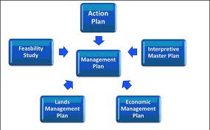

**PLATFORM**

* **Software Environment: -** MySQL and PHP has been used for the implementation of the website. Here MySQL is used for making database of entities. This website can be displayed by the web browser like: Mozilla Firefox, Opera, Google Chrome & Internet Explorer.
* **Hardware Environment:-** Minimum hardware required for browsing the website is as follows:
* **Intel Pentium Dual Core Processor T4500**
  1. **GHz, 800 MHz FSB)**
* **Intel GMA 4500M**
* **320 GB HDD**
* **CD/DVD – ROM Writer**
* **3 GB DDR3 RAM**

**PHP**

PHP is a general-purpose scripting language that is especially suited to server-side web development where PHP generally runs on a web server. Any PHP code in a requested file is executed by the PHP runtime, usually to create dynamic web page content. It can also be used for command-line scripting and client-side GUI applications. PHP can be deployed on most web servers, many operating systems and platforms, and can be used with many relational database management systems. It is available free of charge, and the PHP Group provides the complete source code for users to build, customize and extend for their own use.

PHP primarily acts as a filter, taking input from a file or stream containing text and/or PHP instructions and outputs another stream of data; most commonly the output will be HTML. Since PHP 4, the PHP parser compiles input to produce byte code for processing by the Zend Engine, giving improved performance over its interpreter predecessor.

Originally designed to create dynamic web pages, PHP now focuses mainly on server-side scripting, and it is similar to other server-side scripting languages that provide dynamic content from a web server to a client, such as Microsoft’s Active Server Pages, Sun Microsystems’ Java Server Pages, and mod_perl. PHP has also attracted the development of many frame works that provide building blocks and a design structure to promote rapid application development (RAD). Some of these include CakePHP, Symfony, Codelgniter, and Zend Framework, offering features similar to oter web application frameworks.

**MYSQL**

MySQL is a database system used on the web. Basically, a MySQL database allows you to create a relational database structure on a web-server somewhere in order to store data or automate procedures. If you think of it in comparison to Microsoft Access, MySQL is what holds all of your tables, PHP acts as your queries (among other things), and your forms are basically web pages with fields in them. With all of this combined, you can create truly spectacular projects on the web.MySQL is also open source in that it’s free and falls under the GNU General Public License (GPL). Chances are, if you are getting your own web-page or already have one – your host supports MySQL and PHP. They are generally associated with (though not limited to) Unix/Linux based servers. If by chance you are considering getting your own page and want MySQL and PHP support, check out Dream host – I’ve been using them for years and they absolutely can’t be beat.

Interacting with a MySQL database is a little weird as you don’t have the tried and true WYSIWYG interface that something as easy as Microsoft Access affords. When creating tables, you’ll either have to create them by using SQL Statements, or by using another open-source tool available online called PHPMyAdmin. PHPMyAdmin gives you an easy-to-use interface that allows you to create tables and run queries by filling in a little bit of information and then having the tables created for you. This is good if you’re either lazy, or don’t feel like bothering with big and complicated SQL Statements.

In comparing MySQL to Access you’re going to have a truckload of differences. While MySQL isn’t exactly tough to tackle (once the tables are created – you’re pretty much done with it), it’s capabilities extend far beyond that of Microsoft Access when Interacting with a MySQL database is a little weird as you don’t have the tried and true WYSIWYG interface that something as easy as Microsoft Access affords. When creating tables, you’ll either have to create them by using SQL Statements, or by using another open-source tool available online called PHPMyAdmin. PHPMyAdmin gives you an easy-to-use interface that allows you to create tables and run queries by filling in a little bit of information and then having the tables created for you. This is good if you’re either lazy, or don’t feel like bothering with big and complicated SQL Statements.

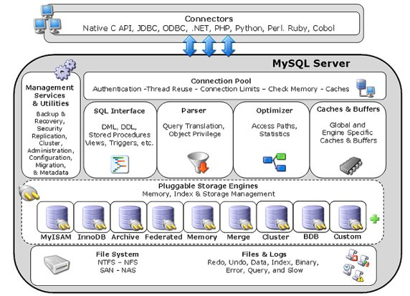**SERVER**

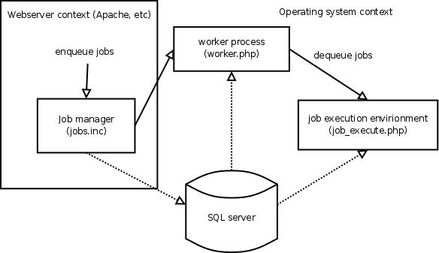

**Fig: SERVER**

**TEAM STRUCTURE**

We, the two project partners have worked together for the completion of the project “Student Information Forum”. First of all the most important member is our guide “Mr. Anirban Mitra” and special thank to Mr. Bryan kerr. We had a very good communication with our project guide as well.

**DATA FLOW DIAGRAM (DFD)**

**Process**

**Data Store**

**Source/sink**

**Data flow**

**DFD LEVEL 0**

**Login Detail**

**Login Detail**

**ADMIN**

**STUDENTS**

**Information Update**

**Information**

**Figure: DFD Level 0**

**DFD LEVEL 1**

**STUDENTS**

Login info

**USERS**

Present

Not present

Present

Login

Current News

Delete

Name & comment

View Question Paper

**NEWS COMENTS**

Update

Book

Reply

Answers

Update

Downloaded

**QUESTIONPAPER**

**COMMENTS**

View Attendance

Logout

Logout

Logout

Registration no.

**ATTENDENCE**

Logout

**Figure: DFD Level 1**

ENTITY RELATIONSHIP DIAGRAM (ERD)

1

**User**

Download

1

1

1

1

Asks

Checks

Downloads

Checks

N

**Question Paper**

**Question**

**Books**

**Attendance**

**News**

Update

N

N

N

N

N

N

Update

Update

Update

Update

Update

1

1

1

1

1

1

**Admin**

**Figure: E-R DIAGRAM**

**DATABASE SCHEMA**

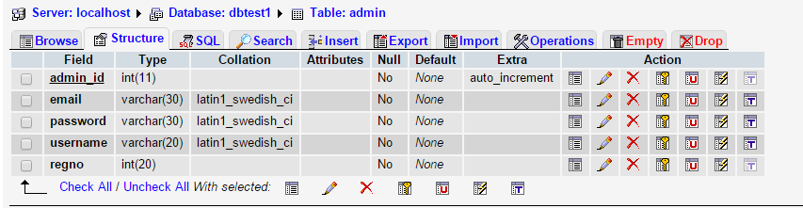**ADMIN DATABASE**

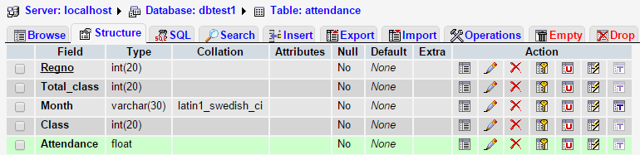**ATTENDANCE DATABASE**

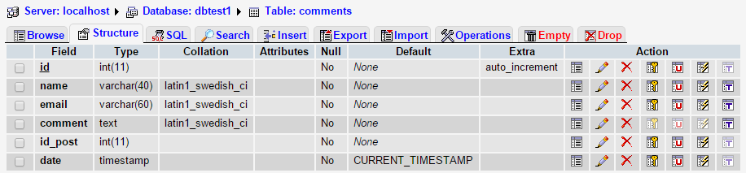**COMMENTS DATABASE**

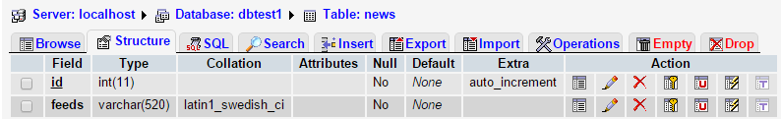**NEWS DATABASE**

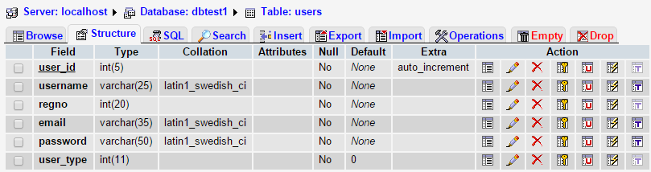**USERS DATABASE**

**PROJECT SNAPSHOTS**

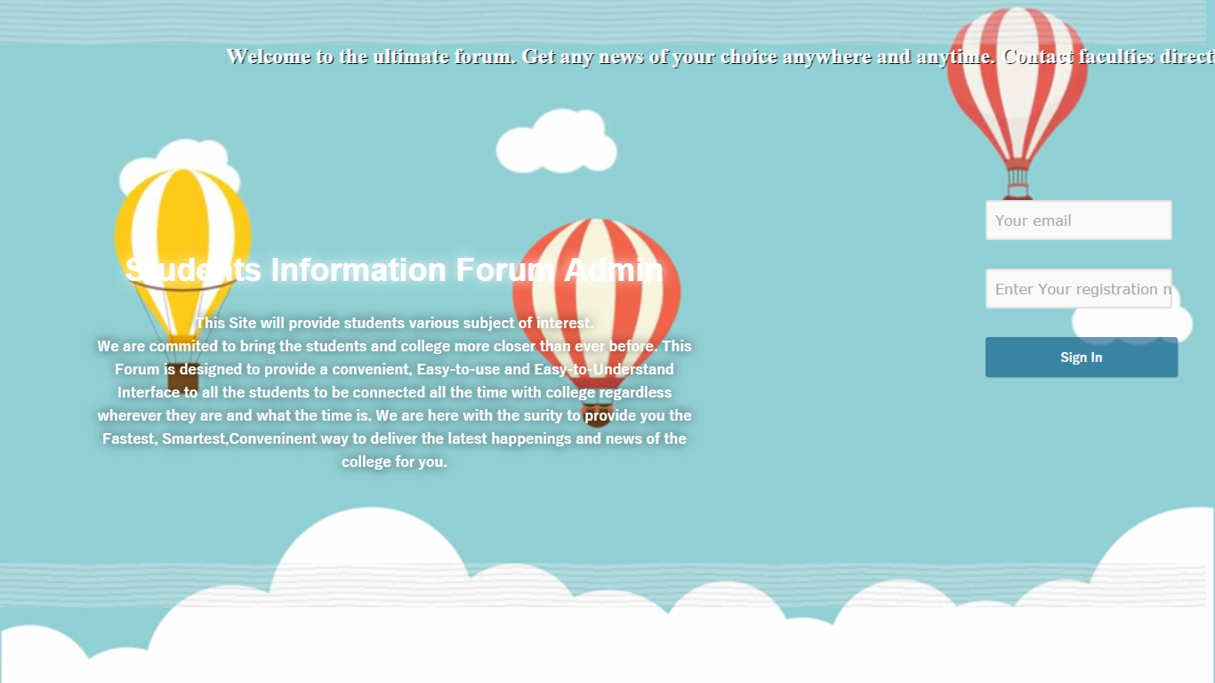**ADMIN LOGIN PAGE**

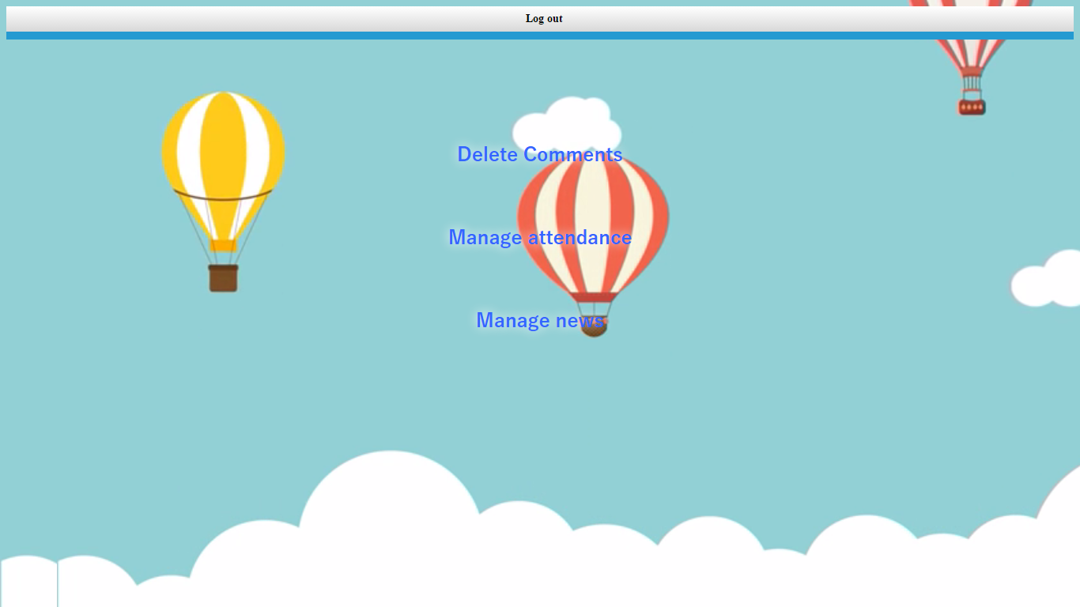**ADMIN DASHBOARD PAGE**

**ADMIN COMMENT UPDATITION PAGE**

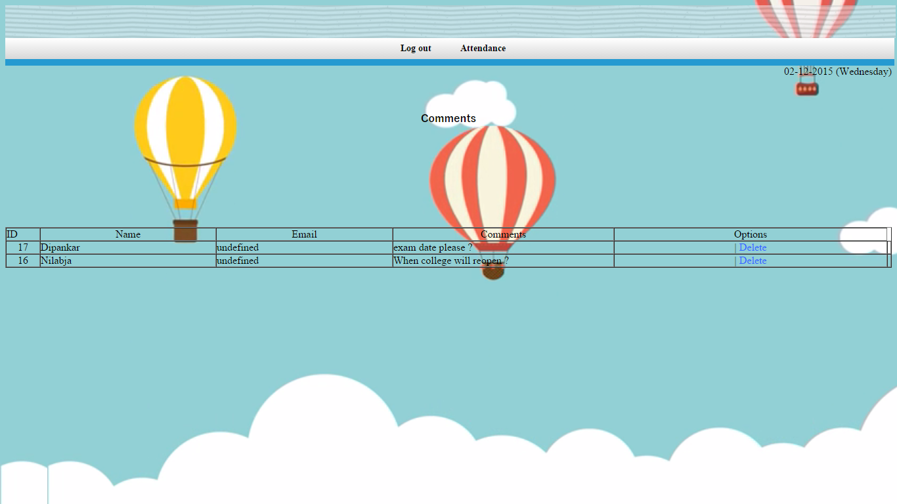

**ATTENDENCE**

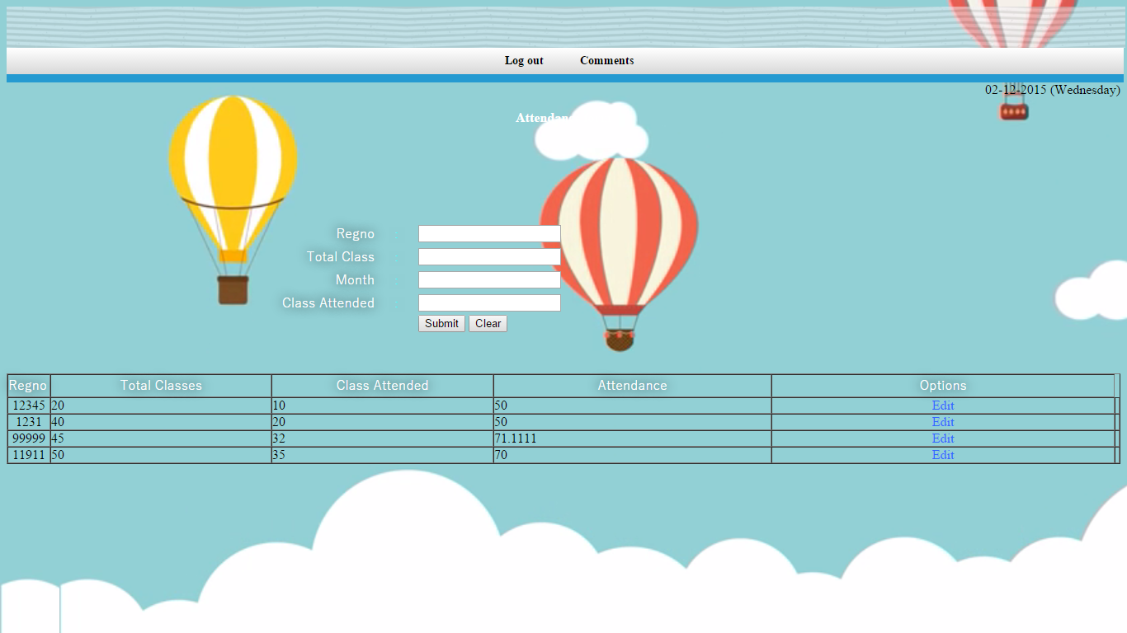

**ADMIN NEWS UPDATITION PAGE**

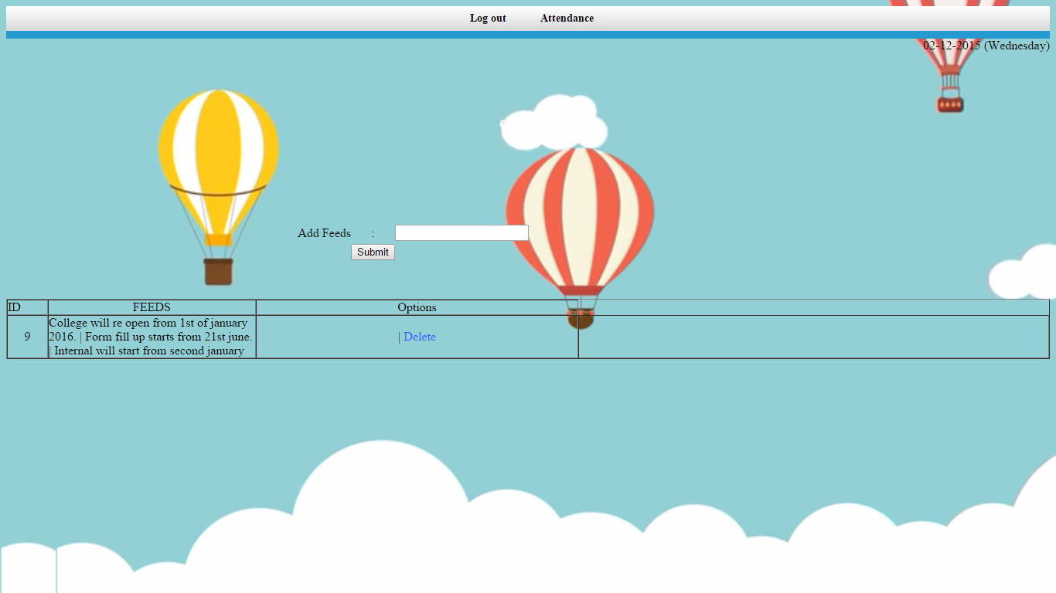

**USER LOGIN**

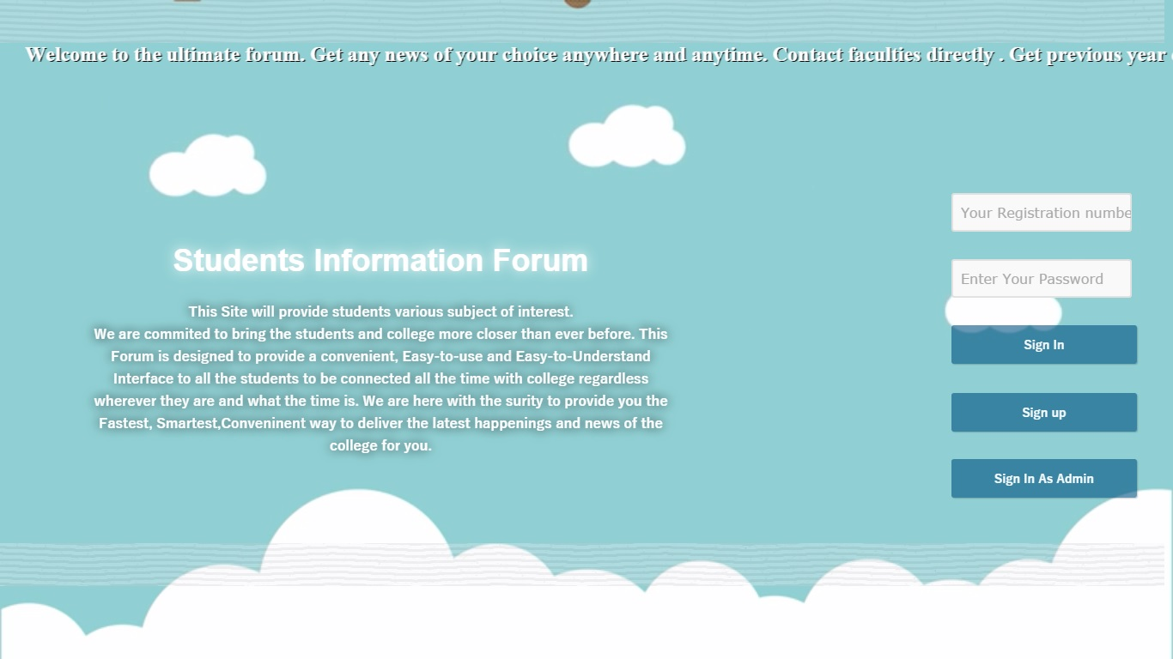

**USER DASHBOARD**



**USER QESTITION PAPER**

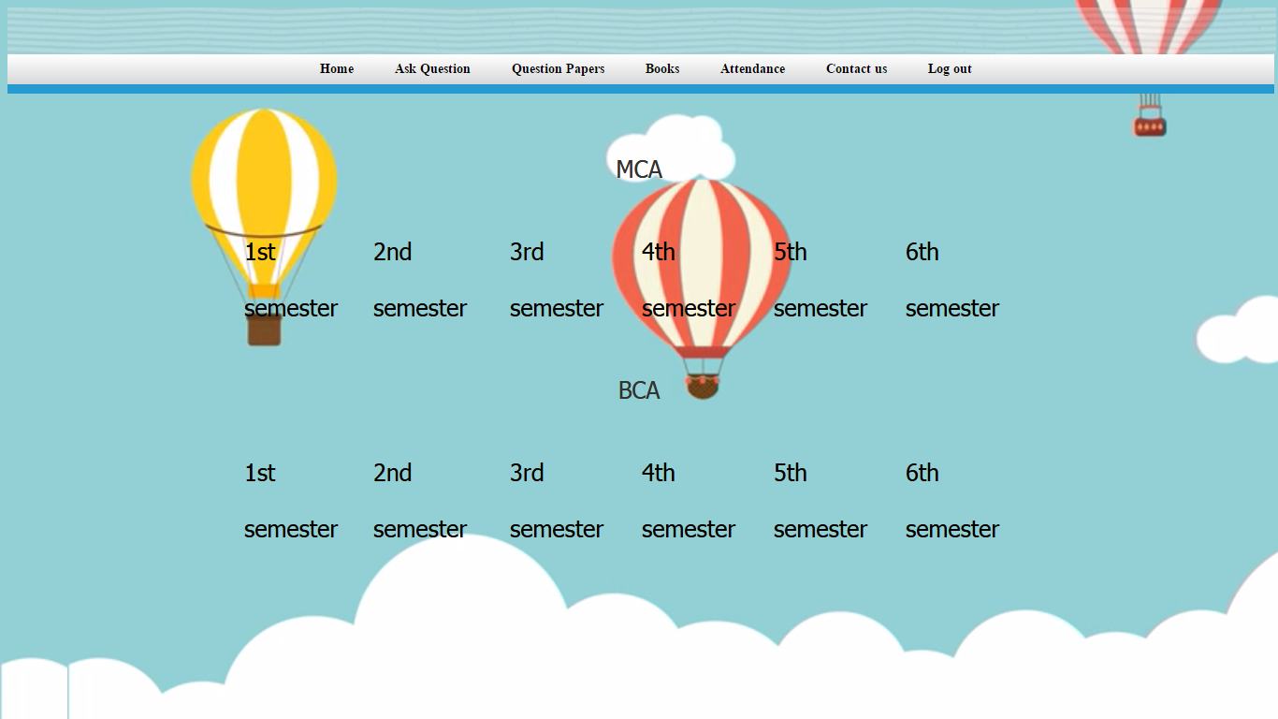

**USER BOOK**

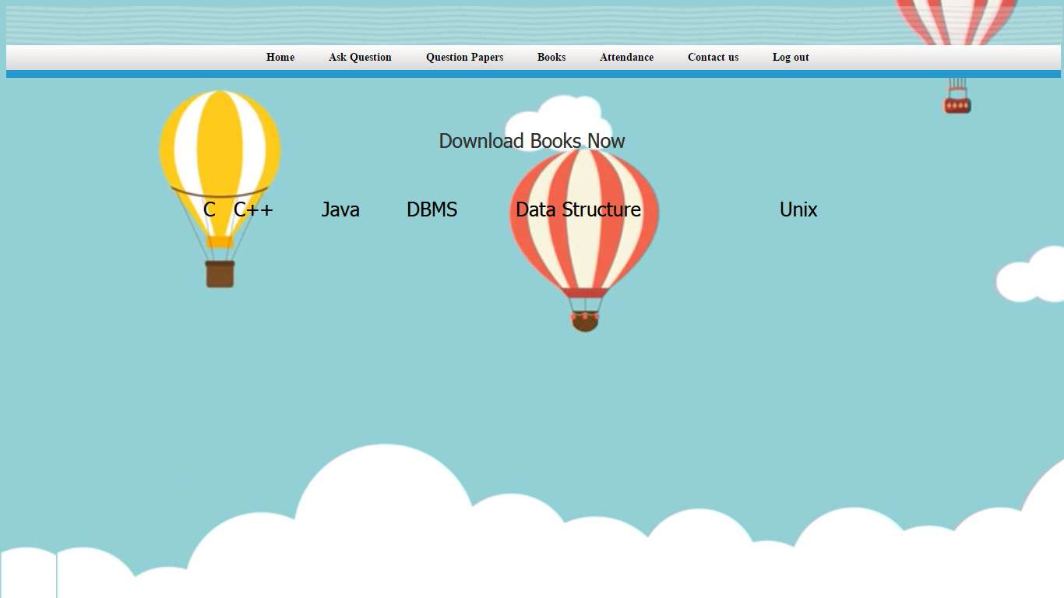

**USER ATTENDENCE**

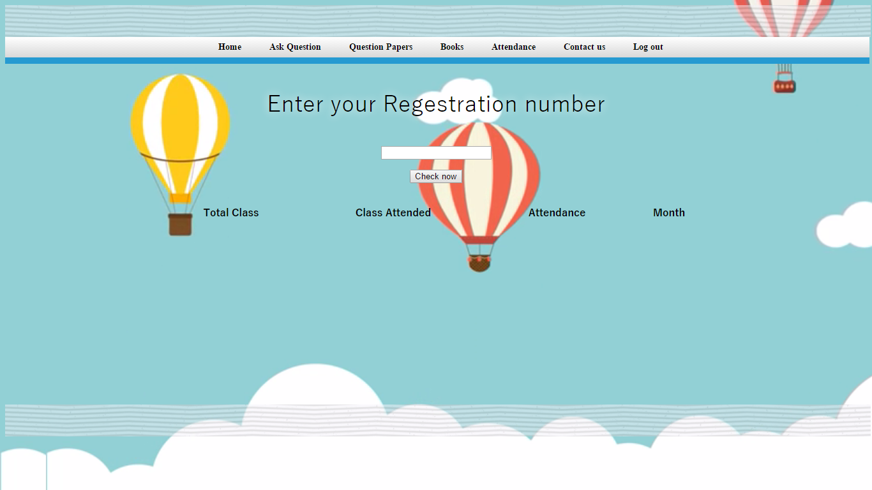

**CONTACT US**

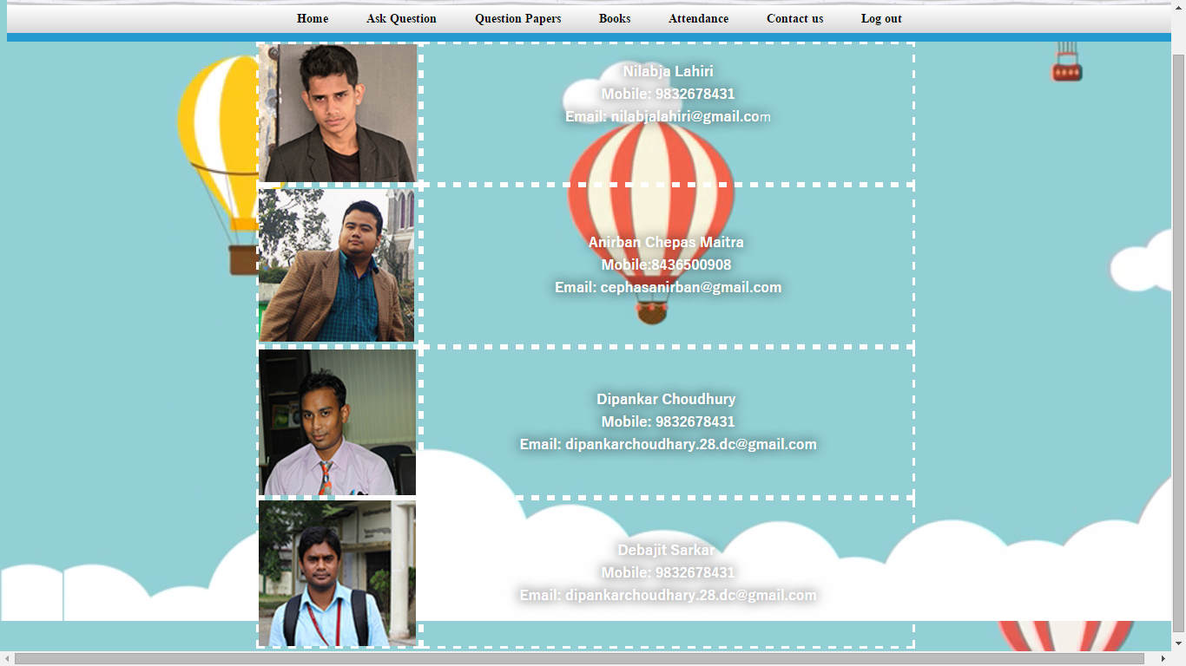

**PROJECT CODING**

**USER LOGIN**

|  |  |
| --- | --- |
| <?php  session_start();  include_once 'dbconnect.php';  if(isset($_SESSION['user'])!="")  {  header("Location: dashboard.php");  }  if(isset($_POST['btn-login']))  {  $regno = mysql_real_escape_string($_POST['regno']);  $upass = mysql_real_escape_string($_POST['pass']);  $res=mysql_query("SELECT * FROM users WHERE regno='$regno'");  $row=mysql_fetch_array($res);    if($row['password']==md5($upass))  {  $_SESSION['user'] = $row['user_id'];  header("Location: dashboard.php");  }  else  {  ?>  <script>alert('wrong details');</script>  <?php  }    }  ?>  <?php include_once("template_header.php");?>  <p><marquee onMouseOver="this.stop()" onMouseOut="this.start()">  <font face="Times New Roman" size="5" color="#00FF00"<b><font color="#FFFFFF"><font style="text-shadow:#000000 1.5px 1px""face="Yu Gothic"><b>Welcome to the ultimate forum. Get any news of your choice anywhere and anytime. Contact faculties directly . Get previous year question papers . Download hundreds of Books just in One-Click. </font></font>  </marquee>  <!DOCTYPE html PUBLIC "-//W3C//DTD XHTML 1.0 Transitional//EN" "http://www.w3.org/TR/xhtml1/DTD/xhtml1-transitional.dtd">  <html xmlns="http://www.w3.org/1999/xhtml">  <head>  <meta http-equiv="Content-Type" content="text/html; charset=utf-8" />  <title>Login & Registration System</title>  <link rel="stylesheet" href="style.css" type="text/css" />  <style type="text/css">  video#bgvid {  position: fixed;  right: 0;  top: 0;  min-height:100%;  min-width: 100%;  width: auto;  height:auto;  max-height: 1000px;  z-index: -100;  background: url(sample.png) no-repeat;  -webkit-background-size: cover;  -moz-background-size: cover;  -o-background-size: cover;  }  video { display: block; }  .myButton{  background: url(button.png) no-repeat;  margin:0 auto;  width:300px;  height:300px;  }  #textArea{  position:fixed;  top:610px;  }  .clear{  clear:both;  }    p{  text-align:center;  }  glow  {  color:#33FFFF;  text-shadow:0 0 20px black;  }  .glow1  {  color:#33FFFF;  text-shadow:0 0 20px white;  }  -->  img {  opacity: 0.3;  filter: alpha(opacity=10); /* For IE8 and earlier */  }  <!--  .style11 {color: #FFFFFF}  .style12 {font-family: "Yu Gothic"}  .style22 { font-size: 17px;  color: #333333;  }  .style28 {word-spacing: normal; color: #333333; text-shadow: #CCCCCC; font-family: Georgia, "Times New Roman", Times, serif; text-align: center; text-shadow:#0066FF; 3px;} | .style31 {  color: #0066FF;  font-family: "Yu Gothic";  }  .style32 {  color: #FFFFFF;  font-weight: bold;  }  .style40 {color: #000000}  .style49 {font-family: "Comic Sans MS"}  .style52 {  text-shadow: 0 0 20px white;  font-size: 36px;  color: #FFFFFF;  font-family: Geneva, Arial, Helvetica, sans-serif;  font-weight: bold;  }  -->  </style>  </head>  <body>  <video autoplay loop poster="sample.jpg" id="bgvid">  <source src="xx.mp4" type="video/mp4">  </video>  <p>  <p>  <p>  <p>  <p>  <p>  <p>  <center>  </br></br>  <div id="login-form">  <form method="post">  <div align="right">  <div align="center">  <table align="right" width="0%" border="0">  <tr>  <td><input name="regno" type="text" id="regno" placeholder="Your Registration number" required /></td>  </tr>  <tr>  <td><input type="password" name="pass" placeholder="Enter Your Password" required /></td>  </tr>  <tr>  <td><button type="submit" name="btn-login">Sign In</button></td>  </tr>  <tr>  <tr>  <td>      <button type="submit" name="btn-login1">  <span class="style23"><a href="register.php">Sign up</td>  </tr>  <tr>  <td><button type="submit" name="btn-login">  <span class="style23"><a href="adminlogin.php">Sign In As Admin</button></td>  </tr>  </table>  </div>  </div>  </form>  </div>  <table width="65%" height="125" border="0" align="left" cellpadding="30" cellspacing="60" bordercolor="#FFFFFF" id="123">  <tr class="glow">  <td align="center" valign="bottom">  <div align="justify" class="style49">  <div align="center"><span class="style52">Students Information Forum</span> </div>  </div>  <p align="center" class="style28 style31 style32">&nbsp;</p>  <p align="center" class="style28 style31 style32 style11">This Site will provide students various subject of interest.</p>  <p align="center" class="style31 style28 style40"><strong><span class="style11">We are commited to bring the students and college more closer than ever before. This Forum is designed to provide a convenient, Easy-to-use and</span> <span class="style11">Easy-to-Understand Interface to all the students to be connected all the</span> <span class="style11">time with college regardless wherever they are and what the time is. We are here with the surity to provide you the Fastest, Smartest,Conveninent</span> <span class="style11">way to deliver the latest happenings and news of the college for you.</span></strong></p></td>  </tr>  </table>  <p align="center" class="style5 style12 style11 style22">&nbsp;</p>  <p align="center" class="style5 style12 style11 style22">&nbsp;</p>  <form method="post">  <div align="right">  <p align="right">&nbsp;</p>  <div align="center"></div>  </div>  </form>  <p align="center" class="style5 style12 style11 style22">&nbsp;</p>  <p align="center" class="style5 style12 style11 style22">&nbsp;</p>  <p align="center" class="style5 style12 style11 style22">&nbsp;</p>  <p align="center" class="style5 style12 style11 style22">&nbsp;</p>  <p align="center" class="style5 style12 style11 style22">&nbsp;</p>  <p align="center" class="style5 style12 style11 style22">&nbsp;</p>  <p align="center" class="style5 style12 style11 style22">&nbsp;</p>  <p align="center" class="style5 style12 style11 style22">&nbsp;</p>  <p align="center" class="style5 style12 style11 style22">&nbsp;</p>  <p align="center" class="style5 style12 style11 style22">&nbsp;</p>  <p align="center" class="style5 style12 style11 style22">&nbsp;</p>  </center>  </br></br></br></br>  <?php include_once("template_footer.php");?>  </body>  </html> |

**REGISTER**

|  |  |
| --- | --- |
| <?php  session_start();  if(isset($_SESSION['user'])!="")  {  header("Location: home.php");  }  include_once 'dbconnect.php';  if(isset($_POST['btn-signup']))  {  $uname = mysql_real_escape_string($_POST['uname']);  $regno = mysql_real_escape_string($_POST['number']);  $email = mysql_real_escape_string($_POST['email']);  $upass = md5(mysql_real_escape_string($_POST['pass']));    if(mysql_query("INSERT INTO users(username,regno,email,password) VALUES('$uname','$regno','$email','$upass')"))  {  ?>  <script>alert('successfully registered ');</script>  <?php  }  else  {  ?>  <script>alert('error while registering you...');</script>  <?php  }  }  ?>  <?php include_once("template_header.php");?>  <!DOCTYPE html PUBLIC "-//W3C//DTD XHTML 1.0 Transitional//EN" "http://www.w3.org/TR/xhtml1/DTD/xhtml1-transitional.dtd">  <html xmlns="http://www.w3.org/1999/xhtml">  <head>  <meta http-equiv="Content-Type" content="text/html; charset=utf-8" />  <title>Login & Registration System</title>  <link rel="stylesheet" href="style.css" type="text/css" /> | <style type="text/css">  img {  opacity: 0.8;  filter: alpha(opacity=10); /* For IE8 and earlier */  }  <!--  body {  background-image: url(Untitled1.png);  }  -->  </style></head>  <body>  <center>  <div id="login-form">  <form method="post">  <table align="center" width="30%" border="0">  <tr>  <td><input type="text" name="uname" placeholder="User Name" required /></td>  </tr>  <tr>  <td><input name="email" type="email" id="email" placeholder="Your Email" required /></td>  </tr>  <tr>  <td><input type="number" name="number" placeholder="Your Registration number" required /></td>  </tr>  <tr>  <td><input type="password" name="pass" placeholder="Your Password" required /></td>  </tr>  <tr>  <td><button type="submit" name="btn-signup">Sign Me Up</button></td>  </tr>  <tr>  <td><button type="submit" name="btn-signup"><a href="index.php">Login now</button></td>  </tr>  </table>  </form>  </div>  </center>  </body>  </html> |

**QUESTION PAPER**

|  |  |
| --- | --- |
| <style type="text/css">  <!--  body {  background-image: url(../Untitled1.png);  }  -->  </style>  <?php    include_once("../template_header.php");  include('authcode.php');  echo '<html>  <head>  <title> MCA BCA books download</title>  <link type="text/css" rel="stylesheet" href="css/main.css" />  <link type="text/css" rel="stylesheet" href="css/ads.css" />  </head>  <body>  <ul class="slideuptabs blue">  <li><a href="../dashboard.php"><span>Home</span></a></li>  <li><a href="../WCD_comment_system_php_jquery_ajax_db/index.php"><span>Ask Question</span></a></li>  <li><a href="dq.php"><span>Question Papers</span></a></li>  <li><a href="dbooks.php"><span>Books</span></a></li>  <li><a href="../attendance.php"><span>Attendance</span></a></li>  <li><a href="#"><span>Contact us</span></a></li>  <li><a href="../logout.php"><span>Log out</span></a></li>  </ul> | <span class="glow">  <div id="content">  <table width="100%">  <tr>    <p align="center">MCA</p></font>  <td><a href="download.php?file='.urlencode('files/questionmca/First/First.rar').'"><font color="black"> 1st semester</font></a></td>  <td><a href="download.php?file='.urlencode('files/questionmca/second/second.rar').'&amp;authcode='.create_authcode('example2.jpg').'"><font color="black"> 2nd semester</a></td>  <td><a href="download.php?file='.urlencode('files/questionmca/Third/Third.rar').'"><font color="black"> 3rd semester</a></td>  <td><a href="download.php?file='.urlencode('files/questionmca/fourth/fourth.rar').'"><font color="black"> 4th semester</a></td>  <td><a href="download.php?file='.urlencode('files/questionmca/fifth/fifth.rar').'"><font color="black"> 5th semester</a></td>  <td><a href="#"><font color="black"> 6th semester</a></td>  </span></tr>    </table>  <table width="100%">  <tr>  <p align="center">BCA</p></font>  <td><a href="download.php?file='.urlencode('files/questionbca/first/First.rar').'"><font color="black"> 1st semester</a></td>  <td><a href="download.php?file='.urlencode('files/questionbca/second/second.rar').'&amp;authcode='.create_authcode('example2.jpg').'"><font color="black"> 2nd semester</a></td>  <td><a href="download.php?file='.urlencode('files/questionbca/third/Third.rar').'"><font color="black"> 3rd semester</a></td>  <td><a href="download.php?file='.urlencode('files/questionbca/fourth/fourth.rar').'"><font color="black"> 4th semester</a></td>  <td><a href="download.php?file='.urlencode('files/questionbca/fifth/fifth.rar').'"><font color="black"> 5th semester</a></td>  <td><a href="download.php?file='.urlencode('files/questionbca/sixth/sixth.rar').'"><font color="black"> 6th semester</a></td>      </table>  </div>        </div>';  ?> |

**BOOKS**

|  |  |
| --- | --- |
| <style type="text/css">  <!--  body {  background-image: url(../Untitled1.png);  }  -->  </style><?php  include_once("../template_header.php");  include('authcode.php');  echo '<html>  <head>  <title>(Secure)Books Download</title>  <link type="text/css" rel="stylesheet" href="css/main.css" />  <link type="text/css" rel="stylesheet" href="css/ads.css" />  </head>  <body>  <ul class="slideuptabs blue">  <li><a href="../dashboard.php"><span>Home</span></a></li>  <li><a href="../WCD_comment_system_php_jquery_ajax_db/index.php"><span>Ask Question</span></a></li>  <li><a href="dq.php"><span>Question Papers</span></a></li>  <li><a href="dbooks.php"><span>Books</span></a></li> | <li><a href="../attendance.php"><span>Attendance</span></a></li>  <li><a href="#"><span>Contact us</span></a></li>  <li><a href="../logout.php"><span>Log out</span></a></li>  </ul>  <span class="glow">  <div id="content">  <table width="100%">  <tr>  <p align="center">Download Books Now </p></font>  <td><a href="download.php?file='.urlencode('files/Ebooks/c/cprogramming_tutorial.pdf').'"><font color ="black">C</font></a></td>  <td><a href="download.php?file='.urlencode('files/Ebooks/C++/tutorial.pdf').'&amp;authcode='.create_authcode('example2.jpg').'"><font color ="black">C++</font></a></td>  <td><a href="download.php?file='.urlencode('files/Ebooks/Java/java.pdf').'"><font color ="black">Java</a></td>  <td><a href="download.php?file='.urlencode('files/Ebooks/Database Management System/dbms.pdf').'"><font color ="black">DBMS</font></a></td>  <td><a href="download.php?file='.urlencode('files/Ebooks/Data Structure/Dsa.pdf').'"><font color ="black">Data Structure</font></a></td>  <td><a href="download.php?file='.urlencode('files/Ebooks/unix/unix.pdf').'"><font color ="black">Unix</font></a></td>  </span>    </table>  </div>    </div>';  ?> |

**MAIN PAGE**

|  |  |
| --- | --- |
| <?php include_once("template_header.php");?>  <?php include ('dbconnect.php'); ?>  <!DOCTYPE HTML PUBLIC "-//W3C//DTD HTML 4.01 Transitional//EN" "http://www.w3.org/TR/html4/loose.dtd">  <html>  <head>  <title>Wel come to Online Exam</title>  <meta http-equiv="Content-Type" content="text/html; charset=iso-8859-1">  <link href="quiz.css" rel="stylesheet" type="text/css">  <style type="text/css">  .glow  {  color:#33FFFF;  text-shadow:0 0 20px black;  }  img {  opacity: 0;  filter: alpha(opacity=10); /* For IE8 and earlier */  }  ul.slideuptabs{  list-style: none;  margin: 0;  padding: 0;  position: relative;  text-align: center;/* change to "center" or "right" to align differently */  border-bottom: 10px solid green; /* bottom border */  background: #ffffff;  background: -moz-linear-gradient(top, #ffffff 0%, #d8d8d8 100%); /* gray gradient background */  background: -webkit-gradient(linear, left top, left bottom, color-stop(0%,#ffffff), color-stop(100%,#d8d8d8));  background: -webkit-linear-gradient(top, #ffffff 0%,#d8d8d8 100%);  background: -o-linear-gradient(top, #ffffff 0%,#d8d8d8 100%);  background: -ms-linear-gradient(top, #ffffff 0%,#d8d8d8 100%);  background: linear-gradient(to bottom, #ffffff 0%,#d8d8d8 100%);  filter: progid:DXImageTransform.Microsoft.gradient( startColorstr='#ffffff', endColorstr='#d8d8d8',GradientType=0 );  width: 1354;  }  ul.slideuptabs li{  display: inline;  }  ul.slideuptabs li:first-of-type{  margin-left: 10px;  }  ul.slideuptabs a{  position: relative;  display: inline-block;  overflow: hidden;  color: black; /* font color */  text-decoration: none;  padding: 8px 20px;  font-size: 14px; /* font size */  font-weight: bold;  vertical-align: bottom;  -webkit-transition: color 0.5s; /* transition property and duration */  -moz-transition: color 0.5s;  transition: color 0.5s;  }  ul.slideuptabs a span{  position: relative;  z-index: 10;  }  ul.slideuptabs a::before{  content: '';  color: white;  display: block;  position: absolute;  width: 100%;  height: 100%;  background: green; /* tab background */  left: 0;  top: 110%; /* extra 10% is to account for shadow dimension */  box-shadow: -2px 2px 10px rgba(255,255,255,.5) inset;  border-radius: 15px 15px 0 0 / 12px 12px; /* oval shaped border for top-left and top-right corners */  -webkit-transition: top 0.5s; /* transition property and duration */  -moz-transition: top 0.5s;  transition: top 0.5s;  }  ul.slideuptabs a:hover{  color: white; /* hover color */  }  ul.slideuptabs a:hover::before{  top: 0; /* slide tab up */  }  /****** Responsive Code ******/  @media screen and (max-width: 640px) {    ul.slideuptabs li:first-of-type{  margin-left: 0;  }  }  /****** Theme Blue ******/  ul.slideuptabs.blue{  border-bottom-color: #259AD1;  }  ul.slideuptabs.blue a::before{  background: #259AD1;  }  <!--[if lte IE 8]>  <style type="text/css">  ul.slideuptabs a:hover{  color: black; /* hover color for IE8 where tabs don't slide up */  }  #content{font-weight:lighter;  text-shadow:#333300 .25px .25px;}  a{color:#3366FF;  text-decoration:none;  }  a:hover{color:#000000;  font-size:20px;  }  <!--  body {  background-image: url(Untitled1.png);  }  .style9 {color: #000000}  .style10 {  color: #666666;  font-family: "Yu Gothic";  font-weight: bold;  } | .style23 {color: #666666}  -->  div.flip{  position:relative;  width: 300px; /* Set default width of flip */  height: 250px; /* Set default height */  -webkit-perspective: 600px; /* larger the value, the less pronounced the 3D effect */  -moz-perspective: 600px;  -o-perspective: 600px;  perspective: 600px;  }  div.flip div.rotate{  width: 100%;  height: 100%;  -moz-transform-style: preserve-3d; /* Specify all child elements inside this DIV maintain the same perspective */  -webkit-transform-style: preserve-3d;  -o-transform-style: preserve-3d;  transform-style: preserve-3d;  -moz-transition: all 0.6s ease-in-out 0.3s; /* final 0.3s specifies delay before effect kicks in */  -webkit-transition: all 0.6s ease-in-out 0.3s;  -o-transition: all 0.6s ease-in-out 0.3s;  transition: all 0.6s ease-in-out 0.3s;  }  div.flip div.rotate > *{ /* Target all children elements */  position:absolute;  width: 100%;  height: 100%;  -moz-backface-visibility: hidden;  -webkit-backface-visibility: hidden;  -o-backface-visibility: hidden;  backface-visibility: hidden;  }  div.flip div.rotate > div{ /* Target all child DIVs */  -webkit-box-sizing: border-box; /* Specify that any border/ paddings do not add to the DIV's total width */  -moz-box-sizing: border-box;  box-sizing: border-box;  padding: 8px;  background: #eee;  }  div.rotate.x *:nth-child(2){ /* X Axis rotate specific CSS. Rotate 2nd child DIV 180deg in the X axis */  -moz-transform: rotateX(180deg);  -webkit-transform: rotateX(180deg);  -o-transform: rotateX(180deg);  transform: rotateX(180deg);  }  div.flip:hover > div.rotate.x{ /* X Axis rotate specific CSS. Rotate div.rotate.x when mouse rolls over container */  -moz-transform: rotateX(180deg);  -webkit-transform: rotateX(180deg);  -o-transform: rotateX(180deg);  transform: rotateX(180deg);  }  div.rotate.y *:nth-child(2){ /* Y Axis rotate specific CSS. Rotate 2nd child DIV 180deg in the Y axis so it mirrors the first */  -moz-transform: rotateY(180deg);  -webkit-transform: rotateY(180deg);  -o-transform: rotateY(180deg);  transform: rotateY(180deg);  }  div.flip:hover > div.rotate.y{ /* Y Axis rotate specific CSS. Rotate div.rotate.y when mouse rolls over container */  -moz-transform: rotateY(180deg);  -webkit-transform: rotateY(180deg);  -o-transform: rotateY(180deg);  transform: rotateY(180deg);  }  img {  opacity: 0.5;  filter: alpha(opacity=10); /* For IE8 and earlier */  }  .style27 {color: #FFFFFF; text-shadow: 0 0 20px black; }  .style28 {font-size: 30px}  </style>    </head>  <body>  <ul class="slideuptabs blue">  <li><a href="dashboard.php"><span>Home</span></a></li>  <li><a href="WCD_comment_system_php_jquery_ajax_db/index.php"><span>Ask Question</span></a></li>  <li><a href="download/dq.php"><span>Question Papers</span></a></li>  <li><a href="download/dbooks.php"><span>Books</span></a></li>  <li><a href="attendance.php"><span>Attendance</span></a></li>  <li><a href="contactus.php"><span>Contact us</span></a></li>  <li><a href="logout.php"><span>Log out</span></a></li>  </ul>  <div align="right" class="glow"><b><font color="#ffffff"><?php echo date("d-m-Y")." (".date("l",strtotime("now")).")";?></div>  <font face="Times New Roman" size="4" color="black"><strong><font color="white" face="Yu Gothic">  <h3 class="glow"><small class="style27"><?php  $fetch=mysql_query("select * from news");  if(mysql_num_rows($fetch))  {  ?>  <marquee behavior="scroll" scrollamount="5" direction="left" onmouseover="this.stop();" onmouseout="this.start();">  <ul class="ulclass" >  <?php  while($row=mysql_fetch_array($fetch))  {  $id=$row['id'];  $feed=$row['feeds'];  ?>    <?php echo $feed; ?>  <?php } ?>  </li>  <?php } ?>  </tr>  </ul>    </marquee>  </h3>  </font></font>  </marquee>    <tr>  <td width="70%" height="368" valign="top"><div align="center">  <h1 align="center" class="style8 style10">&nbsp;</h1>  <h1 align="center" class="style8 style10"><b><small class="style27 style28">Welcome to Student Information Forum </small></h1>  <p align="center" class="style5 style9">&nbsp;</p>  <div align="center" class="style9">  <blockquote class="style23">&nbsp; </blockquote>  </div>  <blockquote>    <div id="sliderFrame">  <div id="htmlcaption" style="display: none;">    </div>  </div>  </body></blockquote>  </br>  </br>    </br></br></br></br></br></br>  </br></br></br></br></br></br></br>  <?php include_once("template_footer.php");?>  </html> |

**ATTENDANCE**

|  |  |
| --- | --- |
| <?php  include_once("template_header.php");  $re= $_POST['re'];  include "dbconnect.php";  ?>  <!DOCTYPE html PUBLIC "-//W3C//DTD XHTML 1.0 Transitional//EN" "http://www.w3.org/TR/xhtml1/DTD/xhtml1-transitional.dtd">  <html xmlns="http://www.w3.org/1999/xhtml">  <head>  <meta http-equiv="Content-Type" content="text/html; charset=utf-8" />  <title>Untitled Document</title>  <style type="text/css">  img {  opacity: 0;  filter: alpha(opacity=10); /* For IE8 and earlier */  }  ul.slideuptabs{  list-style: none;  margin: 0;  padding: 0;  position: relative;  text-align: center;/* change to "center" or "right" to align differently */  border-bottom: 10px solid green; /* bottom border */  background: #ffffff;  background: -moz-linear-gradient(top, #ffffff 0%, #d8d8d8 100%); /* gray gradient background */  background: -webkit-gradient(linear, left top, left bottom, color-stop(0%,#ffffff), color-stop(100%,#d8d8d8));  background: -webkit-linear-gradient(top, #ffffff 0%,#d8d8d8 100%);  background: -o-linear-gradient(top, #ffffff 0%,#d8d8d8 100%);  background: -ms-linear-gradient(top, #ffffff 0%,#d8d8d8 100%);  background: linear-gradient(to bottom, #ffffff 0%,#d8d8d8 100%);  filter: progid:DXImageTransform.Microsoft.gradient( startColorstr='#ffffff', endColorstr='#d8d8d8',GradientType=0 );  width: 1354;  }  ul.slideuptabs li{  display: inline;  }  ul.slideuptabs li:first-of-type{  margin-left: 10px;  }  ul.slideuptabs a{  position: relative;  display: inline-block;  overflow: hidden;  color: black; /* font color */  text-decoration: none;  padding: 8px 20px;  font-size: 14px; /* font size */  font-weight: bold;  vertical-align: bottom;  -webkit-transition: color 0.5s; /* transition property and duration */  -moz-transition: color 0.5s;  transition: color 0.5s;  }  ul.slideuptabs a span{  position: relative;  z-index: 10;  }  ul.slideuptabs a::before{  content: '';  color: white;  display: block;  position: absolute;  width: 100%;  height: 100%;  background: green; /* tab background */  left: 0;  top: 110%; /* extra 10% is to account for shadow dimension */  box-shadow: -2px 2px 10px rgba(255,255,255,.5) inset;  border-radius: 15px 15px 0 0 / 12px 12px; /* oval shaped border for top-left and top-right corners */  -webkit-transition: top 0.5s; /* transition property and duration */  -moz-transition: top 0.5s;  transition: top 0.5s;  }  ul.slideuptabs a:hover{  color: white; /* hover color */  }  ul.slideuptabs a:hover::before{  top: 0; /* slide tab up */  }  /****** Responsive Code ******/  @media screen and (max-width: 640px) {    ul.slideuptabs li:first-of-type{  margin-left: 0;  }  }  /****** Theme Blue ******/  ul.slideuptabs.blue{  border-bottom-color: #259AD1;  }  ul.slideuptabs.blue a::before{  background: #259AD1;  }  <!--[if lte IE 8]>  <style type="text/css">  ul.slideuptabs a:hover{  color: black; /* hover color for IE8 where tabs don't slide up */  }  #content{font-weight:lighter;  text-shadow:#333300 .25px .25px;}  a{color:#3366FF;  text-decoration:none;  }  a:hover{color:#000000;  font-size:20px;  }  <!--  body {  background-image: url(Untitled1.png);  }  -->  div.flip{  position:relative;  width: 300px; /* Set default width of flip */  height: 250px; /* Set default height */  -webkit-perspective: 600px; /* larger the value, the less pronounced the 3D effect */  -moz-perspective: 600px;  -o-perspective: 600px;  perspective: 600px;  } | div.flip div.rotate{  width: 100%;  height: 100%;  -moz-transform-style: preserve-3d; /* Specify all child elements inside this DIV maintain the same perspective */  -webkit-transform-style: preserve-3d;  -o-transform-style: preserve-3d;  transform-style: preserve-3d;  -moz-transition: all 0.6s ease-in-out 0.3s; /* final 0.3s specifies delay before effect kicks in */  -webkit-transition: all 0.6s ease-in-out 0.3s;  -o-transition: all 0.6s ease-in-out 0.3s;  transition: all 0.6s ease-in-out 0.3s;  }  div.flip div.rotate > *{ /* Target all children elements */  position:absolute;  width: 100%;  height: 100%;  -moz-backface-visibility: hidden;  -webkit-backface-visibility: hidden;  -o-backface-visibility: hidden;  backface-visibility: hidden;  }  div.flip div.rotate > div{ /* Target all child DIVs */  -webkit-box-sizing: border-box; /* Specify that any border/ paddings do not add to the DIV's total width */  -moz-box-sizing: border-box;  box-sizing: border-box;  padding: 8px;  background: #eee;  }  div.rotate.x *:nth-child(2){ /* X Axis rotate specific CSS. Rotate 2nd child DIV 180deg in the X axis */  -moz-transform: rotateX(180deg);  -webkit-transform: rotateX(180deg);  -o-transform: rotateX(180deg);  transform: rotateX(180deg);  }  div.flip:hover > div.rotate.x{ /* X Axis rotate specific CSS. Rotate div.rotate.x when mouse rolls over container */  -moz-transform: rotateX(180deg);  -webkit-transform: rotateX(180deg);  -o-transform: rotateX(180deg);  transform: rotateX(180deg);  }  div.rotate.y *:nth-child(2){ /* Y Axis rotate specific CSS. Rotate 2nd child DIV 180deg in the Y axis so it mirrors the first */  -moz-transform: rotateY(180deg);  -webkit-transform: rotateY(180deg);  -o-transform: rotateY(180deg);  transform: rotateY(180deg);  }  div.flip:hover > div.rotate.y{ /* Y Axis rotate specific CSS. Rotate div.rotate.y when mouse rolls over container */  -moz-transform: rotateY(180deg);  -webkit-transform: rotateY(180deg);  -o-transform: rotateY(180deg);  transform: rotateY(180deg);  }  img {  opacity: 0.5;  filter: alpha(opacity=10); /* For IE8 and earlier */  }  .glow  {  color:#33FFFF;  text-shadow:0 0 20px black;  }  .glow1  {  color:#33FFFF;  text-shadow:0 0 20px white;  }  <!--  body {  background-image: url(Untitled1.png);  }  .style2 {  color: #000000;  text-shadow: 0 0 20px white;  font-size: 36px;  font-family: "Yu Gothic";  }  .style3 {font-family: "Yu Gothic"}  .style5 {font-family: "Yu Gothic"; font-weight: bold; }  -->  </style></head>  <body>  <ul class="slideuptabs blue">  <li><a href="dashboard.php"><span>Home</span></a></li>  <li><a href="WCD_comment_system_php_jquery_ajax_db/index.php"><span>Ask Question</span></a></li>  <li><a href="download/dq.php"><span>Question Papers</span></a></li>  <li><a href="download/dbooks.php"><span>Books</span></a></li>  <li><a href="attendance.php"><span>Attendance</span></a></li>  <li><a href="#"><span>Contact us</span></a></li>  <li><a href="logout.php"><span>Log out</span></a></li>  </ul>  <form action="" method="post">  <p align="center" class="style2"> Enter your Regestration number </p>  <p align="center"><input type="text" value="" name="re" />  <p>  <p align="center"><input type="submit" name="submit" value="Check now" />  <p>  <table width="861" height="63" border="0" align="center">  <tr>  <th scope="col"><span class="style3">Total Class</span></th>  <th scope="col"><span class="style3">Class Attended</span></th>  <th scope="col"><span class="style3">Attendance</span></th>  <th scope="col"><span class="style3">Month</span></th>  </tr>  <?php  if(isset ($_POST['submit']))  {  $sql = "SELECT * FROM attendance where Regno =$re";  $query = mysql_query($sql);  while($row = mysql_fetch_assoc($query))  {  ?>  <tr>  <td align="center"><span class="style5"><?php echo(stripslashes($row['Total_class']));?></span></td>  <td align="center"><span class="style5"><?php echo(stripslashes($row['Class']));?></span></td>  <td align="center"><span class="style5"><?php echo(stripslashes($row['Attendance']))?>%</span></td>  <td align="center"><span class="style5"><?php echo(stripslashes($row['Month']));?></span></td>  </tr>  <?php  }  }  ?>  </table>  <p>  </form>  </body>  </br>  </br>  </br>  </br>  </br></br></br>  </br></br></br></br></br></br></br>  <?php include_once("template_footer.php");?>  </html> |

**UPDATION OF NEWS**

|  |  |
| --- | --- |
| <?php  include "dbconnect.php";  if(isset($_POST['Submit']))  {  $id = $_POST['id'];  $feeds = $_POST['feeds'];    if($_POST['Submit'] == "Submit")  {  $sql = "insert into news(id,feeds) values('$id','$feeds')";  $rec = mysql_query($sql);    if($rec)  {  echo "<script>  alert('You have Successfully inserted news');  location.replace('adminnews.php?');  </script>";  }  }  elseif($_POST['Submit'] == "Update")  {  $pk = $_POST['pk'];    $usql = "update news set feeds='$feeds' where id='$pk'";  $urec = mysql_query($usql);  if($urec)  {  echo "<script>  alert('You have Successfully updated a profile ');  location.replace('adminnews.php?');  </script>";  }  }  }  if(isset($_GET['E']))  {  $esql = "select * from news where id='$_GET[E]'";  $erec = mysql_query($esql);  $eres = mysql_fetch_assoc($erec);  }  if(isset($_GET['D']))  {  $esql = "delete from news where id='$_GET[D]'";  $erec = mysql_query($esql);  if($erec)  {  echo "<script>  alert('You have Successfully Deleted a profile ');  location.replace('adminnews.php?');  </script>";  }  }  ?>  <!DOCTYPE html PUBLIC "-//W3C//DTD XHTML 1.0 Transitional//EN" "http://www.w3.org/TR/xhtml1/DTD/xhtml1-transitional.dtd">  <html xmlns="http://www.w3.org/1999/xhtml">  <head>  <meta http-equiv="Content-Type" content="text/html; charset=iso-8859-1" />  <title>Admin Attendance</title>  <style type="text/css">  img {  opacity: 0;  filter: alpha(opacity=10); /* For IE8 and earlier */  }  ul.slideuptabs{  list-style: none;  margin: 0;  padding: 0;  position: relative;  text-align: center;/* change to "center" or "right" to align differently */  border-bottom: 10px solid green; /* bottom border */  background: #ffffff;  background: -moz-linear-gradient(top, #ffffff 0%, #d8d8d8 100%); /* gray gradient background */  background: -webkit-gradient(linear, left top, left bottom, color-stop(0%,#ffffff), color-stop(100%,#d8d8d8));  background: -webkit-linear-gradient(top, #ffffff 0%,#d8d8d8 100%);  background: -o-linear-gradient(top, #ffffff 0%,#d8d8d8 100%);  background: -ms-linear-gradient(top, #ffffff 0%,#d8d8d8 100%);  background: linear-gradient(to bottom, #ffffff 0%,#d8d8d8 100%);  filter: progid:DXImageTransform.Microsoft.gradient( startColorstr='#ffffff', endColorstr='#d8d8d8',GradientType=0 );  width: 1354;  }  ul.slideuptabs li{  display: inline;  }  ul.slideuptabs li:first-of-type{  margin-left: 10px;  }  ul.slideuptabs a{  position: relative;  display: inline-block;  overflow: hidden;  color: black; /* font color */  text-decoration: none;  padding: 8px 20px;  font-size: 14px; /* font size */  font-weight: bold;  vertical-align: bottom;  -webkit-transition: color 0.5s; /* transition property and duration */  -moz-transition: color 0.5s;  transition: color 0.5s;  }  ul.slideuptabs a span{  position: relative;  z-index: 10;  }  ul.slideuptabs a::before{  content: '';  color: white;  display: block;  position: absolute;  width: 100%;  height: 100%;  background: green; /* tab background */  left: 0;  top: 110%; /* extra 10% is to account for shadow dimension */  box-shadow: -2px 2px 10px rgba(255,255,255,.5) inset;  border-radius: 15px 15px 0 0 / 12px 12px; /* oval shaped border for top-left and top-right corners */  -webkit-transition: top 0.5s; /* transition property and duration */  -moz-transition: top 0.5s;  transition: top 0.5s;  }  ul.slideuptabs a:hover{  color: white; /* hover color */  }  ul.slideuptabs a:hover::before{  top: 0; /* slide tab up */  }  /****** Responsive Code ******/  @media screen and (max-width: 640px) {    ul.slideuptabs li:first-of-type{  margin-left: 0;  }  }  /****** Theme Blue ******/  ul.slideuptabs.blue{  border-bottom-color: #259AD1;  }  ul.slideuptabs.blue a::before{  background: #259AD1;  }  <!--[if lte IE 8]>  <style type="text/css">  ul.slideuptabs a:hover{  color: black; /* hover color for IE8 where tabs don't slide up */  } | .style1 {color: #FFFFFF}  #content{font-weight:lighter;  text-shadow:#333300 .25px .25px;}  a{color:#3366FF;  text-decoration:none;  }  a:hover{color:#000000;  font-size:20px;  }  <!--  body {  background-image: url(Untitled1.png);  }  .style9 {  color: #000000;  font-family: "Yu Gothic";  font-weight: bold;  }  -->  div.flip{  position:relative;  width: 300px; /* Set default width of flip */  height: 250px; /* Set default height */  -webkit-perspective: 600px; /* larger the value, the less pronounced the 3D effect */  -moz-perspective: 600px;  -o-perspective: 600px;  perspective: 600px;  }  div.flip div.rotate{  width: 100%;  height: 100%;  -moz-transform-style: preserve-3d; /* Specify all child elements inside this DIV maintain the same perspective */  -webkit-transform-style: preserve-3d;  -o-transform-style: preserve-3d;  transform-style: preserve-3d;  -moz-transition: all 0.6s ease-in-out 0.3s; /* final 0.3s specifies delay before effect kicks in */  -webkit-transition: all 0.6s ease-in-out 0.3s;  -o-transition: all 0.6s ease-in-out 0.3s;  transition: all 0.6s ease-in-out 0.3s;  }  div.flip div.rotate > *{ /* Target all children elements */  position:absolute;  width: 100%;  height: 100%;  -moz-backface-visibility: hidden;  -webkit-backface-visibility: hidden;  -o-backface-visibility: hidden;  backface-visibility: hidden;  }  div.flip div.rotate > div{ /* Target all child DIVs */  -webkit-box-sizing: border-box; /* Specify that any border/ paddings do not add to the DIV's total width */  -moz-box-sizing: border-box;  box-sizing: border-box;  padding: 8px;  background: #eee;  }  div.rotate.x *:nth-child(2){ /* X Axis rotate specific CSS. Rotate 2nd child DIV 180deg in the X axis */  -moz-transform: rotateX(180deg);  -webkit-transform: rotateX(180deg);  -o-transform: rotateX(180deg);  transform: rotateX(180deg);  }  div.flip:hover > div.rotate.x{ /* X Axis rotate specific CSS. Rotate div.rotate.x when mouse rolls over container */  -moz-transform: rotateX(180deg);  -webkit-transform: rotateX(180deg);  -o-transform: rotateX(180deg);  transform: rotateX(180deg);  }  div.rotate.y *:nth-child(2){ /* Y Axis rotate specific CSS. Rotate 2nd child DIV 180deg in the Y axis so it mirrors the first */  -moz-transform: rotateY(180deg);  -webkit-transform: rotateY(180deg);  -o-transform: rotateY(180deg);  transform: rotateY(180deg);  }  div.flip:hover > div.rotate.y{ /* Y Axis rotate specific CSS. Rotate div.rotate.y when mouse rolls over container */  -moz-transform: rotateY(180deg);  -webkit-transform: rotateY(180deg);  -o-transform: rotateY(180deg);  transform: rotateY(180deg);  }  img {  opacity: 0.5;  filter: alpha(opacity=10); /* For IE8 and earlier */  }  </style>  <!--  body {  background-image: url(Untitled1.png);  }  -->  </style></head>  <body>  <body>  <ul class="slideuptabs blue">  <li><a href="logout.php"><span>Log out</span></a></li>  <li><a href="adminattend.php"><span>Attendance</span></a></li>  </ul>  <div align="right"><?php echo date("d-m-Y")." (".date("l",strtotime("now")).")";?></div>  <form id="form1" name="form1" method="post" action="" onSubmit="return chk_null()">  <p>&nbsp;</p>  <p>&nbsp;</p>  <div class="container style1" id="myfirstdivtag">  <div align="center"><strong>Comments </strong></div>  </div>  <p>&nbsp;</p>  <p>&nbsp;</p>  <p>&nbsp;</p>  <table width="99%" border="0" align="center" cellpadding="0" cellspacing="0">  <?php  if(!isset($_GET['E']))  {  ?>    <tr>  <?php  }  ?>  <td width="33%" height="28" align="right">Add Feeds</td>  <td width="4%" align="center">:</td>  <td width="63%" align="left"><input name="feeds" type="text" id="feeds" value="" /></td>  </tr>  <td align="left">&nbsp;</td>  <input name="pk" type="hidden" value="<?php echo $_GET['E']?>" /></td>  <td align="right" valign="middle"><div align="center">  <input type="submit" align="left" name="Submit" <?php if(isset($_get['e'])){echo "value='delete'";}else{?>value="Submit"<?php }?> />  </div></td>  </tr>  </table>  <p>&nbsp;</p>  </form>  <table width="100%" border="1" cellspacing="0" cellpadding="0">  <tr>  <td width="4%">ID </td>  <td width="20%"><div align="center">FEEDS </div></td>  <td width="31%"><div align="center">Options</div></td>  </tr>  <?php  $sql = "select * from news";  $rec = mysql_query($sql);  $i = 0;  while($res = mysql_fetch_assoc($rec))  {  ?>    <tr>  <td align="center"><?php echo $res['id'];?></td>  <td><?php echo $res['feeds'];?></td>  <td align="center"><a href="adminnews.php?E=<?php echo $res['id'];?>"></a> | <a href="adminnews.php?D=<?php echo $res['id'];?>">Delete</a> </td>  <td align="center">&nbsp;</td>    </tr>  <?php  $i++;  }  ?>  </table>  </body>  </html> |

**ADMIN LOGIN**

|  |  |
| --- | --- |
| <?php  session_start();  include_once 'dbconnect.php';  if(isset($_SESSION['user'])!="")  {  header("Location: dashboard.php");  }  if(isset($_POST['btn-login']))  {  $email = mysql_real_escape_string($_POST['email']);  $upass = mysql_real_escape_string($_POST['pass']);  $res=mysql_query("SELECT * FROM admin WHERE email='$email'");  $row=mysql_fetch_array($res);    if($row['regno']==($upass))    {  $_SESSION['user'] = $row['user_id'];  header("Location: admindashboard.php");  }  else  {  ?>  <script>alert('wrong details');</script>  <?php  }  }  ?>  <?php include_once("template_header.php");?>  <p><marquee onMouseOver="this.stop()" onMouseOut="this.start()">  <font face="Times New Roman" size="5" color="#00FF00"<b><font color="#FFFFFF"><font style="text-shadow:#000000 1.5px 1px""face="Yu Gothic"><b>Welcome to the ultimate forum. Get any news of your choice anywhere and anytime. Contact faculties directly . Get previous year question papers . Download hundreds of Books just in One-Click. </font></font>  </marquee>  <!DOCTYPE html PUBLIC "-//W3C//DTD XHTML 1.0 Transitional//EN" "http://www.w3.org/TR/xhtml1/DTD/xhtml1-transitional.dtd">  <html xmlns="http://www.w3.org/1999/xhtml">  <head>  <meta http-equiv="Content-Type" content="text/html; charset=utf-8" />  <title>Login & Registration System</title>  <link rel="stylesheet" href="style.css" type="text/css" />  <style type="text/css">  video#bgvid {  position: fixed;  right: 0;  top: 0;  min-height:100%;  min-width: 100%;  width: auto;  height:auto;  max-height: 1000px;  z-index: -100;  background: url(sample.png) no-repeat;  -webkit-background-size: cover;  -moz-background-size: cover;  -o-background-size: cover;  }  video { display: block; }  .myButton{  background: url(button.png) no-repeat;  margin:0 auto;  width:300px;  height:300px;  }  #textArea{  position:fixed;  top:610px;  }  .clear{  clear:both;  }    p{  text-align:center;  }  .glow  {  color:#33FFFF;  text-shadow:0 0 20px black;  }  .glow1  {  color:#33FFFF;  text-shadow:0 0 20px white;  }  -->  img {  opacity: 0.3;  filter: alpha(opacity=10); /* For IE8 and earlier */  }  <!--  .style11 {color: #FFFFFF}  .style12 {font-family: "Yu Gothic"}  .style22 { font-size: 17px;  color: #333333;  }  .style28 {word-spacing: normal; color: #333333; text-shadow: #CCCCCC; font-family: Georgia, "Times New Roman", Times, serif; text-align: center; text-shadow:#0066FF; 3px;}  .style31 {  color: #0066FF;  font-family: "Yu Gothic";  } | .style32 {  color: #FFFFFF;  font-weight: bold;  }  .style40 {color: #000000}  .style49 {font-family: "Comic Sans MS"}  .style52 {  text-shadow: 0 0 20px white;  font-size: 36px;  color: #FFFFFF;  font-family: Geneva, Arial, Helvetica, sans-serif;  font-weight: bold;  }  -->  </style>  </head>  <body>  <video autoplay loop poster="sample.jpg" id="bgvid">  <source src="xx.mp4" type="video/mp4">  </video>  <p>  <p>  <p>  <p>  <p>  <p>  <p>  <center>  </br></br>  <div id="login-form">  <form method="post">  <div align="right">  <div align="center">  <table align="right" width="0%" border="0">  <tr>  <td><input name="email" type="text" id="email" placeholder="Your email" required /></td>  </tr>  <tr>  <td><input type="password" name="pass" placeholder="Enter Your registration number" required /></td>  </tr>  <tr>  <td><button type="submit" name="btn-login">Sign In</button></td>  </tr>  <tr>  <tr>  <td>&nbsp;</td>  </tr>  <tr>  <td>&nbsp;</td>  </tr>  </table>  </div>  </div>  </form>  </div>  <table width="65%" height="125" border="0" align="left" cellpadding="30" cellspacing="60" bordercolor="#FFFFFF" id="123">  <tr class="glow">  <td align="center" valign="bottom">  <div align="justify" class="style49">  <div align="center"><span class="style52">Students Information Forum Admin </span> </div>  </div>  <p align="center" class="style28 style31 style32">&nbsp;</p>  <p align="center" class="style28 style31 style32 style11">This Site will provide students various subject of interest.</p>  <p align="center" class="style31 style28 style40"><strong><span class="style11">We are commited to bring the students and college more closer than ever before. This Forum is designed to provide a convenient, Easy-to-use and</span> <span class="style11">Easy-to-Understand Interface to all the students to be connected all the</span> <span class="style11">time with college regardless wherever they are and what the time is. We are here with the surity to provide you the Fastest, Smartest,Conveninent</span> <span class="style11">way to deliver the latest happenings and news of the college for you.</span></strong></p></td>  </tr>  </table>  <p align="center" class="style5 style12 style11 style22">&nbsp;</p>  <p align="center" class="style5 style12 style11 style22">&nbsp;</p>  <form method="post">  <div align="right">  <p align="right">&nbsp;</p>  <div align="center"></div>  </div>  </form>  <p align="center" class="style5 style12 style11 style22">&nbsp;</p>  <p align="center" class="style5 style12 style11 style22">&nbsp;</p>  <p align="center" class="style5 style12 style11 style22">&nbsp;</p>  <p align="center" class="style5 style12 style11 style22">&nbsp;</p>  <p align="center" class="style5 style12 style11 style22">&nbsp;</p>  <p align="center" class="style5 style12 style11 style22">&nbsp;</p>  <p align="center" class="style5 style12 style11 style22">&nbsp;</p>  <p align="center" class="style5 style12 style11 style22">&nbsp;</p>  <p align="center" class="style5 style12 style11 style22">&nbsp;</p>  <p align="center" class="style5 style12 style11 style22">&nbsp;</p>  <p align="center" class="style5 style12 style11 style22">&nbsp;</p>  </center>  </br></br></br></br>  <?php include_once("template_footer.php");?>  </body>  </html> |

**ADMIN HOMEPAGE**

|  |  |
| --- | --- |
| <!DOCTYPE html PUBLIC "-//W3C//DTD XHTML 1.0 Transitional//EN" "http://www.w3.org/TR/xhtml1/DTD/xhtml1-transitional.dtd">  <html xmlns="http://www.w3.org/1999/xhtml">  <head>  <meta http-equiv="Content-Type" content="text/html; charset=iso-8859-1" />  <title>Untitled Document</title>  <style type="text/css">  .glow1  {  color:#33FFFF;  text-shadow:0 0 20px white;  }  img {  opacity: 0;  filter: alpha(opacity=10); /* For IE8 and earlier */  }  ul.slideuptabs{  list-style: none;  margin: 0;  padding: 0;  position: relative;  text-align: center;/* change to "center" or "right" to align differently */  border-bottom: 10px solid green; /* bottom border */  background: #ffffff;  background: -moz-linear-gradient(top, #ffffff 0%, #d8d8d8 100%); /* gray gradient background */  background: -webkit-gradient(linear, left top, left bottom, color-stop(0%,#ffffff), color-stop(100%,#d8d8d8));  background: -webkit-linear-gradient(top, #ffffff 0%,#d8d8d8 100%);  background: -o-linear-gradient(top, #ffffff 0%,#d8d8d8 100%);  background: -ms-linear-gradient(top, #ffffff 0%,#d8d8d8 100%);  background: linear-gradient(to bottom, #ffffff 0%,#d8d8d8 100%);  filter: progid:DXImageTransform.Microsoft.gradient( startColorstr='#ffffff', endColorstr='#d8d8d8',GradientType=0 );  width: 1354;  }  ul.slideuptabs li{  display: inline;  }  ul.slideuptabs li:first-of-type{  margin-left: 10px;  }  ul.slideuptabs a{  position: relative;  display: inline-block;  overflow: hidden;  color: black; /* font color */  text-decoration: none;  padding: 8px 20px;  font-size: 14px; /* font size */  font-weight: bold;  vertical-align: bottom;  -webkit-transition: color 0.5s; /* transition property and duration */  -moz-transition: color 0.5s;  transition: color 0.5s;  }  ul.slideuptabs a span{  position: relative;  z-index: 10;  }  ul.slideuptabs a::before{  content: '';  color: white;  display: block;  position: absolute;  width: 100%;  height: 100%;  background: green; /* tab background */  left: 0;  top: 110%; /* extra 10% is to account for shadow dimension */  box-shadow: -2px 2px 10px rgba(255,255,255,.5) inset;  border-radius: 15px 15px 0 0 / 12px 12px; /* oval shaped border for top-left and top-right corners */  -webkit-transition: top 0.5s; /* transition property and duration */  -moz-transition: top 0.5s;  transition: top 0.5s;  }  ul.slideuptabs a:hover{  color: white; /* hover color */  }  ul.slideuptabs a:hover::before{  top: 0; /* slide tab up */  }  /****** Responsive Code ******/  @media screen and (max-width: 640px) {    ul.slideuptabs li:first-of-type{  margin-left: 0;  }  }  /****** Theme Blue ******/  ul.slideuptabs.blue{  border-bottom-color: #259AD1;  }  ul.slideuptabs.blue a::before{  background: #259AD1;  }  <!--[if lte IE 8]>  <style type="text/css">  ul.slideuptabs a:hover{  color: black; /* hover color for IE8 where tabs don't slide up */  }  #content{font-weight:lighter;  text-shadow:#333300 .25px .25px;}  a{color:#3366FF;  text-decoration:none;  }  a:hover{color:#000000;  font-size:20px;} | <!--  body {  background-image: url(Untitled1.png);  }  -->  div.flip{  position:relative;  width: 300px; /* Set default width of flip */  height: 250px; /* Set default height */  -webkit-perspective: 600px; /* larger the value, the less pronounced the 3D effect */  -moz-perspective: 600px;  -o-perspective: 600px;  perspective: 600px;  }  div.flip div.rotate{  width: 100%;  height: 100%;  -moz-transform-style: preserve-3d; /* Specify all child elements inside this DIV maintain the same perspective */  -webkit-transform-style: preserve-3d;  -o-transform-style: preserve-3d;  transform-style: preserve-3d;  -moz-transition: all 0.6s ease-in-out 0.3s; /* final 0.3s specifies delay before effect kicks in */  -webkit-transition: all 0.6s ease-in-out 0.3s;  -o-transition: all 0.6s ease-in-out 0.3s;  transition: all 0.6s ease-in-out 0.3s;  }  div.flip div.rotate > *{ /* Target all children elements */  position:absolute;  width: 100%;  height: 100%;  -moz-backface-visibility: hidden;  -webkit-backface-visibility: hidden;  -o-backface-visibility: hidden;  backface-visibility: hidden;  }  div.flip div.rotate > div{ /* Target all child DIVs */  -webkit-box-sizing: border-box; /* Specify that any border/ paddings do not add to the DIV's total width */  -moz-box-sizing: border-box;  box-sizing: border-box;  padding: 8px;  background: #eee;  }  div.rotate.x *:nth-child(2){ /* X Axis rotate specific CSS. Rotate 2nd child DIV 180deg in the X axis */  -moz-transform: rotateX(180deg);  -webkit-transform: rotateX(180deg);  -o-transform: rotateX(180deg);  transform: rotateX(180deg);  }  div.flip:hover > div.rotate.x{ /* X Axis rotate specific CSS. Rotate div.rotate.x when mouse rolls over container */  -moz-transform: rotateX(180deg);  -webkit-transform: rotateX(180deg);  -o-transform: rotateX(180deg);  transform: rotateX(180deg);  }  div.rotate.y *:nth-child(2){ /* Y Axis rotate specific CSS. Rotate 2nd child DIV 180deg in the Y axis so it mirrors the first */  -moz-transform: rotateY(180deg);  -webkit-transform: rotateY(180deg);  -o-transform: rotateY(180deg);  transform: rotateY(180deg);  }  div.flip:hover > div.rotate.y{ /* Y Axis rotate specific CSS. Rotate div.rotate.y when mouse rolls over container */  -moz-transform: rotateY(180deg);  -webkit-transform: rotateY(180deg);  -o-transform: rotateY(180deg);  transform: rotateY(180deg);  }  img {  opacity: 0.5;  filter: alpha(opacity=10); /* For IE8 and earlier */  }  .style18 {color: #FFFFFF; text-shadow: 0 0 20px black; font-family: "Yu Gothic"; font-weight: bold; font-size: 24px; }  .style22 {text-shadow: 0 0 20px white}  .style23 {  color: #FFFFFF;  text-shadow: 0 0 20px white;  font-weight: bold;  font-size: 24px;  font-family: "Yu Gothic";  }  .style27 {color: #FFFFFF}  .style28 {font-size: 24px; font-family: "Yu Gothic"; font-weight: bold; text-shadow: 0 0 20px white;}  </style>    </head>  </head>  <body>  <ul class="slideuptabs blue">  <li><a href="logout.php"><span>Log out</span></a></li>  </ul>  <div align="center">  <p>&nbsp;</p>  <p>&nbsp;</p>  <p>&nbsp;</p>  <p class="style18"><a href="delcomment.php"><span class="style22">Delete Comments</span></p>  <p>&nbsp;</p>  <p class="style23"><a href="adminattend.php">Manage attendance </p>  <p>&nbsp;</p>  <p class="style23 style27"><a href="adminnews.php"><span class="style28">Manage news </span></p>  </div>  </body>  </html> |

**ADMIN ATTENDENCE UPDATE**

|  |  |
| --- | --- |
| <?php  include_once("template_header.php");  include "dbconnect.php";  if(isset($_POST['Submit']))  {  $re = $_POST['re'];  $tc = $_POST['tc'];  $mn = $_POST['mn'];  $ca = $_POST['ca'];  $att=($ca/$tc)*100;  if($_POST['Submit'] == "Submit")  {  $sql = "insert into attendance(Regno,Total_class,Month,Class,Attendance) values('$re','$tc','$mn','$ca','$att')";  $rec = mysql_query($sql);    if($rec)  {  echo "<script>  alert('You have Successfully created a profile ');  location.replace('adminattend.php?');  </script>";  }  }  elseif($_POST['Submit'] == "Update")  {  $pk = $_POST['pk'];    $usql = "update attendance set Total_class='$tc',Month='$mn',Class='$ca',Attendance='$att' where Regno='$pk'";  $urec = mysql_query($usql);  if($urec)  {  echo "<script>  alert('You have Successfully updated a profile ');  location.replace('adminattend.php?');  </script>";  }  }  }  if(isset($_GET['E']))  {  $esql = "select * from attendance where Regno='$_GET[E]'";  $erec = mysql_query($esql);  $eres = mysql_fetch_assoc($erec);  }  ?>  <!DOCTYPE html PUBLIC "-//W3C//DTD XHTML 1.0 Transitional//EN" "http://www.w3.org/TR/xhtml1/DTD/xhtml1-transitional.dtd">  <html xmlns="http://www.w3.org/1999/xhtml">  <head>  <meta http-equiv="Content-Type" content="text/html; charset=iso-8859-1" />  <title>Admin Attendance</title>  <style type="text/css">  .glow  {  color:#33FFFF;  text-shadow:0 0 20px black;  }  img {  opacity: 0;  filter: alpha(opacity=10); /* For IE8 and earlier */  }  ul.slideuptabs{  list-style: none;  margin: 0;  padding: 0;  position: relative;  text-align: center;/* change to "center" or "right" to align differently */  border-bottom: 10px solid green; /* bottom border */  background: #ffffff;  background: -moz-linear-gradient(top, #ffffff 0%, #d8d8d8 100%); /* gray gradient background */  background: -webkit-gradient(linear, left top, left bottom, color-stop(0%,#ffffff), color-stop(100%,#d8d8d8));  background: -webkit-linear-gradient(top, #ffffff 0%,#d8d8d8 100%);  background: -o-linear-gradient(top, #ffffff 0%,#d8d8d8 100%);  background: -ms-linear-gradient(top, #ffffff 0%,#d8d8d8 100%);  background: linear-gradient(to bottom, #ffffff 0%,#d8d8d8 100%);  filter: progid:DXImageTransform.Microsoft.gradient( startColorstr='#ffffff', endColorstr='#d8d8d8',GradientType=0 );  width: 1354;  }  ul.slideuptabs li{  display: inline;  }  ul.slideuptabs li:first-of-type{  margin-left: 10px;  }  ul.slideuptabs a{  position: relative;  display: inline-block;  overflow: hidden;  color: black; /* font color */  text-decoration: none;  padding: 8px 20px;  font-size: 14px; /* font size */  font-weight: bold;  vertical-align: bottom;  -webkit-transition: color 0.5s; /* transition property and duration */  -moz-transition: color 0.5s;  transition: color 0.5s;  }  ul.slideuptabs a span{  position: relative;  z-index: 10;  }  ul.slideuptabs a::before{  content: '';  color: white;  display: block;  position: absolute;  width: 100%;  height: 100%;  background: green; /* tab background */  left: 0;  top: 110%; /* extra 10% is to account for shadow dimension */  box-shadow: -2px 2px 10px rgba(255,255,255,.5) inset;  border-radius: 15px 15px 0 0 / 12px 12px; /* oval shaped border for top-left and top-right corners */  -webkit-transition: top 0.5s; /* transition property and duration */  -moz-transition: top 0.5s;  transition: top 0.5s;  }  ul.slideuptabs a:hover{  color: white; /* hover color */  }  ul.slideuptabs a:hover::before{  top: 0; /* slide tab up */  }  /****** Responsive Code ******/  @media screen and (max-width: 640px) {    ul.slideuptabs li:first-of-type{  margin-left: 0;  }  }  /****** Theme Blue ******/  ul.slideuptabs.blue{  border-bottom-color: #259AD1;  }  ul.slideuptabs.blue a::before{  background: #259AD1;  }  <!--[if lte IE 8]>  <style type="text/css">  ul.slideuptabs a:hover{  color: black; /* hover color for IE8 where tabs don't slide up */  }  .style1 {color: #FFFFFF}  #content{font-weight:lighter;  text-shadow:#333300 .25px .25px;}  a{color:#3366FF;  text-decoration:none;  }  a:hover{color:#000000;  font-size:20px;  } | <!--  body {  background-image: url(Untitled1.png);  }  -->  div.flip{  position:relative;  width: 300px; /* Set default width of flip */  height: 250px; /* Set default height */  -webkit-perspective: 600px; /* larger the value, the less pronounced the 3D effect */  -moz-perspective: 600px;  -o-perspective: 600px;  perspective: 600px;  }  div.flip div.rotate{  width: 100%;  height: 100%;  -moz-transform-style: preserve-3d; /* Specify all child elements inside this DIV maintain the same perspective */  -webkit-transform-style: preserve-3d;  -o-transform-style: preserve-3d;  transform-style: preserve-3d;  -moz-transition: all 0.6s ease-in-out 0.3s; /* final 0.3s specifies delay before effect kicks in */  -webkit-transition: all 0.6s ease-in-out 0.3s;  -o-transition: all 0.6s ease-in-out 0.3s;  transition: all 0.6s ease-in-out 0.3s;  }  div.flip div.rotate > *{ /* Target all children elements */  position:absolute;  width: 100%;  height: 100%;  -moz-backface-visibility: hidden;  -webkit-backface-visibility: hidden;  -o-backface-visibility: hidden;  backface-visibility: hidden;  }  div.flip div.rotate > div{ /* Target all child DIVs */  -webkit-box-sizing: border-box; /* Specify that any border/ paddings do not add to the DIV's total width */  -moz-box-sizing: border-box;  box-sizing: border-box;  padding: 8px;  background: #eee;  }  div.rotate.x *:nth-child(2){ /* X Axis rotate specific CSS. Rotate 2nd child DIV 180deg in the X axis */  -moz-transform: rotateX(180deg);  -webkit-transform: rotateX(180deg);  -o-transform: rotateX(180deg);  transform: rotateX(180deg);  }  div.flip:hover > div.rotate.x{ /* X Axis rotate specific CSS. Rotate div.rotate.x when mouse rolls over container */  -moz-transform: rotateX(180deg);  -webkit-transform: rotateX(180deg);  -o-transform: rotateX(180deg);  transform: rotateX(180deg);  }  div.rotate.y *:nth-child(2){ /* Y Axis rotate specific CSS. Rotate 2nd child DIV 180deg in the Y axis so it mirrors the first */  -moz-transform: rotateY(180deg);  -webkit-transform: rotateY(180deg);  -o-transform: rotateY(180deg);  transform: rotateY(180deg);  }  div.flip:hover > div.rotate.y{ /* Y Axis rotate specific CSS. Rotate div.rotate.y when mouse rolls over container */  -moz-transform: rotateY(180deg);  -webkit-transform: rotateY(180deg);  -o-transform: rotateY(180deg);  transform: rotateY(180deg);  }  img {  opacity: 0.5;  filter: alpha(opacity=10); /* For IE8 and earlier */  }  .style13 {color: #FFFFFF; font-family: "Yu Gothic"; }  </style>    </head>  </head>  <body>  <ul class="slideuptabs blue">  <li><a href="logout.php"><span>Log out</span></a></li>  <li><a href="delcomment.php"><span>Comments</span></a></li>  </ul>  <div align="right"><?php echo date("d-m-Y")." (".date("l",strtotime("now")).")";?></div>  <form id="form1" name="form1" method="post" action="" onSubmit="return chk_null()">  <p>  </p>  <div class="container style1" id="myfirstdivtag">  <div align="center"><strong>Attendance form </strong></div>  </div>  <p>&nbsp;</p>  <p>&nbsp;</p>  <p>&nbsp;</p>  <table width="99%" border="0" align="center" cellpadding="0" cellspacing="0">  <?php  if(!isset($_GET['E']))  {  ?>  <tr class="glow">  <td width="33%" height="28" align="right"> <span class="style13">Regno </strong> </span></td>  <td width="4%" align="center">:</td>  <td width="63%" align="left"><input name="re" type="text" id="re" value="" /></td>  </tr>  <tr>  <?php  }  ?> <tr class="glow">  <td height="28" align="right"><span class="style13">Total Class</span></td>  <td align="center">:</td>  <td align="left"><input name="tc" type="text" id="tc" value="" /></td>  </tr>  <tr <tr class="glow">  <td height="28" align="right"><span class="style13">Month </span></td>  <td align="center">:</td>  <td align="left"><input name="mn" type="text" id="mn" value="" /></td>  </tr>  <tr class="glow">  <td height="28" align="right"><span class="style13">Class Attended</span></td>  <td align="center">:</td>  <td align="left"><input name="ca" type="text" id="ca" value="" /> </td>  </tr>  <td height="28" align="right">&nbsp;</td>  <td align="center">&nbsp;</td>  <td align="left"><p>  <input type="submit" name="Submit" <?php if(isset($_GET['E'])){echo "value='Update'";}else{?>value="Submit"<?php }?> />    <input type="reset" name="clear" id="clear" value="Clear" />  </p>  <p>&nbsp;</p></td>  <input name="pk" type="hidden" value="<?php echo $_GET['E']?>" /></td>  <td align="right" valign="middle">&nbsp;</td>  </tr>  </table>  </form>  <table width="100%" border="1" cellspacing="0" cellpadding="0">  <tr class="glow">  <td width="4%"><span class="style13">Regno </span></td>  <td width="20%"><div align="center" class="style13">Total Classes </div></td>  <td width="20%"><div align="center" class="style13">Class Attended</div></td>  <td width="25%"><div align="center" class="style13">Attendance</div></td>  <td width="31%"><div align="center" class="style13">Options</div></td>  </tr>  <?php  $sql = "select * from attendance";  $rec = mysql_query($sql);  $i = 0;  while($res = mysql_fetch_assoc($rec))  {  ?>  <td align="center"><?php echo $res['Regno'];?></td>  <td><?php echo $res['Total_class'];?></td>  <td><?php echo $res['Class'];?></td>  <td><?php echo $res['Attendance'];?></td>  <td align="center"><a href="adminattend.php?E=<?php echo $res['Regno'];?>">Edit</a></td>  <td align="center">&nbsp;</td>  </tr>  <?php  $i++;  }  ?>  </table>  <a href="logout.php">  </body>  </html> |

**TESTING**

In the testing phase we provided wrong information to website to check if validation work or not.

|  |  |  |  |
| --- | --- | --- | --- |
| Page | Value Given | Actual Value | Result |
| User Login | Regno: 98734  Password: 734499 | Regno: 123456  Password: XXXXXX | Wrong Details |
| User Login | Regno: 98734  Password: | Regno:123456  Password: XXXXXX | Please fill out the field |
| User Login | Regno:  Password: | Regno:123456  Password: XXXXXX | Please fill out the field |
| Admin Login | Email: [Admin@gmail.com](mailto:Admin@gmail.com)  Regno: 123457 | Email: [anirban@gmail.com](mailto:anirban@gmail.com)  Regno: 123456 | Wrong Details |
| Attendance | Regno: 123458 | Regno: 123456 | Wrong Details |

FURTURE SCOPE

This project will have a very bright future in if the following incorporated

* An online exam can be added so that students can test their skills about particular subject
* An interactive chat session between students and faculties can be added

Again we like to bring to notice that right now the project is limited only for BCA Department and we would like to incorporated databases of all other Department too. So that this website is accessible to all students of the institution.

**CONCLUSION**

Student information forum is a web application which can be easily accessed by students. It essentially acts as a bridge between students and the institution. It is beneficial sites for students as they will have information regarding everything taking place in the institution

On realizing the importance of systematic documentation all processes are implemented systematically using software engineering approach. We have gained lot of practical knowledge from this project which will be beneficial for us in future.

**BIBLIOGRAPHY**

We would like to first of all thank our mentor Mr. Bryan Kerr for her help and support. We took references from the following sources:

* [www.google.co.in](http://www.google.co.in)
* [www.w3schools.com](http://www.w3schools.com)
* [www.dynamicdrive.com](http://www.dynamicdrive.com)
* [www.stackoverflow.com](http://www.stackoverflow.com)

We would also like to thank our special mentor Mr. Anirban Maitra for his help and support.