Sensitivity-Guided Transistor Sizing and Post-Layout Verification
of a StrongARM Comparator for 10-bit SAR ADC Applications
Dongui Hong  School of Electrical and Electronics  Engineering  Chung-Ang University · Seoul, Korea  darwin5991@cau.ac.kr | Min Kim  School of Electrical and Electronics  Engineering  Chung-Ang University · Seoul, Korea  kimminjoshua@cau.ac.kr | Doohyeong Kim  School of Electrical and Electronics  Engineering  Chung-Ang University · Seoul, Korea  engud5027@naver.com
Sangyun Kim  School of Electrical and Electronics  Engineering  Chung-Ang University · Seoul, Korea  goodalbert@naver.com | Wooeun Choi  School of Electrical and Electronics  Engineering  Chung-Ang University · Seoul, Korea  w030901@naver.com | Yunjae Lee  School of Electrical and Electronics  Engineering  Chung-Ang University · Seoul, Korea  dldbswo2003@naver.com

Abstract—This paper analyzes the sensitivity of noise, decision delay, and energy to the sizing of five transistor groups in a StrongARM comparator for SAR ADCs implemented in a 500-nm CMOS process. Based on the analysis, an improved circuit with wider input-pair and PMOS-latch transistors was designed, and its performance was verified through pre- and post-layout simulations. Compared with the baseline, the improved circuit reduced the average decision delay and energy per comparison by 31.11% and 50.42%, respectively, in pre-layout simulation, and by 17.77% and 40.76%, respectively, in post-layout simulation. These results confirm that the improvement obtained by sensitivity-guided sizing is preserved after parasitic extraction.
I. INTRODUCTION
Various comparator architectures are used in successive-approximation-register (SAR) ADCs, and the StrongARM latch is a dynamic comparator architecture characterized by low static power consumption^{[1], [2]}. Because the transistor sizes of a StrongARM comparator affect its noise, decision delay, and power consumption, sizing that accounts for the trade-offs among these metrics is important^{[2], [3]}. In this work, the sizing sensitivity of five transistor groups is analyzed, and an improved circuit designed on that basis is verified in pre- and post-layout simulations.
II. CIRCUIT DESIGN AND EVALUATION METHOD
The comparator was designed in a 500-nm CMOS process with a 5-V supply voltage and a 2.5-V input common-mode voltage, and it consists of a StrongARM core and an SR latch. In the StrongARM core shown in Fig. 1, five groups—the input pair, tail NMOS, NMOS latch, PMOS latch, and reset transistors—were set as sizing variables. The baseline widths of these groups are 6.4, 3.2, 3.2, 1.6, and 3.2 μm, respectively, and all channel lengths were fixed at 0.5 μm.
Referring to the 10-bit SAR ADC in [4] and assuming a separately defined differential full-scale range of 2.5 V, the design targets were set to a decision center of |μ| ≤ 0.5 LSB and an input-referred noise of σ ≤ 0.1 LSB. The comparator performance was evaluated in terms of input-referred noise, average decision delay, and energy per comparison. An 80-MHz clock and a 5-ns decision deadline were applied, and the decision center and input-referred noise were extracted by fitting the output probability obtained from transient noise simulations to a Gaussian CDF.
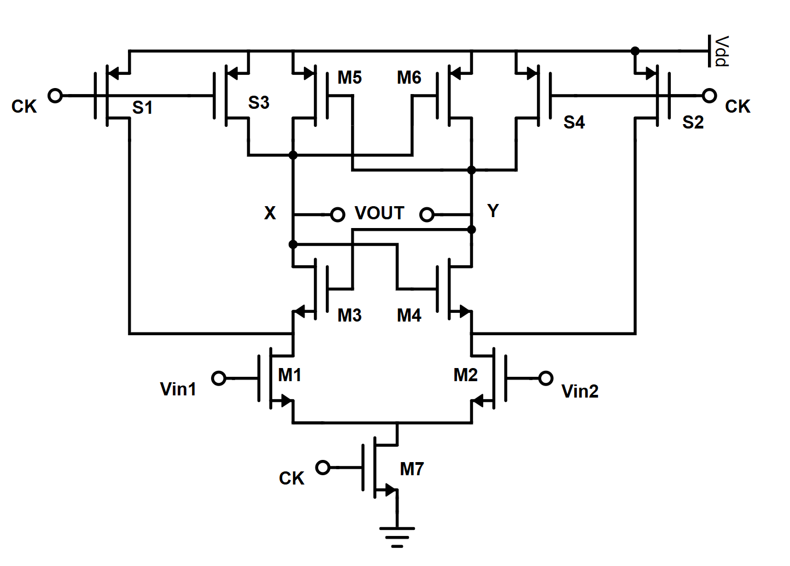
Fig. 1. Schematic of the StrongARM comparator core with the five transistor sizing groups.

III. SIMULATION RESULTS AND DISCUSSION
A. Transistor Sizing Sensitivity
The width of each of the five transistor groups was varied individually while the other groups were fixed at their baseline values, and the changes in noise, delay, and energy were analyzed under a total of 15 conditions. As shown in Fig. 2, increasing the PMOS-latch width reduced the average delay and energy by up to 27.4% and 49.2%, respectively, whereas the noise increased. Reducing the tail NMOS width revealed a trade-off between noise/energy and delay. Increasing the input-pair width reduced the noise, delay, and energy by 9.1%, 4.9%, and 7.5%, respectively. Accordingly, these two groups were selected as sizing targets to improve delay and energy while compensating for the noise degradation caused by the wider PMOS latch.
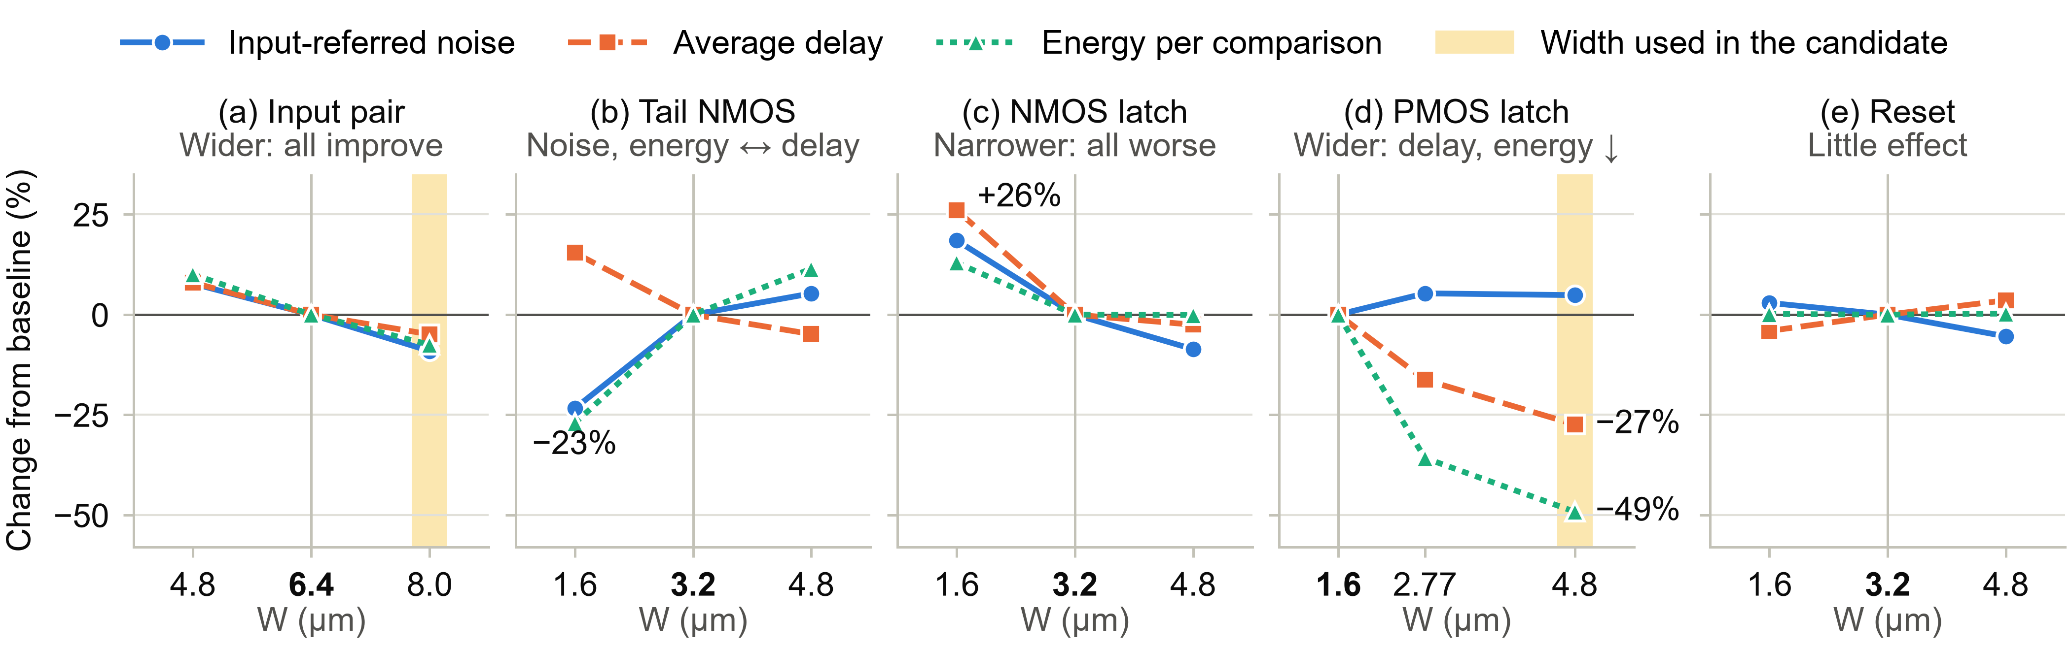
Fig. 2. Change from baseline in noise, average delay, and energy versus width: (a) input pair, (b) tail NMOS, (c) NMOS latch, (d) PMOS latch, and (e) reset.
B. Design Application of the Sensitivity Analysis
The widths of the input pair and PMOS latch, which were favorable for improving delay and energy in the sensitivity analysis, were increased from 6.4 to 8.0 μm and from 1.6 to 4.8 μm, respectively, while the other groups were kept at their baseline values. Pre-layout simulation of this improved circuit showed that the average delay and energy per comparison were reduced by 31.11% and 50.42%, respectively, compared with the baseline, and that the decision center and input-referred noise also satisfied the specified accuracy targets. This sizing combination was therefore selected as the final improved circuit, and post-layout verification was performed.
C. Post-Layout Performance Verification
To confirm that the performance improvement of the selected circuit is preserved after layout, the StrongARM cores of the baseline and improved circuits were laid out separately, and parasitic extraction (PEX) was performed. Both circuits used the same SR-latch schematic for the performance comparison.
As listed in Table I, in post-layout simulation the improved circuit reduced the average decision delay and energy per comparison by 17.77% and 40.76%, respectively, compared with the baseline, and the decision center and input-referred noise also satisfied the specified accuracy targets. This confirms that the performance improvement achieved through sizing is preserved even after parasitics are included.

TABLE I. PRE- AND POST-LAYOUT PERFORMANCE OF THE BASELINE AND IMPROVED CIRCUITS
Parameter | Pre: Baseline | Pre: Improved | Post: Baseline | Post: Improved
Decision center μ (μV) | 13.061 | 12.190 | 248.624 | 18.594
Input-referred noise σ (μV RMS) | 206.440 | 201.476 | 95.927 | 60.016
Average delay (ns) | 2.1366 | 1.4719 | 5.0227 | 4.1304
Energy per comparison (pJ) | 28.646 | 14.202 | 54.537 | 32.305

However, the decision was not completed within 5 ns for some input conditions; therefore, timing compliance could not be guaranteed under all conditions.

IV. CONCLUSION
In this work, the sizing sensitivity of five transistor groups in a StrongARM comparator was analyzed, and an improved circuit was designed based on the results. In post-layout simulation, the improved circuit reduced the average decision delay and energy per comparison by 17.77% and 40.76%, respectively, compared with the baseline. Although timing limitations remain under some input conditions, the performance improvement from sensitivity-guided sizing was confirmed to be preserved after parasitic extraction.

ACKNOWLEDGMENT
This paper was supported by Korea Institute for Advancement of Technology (KIAT) grant funded by the Korea Government (Ministry of Education) (P0030093, “Semiconductor”-Specialized University).

REFERENCES
[1] B. Razavi, “The StrongARM latch [A circuit for all seasons],” IEEE Solid-State Circuits Mag., vol. 7, no. 2, pp. 12–17, Spring 2015.
[2] B. Razavi, “The design of a comparator [The analog mind],” IEEE Solid-State Circuits Mag., vol. 12, no. 4, pp. 8–14, Fall 2020.
[3] P. Nuzzo, F. De Bernardinis, P. Terreni, and G. Van der Plas, “Noise analysis of regenerative comparators for reconfigurable ADC architectures,” IEEE Trans. Circuits Syst. I, vol. 55, no. 6, pp. 1441–1454, Jul. 2008.
[4] D. Verma et al., “A design of low-power 10-bit 1-MS/s asynchronous SAR ADC for DSRC application,” Electronics, vol. 9, no. 7, Art. no. 1100, Jul. 2020.

