**Computer Vision 2016 Spring HW#2 write-up**

2013-11415 Sanha Lee

**Q1.** Orientation-consistency cue is that under some ideal circumstances, two points on the identical surface with identical surface normal show same light reflection. This is very important and informing clue because it make us to know about other points by knowing one point.

**Q2.** For more source images, the observation vector of pixel in image will belong to much higher dimension, and OV’s higher dimension makes finding corresponding reference image pixel from target image pixel much easier and precise. Therefore, having many source images help to find the accurate normal of target image.

**Q3.** At first, every target image pixel was matched with reference pixel using kdtree with OVs. After that, the reference image’s surface normal was calculated using known geometry. Lastly, target object’s surface normal matrix was get from assigning reference image’s surface normal to target object corresponding first and second step’s result.

**Experiment result**

As a result of visualization normal which is answer about Q3, three figures representing the shape of each object image are reconstructed.

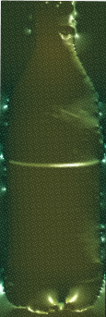

Figure shape reconstriction of bottle

By seeing above figures, we can notice that the reconstruction of bottle image was successful.

The first reason of this success might be that only the bottle’s reference shape is sphere. Sphere has much more kind of surface normal than cylinder, so it could help to reconstruct bottle rightly, especially helping y-axis reconstruction.

The second reason might be the homogeneity of the surface. This bottle seems to have homogeneous plastic surface, so it satisfies the condition invariant light source distribution.

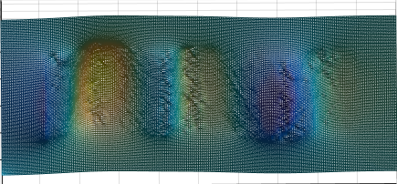

Figure shape reconstruction of velvet

By seeing second figures, we can notice that the reconstruction of bottle image was somewhat disappointing.

The reason of this result might be the texture of velvet. Velvet has more variant of light source distribution than plastic, so it could cause influence to the result.

The velvet attached to cylinder shape things, so the reference shape was proper.

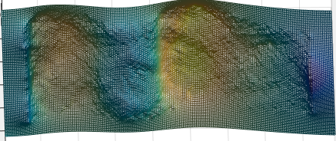

Figure shape reconstruction of wavy

By seeing last figures, we can notice that the reconstruction of bottle image was weird.

The reason of this failure might be the texture and color of this wavy fabric. Firstly, the rough texture would cause bad influence to the result similar to velvet, but more badly. Secondly, the color difference of fabric would also make some bad effect to result, because different color parts have different light reflectance property(BRDF).

Through this experiment, it was exposed that the image well satisfying the orientation-consistency cue assumption shows more accuracy when the shape of image was reconstructed.

**Extra**

When I tried to use kdtreeidx2 function with pure OV get from createObjectVectors function, it spited some error. I thought that it might be related to un-masked object vectors, so re-tried with OV filtered with provided mask file, and it worked.

And I didn’t attach the kdtree functions in my zip.