**Computer Vision 2016 Spring HW#3 write-up**

2013-11415 Sanha Lee

**Experiment result**

**1. Programming 1**

As a result of collecting Moving_image which is the result of SubtractDominantMotion function, a movie file like below was get.

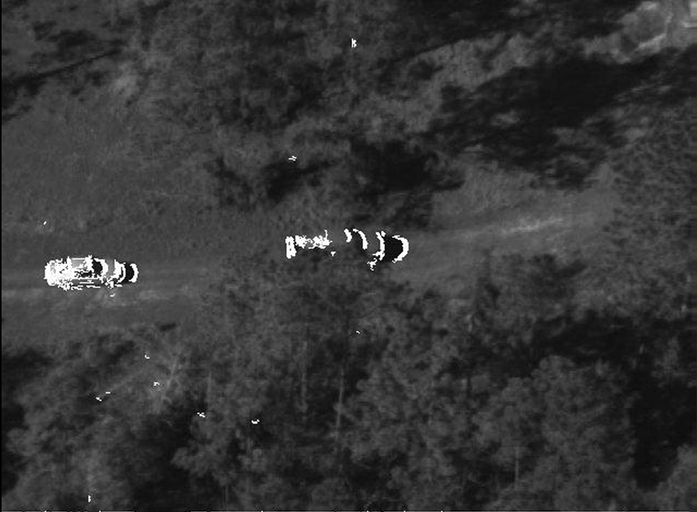

Figure 1 result of moving_image

Even though it has some noise, it seems quite well detecting the motion.

However, because of the assumption that the camera would move very slightly, this movie shows a lots of noise shown when the camera move a lot at once.

I used Lucas-Kanade algorithm for affine transform.

**Parameters**

num_frames = 700

The initial num_frames value was 100, but this movie was get from analyzing 700 frames whole for testing the entire movie.

threshold = 0.05

threshold parameter is compared with the norm of $∆p$ to check the iteration would be finished or not.

convergence_limit = 20

convergence_limit is set to 20 because the almost iteration end in 20 cycle.

hysthresh low threshold = 10

hysthresh high threshold = 20

I used hysthresh threshold to reduce noise in the result scene. This function reduce noise by checking the surrounding pixels of one to check whether it is noise or not, so it was very useful.

After a series of test, I figured out that these parameter values are proper to de-noise process.

Also, when applying Lucas-Kanade algorithm, I cropped the boundary of template image by 5% to prevent to the dark part of warped image influence the result.

**2. Programming 2**

As a result of object tracking using trackTemplate function, figures like below was get.

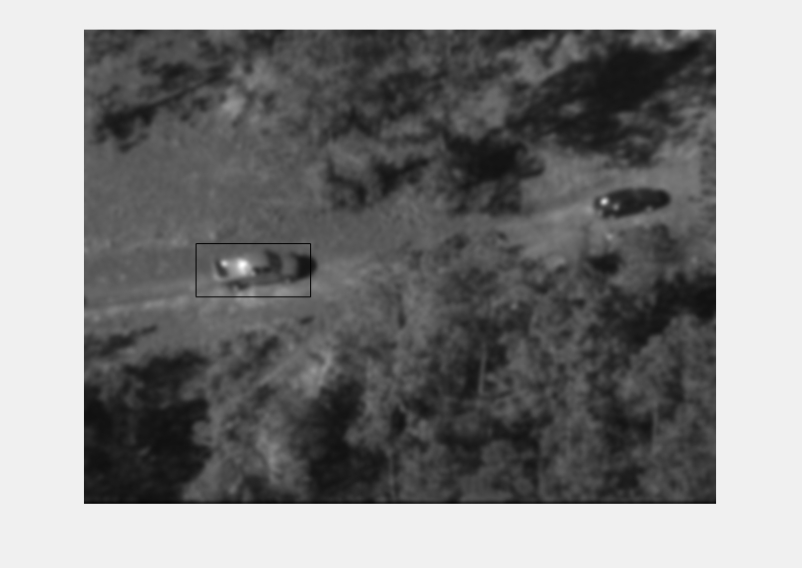

Figure 2 object tracked at 70th frame

It seems quite well track the object (truck).

However, after this truck meet some tree, because of the assumption that the object image would similar, the result of tracking becomes rapidly bad like below.

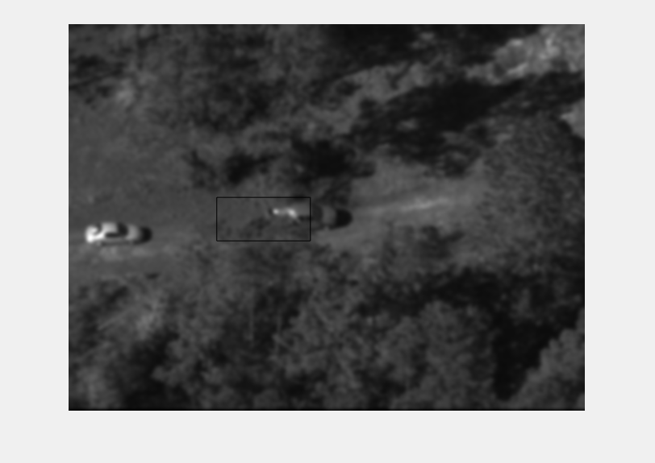

Figure 3 object tracked at 154th frame

I used Lucas-Kanade algorithm for translation. I cropped two images regards to the template given by user, and apply this algorithm.

**Parameters**

sigma = 2

To improve the performance of tracker, Gaussian filter was applied to images.

According to sigma value, the frame number that tracker loose the object was differed like below.

|  |  |
| --- | --- |
| Sigma | Lost frame |
| 1 | 126 |
| 2 | 156 |
| 3 | 150 |
| 4 | 148 |
| 5 | 135 |

Table 1 lost frame accordint to sigma

Therefore, sigma 2 was chosen.

maxIterations = 20

maxIterations is set to 20 because the almost iteration end in 20 cycle.

Also, like programming 1, when applying Lucas-Kanade algorithm, I cropped the boundary of template image by 5% to prevent to the dark part of warped image influence the result.