**Computer Vision 2016 Spring HW#4 theory**

2013-11415 Sanha Lee

**Q1.**

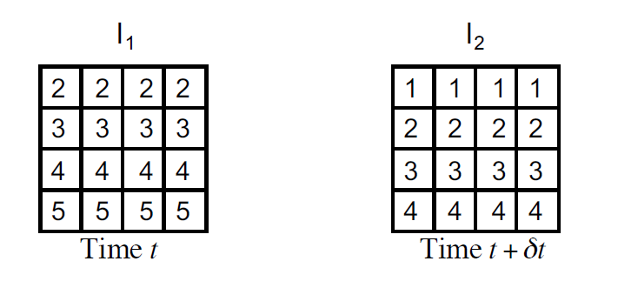

(This image is get from lec15_opticalflow lecture slide)

We have two unknowns u and v in optical flow constraint equation.

However, because $E_{x}$ of every point is 0, we cannot recover the v.

In this circumstances, we cannot recover the vertical components of motion.

**Q2.**

|  |  |  |
| --- | --- | --- |
| 1 | 2 | 3 |
| 4 | 5 | 6 |
| 7 | 8 | 9 |

$I_{1}$ at time t

|  |  |  |
| --- | --- | --- |
| 2 | 4 | 5 |
| 6 | 7 | 8 |
| 9 | 10 | 11 |

$I_{2}$ at time $t+δt$.

If this condition, we know that $E_{x}=1, E_{y}=3$.

In this circumstances, we have a single linear equation for two unknowns u and v, we can always recover u or v.

**Q3.**

In those conditions, the constraint optical flow equation might not hold. To find the optical flow, we have to use Lucas Kanade tracking algorithm with affine transform. If so, we can figure out not only the optical flow of camera but also object’s. After that, we can easily know the object’s destination by this optical flows.

**Q4.**

The perspective distortion would be like this.

$$\left(x^{'}, y^{'}\right)≡\{{\frac{x_{0}+ut}{z_{0}+wt} }_{,} \frac{y_{0}+vt}{z_{0}+wt}\}$$

Then, when $t→∞$, $\left(x^{'}, y^{'}\right)≡\{\frac{u}{w},\frac{v}{w}\}$