**Computer Vision 2016 Spring HW#3 write-up**

2013-11415 Sanha Lee

**Experiment result**

As a result of warping and merging images, these figures were get.

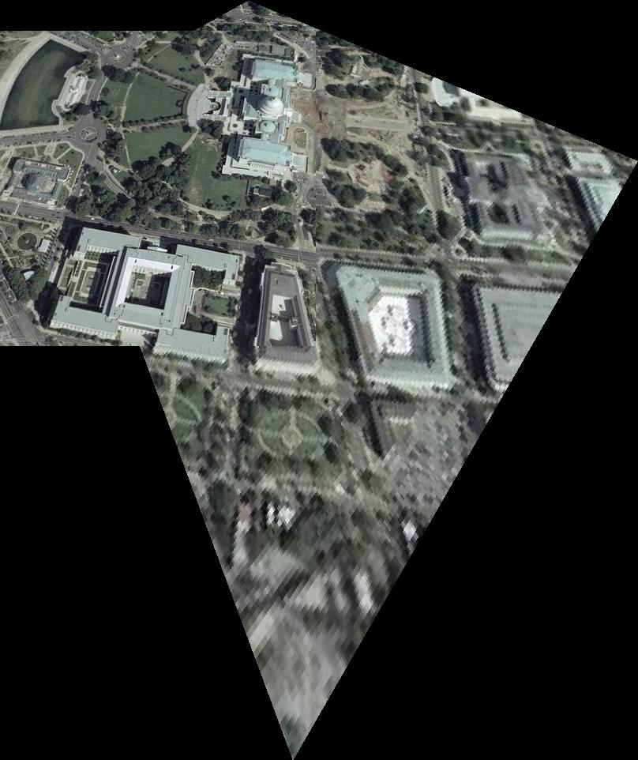

Figure 1 merged wdc image

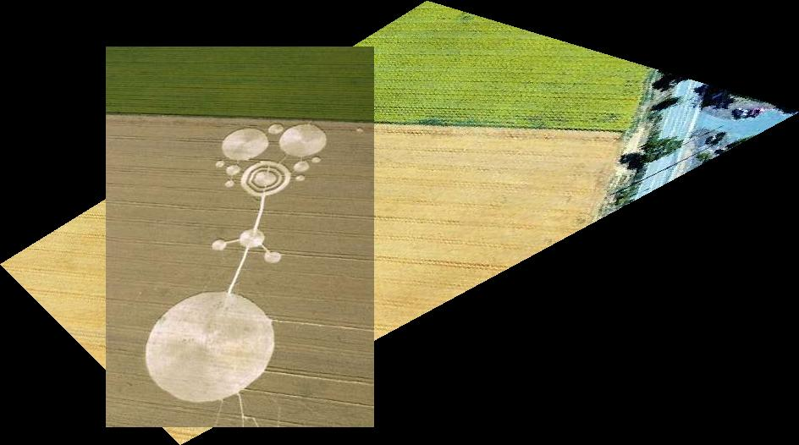

Figure 2 merged crop image

Judging from above figures, this warping process performs well. Because only 9 sets of points are used in wdc image warping, wdc image shows slightly astray matching than crop which uses 12 sets of points.

**Extra**

The points.mat’s coordinate has y axis growing downward, fallowing cpselect function result. And because of this, all function using these x-y coordinate assumes that y axis growing downward.

I don’t know how to assign red dot on original image for creating points_used.jpg, so just used paint program and put red dots manually.

The frame of warped image was made by considering 4 corner points transformed by homography. The frame of merged image was also made by considering 4 corner points of reference image and 4 corner points transformed by homography.