**Computer Vision 2016 Spring HW#5 Experiment**

2013-11415 Sanha Lee

**Experiment result**

Basic cnnExercise.m shows accuracy around 80%. This classifier classifies things fairly well.

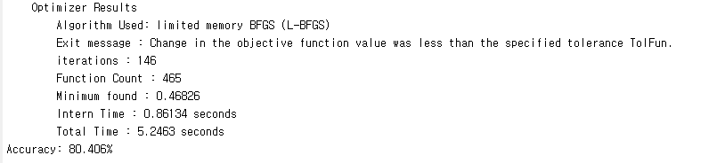

Accuracy and training iteration was differ depending on decaying factor softmaxLambda like below.

Iteration was changed in each trial, so average iteration was filled in.

|  |  |  |
| --- | --- | --- |
| Lambda | Training iteration | Accuracy |
| $$1.0×{10}^{-5}$$ | 314 | 80.781 |
| $$5.0×{10}^{-5}$$ | 220 | 80.500 |
| $$1.0×{10}^{-4}$$ | 145 | 80.406 |
| $$2.0×{10}^{-4}$$ | 122 | 80.063 |
| $$3.0×{10}^{-4}$$ | 103 | 79.656 |
| $$4.0×{10}^{-4}$$ | 82 | 79.094 |

This experiment means that small decaying lambda makes the cost decaying slower. Because of this, smaller lambda require much more iteration, but it shows also much better performance (accuracy).

Also, loss (softmax cost) decreasing fallowed by iteration was observed.

This means that softmax cost minimizing operation is conducted with iteration.