Contents

Installation requirement: 1

1. Requirement: 1

2. Deploying steps: 1

3. First time user: 2

End-User Guide: 3

Back-End architecture: 3

Database architecture 3

Front-End architecture: 3

Gadget Front-end components: 3

Gadget common interactive input 3

Epic Test Execution Statistics Gadget 3

User Story Text Execution Statistics Gadget 3

Assignee Text Execution Statistics Gadget 3

Text Execution Statistics Gadget 3

# Installation requirement:

## Requirement:

* Mongodb: version 3.4 or later.
* Apache maven: version 3.0 or later.
* JDK: version 1.8 or later.
* (Optional) MongoChef for database management: any version.

## Deploying steps:

1. Run *mongod.exe* from mongodb bin folder. This should start the server.
2. Navigate to project source folder, run maven command: *mvn package ninja:run*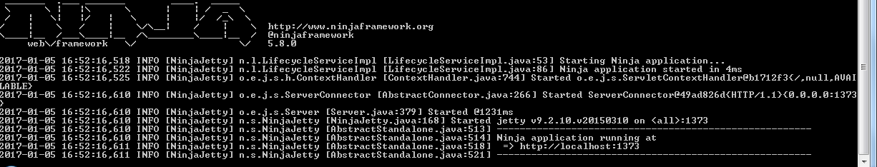
3. Once this ninja framework cmd screen showed up, project is fully deployed. Use the localhost port on your screen to access web page.

(Optional)

* To be able to import project code into eclipse, run maven cmd in source folder: *mvn eclipse:eclipse*
* By default proxy is disabled. To change proxy option, modify *“src/main/resources/message.properties”* file.
* By default port number is 1373. To change port, modify *“src/main/java/conf/application.conf”* file.

## First time user:

* In order to use Epic/User Story/Assignee/Cycle Test Execution Report Statistics gadget. Jira Administrator should manually add product and test cycle to database. This should be done every time you want new product/cycle options available to end-user.

1. 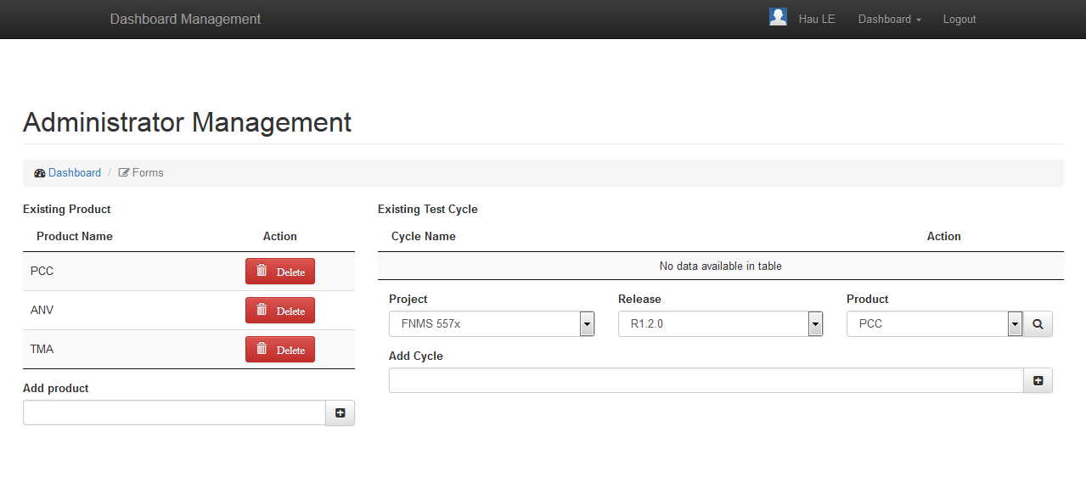Access localhost:1373/product. A page similar to below should appear.
2. Adding new product is fairly easy. Just type in product name and click the button next to input field.
3. Adding test cycle is based on existing product. Once you have added new product, reload the page to have it shown up on Existing Test Cycle.
4. 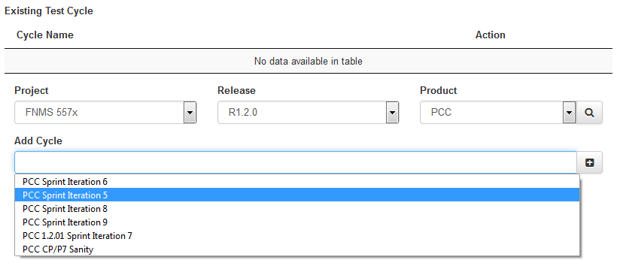Choose the project/release/product to search for test cycle list, then click on the magnifier icon to search for product.
5. Once loading icon disappeared or select field is enabled again. Double-click on Add Cycle input field, it should show the search result in the form of drop-down list. Select and add the one you want.

## End-User Guide:

# Back-End architecture:

# Database architecture

# Front-End architecture:

## Gadget Front-end components:

### Gadget common interactive input

* **Project**: project name needed to execute query to greenhopper.
* **Release**: release needed to execute query to greenhopper.
* **Product**: product name needed to execute query to greenhopper.
* **Metric**: multi choice drop down that will determine table columns.
* **Update button**: On click, update gadget to database and attempt to draw table. Reenable button when task is completed.

### Epic Test Execution Statistics Gadget

* **Epic links**: once product/release/project are chosen, browser will send ajax requesting list of epic keys. By default epic links are checked “Select All”. If you want to select individual epic link, untick this option.

### User Story Text Execution Statistics Gadget

* **Available epic links**: all available epic links of the chosen product/release/project.
* **To be fetched epic links**: once epic links are added to this field, browser will send ajax requesting a list of story issues belong to those epics.
* **User Story**: every time **to be fetched epic links** changed, reload this field.

### Assignee Text Execution Statistics Gadget

* **Available Cycle**: fetch database and get the cycle list added beforehand.
* **To be fetched Cycle**: once cycles are added to this multiselect input, browser will send ajax requesting a list of assignees belong to these cycles.
* **Assignee**: every time **to be fetched Cycle** changed, reload this field. Since assignees list is often short and limited, this field has been disabled and gadget will show all assignees for the chosen cycles. This change will reduce user interaction and complexity of the gadget.

### Text Execution Statistics Gadget

* **Available Cycle**: fetch database and get the cycle list added beforehand.