Univariate and Bivariate Analysis Results

Univariate: ottTIME
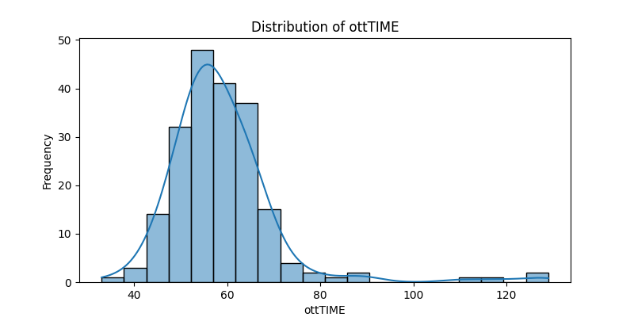
count 204.000000
mean 58.764706
std 12.125921
min 33.000000
25% 53.000000
50% 57.000000
75% 63.000000
max 129.000000

Univariate: HGB_Blood
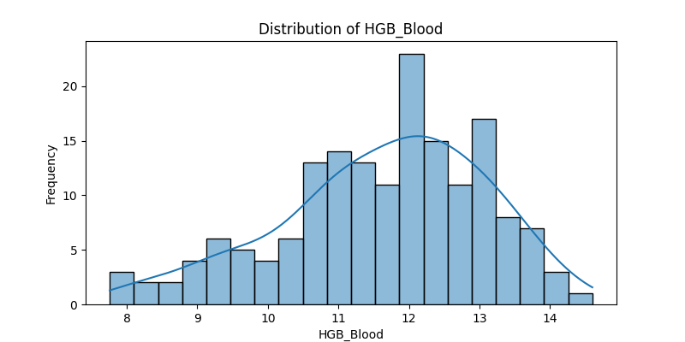
count 168.000000
mean 11.634107
std 1.446661
min 7.760000
25% 10.775000
50% 11.900000
75% 12.625000
max 14.600000

Univariate: AGR
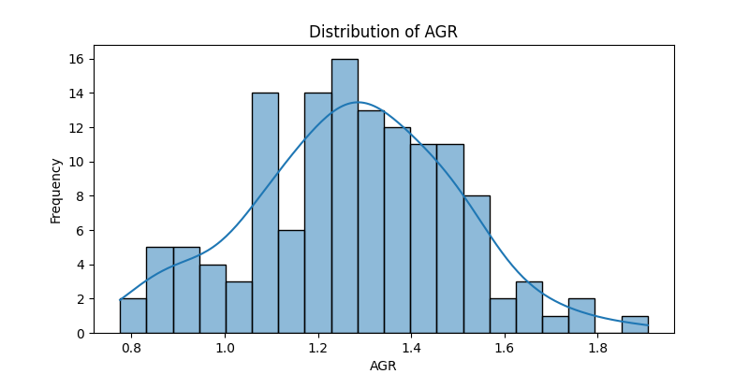
count 133.000000
mean 1.273184
std 0.219751
min 0.775510
25% 1.117318
50% 1.281250
75% 1.415625
max 1.907563

Univariate: NEU/LYM
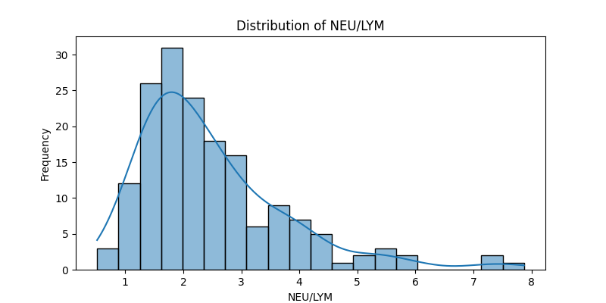
count 168.000000
mean 2.484788
std 1.290126
min 0.515773
25% 1.633710
50% 2.140153
75% 2.978155
max 7.871287

Univariate: Albumin_Serum
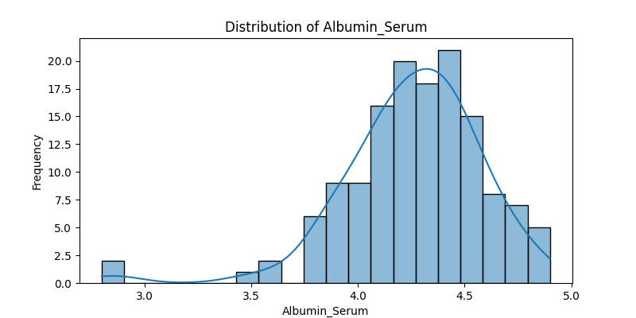
count 139.000000
mean 4.256547
std 0.322382
min 2.800000
25% 4.100000
50% 4.300000
75% 4.480000
max 4.900000

Bivariate: ottTIME vs Survival Days
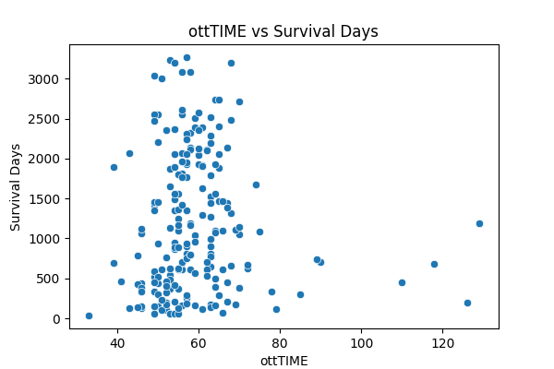

Bivariate: ottTIME vs Survival Days LT2Y
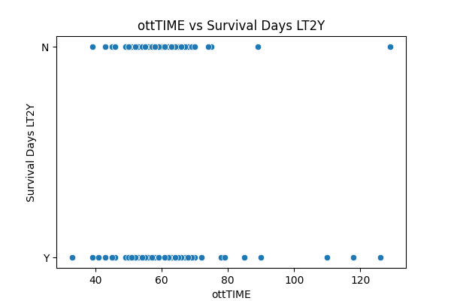

Bivariate: HGB_Blood vs Survival Days
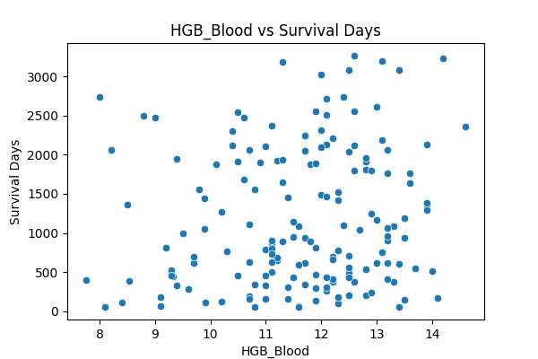

Bivariate: HGB_Blood vs Survival Days LT2Y
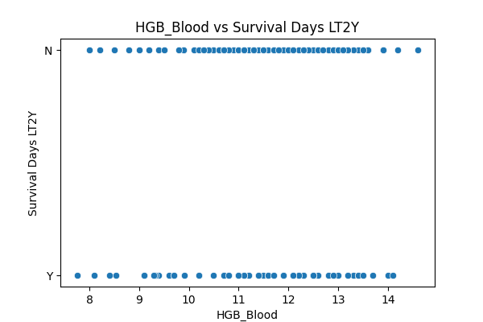

Bivariate: AGR vs Survival Days
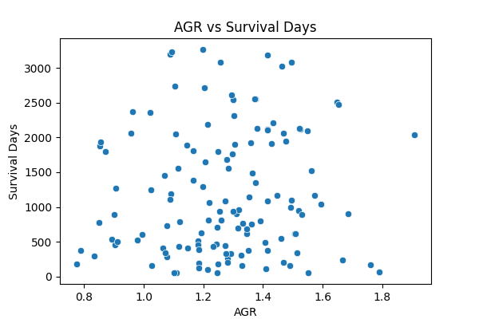

Bivariate: AGR vs Survival Days LT2Y
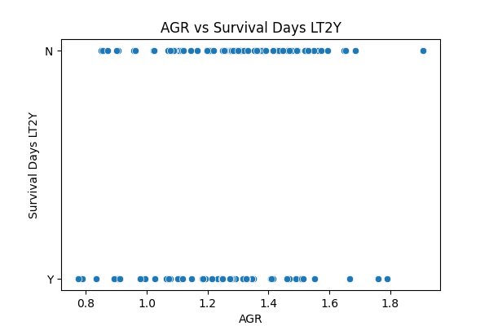

Bivariate: NEU/LYM vs Survival Days
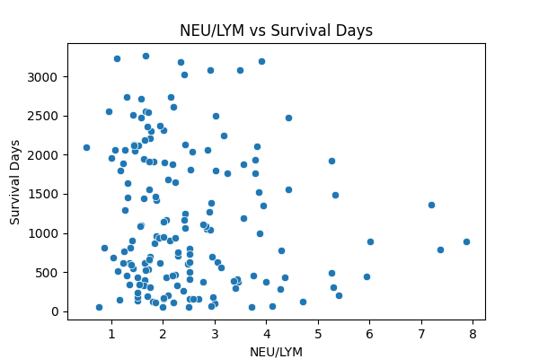

Bivariate: NEU/LYM vs Survival Days LT2Y
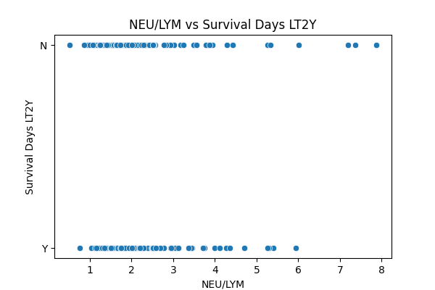

Bivariate: Albumin_Serum vs Survival Days
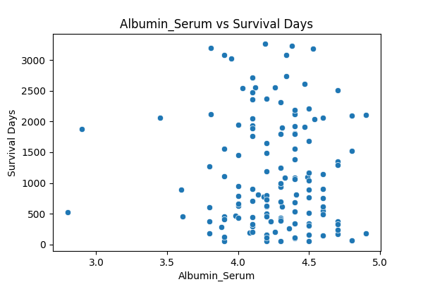

Bivariate: Albumin_Serum vs Survival Days LT2Y
