

1. Login Screen
The Login Screen is the first screen you see when you open Café 101. It verifies your identity and routes you directly to the dashboard for your role. Each staff member has a unique email and password assigned by the Manager.

1.1 What is the Login Screen?
The Login Screen is divided into two sections. The left side shows the Café 101 branding, feature highlights, and the UKZN campus information. The right side contains the login card where you enter your credentials.

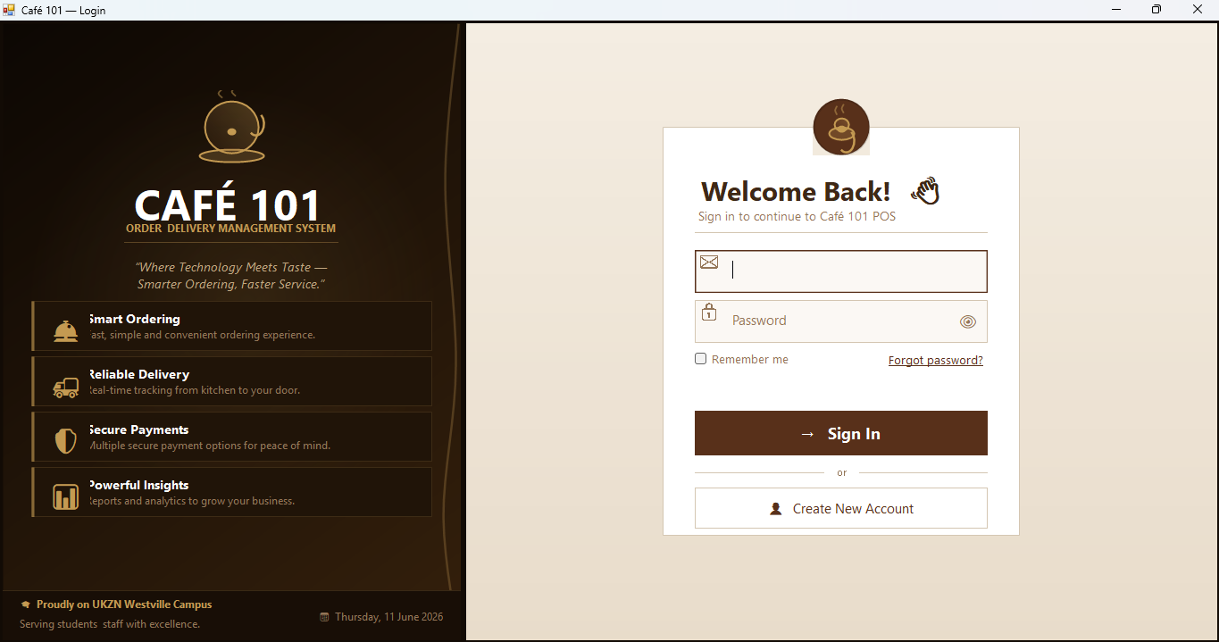
Figure 1 Café 101 Login Screen — left branding panel, right login card

1.2 How to Log In
- Step 1 — Double-click the Café 101 shortcut on the desktop to launch the application.
- Step 2 — Enter your Email Address in the email field (e.g. jane.smith@cafe101.com).
- Step 3 — Enter your Password. Passwords are case-sensitive. Click the 👁 eye icon to reveal what you type.
- Step 4 — Click Sign In or press Enter on your keyboard.
- Step 5 — The system opens your role's main screen automatically. Cashier → POS, Manager → Dashboard, Head Chef → Kitchen Display, Owner → Analytics.

1.3 Field Descriptions
Field | Description
Email Address | Your assigned staff email address (e.g. jane.smith@cafe101.com). Provided by your Manager.
Password | Your personal password. Click the 👁 icon to show or hide what you have typed.
Remember Me | Tick this checkbox to keep your email pre-filled the next time you open the application.
Forgot Password? | Click this link to open the Password Reset screen. Enter your registered email address to reset.
Sign In button | Submit your credentials. You can also press Enter to log in.
Creating New Account | Opens the staff registration form. Available to Managers when adding new staff only.

1.4 Error Messages
Error Message | What It Means / What to Do
"Incorrect email or password" | The credentials do not match any active account. Check for typos and ensure Caps Lock is off.
"Please enter your email address" | The email field is empty. Fill it in before clicking Sign In.
"Enter a valid email address" | The email must contain @ and a domain (e.g. name@cafe101.com).
"Please enter your password" | The password field is empty. Fill it in before clicking Sign In.
"Connection error. Check your network" | The system cannot reach the database server. Check your network connection and contact your manager.

NOTE: Never share your login credentials with other staff members. Every action performed in Café 101 is recorded against your staff account.

2. Cashier Landing Page
After logging in as a Cashier, the Landing Page is displayed. This screen shows today's live statistics and provides three quick-action tiles to navigate the main areas of the system.

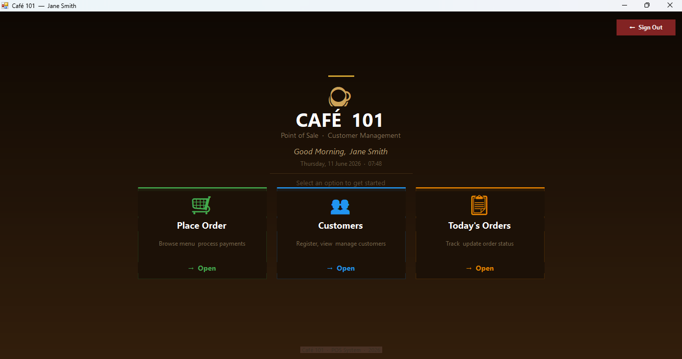
Figure 2 Cashier Landing Page showing live stats and navigation tiles

2.1 Landing Page Overview
Field | Description
Welcome greeting | Displays Good Morning / Good Afternoon / Good Evening followed by your name and today's date and time.
Place Order tile | Click to open the Point-of-Sale ordering screen where you can browse the menu and create orders.
Customers tile | Click to open the Customer Management screen where you can register, edit and view customer records.
Today's Orders tile | Click to view all orders placed today and track their current status.
Sign Out button | Logs you out and returns to the Login Screen.

3. Cashier Point of Sale (POS)
The POS screen is the main ordering workspace. It is divided into three areas: the Category sidebar on the left, the Product grid in the centre, and the Current Order panel on the right.

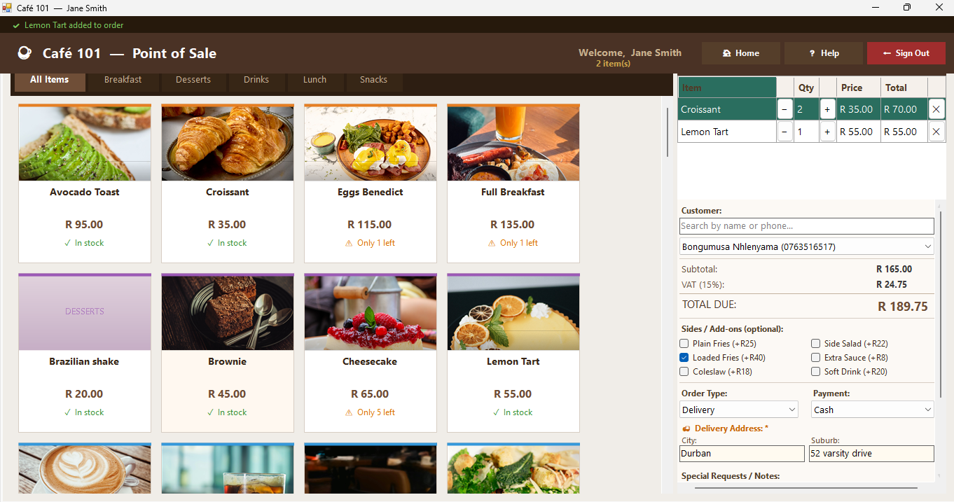
Figure 3 POS Screen — category tab control, product cards, order panel (right)

3.1 How to Place an Order
- Step 1 — Select a customer from the Customer search box at the top of the order panel or leave as “No selected customer” which is guest customer by default.
- Step 2 — Click any product card in the centre grid to add it to the cart. The card shows the item name, photo, and price.
- Step 3 — Use the [ −] and [+] buttons inside the cart to adjust quantity. Click ✕ to remove an item.
- Step 4 — Tick any Sides / Add-ons checkboxes if the customer wants extras (Plain Fries, Coleslaw, Soft Drink, etc.).
- Step 5 — Select the Order Type: Takeaway, Delivery, or Dine-In. If Delivery is selected, enter the full delivery address in the field that appears.
- Step 6 — Select the Payment Method: Cash, Card, or Mobile Payment.
- Step 7 — Add any Special Requests or Notes in the field of notes (e.g. no onions, extra cheese).
- Step 8 — Click PLACE ORDER. A receipt dialog will appear showing the full order details. Click Print Receipt to print or done to close.

3.2 Field Descriptions — Order Panel
Field | Description
Customer search | Type a name or phone number to filter the customer dropdown in real time (2+ characters).
Customer dropdown | Select an existing registered customer. Defaults to Guest if none selected.
Subtotal | Sum of all cart items plus any selected sides, before VAT.
VAT (15%) | Value Added Tax calculated automatically at 15% of the subtotal.
TOTAL DUE | Final amount, including VAT, is what the customer pays.
Order Type | Takeaway (default), Delivery (requires address), or Dine-In.
Delivery Address | Appears only when Delivery is selected. Required before the order can be placed.
Payment | Cash, Card, or Mobile Payment. Must be selected before placing the order.
Special Requests | Free-text field for dietary notes or delivery instructions.
PLACE ORDER | Confirms and save the order. Opens the receipt dialog.
Clear Order | Removes all items from the cart and resets the form.

3.3 Sides / Add-ons
The sides panel allows you to add optional extras to any order. Each side has a fixed price that is added to the order total automatically.

Field | Description
Plain Fries | R 25.00
Loaded Fries | R 40.00
Coleslaw | R 18.00
Side Salad | R 22.00
Extra Sauce | R 8.00
Soft Drink | R 20.00

4. Customer Management
The Customer Management screen allows you to register new customers, edit existing records, and delete customer profiles. It is accessible from the Cashier Landing Page (Customers tile) and from the Customers tab inside the POS workspace.

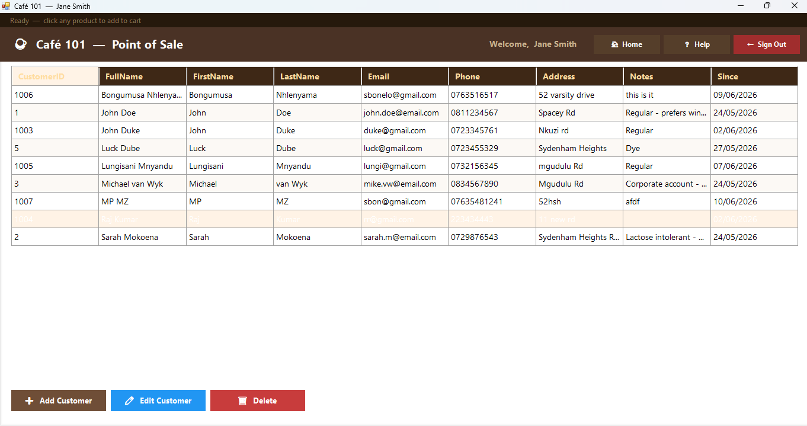
Figure 4 Customer Management — customer grid (centre), action buttons (bottom)

4.1 How to Load details for a customer
- Step 1 — Click any customer row to load their details.

4.2 How to Add a New Customer
- Step 1 — Click the Add Customer button.
- Step 2 — Fill in all required fields marked with *: First Name, Last Name, Phone, and Address.
- Step 3 — Optionally fill in Email and Notes.
- Step 4 — Click Save. The customer is added to the database and auto selected in the POS dropdown.

4.3 Field Descriptions
Field | Description
First Name * | Customer's first name. Letters and hyphens only. Minimum 2 characters. Required.
Last Name * | Customer's last name. Letters and hyphens only. Minimum 2 characters. Required.
Phone * | 10-digit South African phone number starting with 0 (e.g. 0821234567). Required.
Email | Customer email address. Optional — if entered must follow name@domain.ext format.
Address * | Full physical or delivery address. Minimum 5 characters. Required.
Notes | Optional notes about the customer (e.g. dietary requirements, preferences).

4.4 Validation Rules
- First Name and Last Name: letters, spaces and hyphens only — numbers are not allowed.
- Phone number must start with 0 and be exactly 10 digits. The keyboard blocks letters automatically — the field turns light red if the first character is not 0.
- Email is optional but if filled must contain a valid domain suffix.
- Address is compulsory. A minimum of 5 characters is required before the record can be saved.
- All error messages appear in red text inside the dialog — no pop-up boxes interrupt the workflow.

4.5 Error Messages
Error Message | What It Means / What to Do
"First name is required" | The First Name field is empty. Fill it in before saving.
"First name must be at least 2 chars" | The name entered is too short. Enter the full first name.
"First name: letters only" | A number or symbol was entered. Names may only contain letters, spaces and hyphens.
"Phone number is required" | The Phone field is empty. A phone number is mandatory for all customers.
"Phone must start with 0" | The number entered does not begin with 0. SA numbers must start with 0 (e.g. 0821234567).
"Phone must be 10 digits" | The number is either too short or too long. Enter exactly 10 digits.
"Enter a valid email" | The email entered is not in a valid format. Correct format: name@example.com.
"Address is required" | The Address field is empty. A physical address is required for all customer records.

5. Manager Dashboard
The Manager Dashboard is the main control panel for managing Café 101 operations. It is accessible only to staff with the Manager role. Navigation is done through the section button strip directly below the four KPI stat cards and as you move through the tabs there will be tooltips to help you navigate.

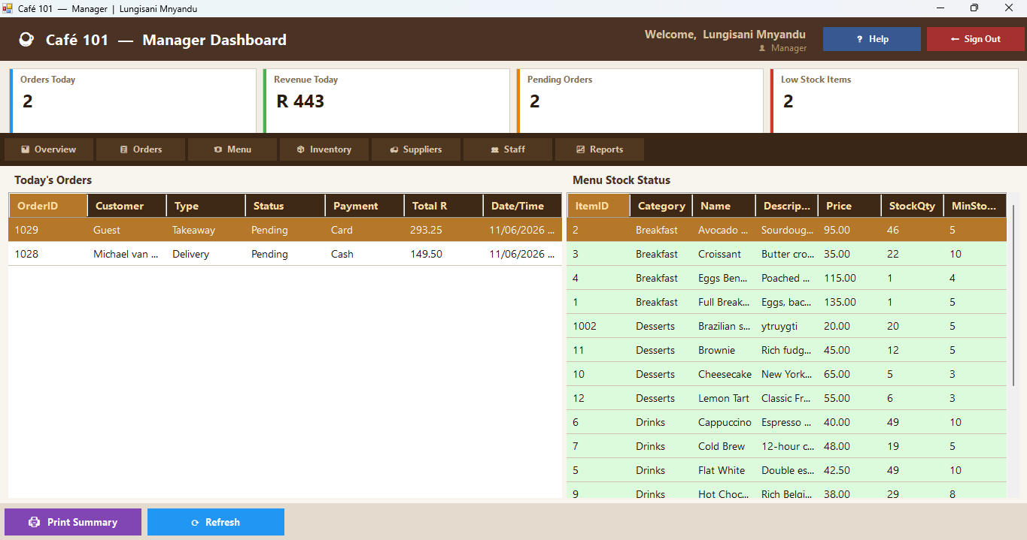
Figure 5 Manager Dashboard — nav bar (top), stat cards, section buttons, data grids

5.1 Navigation Bar Overview
Field | Description
☕ Café 101 — Manager Dashboard | Application name and current user displayed on the left.
Welcome, [Name] | Shows the currently logged-in manager's name on the right side of the nav bar.
📊 Owner View | Opens the Owner Analytics Dashboard (purple button — top right).
⬅ Sign Out | Logs out and returns to the Login Screen (red button — top right).

5.2 KPI Stat Cards
Four stat cards display live data at the top of the dashboard and auto-refresh every 60 seconds.
Field | Description
Orders Today | Total number of orders placed today across all types.
Revenue Today | Total paid revenue for today in Rands.
Pending Orders | Number of orders currently in Pending or Preparing status.
Low Stock Items | Number of menu items where stock has fallen to or below the minimum alert level.

5.3 Section Buttons
Field | Description
📊 Overview | Today's orders (left grid) and full menu stock status (right grid). Print Summary Available.
📋 Orders | All orders with color-coded statuses. Click a row to see its items on the right. Update status and print receipts.
🍽 Menu | Menu item list (left) with Add / Edit panel (right). Use Load Selected for Editing to modify existing items.
📦 Inventory | Full stock list sorted by quantity (left) and low stock alerts (right). Click Update Stock to adjust levels.
🚚 Suppliers | Tab strip: Purchase Orders view and Manage Suppliers view. Click any row to see details on the right.
👥 Staff | All staff list with role summary. Add new staff, edit details, or deactivate accounts.
📈 Reports | 7-day sales summary (left) and top 10 best-selling products (right).

5.4 Orders — Updating Status
- Step 1 — Click 📋 Orders in the section button strip.
- Step 2 — Click a row in the orders grid to select the order. The items appear on the right.
- Step 3 — Click ✏ Update Status to open the status dialog.
- Step 4 — Select the new status from the dropdown: Pending, Preparing, Ready, Out for Delivery, Delivered, Served, or Cancelled.
- Step 5 — Click UPDATE STATUS. The grid refreshes automatically.

To view delivery orders only — click the 🚚 Deliveries Only button in the Orders action bar.

5.5 Menu Management
- Step 1 — Click 🍽 Menu in the section button strip.
- Step 2 — To add a new item: fill in the Category, Item Name, Price, Stock Qty, and Min Stock Alert in the right panel, then click ➕ ADD NEW ITEM.
- Step 3 — To edit an existing item: select the row in the left grid, then click ✏ LOAD SELECTED FOR EDITING. Make your changes and click on “💾 SAVE CHANGES”.
- Step 4 — To remove an item from the menu: select the row and click 🗑 DELETE SELECTED.

6. Suppliers & Purchase Orders
The Suppliers section provides two views accessed through a tab strip: Purchase Orders and Manage Suppliers. Both views use the same left-grid-plus-right-detail layout as the rest of the Manager Dashboard.

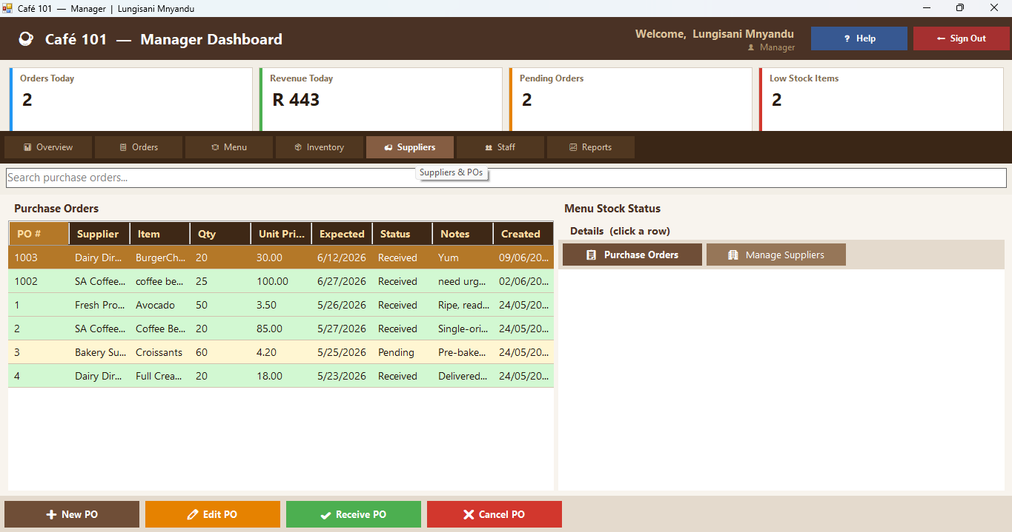
Figure 6 Suppliers section — Purchase Orders tab active, detail panel on the right

6.1 Purchase Orders View
The left grid shows all purchase orders color-coded by status (green = Received, amber = Pending, red = Cancelled). Clicking a row shows the full order details on the right.

Field | Description
➕ New PO | Opens the New Purchase Order dialog. Supplier, Item Name, Quantity, and Expected Date are required.
✏ Edit PO | Select a PO then click to edit its details.
✔ Receive PO | Marks the selected PO as Received and automatically adds the quantity to the matching menu stock.
❌ Cancel PO | Marks the selected PO as Cancelled. This cannot be undone.

6.2 Manage Suppliers View
Click 🏢 Manage Suppliers to switch views. The left grid shows all active suppliers. Clicking a supplier row shows all purchase orders made with that supplier on the right — useful for checking order history per supplier.

Field | Description
➕ Add Supplier | Opens the Add Supplier dialog. Company Name and Address are required.
✏ Edit Supplier | Select a supplier then click to update their details.
🗑 Remove | Deactivates the selected supplier. They will no longer appear in the PO supplier dropdown.

6.3 Purchase Order Validation Rules
- Supplier: must be selected from the dropdown before saving.
- Item Name: required, minimum 2 characters.
- Quantity: required must be a positive whole number (no decimals), maximum 10,000.
- Unit Price: optional option, if entered must be a valid positive decimal (e.g. 45.00).
- Expected Delivery Date: cannot be set in the past.

7. Head Chef — Kitchen Display
The Kitchen Display System (KDS) is the primary workspace for the Head Chef. It shows all active orders (Pending and Preparing) in real time and auto-refreshes every 30 seconds. A live clock is displayed in the navigation bar.

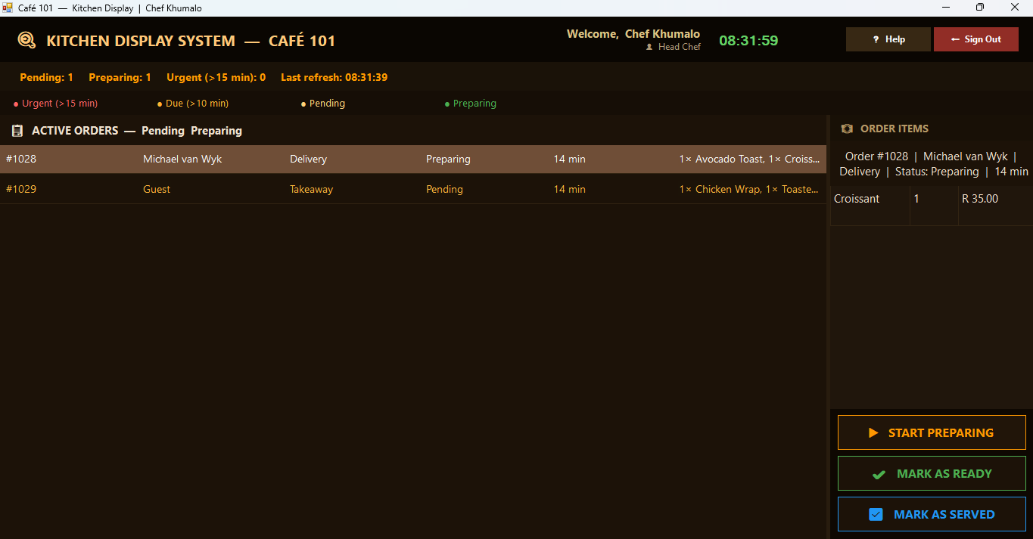
Figure 7 Kitchen Display — orders grid (left), order items and actions (right)

7.1 What is the Kitchen Dashboard?
The Kitchen Dashboard allows kitchen staff to view incoming orders, check order items, read customer special requests, update order status, and complete orders. Orders are color-coded by urgency based on how long they have been waiting.

7.2 Color Guide
Field | Description
Red text (dark background) | Order has been waiting MORE than 15 minutes — URGENT. Prioritise immediately.
Amber text (dark background) | Order has been waiting more than 10 minutes — Due. Prepare without delay.
Yellow text | Standard Pending orders are waiting to be started.
Green text | Order is currently being Prepared.

7.3 How to Process an Order
- Step 1 — Locate the order in the left grid. Orders are sorted oldest first — process from top to bottom.
- Step 2 — Click the order row. The items and customer special requests load on the right panel.
- Step 3 — Review the order items and check the special requests carefully before starting.
- Step 4 — Click ▶ START PREPARING immediately once you begin cooking. The status updates to Preparing.
- Step 5 — Once all items are plated and ready, click ✔ MARK AS READY. The order leaves the kitchen display.
- Step 6 — Once the order has been collected or delivered, click ☑ MARK AS SERVED to complete the order.

7.4 Field Descriptions — Order Panel
Field | Description
Order # | Unique order number assigned by the system.
Customer | Name of the customer who placed the order.
Type | Takeaway, Delivery, or Dine-In.
Status | Status: Pending or preparing.
⏱ Min | Number of minutes since the order was placed.
Items (summary) | A comma-separated list of all items in the order shown in the grid row.
Order Items panel | Full item list with quantities when a row is selected.
Special Requests | Any notes the cashier entered when placing the order (dietary needs, delivery instructions, sides).

NOTE: Always check the Special Requests section before beginning preparation. Never mark an order as Served until all items are fully prepared and handed over.

8. Owner Analytics Dashboard
The Owner Analytics Dashboard provides business intelligence for the café owner. It is accessible from the Manager Dashboard via the 📊 Owner View button. All data loads automatically on open and can be refreshed with the ⟳ Refresh button.

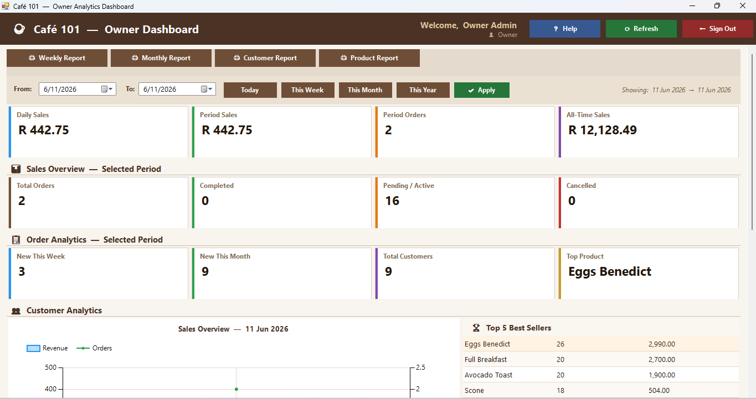
Figure 8 Owner Dashboard — KPI cards, 30-day chart, top products, print report buttons

8.1 Dashboard Sections
Field | Description
📊 Sales Overview | Four KPI cards: Daily Sales, Weekly Sales, Monthly Sales, and All-Time Sales totals in Rands.
📋 Order Analytics | Four KPI cards: Total Orders, Completed, Pending/Active, and Cancelled order counts.
👥 Customer Analytics | New customers this week, new this month, total registered customers, and the most purchased product.
📈 30-Day Sales Chart | Area chart (revenue) and line chart (order count) over the last 30 days on dual Y-axes.
🏆 Top 5 Best Sellers | Grid showing the five best-selling items with total quantity sold and revenue.
📉 Least Selling Items | Items with the lowest sales volume — useful for reviewing the menu.
👥 Recent Customers | Latest 20 registered customers with phone, email, and registration date.

8.2 Print Reports
Four print reports are available from the toolbar at the top of the dashboard. Clicking any report button opens the system Print Dialog where you can select your printer.
Field | Description
🖨 Weekly Report | 7-day sales breakdown by date showing orders and revenue per day with totals.
🖨 Monthly Report | 30-day daily sales breakdown plus the top 10 selling products.
🖨 Customer Report | Full customer list with phone numbers, registration dates, and new customer summary statistics.
🖨 Product Report | Top 20 selling products ranked by quantity sold, plus least selling items.

8.3 How to Refresh the Dashboard
- Step 1 — Click the ⟳ Refresh button in the top navigation bar.
- Step 2 — All KPI cards, grids, and the chart will reload with the latest data from the database.

NOTE: The 30-day chart requires at least one completed paid order to display meaningful data. If the chart appears empty, no paid orders exist in the last 30 days.

9. Important Notes

- Process orders in the sequence they are received — oldest orders appear at the top of all grids.
- Always check Special Requests and Notes fields before preparing or dispatching any order.
- Mark orders as Preparing immediately after you begin cooking so the manager can track kitchen progress.
- Mark orders as Delivered or Served only after the customer has physically received their order.
- Never share your login credentials with other staff. Every action is recorded against your account.
- Always sign out when leaving your workstation unattended.
- Archiving or deactivating a staff account is permanent within the application process, contact your manager to restore access.
- The delivery address field is compulsory for all Delivery orders — the order cannot be placed without it.
- Stock levels are updated automatically when a cashier places an order (reduced) and when a manager receives a purchase order (increased).

Phone numbers must start with 0 and be exactly 10 digits. The keyboard blocks non-numeric input in all phone fields across the system.

10. Need Further Help?
If your issue is not covered in this guide, contact your system manager or the Café 101 IT support team. Please have your staff email address ready when asking for help.

Manager Contact  Email: gedeza@cafe101.com  +27 336 5747 | IT Support  Email: admin@cafe101.com  Tel: 031 186 6947

Café 101 — Order & Delivery Management System | User Help Guide | Version 1.0 | UKZN Westville Campus

