SMARTCFP
Project Report
Android Conference Discovery Application
Spring Boot REST Backend • MySQL • Multi-source Ingestion
Architecture • Requirements • UML • ERD • APIs • Testing • Operations
Prepared from repository implementation
24 October 2026

Contents
This report is organized as a project dossier. Each numbered topic begins on a new page to make review and printing predictable. The document contains implementation evidence and explicitly labels future recommendations.
01. Executive Summary
02. Abstract
03. Project Background
04. Problem Statement
05. Goals and Objectives
06. Scope and Assumptions
07. Stakeholders and Actors
08. Use Cases
09. Functional Requirements
10. Non-Functional Requirements
11. Development Method and Evidence
12. System Context
13. Logical Architecture
14. Architecture Diagram
15. Android Client Architecture
16. Backend Architecture
17. Android User Journey
18. Authentication and Accounts
19. Interest Preference Management
20. Personalized Recommendation Logic
21. Conference Search
22. Conference Details and Registration Links
23. Saved Conferences
24. Notifications, Profile, and Settings
25. REST API Catalogue
26. API Contract: Signup and Login
27. API Contract: Topics and Recommendations
28. API Contract: Import and Sources
29. Database Overview
30. Entity Relationship Diagram
31. User Entity and Topic Collection
32. Conference Entity and Catalog Fields
33. Persistence and Import Lifecycle
34. Data Sources and Adapter Pattern
35. Call4Paper Scraper
36. WikiCFP Scraper
37. CallForPaper.org Scraper
38. IEEE Source Adapter
39. Recommendation Matching Details
40. Security and Privacy
41. Error Handling and Observability
42. UML Class Diagram
43. Sequence Diagram: Signup and Topic Selection
44. Sequence Diagram: Personalized Feed
45. Sequence Diagram: Conference Import
46. Android UI and Interaction Design
47. Networking and Serialization
48. Lifecycle and State Management
49. Testing Strategy
50. Verification Results
51. Backend Setup
52. Android Setup
53. Deployment and Operations
54. Limitations and Risks
55. Roadmap and Recommendations
56. UML and Data Model Interpretation
57. API Error and Status Matrix
58. Data Quality and Normalization
59. Privacy and Data Retention
60. Maintainability and Extensibility
61. UML Sequence: Registration Link
62. Acceptance Criteria and Evaluation
63. Glossary
64. References and Repository Evidence

01 Executive Summary
SmartCFP is a mobile-first academic conference discovery application. Its Android client presents conference cards, search, saved items, topic selection, profile/settings, and conference details. A Spring Boot REST backend authenticates account credentials, stores user-selected interests, imports conference records from external sources, and exposes general, search, and personalized conference endpoints.
The implementation is a two-part system: an Android Java application in PaperPath and a Java 21 Spring Boot backend in Backend. Retrofit carries JSON requests, Spring MVC dispatches endpoints, service classes hold business logic, Spring Data JPA persists entities, and MySQL stores users, topics, and conference metadata. Jsoup handles HTML sources; IEEE is queried through its public search API.
The most important product flow is preference-based discovery. Users save topics; the home feed calls the recommendation endpoint with the signed-in email; the backend compares normalized interests with conference titles and topic metadata. Call4Paper records additionally preserve a distinct external registration URL when its detail page publishes one.

02 Abstract
This report documents SmartCFP’s purpose, functional behavior, mobile and server architecture, persistence model, external data collection, REST API, quality approach, operational setup, and future work. It distinguishes features visible in the code from proposed improvements and does not treat demo UI controls as production integrations.
The current system demonstrates an end-to-end path from account creation to saved topic preferences, scraped conference persistence, personalized result retrieval, and opening a conference link. The schema contains users, a user_topics collection table, and conference rows. The report includes context, UML class, ERD, and sequence diagrams, plus API and test summaries.
The evidence base is the repository as inspected on 24 October 2026. Concrete behavior is grounded in Java source, Gradle/Maven configuration, Android client code, and JUnit tests. Database credentials and other local secrets are intentionally omitted.
- Implemented behavior is identified from current source and test code.
- Recommendations are proposed work and are not represented as completed features.
- All local secrets and credential values are intentionally excluded.

03 Project Background
Academic calls for papers, deadlines, and conference announcements are distributed across independent websites. A researcher may need to repeatedly inspect multiple portals, compare subject areas, and return to original event pages to find submission details. SmartCFP centralizes basic discovery data in a searchable mobile interface.
The project combines a mobile feed with a backend catalog. A user can create an account, choose interests, see matching records, search the catalog, save interesting entries locally, inspect details, and follow a direct link where the source supplies one. Scrapers convert heterogeneous source data to a common conference model.
SmartCFP should be understood as a discovery and navigation aid, not an authoritative submission platform. Deadlines and links originate from third-party sites and may change. Users should verify final dates and instructions on the organizer’s page.

04 Problem Statement
Researchers face fragmented event information, inconsistent naming, differing page structures, and uncertain relevance. A generic list does not prioritize a user’s discipline, while a static curated dataset quickly becomes stale. A mobile application alone cannot solve freshness if the server has no repeatable ingestion or database persistence path.
The project’s engineering problem is therefore twofold: normalize external listings into a stable record shape, and connect saved user interests to records at read time. The first problem is addressed with source-specific parsers and a shared Conference entity. The second uses a recommendation endpoint and normalized phrase matching.
The implementation has known boundaries: recommendation matching is lexical rather than semantic, only the fields gathered by each source can be searched, and not every source exposes a direct registration URL. Those constraints should be considered when interpreting an empty recommendation list.

05 Goals and Objectives
The product goals are to reduce repeated conference searches, make relevant event information easier to scan, preserve a per-user interest profile, and provide a direct route to the organizer’s information. The implementation also aims to keep source-specific scraping separate from API and persistence logic.
Technical objectives include exposing JSON endpoints, validating required account and topic inputs, hashing passwords, using normalized email lookup, persisting conferences, deduplicating imports by website, and covering parsing and service behavior with automated tests. The Android app should remain responsive during network calls and report failures to the user.
Objectives not yet fully realized include token-based authentication, server-synchronized bookmarks, robust pagination and background refresh, broad search/filter parity, explicit metrics, and semantic topic classification. These are documented as roadmap work rather than claimed capabilities.

06 Scope and Assumptions
In scope are Android UI and Retrofit integration, Spring REST controllers, account signup/login, saved topics, recommendation filtering, conference listing/search, source discovery/import, persistence, registration-link handling for Call4Paper, and tests. The current deployment target is a local development environment with Android emulator and MySQL.
The system assumes external web pages are reachable and their markup remains recognizable. Jsoup parses only information present in fetched HTML, and the IEEE source consumes a public JSON-like response. Import results depend on source availability at the time of execution.
Out of scope are paper submission, payment, conference organizer administration, push notification delivery, real Google OAuth, password reset delivery, and cloud operations. Several screens show placeholders for these ideas; the report labels them as demos or incomplete flows.

07 Stakeholders and Actors
The primary actor is a researcher who signs up, chooses one or more topics, browses recommended conferences, searches, bookmarks, and opens details. The secondary actor is an administrator or developer who invokes source import and monitors its result report. External conference sites act as data providers rather than trusted system users.
Android activities represent user-facing workflows. The backend treats a request’s email as the lookup key for topic retrieval and recommendation. The present code does not bind that email to an authenticated bearer identity, which is a security and authorization limitation.
Database operators maintain the MySQL instance and schema availability. Source-site maintainers can alter HTML or block automated fetches. These external dependencies make observability, respectful crawl rates, parser fixtures, and clear source attribution important.

08 Use Cases
The core use cases are account registration, login, preference retrieval/update, all-conference listing, keyword search, personalized recommendations, source listing, full or source-specific import, bookmarking, and conference-link opening. Signup routes new users to topic selection; editing topics returns to the existing settings flow.
A recommendation use case begins with email in the Android activity, calls the recommended endpoint, loads the User and topic collection, reads conference rows, and keeps records whose title or saved topic text matches a normalized user phrase. A saved item is a device-local action managed by SharedPreferences.
Import use cases scrape source records, reject empty URLs, look up records by website, insert new records, and refresh fields on existing records. The report response includes per-source status and counts. A failed source is logged while other sources can still be processed.

09 Functional Requirements
Implemented functional requirements include JSON signup and login, persistence of selected topics, retrieval of topics for the settings UI, listing all conferences, keyword search across titles/location/source, and recommendation filtering using a user’s saved topics. Public conference and user endpoints are allowed by the current security configuration.
The mobile client supports asynchronous request callbacks, loading/error toasts, selecting built-in and custom topics, bookmark toggling, category filtering, search tabs, detail rendering, and intent-based browser opening. Registration-link use is preferred over the source page when the DTO contains a registration URL.
Import APIs expose all-source and source-specific paths. Source components return the shared Conference model. Import refreshes existing records keyed by website, allowing newly scraped topics and registration URLs to replace stale values when the new value is present.

10 Non-Functional Requirements
Usability requires readable event cards, understandable empty states, and feedback for failed requests. Reliability requires bounded HTTP timeouts, per-source error reporting, duplicate prevention, and tests that avoid live network dependencies for parsing logic. Maintainability relies on clear controller/service/repository/source boundaries.
Performance is acceptable for a small local catalog, but current recommendation matching loads the full conference list and filters in application memory. Scraping Call4Paper can fetch a detail page for every event card sequentially, increasing import latency. Larger deployments should add database-side filtering, pagination, caching, and controlled concurrency.
Security requirements include secure password hashing and credential protection. BCrypt is configured. However, API authorization and account identity remain incomplete because many routes are permitted without identity verification and login does not issue an authentication token.

11 Development Method and Evidence
This report uses source inspection and existing automated tests as its evidence method. Backend tests cover parser behavior, persistence/import behavior, recommendation matching, user topic validation, application startup, and endpoint accessibility. Android build validation compiles the Java application against the configured SDK.
A test fixture for Call4Paper verifies extraction of event and journal cards, detail URLs, subjects, location/date fallbacks, and direct registration URLs. Recommendation tests cover normalized email, alias matching, empty topics, and unknown users. Persistence tests cover inserting records and refreshing registration data.
Test counts are point-in-time evidence from the development run and can change as the project evolves. Tests that contact the real Call4Paper site are integration checks and may depend on network availability; stable unit tests should use captured HTML fixtures.

12 System Context
The Android app communicates with the backend using Retrofit over HTTP in the current emulator configuration. The backend communicates with MySQL using Spring Data JPA. Import services contact external providers using Jsoup or RestClient. No message broker or external identity provider is configured in the inspected code.
The Android emulator address 10.0.2.2 routes to the host machine’s localhost, where the backend listens on port 8080 by default. A physical device requires a reachable host address and appropriate network/firewall configuration. Production deployment would require HTTPS and a managed endpoint.
The system boundary excludes event registration itself. SmartCFP presents URLs; the browser hands control to the organizer’s site. It also excludes authoritative freshness guarantees: imported records are snapshots that become stale until the next import.

13 Logical Architecture
The architecture separates presentation, HTTP API, business services, persistence repositories, domain entities, and source adapters. Android activities orchestrate UI workflows and adapters render lists. Controllers accept HTTP requests and delegate to services. Services coordinate repository calls or source imports.
Repositories abstract JPA queries. ConferenceImportService consumes every ConferenceSource bean and persists normalized rows. ConferenceService handles listing, search, and recommendation matching. UserTopicsService validates and stores preferences. AuthService performs account checks and password encoding.
The source interface makes adding another provider localized: implement a name and scrape method, parse records to Conference, register the class as a Spring component, and add parser tests. The shared entity reduces coupling between source markup and the client.

14 Architecture Diagram
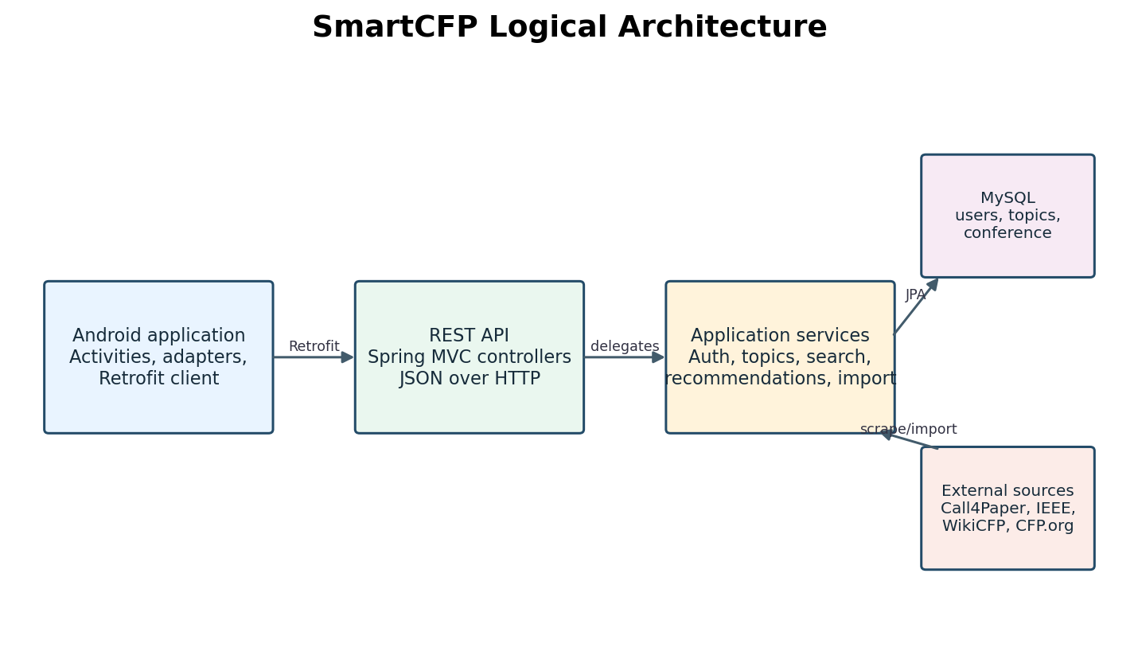
Figure 1. Logical system architecture
Figure 1 shows the logical runtime path. The Android application is a REST client; it does not directly query MySQL or scrape external pages. Backend service classes mediate API operations and source ingestion. JPA manages persistence to MySQL.
The diagram represents logical components rather than deployment replicas or network security zones. It shows the intended flow for listing and import, not a guarantee that each external provider is available. Source-specific responses are normalized before database storage.
The diagram can guide troubleshooting: inspect Android base URL and request callbacks first, then controller mapping, service logic, repository query, database state, or upstream source parsing depending on the failing boundary.

15 Android Client Architecture
The app is a native Android Java project using Activities, RecyclerView adapters, Material widgets, Retrofit, and Gson. MainActivity loads recommended data and applies local category/bookmark filters. SearchActivity uses delayed query scheduling to avoid a request for each keystroke.
TopicSelectionActivity restores server preferences, presents predefined chip groups, permits custom chips, validates at least one selection, and posts a TopicsRequest. SettingsActivity reloads saved topics and launches the editor. ConferenceDetailActivity renders one serializable Conference object and opens its effective URL.
RetrofitClient centralizes the base URL and converter. ApiService describes endpoint contracts. There is no separate Android domain/data layer or dependency-injection framework visible; as complexity grows, a repository/view-model architecture could isolate lifecycle and networking concerns.

16 Backend Architecture
The backend uses Spring Boot, Spring MVC, Spring Security, Spring Data JPA, Hibernate, MySQL Connector/J, Jsoup, and Java 21 source compatibility. SmartCfpApplication is the application entry point. Component scanning discovers controllers, services, repositories, and source adapters.
Controllers include AuthController, ConferenceController, UserTopicsController, ConferenceImportController, SourceController, and ScraperController. Services contain authentication, topic, conference, scraper, and import behavior. JPA entities are User and Conference; topic preferences are an element collection.
SecurityConfig disables CSRF for the stateless API and permits authentication, users, and conference routes. Other paths require authentication under Spring Security’s configured chain. This is development-oriented and needs deliberate production identity and role design.

17 Android User Journey
A new user submits name, email, and password through SignUpActivity. On success the app opens TopicSelectionActivity, which reads saved topics and allows selection. After a successful update it navigates to MainActivity with user identity extras. A returning user signs in and opens the feed.
MainActivity obtains the email from the intent and calls the recommended endpoint on resume. It keeps results in memory and applies category and saved-only views. Selecting a result opens ConferenceDetailActivity. Editing preferences from Settings causes the feed to reload when the user returns.
Some flows are intentionally incomplete: Google sign-in currently proceeds using a fixed demo identity, password reset shows a local confirmation message, and bookmarking is not synchronized to the backend. These should not be mistaken for connected production services.

18 Authentication and Accounts
AuthService rejects missing signup fields, normalizes email to lowercase, enforces an eight-character minimum password, checks duplicate email, encodes the password with BCrypt, and persists a User. Login retrieves by normalized email and compares the submitted password with the stored encoding.
AuthController maps signup to HTTP 201 and login to HTTP 200 on success, with client errors represented as message bodies. Invalid signup produces 400; invalid login produces 401. The response currently contains a message rather than a token or user profile.
Because the session policy is stateless and no token issuer is implemented, successful login does not establish a protected user session. Routes that accept email as a path or query parameter must not be treated as proof of ownership. Production hardening is a priority.

19 Interest Preference Management
User stores topics as an eager Set<String> element collection. JPA writes the values to user_topics with a user_id join column and a topic column. UserTopicsService validates a nonempty list and rejects null or blank values before saving the normalized selection.
GET /api/users/{email}/topics returns a compact response with name, email, and sorted topic strings. PUT on the same route replaces the set. The mobile screen restores known chips and creates custom chips for preferences not found among predefined options.
The data model permits arbitrary strings, which is flexible for custom fields but creates vocabulary variance. A future canonical topic taxonomy could preserve user labels while mapping them to normalized identifiers for dependable matching and analytics.

20 Personalized Recommendation Logic
GET /api/conferences/recommended?email=... resolves the user by lowercase email. Unknown users produce 404; blank email produces 400; a user with no preferences gets an empty list. Otherwise, the service reads all conferences in descending ID order and filters them.
Matching normalizes text to lowercase, replaces punctuation with spaces, collapses whitespace, and uses phrase boundaries. It checks short title, long title, and stored conference topics. Compound preference strings split on ampersand, comma, or slash. Known aliases include AI/artificial intelligence, ML/machine learning, and NLP/natural language processing.
This is explainable lexical matching, not a learned recommender. It can miss synonyms and abbreviations not in the alias map, and broad one-word terms may create false positives. It currently ranks by insertion order rather than relevance score.

21 Conference Search
GET /api/conferences/search accepts an optional keyword. A blank or absent keyword returns all conference rows. A supplied keyword is sent to a JPQL query that performs case-insensitive contains matching over short title, long title, location, and source name, ordering results by descending ID.
SearchActivity debounces text input by 300 milliseconds, calls the general all-conference endpoint for an empty query, and calls search for a nonempty query. It locally filters the result list by selected status tab. The inspected backend does not supply a dedicated status field in the Conference entity.
The distinction between personalized home and general search is important: search intentionally explores the full catalog, while the home feed uses saved interests. Topics are included in recommendation matching, but the current repository keyword query does not search the topics field.

22 Conference Details and Registration Links
Conference records retain a source/detail website and, where available, a separate registrationUrl. For Call4Paper events, the card link leads to a Call4Paper detail page; the scraper visits that page and extracts the external URL from an event description item labeled URL.
The Android Conference model deserializes registrationUrl and getOfficialUrl prefers it, falling back to website. ConferenceDetailActivity displays and opens this effective URL and includes it when sharing a conference. A missing or invalid external link falls back rather than creating a fabricated address.
The URL is not guaranteed to be a registration form; Call4Paper labels it generically as URL and it may point to event information or a submission portal. Users should confirm the destination. The source detail page remains available in the stored website field for provenance.

23 Saved Conferences
BookmarkManager stores IDs in Android SharedPreferences under the SmartCFP_Bookmarks preference file. It supports read, set, toggle, and listing bookmarked IDs. ConferenceAdapter toggles the local state and notifies MainActivity; the saved tab filters the loaded conference list.
The current bookmark feature is device-local. It is not linked to User or stored in MySQL, so bookmarks do not follow users across installations or devices. A seeded default bookmark exists for a demo conference ID.
A production design should associate a bookmark table with a user and conference, define uniqueness on the pair, expose authenticated add/remove/list endpoints, and migrate local values. The ERD in this report intentionally does not show such a table as implemented.

24 Notifications, Profile, and Settings
ProfileActivity displays account name/email passed through intents and routes to home, saved, notifications, and settings. SettingsActivity calls the topic API and renders topics as non-editable chips; its Edit action opens TopicSelectionActivity in editing mode.
NotificationsActivity and NotificationAdapter exist in the Android project. The inspected code includes demo notification content, not a backend notification feed or push-notification service. The profile’s applications menu similarly presents a local message rather than persisted application records.
This distinction matters for requirements and evaluation: the current product offers UI entry points and placeholders for broader researcher workflows, while only the account, topic, conference, and scraping paths are backed by the demonstrated backend.
Method | Path | Purpose
GET | /api/conferences | List catalogue
GET | /api/conferences/search | Keyword search
GET | /api/conferences/recommended | Topic matches

25 REST API Catalogue
The API uses JSON and is rooted at /api. Authentication endpoints are POST /api/auth/signup and POST /api/auth/login. Conference endpoints are GET /api/conferences, GET /api/conferences/search?keyword=..., and GET /api/conferences/recommended?email=....
User preferences use GET and PUT /api/users/{email}/topics. Source discovery uses GET /api/sources. Imports use POST /api/sources/import and POST /api/sources/import/{sourceName}. A separate GET /api/scraper/details endpoint is present for a scraper demonstration.
All-conference and search endpoints are public in the configured security chain. Import paths are not explicitly permitted and therefore follow the remaining security rule. API consumers should inspect status codes and response schemas rather than assume every route is public.
Method | Path | Purpose
POST | /api/auth/signup | Create account
POST | /api/auth/login | Verify credentials

26 API Contract: Signup and Login
Signup request fields are name, email, and password as a JSON object. The backend trims name, normalizes email, validates presence and password length, checks uniqueness, and stores an encoded password. A successful request returns a message with HTTP 201.
Login request fields are email and password. Successful verification returns a message with HTTP 200. Missing credentials or unknown email/wrong password are rejected. The backend deliberately uses a generic invalid-credentials message for the latter cases.
The Android ApiService defines SignupReq and LoginReq request models and maps results to AuthResponse. The client shows server messages or HTTP-based errors. No access token is returned, which constrains secure access control for personal data.
Method | Path | Purpose
GET | /api/users/{email}/topics | Read preferences
PUT | /api/users/{email}/topics | Replace preferences

27 API Contract: Topics and Recommendations
The preference response is UserTopicsResponse with name, email, and topics. Topic updates submit a TopicsRequest containing a list of strings. Empty, null, or blank entries fail with a bad-request response; successful update returns the saved sorted topics.
Recommendation requests use an email query parameter and return a JSON array of Conference objects. The array is filtered by titles and topic metadata. Error conditions include missing email and user not found. The current Android main feed uses this endpoint and reloads on resume.
Email in a URL can appear in access logs and is not an authentication credential. Future APIs should derive the user identity from a verified token and avoid allowing one user to retrieve another user’s private preferences.
Method | Path | Purpose
GET | /api/sources | List source adapters
POST | /api/sources/import | Import all sources
POST | /api/sources/import/{sourceName} | Import one source

28 API Contract: Import and Sources
GET /api/sources lists names of discovered ConferenceSource components. POST /api/sources/import runs all sources. POST /api/sources/import/{sourceName} runs one source selected case-insensitively by source name; unknown sources return 404 and blank names return 400.
The import response is a map containing per-source status and counts such as found, inserted, updated, and duplicates, plus totals. Each source is isolated with exception logging so a failure in one provider does not prevent later providers from running.
Scrapes are network-dependent and can take time. Operational clients should set adequate timeouts, avoid launching duplicate imports concurrently, and show the returned per-source status. A job queue and scheduled import worker would be preferable at larger scale.

29 Database Overview
MySQL is the configured relational database. JPA maps the users table, user_topics collection table, and conference table. The Conference table has generated identity, short and long titles, location, deadline, website, source name, topics, and registration URL.
Email is unique for User. Conference website is used by the importer to find an existing row; the entity mapping shown does not itself declare a unique constraint for website. Production schema should add an index/unique constraint if the business rule requires exactly one record per URL.
The schema is evolved with Hibernate DDL update in the inspected properties. That is convenient for development but should be replaced by controlled database migrations for shared and production databases.

30 Entity Relationship Diagram
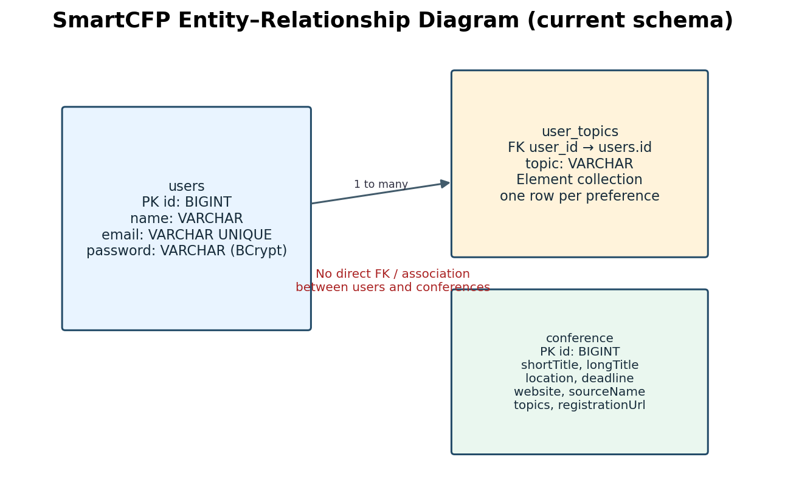
Figure 2. Current persistence model (ERD)
Figure 2 models the current relational shape. One User has zero or more topic rows in user_topics. The topic collection references users through user_id. Conference records are independent catalogue rows; user recommendations are computed at request time and are not represented as a persistent many-to-many relation.
The ERD deliberately omits bookmarks, notifications, submissions, and registration history because the backend entities shown do not persist those features. An ERD is an implementation snapshot, not a wishlist. Any future entities must include explicit foreign keys and lifecycle rules.
The diagram lists logical column intent rather than all engine-specific SQL types and indexes. Hibernate naming conventions may translate camelCase Java fields into snake_case physical columns, as seen in runtime SQL.

31 User Entity and Topic Collection
User contains generated ID, name, unique email, password, and a Set<String> topics. Topics use FetchType.EAGER and @ElementCollection with @CollectionTable(name="user_topics", joinColumns=@JoinColumn(name="user_id")). Each element is stored in a non-null topic column.
Eager loading makes topic access simple in recommendation and settings services, but may increase cost when loading users for unrelated operations. A lazy collection within transaction boundaries may scale better. A dedicated Topic entity would support canonical identifiers, descriptions, and multilingual labels.
Password is present in the persistence entity but should never be serialized to clients. Current controllers return messages and a separate UserTopicsResponse rather than User directly, reducing accidental exposure. Response DTO discipline should be maintained.

32 Conference Entity and Catalog Fields
Conference represents normalized source data. The ID is generated by the database. Titles, location, deadline, website, sourceName, topics, and registrationUrl are persisted. Longer strings use explicit column lengths for selected fields. The old seven-argument constructor remains for sources that do not provide topics or registration URLs.
Source name enables provenance and report grouping. Website supports source detail navigation and deduplication. Registration URL separates the user-action destination from provenance. Topics support personalized relevance matching. Deadline stores source text and is not parsed into a date type.
String deadlines preserve heterogeneity but complicate filtering and reminders. A normalized model could store event start/end and paper deadline as LocalDate/LocalDateTime, plus original source text and timezone when available.

33 Persistence and Import Lifecycle
During import, each ConferenceSource scrapes records. The service skips a record with a blank website. Existing website matches have title, location, deadline, source, and topics refreshed; a nonblank registration URL replaces the previous one. New rows are saved as-is.
This update strategy addresses the earlier missing-data issue: adding a new field to the scraper is insufficient unless existing rows are refreshed. Keeping a pre-existing registration URL when a fresh scrape has none prevents an intermittent detail-page failure from erasing a known link.
The import loop performs one lookup and save per record. It is simple and auditable but not optimized for large volumes. A bulk-upsert strategy and transactional policy could improve throughput while preserving useful source-specific error isolation.

34 Data Sources and Adapter Pattern
ConferenceSource defines getSourceName and scrape returning List<Conference>. Spring discovers each adapter as a component and injects the complete list into ConferenceImportService and SourceController. This is a small adapter/plugin pattern for heterogeneous providers.
Current providers include Call4Paper, IEEE, WikiCFP, and CallForPaper.org. Their parsing strategies differ: HTML selectors for the two CallForPaper sites and WikiCFP, and a public search API for IEEE. Each implementation maps into the same database entity.
A source adapter should define source URL, timeout, selectors or response shape, normalization rules, optional-field fallbacks, canonical link behavior, and fixture tests. Avoid adding provider-specific assumptions to controllers or the mobile client.

35 Call4Paper Scraper
Call4Paper fetches https://www.call4paper.com/ with Jsoup and a browser-like user agent. It selects div.top-banner.special cards, finds the enclosing anchor, reads .cfp_ad_title and .cfp_ad_title_abbr, and collects .cfp_ad_subject text, date, and location.
Event cards have a detail URL under /cfp/detail/event/; the scraper fetches these pages and looks for .event-desc list items whose own text starts with URL:. The linked absolute URL is stored as registrationUrl. Per-detail IOException is logged and does not discard the card.
Journal cards are parsed as records but are not event registration pages. Records without location/date use Not available. External markup may change, and sequential detail requests can be slow. Parser fixtures should be periodically updated from representative HTML without depending on live scraping.

36 WikiCFP Scraper
WikiCfpSource fetches the CFP page with Jsoup, selects anchors containing event.showcfp, and derives the short title from anchor text. It inspects the containing table row and next sibling row to find a full title, location, and deadline.
When row details are missing, the parser uses empty title or Not available fallbacks for location and deadline. It stores the event link and the source name WikiCFP. Current logic is based on a page-table layout and can break if markup changes.
The parser tests establish the expected row mapping and URL formation. A future implementation should handle multiple listing pages, encoding, source rate limitations, retry strategy, and validation for empty titles or malformed links.

37 CallForPaper.org Scraper
CallForPaperSource fetches callforpaper.org and selects h3 anchors. It uses link text as the long title, derives the short title before a colon when present, and walks up parent elements looking for a container with time and country links.
The parser extracts location from the country link and deadline from time; missing optional data becomes Not available. The resulting website is the absolute event link, and sourceName is CallForPaper.org. Tests verify retention when metadata is absent.
This parser is distinct from the Call4Paper.com scraper despite similar branding. Their HTML and data fields differ. Keeping explicit class names and site identifiers prevents misattribution and makes source-specific troubleshooting tractable.

38 IEEE Source Adapter
Ieee uses Spring RestClient to POST a form-encoded query to the public IEEE search endpoint. It reads the nested entity results, totalResults, and pageSize values, iterates through pages, and converts event maps into Conference objects.
The mapper requires eventTitle and eventId. It joins start and end dates, composes city/region/country when available, and builds the IEEE conference detail URL using the event ID. Invalid/missing API structure raises IOException; RestClient exceptions are wrapped with context.
The current stored deadline field receives conference event dates for IEEE, while other sources may supply a submission deadline. This semantic mismatch is preserved for compatibility and should be addressed by a richer date model.

39 Recommendation Matching Details
The service combines short title, long title, and topics, lowercases using Locale.ROOT, replaces non-letter/digit runs, trims, and collapses whitespace. Matching adds spaces at both ends to avoid matching a short phrase inside unrelated token sequences.
A user interest can be a compound category such as AI & ML; splitting on ampersand, comma, and slash produces smaller phrases. Aliases handle selected common abbreviations. Any one matching selected interest is enough to include a conference.
The algorithm has deterministic behavior and no external ML dependency. It is easy to test and explain, but matching quality depends on source metadata richness. It does not currently use location, date freshness, ranking, user behavior, or click/bookmark signals.

40 Security and Privacy
Passwords are encoded with BCrypt before persistence, and the stateless security chain disables CSRF for API requests. Request controllers use dedicated DTOs for topic operations. Sensitive local database configuration is not included in this report.
The current authorization rules permit /api/users/** and /api/conferences/** without authentication. Recommendations and topic endpoints identify a user by email supplied in the request. This means the implementation should not be deployed with private user data until authentication and ownership checks are added.
Recommended controls include HTTPS, token-based auth, identity derived from token claims, endpoint role rules, input DTO validation, rate limiting, secure secret configuration, structured audit logs without passwords/email leakage, and database least privilege.

41 Error Handling and Observability
Services use HTTP status exceptions for invalid or unknown users. Import logs source exceptions and places a generic failure status in the report. Android callbacks report HTTP errors and network failures via Toasts. Scraper detail-page failures log the affected title and continue.
Generic user-facing errors avoid leaking stack traces, while server logs retain exception context. The app should distinguish no results from request failure and has separate empty-state text for category filtering and empty backend data.
Operational improvements include correlation IDs, metrics for found/inserted/updated counts, source latency and failure rates, structured logs, health checks for MySQL, and explicit parser-empty warnings. Avoid logging credentials or full sensitive request payloads.

42 UML Class Diagram
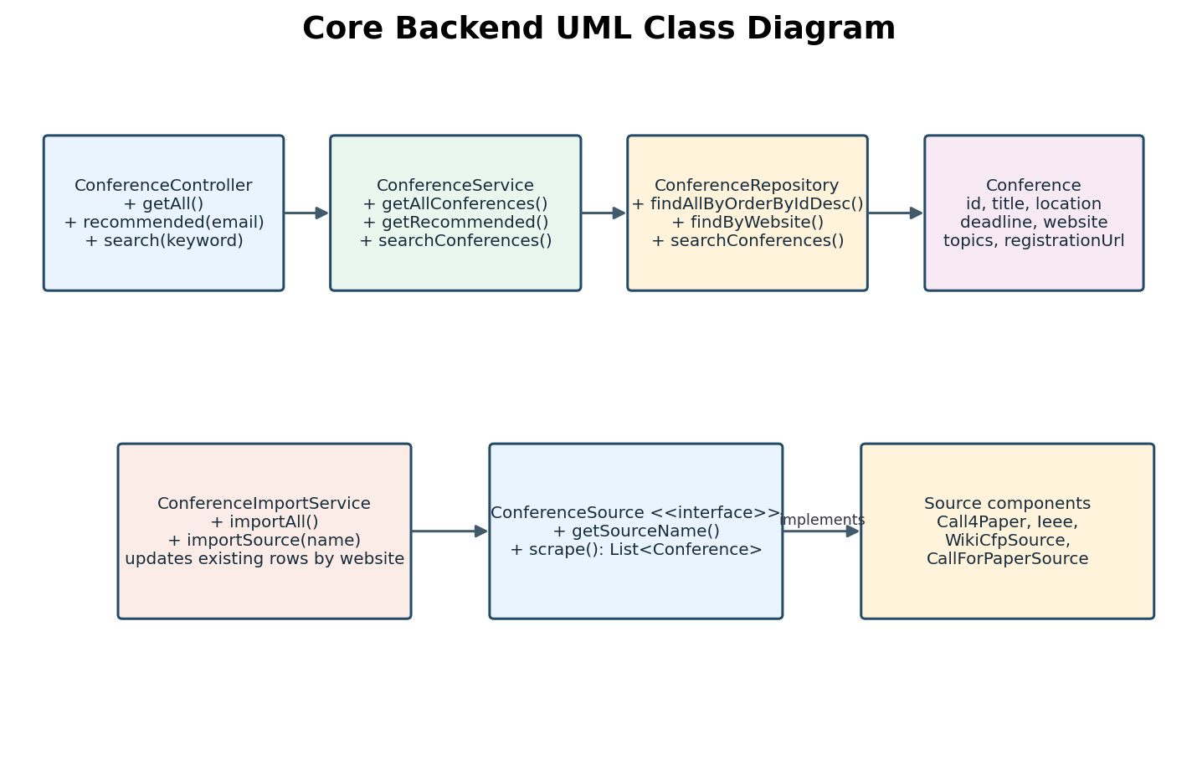
Figure 3. Core backend UML class diagram
Figure 3 presents the core backend class relationships. ConferenceController delegates to ConferenceService, which uses ConferenceRepository for persistence. ConferenceImportService depends on the ConferenceSource abstraction and ConferenceRepository; provider classes implement the interface.
The diagram is intentionally selective to remain readable and to focus on architectural responsibility. UserTopicsService, AuthService, entities, and additional controllers are described elsewhere. It should not be interpreted as a complete generated class diagram of every Android and backend type.
The diagram illustrates dependency direction: controllers depend on service abstractions, while source parsing is decoupled from persistence through the shared Conference model. The use of constructor injection supports testability.

43 Sequence Diagram: Signup and Topic Selection
A signup begins when SignUpActivity validates user-entered fields and invokes Retrofit ApiService.signup. AuthController delegates to AuthService, which validates and hashes the password, checks uniqueness through UserRepository, and saves the User. A created response opens TopicSelectionActivity.
TopicSelectionActivity GETs the existing topic response so it can restore preferences. The user selects chips and submits a TopicsRequest. The controller delegates to UserTopicsService, which validates values, loads the user, replaces the topic set, saves it, and returns sorted values.
Successful first-time topic selection navigates to MainActivity. Editing mode returns to SettingsActivity; MainActivity reloads its recommendation list on resume. Network failures leave the user in the current flow with explicit retry guidance.

44 Sequence Diagram: Personalized Feed
When MainActivity resumes, it calls getRecommendedConferences with the current email. ConferenceController binds the query parameter and delegates to ConferenceService. The service validates the email, reads the matching User, and accesses the saved topics.
If topics exist, the service requests Conference rows ordered by descending ID and applies phrase matching in memory. The response is serialized as JSON and Retrofit/Gson constructs client Conference objects. The activity stores the response and applies device-local category and bookmark filters.
An empty list is a valid response when there are no topics or no matches. An unknown email returns not found. If data exists but all matches fail, users may need richer conference topic tags or broader aliases rather than a transport fix.

45 Sequence Diagram: Conference Import
An administrator/developer issues POST /api/sources/import/Call4Paper.com. ConferenceImportController passes the source identifier to ConferenceImportService. The service resolves the bean by case-insensitive source name and invokes scrape.
Call4Paper fetches the home listing, parses cards, visits event detail pages for external URLs, and returns normalized entities. The import service skips blank websites, looks up each URL, inserts new rows, and updates existing rows while preserving old registration URLs if the new scrape has none.
A per-source report returns success, found, inserted, updated, and duplicate counts. Exceptions are logged and reported as failure. Network access, schema changes, and external site layout all affect this sequence.

46 Android UI and Interaction Design
MainActivity contains home and saved tabs, category controls, conference list, search navigation, profile navigation, and empty states. ConferenceAdapter renders conference cards and bookmark actions. SearchActivity has query input, clear control, and All/Upcoming/Ongoing tabs.
Topic selection uses Material chips grouped by subject and a custom-topic entry. Settings displays the server-saved topics. ConferenceDetailActivity exposes title, dates, venue, descriptive text, tags, URL, sharing, and save-for-later controls.
The project has dark-gradient visual resources and Material components. Accessibility review should verify content descriptions, focus order, text contrast, dynamic font scaling, and touch target dimensions for all visible controls.

47 Networking and Serialization
RetrofitClient creates one Retrofit instance with a Gson converter and base URL http://10.0.2.2:8080/. ApiService describes GET, POST, and PUT endpoints. The base address is suitable for an Android emulator to reach host localhost, not for production or a physical handset.
The Android Conference uses SerializedName aliases for server fields such as id, shortTitle, longTitle, sourceName, location, deadline, and website. registrationUrl is an additional field. The app’s getOfficialUrl selects registrationUrl first, then website.
The Java server serializes a Long conference ID, while Android declares a String ID. Gson can generally coerce primitive JSON values, but explicit ID typing would be more robust. Network calls use enqueue callbacks to avoid blocking the UI thread.

48 Lifecycle and State Management
Activities obtain identity through Intent extras. MainActivity reloads conferences in onResume and refreshes bookmark UI. Settings reloads topics in onResume. SearchActivity cancels pending debounce callbacks on destroy and ignores stale search responses using a request ID.
This design uses activity-scoped in-memory data and SharedPreferences for bookmarks. It has no persistent offline cache for conference records, no centralized session state, and no ViewModel-based survival across configuration changes. Recreating an activity can initiate new network calls.
A repository plus ViewModel and lifecycle-aware observable state would make loading/error/content states explicit, prevent redundant fetches, and simplify unit testing. A local database could support offline browsing and synchronized bookmarks.
- Implemented behavior is identified from current source and test code.
- Recommendations are proposed work and are not represented as completed features.
- All local secrets and credential values are intentionally excluded.

49 Testing Strategy
Backend tests include source parsing tests, conference persistence/import tests, recommendation service tests, topic service tests, application context startup, and HTTP access checks. Unit-level parsing tests use Jsoup.parse against inline fixture HTML so the test does not need an external site.
Recommendation tests use mocked repositories and users. They validate alias handling, topic-empty behavior, and not-found semantics. Persistence tests verify insertion and updates to topic/registration fields. Controller access tests run a random-port Spring Boot server.
Android tests include a Conference API mapping test plus template unit/instrumented tests. Build validation compiles the app. Additional UI tests should cover selection, navigation, loading/error states, empty feeds, URL opening, and bookmark persistence.
- Implemented behavior is identified from current source and test code.
- Recommendations are proposed work and are not represented as completed features.
- All local secrets and credential values are intentionally excluded.

50 Verification Results
At the time of implementation, the backend Maven suite completed successfully with 15 tests and no failures after registration URL support. A subsequent targeted real-database Call4Paper integration test confirmed that at least one imported Call4Paper record had a nonblank registration URL.
The Android Gradle task :app:compileDebugJavaWithJavac succeeded after the registration URL DTO change. A separate earlier validation also compiled the Android client after recommendation API wiring. Build warnings included an existing deprecated URL constructor in a test and general toolchain notices.
Integration test success proves behavior against the local development database and current reachable Call4Paper page at test time, not a guaranteed future upstream response or production database configuration.
- Implemented behavior is identified from current source and test code.
- Recommendations are proposed work and are not represented as completed features.
- All local secrets and credential values are intentionally excluded.

51 Backend Setup
The backend is a Maven project with a Maven wrapper. It requires a compatible JDK (pom specifies Java 21), a running MySQL database, and application properties for JDBC URL, username, password, port, and JPA options. Do not commit real secrets.
From the Backend directory, run .\mvnw.cmd test to execute tests and .\mvnw.cmd spring-boot:run to start the service. The default server port is 8080. Hibernate ddl-auto is update in development, which creates or adapts schema on startup.
The source import endpoints require network access to provider sites. Run a source-specific import after the backend is available, inspect per-source status, and verify persisted rows. Schema migrations and external configuration should replace development defaults before deployment.

52 Android Setup
The mobile project is PaperPath, an Android Gradle project with Java source compatibility 11, compile SDK 36, minimum SDK 24, and target SDK 36. Dependencies include AndroidX AppCompat, Material, RecyclerView, Retrofit, Gson, and constraint layout.
Open PaperPath in Android Studio, sync Gradle, configure an emulator, and build the debug variant. RetrofitClient targets 10.0.2.2:8080, so the backend must run on the host. A physical device needs a reachable LAN/server address and may require cleartext/network-security configuration changes.
The app has no release signing configuration or production API endpoint in the inspected Gradle build. Release deployment should use HTTPS, build variants or secure configuration injection, signed artifacts, and a privacy-reviewed account/session flow.

53 Deployment and Operations
A local deployment consists of MySQL, the Spring Boot process, and Android emulator. The logical architecture permits later deployment of the backend to a managed Java host and database, but the current base URL and local datasource settings are development-oriented.
Production readiness requires TLS termination, database backups, migrations, connection-pool sizing, health/readiness probes, log retention, rate limits, CORS policy if a web client is introduced, and secrets supplied by an environment or secret manager. Scraping should use responsible request intervals.
Import should preferably be run as a controlled background job. Exposing a long synchronous scrape request can exceed gateway timeouts and make mobile/admin interactions unresponsive. The current endpoint returns after processing all chosen sources.

54 Limitations and Risks
The most material limitations are incomplete authentication authorization, email-based identity in query/path parameters, in-memory unranked recommendation filtering, source markup fragility, sequential detail-page fetches, string-based dates, and the lack of server-synchronized bookmarks.
The search path is not personalized and its JPQL does not include topics. Several mobile features are demos. The conference schema has no explicit event category ontology or organizer registration metadata. Updates keyed by website depend on a stable canonical URL.
External source terms and robots policies should be reviewed before operating scrapers at scale. The system should not make unsupported claims about deadline correctness, conference quality, or registration availability. User-facing UI should preserve source attribution.

55 Roadmap and Recommendations
First, add proper authentication (for example, signed access tokens), bind preference and recommendation operations to the authenticated identity, protect source import, and move secrets out of properties. Add validation and integration tests for the security policy.
Second, enrich catalog modeling with normalized event start/end, submission deadline, source URL, registration URL, event type, timezone, crawl timestamp, and topic identifiers. Add source provenance and confidence fields. Enforce URL uniqueness with a database constraint and migrations.
Third, improve recommendations using topic taxonomy and relevance scoring, search topics, add pagination and filters, synchronize bookmarks, provide meaningful notification events, and schedule ingestion with metrics. Add Android ViewModels, offline cache, UI tests, and production endpoint configuration.

56 UML and Data Model Interpretation
The report’s UML class diagram shows the principal backend dependency chain, while the ERD shows the implemented persistence relationships. UML captures runtime responsibilities; ERD captures stored entities and keys. Neither should be read as a claim that all screens have corresponding server tables.
Recommendation results are computed and returned, not persisted as a separate table. User topic rows are a collection owned by User. Conference records are shared catalogue entries. This allows all users to reference the same event without duplicating it.
If the system later stores bookmarks or applications, those would introduce user-to-conference relationships with explicit lifecycle behavior. A conference application could include state, submitted paper metadata, and timestamps, but none is present in the current schema.

57 API Error and Status Matrix
Signup returns 201 on success, 400 for invalid input or duplicate email. Login returns 200 on success and 401 for invalid credentials. Topic retrieval/update may return 400 for invalid email or empty topics and 404 for a missing user.
Recommendations return 200 with an array, including an empty array for no topics/no matches; blank email is a client error and unknown user is not found. Source import returns a report map; unknown source is 404. Source-specific scrape failures are reported within the response rather than aborting all imports.
The mobile app should parse error bodies when possible and avoid mapping every non-200 response to the same generic state. Server-side exception details belong in logs, not API responses. Consistent error DTOs would improve client handling.

58 Data Quality and Normalization
Each adapter maps external labels into shortTitle, longTitle, location, deadline, website, sourceName, topics, and registrationUrl. Missing optional values use Not available or null. This normalization makes client rendering consistent but retains strings in original source conventions.
Conference titles and subjects are primary recommendation inputs. Inconsistent abbreviations, HTML entities, punctuation, and source-language variants can produce false negatives. Normalization removes punctuation and handles a small alias list but does not perform stemming, translation, or ontology mapping.
Data quality can be improved by validating URLs, trimming text, canonicalizing source URLs, rejecting empty titles, storing scrape time, and comparing fresh records with existing values. A manual review or source confidence indicator can help users judge metadata.

59 Privacy and Data Retention
Account data includes name, email, encoded password, and selected interest strings. Passwords are not plaintext in the database. The Android client receives name/email/topics in the topic response and carries identity through intents for navigation.
There is no explicit account deletion or data export endpoint in the inspected backend. Bookmarks are local and therefore outside backend retention controls. Import records represent public conference content and have no user ownership relationship.
A production privacy policy should state processing purposes, retention, log handling, third-party source access, and user rights. Avoid transmitting email unnecessarily and use secure authentication claims to scope personalized requests.

60 Maintainability and Extensibility
The ConferenceSource interface allows provider additions without modifying endpoint contracts. Constructor injection and repository interfaces support mocking. DTOs isolate topic API payloads from the User entity. Parser tests provide a safety net against markup changes.
The service layer currently carries multiple responsibilities in some areas, and the entity doubles as an API object. As the API evolves, response DTOs, source-specific mapper classes, and database migrations can reduce accidental coupling. Shared parsing utilities should be introduced only when source behavior is genuinely shared.
Consistent formatting, package naming, source naming, error contracts, and source-specific tests reduce maintenance cost. Documentation should clearly note that Call4Paper.com and CallForPaper.org are distinct sites and adapters.

61 UML Sequence: Registration Link
The link retrieval extension begins in the Call4Paper card parser, which stores the Call4Paper detail link in website. For event cards, the scraper fetches that detail page and extracts an absolute external URL from the labeled URL list item.
The importer inserts or refreshes registrationUrl in the conference record. JSON serialization sends registrationUrl to Android. Gson maps it onto the client Conference field, and getOfficialUrl chooses it before the website fallback. The detail activity opens the effective destination using ACTION_VIEW.
For journals, a registration link is not expected. For events where the detail page has no URL or cannot be fetched, the source page remains available. Fetch exceptions are logged rather than falsely reporting a direct link.

62 Acceptance Criteria and Evaluation
A valid end-to-end acceptance run signs up a user, selects and saves an interest, imports sources, and confirms that at least one matching conference appears when its metadata contains the chosen subject. A nonmatching topic should not include unrelated records under the lexical rule.
Import acceptance checks that each source report states success or failure, records are visible in GET /api/conferences, repeated imports update rather than duplicate by website, and Call4Paper event details with an external URL expose registrationUrl.
Mobile acceptance checks include search debounce, empty/error states, detail rendering, direct registration URL preference, fallback source URL behavior, bookmark persistence after app restart on the same device, and settings topic refresh. Security acceptance must wait for token-based auth work.

63 Glossary
Conference record: normalized database row representing a public event or, for current Call4Paper parsing, a journal card. Source/detail URL: provider page retained for provenance. Registration URL: optional external destination surfaced as the primary action link.
Topic/interest: user-selected string persisted in user_topics. Recommendation: title/topic phrase match computed for a user at request time. Adapter: ConferenceSource implementation that fetches and maps one provider. Import: scrape, deduplicate, insert, and refresh workflow.
DTO: data transfer object used for a request or response. JPA: Java Persistence API mapping to relational storage. Retrofit: Android HTTP client abstraction. UML: Unified Modeling Language. ERD: entity relationship diagram.

64 References and Repository Evidence
Backend evidence includes Backend\pom.xml; src\main\resources\application.properties (configuration only; secret values excluded); model\User.java, model\Conference.java, and topic DTOs; controller, service, repository, config, and source packages.
Android evidence includes PaperPath\app\build.gradle.kts; app\src\main\java\com\example\paperpath\ApiService.java, RetrofitClient.java, MainActivity.java, TopicSelectionActivity.java, SearchActivity.java, ConferenceDetailActivity.java, Conference.java, and BookmarkManager.java.
Test evidence includes ConferenceSourceParsingTest, ConferencePersistenceTest, ConferenceRecommendationTest, UserTopicsServiceTest, ConferenceControllerAccessTest, and Android ConferenceApiMappingTest. External page structures cited are the observed Call4Paper homepage/detail page and must be revalidated before future scraper changes.

Appendix A — Repository Map
The backend is organized under com.example.smartcfp into config, controller, model, repository, service, and source packages. The Android application is under com.example.paperpath. The following inventory is concise and describes each subsystem.
Area | Inventory
Backend config | PasswordConfig, SecurityConfig
Backend controllers | AuthController, ConferenceController, ConferenceImportController, ScraperController, SourceController, UserTopicsController
Backend models | Conference, User, TopicsRequest, UserTopicsResponse
Backend repositories | ConferenceRepository, UserRepository
Backend services | AuthService, ConferenceImportService, ConferenceService, ScraperService, UserTopicsService
Backend sources | ConferenceSource, Call4Paper, CallForPaperSource, Ieee, WikiCfpSource
Android screens | SplashActivity, SignInActivity, SignUpActivity, TopicSelectionActivity, MainActivity, SearchActivity, ConferenceDetailActivity, ProfileActivity, SettingsActivity, NotificationsActivity
Android support | ApiService, RetrofitClient, Conference, adapters, BookmarkManager, request/response models

Appendix B — Report Notes
This document is intended for project review, academic documentation, and onboarding. It is not a security certification, deployment runbook, or guarantee that external conference data is current. Re-run the tests and review provider policies before release.
The diagrams are logical views derived from current code. The ERD excludes proposed features such as server-side bookmarks. The source list and endpoint inventory should be updated whenever repository structure or contracts change.

