SmartCfp: A Mobile Application for Discovering and Tracking Academic Conference Calls for Papers

A Project Report
Submitted by: Saniya Sandesh Gaonkar and Renuka Veer
Roll No.: 2645 and 2639
Department of Masters of Computer Application, Goa Business School, Taleigao
Academic Year 2026–2027

Declaration
We hereby declare that the project report entitled “SmartCfp: A Mobile Application for Discovering and Tracking Academic Conference Calls for Papers” is a record of original work carried out by us under the guidance of Hanumanth Redkar and Sarvesh Velip. Wherever information has been taken from other sources, it has been acknowledged in the references. This report has not been submitted to any other university or institution for the award of any degree or diploma.

Acknowledgement
We express our sincere gratitude to our project guide, Hanumanth Redkar and Sarvesh Velip, for the guidance, encouragement and constructive feedback given throughout the development of this project .We thanks the faculty of the Department of MCA for providing the resources and the environment needed to complete this work.
We also thank our classmates and friends for their suggestions, and our families for their constant support. Finally, we acknowledge the open-source communities behind Android, Spring Boot, MySQL, Retrofit and Jsoup, whose tools made this project possible.

Abstract
Researchers and students depend on conferences to publish and discuss their work, and every conference announces its requirements through a call for papers (CFP). These announcements are spread across many websites, each with its own layout and search facilities, so finding a suitable conference before its deadline is slow and error-prone. A missed deadline can delay publication by a full year.
Smartcfp is a mobile application that brings these announcements into one place. The system has two parts: a Spring Boot backend and an Android application. The backend collects conference information from three sources (ConferenceMonkey, the IEEE conference listing service and CallForPaper.org) using web scraping and a JSON interface, converts it into one common structure and stores it in a MySQL database. It also provides a REST API for registration, login, listing and searching. The Android application lets users sign up, browse and search conferences, view details, open the official website, share a conference, keep a list of saved conferences and view notifications. Users can also select their interest topics; these are stored on the server and used to recommend conferences that match their interests.
Passwords are stored only as BCrypt hashes, and the design separates the user interface, the business logic and the data store so that new conference sources can be added without changing the rest of the system. This report describes the problem, the analysis, the design (including ER and UML diagrams), the implementation, the testing and the limitations of SmartCfp, and suggests future improvements.
Keywords: call for papers, conference discovery, Android, Spring Boot, REST API, web scraping, MySQL, recommendation.

Contents
1. Introduction
2. Literature Survey and Existing Systems
3. System Analysis and Requirements
4. Technology Overview
5. System Design
6. Implementation
7. Testing
8. Results and User Interface
9. Limitations and Future Scope
10. Conclusion
References
Appendix A: API Reference
Appendix B: Database Schema
Appendix C: Setup and Running Instructions

List of Figures
• Figure 1.1: Brainstorming (mind map) diagram of SmartCfp
• Figure 5.1: Entity-relationship (ER) diagram
• Figure 5.2: Use case diagram
• Figure 5.3: Class diagram
• Figure 5.4: Object diagram
• Figure 5.5: Sequence diagram
• Figure 5.6: Activity diagram
• Figure 8.1 to 8.10: Application screenshots; Figure 8.11: Tables of the database schema

Chapter 1: Introduction

1.1 Background
Academic conferences are one of the main places where researchers present new results, receive feedback and meet others working in the same area. Each conference publishes a call for papers (CFP): an announcement that states the topics of interest, the submission deadline, the venue and dates, the format required for papers and a link to the official website. For a student or an early-career researcher, choosing the right conference at the right time directly affects whether a piece of work gets published, because a missed deadline usually means waiting for the next yearly edition.
CFPs are published in many places: conference websites, listing services, publisher and society pages, mailing lists and social media. Each place has its own layout, its own way of searching and its own update rhythm. A person who wants to know which conferences in a given area still accept papers has to visit several of them, compare the results by hand and keep track of the deadlines separately.
The widespread use of smartphones makes a mobile application a natural way to solve this problem. A phone is always at hand, can notify its user, and can present a long list of items in a compact and searchable form. SmartCfp is built on this idea.

1.2 Problem Statement
The problem addressed by this project can be stated as follows:
Conference calls for papers are scattered across many websites that differ in structure and presentation. Researchers and students therefore spend considerable time searching, comparing and tracking them, and they risk missing deadlines. A single, searchable, mobile-friendly source that collects these announcements and highlights the ones relevant to a user’s interests is needed.

1.3 Objectives
The objectives of the project are:
1. To collect conference information automatically from more than one source and store it in one common format.
2. To avoid duplicate entries when the same conference is listed by several sources.
3. To provide a secure registration and login mechanism for users, with passwords stored as hashes and never as plain text.
4. To provide an Android application in which users can browse conferences, search them by keyword and view their details.
5. To let users open the official website of a conference and share a conference with others.
6. To let users keep a list of saved conferences and view it later.
7. To let users select topics of interest and to recommend conferences that match those topics.
8. To design the system in layers so that new sources and new features can be added with small changes.

1.4 Scope of the Project
The scope of SmartCfp covers the following:
• A backend service that scrapes or queries three sources, stores the results in a MySQL database and exposes them through a REST API.
• User accounts with sign up and log in.
• An Android application for browsing, searching, viewing details, saving, sharing and receiving recommendations.
• Storage of each user’s selected topics on the server.
The following are outside the present scope: paper submission itself, peer-review workflows, payment for conference registration, an iOS or web client, and automatic push notifications for deadlines. Some of these are discussed as future work in Chapter 9.

1.5 Motivation
The project was motivated by the everyday experience of students who need to find a venue for a paper or a project. Checking several websites is repetitive work that a program can do better. At the same time, the project gave an opportunity to apply the subjects studied during the course in one working system: object-oriented programming in Java, database design, computer networks (client–server communication over HTTP), software engineering (requirements, design, testing) and operating-system concepts such as processes and persistent storage.

1.6 Development Approach
The project followed an iterative approach. Features were built in small steps, and after each step the system was run end to end (database, server and application on an emulator) before the next step was planned. Version control with Git and GitHub was used throughout.

1.7 Organization of the Report
Chapter 2 reviews the existing ways of finding CFPs and identifies their limitations. Chapter 3 lists the requirements of the system and studies its feasibility. Chapter 4 describes the technologies used. Chapter 5 presents the design, including the architecture, the database and the UML diagrams. Chapter 6 explains the implementation of the backend and the Android application. Chapter 7 describes the testing. Chapter 8 shows the user interface. Chapter 9 discusses limitations and future scope, and Chapter 10 concludes the report.
Figure 1.1 shows the brainstorming (mind map) diagram that summarizes the problem, the users, the features and the technologies of the project.
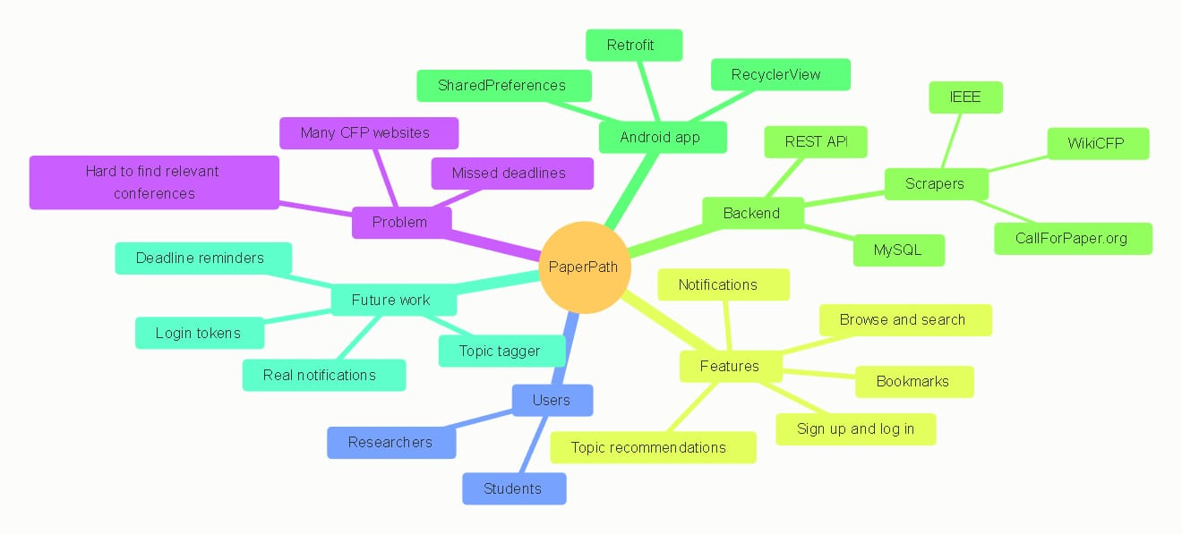

Chapter 2: Literature Survey and Existing Systems

2.1 Overview
This chapter reviews how researchers currently discover conferences and what problems remain. The review is based on the services that SmartCfp itself uses as data sources, and on the other common practices.

2.2 WikiCFP
WikiCFP is a community-maintained calendar of calls for papers. Entries are grouped by category and list the short name and full title of the event, the dates, the location and the submission deadline. The information is presented as HTML pages, so it is easy for a person to read but has no official programming interface. For this reason SmartCfp reads the pages with an HTML parser and extracts the fields that it needs.

2.3 IEEE Conference Listings
The IEEE publishes information about the conferences that it sponsors through its conference search service. The service returns results in JSON format, which is easier to process than HTML. SmartCfp queries this interface, reads the events returned and maps each one to the common conference structure. Only IEEE-sponsored events appear here, so it cannot be the only source for a user who is interested in other publishers.

2.4 CallForPaper.org
CallForPaper.org is a listing website for calls for papers. Like WikiCFP it presents its data as web pages, and SmartCfp again uses an HTML parser to read them. The structure of the page is different from WikiCFP, so a separate reader is needed.

2.5 Other Practices
Researchers also learn about CFPs from mailing lists, social media posts, messages from supervisors, the web pages of societies and publishers, and alerts offered by some services. These channels are useful but they are not searchable in one place, the information arrives in different formats and it is easy to lose a message that arrived weeks before the deadline.

2.6 Limitations of the Existing Approaches
The study of the existing approaches shows the following limitations:
• Fragmentation: no single source covers all conferences, so several sites must be visited.
• Different formats: each source uses its own fields and layout, which makes comparison slow.
• Duplicates: the same conference can appear on more than one site, and a person has no easy way to know that two entries refer to the same event.
• Limited search: searching works only inside one site and with the options that the site provides.
• No personalisation: most listings show every event to every visitor, so the visitor has to filter manually for the topics that matter.
• Weak mobile support: several listing pages are designed mainly for desktop browsers.
• No personal tracking: apart from browser bookmarks, there is no simple way to keep a short list of conferences that one wants to follow.

2.7 Comparison
Table 2.1 compares the usual practice of visiting separate websites with SmartCfp.
Aspect | Separate websites | SmartCfp
Where to look | Several sites, visited one by one | One mobile application
Data format | Different on every site | Converted to one common structure
Search | Only inside one site | One keyword search over title, location and source
Duplicate entries | The same event may appear several times | Detected by comparing website addresses
Personalisation | Limited or none | Topic selection and recommendations
Mobile use | Varies; often desktop-oriented | Native Android application
Keeping a short list | Browser bookmarks | Saved conferences list in the app
Table 2.1: Comparison of existing practice and SmartCfp

2.8 Proposed System
SmartCfp is proposed as a layered system that removes these limitations. A backend service collects the data from several sources on demand, converts every entry to the same structure, rejects entries whose website address is already stored, and keeps the result in a relational database. The Android application talks to the backend through a REST API. A user creates an account, selects topics of interest, and then browses, searches and saves conferences. Because every source is hidden behind one common interface on the backend, adding a new source means writing one new reader class and does not change the rest of the code.

2.9 Summary
The review shows that the information needed to find a conference exists, but it is fragmented. The need is for a tool that gathers it, normalises it and presents it in a form suited to a mobile user. The next chapter turns this need into concrete requirements.

Chapter 3: System Analysis and Requirements

3.1 Introduction
System analysis is the study of what the system must do, for whom, and under which conditions. This chapter identifies the users of SmartCfp, lists the functional and non-functional requirements, states the software and hardware needed, and examines whether the project is feasible. The requirements are written so that each of them can be checked later during testing (Chapter 7).

3.2 Users and Stakeholders
Table 3.1 lists the people and systems that interact with SmartCfp.
Stakeholder | Description | Interest in the system
Student / researcher | The end user of the Android application | Find conferences, keep a list of them, receive recommendations
Administrator / developer | The person who runs and maintains the backend | Import conferences, maintain sources, manage the database
WikiCFP, IEEE listing service, CallForPaper.org | External sources of conference data | Provide the data that SmartCfp collects
Table 3.1: Stakeholders of SmartCfp

3.3 Functional Requirements
The functional requirements describe the services that the system must provide. They are listed in Table 3.2.
ID | Requirement | Description
FR-1 | Sign up | A new user creates an account with a name, an e-mail address and a password of at least eight characters. The e-mail address must be unique.
FR-2 | Log in | A registered user logs in with an e-mail address and a password. Wrong credentials are rejected with a clear message.
FR-3 | Browse conferences | The user sees a list of conferences, with the most recently added first.
FR-4 | Search conferences | The user types a keyword and sees the conferences whose title, location or source matches it.
FR-5 | View details | The user opens a conference to see its title, location, deadline, source and website.
FR-6 | Open official website | From the details screen the user opens the official website of the conference.
FR-7 | Share a conference | The user shares the conference with other applications installed on the phone.
FR-8 | Save conferences | The user keeps a list of conferences to follow and opens that list from the Saved section.
FR-9 | Select topics | The user selects topics of interest, and the choice is stored on the server.
FR-10 | Recommendations | The system shows conferences that match the topics selected by the user.
FR-11 | Notifications | The user can open a notifications screen.
FR-12 | Profile and sign out | The user can see account information and sign out.
FR-13 | Import conferences | The administrator starts an import that collects conferences from all sources, ignores entries without a website address, and skips entries that are already stored.
Table 3.2: Functional requirements

3.4 Non-Functional Requirements
• Usability: the screens should be simple, use familiar Android patterns (lists, cards, tabs) and show short messages for errors.
• Performance: a search should return its result quickly enough to feel immediate on a normal network. The application waits a short time after the user stops typing before it sends a request, so that it does not send a request for every key press.
• Security: passwords are never stored in plain text; they are stored as BCrypt hashes. The server must not send the stored hash back to the client.
• Reliability: if one source is unavailable during an import, the import of the other sources must continue and the failure must be reported.
• Maintainability: every source is hidden behind a common interface, and the code is divided into controllers, services, repositories and models, so that a change in one part has a small effect on the others.
• Portability: the backend runs on any system with Java 21 and MySQL; the application runs on Android devices and emulators.
• Scalability: the data is held in a relational database, so it can be moved to a larger database server without changing the application logic.

3.5 Software Requirements
Component | Requirement
Backend language | Java 21
Backend framework | Spring Boot (Web, Data JPA, Security)
Database | MySQL, with a schema named smartcfp
Web data collection | Jsoup for HTML pages; RestClient for the JSON interface
Android language | Java
Android libraries | Retrofit, Gson, RecyclerView and standard Android UI components
Build tools | Maven (backend) and Gradle (Android)
Development tools | Android Studio, a Java IDE, the MySQL command-line client, Git and GitHub
Operating system | Windows, Linux or macOS for development
Testing target | Android emulator or a physical Android phone
Table 3.3: Software requirements

3.6 Hardware Requirements
Item | Recommended specification
Development computer | Multi-core processor, 8 GB RAM or more, 10 GB or more of free disk space
Database and backend host | The same computer during development; any server that can run Java and MySQL for deployment
Android device | An Android phone with network access, or the emulator from Android Studio
Network | Internet access for the backend (to reach the sources) and a local network or emulator bridge between the application and the backend
Table 3.4: Hardware requirements

3.7 Feasibility Study
Technical feasibility. All the technologies are mature and well documented. Java, Spring Boot, MySQL, Android and the libraries used are widely taught and used, and the team had the skills needed to use them. The project was therefore technically feasible.
Economic feasibility. Every tool used is free or open source, and development was done on existing computers. The only recurring cost would be a server if the system were deployed publicly. The economic cost during development is therefore negligible.
Operational feasibility. The application follows the interaction style that Android users already know, so little training is needed. The administrator needs only to start the backend and trigger an import.
Legal and ethical feasibility. SmartCfp reads publicly visible announcements, stores only basic descriptive fields and links back to the official website of each conference. Before any wider public deployment, the terms of use of each source should be reviewed and the rate of requests kept low. User data is limited to a name, an e-mail address, a password hash and the selected topics.

3.8 Assumptions and Constraints
• The sources keep a stable page structure; if a source changes its layout, its reader must be updated.
• The date fields are kept as text because the three sources write dates in different formats.
• The application needs a network connection to the backend; offline use is not supported except for the locally kept list of saved conferences.
• During development the application reaches the backend through the emulator address of the host computer; a deployed version needs a public address and an encrypted (HTTPS) connection.

3.9 Summary
This chapter listed thirteen functional requirements, the quality attributes expected from the system, the software and hardware needed and the result of the feasibility study. The next chapter describes the technologies chosen to meet these requirements.

Chapter 4: Technology Overview

4.1 Technology Stack
SmartCfp uses a client–server architecture. Table 4.1 summarizes the technologies by layer.
Layer | Technology | Purpose
Client | Android (Java) | User interface and interaction
Client networking | Retrofit and Gson | Calling the REST API and converting JSON to Java objects
Client storage | SharedPreferences | Keeping small amounts of data on the phone
Server | Spring Boot (Java 21) | REST API, business logic, import of data
Server security | Spring Security and BCrypt | Request rules and password hashing
Server data access | Spring Data JPA with Hibernate | Mapping Java objects to database tables
Database | MySQL | Persistent storage
Data collection | Jsoup and RestClient | Reading HTML pages and JSON responses from the sources
Tools | Maven, Gradle, Git, GitHub | Building and version control
Table 4.1: Technology stack

4.2 Android Platform and Java
Android is the most widely used mobile operating system and its applications are built from activities (screens), layouts written in XML, and ordinary Java classes. Each screen of SmartCfp, such as the sign-in screen, the home screen and the details screen, is an activity. The activities are declared in the application manifest, which also declares the permission to use the network. Java was chosen because it is the language studied in the course and it is also the language of the backend, so the same concepts (classes, interfaces, collections, exceptions) are used on both sides.

4.3 Retrofit and Gson
Retrofit is a library that turns a Java interface into a working HTTP client. The interface declares methods such as one to list conferences or to log in, and each method carries an annotation that gives the HTTP method and the path. Retrofit performs the request on a background thread and calls back with the result, so the user interface is not blocked. Gson is used with Retrofit to convert the JSON text of a response into Java objects and to convert request objects into JSON. Annotations on the fields of the Conference class map the names used by the server to the names used by the application.

4.4 RecyclerView and User Interface Components
Lists of conferences are shown with RecyclerView, which creates only as many row views as fit on the screen and reuses them while the user scrolls. This keeps scrolling smooth even when the list is long. An adapter class connects the list of Conference objects to the row layout. Other standard components, such as cards, chips for categories, tabs and a bottom navigation bar, give the application a familiar appearance.

4.5 SharedPreferences
SharedPreferences is a simple key–value store that belongs to the application and survives restarts. SmartCfp uses it for small items of local data, such as the identifiers of the conferences that a user has saved. Because it is local, reading it needs no network request.

4.6 Spring Boot
Spring Boot is a framework that simplifies building Java server applications. It provides an embedded web server, automatic configuration and a clear structure based on controllers, services and repositories. In SmartCfp, controllers receive HTTP requests and return JSON; services hold the business rules, such as checking that an e-mail address is not already registered; and repositories talk to the database. Spring’s dependency injection creates the objects and connects them, which is also how the list of all conference sources is supplied to the import service.

4.7 Spring Data JPA and Hibernate
The Java Persistence API (JPA) describes how Java objects are mapped to relational tables. Hibernate is the implementation used by Spring Data JPA. A class annotated as an entity becomes a table, and its fields become columns. A repository interface that extends the JPA repository gets methods such as save and find without any implementation code, and custom queries can be added with an annotation. SmartCfp is configured to create or update its tables automatically when the server starts, which is convenient during development.

4.8 Spring Security and BCrypt
Spring Security controls which requests are allowed. In SmartCfp the registration, login and conference listing paths are open, and the other paths follow the default rule that requires authentication. Passwords are protected with BCrypt, a hashing function designed for passwords. BCrypt adds a random salt to every password and is intentionally slow, so that guessing passwords from a stolen database is expensive. Only the hash is stored; at login the entered password is hashed again and compared with the stored value.

4.9 MySQL
MySQL is an open-source relational database. It stores data in tables with defined columns and supports keys, constraints and joins. SmartCfp keeps its data in a schema named smartcfp with three tables: users, user_topics and conference. The MySQL command-line client was used during development to inspect the tables and the stored rows.

4.10 Jsoup and RestClient
Jsoup is a Java library for reading and querying HTML. It downloads a page, builds a tree of elements and lets the programmer select elements with CSS-like selectors. It is used for WikiCFP and CallForPaper.org. RestClient, part of Spring, is used to call the JSON interface of the IEEE listing service. Both are hidden behind the same source interface so that the rest of the backend treats every source in the same way.

4.11 REST and JSON
REST is an architectural style in which a server exposes resources through URLs and clients use the standard HTTP methods (GET to read, POST to create) to work with them. Data is exchanged in JSON, a light text format that is easy for both people and programs to read. This keeps the Android application and the backend independent: either can be changed as long as the API stays the same.

4.12 Build and Version Control Tools
Maven builds the backend and downloads its dependencies; Gradle does the same for the Android application. Git records the history of the code and GitHub hosts the repository, which allows the team members to work on the same code and go back to earlier versions when a change causes a problem.

4.13 Summary
The chosen technologies are widely used, free, and well suited to a layered system. The next chapter shows how they are combined in the design of SmartCfp.

Chapter 5: System Design

5.1 Design Goals
The design of SmartCfp follows five goals taken from the requirements of Chapter 3:
1. Separation of concerns: the user interface, the business logic, the data access and the data collection are kept in separate layers.
2. Extensibility: a new data source can be added without changing the other parts.
3. Security: passwords are hashed and the server exposes only what the client needs.
4. Simplicity: the client talks to the server through a small, clear REST API.
5. Responsiveness: the application avoids unnecessary requests and does its network work in the background.

5.2 System Architecture
SmartCfp has a three-layer architecture together with an integration layer that reaches the external sources.
• Presentation layer (Android application): the activities, layouts and adapters that the user sees and touches. This layer also contains the Retrofit client that calls the server.
• Application layer (Spring Boot): the controllers, which receive HTTP requests, and the services, which apply the business rules such as checking for a duplicate e-mail address or building the list of recommended conferences.
• Data layer (MySQL): the database and the repository classes that read and write it.
• Integration layer (source readers): one reader class for each external source. Every reader implements the same interface, so the import service can treat them all alike.

5.3 Deployment View
During development the whole system runs on one computer and one phone (or emulator). The Android application connects to the backend through the address that the emulator uses to reach its host computer, on port 8080. The backend connects to MySQL on its default port, 3306, and connects to the three external sources over the internet. In a real deployment the backend and the database would run on a server with a public address, and the connection between the application and the backend would be encrypted with HTTPS.
5.4 Database Design

5.4.1 Entity-Relationship Diagram
The database has three tables: users, user_topics and conference. A user can have many topics, which are stored as rows of user_topics that refer to the user by user_id. The conference table is independent of the user tables, because a conference is not owned by any one user. Figure 5.1 shows the ER diagram.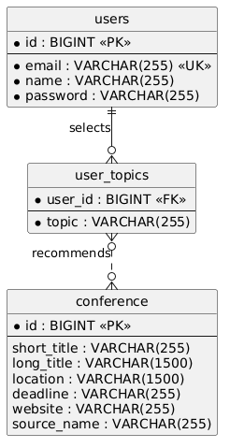

5.4.2 Data Dictionary
Table users
Column | Type | Constraint | Description
id | BIGINT | Primary key, auto-generated | Identifier of the user
email | VARCHAR(255) | Not null, unique | E-mail address used to log in
name | VARCHAR(255) | Not null | Display name
password | VARCHAR(255) | Not null | BCrypt hash of the password
Table 5.1: The users table
Table user_topics
Column | Type | Constraint | Description
user_id | BIGINT | Foreign key to users.id | The user who selected the topic
topic | VARCHAR(255) | Not null | Name of the selected topic, for example Artificial Intelligence (AI)
Table 5.2: The user_topics table
Table conference
Column | Type | Constraint | Description
id | BIGINT | Primary key, auto-generated | Identifier of the conference
short_title | VARCHAR(255) |  | Acronym or short name
long_title | VARCHAR(1500) |  | Full title
location | VARCHAR(1500) |  | Venue and city
deadline | VARCHAR(255) |  | Deadline or event date, kept as text
website | VARCHAR(255) |  | Official website; used to detect duplicates
source_name | VARCHAR(255) |  | Source that supplied the entry
topic | VARCHAR(255) |  | Name of the selected topic, for example Artificial Intelligence (AI)
Table 5.3: The conference table

5.4.3 Design Decisions
• Passwords as hashes: the password column stores only the BCrypt hash, which includes its own salt.
• Dates as text: the sources write dates in different forms (a date, a range of dates, or a phrase), so the deadline is kept as text and shown to the user as it was published.
• Website as the duplicate key: two entries that point to the same website are treated as the same conference, and the second one is not stored.
• Topics as text: a topic is stored as text in user_topics. This keeps the table simple, and the topic names are the same names that the user sees on the topic selection screen.
• Newest first: conferences are listed in descending order of their identifier, so recently imported conferences appear at the top.

5.5 UML Diagrams
The Unified Modeling Language (UML) is used to describe the system from different points of view. The following diagrams were drawn for SmartCfp.

5.5.1 Use Case Diagram
The use case diagram shows what the actors can do with the system. The user can sign up, log in, select interest topics, view recommended conferences, browse and search conferences, view the details of a conference, share a conference, open its official website, view saved conferences, view notifications and sign out. The administrator can import conferences; this use case includes scraping each of the three sources. The three external sources appear as secondary actors because they supply the data. Figure 5.2 shows the diagram.
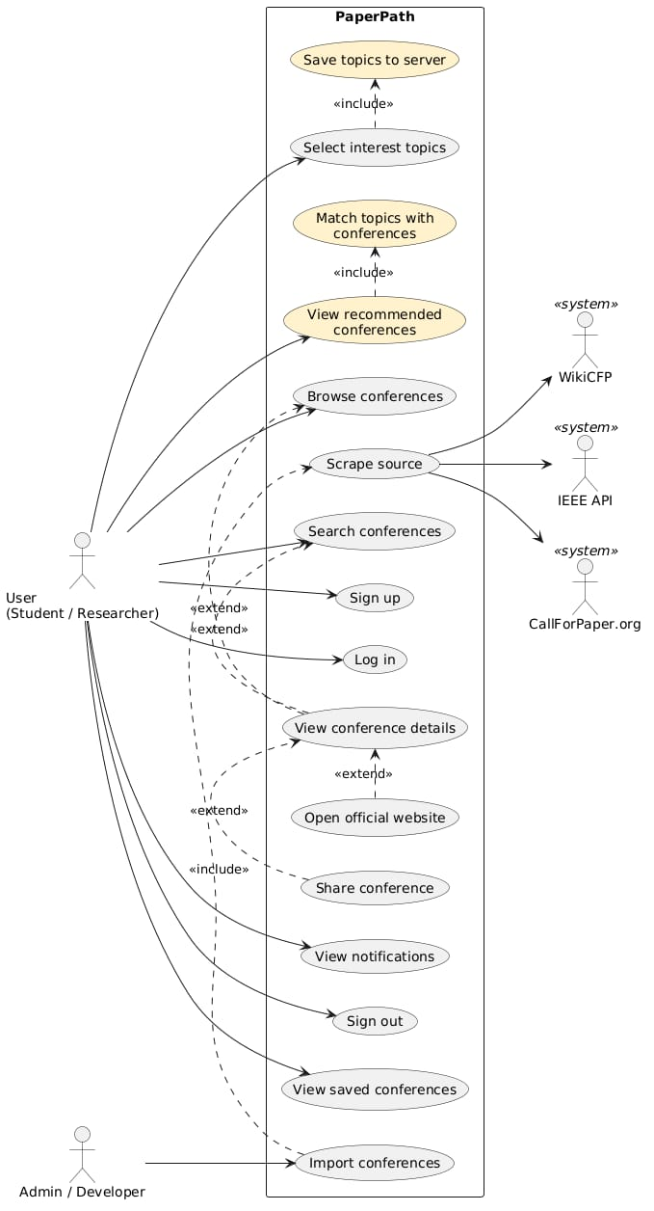
Tables 5.4 to 5.6 give a short specification of three important use cases.
Item | Description
Use case | Log in
Actor | User
Precondition | The user has an account
Main flow | 1. The user enters an e-mail address and a password. 2. The application checks that both are filled in. 3. The application sends them to the server. 4. The server finds the user and compares the password with the stored hash. 5. The server answers that the login succeeded. 6. The application opens the home screen.
Alternative flow | If the e-mail address is unknown or the password is wrong, the server answers with an error and the application shows a message.
Postcondition | The user is on the home screen
Table 5.4: Specification of the Log in use case
Item | Description
Use case | Select interest topics
Actor | User
Precondition | The user is logged in
Main flow | 1. The user opens the topic selection screen. 2. The user chooses one or more topics. 3. The user confirms. 4. The application sends the topics to the server. 5. The server stores them in user_topics. 6. The application opens the home screen.
Postcondition | The topics are stored and are used for recommendations
Table 5.5: Specification of the Select interest topics use case
Item | Description
Use case | Search conferences
Actor | User
Precondition | The user is on the search screen
Main flow | 1. The user types a keyword. 2. The application waits a short time (300 milliseconds) after the last key press. 3. The application sends the keyword to the server. 4. The server returns the conferences whose title, location or source contains the keyword. 5. The application shows the result list.
Alternative flow | If the keyword is empty, the server returns the full list. If an older response arrives after a newer request was sent, the application ignores it.
Postcondition | The list on the screen matches the last keyword typed
Table 5.6: Specification of the Search conferences use case

5.5.2 Class Diagram
The class diagram shows the main classes of the problem domain and how they are related. A User has a name, an e-mail address and a password, and can sign up, log in and select topics. A Topic has a name. A Conference has a short title, a long title, a location, a deadline and a website. A Source, which stands for WikiCFP, the IEEE listing service or CallForPaper.org, provides many conferences. Users and topics are linked in a many-to-many relationship, because a user can select many topics and a topic can be selected by many users. Topics are matched with conferences, and users can save conferences. Figure 5.3 shows the diagram.
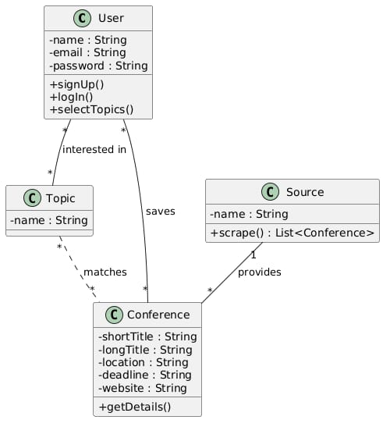
Inside the backend the classes are organized in layers. Controllers (for authentication, conferences and import) depend on services; services depend on repositories and on the source interface; repositories work with the entities User and Conference. The three source classes implement the source interface, which is an example of the Strategy design pattern: the import service does not need to know how each source reads its data.

5.5.3 Object Diagram
An object diagram shows a snapshot of the system at one moment. In the diagram of SmartCfp a sample user has two selected topics and the system holds several conferences; the recommendation service returns those conferences that match the user’s topics and leaves out those that do not. The diagram makes the class diagram concrete by showing real values in the attributes. Figure 5.4 shows the object diagram.
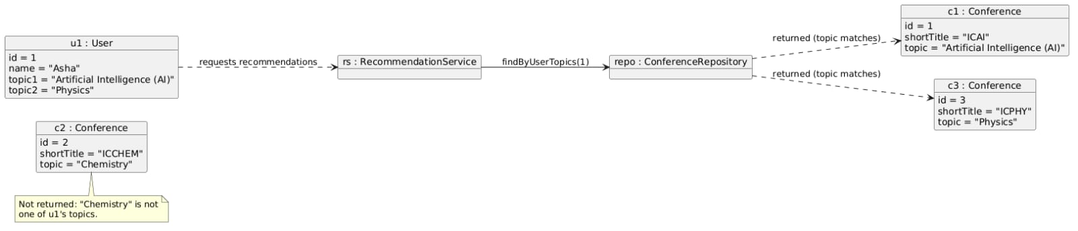

5.5.4 Sequence Diagram
The sequence diagram shows the order of messages between the user, the mobile application, the server and the database. It has two parts. In the first part the user selects topics, the application sends them to the server, and the server saves them in the database. In the second part the user opens the home screen, the application requests recommended conferences, the server reads the user’s topics from the database, finds the matching conferences and returns them, and the application displays them. Figure 5.5 shows the diagram.
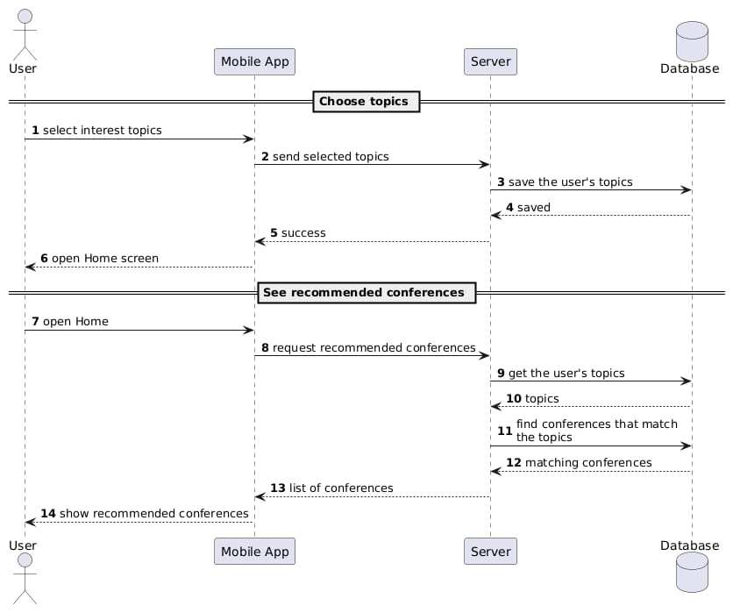

5.5.5 Activity Diagram
The activity diagram describes the flow of work with three swimlanes: the user, the application and the server. The user signs up or logs in, opens the topic selection screen and chooses topics. The application sends the topics to the server, and the server saves them. The application then asks for recommended conferences, the server finds the matches and returns them, and the application shows the list. The user can then browse, search and open details. Figure 5.6 shows the diagram.
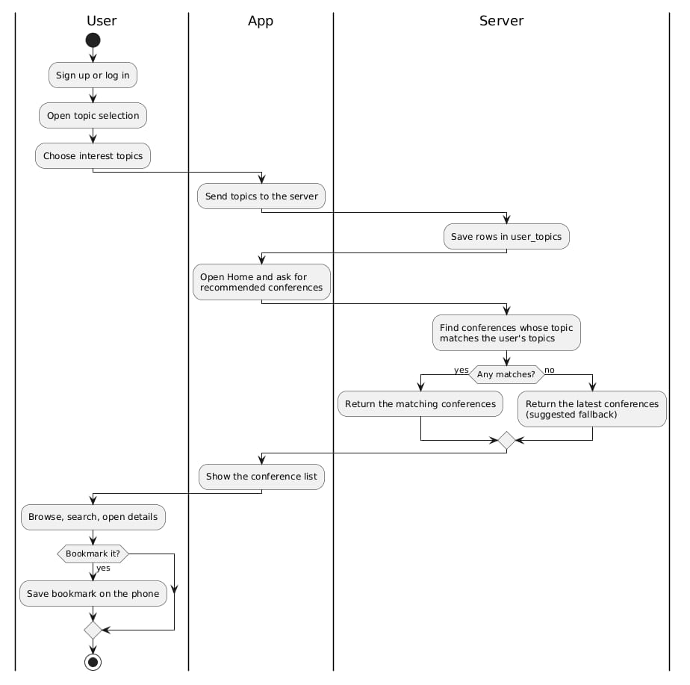

5.6 API Design
Table 5.7 lists the REST endpoints of the backend. All data is exchanged as JSON.
Method | Path | Purpose | Success response | Error response
POST | /api/auth/signup | Create a new account | 201 with a message | 400 when the details are invalid or the e-mail address is already registered
POST | /api/auth/login | Log in | 200 with a message | 401 when the e-mail address or the password is wrong
GET | /api/conferences | List all conferences, newest first | 200 with a list
GET | /api/conferences/search?keyword=text | Search conferences | 200 with a list
POST | /api/sources/import | Import conferences from all sources | 200 with a report of inserted and duplicate entries
[confirm path] | [confirm path] | Save the topics selected by a user | 200
[confirm path] | [confirm path] | Get recommended conferences for a user | 200 with a list
Table 5.7: REST endpoints (replace the two [confirm path] rows with the paths used in the final code)

5.7 Security Design
The security measures of the system are the following:
• Password hashing: passwords are hashed with BCrypt before they are stored, and the comparison at login uses the hash.
• Validation: the server checks that the name, the e-mail address and the password are present, that the e-mail address is not already registered and that the password has at least eight characters. The application performs similar checks before it sends a request, so that the user gets a quick message.
• Uniform error message: a failed login gives one message for both an unknown e-mail address and a wrong password, so that the message does not reveal which e-mail addresses are registered.
• Stateless API: the server does not keep a session for each client. Cross-site request forgery protection, which is meant for browser sessions, is switched off for this API.
• Access rules: the registration, login and listing paths are open; the other paths follow the default rule that requires authentication.
The limitations of this design, in particular the absence of a login token, are discussed in Chapter 9.

5.8 User Interface Design
The interface has the following screens: splash, sign in, sign up, topic selection, home (with a home tab and a saved tab), search, conference details, notifications, profile and settings. The design follows these principles:
• Familiar patterns: a bottom navigation bar, cards for conferences and tabs for sections, as in other Android applications.
• Few steps: a conference is reachable from the home screen in one tap, and a search needs only typing.
• Clear feedback: short messages tell the user when a field is missing, when a login fails or when something has been saved.
• Consistent appearance: the same colours, typefaces and card layout are used on all screens.
Screenshots of the screens are given in Chapter 8.

5.9 Summary
This chapter described the architecture, the database, the UML models, the API and the security and interface design of SmartCfp. The next chapter explains how this design was implemented.

Chapter 6: Implementation

6.1 Project Structure
The project consists of two separate programs kept in one repository: the backend (Spring Boot, Java 21, built with Maven) and the Android application (Java, built with Gradle).
The backend code is divided into packages with clear roles:
Package | Contents
config | Security configuration and the password encoder
controller | The classes that receive HTTP requests: authentication, conferences, import and the list of sources
model | The entities User and Conference
repository | The repository interfaces for users and conferences
service | The business logic: authentication, conference listing and search, and import
source | The source interface and the three readers (WikiCFP, IEEE, CallForPaper.org)
Table 6.1: Packages of the backend
The Android code contains one class for each screen (activity), the adapters for the lists, the model classes for the data, the Retrofit client and API interface, and a helper that keeps the saved conferences on the phone.

6.2 Backend Implementation

6.2.1 Entities
The Conference entity has the fields id, short title, long title, location, deadline, website and source name, and the User entity has id, name, e-mail address and password. The annotations on these classes tell Hibernate how to create the tables. The e-mail address column is marked as unique and not null, and the long title and location columns are allowed to hold up to 1,500 characters because conference titles and venues can be long. The selected topics of a user are held in the separate user_topics table.

6.2.2 Repositories
The repository interfaces extend the Spring Data JPA repository, so basic operations need no code. Three custom operations are important. The first returns all conferences in descending order of identifier. The second finds a conference by its website, and is used for duplicate detection. The third is a query that returns the conferences in which the keyword occurs in the title, the location or the source name, ignoring the case of the letters. For users, the repository can find a user by e-mail address and can tell whether an e-mail address already exists.

6.2.3 Source Readers
Every source implements one interface with two methods: one that returns the name of the source and one that returns the list of conferences that it found. The three implementations are:
• WikiCFP reader: downloads the listing page with Jsoup, goes through the rows of the event table and reads the short name, the full title, the dates and location and the deadline. It also takes the link of the event as the website.
• CallForPaper.org reader: works in the same way, but with the structure of its own pages.
• IEEE reader: sends a request to the JSON interface of the IEEE conference listing with RestClient, reads the events from the response and maps the title, the place, the dates and the address of each event to a Conference object.
If a page cannot be downloaded or the response cannot be read, the reader raises an exception. The import service catches it so that the other sources are not affected.

6.2.4 Import Service
The import service receives the list of all sources from Spring, because every class that implements the source interface is registered automatically. Its work can be described as follows:
for each source in sources:
try:
list = source.scrape()
for each conference in list:
if conference.website is empty: skip
else if repository.findByWebsite(conference.website) exists: duplicates++
else: repository.save(conference); inserted++
report[source] = SUCCESS
catch error:
log the error
report[source] = FAILED
return report with totals
The report that is returned to the caller states, for each source, whether it succeeded, and it gives the total number of new and duplicate conferences. The administrator can read it to see at once whether any source has stopped working.

6.2.5 Authentication
Sign up and login are implemented in the authentication service:
signup(name, email, password):
check that all three values are present
check that password has at least 8 characters
if a user with this email exists: reject
hash = BCrypt(password)
save user(name, email, hash)
return 'Account created successfully'
login(email, password):
user = find user by email
if no user, or BCrypt.matches(password, user.hash) is false: reject
return 'Login successful'
The controller turns a rejection into an HTTP error response (400 for sign up, 401 for login) with a short message, and a success into a normal response. The stored hash is never included in a response.

6.2.6 Conference Service
The conference service has two methods. The first returns all conferences, newest first. The second receives a keyword: if the keyword is empty or contains only spaces it returns the full list, and otherwise it trims the keyword and calls the search query of the repository. Keeping this logic in the service means that the controller stays thin.

6.2.7 Security Configuration
The security configuration defines the password encoder as a BCrypt encoder and sets the rules for the requests. The API is stateless, so no session is created, and the protection against cross-site request forgery, which is intended for browser sessions, is disabled. The registration, login and conference paths are open to everyone and any other path requires authentication.

6.2.8 Topics and Recommendations
When the user confirms the topics on the topic selection screen, the application sends them to the server, and the server stores one row in user_topics for each topic. To produce recommendations the server reads the topics of the user and compares them with the content of the conferences, such as the title, and it returns the conferences that match at least one topic:
recommend(userId):
topics = topics saved for userId
result = empty list
for each conference in all conferences:
if conference text matches any topic in topics: add to result
return result
Because the match is made on the text of the conference, no topic has to be assigned to a conference at import time. The quality of the recommendations depends on how well the topic names correspond to the words used in conference titles, which is discussed in Chapter 9.

6.3 Android Implementation

6.3.1 Network Layer
The Retrofit client is created once with the base address of the backend. During development this address is the one that the Android emulator uses to reach the computer on which it runs, on port 8080. The API interface declares one method for each endpoint: listing conferences, searching with a keyword, signing up and logging in, and the methods for saving topics and getting recommendations. Request classes hold the values sent for sign up and login, and a response class holds the message returned by the server. The Conference class has annotations that map the names of the server fields to the names used in the application, and its getter methods return a readable default text when a field is missing, so that a missing value does not break the screen.

6.3.2 Screens
- Splash screen: shows the name of the application for a short time and then opens the sign-in screen. A tap skips the wait.
- Sign-in screen: the “Welcome Back” screen asks for an e-mail address or username and a password. An eye icon shows or hides the password. The application checks that both fields are filled in before it calls the login method, and on success it opens the home screen. A Forgot Password link and a Sign Up link are also on the screen.
- Sign-up screen: the “Create Account” screen asks for a full name, an e-mail address, a password and a confirmation of the password. Before it calls the server, the application checks the name, the format of the e-mail address, the length of the password and that the two passwords match. A Continue with Google button and a Login link for existing users are also shown.
- Topic selection screen: “Select Research Tracks” shows research fields such as Artificial Intelligence, Computer Vision, Natural Language Processing and Machine Learning as selectable choices. The selected ones are highlighted. The button “Continue to Smart Feed” sends them to the server and opens the home screen.
- Home screen: has a search bar with a filter button and category chips such as All, Computer Science and AI & ML. Under “Latest Conferences” it shows the conferences loaded from the server as cards. Each card gives the title, dates, location, the submission deadline in red, the source name and a star for saving. A See All link opens the full list, and a bottom navigation bar with Home, Saved, Notifications and Profile leads to the other screens.
- Search screen: sends the keyword to the server and shows the matching conferences, with tabs to filter the list by status.
- Details screen: shows the title, dates, location, the website link and the source of one conference, followed by an About section and a Key Dates section. Icons at the top share the conference or star it, and a “Save for Later” button at the bottom saves it. The share icon opens the phone’s share sheet.
- Saved screen: lists the starred conferences, shows how many are saved and gives the line “Track your submission milestones”.
- Notifications screen: lists alerts such as “New conference matching your interests”, each with the name of the conference and the time it arrived.
- Profile and settings screens: show information about the account, give access to the topic selection and allow the user to sign out.

6.3.3 Saved Conferences
The identifiers of the saved conferences are kept in SharedPreferences by a small helper class with methods to test whether a conference is saved, to save it and to remove it. When the home screen is shown, it reads this set and marks the saved conferences, and the saved tab shows only those. Because the data stays on the phone, the saved list opens immediately and works without a network connection to the server, although the full details are loaded from the server.

6.3.4 Adapters
Each list has an adapter that creates the row views and fills them from a Conference object. A click listener passes the clicked conference to the screen, which opens the details screen and sends the conference to it. The adapters also show whether a conference is saved and react to a tap on the save icon.

6.3.5 Asynchronous Calls and Errors
Retrofit calls run in the background and return their result through a callback, so the screen stays responsive. Every callback handles three situations: a successful response, an error response from the server and a failure of the network. The user sees a short message in the last two cases instead of a frozen or empty screen.

6.4 Key Algorithms
Duplicate detection. The website is used as the identity of a conference. Before saving, the import service looks for a stored conference with the same website. The check is one indexed lookup in practice and prevents the same event from being listed twice when two sources announce it.
Debounced search. If the application sent a request after every key press, it would send many unnecessary requests while the user is still typing. The search screen therefore starts a timer of 300 milliseconds at each key press and cancels the previous timer. Only when the user pauses for that time is the request sent.
Ignoring outdated responses. Responses can arrive in a different order from the requests. The search screen gives each request a number and remembers the latest one; a response whose number is not the latest is ignored, so that an old result never replaces a newer one.

6.5 Problems Faced and Solutions
Problem | Solution
Each source uses a different structure | One reader class per source behind a common interface
Dates are written in different forms | The deadline is stored and shown as text
The same conference appears on several sources | Duplicate check on the website address
The emulator cannot reach the computer through the usual local address | The special address that the emulator provides for its host computer is used
Responses arrive in a different order from requests | A request number is kept and old responses are ignored
A source is temporarily unavailable | The import catches the error, reports that source as failed and continues with the others
A page layout may change | The reader of that source is isolated, so only it needs to be updated
Table 6.2: Problems and solutions

6.6 Summary
This chapter explained how the backend collects, stores and serves the data and how the Android application presents it. The next chapter describes how the system was tested.

Chapter 7: Testing

7.1 Objectives of Testing
Testing is carried out to confirm that each requirement of Chapter 3 is met, to find defects before users do, and to check that the parts of the system work together. The tests cover the backend logic, the API, the screens of the application and the security measures.

7.2 Test Strategy
Four levels of testing were planned:
1. Unit testing: single classes or methods are tested alone, for example the validation of a password or the mapping of the fields of a response.
2. Integration testing: the controller, the service, the repository and the database are tested together by calling the API with a tool such as a browser, a REST client or the application itself.
3. System testing: the complete system, with the database, the backend and the application on an emulator or a phone, is tested against the functional requirements.
4. Acceptance testing: a few users try the application and say whether it is understandable and useful.

7.3 Test Environment
Item | Detail
Backend | Spring Boot on Java 21, running on a development computer
Database | MySQL with the schema smartcfp
Client | Android emulator from Android Studio and, where available, a physical phone
Network | Local connection between the application and the backend; internet access for the import
Table 7.1: Test environment

7.4 Automated Tests
The project contains automated tests that run with the build tools. One example is a test that checks that the JSON fields sent by the server are converted correctly to the fields of the Conference class in the application. Automated tests are valuable because they can be repeated after every change and show at once if a change has broken something that worked before.

7.5 Functional Test Cases
Table 7.2 lists the test cases. The Result column is filled in with Pass or Fail, together with the date, when the test is executed.
ID | Feature | Action | Expected result | Result
TC-01 | Sign up | Enter a valid name, a new e-mail address and a password of eight or more characters | The account is created and the home screen opens
TC-02 | Sign up | Enter an e-mail address that is already registered | An error message is shown and no account is created
TC-03 | Sign up | Enter a password of fewer than eight characters | The application or the server rejects it with a message
TC-04 | Sign up | Enter two different passwords in the two password fields | The application shows that the passwords do not match
TC-05 | Log in | Enter a registered e-mail address and the correct password | The home screen opens
TC-06 | Log in | Enter a registered e-mail address and a wrong password | An error message is shown and the user stays on the sign-in screen
TC-07 | Log in | Leave a field empty | The application asks for the missing value
TC-08 | Browse | Open the home screen | The list of conferences is shown, newest first
TC-09 | Search | Type a word that appears in a title | Only the conferences that contain the word are listed
TC-10 | Search | Type a word that appears in no conference | An empty result is shown without an error
TC-11 | Search | Clear the search box | The full list is shown again
TC-12 | Details | Tap a conference card | The details screen shows the title, location, deadline, source and website
TC-13 | Website | Tap the website button on the details screen | The official website opens in the browser
TC-14 | Share | Tap the share button | The share sheet of the phone opens with the conference information
TC-15 | Saved conferences | Save a conference and open the saved tab | The conference appears in the saved list
TC-16 | Saved conferences | Remove a saved conference | It no longer appears in the saved list
TC-17 | Topics | Select topics and confirm | The topics are stored in user_topics for that user
TC-18 | Recommendations | Open the home screen after selecting a topic | The conferences that match the topic are shown
TC-19 | Import | Start an import with the backend running | A report with the inserted and duplicate numbers is returned
TC-20 | Import | Start the import a second time | The conferences already stored are counted as duplicates and not stored again
TC-21 | Import | Make one source unavailable and start an import | That source is reported as failed and the others are imported
TC-22 | Sign out | Sign out from the profile or settings screen | The sign-in screen opens
Table 7.2: Functional test cases

7.6 Security Tests
ID | Check | Expected result | Result
ST-01 | Read the password column of the users table in MySQL | Only BCrypt hashes are visible; no password is readable
ST-02 | Register two users with the same password | The two stored hashes are different, because each has its own salt
ST-03 | Inspect the response of the login and sign-up calls | The response contains a message and no password or hash
ST-04 | Log in with an unknown e-mail address and with a wrong password | The same kind of error message is returned in both cases
ST-05 | Call a protected path without logging in | The request is refused
Table 7.3: Security tests

7.7 Usability Testing
In usability testing, a small group of students is asked to use the application without instructions and to perform three tasks: create an account, find a conference with a given word in its title and open its website. The observations (time taken, mistakes and comments) should be recorded here. The questions asked afterwards are whether the screens were clear, whether the search was fast enough and whether the recommended list was useful.

7.8 Test Results
The results of the executed test cases are summarized in Table 7.4. The figures are filled in after the tests are run.
Category | Number of tests | Passed | Failed
Functional | 22
Security | 5
Total | 27
Table 7.4: Summary of the test results
Failed tests, if any, are listed with the correction that was made and the result of the repeated test.

7.9 Summary
The test plan covers every functional requirement and the main security measures. The next chapter presents the application as the user sees it.

Chapter 8: Results and User Interface

8.1 Introduction
This chapter presents SmartCfp as the user sees it and shows how the objectives of Chapter 1 were met. Each figure is a screenshot taken from the running application on an emulator or a phone.

8.2 Application Screens
Figure 8.1: Sign-in screen. The “Welcome Back” screen asks for an e-mail or username and a password, with an eye icon to show or hide the password. It also has a Login button, a Forgot Password link and a Sign Up link.
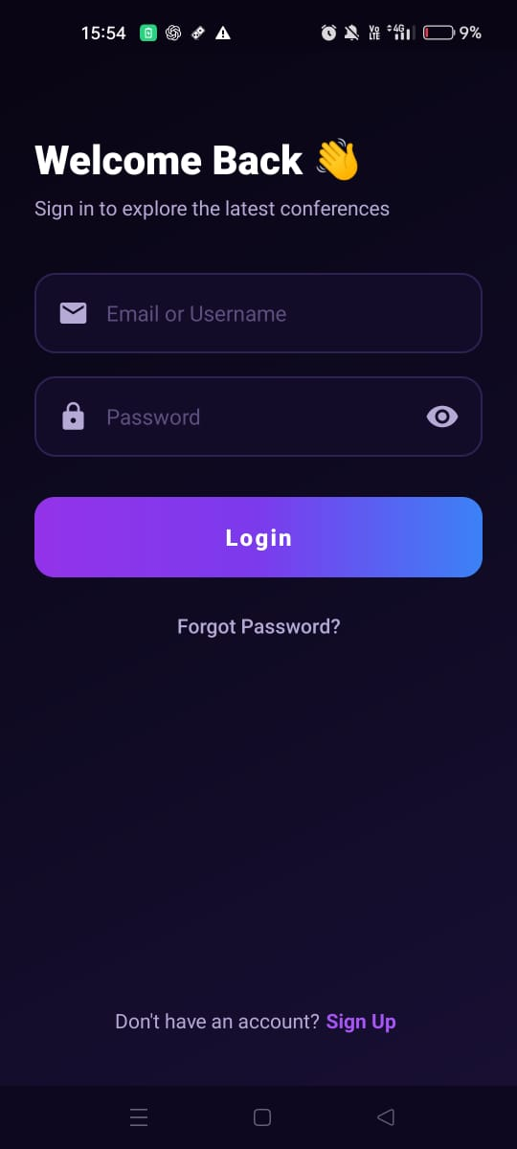
Figure 8.2: Sign-up screen. The “Create Account” screen asks for a full name, e-mail, password and confirm password. The user can register with the Sign Up button and there is a Login link for existing users.
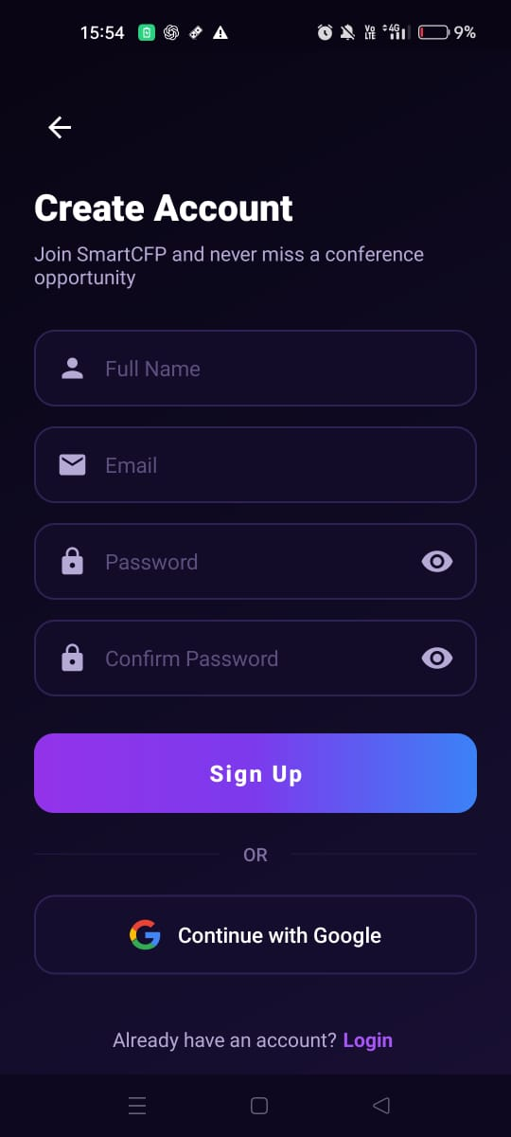
Figure 8.3: Topic selection screen. “Select Research Tracks” lets the user choose one or more research fields, such as AI, Computer Vision, NLP, Machine Learning and Cybersecurity. Selected topics are highlighted, and “Continue to Smart Feed” saves the choice.
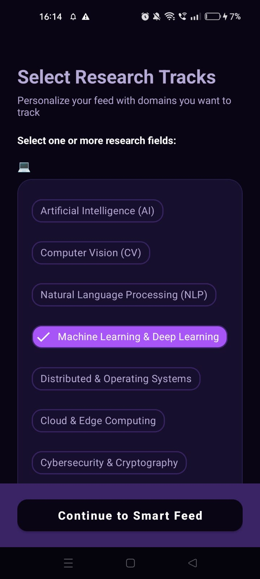
Figure 8.4: Home screen. The home screen has a search bar with a filter button and category chips (All, Computer Science, AI & ML and more). Below them, “Latest Conferences” shows cards with the title, dates, location, submission deadline in red, the source name and a star to save.
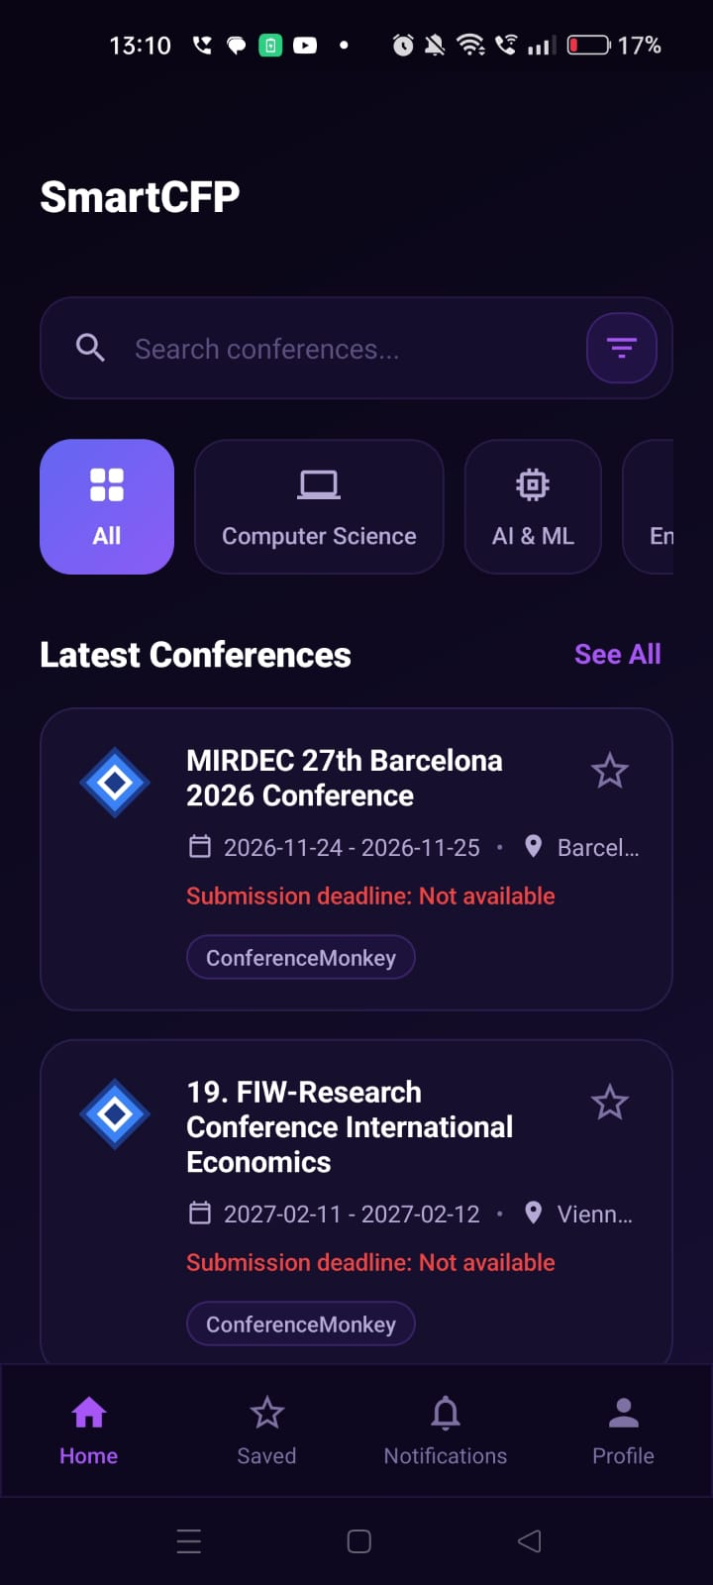
Figure 8.5: Home screen filtered by category. Selecting the AI & ML chip narrows the list to matching conferences. Saved conferences show a filled star.
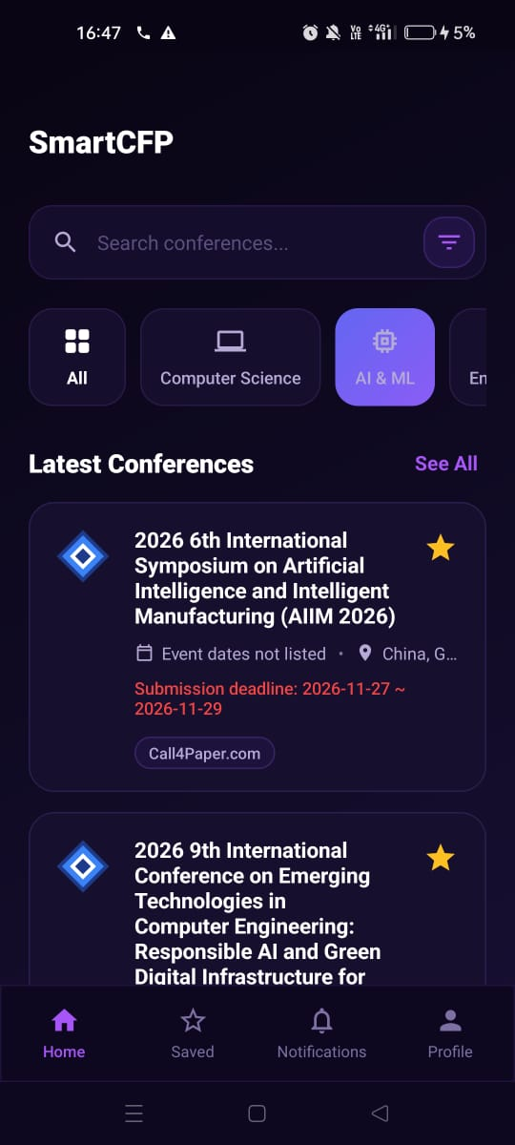
Figure 8.6: Home screen list. Scrolling shows more conference cards. Each one gives its dates, location and deadline, and the unsaved ones have an empty star.
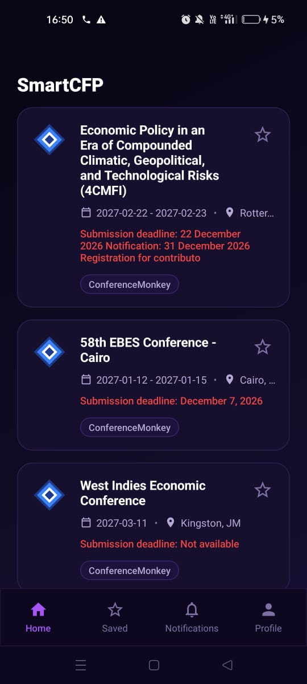

Figure 8.7: Conference details screen. This screen shows the title, dates, location, the official website link and the source name, with an About section below. Share and star icons are at the top, and a “Save for Later” button is at the bottom.
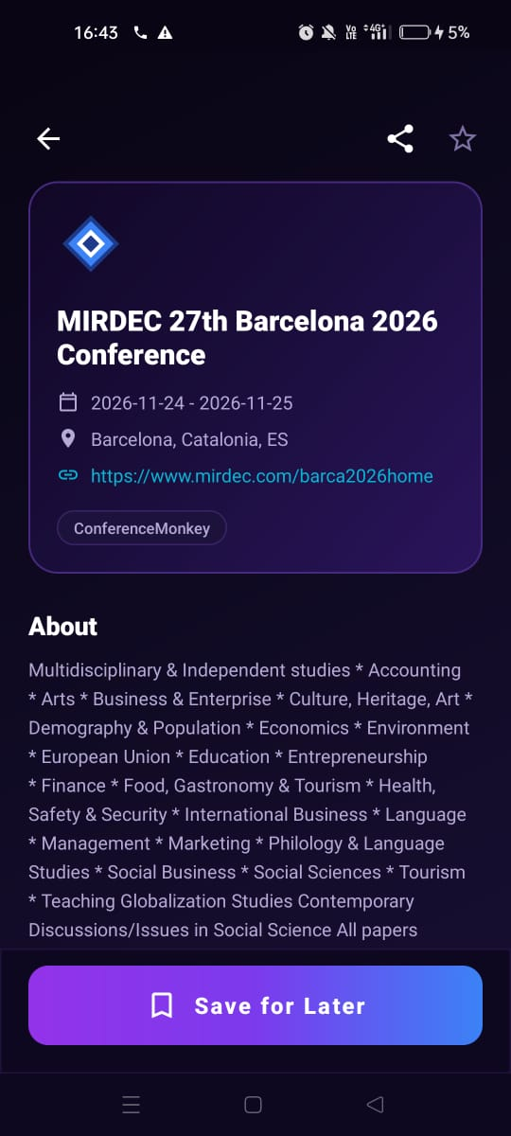
Figure 8.8: Details of a conference with missing information. When a source gives no dates or location, the screen shows “Event dates not listed” and “Not available”. This keeps the screen working with incomplete data.

Figure 8.9: Share screen. The share icon opens the phone’s share sheet, so the user can send the conference to WhatsApp, Instagram and other apps.
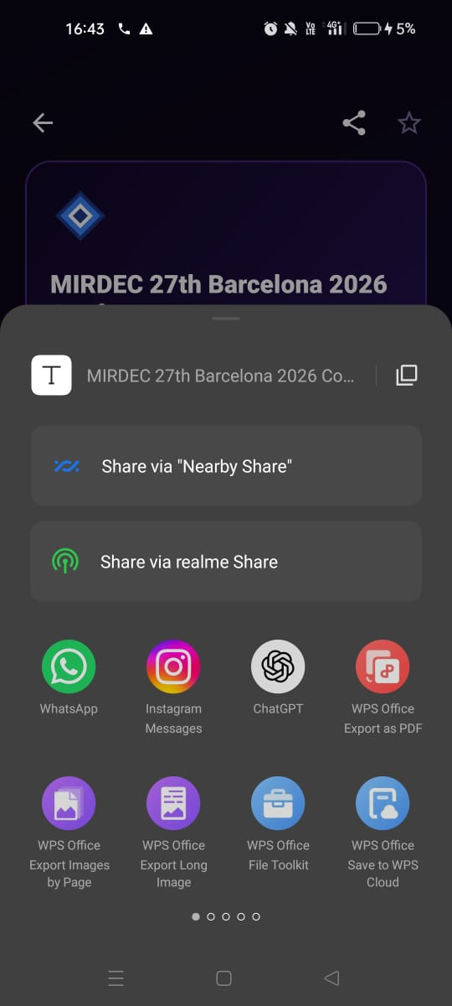
Figure 8.10: Saved conferences screen. It lists the conferences the user has starred, with a count (for example “3 saved conferences”) and the line “Track your submission milestones”.
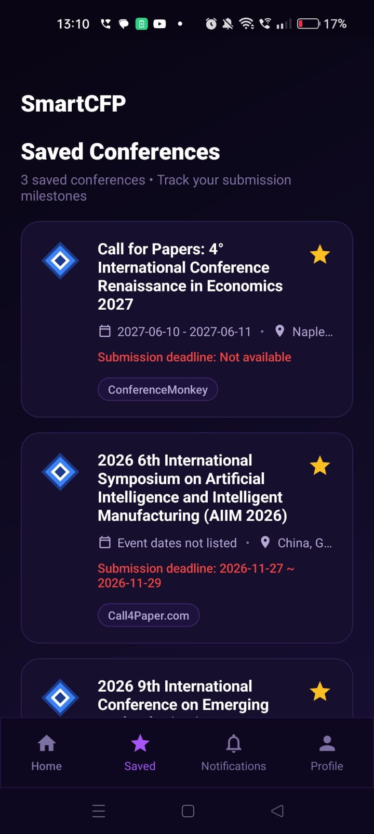
Figure 8.11: Notifications screen. It shows alerts such as “New conference matching your interests”, each with the conference name and how long ago it arrived.
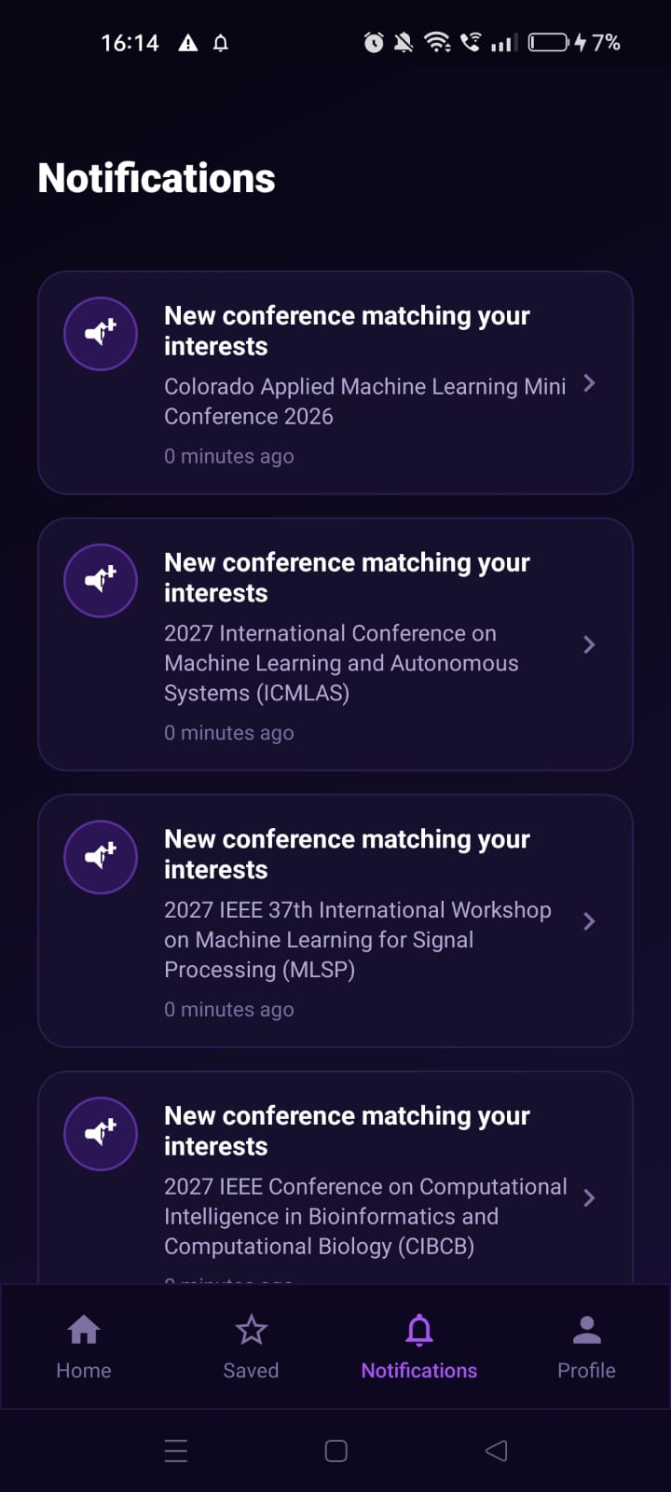

8.3 Backend and Database Results
The backend was run together with the MySQL database. After the import, the conference table holds the entries collected from the sources, each with a website address that is unique among the stored entries. The users table holds the registered users, and in it every password appears as a BCrypt hash that begins with a fixed prefix and cannot be read. The user_topics table holds one row for every topic that a user has selected. Figure 8.11 shows the tables of the schema as listed by the MySQL command-line client.
[Insert Figure 8.11: Tables of the smartcfp schema (crop the image so that it shows only the table names)]

8.4 Evaluation Against the Objectives
Objective | How it was met
1. Collect data from more than one source | Three readers collect data from WikiCFP, the IEEE listing service and CallForPaper.org (Section 6.2.3)
2. Avoid duplicates | The import service skips a conference whose website is already stored (Section 6.4)
3. Secure registration and login | Passwords are hashed with BCrypt and the server validates the input (Sections 5.7 and 6.2.5)
4. Browse, search and view details | The home, search and details screens (Sections 6.3.2 and 8.2)
5. Open website and share | Buttons on the details screen (Section 8.2)
6. Saved list | A saved tab, with the identifiers kept on the phone (Section 6.3.3)
7. Topics and recommendations | Topics are stored in user_topics and matched with the conferences (Section 6.2.8)
8. Layered, extensible design | Layers and a common source interface (Chapter 5)
Table 8.1: Objectives and how they were met

8.5 Summary
The screens and the stored data show that the main objectives of the project were reached. The remaining shortcomings are discussed in the next chapter.

Chapter 9: Limitations and Future Scope

9.1 Limitations
SmartCfp is a working system, but it has limitations that should be stated clearly:
• Dependence on page structure: the HTML readers depend on the layout of the source pages. If a page changes, its reader must be updated.
• Manual import: conferences are collected when the administrator starts the import. There is no scheduled refresh, so the data can become outdated.
• No login token: the server answers a successful login with a message only. It does not issue a token, so later requests cannot be tied to a logged-in user, and the access rules for protected paths such as the import path need a proper administrator mechanism.
• Dates as text: because the deadline is stored as text, the application cannot sort by deadline, filter by a date range or count the days that are left.
• Simple recommendations: matching topics with the text of conferences is a keyword method. It can miss a relevant conference that uses different words, and it can include one that only mentions a word in passing. There is no ranking of the matches.
• Saved conferences stay on the phone: the saved list is kept locally, so it is not shared between devices and is not linked to the user account on the server.
• No automatic alerts: the application does not yet send notifications before a deadline.
• Unencrypted connection in development: the application reaches the backend over plain HTTP during development. A public deployment needs HTTPS.
• Complete list download: the application loads the whole list of conferences, which will become slow when the database grows large.
• Android only: there is no iOS or web client.

9.2 Future Scope
The following improvements would make SmartCfp more useful:
1. Deadline reminders: store deadlines as real dates and send push notifications a few days before a deadline for the conferences that the user has saved.
2. Scheduled import: run the import automatically, for example once a day, and mark conferences whose deadline has passed.
3. Token-based authentication: issue a signed token (for example a JSON Web Token) at login, and add roles so that only an administrator can start an import.
4. Better recommendations: assign topics to conferences, or use text similarity measures, and rank the results by how well they match.
5. Saved conferences on the server: store the saved list per user so that it is available on every device.
6. More sources and filters: add other listing services and publishers, and let the user filter by location, deadline range and source.
7. Paging and caching: load the list in pages and keep a local copy so that the application also works offline.
8. Calendar integration: add a conference or its deadline to the calendar of the phone.
9. Deployment: host the backend and the database on a server with HTTPS, and publish the application.
10. Other platforms: build a web client and an iOS client on the same API.

Chapter 10: Conclusion
SmartCfp was developed to solve a practical problem: calls for papers are announced on many websites in many formats, and a researcher who wants to find a suitable conference has to search them one by one. The project delivers a backend that collects conference information from three sources, converts it to one structure, removes duplicates and stores it in a MySQL database, and an Android application that lets users register, log in, browse, search, view details, share, save conferences, select topics of interest and see recommendations.
The design follows good software engineering practice. The system is divided into layers, the sources are hidden behind a common interface, the passwords are stored as BCrypt hashes and the client and the server communicate through a small REST API. The UML models in Chapter 5 document the system from several points of view, and the test plan in Chapter 7 links every requirement to a test.
The project also gave the team practical experience of the subjects of the course: object-oriented design in Java, relational database design, communication between a client and a server over HTTP, and the software engineering process from requirements to testing. The limitations listed in Chapter 9, in particular the missing login token, the manual import and the simple recommendation method, point to clear directions for further work. With these improvements, SmartCfp can grow from a student project into a dependable tool that helps researchers find the right conference before the deadline.

References
1. Fielding, R. T. (2000). Architectural Styles and the Design of Network-based Software Architectures. Doctoral dissertation, University of California, Irvine.
2. Provos, N., & Mazières, D. (1999). A Future-Adaptable Password Scheme. Proceedings of the USENIX Annual Technical Conference.
3. Booch, G., Rumbaugh, J., & Jacobson, I. (2005). The Unified Modeling Language User Guide (2nd ed.). Addison-Wesley.
4. Sommerville, I. (2015). Software Engineering (10th ed.). Pearson.
5. Elmasri, R., & Navathe, S. B. (2016). Fundamentals of Database Systems (7th ed.). Pearson.
6. Gamma, E., Helm, R., Johnson, R., & Vlissides, J. (1994). Design Patterns: Elements of Reusable Object-Oriented Software. Addison-Wesley.
7. Spring Boot Reference Documentation. https://docs.spring.io/spring-boot/
8. Android Developers Documentation. https://developer.android.com/
9. Retrofit documentation. https://square.github.io/retrofit/
10. Jsoup documentation. https://jsoup.org/
11. MySQL Reference Manual. https://dev.mysql.com/doc/
12. OWASP Password Storage Cheat Sheet. https://cheatsheetseries.owasp.org/cheatsheets/Password_Storage_Cheat_Sheet.html
13. WikiCFP, a calendar of academic conferences and calls for papers. http://www.wikicfp.com/
14. IEEE conference listings, ieee.org, and CallForPaper.org (data sources used by the project).

Appendix A: API Reference
POST /api/auth/signup
Request body:
{
"name": "Asha",
"email": "asha@example.com",
"password": "a-long-password"
}
Response (201): a JSON object with a message, for example Account created successfully. Response (400): a message that states why the request was rejected.
POST /api/auth/login
Request body:
{
"email": "asha@example.com",
"password": "a-long-password"
}
Response (200): a JSON object with the message Login successful. Response (401): a message that the login failed.
GET /api/conferences
Returns a list of conferences, newest first. One element of the list looks like this:
{
"id": 1,
"shortTitle": "ICAI",
"longTitle": "International Conference on AI",
"location": "Vancouver, Canada",
"deadline": "2027-01-10",
"website": "https://example.org/icai",
"sourceName": "WikiCFP"
}
GET /api/conferences/search?keyword=text
Returns the conferences in which the keyword occurs in the title, the location or the source, in the same format as above. An empty keyword returns the full list.
POST /api/sources/import
Starts the import from all sources and returns a report with the status of each source and the totals of inserted and duplicate conferences.

Appendix B: Database Schema
The tables are created automatically by Hibernate. The following statements show the equivalent definition for reference.
CREATE TABLE users (
id BIGINT AUTO_INCREMENT PRIMARY KEY,
email VARCHAR(255) NOT NULL UNIQUE,
name VARCHAR(255) NOT NULL,
password VARCHAR(255) NOT NULL
);
CREATE TABLE user_topics (
user_id BIGINT NOT NULL,
topic VARCHAR(255) NOT NULL,
FOREIGN KEY (user_id) REFERENCES users(id)
);
CREATE TABLE conference (
id BIGINT AUTO_INCREMENT PRIMARY KEY,
short_title VARCHAR(255),
long_title VARCHAR(1500),
location VARCHAR(1500),
deadline VARCHAR(255),
website VARCHAR(255),
source_name VARCHAR(255)
);

Appendix C: Setup and Running Instructions
Prerequisites: Java 21, Maven, MySQL, Android Studio and Git.
1. Clone the repository with Git.
2. Start MySQL and create the schema: CREATE DATABASE smartcfp;
3. In the configuration file of the backend, set the database address, the user name and the password. Keep the real password out of the repository, for example by reading it from an environment variable.
4. Start the backend from the Backend folder with Maven (spring-boot:run). It listens on port 8080 and creates the tables on the first start.
5. Import the conferences by sending a POST request to /api/sources/import. The path must be allowed by the security configuration for the request to be accepted.
6. Open the Android project in Android Studio. Check that the base address in the Retrofit client points to the backend: for the emulator this is the special address of the host computer on port 8080; for a physical phone it is the local network address of the computer.
7. Run the application on an emulator or a phone. Sign up, select topics and browse the conferences.

