NLP-Augmented Aggregate Prediction of Municipal Service Delays and Repeat Requests: Evidence from NYC 311
Taher Panbiharwala¹, Sanidhya Bhandari¹, *, Chinmoy Deb¹
¹ School of Computer Science and Engineering (SCOPE), Vellore Institute of Technology, Vellore, Tamil Nadu 632014, India
* Corresponding author: Sanidhya Bhandari, sanidhya.bhandari2023@vitstudent.ac.in

Abstract
A municipal 311 record shows what was reported and when an agency closed the request, but closure does not necessarily mean that the resident was satisfied or that the underlying condition ended. This paper tests whether sentiment, topic, grievance-aspect, and survey features improve one-month-ahead prediction of resolution delay and repeat requests. We combine 4,204,783 NYC 311 service requests with 406,581 Resolution Satisfaction Survey responses at a privacy-safe service-borough-year-month grain. Topic models are fitted on training-period text only, all operational features are lagged by one month, and duplicate agency boilerplate is kept within one ABSA split. On 994 held-out 2024 cells, the validation-selected Ridge delay model changed R² from 0.5840 to 0.5743 (Delta R² = -0.0096); its p-value of 0.00782 comes from a paired test of absolute cell errors, not from a direct test of R². The best augmented delay model did not exceed the best structured delay model (difference -0.0252); for repeat rate, the corresponding best-model difference was +0.0017. Five-seed and 2,000-resample checks quantify uncertainty, and held-out Precision@k evaluates the dashboard queue. The results support aggregate monitoring, but agency-authored text, one-city coverage, and address-based repeat proxies limit generalisation.
Keywords: municipal services; citizen satisfaction; sentiment analysis; aspect-based sentiment analysis; transformer NLP; NYC 311

1. Introduction
Cities use 311 systems to collect requests about services such as sanitation, housing, noise, parking, and infrastructure. These records are useful because they include time, location, service type, and closure information. Still, a ticket marked closed is an administrative outcome; it is not proof that the resident felt the issue was resolved. Earlier studies also show that 311 activity is influenced by neighbourhood conditions, reporting behaviour, and the visibility of particular services [1-4].
Text features can add context that is missing from counts and timestamps. VADER gives a simple and transparent sentiment baseline [5]. Transformer models are more flexible with context, while LDA and BERTopic help group recurring themes [6-8]. ABSA is useful for municipal feedback because dissatisfaction can concern response time, issue correction, communication, or work quality rather than one general sentiment label. At the same time, public-sector text is different from product reviews, and a model trained in another domain may not transfer well [9-12].
The main question in this work is practical: after accounting for service, borough, season, and request volume, do language and satisfaction signals improve prediction of municipal outcomes? Civic NLP papers often stop at sentiment or topic description, while operational 311 models often use structured variables alone. Few studies put both types of evidence into the same model and then test it on a later time period. There is also an important privacy boundary here. The public RSAT data do not provide unrestricted citizen comments, so this paper uses survey satisfaction and standardised dissatisfaction reasons as aggregate evidence. The text features come from official 311 resolution descriptions.
We therefore test whether adding these features improves out-of-time prediction of mean resolution delay and 14-day repeat-request rate. The results are predictive associations, not evidence of a causal effect.
The study makes four practical contributions:

A privacy-safe multi-source integration design that joins NYC 311 operations and RSAT survey evidence at service-borough-year-month grain without claiming a request-level match.

A reproducible NLP pipeline that compares lexicon sentiment, topic discovery, supervised ABSA, and Transformer adaptation under chronological evaluation.

A service-controlled, one-month-ahead comparison that reports algorithm-specific gains, the strongest structured benchmark, paired absolute-error tests, and bootstrap uncertainty.

An operational dashboard that exposes priority cells, historical trends, and model evidence for municipal and resident-facing use.
The remainder of this paper is organised as follows. Section 2 reviews related work. Section 3 describes the data, formulation, NLP pipeline, outcomes, experimental design, and reproducibility controls. Section 4 reports descriptive, NLP, predictive, robustness, and explainability results. Section 5 discusses interpretation, practical implications, and limitations. Section 6 concludes.

2. Literature Review

2.1 Sentiment analysis and Transformer models
Lexicon methods are still useful when labelled examples are limited. They are quick to run, easy to inspect, and provide a baseline that other models should beat. VADER was designed for short, informal text and uses lexical, grammatical, and punctuation cues [5]. Its limitation in this project is vocabulary: a formal closure description may contain words that look positive or negative without expressing a resident's actual experience. This is part of the wider trade-off between simple, transparent methods and domain adaptation [13, 14].
Transformer pretraining made it possible to use context more effectively in text classification. BERT introduced bidirectional representations that can be fine-tuned for a specific task [6]. However, a larger model does not remove problems caused by noisy labels, boilerplate, local abbreviations, or implicit dissatisfaction. We use VADER as a transparent baseline and DistilBERT as a compact adapted model, while keeping the evaluation design more important than the model name.

2.2 ABSA and topic discovery in public-sector text
ABSA links a text span or record to an aspect and its associated sentiment or grievance category. Recent surveys show a move from hand-built rules toward unified and generative models, but they also identify recurring problems: implicit aspects, domain shift, imbalanced classes, and limited annotated data [9-12]. These issues are especially relevant to public services because a record may describe the original event, the response process, or a communication failure.
Topic models give a second view of the same text. LDA represents each document as a mixture of topics and is still useful when interpretability matters [7]. BERTopic uses sentence embeddings, clustering, and class-based TF-IDF to find groups of semantically related documents [8]. Civic studies have used these tools for government inquiries, environmental complaints, emergency management, and policing, but many of them remain descriptive [15-19]. In this project, the topic proportions and topic entropy are turned into cell-level features and tested for their value in outcome prediction.

2.3 311 data, reporting bias, and service outcomes
Earlier 311 research shows that service-request categories contain information about urban location and neighbourhood conditions [1]. Other studies have used 311 as a social-sensing source for distress and public-health risk [2]. Work on reporting bias is important because a low complaint count does not always mean that a community has fewer problems [3, 4]. Resolution-time prediction has also been studied in helpdesk data, where ensemble models can perform well, although a corporate ticket is not the same as a municipal request [20].
Taken together, these studies leave a useful gap. Structured 311 models often do not include language or satisfaction signals, while civic NLP studies often stop after describing sentiment or topics. This project compares both feature sets on the same service-borough-month cells, keeps a later period untouched for testing, and reports uncertainty instead of presenting only the best score.

2.4 Research gap
The project focuses on four gaps: limited testing of civic language against operational outcomes; the separation between ABSA and municipal prediction; weak integration of service, place, and time; and unclear privacy and domain-transfer boundaries. Table 1 summarises how the present study differs from representative earlier work. The aim is not to claim that NLP solves municipal management. It is to test, under a controlled design, whether citizen-experience proxies add predictive information.
Table 1. Representative related work and the gap addressed by this study.
Study / stream | Approach | Setting | Limitation addressed here
Wang et al. [1] | Structured 311 signatures | NYC 311 / urban location | No text or satisfaction outcome
Kontokosta and Hong [3] | Reporting-bias analysis | Kansas City 311 | Does not test language augmentation
Tang et al. [15] | BERTopic civic inquiries | Chinese government platform | Descriptive; no operational target
Tai et al. [20] | ML resolution-time prediction | Corporate helpdesk | Not municipal and no citizen signal
This study | NLP-augmented outcome models | NYC 311 + RSAT | Privacy-safe aggregate, time-held-out comparison

3. Methodology

3.1 Problem formulation
The unit of analysis is a cell c = (s, b, y, m), where s denotes the service category, b the borough, y the year, and m the month. Each cell contains operational variables x_{c}, language features z_{c}, and the outcome vector y_{c}. The two primary outcomes are mean resolution delay d_{c} in hours and the 14-day repeat-request rate r_{c}.
y_{c} = f₀(x_{c}) + ε_{c} (1)
y_{c} = f₁(x_{c}, z_{c}) + ε_{c} (2)
The baseline model f₀ uses service identity, borough, request volume, and month-related variables. The augmented model f₁ adds VADER, topic, ABSA, and satisfaction features. We measure the change in held-out R² as Delta R² = R²_augmented - R²_baseline. A positive value means that the augmented model predicted the test cells better; it does not show that the added features caused the outcome.

3.2 Data and materials
The first source is the NYC 311 Service Requests dataset (Socrata identifier erm2-nwe9). The case-normalised, paged extract contains 4,204,783 valid closed requests from January 2023 through December 2024 for the twenty selected service categories and five mapped boroughs. Every calendar month is present. Relevant fields include complaint type, borough, created and closed timestamps, location fields used for repeat detection, and resolution_description text. The second source is the NYC 311 Resolution Satisfaction Survey (RSAT; Socrata identifier 5ijn-vbdv). After study-period, borough, and Likert-value checks, 406,581 survey responses remained in the analytic sample.
The portal headline count for RSAT is larger because it includes records outside the study window and rows that fail validation. The final count is therefore an audited analytic sample. During the schema check, we also found that the public RSAT data do not contain unrestricted citizen comments. The open-text field is not treated as citizen prose. RSAT contributes overall satisfaction and standardised dissatisfaction reasons, while the language features are extracted from official 311 resolution descriptions. This distinction matters when interpreting ABSA performance.
Both sources are public administrative or survey data. The integrated file contains no direct personal identifiers and the modelling is carried out at the aggregate cell level. We do not make individual predictions and do not claim a one-to-one survey-to-ticket match. Since the data are public and de-identified, the project did not involve new human intervention; a formal submission should still follow the university's ethics and data-governance requirements.
At the cell level, 2,100 operational outcome cells were available, 2,054 matched an RSAT cell, and 2,006 met the minimum operational request threshold before temporal exclusions. VADER has a different count (1,747) because its benchmark requires at least ten RSAT responses in addition to a matched VADER cell. The one-month lag then requires a consecutive service-borough month pair, leaving 1,885 modelled cells. These filters explain the cell counts rather than representing contradictory datasets.
The primary operational analysis is a one-month-ahead aggregate forecast. Language, survey, volume, service, borough, and seasonal features observed in month t predict delay and repeat outcomes for the same service and borough in month t+1. The original same-month model is retained only as a secondary monitoring analysis and is not presented as a pre-closure ticket forecast.
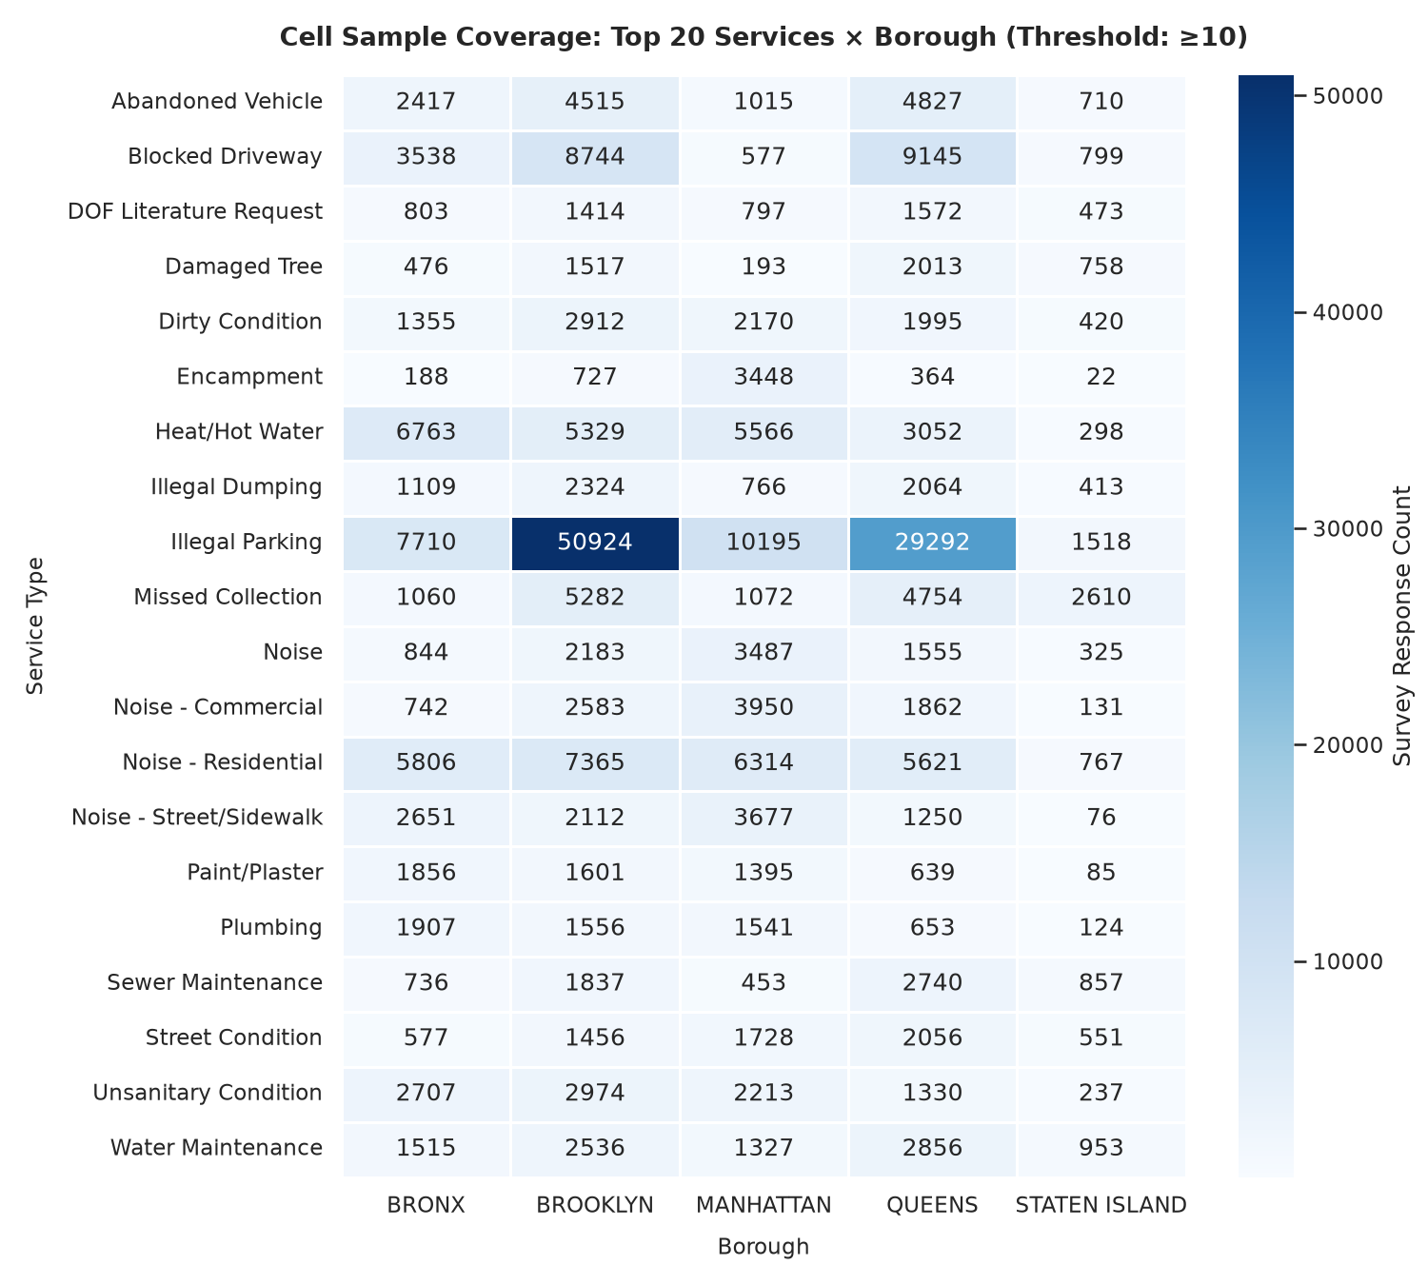
Figure 1. Coverage of the integrated service-borough-month cells used to combine operational and survey-derived features.

3.3 Text preprocessing and NLP feature extraction
Missing resolution descriptions were normalised before applying the common text-processing steps. VADER produced compound scores and positive, neutral, and negative rates for each record. We then aggregated the scores to the cell level using means, standard deviations, and polarity proportions. VADER was compared with RSAT satisfaction polarity on 1,747 matched cells, but it was used only as a baseline and not as a source of training labels.
For topic discovery, Gensim LDA was fitted with 10 topics and evaluated with C_{v} coherence. BERTopic used all-MiniLM-L6-v2 embeddings, density-based clustering, and class-based TF-IDF, producing 14 non-outlier clusters. Both models were fitted only on 2023-01 through 2023-07; later texts were transformed without refitting. LDA and BERTopic assignments, topic entropy, and outlier rates were aggregated to analysis cells.
Each supervised ABSA example begins as one RSAT row: the agency-authored resolution_description and standardised dissatisfaction_reason are fields in that same survey record. The eight raw reasons are mapped to six classes: Information Intake, Issue Correction, Other, Response Time, Status Updates, and Work Quality. This pairing does not use or claim a direct join to the separate 311 request dataset. The source has 250,703 labelled rows but only 593 normalised descriptions. Each text group is assigned to its first observed year, only labels observed in that first year are retained, and one example per text-label pair remains. This yields 1,647 examples with zero text overlap across the 2023 train, 2024 validation, and 2025 test splits. The trained TF-IDF model is then applied to 311 resolution descriptions to create cell-level aspect rates.
DistilBERT (distilbert-base-uncased) was fine-tuned locally with AdamW, learning rate 2.0e-05, batch size 16, maximum length 64, and 4 epochs. Rule, TF-IDF, and DistilBERT are evaluated on the same 173-example duplicate-controlled test split. Because citizen comments are privacy-suppressed, this remains a domain-transfer experiment rather than a human-annotated evaluation of citizen prose.
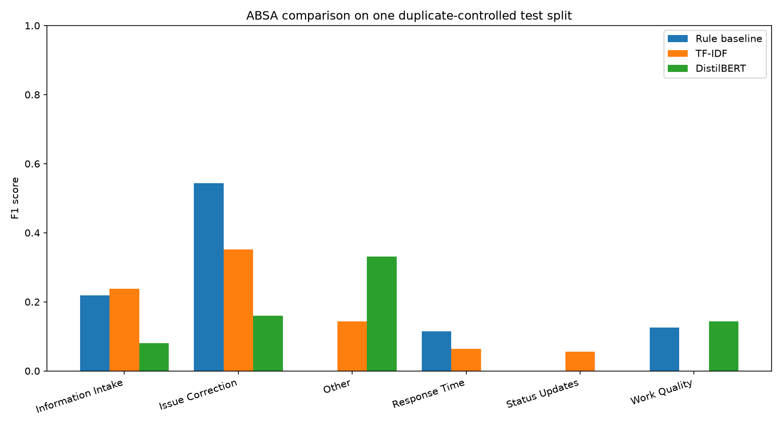
Figure 2. Per-aspect F1 comparison for rule, TF-IDF, and DistilBERT grievance classifiers on the same duplicate-controlled 2025 test split.
For operational feature generation, the TF-IDF classifier is fitted on the duplicate-controlled 2023 RSAT training portion before application to 311 narratives. VADER is a fixed lexicon method. LDA and BERTopic are fitted only on training-period 311 text and then frozen for later-month transformation.

3.4 Operational outcomes
Resolution delay was calculated from valid created and closed timestamps. The raw values have a long right tail, so the primary modelling outcome was winsorised at the 99th percentile, or 2044.34 hours. We report the raw median together with the winsorised mean so that the typical case and the overall operational scale are both visible.
Repeat requests were identified from consecutive records matching borough, complaint type, and cleaned incident address. Including borough prevents identical street strings in different boroughs from being linked. Blank or UNKNOWN addresses cannot create a repeat, but they remain in the denominator. The preceding request had to occur more than 0 and no more than the selected 7-, 14-, or 30-day window. These are operational recurrence indicators, not proof that the same resident or underlying incident returned. Sensitivity checks report Heat/Hot Water, a broader housing-service proxy, and high-volume borough-address groups; the public extract has no authoritative building-type field.
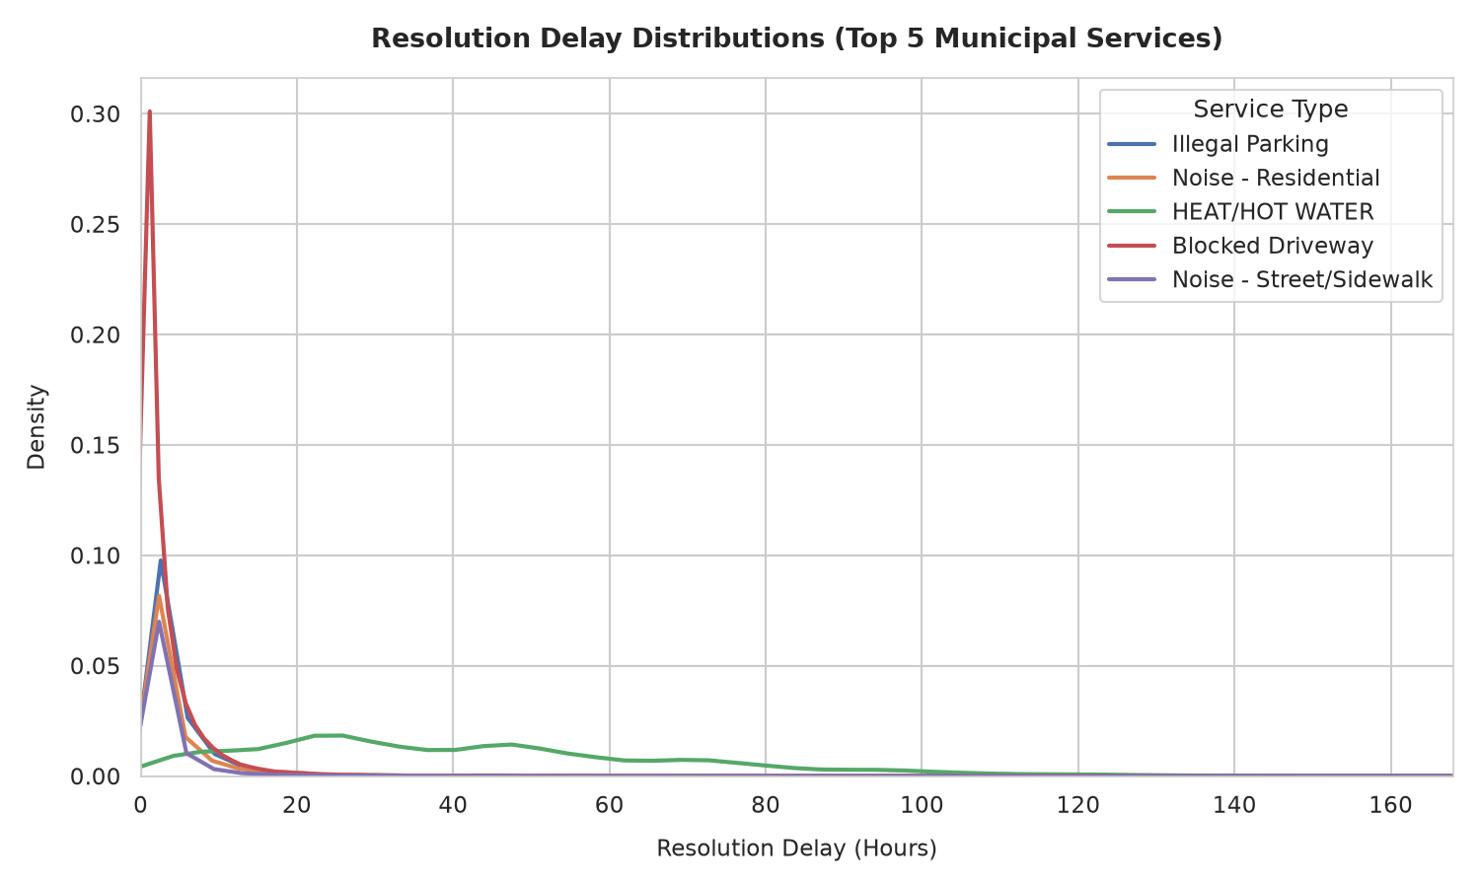
Figure 3. Resolution-delay distribution for the selected municipal services; the long right tail motivates winsorisation before prediction.

3.5 Experimental design and statistical analysis
After feature integration and one-month alignment, the primary modelling file contained 1,885 cells. The split used 578 training cells predicting February-August 2023, 313 validation cells predicting September-December 2023, and 994 untouched cells predicting January-December 2024. The 2025 split used for ABSA is a separate text-classification experiment.
Ridge regression, Random Forest, and LightGBM were compared. Model choice used validation performance before the untouched horizon was evaluated. We report R², mean absolute error, and root mean squared error. The reported p-value is from a two-sided paired t-test on per-cell absolute errors for baseline and augmented predictions. It is not a direct significance test of the R² difference. Cells share service and borough structure, so this test is supporting evidence rather than request-level inference.
The same LightGBM recipe is used in the primary and robustness analyses: 100 trees, maximum depth six, learning rate 0.05, row subsampling 0.85, feature subsampling 0.90, and matched random seeds. Five seeds are evaluated after fitting on train plus validation cells. Two thousand bootstrap replicates resample the held-out cells and evaluate the mean prediction across seeds. SHAP TreeExplainer is used for global model interpretation. The dashboard ranking is evaluated separately with Precision@k, lift over random, and NDCG@k.
Table 2. Chronological partitions used for the integrated operational modelling experiment.
Partition | Period | Cells | Purpose
Train | Targets Feb-Aug 2023 | 578 | Fit models
Validation | Targets Sep-Dec 2023 | 313 | Select algorithm/features
Out-of-time test | Targets Jan-Dec 2024 | 994 | Final held-out evaluation

3.6 Reproducibility and dashboard implementation
The project is implemented in Python with PyTorch, Hugging Face Transformers, LightGBM, scikit-learn, Gensim, BERTopic, NLTK VADER, Parquet, and Streamlit. The accompanying project archive contains configuration files, processed feature tables, metric JSON files, figures, model artifacts, and a 20-test pytest suite. The dashboard has two views: municipal staff can inspect priority cells, trends, borough comparisons, and model evidence; residents can see aggregate service indicators in plain language. Names, addresses, and raw personal ticket text are not shown. Raw data access is documented through the two NYC Open Data identifiers in the Data availability statement.

4. Results

4.1 Descriptive and NLP results
In the validated RSAT sample, 62.14% of responses are classified as dissatisfied. Issue Correction is the largest standardised grievance category. On 1,747 robust matched cells, VADER reached 0.6846 accuracy and 0.8138 negative-class F1. Its macro-F1 was 0.2750, showing that performance was not balanced across classes.
Table 3. Summary of sentiment, topic, and grievance-classification results.
Component | Evaluation | Metric | Result
VADER | 1,747 matched cells | Accuracy | 0.6846
VADER | 1,747 matched cells | Negative F1 | 0.8138
LDA | 2023-01 through 2023-07 | C_{v} coherence | 0.4675
BERTopic | 2023-01 through 2023-07 | Clusters | 14
Rule ABSA | Common deduplicated test | Macro-F1 | 0.1668
TF-IDF ABSA | Common deduplicated test | Macro-F1 | 0.1420
DistilBERT ABSA | Common deduplicated test | Macro-F1 | 0.1191

On the strict common test, the rule baseline reached macro-F1 0.1668, TF-IDF reached 0.1420, and DistilBERT reached 0.1191. The ordering is reported as observed; duplicate removal substantially lowers the apparent sample size and may reverse conclusions drawn from the earlier duplicate-heavy evaluation. Per-class F1 is reported because the aspect distribution is imbalanced.

4.2 Operational outcome distributions
For 4,204,783 service requests, the median raw delay was 2.85 hours. The 95th percentile was 369.75 hours, and the 99th-percentile winsorisation cutoff was 2044.34 hours. Repeat rates were 40.02% at 7 days, 46.27% at 14 days, and 52.89% at 30 days.
Heat/Hot Water contributes 17.89% of 14-day repeat flags; excluding it changes the rate to 43.04%. A broader housing-service proxy contributes 24.40%; excluding those services gives 45.74%. High-volume borough-address groups account for 90.41% of flags. These proxies explain concentration but do not identify building type.
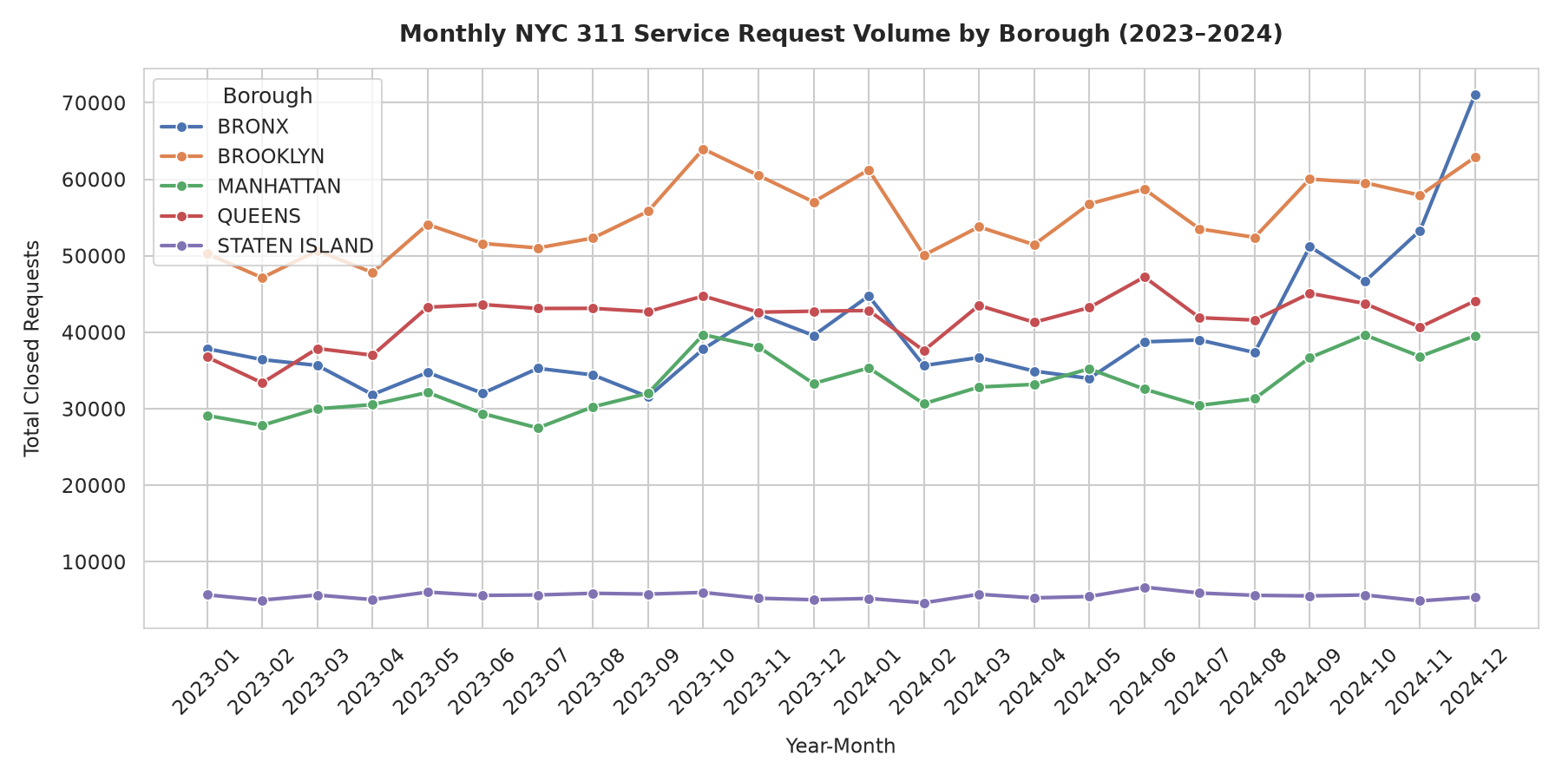
Figure 4. Monthly NYC 311 request volume by borough. All 24 operational months from January 2023 through December 2024 are present.

4.3 Out-of-time predictive comparison
Model selection was based on augmented validation R², not final test scores. The validation-selected delay algorithm was Ridge; its held-out R² changed from 0.5840 to 0.5743 (Delta -0.0096). The paired absolute-error p-value was 0.00782. The strongest structured delay result was LightGBM at 0.5995, while the strongest augmented delay result was Ridge at 0.5743; the augmented model did not exceed that structured benchmark. For repeat rate, the strongest structured and augmented results were LightGBM (0.9224) and LightGBM (0.9241), respectively. Claims are therefore algorithm-specific unless the strongest augmented model exceeds the strongest structured model.
Table 4. One-month-ahead 2024 R² comparison. The p-value tests paired absolute cell errors, not the R² difference.
Target | Algorithm | Baseline R² | Augmented R² | Delta R² | error-test p
Mean delay (hours) | Ridge | 0.5840 | 0.5743 | -0.0096 | 0.00782
Mean delay (hours) | RandomForest | 0.5553 | 0.4591 | -0.0962 | 0.1015
Mean delay (hours) | LightGBM | 0.5995 | 0.4730 | -0.1264 | 0.1363
Repeat rate (14d) | Ridge | 0.9128 | 0.8970 | -0.0158 | 0.004727
Repeat rate (14d) | RandomForest | 0.9097 | 0.9165 | +0.0068 | 1.198e-07
Repeat rate (14d) | LightGBM | 0.9224 | 0.9241 | +0.0017 | 0.05281

Table 5. Mean absolute error and root mean squared error for the selected LightGBM comparisons on the 2024 out-of-time cells.
Target / model | MAE | RMSE
Delay / structured Ridge | 63.7310 h | 115.8032 h
Delay / augmented Ridge | 66.0898 h | 117.1386 h
Repeat / structured Ridge | 0.0395 | 0.0530
Repeat / augmented Ridge | 0.0414 | 0.0576

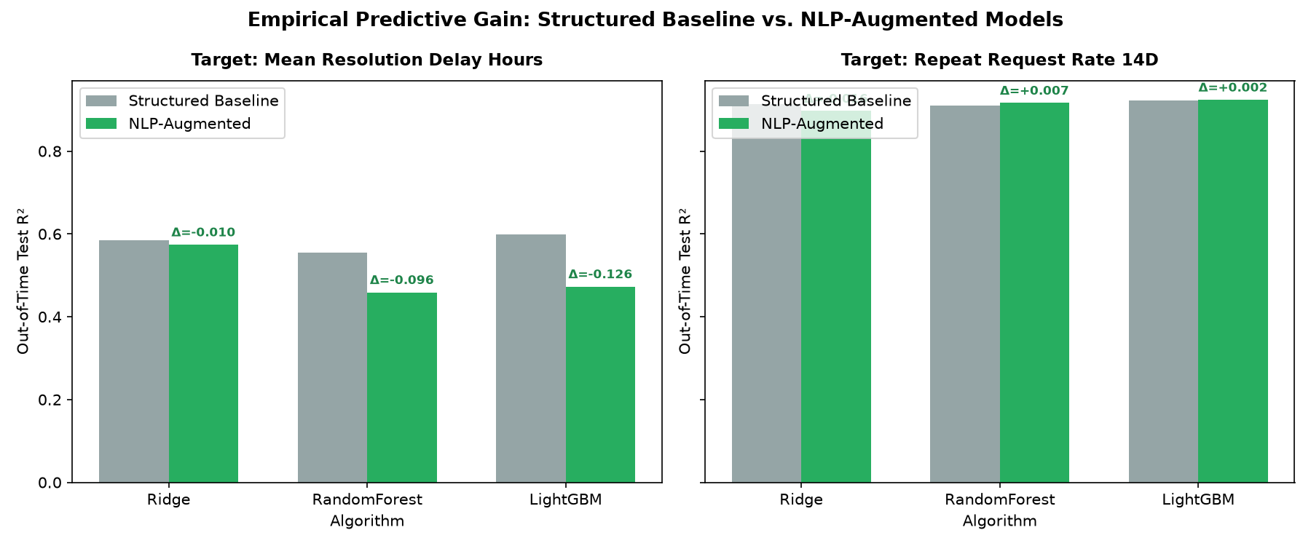
Figure 5. One-month-ahead out-of-time R² comparison for structured and NLP-augmented models across the three algorithms.

4.4 Robustness and uncertainty
Using the exact primary LightGBM recipe across five seeds, the mean delay Delta R² was -0.1396 with standard deviation 0.0158. Its bootstrap 95% interval was [-0.2282, -0.0402]. The mean repeat-rate Delta R² was -0.0008 with standard deviation 0.0017; its interval was [-0.0070, +0.0060].
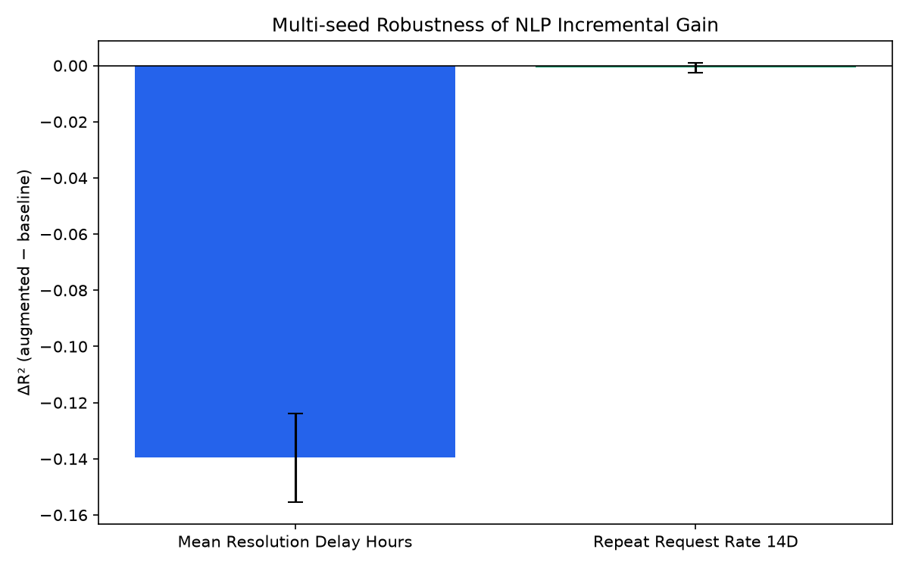
Figure 6. Multi-seed incremental R² with error bars; the delay gain is separated from the repeat-rate uncertainty.

4.5 Model interpretation
SHAP values are computed for the one-month-ahead augmented LightGBM delay model. They describe how month-t variables contribute to month-(t+1) predictions. A high SHAP importance is associative and does not mean that intervening on that variable would necessarily change delay.
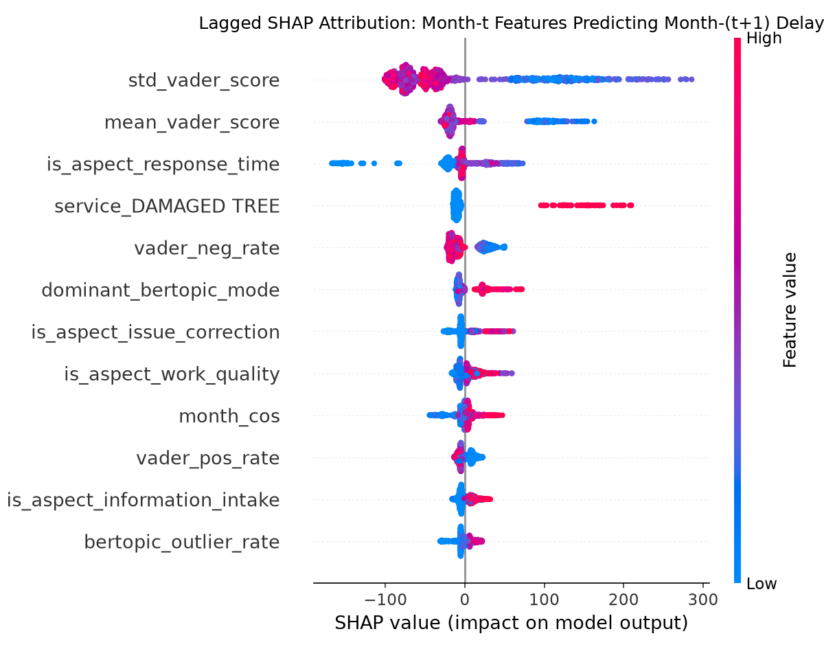
Figure 7. Global SHAP feature importance for the one-month-ahead augmented LightGBM delay model.

4.6 Implementation verification
The project includes complete ingestion, preprocessing, feature aggregation, modelling, dashboard, and reporting code. Automated tests cover data contracts, sentiment thresholds, outcome logic, lag alignment, borough-aware repeat detection, duplicate-text leakage, ranking precision, and dashboard requirements. The municipal dashboard exposes the held-out one-month-ahead queue and its Precision@k evidence; the resident view presents privacy-safe historical summaries.

5. Discussion
For delay, the validation-selected Ridge model produced a within-algorithm Delta R² of -0.0096; the paired absolute-error p-value was 0.00782. Across model families, the best augmented result differed from the strongest structured benchmark by -0.0252. For repeat rate, the corresponding best-model difference was +0.0017. These comparisons separate an algorithm-specific NLP gain from a stronger claim that NLP beats every structured model.
Repeat behaviour requires particular care. It depends on reporting habits, unresolved conditions, address-level recurrence, seasonal events, and the chosen repeat definition. The concentration analysis shows that high-volume addresses account for 90.41% of repeat flags. The signal can therefore be operationally useful without proving resident-level dissatisfaction or failure.
This work adds an outcome-prediction test to earlier 311 studies rather than treating sentiment as the final result. It also connects topic and grievance features to delay and recurrence, which are often left separate in civic NLP work. The findings remain consistent with warnings about domain shift, reporting bias, and public-sector data quality [3, 9, 10]. The ABSA scores should not be compared directly with product-review scores because these municipal descriptions are agency-authored, often formulaic, and only indirectly connected to citizen voice.
The practical use is a prioritisation workflow, not an automatic decision system. Staff can use the dashboard to find service-borough-month cells with high delay risk, repeat activity, dissatisfaction, or negative language signals. The model and SHAP results can support review and resource allocation, but they should not be used to deny service, rank individual residents, or replace staff judgement. The resident view can show aggregate performance without crossing the privacy boundary of the source data.
There are several limitations. First, RSAT suppresses open-ended comments, so ABSA is a domain-transfer evaluation of agency narratives rather than a human-validated study of citizen prose. Second, the study covers one city and one held-out year. Third, ABSA has only 593 distinct normalised descriptions despite many survey rows, and label ambiguity remains. Fourth, address recurrence is not the same as a verified repeated incident, and the selected fields do not identify multi-unit buildings. Fifth, cells sharing services and boroughs are not fully independent, so paired error tests are supporting evidence rather than definitive population inference. Finally, the reproducibility archive is prepared, but a DOI requires upload through an author-owned repository account.

6. Conclusion
This project built and tested an NLP-augmented framework for aggregate municipal service monitoring. A complete 4,204,783-record operational extract and 406,581 survey responses were combined at privacy-safe service-borough-month grain. The corrected primary design uses train-only topic models, duplicate-controlled ABSA, and month-t features to predict month-(t+1) outcomes on 994 held-out 2024 cells. The validation-selected delay model changed R² by -0.0096, while the best augmented delay model differed from the best structured model by -0.0252. The corresponding repeat-rate difference was +0.0017. These are predictive, algorithm-specific results rather than causal or universal claims. The dashboard turns the model into a review queue whose held-out ranking quality is reported with Precision@k. External-city validation and human annotation of genuine citizen text remain important future work.

Declarations
Acknowledgements. The authors thank Dr. Kalaavathi B for academic guidance and the Vellore Institute of Technology School of Computer Science and Engineering for the project setting.
Funding. This research received no specific grant from any funding agency.
Conflict of interest. The authors declare no conflict of interest.
Data availability. The study uses public NYC Open Data Socrata datasets erm2-nwe9 and 5ijn-vbdv. Raw records can be reconstructed with the documented paged queries. Code, configuration, processed cell tables, metric JSON files, figures, citation metadata, and reproducibility instructions are included in the Team 16 archive. A permanent DOI will be added after an author uploads the prepared archive to Zenodo.
Author contributions. Taher Panbiharwala: conceptualisation, methodology, software, formal analysis, and writing - original draft. Sanidhya Bhandari: methodology, data curation, validation, software, and writing - review and editing. Chinmoy Deb: investigation, visualisation, dashboard implementation, validation, and writing - review and editing. All authors approved the manuscript and accept responsibility for the work.
Ethics and privacy. The study uses public, aggregate, and privacy-constrained data. RSAT open-text comments are not used because the public records suppress them. No individual-level prediction or disclosure is performed.
Declaration of generative AI assistance. Generative AI tools were used to support code review, language editing, and document formatting. The authors inspected the source data, executed the analyses, verified every reported metric against saved artifacts, and accept full responsibility for the manuscript.

References
[1] Wang, L., Qian, C., Kats, P., Kontokosta, C., and Sobolevsky, S. (2017). Structure of 311 service requests as a signature of urban location. PLOS ONE, 12(10), e0186314.
[2] Li, Y., Hyder, A., Southerland, L.T., Hammond, G., Miller, H.J., and Porr, A. (2020). 311 service requests as indicators of neighbourhood distress and opioid use disorder. Scientific Reports, 10, 19579.
[3] Kontokosta, C.E., and Hong, B. (2021). Bias in smart city governance: How socio-spatial disparities in 311 complaint behavior impact the fairness of data-driven decisions. Sustainable Cities and Society, 64, 102503.
[4] Boxer, K.S., Hong, B., Kontokosta, C.E., and Neill, D.B. (2025). Estimating reporting bias in 311 complaint data. The Annals of Applied Statistics, 19(2).
[5] Hutto, C.J., and Gilbert, E. (2014). VADER: A parsimonious rule-based model for sentiment analysis of social media text. Proceedings of ICWSM.
[6] Devlin, J., Chang, M.W., Lee, K., and Toutanova, K. (2019). BERT: Pre-training of deep bidirectional transformers for language understanding. Proceedings of NAACL-HLT, 4171-4186.
[7] Blei, D.M., Ng, A.Y., and Jordan, M.I. (2003). Latent Dirichlet allocation. Journal of Machine Learning Research, 3, 993-1022.
[8] Grootendorst, M. (2022). BERTopic: Neural topic modeling with a class-based TF-IDF procedure. arXiv preprint arXiv:2203.05794.
[9] Zhang, W., Li, X., Deng, Y., Bing, L., and Lam, W. (2022). A survey on aspect-based sentiment analysis: Tasks, methods, and challenges. IEEE Transactions on Knowledge and Data Engineering, 35(11), 11019-11038.
[10] Chauhan, G.S., Nahta, R., Meena, Y.K., and Gopalani, D. (2023). Aspect based sentiment analysis using deep learning approaches: A survey. Computer Science Review, 49, 100576.
[11] Nazir, A., Rao, Y., Wu, L., and Sun, L. (2022). Issues and challenges of aspect-based sentiment analysis: A comprehensive survey. IEEE Transactions on Affective Computing, 13(2), 845-863.
[12] Hua, Y.C., Denny, P., Wicker, J., and Taskova, K. (2024). A systematic review of aspect-based sentiment analysis: Domains, methods, and trends. Artificial Intelligence Review, 57(11), 296.
[13] Wankhade, M., Rao, A.C.S., and Kulkarni, C. (2022). A survey on sentiment analysis methods, applications, and challenges. Artificial Intelligence Review, 55(7), 5731-5780.
[14] Barik, K., and Misra, S. (2024). Analysis of customer reviews with an improved VADER lexicon classifier. Journal of Big Data, 11(1), 10.
[15] Tang, Z., Pan, X., and Gu, Z. (2024). Analyzing public demands on China's online government inquiry platform: A BERTopic-based topic modeling study. PLOS ONE, 19(2), e0296855.
[16] Liu, J., Long, R., Chen, H., Wu, M., Ma, W., and Li, Q. (2024). Topic-sentiment analysis of citizen environmental complaints in China using a Stacking-BERT model. Journal of Environmental Management, 371, 123112.
[17] Li, C., Tian, Q., Gao, L., and Liu, H. (2026). Public feedback analysis on multi-stage emergency management policies using a BERTopic-SKEP integrated model. Scientific Reports, 16, 684.
[18] Malik, T., Tahir, A., Bilal, A., Dashtipour, K., Imran, M.A., and Abbasi, Q.H. (2022). Social sensing for sentiment analysis of policing authority performance in smart cities. Frontiers in Communications and Networks, 2, 821090.
[19] Fu, X., Sanchez, T.W., Li, C., and Reu Junqueira, J. (2024). Deciphering public voices in the digital era: Benchmarking ChatGPT for analysing citizen feedback in Hamilton, New Zealand. Journal of the American Planning Association, 90(4), 728-741.
[20] Tai, T.-E., Haw, S.-C., Kong, W.-E., and Ng, K.-W. (2024). Performance evaluation of machine-learning techniques on resolution-time prediction in helpdesk support systems. International Journal on Robotics, Automation and Sciences, 6(2), 59-68.
[21] Zhang, H., and Shafiq, M.O. (2024). Survey of transformers and towards ensemble learning using transformers for NLP. Journal of Big Data, 11(1), 25.
[22] Perikos, I., and Diamantopoulos, A. (2024). Explainable aspect-based sentiment analysis using transformer models. Big Data and Cognitive Computing, 8(11), 141.
[23] Yu, B., and Zhang, S. (2023). A novel weight-oriented graph convolutional network for aspect-based sentiment analysis. The Journal of Supercomputing, 79(1), 947-972.
[24] Zhang, Y., Yang, Y., Liang, B., Chen, S., Qin, B., and Xu, R. (2023). An empirical study of sentiment-enhanced pre-training for ABSA. Findings of ACL 2023, 9633-9651.
[25] Lore, M., Harten, J.G., and Boeing, G. (2024). A hybrid deep learning method for identifying topics in large-scale urban text data. Computers, Environment and Urban Systems, 111, 102131.
[26] Ghahramani, M., Galle, N.J., Ratti, C., and Pilla, F. (2021). Tales of a city: Sentiment analysis of urban green space in Dublin. Cities, 119, 103395.
[27] Haghighi, N.N., Liu, X.C., Wei, R., Li, W., and Shao, H. (2018). Using Twitter data for transit performance assessment. Public Transport, 10, 363-377.
[28] NYC Open Data. (n.d.). 311 Service Requests from 2010 to Present. New York City Open Data, dataset erm2-nwe9.
[29] NYC Office of Technology and Innovation. (2025). 311 Resolution Satisfaction Survey. New York City Open Data, dataset 5ijn-vbdv.
[30] Aggarwal, I., Joseph, S., Jaganathan, N., Patel, A., Kumar, V., and Devarapalli, M. (2025). Sentiment analysis in healthcare: A comparison of VADER, BERT, and Flair NLP models. Cureus, 17(7), e88902.

