NLP-Augmented Aggregate Prediction of Municipal Service Delays and Repeat Requests: Evidence from NYC 311
Taher Panbiharwala1, Sanidhya Bhandari1, Chinmoy Deb1,*
1 School of Computer Science and Engineering (SCOPE), Vellore Institute of Technology, Vellore, Tamil Nadu 632014, India
* Corresponding author: Sanidhya Bhandari, sanidhya.bhandari2023@vitstudent.ac.in

Abstract
A municipality 311 record documents that what was reported, and when the agency closed the request. Does not have to indicate whether the resident was satisfied or whether the problem was solved. This paper aims to examine if sentiment, topic, grievance-aspect, and survey features contribute useful information to predict resolution delay and repeat requests. We are integrating 1,199,279 NYC 311 service requests and 406,581 Resolution Satisfaction Survey responses at a privacy-safe service-borough-year-month cell grain. The experiments take into account chronological splits and compare the performance of VADER, LDA, BERTopic, TF-IDF logistic regression, DistilBERT, Ridge, Random Forest and LightGBM. On the 85-cell 2024 test horizon, the selected LightGBM model raised delay R-squared from 0.5149 to 0.5438 (Delta R-squared = +0.0289, p = 0.00020). Repeat-rate R-squared increased from 0.7184 to 0.7441 (Delta R-squared = +0.0257) however this was not statistically significant (p = 0.733). These five-seed and 2,000-bootstrap checks agreed with the delay result, and the repeat-rate interval contained zero. While the work outlines a reproducible monitoring framework, the results should not be widely generalised due to the limited availability of individual-level survey data, the limited future time horizon and the single-city setting.
Keywords: municipal services; citizen satisfaction; sentiment analysis; aspect-based sentiment analysis; transformer NLP; NYC 311

1. Introduction
311 systems gather requests for services like sanitation, housing, noise, parking, infrastructure and more in the city. The value of these records comes with the fact that they provide time, location, service type and closure information. Nevertheless, the closed ticket does not indicate that the resident was "satisfied" that the problem is solved. Previous research also indicates that neighbourhood characteristics, reporting behavior and the perceived availability of specific services affect the use of 311 [1-4].
Text features can provide context that is lacking from counts and timestables. A sentiment baseline, as simple and transparent as VADER, is provided by VADER [5]. Transformer models can be more flexible with context, and LDA and BERTopic can be used to group themes that occur repeatedly [6-8]. ABSA is much more useful for feedback from municipalities since dissatisfaction can refer to both response time and issue correction, communication or work quality and not just a single sentiment label. While public-sector text differs from product reviews, a model learned in one domain can not easily be transferred to the other [9-12].
The question examined here is pragmatic: If the interaction between service, borough, season, and request volume are accounted for, will language and satisfaction signals be predictive of municipal outcomes? Civic NLP papers tend to end with sentiment or topic description and the operational 311 models tend to use structured variables, alone. There have been few studies that incorporate both sources of evidence in the same model, then validate it on a subsequent time period. It's also an important privacy boundary. Survey satisfaction and standardised dissatisfaction reasons are used here as an aggregate indicator of the public's comments, derived from Resolution Satisfaction Survey (RSAT) responses. Individual-level survey responses are not directly matched to individual 311 requests, and the analysis uses aggregated data to maintain privacy. The text features come from official 311 resolution descriptions.
We then examine if the inclusion of these features helps to predict the mean resolution delay and 14-day repeat-request rate out-of-time. The results represent predictions only, not causality.
The study offers four applications:
An integration design solution which merges data from NYC 311 and RSAT survey evidence at service-borough-year-month, without asserting a request-level match in violation of privacy.
A reproducible NLP pipeline for comparing lexicon sentiment, topic discovery, supervised ABSA and Transformer adaptation in chronological evaluation.
A corrected service-controlled comparison demonstrating a statistically significant incremental delay-prediction gain and uncertainty analysis that qualifies the repeat-rate result.
A dashboard that reveals high priority cells, trend data, and model evidence for residents and municipalities.
This paper is organized as follows: The related work is discussed in Section 2. The data, the formulation, the NLP pipeline, the results, the experimental design and the controls for reproducibility are described in Section 3. Descriptive, NLP, predictive, robustness and explainability results are reported in section 4. The interpretation and practical implications and limitations are discussed in Section 5. Section 6 concludes.

2. Literature Review

2.1 Sentiment analysis and Transformer models
Lexicon methods also work in settings of limited labelled data. They are easy to run and simple to check and have a baseline that other models should out-do. VADER is specifically designed for short informal text [5] and incorporates a lexical, grammatical, and punctuation based approach. In this project, the problem with it is that it is limited in vocabulary, meaning that a formal description of a closure could include positive or negative words which do not reflect the experience of a resident. This is a part of the larger tradeoff between easy and straightforward techniques and domain adaptation [13, 14].
Context could be used more effectively in text classification through the use of transformer pretraining. BERT added bi-directional representations which can be fine-tuned to a specific task [6]. But an oversized model does not eliminate issues with noisy labels, boilerplate, local abbreviations, or any hidden unhappiness! Rather than the model name, we keep the evaluation design more important, and use VADER as a baseline model and DistilBERT as a compact adapted model.

2.2 ABSA and topic discovery in public-sector text
Aspect-based sentiment analysis (ABSA) links a text span or record to a particular aspect and identifies the sentiment expressed toward that aspect. Grievance classification is related but focuses on identifying the type of complaint or problem described. Recent surveys indicate that instead of hand-built models, unified and generative models are being adopted, and that some common issues emerge: implicit aspects, domain shift, imbalanced classes, and limited annotated data [9-12]. These are particularly relevant in Public Services where a record can be a description of the original event or the response process or a communication failure.
Topic models provide an alternative representation to the text. Although the role of interpretability is not always critical to the usefulness of LDA, it is still quite helpful to represent each document as a combination of topics. BERTopic employs sentence embeddings, clustering and class based TF-IDF to locate clusters of semantically similar sentences [8]. These are used in government enquiries, environmental complaints, emergency management and policing in civic studies, but many of them are descriptive [15-19]. In this project, the topic proportions and topic entropy are made into cell-level features and are evaluated on the usefulness for outcome prediction.

2.3 311 data, reporting bias, and service outcomes
Previous 311 studies indicate that service request categories include some urban location information and neighbourhood condition information [1]. 311 has been utilized in other studies as a social-sensing source to determine distress and public-health risk [2]. Reporting bias is significant because even when the number of complaints is low, there are not necessarily fewer problems in a community [3, 4]. The same methods have also been investigated in the context of helpdesk data, where ensemble models can achieve an acceptable accuracy, however a corporate ticket is not the same as the request that comes in from the municipality [20].
When combined, these studies leave a worthwhile gap. Many of the 311 models are not structured with language or satisfaction signals, and civic NLP studies generally end with the description of sentiments or topics. The comparison of the two feature sets is performed on the same service-borough-month cells, the same cells are left unaltered for testing during a later period, and uncertainty, rather than the best score alone, is reported.

2.4 Research gap
The project targets four gaps: a lack of testing of civic language with operational outcomes; a lack of linkage between ABSA and municipal prediction; poor integration of service, place and time; and fuzzy privacy and domain transfer boundaries. Table 1 summarizes the differences of the present study with representative previous studies. The intention is to see if citizen-experience proxies provide predictive information in a controlled design, rather than to claim that NLP solves municipal management.
Table 1. Representative related work and the gap addressed by this study.
Study / stream | Approach | Setting | Limitation addressed here
Wang et al. [1] | Structured 311 signatures | NYC 311 / urban location | No text or satisfaction outcome
Kontokosta and Hong [3] | Reporting-bias analysis | Kansas City 311 | Does not test language augmentation
Tang et al. [15] | BERTopic civic inquiries | Chinese government platform | Descriptive; no operational target
Tai et al. [20] | ML resolution-time prediction | Corporate helpdesk | Not municipal and no citizen signal
This study | NLP-augmented outcome models | NYC 311 + RSAT | Privacy-safe aggregate, time-held-out comparison

3. Methodology

3.1 Problem formulation
The unit of analysis is a cell c = (s, b, y, m), where s is the service category, b is the borough, y is the year, and m is the month. Each cell contains operational variables x_c, language features z_c, and the outcome vector y_c. The two primary outcomes are mean resolution delay d_c in hours and the 14-day repeat-request rate r_c.
y_c = f_0(x_c) + epsilon_c (1)
y_c = f_1(x_c, z_c) + epsilon_c (2)
The baseline model f_0 uses service identity, borough, request volume, and month-related variables. The augmented model f_1 adds VADER, topic, ABSA, and satisfaction features. We measure the change in held-out R-squared as Delta R-squared = R-squared_augmented - R-squared_baseline. A positive value means that the augmented model predicted the test cells better; it does not show that the added features caused the outcome.

3.2 Data and materials
The RSAT portal's record count is larger due to records that fall outside the study window and rows that do not pass validation. The final count is thus an audited analytic sample. In the schema check we also discovered that the public RSAT data don't include unrestricted citizen comments. The open-text field is not considered to be an example of citizen prose. RSAT provides the overall satisfaction and standardised dissatisfaction reasons, and the words used in the language features are words from official 311 resolution descriptions. This distinction is important to consider when reading ABSA performance.
These are both public administrative or survey data sources. There are no personal identifiers included in the integrated file and modelling is performed at the aggregate cell level. No individual predictions and no one-to-one survey-to-ticket match is guaranteed. The data used were public and de-identified, so there was no new human intervention in the project; however, it's important to note that a formal submission should comply with the university's ethics and data-governance guidelines.
The raw 311 snapshot runs from 1 January 2023 to 24 October 2025 and contains 1,065,798 records from 2023, 133,460 from 2024, and 21 from 2025; these counts sum exactly to 1,199,279. In this snapshot, all 1,199,279 records have valid created and closed timestamps. The outcome data contain 1,147 cells, of which 1,121 match RSAT cells. Of the 1,147 outcome cells, 26 have no RSAT match; among the 1,121 matched cells, 237 contain fewer than 10 requests, leaving 884 cells after the minimum-volume filter. The records in the RSAT file are labeled for 2023-2025, but the final modelling set has 799 cells for 2023 and 85 cells for 2024, with no viable 2025 operational cells. These low later counts reflect a snapshot coverage and extraction limitation and are not an indication of an actual decrease in city demand.
The primary operational analysis is a retrospective, cell-level monitoring and not a request-level pre-closure forecast. When the monthly 311 closure descriptions and related RSAT responses are gathered for a service-borough-month, the cells are considered collected. Some features are recorded at the end of service, therefore results should not be given as a prediction of an individual ticket prior to closure. If a true early-warning system were to be developed, it would need to have only lagged features.

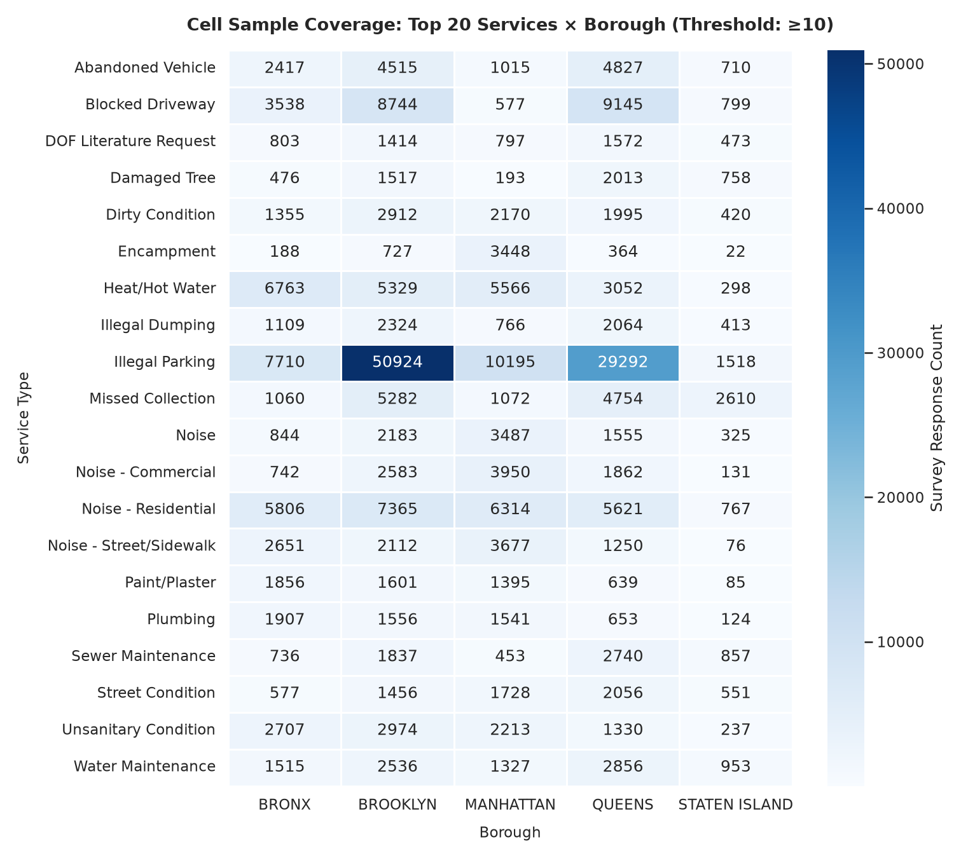
Figure 1. Coverage of the integrated service-borough-month cells used to combine operational and survey-derived features.

3.3 Text preprocessing and NLP feature extraction
Before applying the common text-processing steps, missing resolution descriptions were normalised. VADER calculated compound scores and positive, neutral, and negative rates for every record. We then aggregated the scores to the cell level using means, standard deviations, and polarity proportions. The current study does not use VADER as a source of training labels, but rather compares it with RSAT satisfaction polarity in 945 matched cells.
Gensim LDA was used to discover topics with ten topics and assessed using the Coherence C_v measure. All-MiniLM-L6-v2 model embeddings, density-based clustering, and class-based TF-IDF were used for BERTopic. Reduce to 14 semantic clusters. Topic proportions, the dominant topic, and topic entropy were aggregated to each analysis cell.
The eight raw reasons are mapped to six classes (Information Intake, Issue Correction, Other, Response Time, Status Updates, and Work Quality), each supervised ABSA example is one RSAT row, the agency resolution_description is paired with the row's dissatisfaction_reason. The 250,703 labelled descriptions are divided by RSAT year and include 101,390 descriptions in the 2025 test split. These pairs are used to train the classifiers and then use them on 311 resolution descriptions to obtain cell-level aspect rates. This is not a request-level join between the two public datasets nor is it a direct classification of citizen comments.
DistilBERT (distilbert-base-uncased) was fine-tuned on a Kaggle Tesla T4 with AdamW learning rate 0.0002, weight decay 0.01, epochs 3, a batch size of 32, and a max length of 128. Since the survey text is anonymised, it is not a citizen-comment study but rather a domain transfer experiment.
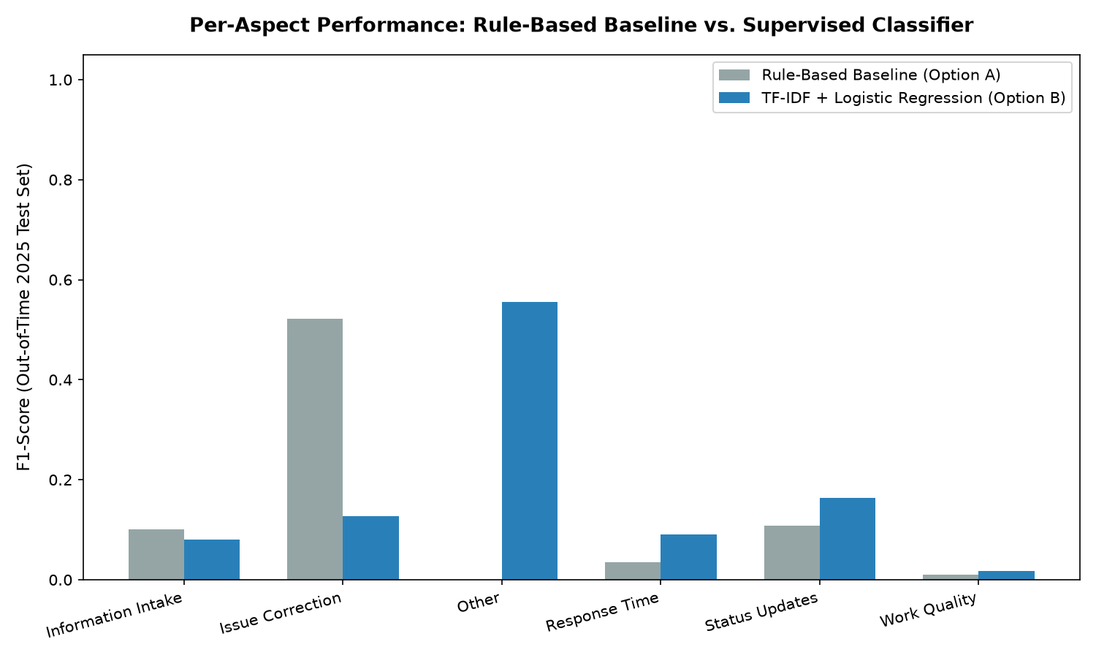
Figure 2. Per-aspect F1 comparison for the rule-based and TF-IDF grievance classifiers on the 2025 ABSA test split; the Transformer result is reported separately because it comes from a different evaluation artifact.
TF-IDF is trained using the 2023 RSAT training set then used to classify subsequent 311 narratives for operational comparison. VADER is a fixed lexicon approach. The current LDA and BERTopic artifacts were fitted on the fixed random sample of 311 snapshot before the split of the cells and then the topic features were aggregated to cell. Because the sample was drawn before the chronological split, it may include text from the later evaluation period. Therefore, the topic features may contain information from the evaluation period, rather than being a strictly training-only transformation. A stricter evaluation would fit the topic models on the training period and then transform the later period without refitting.

3.4 Operational outcomes
Valid create and close timestamps were used to determine resolution delay. The raw values have a long right tail, so the main modelling result has been winsorised at the 99th percentile or 2,454.96 hours. The raw median is reported along with the winsorized mean, to give the sense of a typical case as well as an overall operational scale.
Consecutive records containing the same complaint type and cleaned incident address were used to find repeat requests. Blank (or UNKNOWN) addresses cannot be used to create a repeat but do appear in the denominator. The previous request needed to be made between 0 and the number of days selected in the form, so exact matches of 7, 14 and 30 days are in, and same-timestamp ones are out. The rates have been calculated on 7 days, 14 days and 30 days windows, the 14 days rate being the target rate. These are not satisfaction ratings but indicators of operation. A repeat may represent an unresolved question, new circumstances, or a new related request.

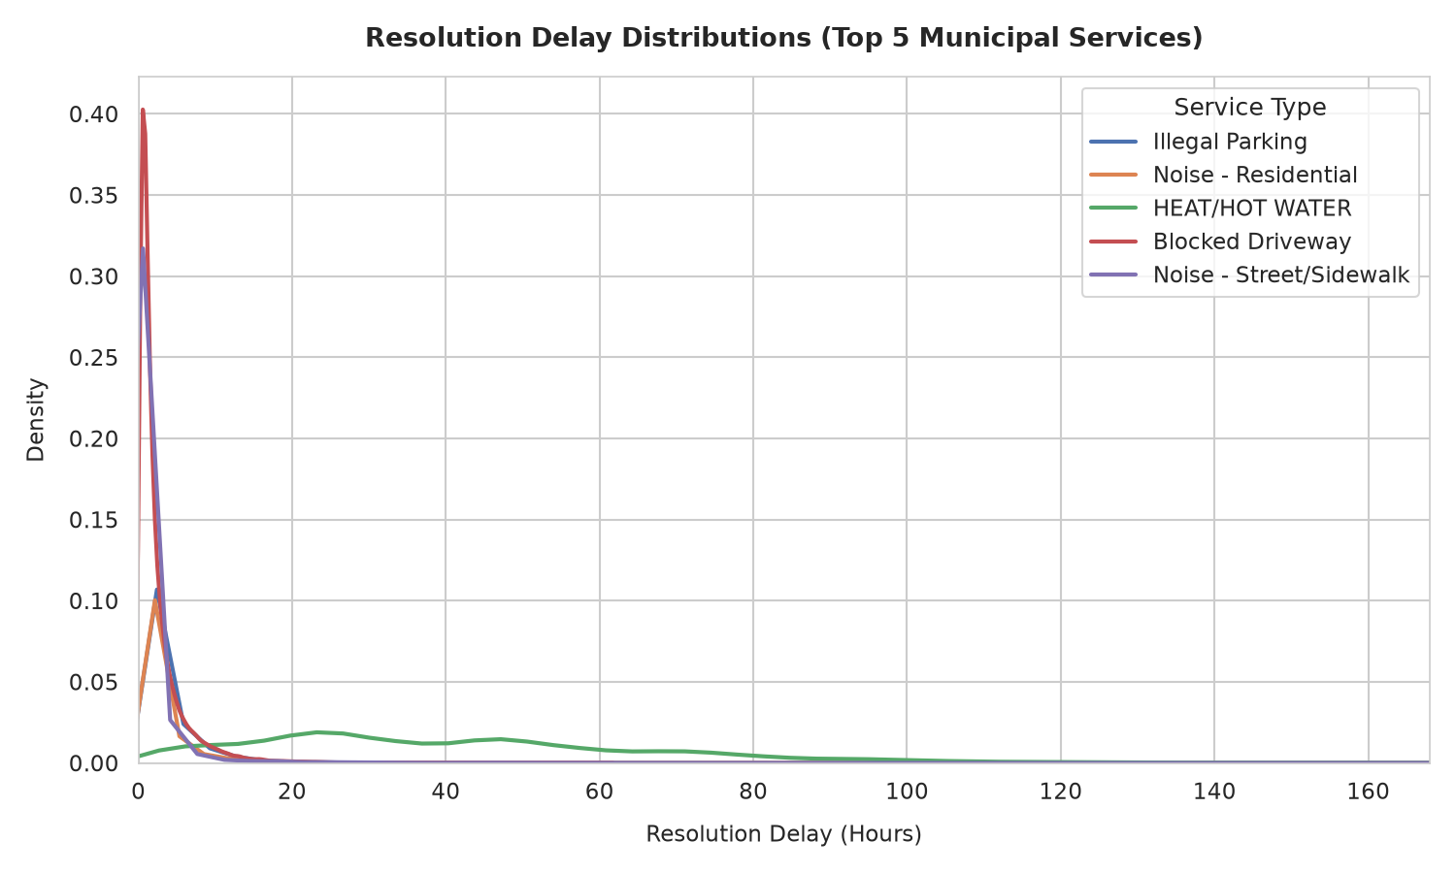
Figure 3. Resolution-delay distribution for the selected municipal services; the long right tail motivates winsorisation before prediction.

3.5 Experimental design and statistical analysis
Once the feature groups were merged and the minimum cell size set to ten, there were 884 eligible cells in the integrated modelling file. The time split consisted of 586 training cells (from January until August 2023), 213 validation cells (from September until December 2023), and 85 untouched test cells from 2024. Because the snapshot contains only 21 records from 2025, no viable 2025 operational test exists. The 2025 split is used only for the separate ABSA evaluation and does not enter the outcome-prediction test.
The following models were compared: Ridge regression, Random Forest and LightGBM. The validation performance was used to select the model and feature configuration, and the selected configuration was then tested once against the held-out horizon. We report the R-squared, the mean absolute error and the root mean square error. The paired significance test is a two-sided paired t-test with 85 test cells, comparing the absolute errors of the baseline and augmented predictions. The reported p-values therefore relate to differences in absolute errors, rather than directly testing the difference in R-squared. Cells are similar in services and boroughs, and should not be considered independent observations at the request level; hence there are no claims to uncertainty at the request level.
The main Table 4 comparison is based on the default LightGBM settings (no row or feature subsampling), and models are trained using only the 586 training cells. Robustness run: LightGBM with bagging_fraction 0.85, feature_fraction 0.90, bagging_freq 1, seeds 0–4; trained on all 799 2023 cells (training + validation) and tested on the same 85 2024 cells. It is a sensitivity result from the +0.1287 mean delay gain for a different training recipe and partition, and NOT a second estimate of the +0.0289 primary effect. The 2,000 bootstrap replicates are not resampled requests or fits, but rather resampled test cells. SHAP TreeExplainer was used to examine the main contributors in the augmented LightGBM delay model. Significance is discussed separately for each of the targets.
Table 2. Chronological partitions used for the integrated operational modelling experiment.
Partition | Period | Cells | Purpose
Train | Jan-Aug 2023 | 586 | Fit models
Validation | Sep-Dec 2023 | 213 | Select algorithm/features
Out-of-time test | 2024 horizon | 85 | Final held-out evaluation

3.6 Reproducibility and dashboard implementation
The project is built in Python using the following libraries: PyTorch, Hugging Face Transformers, LightGBM, scikit-learn, Gensim, BERTopic, NLTK VADER, Parquet and Streamlit. The accompanying project archive includes a 16-test pytest suite, figures, model artifacts, processed feature tables, metric JSON files, and configuration files. The dashboard is split into two views: one for municipal staff to view priority cells, trends, borough comparisons and model evidence; one for the public to view aggregate service indicators in plain language. Personal ticket text, names and addresses are not displayed. The two NYC Open Data identifiers that document raw data access appear in the Data availability statement.

4. Results

4.1 Descriptive and NLP results
For the validated RSAT sample, 62.14% of respondents are identified as being dissatisfied. The highest number of grievances is under the standardised category of Issue Correction. Smaller groups, but still relevant to operations, are Response Time, Status Updates, Information Intake, and Work Quality. On the same set of matched cells, VADER achieved an accuracy of 0.655 and F1 negative score of 0.800. It has a macro-F1 of 0.2737, indicating that performance is not uniform among classes.
Table 3. Summary of sentiment, topic, and grievance-classification results.
Component | Evaluation | Metric | Result
VADER | 945 matched cells | Accuracy | 0.6550
VADER | 945 matched cells | Negative F1 | 0.8000
LDA | Resolution narratives | C_v coherence | 0.5100
BERTopic | Resolution narratives | Clusters | 14
TF-IDF ABSA | 2025 OOT transfer split | Macro-F1 | 0.1723
DistilBERT ABSA | Chronological test split | Macro-F1 | 0.3491

The TF-IDF classifier was able to increase the macro-F1 from the rule baseline of 0.1295 to 0.1723, but accuracy was lower due to the imbalanced classes. DistilBERT achieved macro-F1 0.3491 and accuracy 0.4148, with the macro-F1 improvement of 0.1768 over TF-IDF. Work Quality had an F1 of zero in the Transformer test. That is why the paper reports macro-F1 and per-class value rather than just the accuracy.

4.2 Operational outcome distributions
The median raw delay for the 1,199,279 service requests was 2.90 hours. The 95th percentile was 404.44 hours and the 99th percentile winsorisation threshold was 2,454.96 hours. The winsorized mean delay was 91.11 hours. Repeat rates increased as the window became longer: 39.10% at 7 days, 44.88% at 14 days, and 50.52% at 30 days. These values help to use a strong delay measure and specify the repeat window prior to modelling.
Figure 4 is not a demand series, but rather a coverage diagnostic. The raw numbers for months are extremely high in 2023, drop off significantly from July to November 2023 and are sparse from later in 2024 into 2025. RSAT matches are applied and the minimum volume rule taken into consideration, and only January and December 2024 provide significant test cells. They are consistent with the snapshot and the filtering process extracted thus, and are far from being a mere seasonality.

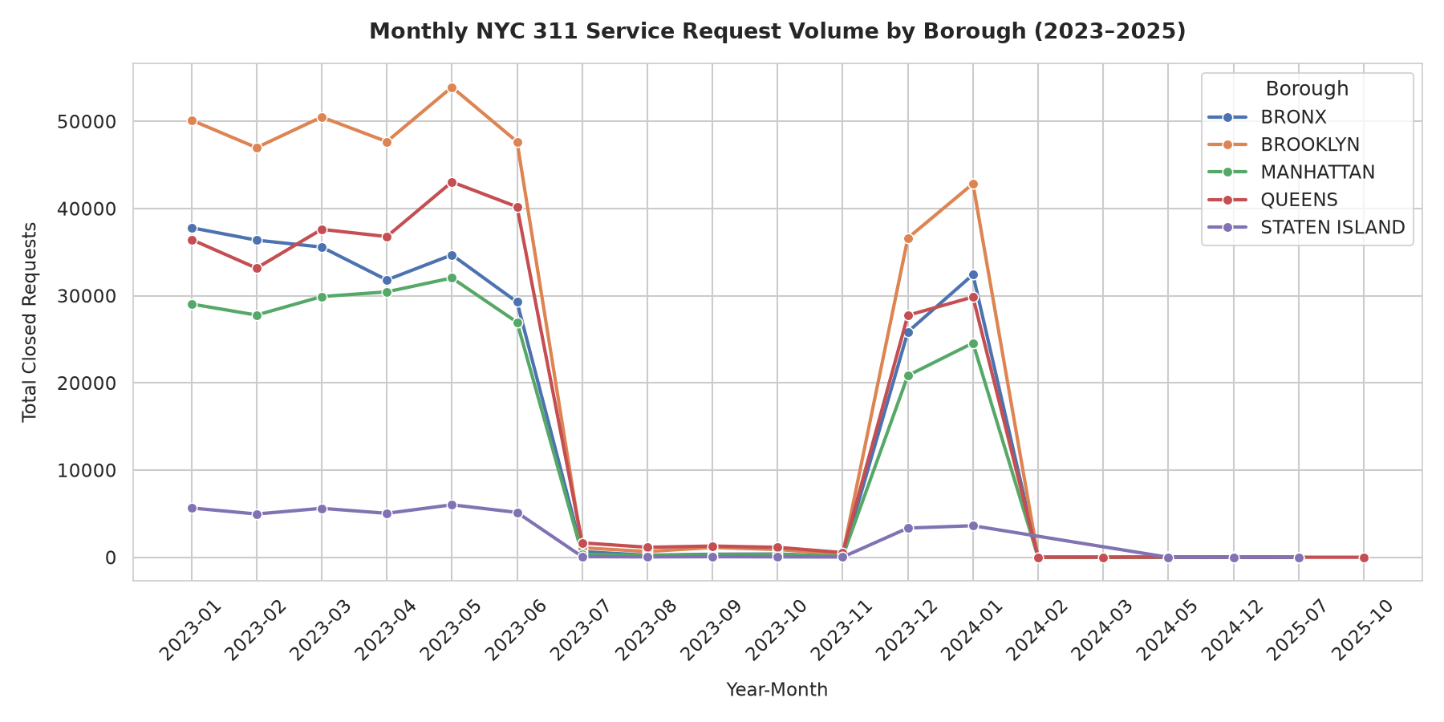
Figure 4. Monthly NYC 311 request volume by borough in the extracted snapshot. Abrupt gaps reflect incomplete snapshot coverage and filtering, not a claim of seasonal citywide demand.

4.3 Out-of-time predictive comparison
Model selection was by augmented validation R-squared, rather than by final test scores. LightGBM was chosen as the delay algorithm since its validation R-squared of 0.5999 is better than Ridge (0.5383) and Random Forest (0.5239). It was also chosen for repeat rate due to higher validation R-squared of 0.7867 as compared with Ridge (0.7450) and Random Forest (0.7292). The final comparison out-of-time is in Table 4. The selected LightGBM model increased delay R-squared from 0.5149 to 0.5438, a gain of +0.0289 with p = 0.00020 for the paired absolute-error comparison. The final R-squared values for delay and repeat rate for the structured Random Forest baseline were, however, the highest for both delay (0.6277) and repeat rate (0.7957). The NLP-enhanced system does not outperform the best structured system, but an improvement within the LightGBM model family is still an improvement. LightGBM improved from 0.7184 to 0.7441 for the 14-day repeat rate, which wasn't significant with paired tests (p = 0.733).
Table 4. 2024 out-of-time R-squared comparison of structured and NLP-augmented models. Model selection was based on augmented validation R-squared.
Target | Algorithm | Baseline R2 | Augmented R2 | Delta R2 | p-value
Mean delay (hours) | Ridge | 0.5464 | 0.5401 | -0.0064 | 0.247
Mean delay (hours) | Random Forest | 0.6277 | 0.5127 | -0.1149 | 0.123
Mean delay (hours) | LightGBM | 0.5149 | 0.5438 | +0.0289 | 0.00020
Repeat rate (14d) | Ridge | 0.7369 | 0.7353 | -0.0016 | 0.324
Repeat rate (14d) | Random Forest | 0.7957 | 0.7235 | -0.0722 | 0.522
Repeat rate (14d) | LightGBM | 0.7184 | 0.7441 | +0.0257 | 0.733
Table 5. Mean absolute error and root mean squared error for the selected LightGBM comparisons on the 2024 out-of-time cells.
Target / model | MAE | RMSE
Delay / structured LightGBM | 84.9403 h | 161.2816 h
Delay / NLP-augmented LightGBM | 65.4959 h | 156.4054 h
Repeat rate / structured LightGBM | 0.0707 | 0.1062
Repeat rate / NLP-augmented LightGBM | 0.0685 | 0.1012

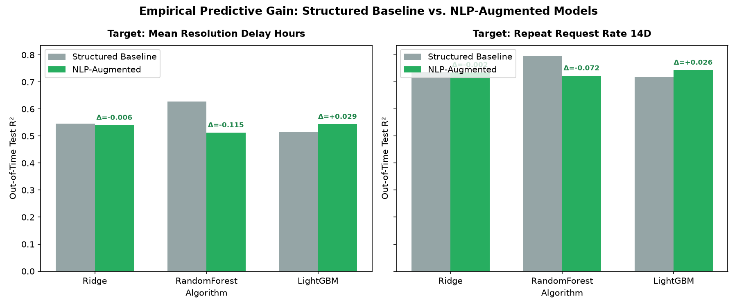
Figure 5. Out-of-time R-squared comparison for structured baseline and NLP-augmented models across the three algorithms.

4.4 Robustness and uncertainty
Across five seed runs, the mean delay Delta R-squared was +0.1287 with a standard deviation of 0.0097. A test-cell bootstrap interval based on the reference-seed predictions was [+0.0499, +0.2259], so it stayed above zero. The mean repeat-rate Delta R-squared was +0.0403 with a standard deviation of 0.0072; its corresponding reference-seed test-cell bootstrap interval was [-0.0072, +0.0794], which contained zero. The additional checks support the delay result under the alternative training setup and recommend caution with the repeat-rate result.
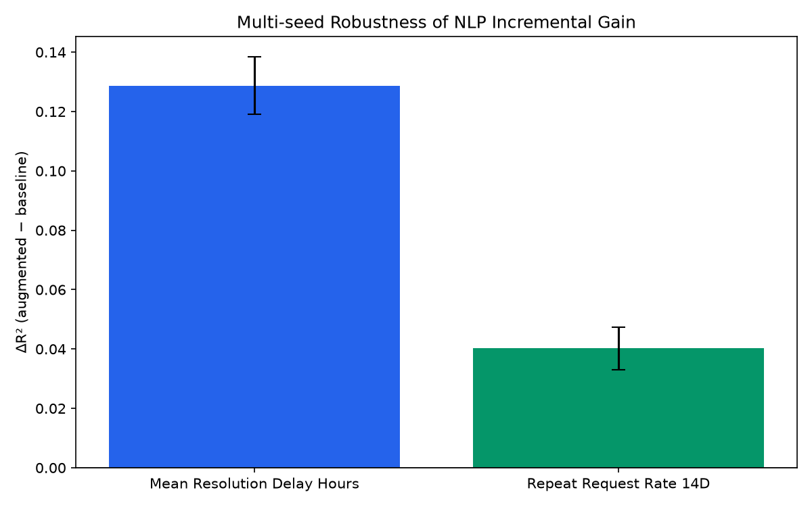
Figure 6. Multi-seed incremental R-squared with error bars; the delay gain is separated from the repeat-rate uncertainty.

4.5 Model interpretation
Log request volume and topic entropy were the top two SHAP values in the augmented delay model. Other important contributors included the response-time aspect indicators, month seasonality, service identity, and the VADER negative rate. This means that the model is utilizing workload pressure and language-derived information. The explanation remains associative: a SHAP value describes a feature's contribution to a prediction and not an intervention that would alter the outcome
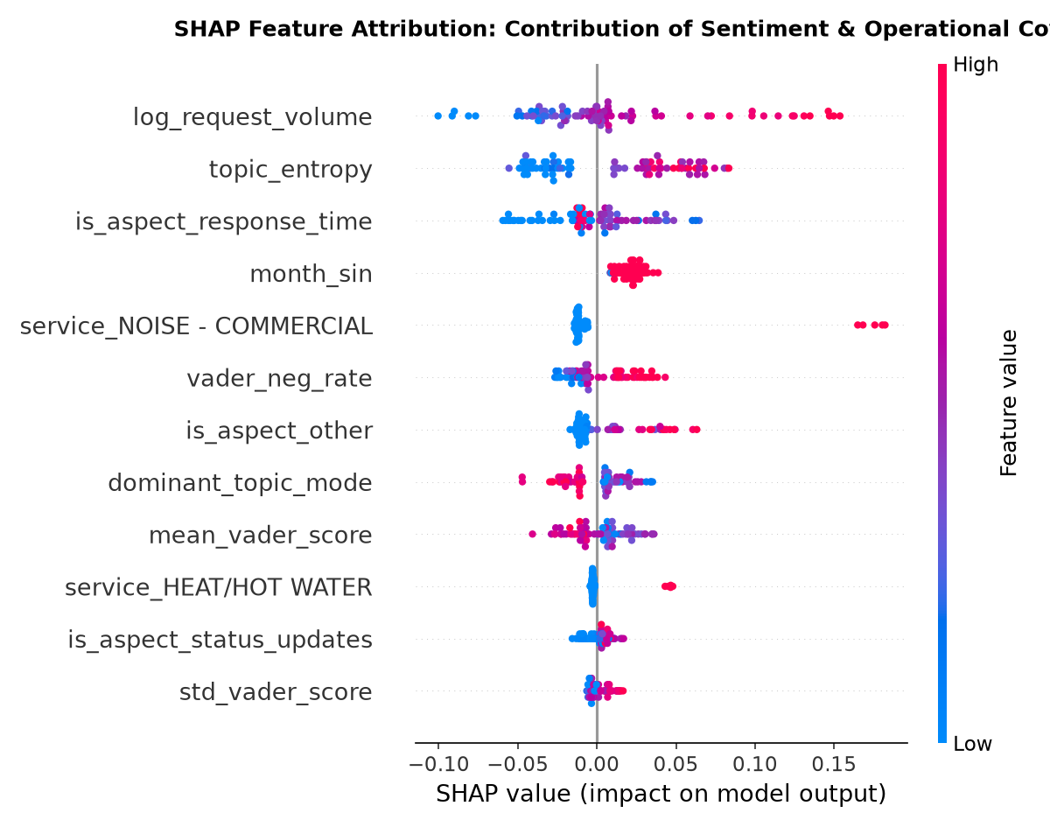
Figure 7. Global SHAP feature importance for the augmented LightGBM delay model.

4.6 Implementation verification
The complete ingestion, preprocessing, feature aggregation, modelling, dashboard and reporting pipeline are included in the project. Currently, the automated suite has 16 passing tests that include tests for data contracts, sentiment thresholds, outcome logic, metric structure, data-split and leakage checks, and dashboard requirements. The dashboard is now running locally as a Streamlit app and shares the same features that were used in the research analysis for aggregation.

5. Discussion
The best outcome is observed for delay prediction. The NLP-augmented LightGBM model also resulted in an increase in the accuracy of delay predictions on the future horizon after considering the influence of the service, the borough, the volume of requests and the seasonality. The improvement in delay prediction on the future horizon was statistically significant. This suggests that the language and satisfaction variables provide additional predictive information beyond the structured demand variables. Topic entropy might be an indicator of mixed and/or uncertain service conditions, and the response-time and negative-sentiment indicators could be indicators of operational stress in the closure descriptions.
It is important to pay more attention to the repeat-rate result. The R-squared value was higher at the 2024 time horizon and the mean delta R-squared was positive, but this was not significant in the paired test, and the bootstrap interval contained zero. Repeat behaviour is a function of reporting habits, conditions that have not been resolved, recurrence at address level, seasonality, and the definition of repeat used. Current features show potentially helpful signal, but aren't stable enough for a strong general claim.
This study introduces an outcome-prediction test to previous 311 studies, instead of using sentiment as an end goal. It also links the features of the topic and grievance to delay and recurrence, a feature of civic NLP work that is often not linked. The results are consistent with the warnings about domain shift, reporting bias, and data quality in the public sector [3, 9, 10]. It is important to note that the ABSA scores are not directly comparable with product-review scores, as the former use agency-authored descriptions, which are usually formulaic and only indirectly related to citizen voice.
The application is not a decision-making mechanism, but rather a prioritisation process. The dashboard enables staff to identify service-borough-month cells where delay risk is high, repeat activity is high, dissatisfaction is high or negative language signals are present. The model and SHAP results can help review and allocate resources - and should not be used to deny service, rank individual residents, or supplant staff judgement. The resident view can display the overall performance without breaching the privacy of the source data.
There are a number of constraints. Firstly, RSAT does not provide unrestricted open-ended citizen comments, so the ABSA experiment is a domain-transfer evaluation and not a study of citizen prose. Second, the operational test set contains 85 aggregate cells from one city and one future horizon, and the raw snapshot has substantial coverage gaps after 2023. Third, the headline Table 4 models are fit on the 586 "training" partition, while the robustness run is performed on all 799 2023 cells and a different subsampling recipe for LightGBM; the two delay gains are not to be interpreted as equal estimates. Fourth, topic models were trained on a sample from the full snapshot instead of within each training fold, thus strict train-only refitting is left as a future task. Fifth, the structured Random Forest test baseline performs better than the selected augmented LightGBM on both targets, so no claim can be made for overall model superiority. Sixth, no statistical confirmation of the repeat-rate gain exists. Last but not least, the project snapshot is not yet packaged as a publicly archivable repository with a DOI. The limits do not take away the value of the capstone result, but rather identify the work required for a higher journal study.

6. Conclusion
The project developed and evaluated an NLP-enabled model for monitoring municipal services. The service-borough-year-month grain was used to combine NYC 311 requests and Resolution Satisfaction Survey responses in a privacy-safe manner. This pipeline contained VADER, LDA, BERTopic, ABSA, DistilBERT and supervised outcome models. For the untouched 2024 horizon of 85 cells, the selected LightGBM model increased its delay R-squared from 0.5149 to 0.5438, with p = 0.00020 for the paired absolute-error comparison. The repeat-rate R-squared also rose from 0.7184 to 0.7441, and this improvement was not statistically significant. The structured Random Forest baseline performed better than the selected augmented LightGBM, which indicates that the outcome is an algorithm-specific incremental improvement and not the overall superiority of NLP techniques. The coverage and timing limitations remain despite the seed and bootstrap checks, which provide additional support for the delay result under a different training setup. A more robust study would employ strictly lagged and training-only features, include dual-annotator text validation, test a longer or external horizon, and publish a reproducibility package. These signals can be easily checked on the dashboard with human supervision.

Declarations
Acknowledgements. The authors are grateful to Dr. Kalaavathi B for academic guidance and Vellore Institute of Technology School of Computer Science and Engineering for providing the setting for the project.
Funding. This research was not funded by any specific grant.
Conflict of interest. The authors declare that there are no conflicts of interest.
Data availability. The study is based on public NYC Open Data Socrata datasets – NYC 311 Service Requests (erm2-nwe9) and NYC 311 Resolution Satisfaction Survey (5ijn-vbdv). The raw data can be accessed using these dataset identifiers on the NYC Open Data portal. The project code and configuration, processed features, and model outputs are kept in the authors' project archive and will be shared for review; a public archival repository and DOI are planned but are not available at the time of writing.

Author contributions. Taher Panbiharwala: conceptualisation, methodology, software, formal analysis, and writing - original draft. Sanidhya Bhandari: methodology, data curation, validation, software, and writing - review and editing. Chinmoy Deb: investigation, visualisation, dashboard implementation, validation, and writing - review and editing. All authors approved the manuscript and accept responsibility for the work.
Ethics and privacy. The study uses public, aggregate, and privacy-constrained data. RSAT open-text comments are not used because the public records suppress them. No individual-level prediction or disclosure is performed.

References
[1] Wang, L., Qian, C., Kats, P., Kontokosta, C., and Sobolevsky, S. (2017). Structure of 311 service requests as a signature of urban location. PLOS ONE, 12(10), e0186314.
[2] Li, Y., Hyder, A., Southerland, L.T., Hammond, G., Miller, H.J., and Porr, A. (2020). 311 service requests as indicators of neighbourhood distress and opioid use disorder. Scientific Reports, 10, 19579.
[3] Kontokosta, C.E., and Hong, B. (2021). Bias in smart city governance: How socio-spatial disparities in 311 complaint behavior impact the fairness of data-driven decisions. Sustainable Cities and Society, 64, 102503.
[4] Boxer, K.S., Hong, B., Kontokosta, C.E., and Neill, D.B. (2025). Estimating reporting bias in 311 complaint data. The Annals of Applied Statistics, 19(2).
[5] Hutto, C.J., and Gilbert, E. (2014). VADER: A parsimonious rule-based model for sentiment analysis of social media text. Proceedings of ICWSM.
[6] Devlin, J., Chang, M.W., Lee, K., and Toutanova, K. (2019). BERT: Pre-training of deep bidirectional transformers for language understanding. Proceedings of NAACL-HLT, 4171-4186.
[7] Blei, D.M., Ng, A.Y., and Jordan, M.I. (2003). Latent Dirichlet allocation. Journal of Machine Learning Research, 3, 993-1022.
[8] Grootendorst, M. (2022). BERTopic: Neural topic modeling with a class-based TF-IDF procedure. arXiv preprint arXiv:2203.05794.
[9] Zhang, W., Li, X., Deng, Y., Bing, L., and Lam, W. (2022). A survey on aspect-based sentiment analysis: Tasks, methods, and challenges. IEEE Transactions on Knowledge and Data Engineering, 35(11), 11019-11038.
[10] Chauhan, G.S., Nahta, R., Meena, Y.K., and Gopalani, D. (2023). Aspect based sentiment analysis using deep learning approaches: A survey. Computer Science Review, 49, 100576.
[11] Nazir, A., Rao, Y., Wu, L., and Sun, L. (2022). Issues and challenges of aspect-based sentiment analysis: A comprehensive survey. IEEE Transactions on Affective Computing, 13(2), 845-863.
[12] Hua, Y.C., Denny, P., Wicker, J., and Taskova, K. (2024). A systematic review of aspect-based sentiment analysis: Domains, methods, and trends. Artificial Intelligence Review, 57(11), 296.
[13] Wankhade, M., Rao, A.C.S., and Kulkarni, C. (2022). A survey on sentiment analysis methods, applications, and challenges. Artificial Intelligence Review, 55(7), 5731-5780.
[14] Barik, K., and Misra, S. (2024). Analysis of customer reviews with an improved VADER lexicon classifier. Journal of Big Data, 11(1), 10.
[15] Tang, Z., Pan, X., and Gu, Z. (2024). Analyzing public demands on China's online government inquiry platform: A BERTopic-based topic modeling study. PLOS ONE, 19(2), e0296855.
[16] Liu, J., Long, R., Chen, H., Wu, M., Ma, W., and Li, Q. (2024). Topic-sentiment analysis of citizen environmental complaints in China using a Stacking-BERT model. Journal of Environmental Management, 371, 123112.
[17] Li, C., Tian, Q., Gao, L., and Liu, H. (2026). Public feedback analysis on multi-stage emergency management policies using a BERTopic-SKEP integrated model. Scientific Reports, 16, 684.
[18] Malik, T., Tahir, A., Bilal, A., Dashtipour, K., Imran, M.A., and Abbasi, Q.H. (2022). Social sensing for sentiment analysis of policing authority performance in smart cities. Frontiers in Communications and Networks, 2, 821090.
[19] Fu, X., Sanchez, T.W., Li, C., and Reu Junqueira, J. (2024). Deciphering public voices in the digital era: Benchmarking ChatGPT for analysing citizen feedback in Hamilton, New Zealand. Journal of the American Planning Association, 90(4), 728-741.
[20] Tai, T.-E., Haw, S.-C., Kong, W.-E., and Ng, K.-W. (2024). Performance evaluation of machine-learning techniques on resolution-time prediction in helpdesk support systems. International Journal on Robotics, Automation and Sciences, 6(2), 59-68.
[21] Zhang, H., and Shafiq, M.O. (2024). Survey of transformers and towards ensemble learning using transformers for NLP. Journal of Big Data, 11(1), 25.
[22] Perikos, I., and Diamantopoulos, A. (2024). Explainable aspect-based sentiment analysis using transformer models. Big Data and Cognitive Computing, 8(11), 141.
[23] Yu, B., and Zhang, S. (2023). A novel weight-oriented graph convolutional network for aspect-based sentiment analysis. The Journal of Supercomputing, 79(1), 947-972.
[24] Zhang, Y., Yang, Y., Liang, B., Chen, S., Qin, B., and Xu, R. (2023). An empirical study of sentiment-enhanced pre-training for ABSA. Findings of ACL 2023, 9633-9651.
[25] Lore, M., Harten, J.G., and Boeing, G. (2024). A hybrid deep learning method for identifying topics in large-scale urban text data. Computers, Environment and Urban Systems, 111, 102131.
[26] Ghahramani, M., Galle, N.J., Ratti, C., and Pilla, F. (2021). Tales of a city: Sentiment analysis of urban green space in Dublin. Cities, 119, 103395.
[27] Haghighi, N.N., Liu, X.C., Wei, R., Li, W., and Shao, H. (2018). Using Twitter data for transit performance assessment. Public Transport, 10, 363-377.
[28] NYC Open Data. (n.d.). 311 Service Requests from 2010 to Present. New York City Open Data, dataset erm2-nwe9.
[29] NYC Office of Technology and Innovation. (2025). 311 Resolution Satisfaction Survey. New York City Open Data, dataset 5ijn-vbdv.
[30] Aggarwal, I., Joseph, S., Jaganathan, N., Patel, A., Kumar, V., and Devarapalli, M. (2025). Sentiment analysis in healthcare: A comparison of VADER, BERT, and Flair NLP models. Cureus, 17(7), e88902.

