B.Tech. BCSE497J - Project-I
SHAP-GUIDED DRIFT DIAGNOSIS FOR ADAPTIVE ANOMALY DETECTION IN AWS CLOUDTRAIL
Submitted in partial fulfillment of the requirements for the degree of
Bachelor of Technology
in
B.Tech. in Computer Science and Engineering (IoT)
by
SANIDHYA BHANDARI
(23BCT0029)
Under the Supervision of
Dr. Badrinath N
School of Computer Science and Engineering (SCOPE)
October 2026

DECLARATION
I hereby declare that the project entitled "SHAP-GUIDED DRIFT DIAGNOSIS FOR ADAPTIVE ANOMALY DETECTION IN AWS CLOUDTRAIL" submitted by me for the award of the degree of Bachelor of Technology in Computer Science and Engineering at VIT is a record of bonafide work carried out under the supervision of Dr. Badrinath N.
The work presented in this report has been prepared for the current project direction. It uses a real but unlabeled CloudTrail-style corpus and controlled perturbations for evaluation. The distinction between observational evidence and controlled labelled evidence is stated wherever it affects interpretation.
I further declare that this report has not been submitted, either in part or in full, for the award of any other degree or diploma at this or any other institution.
Place: Vellore
Date: October 2026
Signature of the Candidate

CERTIFICATE
This is to certify that the project entitled "SHAP-GUIDED DRIFT DIAGNOSIS FOR ADAPTIVE ANOMALY DETECTION IN AWS CLOUDTRAIL" submitted by SANIDHYA BHANDARI (23BCT0029), School of Computer Science and Engineering, VIT, for the award of the degree of Bachelor of Technology in Computer Science and Engineering, is a record of bonafide work carried out under the supervision of Dr. Badrinath N during the Fall Semester 2026.
The work reported in this document has been reviewed as a project implementation and research prototype. The report records the current limitations of the dataset, validation protocol, and external transfer results instead of presenting unsupported production claims.
Place: Vellore
Date: October 2026
Signature of the Guide

ACKNOWLEDGEMENTS
I would like to express my sincere gratitude to Vellore Institute of Technology for providing the academic environment and computing facilities needed to carry out this project.
I am especially thankful to my project guide, Dr. Badrinath N, for the guidance, feedback, and encouragement that helped me refine the project from a broad cloud-security system into a focused study of drift diagnosis and explainable anomaly detection.
I also thank the faculty members and reviewers of the School of Computer Science and Engineering for their questions and suggestions. Their feedback helped me state the dataset limitations clearly, separate real-data observations from controlled evaluation, and improve the reproducibility of the implementation.
Finally, I acknowledge the open-source Python, scikit-learn, SHAP, pandas, and testing tools used to implement and validate the research prototype.
SANIDHYA BHANDARI
23BCT0029

TABLE OF CONTENTS
Update this table in Word: right-click and choose Update Field.
If the table is not populated automatically, open the document in Microsoft Word, select the table, and choose Update Field.

LIST OF FIGURES
Figure 4.1 Research pipeline for drift diagnosis and protected adaptation
Figure 5.1 Monthly feature and SHAP drift signals
Figure 5.2 Held-out controlled diagnosis confusion matrix
Figure 5.3 Adaptation-policy comparison

LIST OF TABLES
Table 2.1 Selected literature and relevance to the project
Table 3.1 Functional and research requirements
Table 3.2 Non-functional requirements and safeguards
Table 5.1 Primary dataset and temporal protocol
Table 5.2 Controlled adaptation results
Table 5.3 Independent external validation

LIST OF ABBREVIATIONS
Abbreviation | Meaning
AWS | Amazon Web Services
API | Application Programming Interface
FPR | False-positive rate
IF | Isolation Forest
JS | Jensen-Shannon divergence
PSI | Population Stability Index
SHAP | SHapley Additive exPlanations
XAI | Explainable Artificial Intelligence

ABSTRACT
Cloud audit behaviour changes over time. New services, regions, identity types, and legitimate automation can alter the distribution of AWS CloudTrail events even when there is no security incident. For an unsupervised anomaly detector, this creates a practical question: when should the model be adapted, and when should a drift alarm be treated as an observation rather than a reason to retrain? This project develops and evaluates a reproducible SHAP-guided drift-diagnosis protocol for that question. The primary corpus contains 1,939,207 CloudTrail-style records across 45 monthly windows and has no attack labels. It is therefore used for observational drift analysis only. A controlled semi-synthetic benchmark injects reproducible benign and security-relevant changes into real-data samples so that diagnosis and adaptation can be evaluated without pretending that the original records are labelled incidents. An Isolation Forest is used as the primary detector, and TreeSHAP is used to measure how the detector's attribution profile changes over time. Feature drift, attribution drift, and their alignment are compared through static, periodic, feature-only, SHAP-only, dual-signal, and coupling-based policies. The validation-tuned diagnosis achieved a macro-F1 of 0.7306 under the controlled protocol. Dual-signal gating reduced the false-positive rate relative to static adaptation by 0.0885, while its paired F1 difference was -0.0028 and not statistically distinguishable from zero. The proposed attribution-feature coupling score was neutral in the controlled benchmark. On a separate labelled CloudTrail corpus, a source-tuned coupling threshold transferred conservatively, while a label-free largest-gap calibration recovered all attack scenario windows in a small 12-window checkpoint. This result is exploratory and requires multi-period validation. The final contribution is a transparent CloudTrail-specific evaluation protocol that combines explainability, drift diagnosis, protected retraining, uncertainty reporting, and explicit limitations.
Keywords: AWS CloudTrail; anomaly detection; concept drift; SHAP; explainable cybersecurity; adaptive retraining; unsupervised learning.

CHAPTER 1

1. INTRODUCTION

1.1 Background
AWS CloudTrail records management activity across services, regions, identities, and API operations. This audit trail is valuable for security monitoring, but a log collection system is not automatically an anomaly detector. The behaviour of a cloud account changes as teams deploy new workloads, enable services, rotate identities, or change automation. A detector trained only on earlier behaviour can therefore become stale or generate alerts for legitimate changes.
The challenge is more subtle for unsupervised detection. In many real environments, attack labels are incomplete or unavailable, so a model learns a representation of normal activity rather than a conventional attack-versus-benign classifier. When the observed distribution changes, a feature-only drift alarm cannot tell us whether the detector's decision logic has become security-relevant. Retraining every time a feature changes can also absorb contaminated records and create unnecessary model versions.

1.2 Motivation
This project is motivated by the need for a cautious adaptation decision. Feature-distribution drift tells us that the observed records changed. SHAP-attribution drift tells us that the detector is relying on different feature contributions. If the same features that changed in the data also become more important to the detector, the change may deserve stronger attention than a distribution shift that has little effect on the model's explanations.

1.3 Scope of the Project
• Observational analysis of a real, unlabeled CloudTrail-style corpus at monthly resolution.
• Isolation Forest anomaly detection with TreeSHAP attribution validation.
• Feature drift, SHAP drift, and attribution-feature coupling for diagnosis.
• Controlled benign and security-relevant perturbations for labelled evaluation.
• Protected retraining using replay data and baseline-normal candidates.
• Independent detector validation and a small external temporal diagnosis checkpoint.
• Out of scope: production AWS enforcement, real incident attribution, and claims of attack recall on the unlabeled primary corpus.

CHAPTER 2

2. PROJECT DESCRIPTION AND GOALS

2.1 Literature Review
The literature review was organized around five connected areas: unsupervised anomaly detection, explainable feature attribution, unlabeled drift detection, selective adaptation, and CloudTrail or cloud-security monitoring. The review shows that the individual building blocks are established. Isolation Forest is a baseline rather than a new contribution, and SHAP provides model attribution rather than causal proof of malicious intent. The research opportunity lies in evaluating how these signals should be combined for a CloudTrail-specific adaptation decision.
Source | Focus | Relevance to this project
Liu, Ting and Zhou (2008) | Isolation Forest | Unsupervised anomaly-scoring baseline; not a drift or CloudTrail method.
Lundberg and Lee (2017) | SHAP | Additive feature attribution used to monitor detector explanations.
Sethi and Kantardzic (2017) | Unlabeled drift detection | Shows why input change can produce false alarms without labels.
Kuppa and Le-Khac (2022) | Security-domain drift adaptation | Motivates robust adaptation and caution around drift.
Han et al. (2023) | OWAD | Connects normality shift, explanation, and adaptation in security.
Lee et al. (2023) | Explainable unsupervised drift | Closest evidence that SHAP drift is already an active direction.
Li et al. (2024) | Drift-type-aware adaptation | Supports diagnosis before choosing a retraining action.
Varma and Ramya (2025) | CloudTrail XAI | CloudTrail explanation pipeline, but no attribution-conditioned drift gate.
AWS SageMaker documentation | Feature attribution drift | Confirms operational use of attribution monitoring.

Table 2.1 Selected literature and relevance to the project

2.2 Research Gap
Existing research establishes anomaly detection, explanation, drift monitoring, and adaptive retraining as separate topics. However, a change in CloudTrail feature distributions is not automatically a change that should trigger adaptation. The defensible gap addressed here is a reproducible CloudTrail-specific evaluation of whether model-attribution drift adds decision-relevant information beyond feature-distribution drift when controlling adaptation of an unlabeled anomaly detector.
The project does not claim to be the first use of SHAP drift or the first use of explanations in security monitoring. Its contribution is the combination of a real CloudTrail audit, an explicit observational-versus-controlled evidence split, an interpretable feature-attribution coupling score, protected retraining, independent transfer checks, and transparent falsification results.

2.3 Objectives
Audit the primary CloudTrail-style corpus and establish its schema, temporal resolution, concentration, and lack of attack labels.
Construct chronological train, validation, and held-out test windows without leaking future information.
Train and validate an Isolation Forest detector and TreeSHAP explanations using a fixed feature contract.
Measure feature drift, attribution drift, and feature-attribution coupling across monthly windows.
Evaluate feature-only, SHAP-only, dual, coupling, static, and periodic adaptation policies on controlled perturbations.
Report robustness, uncertainty, external transfer, and limitations in a form suitable for review.

2.4 Problem Statement
How can an unsupervised AWS CloudTrail anomaly detector distinguish ordinary behavioural change from model-relevant drift, so that adaptation is triggered selectively and explanations remain auditable? The problem is constrained by the absence of attack labels in the primary corpus and by the fact that its main export records month-level timestamps rather than complete event sequences.

2.5 Project Plan
Phase | Work | Current status
1. Audit and literature | Dataset manifest, literature matrix, research gap | Completed; PRISMA human screening remains open
2. Temporal protocol | Monthly windows and 27/9/9 chronological split | Completed
3. Detector and SHAP | Isolation Forest, attribution validation, saved artifacts | Completed
4. Drift diagnosis | Feature, SHAP, coupling, and threshold tuning | Completed
5. Adaptation evaluation | Protected retraining, policy comparison, cost analysis | Completed for controlled protocol
6. Transfer and reporting | External checks, manuscript, report, and presentation | Current Review 3 deliverable

CHAPTER 3

3. TECHNICAL SPECIFICATION

3.1 Requirements

3.1.1 Functional Requirements
ID | Requirement
FR1 | Read the read-only CloudTrail-style CSV and generate a provenance manifest.
FR2 | Build train, validation, and test partitions chronologically by month.
FR3 | Encode event attributes using mappings learned from training data only.
FR4 | Train Isolation Forest and score event-level samples.
FR5 | Validate TreeSHAP additivity and produce per-feature attribution summaries.
FR6 | Compute feature drift, attribution drift, and attribution-feature coupling.
FR7 | Tune thresholds on validation scenarios and evaluate held-out scenarios.
FR8 | Compare protected adaptation policies and save reproducible CSV/JSON outputs.
FR9 | Run detector-only and temporal diagnosis checks on an independent corpus.

3.1.2 Non-Functional Requirements
Property | Requirement / safeguard | Evidence
Reproducibility | Fixed seeds, pinned dependencies, saved artifacts | 28 automated tests and deterministic outputs
Temporal integrity | No random split for drift experiments | 27 train, 9 validation, 9 test months
Label integrity | No attack labels used by detector or controller | Labels restricted to controlled evaluation
Interpretability | Report changed features and attribution alignment | SHAP additivity residual 2.66e-14
Safety | No production AWS enforcement or automatic IAM action | Offline protected-retraining prototype
Auditability | Record limitations and negative results | Manuscript and validation documents

3.2 Feasibility Study
Technical feasibility is supported by mature Python libraries and a CPU-based workflow. Isolation Forest and TreeSHAP are available in the project environment, and the primary computations are reproducible without dedicated GPU hardware. Economic feasibility is also favourable because the project reuses an existing dataset and open-source tools. The main cost is computational time for SHAP and repeated controlled experiments. Social and operational feasibility depend on transparent limitations: the system is a research prototype, not an autonomous security-enforcement service.

3.3 System Specification
Component | Specification
Dataset | 1,939,207 records; 18 columns; 45 monthly windows; no attack labels
Representation | eventName, eventSource, awsRegion, userIdentitytype, errorCode, requestParametersinstanceType, isRoot
Primary model | Isolation Forest; 100 estimators; contamination 0.05; random state 42
Explanation | TreeSHAP on the fitted tree ensemble with additivity checks
Drift signals | PSI/JS-style feature drift, Wasserstein/top-k SHAP drift, coupling metrics
Software | Python 3.11, pandas, NumPy, scikit-learn, SHAP, SciPy, joblib, pytest
Execution | Local reproducible scripts; external source files remain read-only

CHAPTER 4

4. DESIGN APPROACH AND DETAILS

4.1 System Architecture
The architecture is intentionally organized as an offline research pipeline rather than an automated AWS enforcement system. The data flow is: source audit -> temporal feature construction -> train-only encoding -> Isolation Forest scoring -> TreeSHAP explanation -> feature and attribution drift monitoring -> coupling diagnosis -> protected adaptation simulation -> statistical evaluation and reporting.
Stage | Input | Output
Audit | Read-only source CSV | Manifest, checksum, schema, concentration findings
Temporal preparation | eventTime and event attributes | Monthly features, distributions, 27/9/9 split
Detection | Encoded event matrix | Anomaly scores and fitted model artifact
Explanation | Fitted Isolation Forest | SHAP values and attribution summaries
Diagnosis | Feature drift + SHAP drift | Stable, benign, security-relevant, or review-required state
Adaptation | Diagnosis + current sample | Protected retraining policy outcome and metrics

Figure 4.1 Research pipeline for drift diagnosis and protected adaptation

4.2 Design: Data Flow and Decision Logic
The data-flow design keeps evaluation labels outside the detection path. For the controlled benchmark, a perturbation generator creates a current sample and retains the hidden changed-row mask only for evaluation. The detector receives only the sample. The diagnosis layer receives feature drift, SHAP drift, and coupling values. The controller receives the diagnosis and can retrain only on replay data plus records classified as normal by the baseline model.
The dual rule maps low feature and low attribution drift to stable, high feature drift with low attribution drift to likely benign drift, and high values for both signals to security-relevant drift. The coupling extension compares a per-feature PSI vector with a per-feature absolute SHAP-displacement vector. A conservative score is the minimum of cosine alignment and centered alignment. Conflicting signals remain review-required rather than being forced into a binary security decision.

4.3 Use Case
The primary actor is a security analyst or researcher who reviews drift evidence and decides whether a model update is acceptable. The automated components prepare scores, explanations, drift summaries, and protected-retraining results. The project does not attach IAM policies, modify AWS resources, or claim to identify the causal source of an incident. This boundary is important because the current evidence is observational and controlled, not an operational incident-response evaluation.

4.4 Research Protocol
• Train-only mappings and chronological partitions prevent future information from entering the baseline.
• Validation scenarios are used for threshold tuning; held-out seeds are used for final controlled comparison.
• Bootstrap intervals, paired tests, detector ablations, sample-size ablations, and cost sensitivity are reported.
• The independent corpus is evaluated separately because it does not share the primary monthly protocol.

CHAPTER 5

5. IMPLEMENTATION STATUS AND PRELIMINARY RESULTS
This chapter reports the current Review 3 implementation. Results are taken from saved repository artifacts. The primary data is real but unlabeled; controlled labels are used only for the semi-synthetic benchmark and external evaluation after diagnosis.

5.1 Dataset and Temporal Protocol
Property | Verified value
Rows | 1,939,207
Columns | 18
Temporal windows | 45 monthly windows
Primary labels | None
Chronological split | 27 train / 9 validation / 9 held-out test months
SHA-256 | b3aa4fcf28747f4f84457d2d3b76f4c27901bd2e6289bf6d6288cb9587d20589
Important limitation | Month-level eventTime in the primary export; no event-order claims

Table 5.1 Primary dataset and temporal protocol

5.2 Observational Drift Analysis
The monthly analysis measures how CloudTrail behaviour and detector explanations change relative to the training reference months. The timeline is descriptive. It does not provide attack recall because the source corpus has no attack labels.
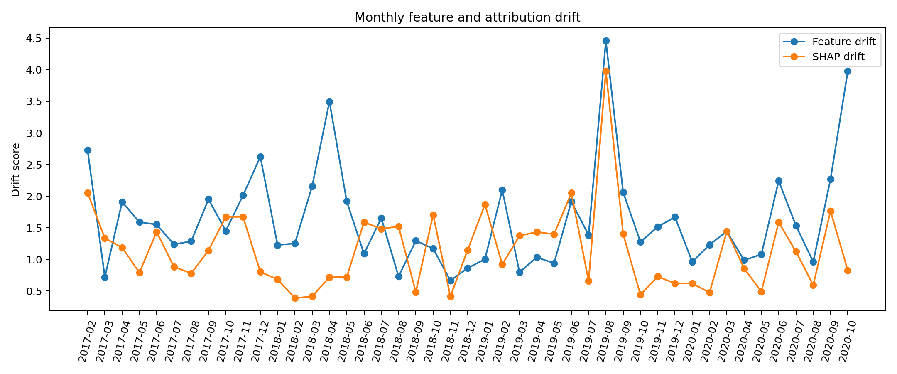
Figure 5.1 Monthly feature and SHAP drift signals

5.3 Controlled Diagnosis
The controlled benchmark uses stable, benign-region, benign-identity, benign-service, security-privilege, security-defense, and security-credential perturbations. Five validation seeds tune thresholds and ten held-out seeds support the final comparison. The validation-tuned diagnosis achieved macro-F1 0.7306. This result measures the defined perturbation protocol, not naturally occurring attack detection.
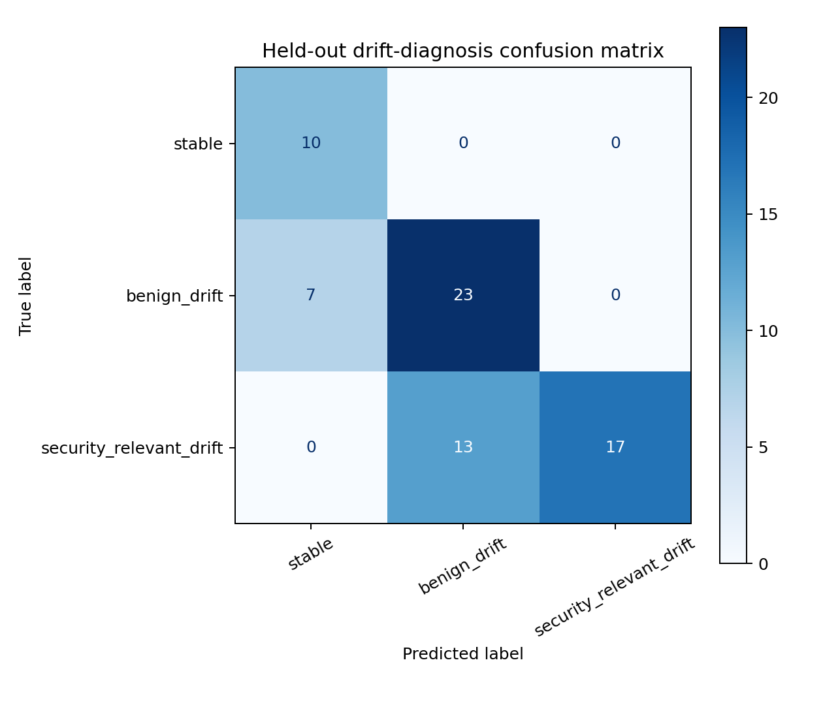
Figure 5.2 Held-out controlled diagnosis confusion matrix

5.4 Selective Adaptation
Policy | Trigger rate | Unnecessary adaptation | Mean F1 | FPR
Static | 0.0000 | 0.0000 | 0.2901 | 0.4282
Periodic | 0.3429 | 0.2000 | 0.2888 | 0.3160
Feature-only | 0.7571 | 0.3286 | 0.2734 | 0.1825
Dual-signal | 0.2429 | 0.0000 | 0.2873 | 0.3397
Coupled / conservative | 0.2429 | 0.0000 | 0.2873 | 0.3397

Table 5.2 Controlled adaptation results
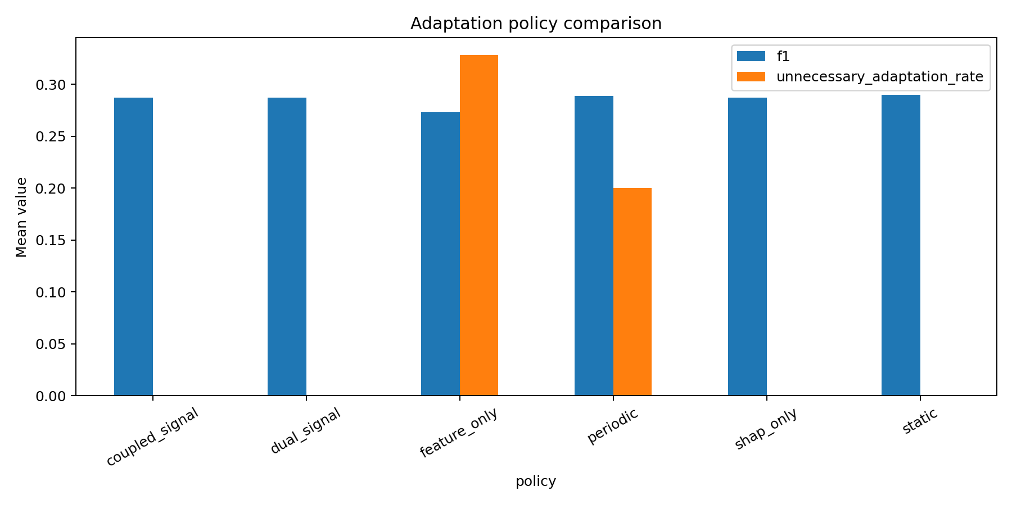
Figure 5.3 Adaptation-policy comparison
Relative to static adaptation, the dual policy reduced FPR by 0.0885 with a 95% bootstrap interval of [-0.1272, -0.0561] and Benjamini-Hochberg adjusted q=0.000434. Its paired F1 difference was -0.0028 with a 95% interval of [-0.0181, 0.0112]. The coupling policy matched the dual policy in this controlled benchmark, so it is reported as a neutral diagnostic ablation rather than a universal improvement.

5.5 Robustness and External Validation
Detector choice matters on the independent Cloud Log Sampling Dataset. Isolation Forest achieved precision 0.3306, recall 0.7137, F1 0.4519, and FPR 0.1738. Local Outlier Factor achieved F1 0.5334 with higher recall and FPR, while One-Class SVM achieved F1 0.0015. These results support portability of the feature contract but not a claim that one detector is universally best.
External policy | Precision | Recall | F1 | FPR
Feature-only | 0.9091 | 1.0000 | 0.9524 | 0.5000
SHAP-only | 0.9091 | 1.0000 | 0.9524 | 0.5000
Dual-signal | 0.9091 | 1.0000 | 0.9524 | 0.5000
Source-tuned coupling | 1.0000 | 0.1000 | 0.1818 | 0.0000
Unsupervised largest-gap coupling | 1.0000 | 1.0000 | 1.0000 | 0.0000

Table 5.3 Independent external temporal diagnosis checkpoint
The successful largest-gap result is based on 12 scenario windows and estimates a coupling threshold from the unlabeled target-score distribution. It is an encouraging transfer checkpoint, not production evidence. Broader multi-period validation is required.

5.6 Novelty and Current Status
The novelty is methodological and empirical. The project connects CloudTrail-specific drift monitoring with model-attribution change, protected adaptation, and a label-free transfer-calibration experiment. It does not claim novelty for Isolation Forest, SHAP, cosine similarity, or drift detection in isolation. The current implementation is complete as a capstone research prototype, while human PRISMA screening, supervisor review, venue verification, and stronger independent post-adaptation validation remain before journal submission.

5.7 Limitations
• The primary corpus has no attack ground truth, so real-data results are observational.
• Controlled perturbations are reproducible but semi-synthetic and do not replace incident evidence.
• Month-level timestamps limit event-order and session-level conclusions.
• Ordinal encoding of categorical attributes may impose artificial geometry.
• The target-window calibration is based on a small external checkpoint and may be unstable with few or contaminated windows.
• The adaptation controller is an offline research prototype and does not enforce AWS IAM changes.

CHAPTER 6

6. REFERENCES
[1] F. T. Liu, K. M. Ting, and Z.-H. Zhou, "Isolation Forest," in Proc. IEEE International Conference on Data Mining, 2008, pp. 413-422. doi:10.1109/ICDM.2008.17.
[2] S. M. Lundberg and S.-I. Lee, "A unified approach to interpreting model predictions," in Advances in Neural Information Processing Systems, vol. 30, 2017.
[3] F. Maggi, W. Robertson, C. Kruegel, and G. Vigna, "Protecting a moving target: Addressing web application concept drift," in RAID, 2009. doi:10.1007/978-3-642-04342-0_2.
[4] R. Sethi and M. Kantardzic, "On the reliable detection of concept drift from streaming unlabeled data," Expert Systems with Applications, 2017. doi:10.1016/j.eswa.2017.04.008.
[5] R. Kuppa and A. H. M. Le-Khac, "Learn to adapt: Robust drift detection in security domain," Computers and Electrical Engineering, 2022. doi:10.1016/j.compeleceng.2022.108239.
[6] S. Han et al., "Anomaly detection in the open world: Normality shift detection, explanation and adaptation," NDSS, 2023. doi:10.14722/ndss.2023.24830.
[7] X. Li, Y. Yu, Y. Zhang, Y. Luo, and X. Xie, "Concept drift adaptation by exploiting drift type," ACM TKDD, 2024. doi:10.1145/3638777.
[8] S. Lee, J. Lee, J. Lee, and J. Lee, "Explainable artificial intelligence-based model drift detection applicable to unsupervised environments," Computers, Materials & Continua, 2023. doi:10.32604/cmc.2023.040235.
[9] A. Varma and P. Ramya, "An explainable machine learning and large language model framework for anomaly detection in AWS CloudTrail logs," ICNGN, 2025. doi:10.1109/ICNGN67480.2025.11413642.
[10] Amazon Web Services, "Feature attribution drift for models in production," Amazon SageMaker Clarify documentation, accessed 2026.
[11] Amazon Web Services, "Understanding CloudTrail events," AWS CloudTrail documentation, accessed 2026.
[12] G. Arora et al., "A systematic review on detection and adaptation of concept drift in streaming data using machine learning techniques," WIREs Data Mining and Knowledge Discovery, 2024. doi:10.1002/WIDM.1536.
[13] Scikit-learn developers, "IsolationForest documentation," scikit-learn User Guide, accessed 2026.
[14] S. Lundberg et al., "TreeExplainer documentation," SHAP documentation, accessed 2026.
[15] PRISMA Statement, "PRISMA 2020 statement and checklist," prisma-statement.org, accessed 2026.

APPENDIX A - SAMPLE CODE
The following excerpt summarizes the core diagnosis rule. The complete implementation is maintained in the project repository.
feature_high = feature_score >= feature_threshold
shap_high = shap_score >= shap_threshold
coupling_high = coupling_score >= coupling_threshold
if not feature_high and not shap_high:
state = 'stable'
elif feature_high and not shap_high:
state = 'benign_drift'
elif feature_high and shap_high and coupling_high:
state = 'security_relevant_drift'
else:
state = 'review_required'
Reproduction commands:
python scripts/run_all.py
python scripts/run_robustness_experiments.py
python scripts/run_external_temporal_diagnosis.py
python -m pytest tests -q

