MACHINE LEARNING CLASSIFICATION PROJECT

Title
- Machine Learning Classification Project

Objective
- To build and evaluate supervised classification models and compare their performance using different evaluation metrics.

Dataset
- The Iris dataset from Scikit-Learn was used. It contains flower measurements used for classification into different species.

Data Preprocessing
- Dataset was loaded using Scikit-Learn.
- Features and target variables were separated.
- Train test split was applied with 80 percent training and 20 percent testing

Models Used
- Logistic Regression
- Random Forest Classifier

Evaluation Metrics
- The models were evaluated using accuracy, precision, recall, F1 score, and ROC AUC score
Screenshot of metrics output
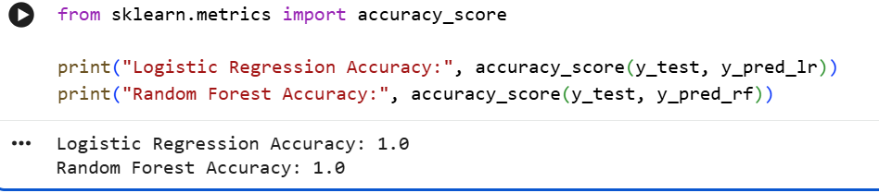
Screenshot of ROC AUC output
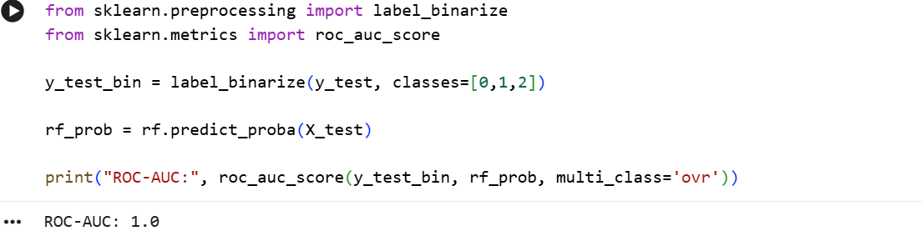

Cross Validation
- Fivefold cross validation was performed to check model stability
Screenshot of cross validation results
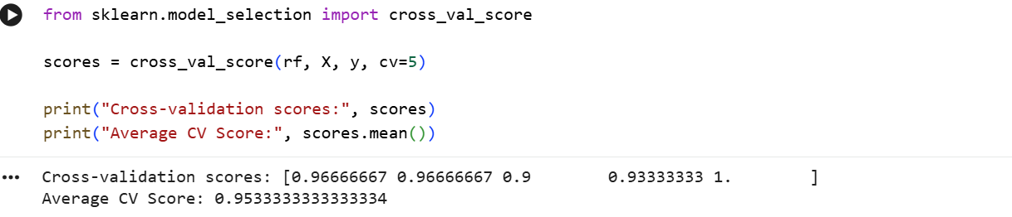

Model Comparison
- Both models were compared based on performance metrics.
- Random Forest performed better than Logistic Regression
Screenshot of bar chart comparison here
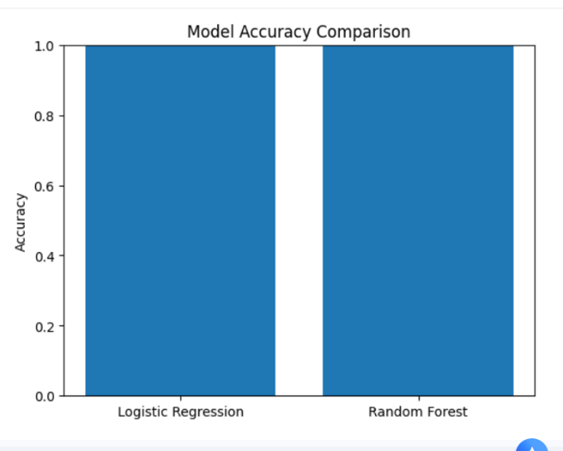

Conclusion
- The project successfully built and evaluated two classification models. Random Forest gave better performance compared to Logistic Regression. Cross validation confirmed that the model results are stable.

