Title
Responsible AI and Model Interpretation

Objective
Analyze model explainability and fairness using SHAP and feature importance techniques.

Dataset
Iris Dataset from Scikit-Learn

Model Used
Random Forest Classifier

Feature Importance Analysis
- Briefly explain that feature importance was calculated.
- Insert:
  - Screenshot of the feature importance table
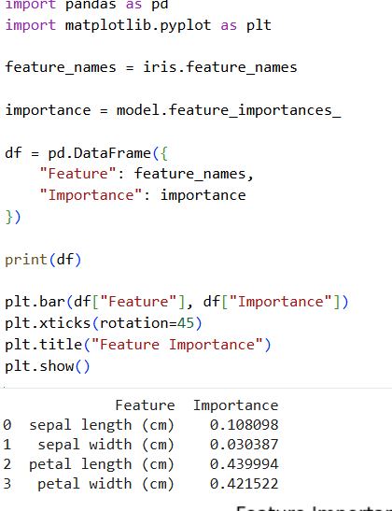
  - Screenshot of the feature importance graph
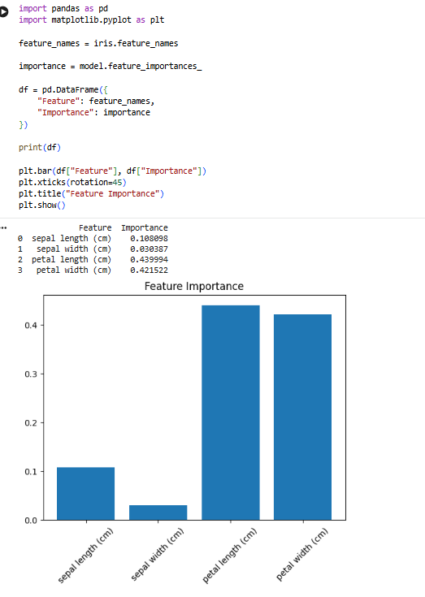

SHAP Analysis
- Explain that SHAP was used to interpret model predictions.
- Insert:
  - SHAP summary plot screenshot
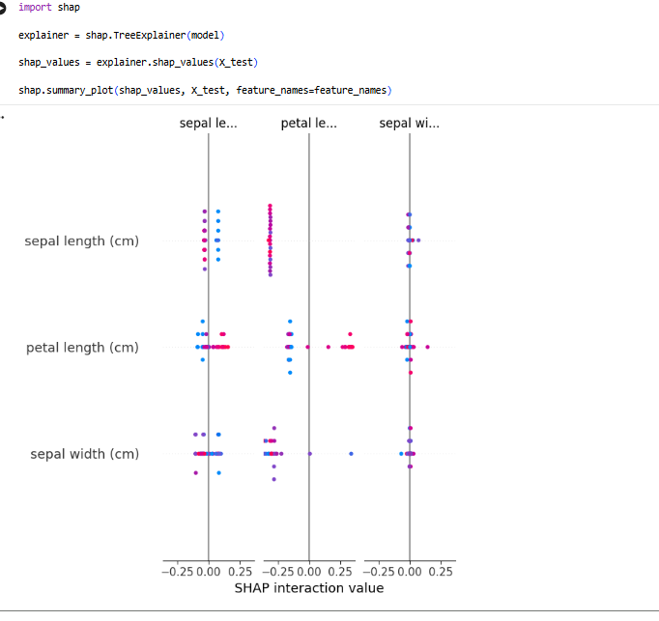

Bias Analysis
- Screenshot of Bias text.
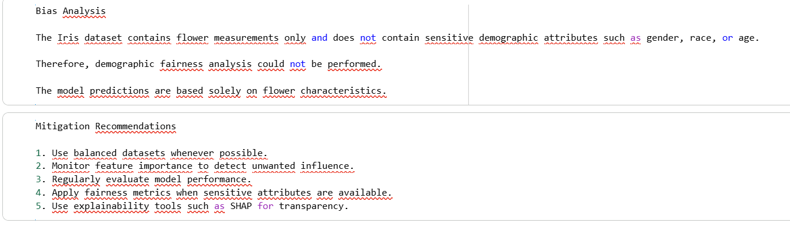
- Write:
The Iris dataset does not contain sensitive attributes such as gender, race, or age. Therefore, demographic bias analysis could not be performed.

Mitigation Recommendations
- Screenshot of mitigation text. 
- Mention the recommendations briefly.

Conclusion
- The model was successfully interpreted using feature importance and SHAP.
- No sensitive attributes were available for demographic fairness evaluation.
- Explainability techniques improved transparency of the model.

