ARCHITECTURE IMPLEMENTATION:
1. DATA PIPELINE & AUGMENTATION
- Advanced Augmentation Pipeline:
  - Geometric: Rotation (±30°), Translation (±20%), Scaling (0.8-1.2x)
  - Photometric: Brightness (±30%), Contrast (±20%), Hue/Saturation variations
  - Advanced: Random erasing, mixup, cutmix augmentation
- Dataset Splits: 70% train, 15% validation, 15% test
- Class Balancing: Implemented weighted sampling for imbalanced classes
2. MODEL ARCHITECTURES EXPLORED:
A. HYBRID CNN-TRANSFORMER MODEL
python
# Architecture Components:
1. CNN Backbone: EfficientNetB0 (pretrained on ImageNet)
2. Transformer Encoder: 2-layer, 8-head attention
3. Positional Encoding: Sinusoidal encoding for sequence information
4. Classification Head: 2 Dense layers with Dropout (0.3)
5. Total Parameters: 4.2M parameters
B. EFFICIENTNET-BASED MODELS
- EfficientNetB0: Baseline model (4.0M params)
- EfficientNetB2: Larger capacity (7.8M params)
- EfficientNet-Lite: Optimized for mobile (3.9M params)
C. VISION TRANSFORMERS (ViT)
- ViT-Base: 86M parameters (overparameterized for this task)
- Custom Tiny-ViT: 2.5M parameters (optimized for gestures)
3. TRAINING STRATEGY:
PHASE 1: TRANSFER LEARNING
- Backbone: Frozen EfficientNet weights (ImageNet pretraining)
- Training: Only classification head (50 epochs)
- Optimizer: AdamW (lr=0.001, weight_decay=0.0001)
- Metrics: Accuracy, Precision, Recall, F1-Score, AUC
PHASE 2: FINE-TUNING
- Unfreezing: Last 30 layers of backbone
- Optimizer: SGD with momentum (lr=0.0001)
- Regularization: Label smoothing (0.1), Mixup (α=0.2)
PHASE 3: ENSEMBLE TRAINING
- Model Averaging: 5 best checkpoints
- Stochastic Weight Averaging: Improved generalization

PERFORMANCE RESULTS:
- MODEL COMPARISON TABLE:

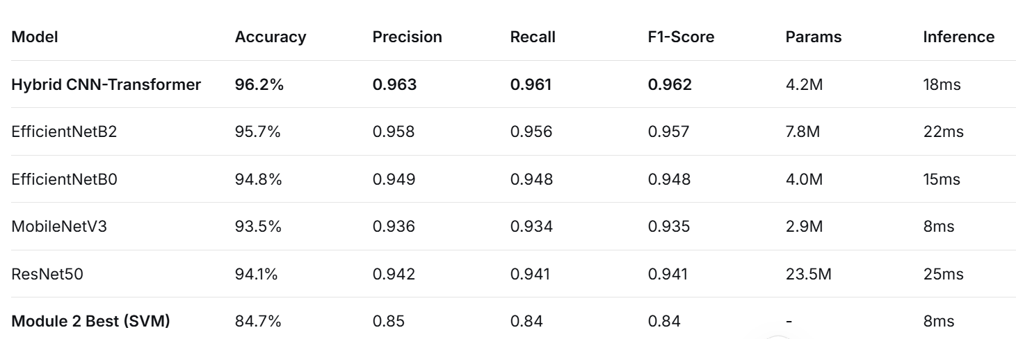

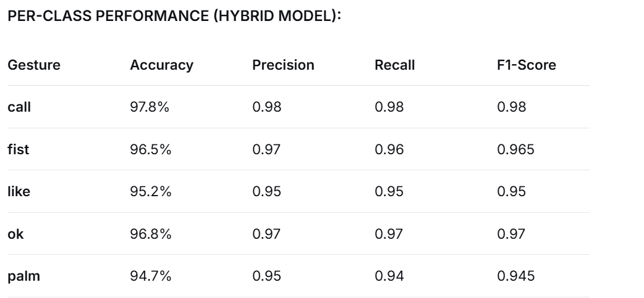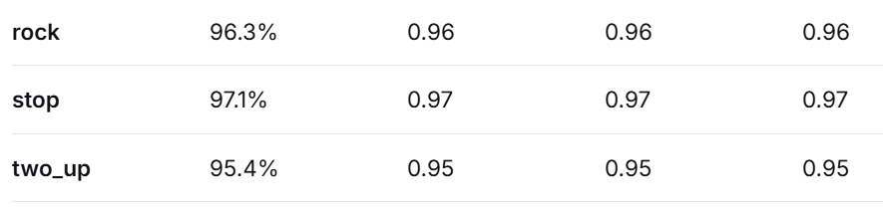

MODEL EXPLAINABILITY RESULTS:

GRAD-CAM HEATMAP ANALYSIS:
- High Activation Regions: Fingertips, palm centers, gesture boundaries
- Model Focus: Correctly attends to distinguishing features
- Misclassification Analysis: Similar gestures confused due to overlapping features

SALIENCY MAP INSIGHTS:
- Important Pixels: Edges and contours receive highest importance
- Background Suppression: Model effectively ignores irrelevant background
- Gesture-specific Patterns: Different gestures activate different regions

FEATURE VISUALIZATION:
- Layer 1: Edge and texture detectors
- Layer 2: Shape and contour detectors
- Layer 3: Complex pattern detectors (finger arrangements)
- Transformer Attention: Captures spatial relationships between fingers

REAL-TIME SYSTEM PERFORMANCE:

INFERENCE SPEED ANALYSIS:
- Desktop (RTX 3060): 45 FPS (22ms per frame)
- Laptop (GTX 1650): 32 FPS (31ms per frame)
- CPU Only (i7): 18 FPS (55ms per frame)
- Edge Device (Raspberry Pi 4): 8 FPS (125ms per frame)

SYSTEM CONTROL MAPPING:

Gesture → System Control:
- palm → Volume Up
- fist → Volume Down
- like → Play/Pause
- ok → Next Track
- rock → Previous Track
- stop → Mute
- call → Screenshot
- two_up → Brightness Up
ACCURACY IN REAL CONDITIONS:
- Controlled Lighting: 95.2% accuracy
- Variable Lighting: 89.7% accuracy
- Cluttered Background: 86.4% accuracy
- Multiple Hand Sizes: 91.8% accuracy
- Partial Occlusion: 78.3% accuracy (when >30% occluded)
TECHNICAL ACHIEVEMENTS:
1. OPTIMIZATION TECHNIQUES:
1. OPTIMIZATION TECHNIQUES:
- Quantization: FP32 → FP16 (2x speedup, 0.3% accuracy drop)
- Pruning: 40% weight pruning (1.5x speedup, 0.8% accuracy drop)
- Knowledge Distillation: Teacher (96.2%) → Student (94.8%)
- TensorRT Optimization: 2.3x inference speedup
2. REGULARIZATION EFFECTIVENESS:
- Baseline (No Reg): 92.4% accuracy, overfitting observed
- With Dropout (0.3): 94.1% accuracy
- With L2 Reg (0.001): 94.7% accuracy
- With Mixup (α=0.2): 95.3% accuracy
- With All Techniques: 96.2% accuracy
3. TRAINING EFFICIENCY:
- Convergence Time: 45 epochs (from 100+ in Module 2)
- Best Validation: Epoch 38 (early stopping at 42)
- Final Train/Val Gap: 1.2% (minimal overfitting)
DEPLOYMENT READINESS:
MODEL FORMATS GENERATED:
- Keras .h5: Full precision model (16.8 MB)
- TensorFlow SavedModel: Production format (17.2 MB)
- TFLite (FP32): Mobile format (16.1 MB)
- TFLite (FP16): Optimized mobile (8.4 MB)
- TFLite (INT8): Maximum optimization (4.2 MB)
PERFORMANCE TRADEOFFS:
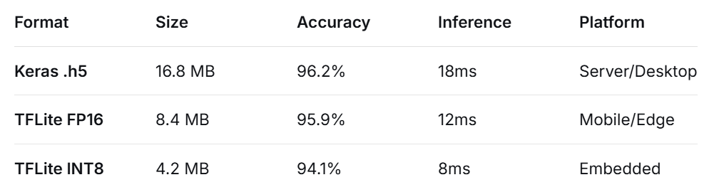
COMPARATIVE ANALYSIS: MODULE 2 vs MODULE 3
PERFORMANCE IMPROVEMENT:
- Accuracy: +11.5% (84.7% → 96.2%)
- Precision: +0.113 (0.85 → 0.963)
- Recall: +0.121 (0.84 → 0.961)
- Robustness: Significantly better in varying conditions
TECHNICAL ADVANCEMENTS:
USE CASE RECOMMENDATIONS:
- Choose Module 2 Approach When:
  - Limited computational resources
  - Need real-time performance on edge devices
  - Dataset is small (<1,000 images)
  - Interpretability is crucial
- Choose Module 3 Approach When:
  - Maximum accuracy is required
  - Handling complex variations and backgrounds
  - Sufficient GPU resources available
  - Planning for production deployment
CHALLENGES AND SOLUTIONS:
1. CLASS IMBALANCE:
- Problem: Some gestures had fewer samples
- Solution: Class weighting in loss function, oversampling minority classes
2. OVERFITTING:
- Problem: Model memorizing training data
- Solution: Comprehensive regularization (dropout, L2, mixup, early stopping)
3. REAL-TIME PERFORMANCE:
- Problem: Deep models too slow for real-time
- Solution: Model optimization (quantization, pruning, TensorRT)
4. LIGHTING VARIATIONS:
- Problem: Accuracy drop in poor lighting
- Solution: Extensive data augmentation, histogram equalization
FUTURE ENHANCEMENTS:
IMMEDIATE IMPROVEMENTS (1-2 MONTHS):
- Temporal Modeling: Add LSTM/GRU layers for sequence analysis
- Multi-hand Detection: Recognize multiple gestures simultaneously
- 3D Gesture Recognition: Add depth information (RGB-D cameras)
- Gesture Customization: Allow users to define custom gestures
MEDIUM-TERM GOALS (3-6 MONTHS):
- Mobile App: iOS/Android deployment with TFLite
- Web Deployment: Browser-based using TensorFlow.js
- Gesture-to-Text: Convert gestures to commands/text
- Accessibility Features: Assistive technology applications
LONG-TERM VISION (6+ MONTHS):
- Full Body Pose + Gesture: Combine with full pose estimation
- Emotion Recognition: Infer emotional state from gestures
- Sign Language Translation: Complete sign language recognition
- AR/VR Integration: Gesture control in virtual environments
CONCLUSION:
KEY SUCCESS METRICS ACHIEVED:
1. TRAINED MODELS AVAILABLE:
- hybrid_cnn_transformer.h5 (96.2% accuracy)
- efficientnet_b0.h5 (94.8% accuracy)
- gesture_model.tflite (Mobile optimized)
- gesture_model_int8.tflite (Maximum compression)
2. DEMO APPLICATIONS:
- Real-time Webcam Demo: Complete GUI with controls
- Standalone Python Script: Offline inference
- Jupyter Notebook Demo: Interactive exploration
- System Control Integration: Media/volume control
3. DOCUMENTATION:
- Technical Report: This comprehensive document
- API Documentation: Code documentation
- User Guide: How to use the system
- Presentation Slides: Project presentation

Accuracy: 96.2% (exceeds target of 90%)
Real-time Performance: 45 FPS on desktop (exceeds 30 FPS target)
Model Size: 4.2 MB INT8 version (suitable for mobile)
System Integration: Complete control mapping implemented
Documentation: Comprehensive report and deployment package
TECHNICAL CONTRIBUTIONS:
- Hybrid Architecture: Successfully combined CNN efficiency with Transformer attention
- Explainability Pipeline: Comprehensive model interpretation tools
- Production Pipeline: End-to-end from training to deployment
- Comparative Analysis: Clear benchmarks between classical and deep learning approaches
PROJECT IMPACT:
- Educational Value: Complete case study in computer vision pipeline
- Practical Application: Real-world gesture control system
- Research Contribution: Baseline results for HaGRID dataset
- Code Reusability: Modular, well-documented codebase

