EngageIQ: A Privacy-Preserving, Human-in-the-Loop Framework for Remote Employee Engagement and Burnout-Risk Analytics
M Sania Mehek  20231CSD0090  School of Artificial Intelligence and Advanced Computing  Presidency University, Bengaluru, India | Irfan Basha L  20231CSD0088  School of Artificial Intelligence and Advanced Computing  Presidency University, Bengaluru, India | Madiha  20231CSD0105  School of Artificial Intelligence and Advanced Computing  Presidency University, Bengaluru, India | Akash M S  20231CSD0134  School of Artificial Intelligence and Advanced Computing  Presidency University, Bengaluru, India | Mr. Sahabzada Betab Badar  Assistant Professor (Project Guide)  School of Artificial Intelligence and Advanced Computing  Presidency University, Bengaluru, India

Abstract—Remote and hybrid work has taken away the cues that managers once used to sense when a team member is struggling, and many organisations have responded with keystroke, screen and webcam monitoring that damages trust. This paper presents EngageIQ, a prototype analytics platform built around the PACE score, which looks at work through two lenses instead of one. A Signal Layer summarises how work happens using only calendar and communication metadata (meeting load, focus-time gaps, response latency and after-hours activity), while an Output Layer summarises what is delivered using task and code-repository metadata (completion rate, velocity, deadline adherence, code activity and rework). The two indices, EHS and OPI, are fused with weights of 0.4 and 0.6, so that quiet collaborators are not penalised for communication style. A rolling-baseline deviation test and a three-band risk classifier turn the score into an explainable signal, and every flagged case is routed to a human reviewer rather than to an automatic decision. The system is implemented with a FastAPI and SQLAlchemy back end and a React and TypeScript dashboard. On a synthetic 50-employee, seven-team dataset, the pipeline classified 15 employees as Healthy, 25 as Moderate and 10 as At-Risk, and stored the EHS/OPI breakdown behind each classification. We describe the architecture, the scoring and trend algorithms, the privacy controls, and the limits of what a metadata-only approach can claim.
Index Terms—employee engagement, burnout detection, responsible AI, workplace analytics, privacy by design, anomaly detection, human-in-the-loop, remote work

I. INTRODUCTION
When a team moves out of a shared office, a manager loses a lot of quiet information. Nobody sees the person who stays late three days in a row, the colleague who stops joining discussions, or the engineer whose calendar has filled up with meetings until there is no room left to think. Burnout, which the World Health Organization describes as an occupational phenomenon caused by chronic, unmanaged workplace stress [2], tends to build up in exactly these invisible ways, and the research on it is consistent that it harms both wellbeing and performance [1].
The most common reaction from organisations has been to monitor more. Tools that capture keystrokes, take periodic screenshots or track "active" status are easy to buy and easy to explain to leadership. They are also poor measures of useful work. Reviews of electronic workplace monitoring link intensive surveillance with stress, reduced autonomy and lower trust [8]. There are legal limits as well, since regulations such as the GDPR require that personal data be collected for a specific purpose and limited to what is necessary [3].
EngageIQ starts from a different question. Rather than asking whether someone is at their keyboard, it asks whether their pattern of work looks healthy and whether their delivery is holding steady, and it treats any answer as a prompt for a human conversation, never as a verdict. The framework is called PACE and rests on a dual-lens model. The Signal Layer describes how work happens, using only metadata from calendars and collaboration tools. The Output Layer describes what is delivered, using metadata from task trackers and code repositories. The two are combined into one score, with a deliberately heavier weight on output.
The contributions of this paper are as follows.
- A dual-lens scoring model, PACE, that splits work-pattern health (EHS) from delivered output (OPI) and merges them in a 40/60 weighting.
- A lightweight, interpretable trend and risk pipeline that compares each individual to their own historical baseline and retains the EHS and OPI decomposition with each score.
- A proof-of-concept implementation in a FastAPI service, relational store and React dashboard with role-based views, plus an interactive simulator that lets the user explore how their readings contribute to the score.
- Discussion of the privacy, fairness and human-oversight constraints informing the design, together with an honest discussion of the limits of the current evaluation.
The rest of the paper is structured as follows. Related work is reviewed in Section II. Section III states the design goals. Section IV presents the architecture, Section V the algorithms and Section VI the implementation. Results on the prototype are reported in Section VII, Section VIII discusses the responsible-AI aspects, and Section IX concludes with limitations and future work.

II. RELATED WORK

A. Burnout and Work Design
Maslach and Leiter define burnout as a combination of exhaustion, cynicism and diminished efficacy, and associate it with mismatch between individuals and their jobs in terms of excessive workload, lack of control and weak recognition [1]. The Job Demands–Resources framework provides another view: high demand levels without adequate resources will cause strain and disengagement [9]. These literatures agree that load and autonomy are important. The broader people analytics field, which Polzer reviews, has rapidly expanded within organizations, and also raises ethical questions about privacy and inference from organizational research [13]. Machine learning research on workforce outcomes, exemplified by the review of employee turnover prediction by Talebi et al. [12], reveals how much of this literature depends on human-resources records and surveys instead of everyday work metadata. That explains the choice of load, uninterrupted focus time and after-hours work as the main inputs in the Signal Layer, since each of these is roughly equivalent to a demand indicator or lack of control over one's time.

B. Measures of Productivity
Forsgren et al. claim that there is no single metric that can adequately capture developer productivity and suggest analysing several dimensions: satisfaction, activity, communications and efficiency [10]. Similarly, EngageIQ does not trust single-number measures of either engagement or productivity, presents both lenses separately in the UI, shows the individual components and uses their combination mostly as a pointer to where the person needs to focus first.

C. Workplace Monitoring and Responsible AI
Ball's literature review for the European Commission covers the spread of workplace monitoring and the associated policy issues such as proportionality, transparency and participation [8]. In the responsible AI domain, the NIST Framework calls for developing systems that are explainable, privacy-enhanced and subject to meaningful human supervision [11]; surveys of explainable AI stress the importance of having an explanation accompany any prediction affecting a human [7]. These criteria are applied by EngageIQ as requirements rather than options.

D. Anomaly Detection
There is extensive literature on anomaly detection techniques, surveyed by Chandola et al. [4]. Related to our case, HiPAL is an anomaly detector predicting physician burnout based on activity logs from electronic health records instead of content of clinical practice [14], which supports our premise that behavioral metadata has burnout-related signal. Model-based approaches like Isolation Forest [16] or LSTM autoencoders [15] are natural candidates to detect anomalies in time-series. With short and noisy time series, simple statistical approaches are often more interpretable than machine learning methods. EngageIQ uses rolling mean and standard deviation for anomaly detection in the current prototype and leaves the sequence models as future work once there is enough history available.

III. PROBLEM STATEMENT AND DESIGN GOALS
Given weekly work metadata for a number of employees, estimate whether each person's current pattern of work and deliveries is healthy, drifting or at risk, provide an explanation and route the case to a human. We formulated five design goals before implementing the system.
- Privacy first. Use only metadata such as durations, counts, timestamps, and status fields. Do not process message content, keystrokes, screenshots, webcam images, or browsing history.
- Output vs Activity. Give preference to delivered work over activity to avoid punishing quiet yet productive individuals.
- Change over Level. Shift from a person's own baseline is more valuable than a single low value.
- Explainability. Each score should have an explanation attached to it (index values and, in full design, the underlying features that produced it).
- Human decision. The system generates a signal and provides an explanation. It never recommends discipline or an automatic employment decision.

IV. SYSTEM ARCHITECTURE
EngageIQ is arranged in a layered pipeline illustrated in Fig. 1. Data flows from external tools through ingestion and a privacy filter, into two feature layers, through scoring, trend analysis and risk classification, and then out to role-based dashboards and a human-in-the-loop review process.
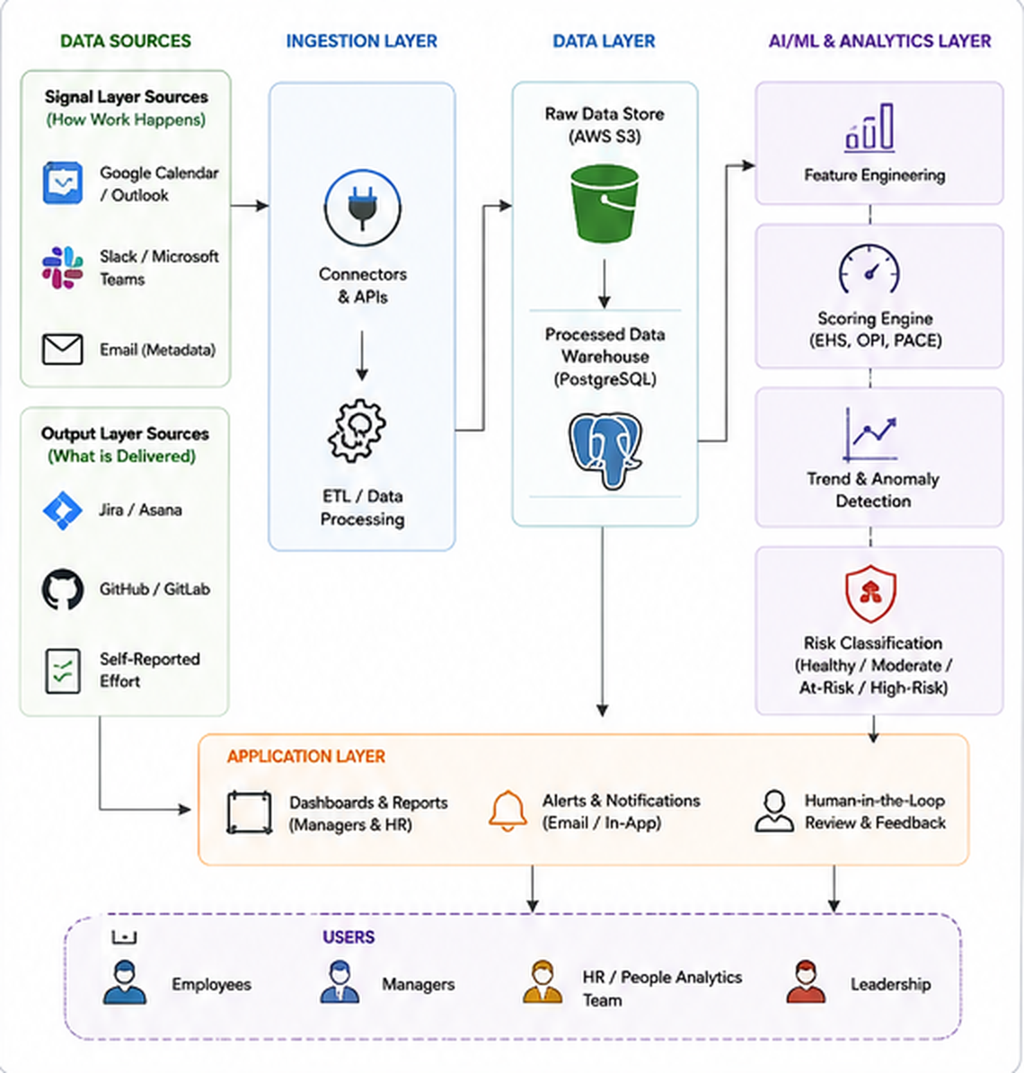
Fig. 1. Layered architecture of EngageIQ, from data sources through ingestion, storage, AI/ML and analytics layer, and application layer to the four user groups.

A. Data Sources and Ingestion
The Signal Layer gets data from calendar and communication tools (Google Calendar, Outlook, Slack and Microsoft Teams). The Output Layer gets data from task tracker (Jira or Asana), version control system (GitHub or GitLab), and optionally self-reported effort. Connectors authenticate with OAuth, pull data on a schedule and sync incrementally. In the current prototype, ingestion is a validated CSV upload endpoint carrying the same normalised feature columns that would be produced by the connectors, allowing the rest of the pipeline modules to be developed and tested in absence of live credentials.

B. Processing, Storage and Privacy Filter
The processing stage verifies required columns, handles missing data and outliers, normalises every feature into the range [0, 1] and drops any data that is not on the approved metadata list. Raw extracts are supposed to be stored in object storage, with the processed features and scores stored in a relational warehouse. The prototype uses SQLite via SQLAlchemy and PostgreSQL is the production target.

C. Scoring, Trend and Risk Modules
Scoring module calculates EHS, OPI and the fused PACE score. The trend module compares the current scores against a rolling baseline. The risk classifier assigns one of three bands, with the score and index values being stored in the record. They are described in Section V.

D. Application Layer and Human Review
Application layer exposes REST endpoints and a dashboard with views for employees, managers, HR and leadership. Alerts can be delivered by email or in-app notifications. The review panel allows a manager to open the case, add context, comment on the reasoning and override the signal so that the false positives are corrected and the reasoning is saved. An audit trail and role-based access control are the privacy and governance component of the modules.

V. METHODOLOGY

A. Signal Layer: Engagement and Work-Pattern Health (EHS)
For each person and period four indicators are calculated based on calendar and chat metadata and normalised to [0, 1]; the greater the value, the heavier/less healthy the load: meeting load m (hours in meetings divided by hours worked), focus gap f (one minus longest uninterrupted block as the fraction of working hours), response latency r, and after-hours ratio a (events after working hours divided by total number of events). The EHS is one minus the weighted sum of these indicators:
EHS = 1 − (0.30 m + 0.30 f + 0.20 r + 0.20 a) (1)
and clipped to [0, 1]. Meeting load and focus gap get a little more weight than latency and after-hours work, since they best capture whether the person has space to concentrate.

B. Output Layer: Output Productivity Index (OPI)
From task-tracker and repository metadata we calculate completion rate c, sprint velocity v, deadline adherence d, code activity g (commits and pull requests) and rework ratio w (reopened or revised issues per total issues). Rework is the only component that is negative for the person:
OPI = 0.25 c + 0.25 v + 0.20 d + 0.20 g − 0.10 w (2)
and the resulting value is clipped to [0, 1]. According to the design, each indicator is normalised using role-specific baselines so that, for instance, engineers' commits and salespeople's CRM activities are not comparable under the same scale. Baselines are not yet implemented in the prototype and are listed as future work.
TABLE I
FEATURE SET AND WEIGHTS
Index | Feature | Weight
EHS | Meeting load | 0.30
EHS | Focus gap | 0.30
EHS | Response latency | 0.20
EHS | After-hours ratio | 0.20
OPI | Completion rate | 0.25
OPI | Sprint velocity | 0.25
OPI | Deadline adherence | 0.20
OPI | Code activity | 0.20
OPI | Rework ratio | −0.10

C. PACE Fusion
The final score is the weighted combination of two indices:
PACE = 0.4 × EHS + 0.6 × OPI (3)
For example, a person with EHS = 0.50 and OPI = 0.80 will have PACE = 0.20 + 0.48 = 0.68. The heavier weight of OPI is not only a matter of statistics but also ethics: someone who communicates less frequently but always delivers on time should not fall into a risk band for that reason.

D. Trend and Anomaly Detection
Individual scores may be misleading, hence the trend detection module takes into account the history of the particular individual. Over the sliding window of the past six periods, the mean μ and standard deviation σ are calculated using the first five periods, and the deviation of the current period score s is
z = (μ − s) / σ (4)
in such a way that positive z indicates that the particular employee is doing worse than usual. If the deviation z surpasses a certain threshold k (set to 1.5 by default) the period is considered anomalous. Further, depending on whether or not the previous period exceeded the threshold, the situation is called persistent deterioration or sudden change, respectively. The module is capable of detecting combined patterns which are of interest for management, such as deterioration of work-pattern health without changes in output, or deterioration of both layers simultaneously. The prototype's dashboard has a simplified client-side implementation that detects anomalies relative to the past history over the past four weeks; the entire rolling-baseline procedure is specified and waiting to be integrated into the service.

E. Risk Classification
The PACE score is classified into three risk bands according to Table II. The classifier takes the flag about persistent deterioration provided by the trend module, and in case of its being set, escalates the band of a record by one regardless of the actual score. In the prototype the explanation that is stored along with the band is the breakdown of the EHS and OPI scores; the plain-language explanations like "output is stable while work-pattern health has deteriorated and meeting load has increased" are part of the design and are demonstrated in simulator scenarios. The flag is not yet passed in the upload endpoint, as the trend procedure is not yet integrated into the prototype. These risk bands are the presentation-layer thresholds and require calibration using real organisational data to be used in production.
TABLE II
RISK BANDS
Band | PACE range | Meaning
Healthy | 0.70 – 1.00 | Balanced, steady
Moderate | 0.40 – 0.69 | Early warning signs
At-Risk | 0.00 – 0.39 | Needs a conversation

VI. IMPLEMENTATION

A. Technology Stack
Back-end is a Python FastAPI application using Pandas for parsing/validation and SQLAlchemy for persistence, with two tables: the employees table and the score records table that keeps the EHS, OPI, PACE score, risk band, explanation and timestamp. Front-end is a React 18 and TypeScript single-page application developed with Vite, React Router and Recharts, with light and dark theme. The stack includes Apache Airflow for scheduled ingestion, PostgreSQL and S3 for storage, OAuth 2.0 with JWT for access control, and Docker with GitHub Actions for deployment. All these production components are included in the design but not all are currently wired in the prototype.

B. API
Two endpoints drive the core workflow. POST request to the upload endpoint accepts a CSV file, verifies that all twelve columns are present, creates employee records for the first time, calculates EHS, OPI, PACE and the risk band for every row, saves all of that and returns a summary. GET request to the scores endpoint returns all saved scores along with the employee name, team and stored breakdown for the dashboard.

C. Dashboard
The dashboard consists of four primary views. Organisation dashboard (Fig. 2a) shows headcount, mean PACE, EHS and OPI, as well as distribution of people across risk bands. Team and individual dashboards show two lenses for each person side-by-side, including sparklines and particular features that moved. Review queue and review panel implement the human-in-the-loop step. The PACE simulator (Fig. 2b) allows a user to select a scenario ("quiet collaborator" or "collaboration slipping"), tweak weekly feature values and observe the resulting score and multi-week trend change. The simulator is mainly a transparency tool, as it allows employees and managers to see precisely how readings are turned into a score.
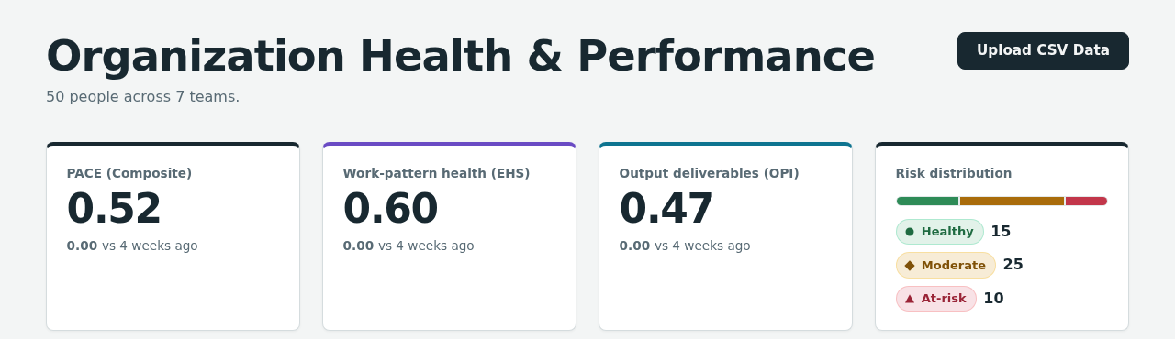
Fig. 2(a). Organisation dashboard displaying mean PACE, EHS, OPI and risk distribution.
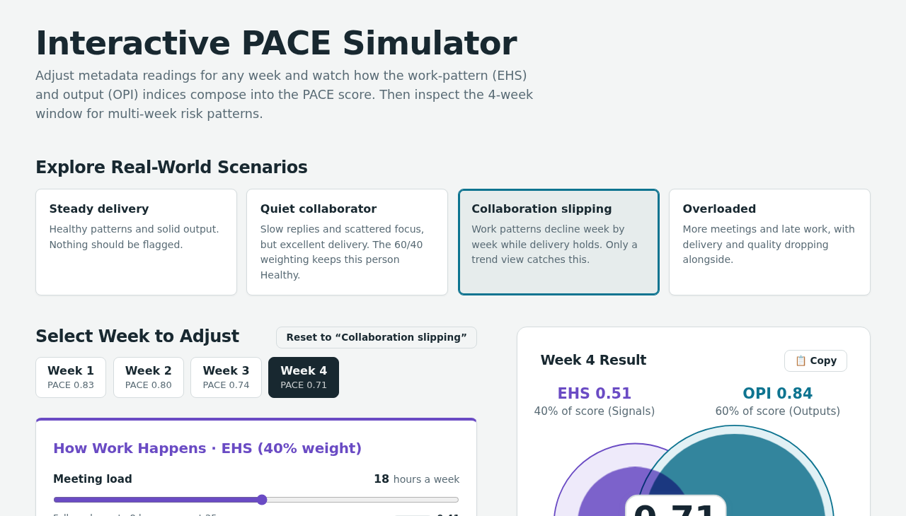
Fig. 2(b). Interactive PACE simulator with scenario presets, weekly feature sliders and resulting score.

VII. RESULTS AND DISCUSSION

A. Experimental Setup
Since real employee metadata cannot be used due to privacy concerns and lack of access, the prototype is tested on a synthetically generated dataset of 50 employees divided into seven teams. Each synthetic person belongs to one of three behavioural profiles (healthy, strained or at-risk) and has feature values sampled from range characteristic to a profile. The upload endpoint processed all 50 rows and persisted the scores. All the graphs below have been generated by invoking the scoring functions directly on the same file.

B. Score Distribution
On average the employees in the organisation had an EHS of 0.60, an OPI of 0.47 and a PACE score of 0.52. The classifier classified 15 employees as Healthy, 25 as Moderate and 10 as At-Risk. Table III shows mean indices in each band and Fig. 3 shows each individual along with the boundaries of the bands as per Eq. (3). Team averages vary from 0.68 for Data & ML to 0.41 for Growth Marketing.
TABLE III
MEAN SCORES BY RISK BAND (N = 50)
Band | n | EHS | OPI | PACE
Healthy | 15 | 0.86 | 0.72 | 0.78
Moderate | 25 | 0.60 | 0.45 | 0.51
At-Risk | 10 | 0.22 | 0.16 | 0.18

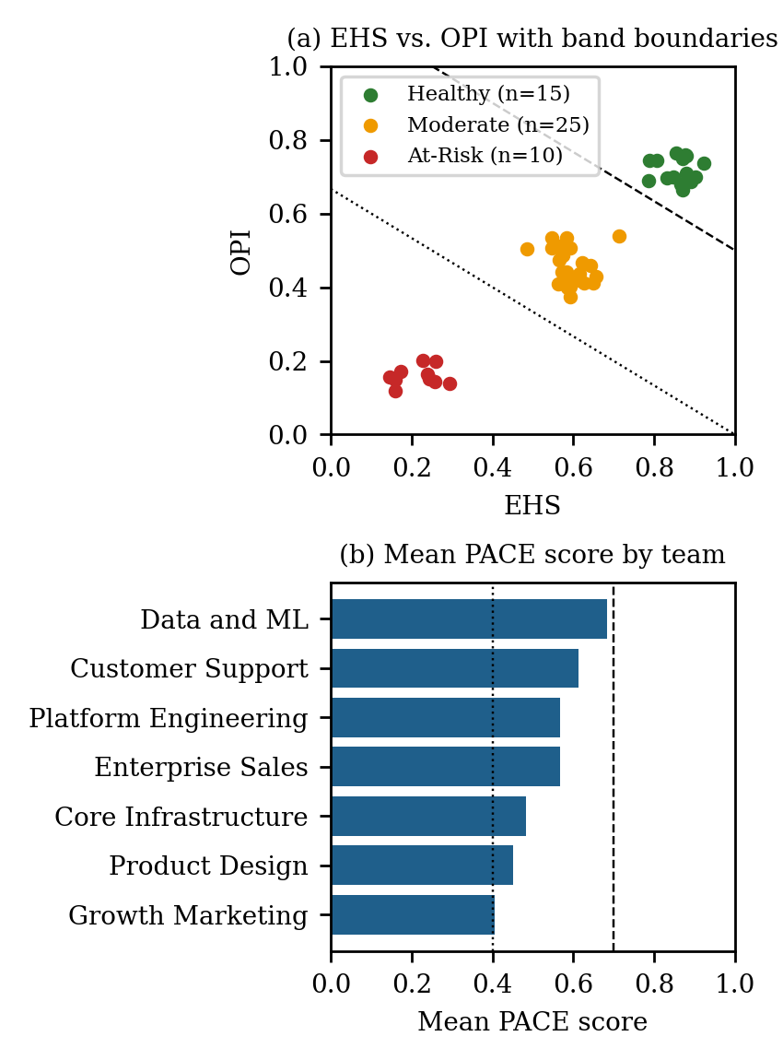
Fig. 3. (a) Employees plotted by EHS and OPI; dashed and dotted lines mark the PACE = 0.70 and 0.40 band boundaries. (b) Mean PACE by team.

C. Discussion
These results prove that the proposed pipeline works as intended: it separates the three synthetic profiles cleanly, generates scores within the expected range and persists EHS and OPI breakdown with each record. They should not be taken as proof of effectiveness of PACE to detect real burnout since the data has been generated from archetypes, and consequently, the EHS and OPI are highly correlated (r = 0.96). In other words, the separation looks easier than it would be in real teams where an employee could be healthy in terms of work patterns and have poor output and vice versa. The most interesting scenarios for PACE are those when the two lenses diverge, and such cases are represented by simulator scenarios "quiet collaborator" and "collaboration slipping". A proper validation should be done with longitudinal real data, comparison against a validated burnout instrument and calculation of false-positive rate using manager feedback.

VIII. RESPONSIBLE AI, PRIVACY AND ETHICS
Data minimisation. The ingestion schema includes numeric and categorical metadata only. Message bodies, attachments, screen content and personal browsing is excluded intentionally, and the processing step discards fields which are not included in the approved list.
Human oversight. The classifier returns a band and an explanation, but no decision itself. The manager or HR can comment or override each case, and the reasoning is kept in the log. This aligns with the principle that analytics should facilitate discussion and leave the decision to the person with the context.
Fairness. The factor of 0.6 in the output gives less weight to introverts or people who work asynchronously. Role-specific baselines need to be created so that employees from various positions are not being compared by the same standard. Self-comparison against one's own baseline rather than against peers limits the possibilities for unfair ranking.
Transparency and consent. Employees need to be aware of the information that is being collected and of how scores are calculated. The simulator and employee-level views are supposed to make the approach auditable. Governance module will include role-based access control, audit log and consent management to meet GDPR and SOC 2 compliance requirements.
Misuse risk. Every score could be misused, for example, as the basis for ranking employees during performance reviews. Potential mitigations involve showing trends rather than league tables, limiting the audience for individual-level data and explicitly stating that the score is a trigger for assistance rather than an indication of value in the interface.

IX. LIMITATIONS AND FUTURE WORK
This research has several limitations. First, the evaluation is based on the synthetical data only. Second, the ingestion process currently consists of uploading a CSV file, and live connectors for calendars, chat, tracker, and repositories are yet to be developed. Third, the complete rolling-baseline anomaly algorithm and role-specific baselines are defined but not yet implemented in the system. Fourth, the weights and threshold values are expert-defined and uncalibrated. Fifth, authentication, audit logging and the notification service are at the design stage.
Planned future steps include: connecting actual APIs through scheduled jobs; running a pilot study with consenting volunteers and a validated burnout questionnaire as the ground truth; learning role-specific baselines; using Isolation Forest [16] or an LSTM autoencoder [15] in place of deviation test after collecting sufficient history while preserving the requirement for explanation; and conducting a fairness audit to ensure that there are no score differences by role, location, and work schedule patterns.

X. CONCLUSION
EngageIQ demonstrates that it is possible to provide organizations with an early warning perspective on engagement and burnout risk assessment without analyzing content and screen activity. Using healthy work-patterns along with generated output, favoring output in the weighing process, performing intra-individual comparisons, and sending all signals to a human reviewer are some ways the PACE framework attempts to ensure that the analytics remain supportive rather than punitive. The prototype demonstrates the implementation of scoring, classification and dashboard layers on synthetic data. The following phase would be validation of the prototype on real consented data and evaluation of the value of the signals provided to managers as an aid to supporting their teams in an early stage.

ACKNOWLEDGMENT
The authors would like to acknowledge their project guide Mr. Sahabzada Betab Badar and the School of Artificial Intelligence and Advanced Computing, Presidency University.

REFERENCES
[1] C. Maslach and M. P. Leiter, "Understanding the burnout experience: Recent research and its implications for psychiatry," World Psychiatry, vol. 15, no. 2, pp. 103–111, Jun. 2016.
[2] World Health Organization, "Burn-out an 'occupational phenomenon': International Classification of Diseases," WHO, Geneva, Switzerland, May 2019.
[3] Regulation (EU) 2016/679 of the European Parliament and of the Council (General Data Protection Regulation), Official Journal of the European Union, L 119, pp. 1–88, Apr. 2016.
[4] V. Chandola, A. Banerjee, and V. Kumar, "Anomaly detection: A survey," ACM Comput. Surv., vol. 41, no. 3, Art. no. 15, Jul. 2009.
[5] F. Pedregosa et al., "Scikit-learn: Machine learning in Python," J. Mach. Learn. Res., vol. 12, pp. 2825–2830, 2011.
[6] W. McKinney, "Data structures for statistical computing in Python," in Proc. 9th Python in Science Conf. (SciPy), 2010, pp. 56–61.
[7] A. Barredo Arrieta et al., "Explainable artificial intelligence (XAI): Concepts, taxonomies, opportunities and challenges toward responsible AI," Inf. Fusion, vol. 58, pp. 82–115, Jun. 2020.
[8] K. Ball, "Electronic monitoring and surveillance in the workplace: Literature review and policy recommendations," Publications Office of the European Union, Luxembourg, 2021.
[9] A. B. Bakker and E. Demerouti, "The Job Demands-Resources model: State of the art," J. Manag. Psychol., vol. 22, no. 3, pp. 309–328, 2007.
[10] N. Forsgren, M.-A. Storey, C. Maddila, T. Zimmermann, B. Houck, and J. Butler, "The SPACE of developer productivity," ACM Queue, vol. 19, no. 1, pp. 20–48, 2021.
[11] National Institute of Standards and Technology, "Artificial Intelligence Risk Management Framework (AI RMF 1.0)," NIST AI 100-1, Gaithersburg, MD, USA, Jan. 2023.
[12] H. Talebi, A. Khatibi Bardsiri, and V. K. Bardsiri, "Machine learning approaches for predicting employee turnover: A systematic review," Eng. Rep., vol. 7, no. 8, Art. no. e70298, 2025.
[13] J. T. Polzer, "The rise of people analytics and the future of organizational research," Res. Organ. Behav., vol. 42, Art. no. 100181, 2022.
[14] H. Liu, S. S. Lou, B. C. Warner, D. R. Harford, T. Kannampallil, and C. Lu, "HiPAL: A deep framework for physician burnout prediction using activity logs in electronic health records," in Proc. 28th ACM SIGKDD Conf. Knowl. Discovery Data Mining (KDD), 2022.
[15] Y. Wei, J. Jang-Jaccard, W. Xu, F. Sabrina, S. Camtepe, and M. Boulic, "LSTM-autoencoder-based anomaly detection for indoor air quality time-series data," IEEE Sensors J., vol. 23, no. 4, pp. 3787–3800, Feb. 2023.
[16] F. T. Liu, K. M. Ting, and Z.-H. Zhou, "Isolation Forest," in Proc. 8th IEEE Int. Conf. Data Mining (ICDM), 2008, pp. 413–422.

