Task 10 : before : 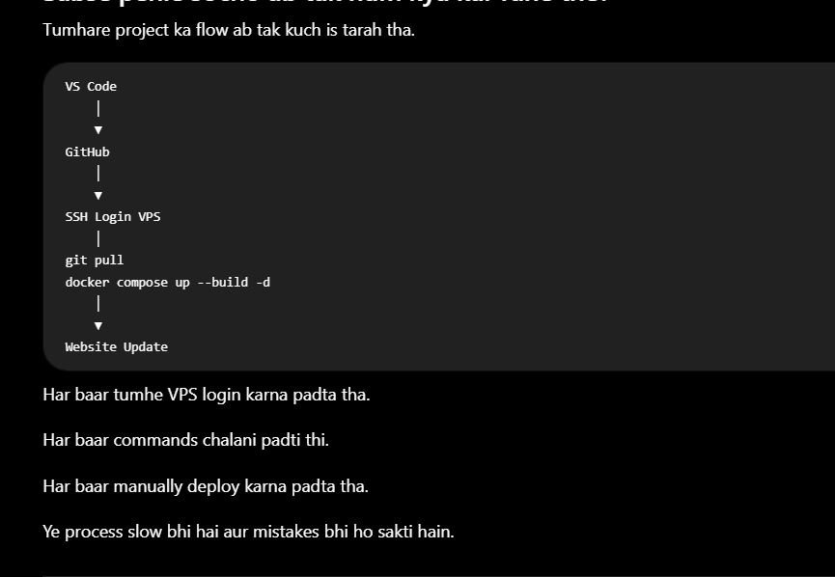
After
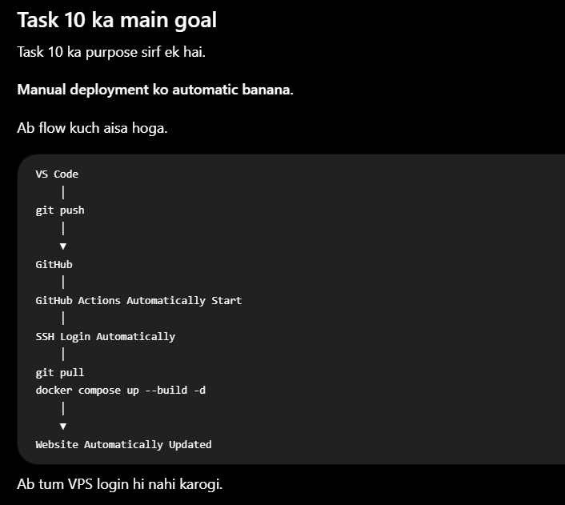

CI
Continuous Integration
Simple language mein.
Developer code likhta hai.
Code Commit Push Automatically Check
Yani jab bhi code push hota hai
system automatically kuch kaam karta hai.
Run Tests Check Errors Build Project Lint Security Scan
CD
Continuous Deployment
Agar code sahi hai
to automatically live server par chala jaye.
Koi SSH login nahi.
Koi git pull nahi.
Koi docker compose command manually nahi.
Task 10 Complete Roadmap
Phase 1 — Check Current Setup (5 minutes)
Goal
Pehle verify karna ke sab ready hai.
✔ Check karenge:
- GitHub repository
- VPS access
- Project VPS par hai
- Current folder structure
Location
🖥️ VPS SSH Terminal

Phase 2 — Generate Deployment SSH Key
Goal
Ek nayi SSH key banani jo sirf GitHub Actions ke liye hogi.
Is key ko tum kabhi normal login ke liye use nahi karogi.
Location
💻 Local Computer (PowerShell / VS Code Terminal)
Output:
devzey-deploy-key
devzey-deploy-key.pub

Phase 3 — VPS ko Trust Karwana
Goal
Public key VPS ko deni hai.
Iske baad VPS kahega:
"Is private key se login allowed hai."
Location
🖥️ VPS SSH Terminal
Hum:
~/.ssh/authorized_keys
edit karenge.

Phase 4 — Passwordless Login Test
Goal
Test karna ke key kaam kar rahi hai.
Command chalegi:
ssh -i devzey-deploy-key ...
Agar password nahi maangta
✅ Perfect.
Location
💻 Local Computer

Phase 5 — GitHub Secrets
Goal
GitHub ko private key deni hai.
Add karenge:
VPS_HOST

VPS_USER

VPS_SSH_KEY
Location
🌐 GitHub Website

Phase 6 — Verify VPS Project Location
Task ke instructions ke mutabiq project hona chahiye:
~/chatapp
Hum dekhenge:
Already hai?
Ya rename karna hai?
Ya clone karna hai?
Location
🖥️ VPS SSH Terminal

Phase 7 — Create GitHub Workflow
Create:
.github/

workflows/

deploy.yml
Isme automation likhenge.
Location
💻 VS Code
Phir:
git add

git commit

git push

Phase 8 — Test Automation
Frontend mein ek small text change karenge.
Example:
Hello

↓

Hello CI/CD
Push.
GitHub Actions automatically start hogi.

Phase 9 — Verify Deployment
Hum dekhenge:
GitHub Actions
↓
SSH
↓
git pull
↓
docker compose
↓
Website update
Without VPS login.

📌 Hamara Rule
Har step par main bataunga:
💻 Local Computer
Yahan command chalani hai.
Ya
🖥️ VPS SSH
Yahan command chalani hai.
Ya
🌐 GitHub
Yahan click karna hai.
Is se confusion bilkul nahi hogi.

Result
Tumhare current folder mein do files ban jayengi:
devzey-deploy-key
devzey-deploy-key.pub
- ✅ devzey-deploy-key → Private Key (GitHub Secrets mein jayegi)
- ✅ devzey-deploy-key.pub → Public Key (VPS mein add hogi)

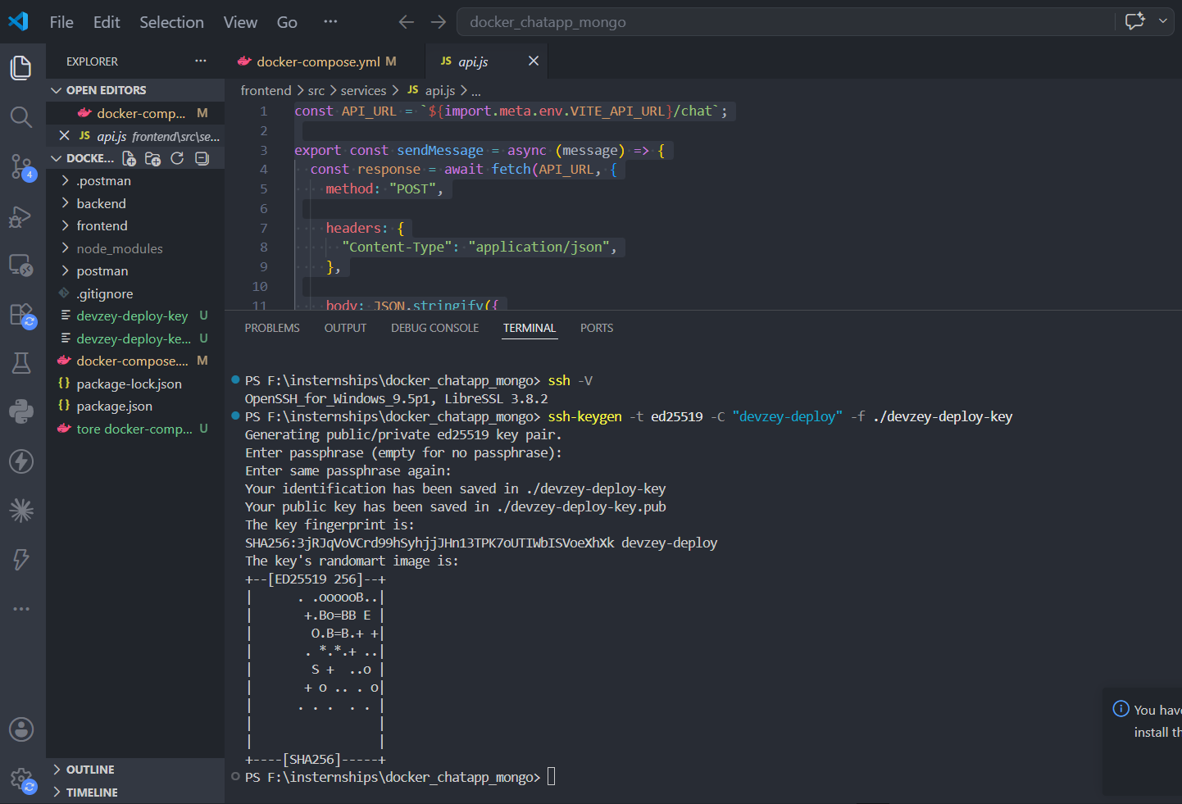
Step 2.1 is complete. ✅
humne deployment ke liye dedicated SSH key pair successfully generate kar liya hai.
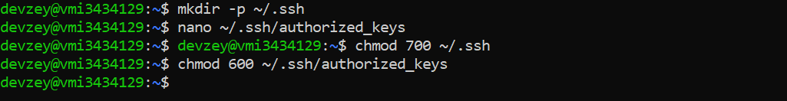
Step | Status
Generate SSH key pair | ✅ Complete
Public key VPS mein add | ✅ Complete
SSH permissions set | ✅ Complete

✅ Public key VPS par sahi add hui.
✅ Private key sahi hai.
✅ SSH authentication working hai.
✅ GitHub Actions isi key ko use karke VPS login kar payegi.
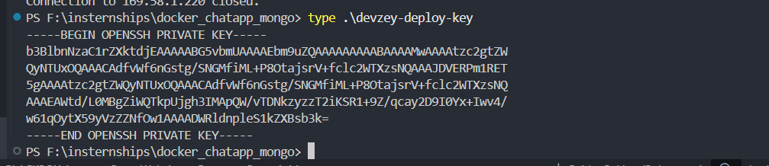
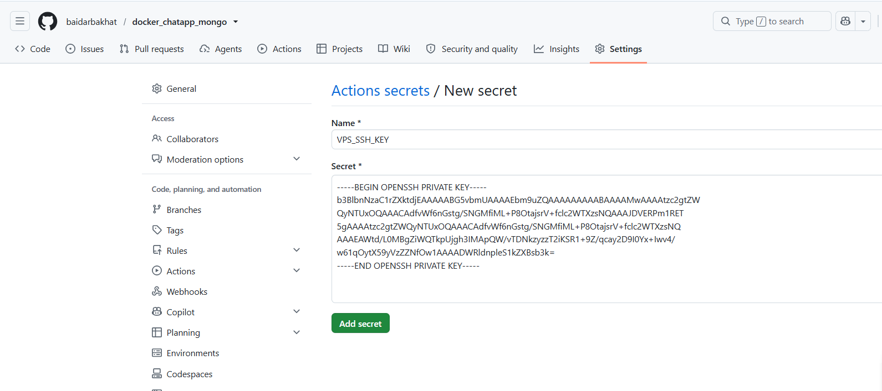
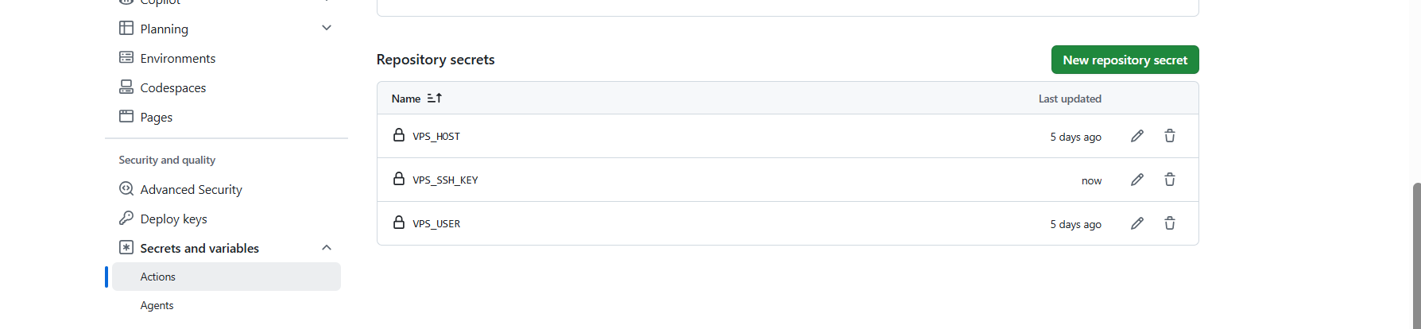

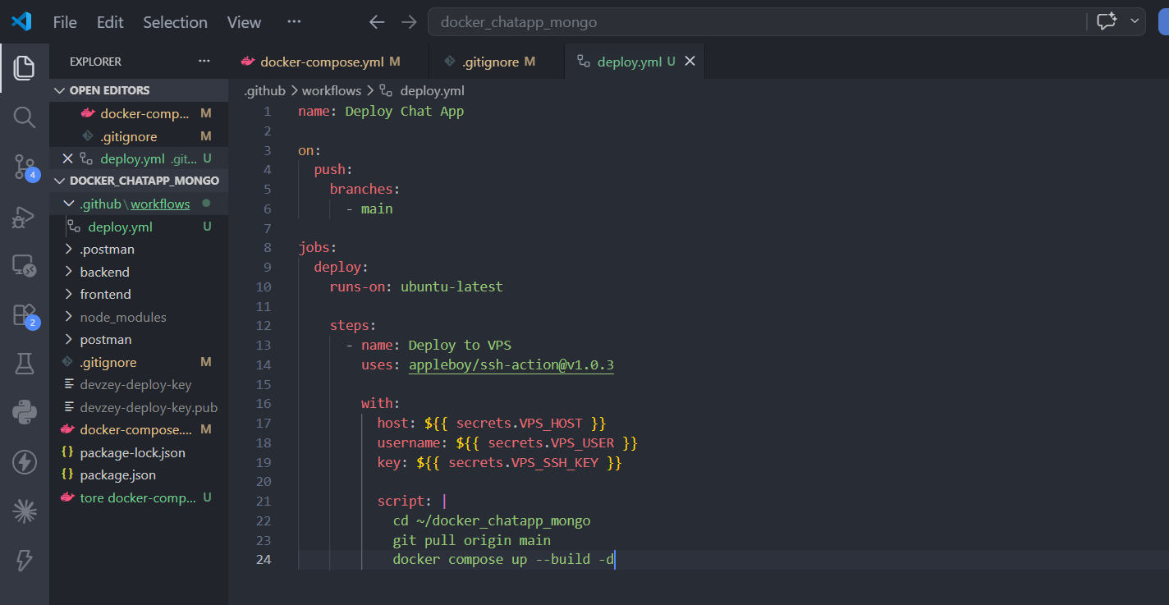
🧠 Har line ka matlab
1.
on:
push:
branches:
- main
Matlab:
Jab bhi main branch par push hoga, workflow automatically start hogi.

2.
runs-on: ubuntu-latest
Matlab:
GitHub apni temporary Ubuntu machine create karega.

3.
uses: appleboy/ssh-action@v1.0.3
Matlab:
Ye ready-made GitHub Action VPS mein SSH login karegi.

4.
host:
username:
key:
Ye GitHub Secrets se values uthayegi.
Isliye humne pehle:
- ✅ VPS_HOST
- ✅ VPS_USER
- ✅ VPS_SSH_KEY
banaye the.

5.
script:
Ye commands GitHub Runner par nahi, VPS ke andar execute hongi.
Sequence:
GitHub Runner

↓

SSH Login

↓

VPS

↓

cd ~/docker_chatapp_mongo

↓

git pull

↓

docker compose up --build -d
