CONNECTING TO THE VPS SAFELY
What is a VPS?
Virtual Private Server
VPS ek remote Linux computer hota hai jo data center mein 24/7 chalta hai aur internet ke through access kiya jata hai.
A Virtual Private Server is a computer that lives in a data center rather than on your desk
Features:
- AC cooling
- Backup electricity
- High-speed internet
- Security
- 24/7 monitoring
Example companies:
- AWS
- Google Cloud
- Azure
- DigitalOcean
- Vultr

What is SSH? = Secure Shell
Socho tum Lahore mein ho.
Aur tumhara computer Karachi mein rakha hai.
Internet ke through uske terminal mein login karogi. Isi ko SSH kehte hain.
Everything you type is encrypted.
SSH ek secure protocol hai jo internet ke through remote Linux server ko access karne ke liye use hota hai.
Root User vs Normal User
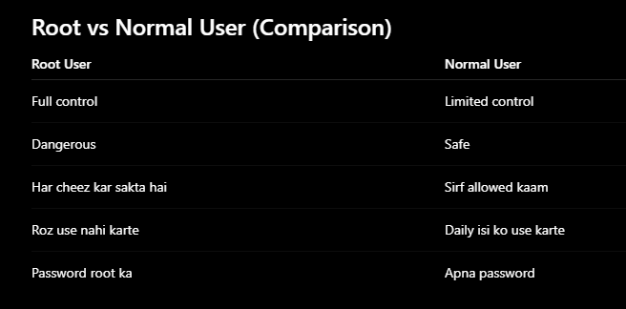
What is sudo?
Super User Do
Temporary admin power.
Example
Tum normal user ho.
Lekin software install karna hai.
To
sudo apt install nginx
Is command mein sirf ye ek command admin ban kar chalegi.
Baad mein phir tum normal user ho.
UFW Full Form
Uncomplicated Firewall
Ubuntu ka simple firewall.
Port 22: SSH
Port 80: HTTP
Port 443: HTTPS
