INSTALLING DOCKER AND NODE.JS ON THE VPS
Docker Image
Image = Blueprint / Recipe
Example:
Pizza ki recipe.
Recipe se pizza nahi khaya ja sakta.

Docker Container
Container = Running Application
Recipe se jab pizza bana...
Wo container hai.

Simple formula:
Image → Container

Recipe → Food
Ek image se 100 containers ban sakte hain.
Docker Engine
Docker Engine Docker ka main software hai.
Ye hi containers ko:
- banata hai
- chalata hai
- stop karta hai
- delete karta hai

Docker Commands (Notes)
Command | Meaning
docker build -t name . | Image banana
docker run image-name | Container chalana
docker ps | Running containers
docker ps -a | Sab containers
docker logs name | Logs dekhna
docker exec -it name sh | Container ke andar jana
docker stop name | Container stop
docker rm name | Container delete
docker images | Images list

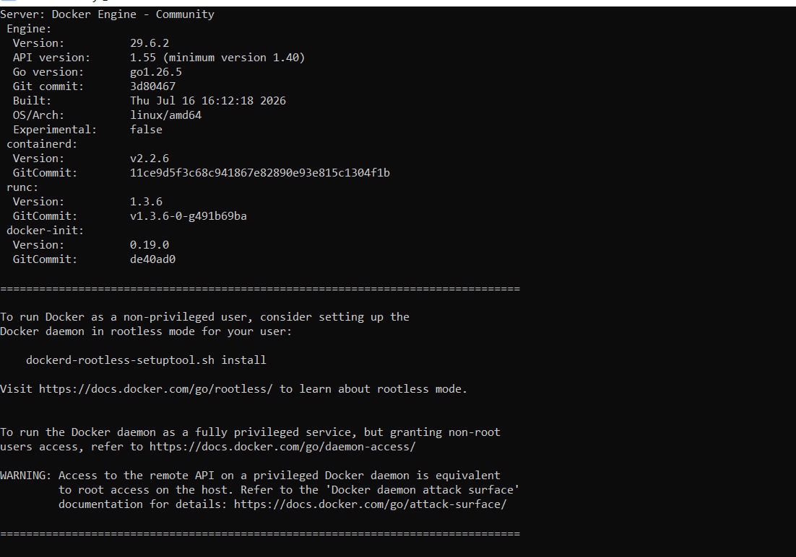

Node install

